EXPLORATORY DATA ANALYSIS
ON A CARS DATASET
A study of used-car prices, usage, fuel types, sellers and ownership
Student | Shreerama L P
Course / Semester | Computer Science and Engineering — 5th Semester
Dataset | CarDekho used-cars dataset
Tools | Python, Pandas, Matplotlib and Seaborn (Google Colab)
Dataset source | https://github.com/RanjitWaghela/Car-Dekho-EDA
Project report submitted for the Exploratory Data Analysis assignment. The analysis focuses on data quality, descriptive statistics, visual patterns and evidence-based observations. No machine-learning model is used.

1. Objective and Dataset Overview
The objective of this project is to explore a used-car dataset and understand how vehicle year, selling price, kilometres driven, fuel type, seller type, transmission and ownership are represented. Exploratory Data Analysis (EDA) helps identify data-quality issues, summarize the variables and communicate patterns using visualizations.

Questions investigated
- What are the main characteristics of the dataset?
- Are any values missing or rows duplicated?
- Which fuel, seller, transmission and ownership categories occur most often?
- How are selling price and kilometres driven distributed?
- Is there an observable relationship between year, price and kilometres driven?

Dataset summary
Item | Result
Rows before cleaning | 4,340
Columns | 8
Rows after removing exact duplicates | 3,577
Numerical columns | year, selling_price, km_driven
Categorical columns | name, fuel, seller_type, transmission, owner

Column descriptions
name: listed car model/name. year: vehicle year. selling_price: listed selling price (reported in the dataset's numeric units, commonly INR). km_driven: kilometres driven. fuel: fuel category. seller_type: seller classification. transmission: manual or automatic. owner: ownership category.
Data types: the notebook reports three integer numerical columns and five object/text columns. The dataset contains 4,340 records before duplicate removal.

2. Data Quality, Cleaning and Descriptive Statistics

Data quality checks
The missing-value check returned zero missing values in each of the eight columns. The duplicate check found 763 exact duplicate rows in the original 4,340 records. These duplicate rows were removed using Pandas drop_duplicates(), leaving 3,577 records and the same eight columns. A second duplicate check returned zero duplicates.
Check | Before cleaning | After cleaning
Rows | 4,340 | 3,577
Columns | 8 | 8
Missing values | 0 | 0
Exact duplicate rows | 763 | 0

Cleaning decision
Exact duplicate records were removed because repeated identical rows can over-represent the same observation in counts and summary statistics. No rows were removed for missing values because none were detected. High or unusual numerical values were not automatically deleted: they may represent genuine vehicles and should be investigated rather than discarded without justification.

Numerical descriptive statistics
Statistic | Year | Selling price | Km driven
Mean | 2012.96 | 473,912.54 | 69,250.55
Median (50%) | 2013 | 350,000 | 60,000
Minimum | 1992 | 20,000 | 1
25th percentile | 2010 | 200,000 | 36,000
75th percentile | 2016 | 600,000 | 90,000
Maximum | 2020 | 8,900,000 | 806,599
The mean selling price is higher than the median, suggesting that high-priced cars pull the average upward. The maximum price and kilometres driven are much higher than their respective medians, so the distributions should be interpreted with attention to possible outliers.

3. Visual Exploratory Data Analysis

Figure 1. Distribution of Car Selling Prices
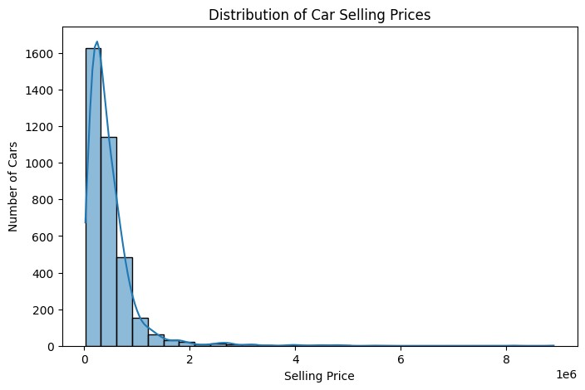
Observation: The distribution is right-skewed: most cars are concentrated at lower price levels, while a smaller number of cars have much higher selling prices.

Figure 2. Top 10 Most Common Car Models
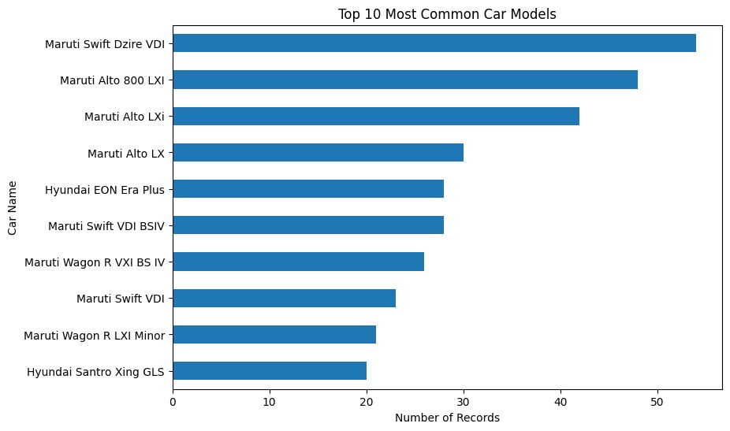
Observation: Maruti Swift Dzire VDI is the most frequently occurring model in the cleaned dataset, appearing 54 times.

Figure 3. Selling Price by Fuel Type
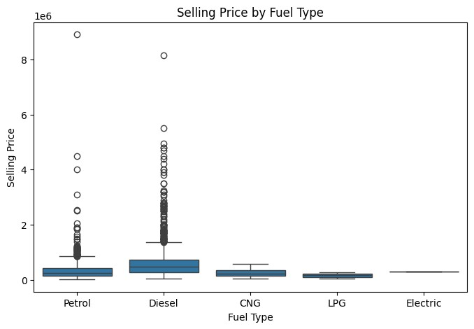
Observation: Selling prices vary across fuel categories. The box plot also helps reveal the spread and potential extreme prices within each category.

3. Visual Exploratory Data Analysis

Figure 4. Kilometres Driven vs Selling Price
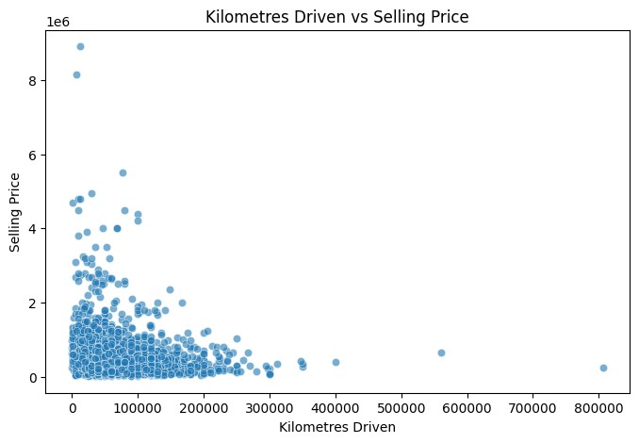
Observation: The scatter plot shows a weak negative relationship overall; the calculated correlation is approximately −0.187.

Figure 5. Number of Cars by Transmission Type
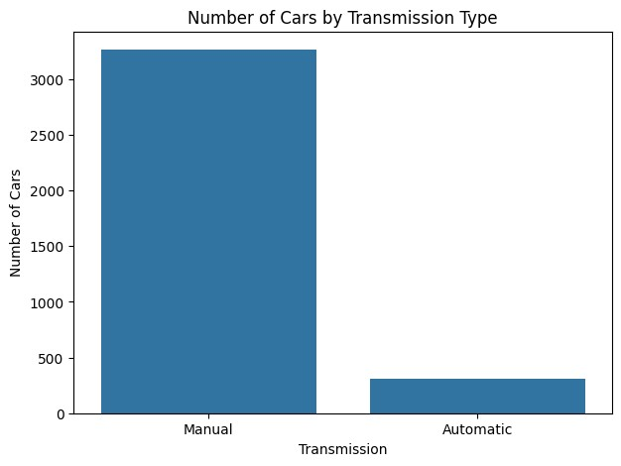
Observation: Manual cars dominate the dataset: 3,265 manual cars compared with 312 automatic cars after duplicate removal.

Figure 6. Correlation Heatmap of Year, Price and Kilometres Driven
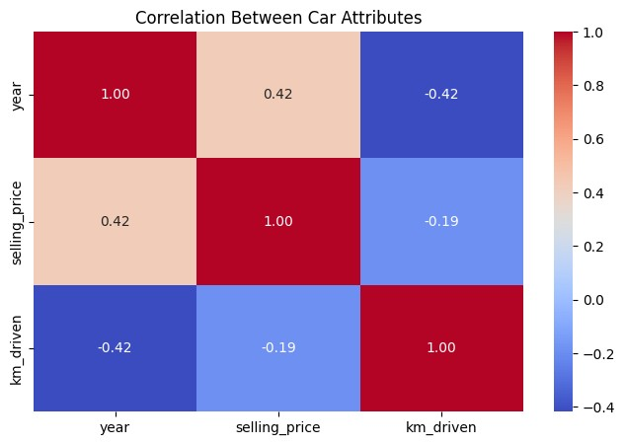
Observation: The heatmap summarizes pairwise linear relationships between year, selling price and kilometres driven. Correlation indicates association, not causation.

4. Key Findings, Limitations and Conclusion

Key findings supported by the analysis
- Duplicate records were significant. The original dataset had 763 exact duplicate rows; removing them reduced the dataset from 4,340 to 3,577 rows, while preserving all eight columns.
- No missing values were detected. The missing-value check returned zero for every column, so no missing-value imputation was needed.
- Diesel was the most common fuel category. After duplicate removal, 1,800 records were Diesel and 1,717 were Petrol; CNG, LPG and Electric were much less common.
- Individual sellers were the largest seller group. There were 2,832 Individual records, compared with 712 Dealer and 33 Trustmark Dealer records.
- Manual transmission dominated. The cleaned data contained 3,265 manual cars and 312 automatic cars.
- The most common model was Maruti Swift Dzire VDI. It appeared 54 times in the cleaned dataset.
- Price varied substantially. The median selling price was 350,000, while the mean was 473,912.54 and the maximum was 8,900,000. This supports the visual observation that a smaller number of high-priced vehicles affect the average.
- Kilometres driven had a weak negative linear correlation with selling price. The computed correlation was approximately −0.187. This indicates only a weak linear association in this dataset and does not establish causation.

Limitations
This dataset contains only the attributes shown in the eight columns; it does not include all factors that may influence a car's price, such as detailed condition, service history, location, or exact variant specifications. Some categories, such as Electric, have very few records, so comparisons involving them may be unreliable. Correlation describes linear association and does not prove cause and effect. Extreme values were retained rather than removed automatically.

Conclusion
This EDA project provided a clearer understanding of a used-car dataset through data inspection, duplicate removal, descriptive statistics and six visualizations. The analysis found no missing values, identified and removed exact duplicate records, and showed that Diesel fuel, individual sellers and manual transmission were common in the cleaned data. Selling prices varied widely, and kilometres driven had only a weak negative correlation with price. Further work could compare prices by vehicle age and ownership category, after checking that each comparison has enough records.
Tools used: Python, Pandas, NumPy, Matplotlib and Seaborn in Google Colab. Dataset reference:
https://github.com/RanjitWaghela/Car-Dekho-EDA

