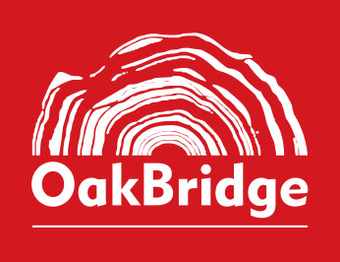
BOOK PROPOSAL FORM
OakBridge Publishing Pvt. Ltd.
Please complete this form in as much detail as you can and email it, together with one sample chapter of the proposed book, to info@oakbridge.in. Fields marked * are required. Our editorial team will review your proposal and get back to you with the next steps.
1. AUTHOR DETAILS
Full name(s) *
Designation & affiliation *
Institution, firm or organisation
Postal address
Email *
Phone / mobile *
Short author bio *
100–150 words; qualifications, experience and expertise in the subject
Previous publications
Books, journal articles, chapters — with publisher and year
2. ABOUT THE BOOK
Working title *
Subtitle
Category * | ☐ Law ☐ Tax ☐ Academic ☐ Business & General ☐ Other
Subject / area of law or discipline *
Type of work | ☐ Commentary ☐ Practitioner's guide ☐ Textbook ☐ Reference ☐ Monograph ☐ General reading
Synopsis *
200–300 words: what the book covers and why it is needed now
Key features / USP
What makes this book distinctive
Proposed table of contents *
Chapter titles, with a line on each if possible
3. MANUSCRIPT
Estimated length
Approx. word count or number of pages
Manuscript status * | ☐ Complete ☐ In progress
If in progress: % complete & expected completion date
Tables, figures, illustrations
Approximate number, and whether any are third-party material
Preferred format | ☐ Print ☐ eBook ☐ Both
4. READERSHIP & MARKET
Primary readership *
e.g. practitioners, judges, students (course/level), corporate counsel
Secondary readership
Institutional / bulk sales potential
Courses, bar associations, firms, organisations that may adopt or buy in bulk
Competing or comparable titles
Title | Author(s) | Publisher / Year | How your book differs
5. OTHER INFORMATION
Has this work been published before, in whole or part? | ☐ Yes ☐ No
Is this proposal under consideration with another publisher? | ☐ Yes ☐ No
If yes to either, please give details
Does the work include third-party copyright material?  Permissions will be the author's responsibility | ☐ Yes ☐ No
Anything else we should know
6. CHECKLIST & DECLARATION
☐ Completed Book Proposal Form ☐ Sample chapter attached
I confirm that the proposed work is original, that the information given above is accurate to the best of my knowledge, and that the work does not infringe the rights of any third party.
Signature | Name & date
Please email the completed form and a sample chapter to info@oakbridge.in. For office use only — Ref. no.: ____________ Received on: ____________

