HR Portal - Application Screenshots
Phase-End Project — Designing a Dynamic Frontend with React
Student Name | Shreesh Maurya
Course | Full Stack Development Program with Generative AI (Simplilearn)
Project Title | Creating an HR Portal Using React
Technologies | React 19, React Router, Vite, CSS3, localStorage (JSON)
Date | March 2026

Login Page
User authentication page with email/password form and demo credentials display.
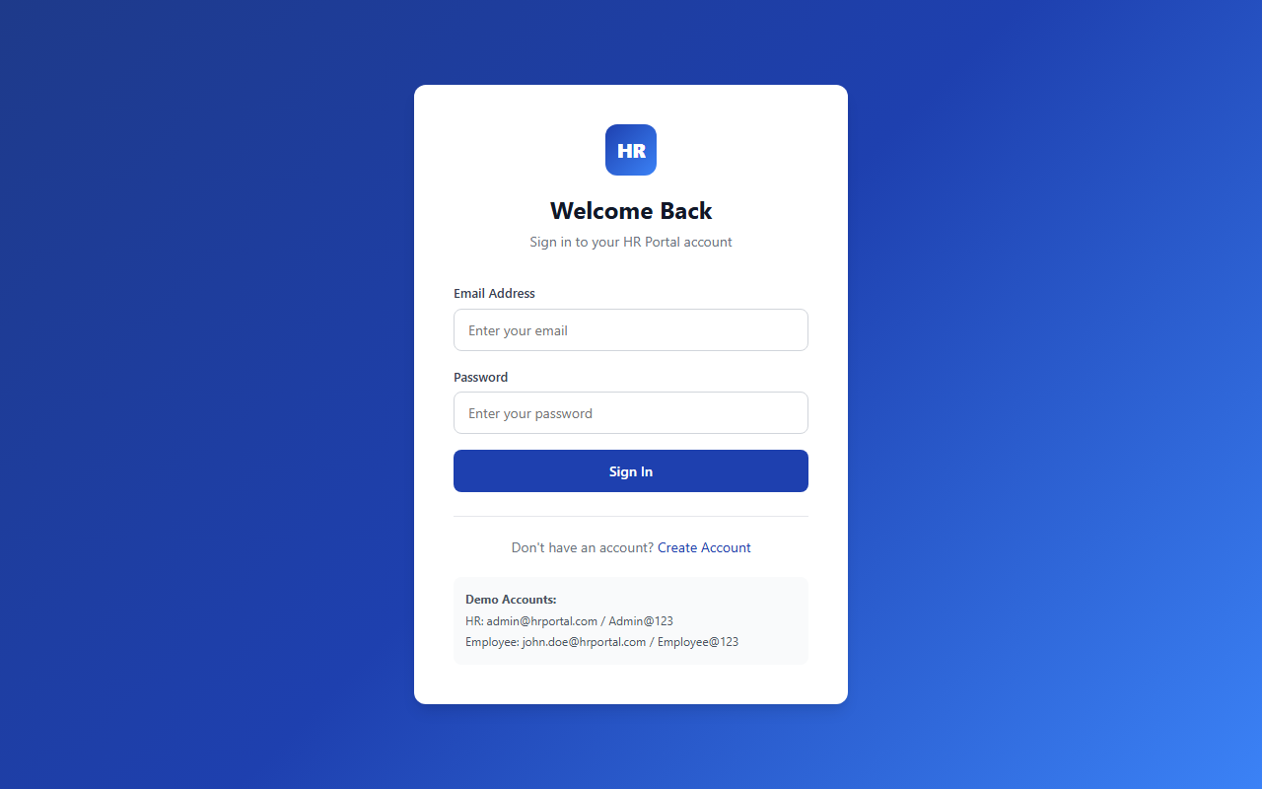

Signup / Employee Registration Page
Multi-field registration form with password strength indicator and validation.
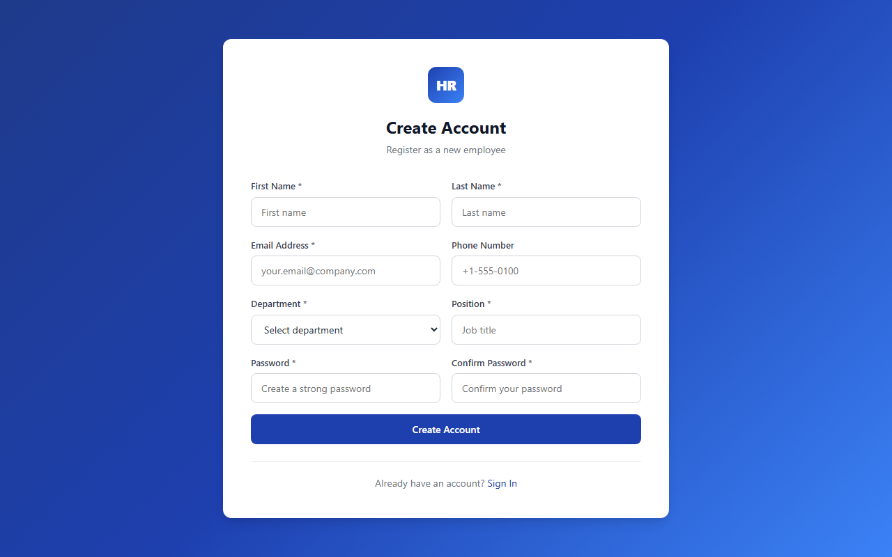

HR Dashboard
Overview dashboard showing employee stats, recent employees, and pending leave requests.
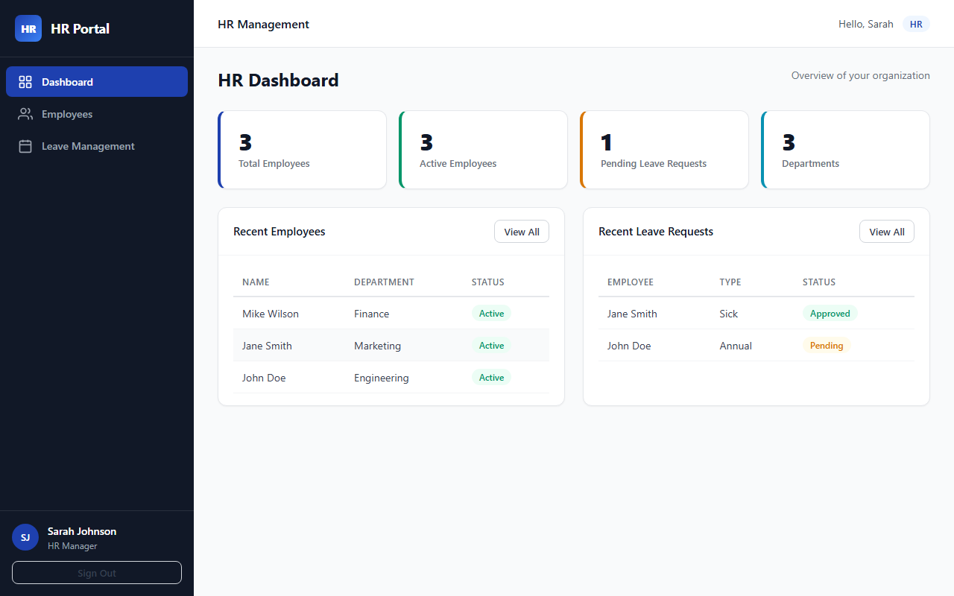

HR - Employee Management
Searchable and filterable employee list with CRUD actions (edit, deactivate, delete).
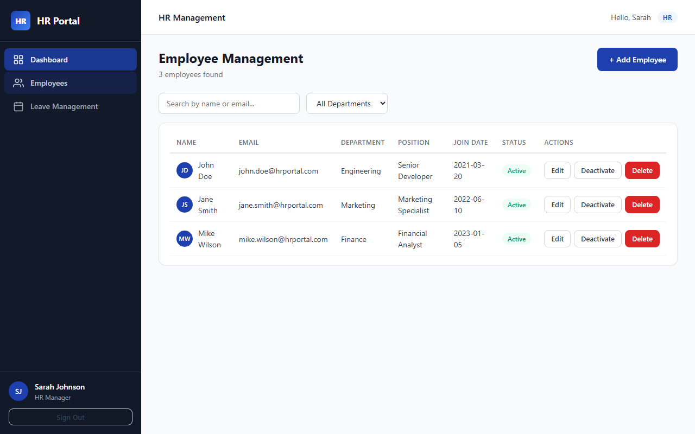

HR - Add New Employee
Modal form for HR to add a new employee with all required fields.
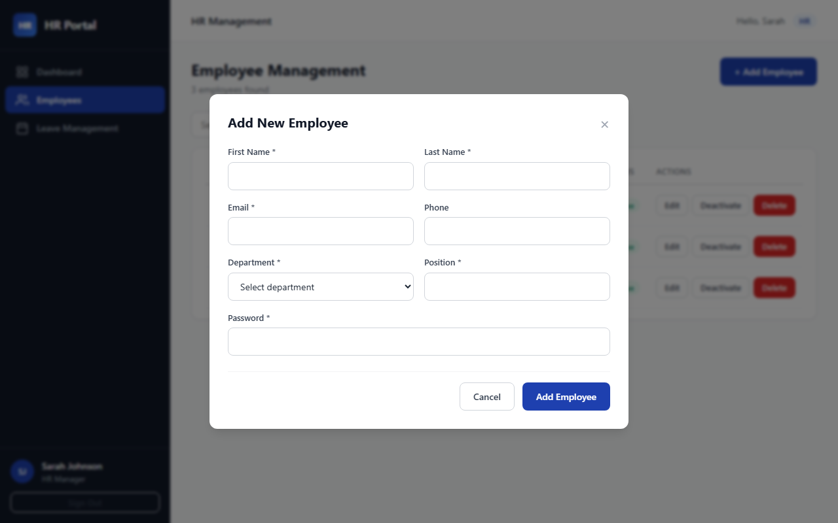

HR - Leave Management
Leave request review panel where HR can approve or reject employee requests.
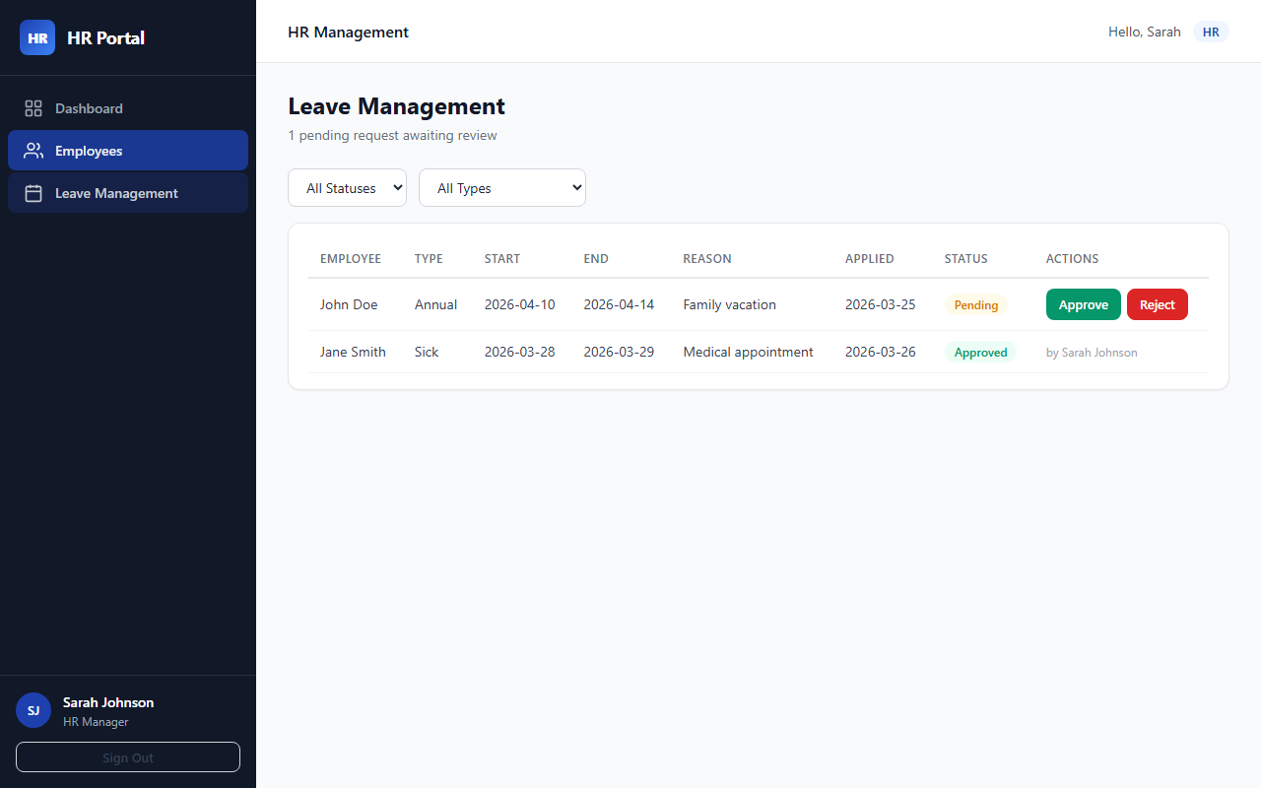

Employee Dashboard
Personal dashboard with leave statistics and profile summary.
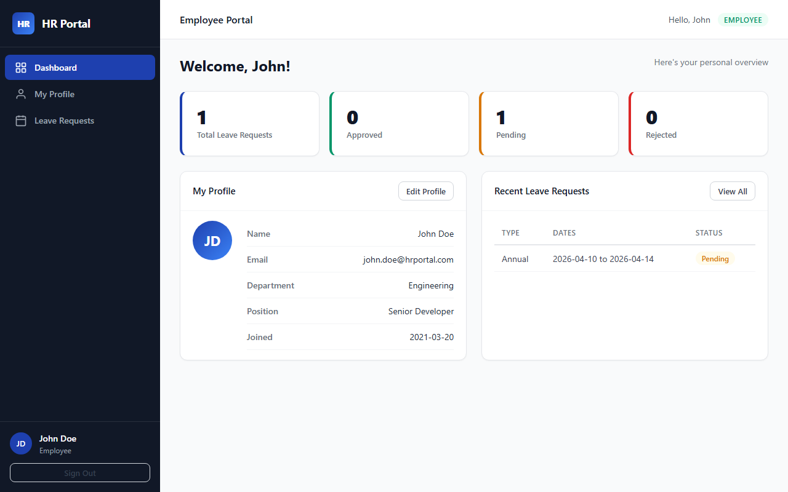

Employee - My Profile
Read-only profile view showing personal details, department, and join date.
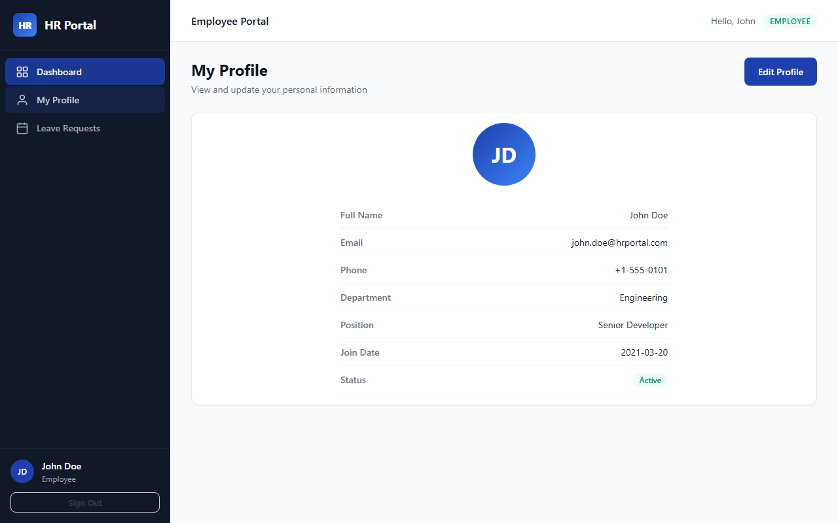

Employee - Edit Profile
Editable profile form for updating personal information.
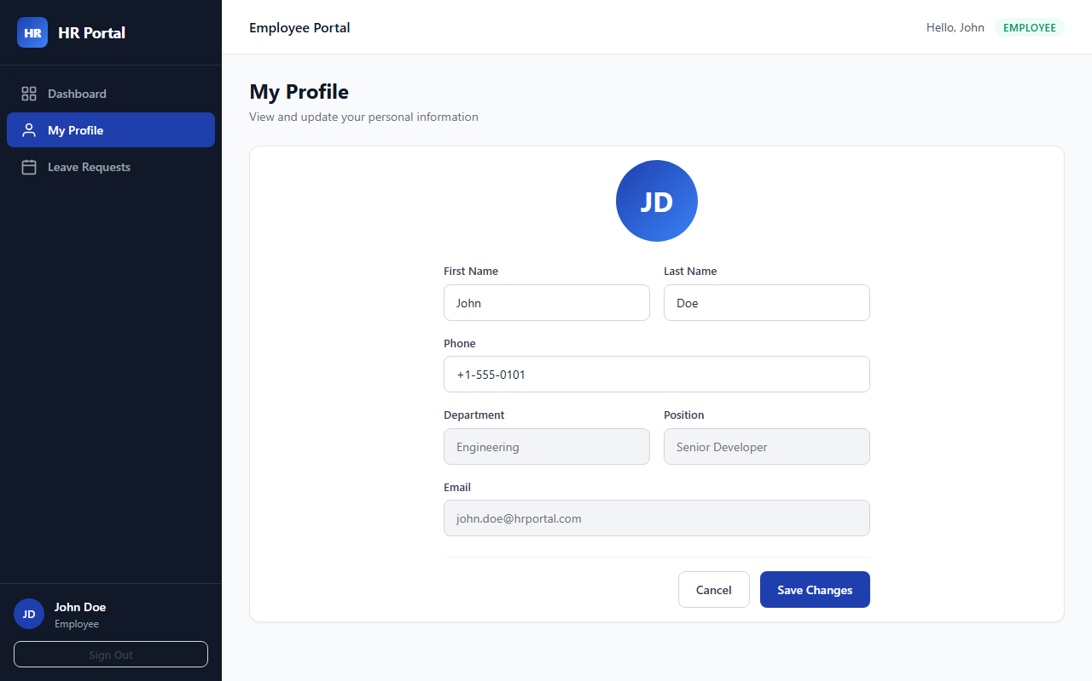

Employee - Leave Requests
List of employee leave requests with status badges and filter controls.
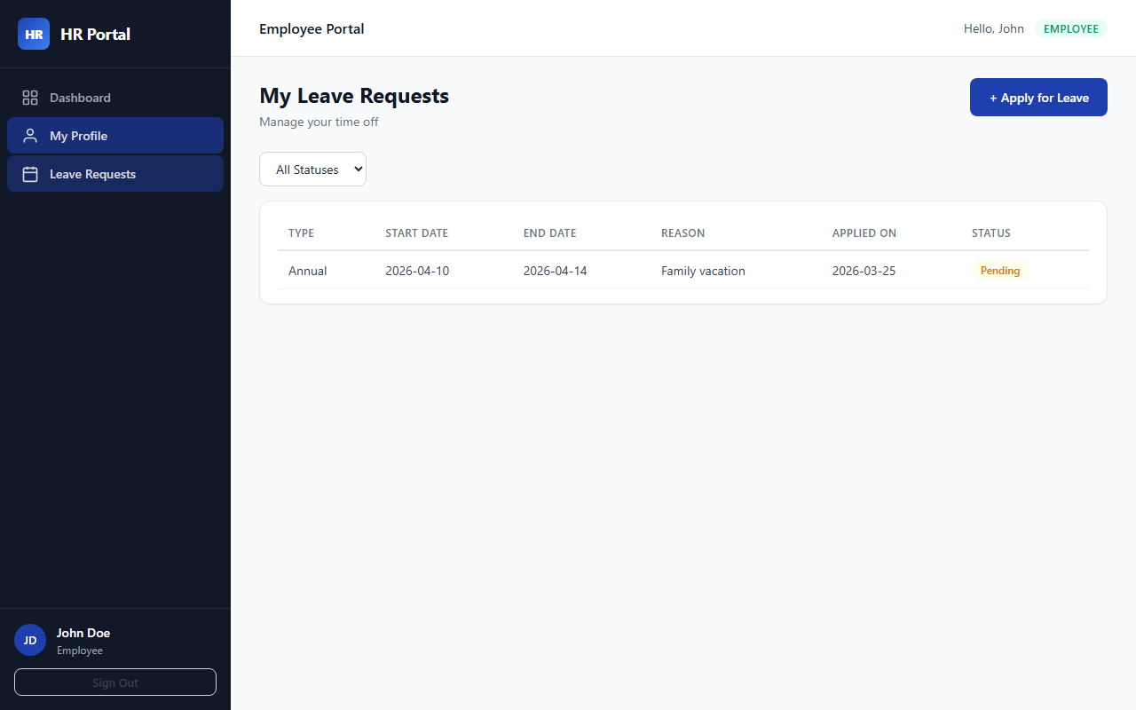

Employee - Apply for Leave
Leave application form with type selection, date range, and reason fields.
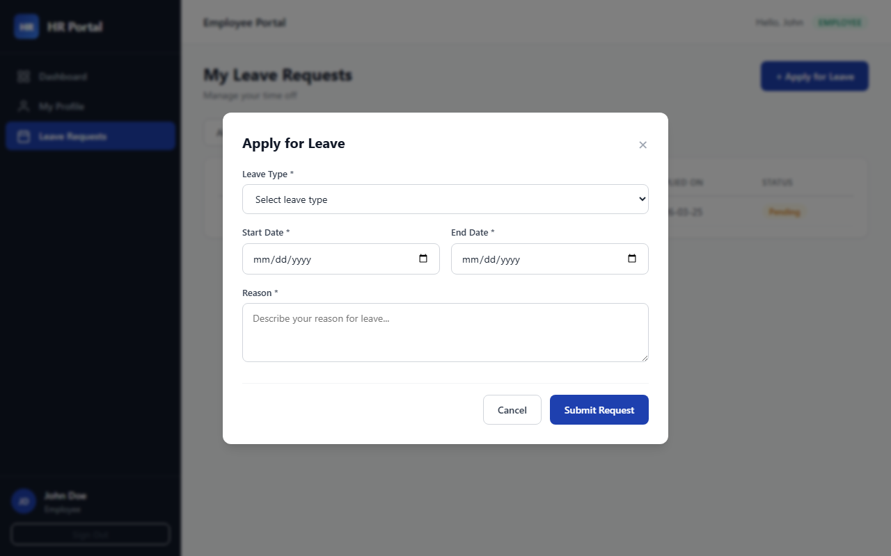

Login - Error State
Error feedback displayed when user enters invalid credentials.
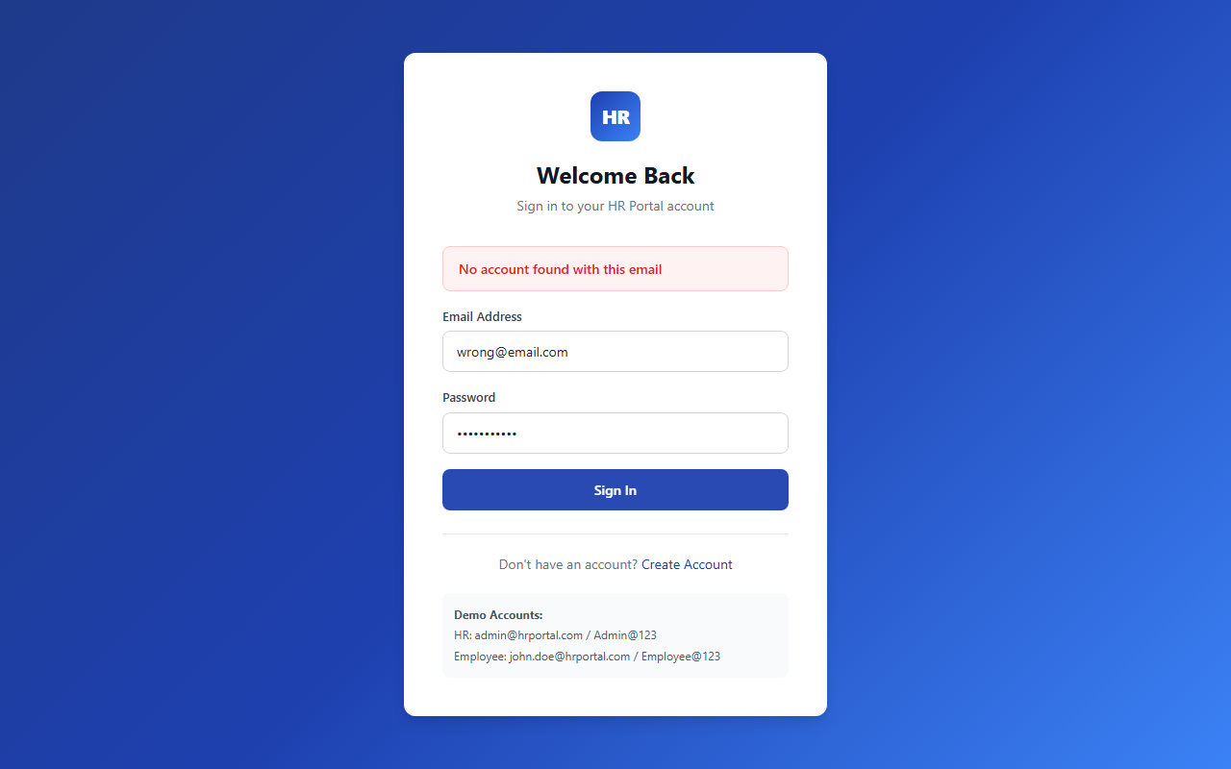
HR Portal — Simplilearn — Full Stack Development Program with Generative AI — March 2026

