FINAL PROJECT REPORT

CampusFix AI
Smart Complaint Management System
Domain: Smart Campus Community

Team VISIONX
Role | Name | Register Number
Team Leader | Shree Shopika S.N | 7376251CS404
Member 1 | Rithanya S | 7376251CS364
Member 2 | Dharunika R | 7376252AL119

College: [BANNARI AMMAN INSTITUTE OF TECHNOLOGY]
Date: October 2026

Table of Contents
1. Problem 3
2. Problem Description 3
3. Objectives 4
4. Literature Survey 4
5. Requirements 5
6. Obtained Solution 6
7. Output Screenshots 8
8. GitHub Link 10
References 10

1. Problem
Campus complaints about electrical faults, plumbing, cleanliness, Wi-Fi and classroom equipment are handled manually, so students and staff do not know which department to approach and complaints stay unresolved for a long time. Administrators receive duplicate reports and cannot see the status, priority or repeated problems. This delays repairs and reduces trust in the institution.

2. Problem Description

2.1 Background and Context
Educational campuses have many buildings, hostels, laboratories and classrooms, and hundreds of facility issues are raised every month. In most institutions these are reported through verbal requests, paper registers, phone calls or general e-mail. The student must first find the right department, and the administrator must read, sort and forward every complaint by hand.

2.2 Current Limitations and Gaps
- No single place to submit a complaint, and users often do not know which department is responsible.
- Several people report the same problem, which creates duplicate work and hides how serious the issue is.
- Complaints are not prioritised, so a dangerous electrical fault can wait behind a minor cleaning request.
- Users cannot see the status, the responsible department or the expected resolution time.
- There is no automatic escalation when a complaint crosses its expected resolution time.
- Location details are often wrong or incomplete, and there is no analysis of repeated problems or problem areas.

2.3 Scope of the Project
Covered: complaint submission with text, image and QR-based location; AI classification, priority, duplicate detection and department assignment; status tracking, SLA and escalation; notifications and feedback; administrator analytics, heatmap and predictive maintenance recommendations. Users are students, faculty, campus staff, maintenance staff, supervisors and administrators. Categories are electrical, plumbing, housekeeping, Wi-Fi, classroom facilities, laboratory equipment, hostel maintenance, water supply, furniture and other infrastructure.
Not covered in this version: voice complaints, multilingual support, mobile apps for Android and iOS, IoT sensors, image-based defect detection and ERP integration. These are listed as future work.

3. Objectives
Main objective: To design and develop CampusFix AI, a centralised web system that uses AI to classify, prioritise, route, track and escalate campus complaints and to predict recurring problems.
Specific objectives:
- Design a complaint submission module with text, image and QR-based location so that every complaint has correct location details.
- Develop an AI module that classifies a complaint into a category and department and assigns one of four priority levels (Low, Medium, High, Critical).
- Implement duplicate detection that merges reports of the same issue at the same location into one master complaint.
- Implement status tracking, SLA deadlines (2, 6, 24 and 48 hours by priority) and automatic escalation of overdue complaints.
- Develop an administrator dashboard with complaint statistics, heatmap and predictive maintenance recommendations, and evaluate the system with sample complaints.

4. Literature Survey
Existing grievance and complaint management systems were reviewed. The table compares six of them by method and limitation.
No. | Title | Author / Year | Method Used | Limitation
1 | An AI-driven smart grievance analysis and escalation system for educational institutions | K. Kiruthiga, R. Gobika, V. Kavyashree, 2026 | Conversational chatbot, Google Gemini API for category, urgency and sentiment; React, Firebase; role-based dashboards; auto escalation | Needs clear user text; possible bias; no QR location, duplicate merging or heatmap; trend prediction left as future work
2 | AI-Powered Grievance Management System for Petition Analysis, Prioritization, Routing and Transparent Tracking | [Add authors], 2026 | NLP text classification (BERT), sentiment for urgency, embedding similarity for duplicates; MERN stack | Built for government petitions, not campus facilities; no QR-based location or SLA-based maintenance planning
3 | College Complaints and Grievance Management System with Mentor-Mentee Support | [Add authors], 2026 | Web application with complaint categories and mentor-mentee routing | Focus on academic and personal grievances; AI routing listed as future development
4 | Smart Public Grievance Management System using AI and Geo-Tagging | [Add authors], 2026 | BERT classification, GPS and Google Maps for location and hotspots, computer vision on images | Designed for public civic complaints; GPS location is less precise than room-level QR location inside buildings
5 | Smart Complaint Management System with AI-Powered Prioritization and Escalation | [Add authors], 2025 | NLP and sentiment analysis for classification, urgency and priority; AI escalation; real-time tracking | Sentiment-based; does not describe duplicate merging, heatmaps or predictive maintenance
6 | NLP based grievance redressal system for Indian Railways | [Add authors], 2021 (arXiv:2111.08999) | Text analytics on railway complaint tweets to classify complaints and find the responsible division and department | Domain-specific to railways and social media text; no tracking, SLA or maintenance analytics

Gap identified: The reviewed systems classify and route complaints, and some add sentiment analysis, escalation or GPS. None of them combines, for campus facilities, room-level QR location, duplicate merging into a master complaint, SLA-based escalation, a complaint heatmap and predictive maintenance recommendations in one platform. CampusFix AI fills this gap.

5. Requirements

5.1 Functional Requirements
The system shall provide the following functions. The third column gives the input and the expected output.
ID | Requirement | Input → Processing → Output
FR-01 | Register and log in | Name, email, password, role → authenticated session (JWT)
FR-02 | Submit a complaint | Description, photo, location, optional category → saved complaint with ID
FR-03 | QR-based location | Scanned QR code → building, block, floor, room, facility filled automatically
FR-04 | AI classification | Complaint text → category, problem type, department
FR-05 | Smart priority | Severity, users affected, location, frequency → Low / Medium / High / Critical
FR-06 | Duplicate detection | Location, text, category, time → duplicates merged into a master complaint
FR-07 | Automatic department assignment | Category → complaint routed to the responsible department
FR-08 | Status tracking | Staff updates → Submitted, Assigned, Accepted, In Progress, Resolved, Closed, Escalated
FR-09 | SLA management | Priority → deadline (Critical 2 h, High 6 h, Medium 24 h, Low 48 h)
FR-10 | Automatic escalation | SLA deadline passed → complaint sent to supervisor or administrator
FR-11 | Notifications | Each status change → notification to the user
FR-12 | Feedback and rating | Rating and comments after resolution → stored feedback
FR-13 | Admin dashboard | All complaint data → totals, pending, critical, categories, department performance, trends
FR-14 | Complaint heatmap | Complaint locations → concentration map of problem areas
FR-15 | Predictive maintenance | Historical complaints → recurring issues and preventive maintenance suggestions

5.2 Non-Functional Requirements
Attribute | Requirement (measurable)
Performance | Pages shall load within 3 seconds and complaint submission shall complete within 5 seconds on a normal campus network. The AI service shall return a classification within 3 seconds.
Scalability | The system shall support at least 500 concurrent users and shall allow new departments, buildings, hostels and categories to be added without code changes.
Security | Passwords shall be stored hashed; all API calls shall use HTTPS with JWT; role-based access control shall block users from other roles' pages.
Reliability | Availability shall be at least 99% during campus working hours; no complaint data shall be lost (daily database backup).
Usability | A new user shall be able to submit a complaint in under 2 minutes without training; the interface shall work on mobile screens.
Compatibility | The web application shall work on the latest versions of Chrome, Edge, Firefox and Safari.
Maintainability | The system shall follow a modular architecture so that a new complaint category can be added by configuration.

6. Obtained Solution

6.1 Approach and Architecture
The solution follows a layered architecture. The presentation layer (React.js and Tailwind CSS) gives the user interface. The application layer (Node.js and Express.js with JWT) handles business logic, SLA and notifications. The AI layer (Python with FastAPI or Flask) performs classification, priority prediction, duplicate detection and recurring-issue analysis. The data layer (MongoDB) stores users, complaints, departments, feedback and locations. The layers communicate through REST APIs.
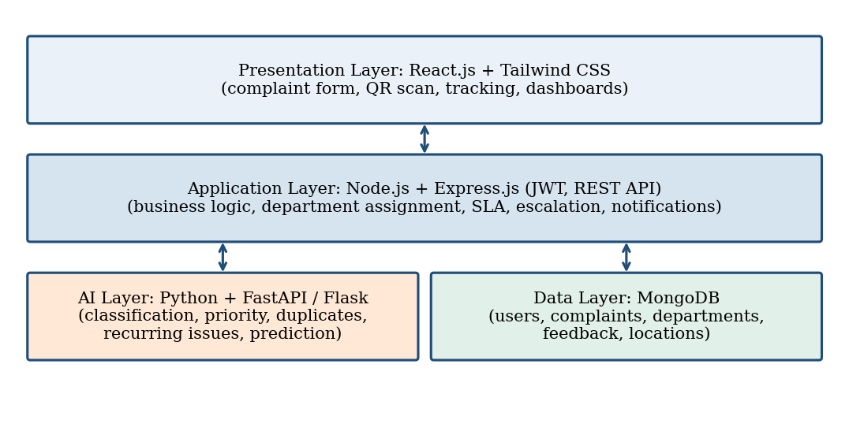
Figure 1: Block diagram of CampusFix AI
The four layers and how they communicate.

6.2 Technologies and Tools
Component | Technology
Frontend / UI | React.js, Tailwind CSS
Backend | Node.js, Express.js, JWT authentication
AI / ML | Python, FastAPI / Flask
Database | MongoDB
Charts | Recharts / Chart.js
Location | QR code and GPS
Prototype built | HTML, CSS and JavaScript

6.3 Key Modules
- Complaint module: accepts the description, image and location and creates the complaint record.
- AI module: finds category and department from the text, assigns priority and checks for duplicates.
- Workflow module: assigns the complaint, tracks the six statuses, applies the SLA time and escalates overdue complaints.
- Notification and feedback module: informs the user at each step and collects the rating after resolution.
- Analytics module: dashboard, heatmap, recurring-issue analysis and predictive maintenance advice.
A user submits a complaint, the AI module classifies it and checks for duplicates, the workflow module routes it and starts the SLA clock, staff update the status, and the analytics module learns from the stored history.

6.4 Results Achieved
A working web prototype of the main complaint flow was built using HTML, CSS and JavaScript. It reads a complaint and shows the category, department, priority and SLA time as the user types. It submits the complaint, merges a second complaint of the same category at the same location into the first one, tracks the status through six stages, marks overdue complaints as Escalated and shows live counts of total, pending, resolved and critical complaints. This meets the objectives for classification, priority, duplicate merging, tracking, SLA and escalation at prototype level. In the test, "Fan is not working in Room 204" was classified as Electrical, sent to Electrical Maintenance with High priority and a 6-hour SLA.

6.5 Limitations and Future Work
In the prototype the classification uses keyword rules instead of a trained AI model, data is stored in the browser, and login, image upload, QR scanning, notifications, heatmap and predictive maintenance are described in the design but not yet implemented. Future work is to build the Node.js backend and MongoDB database, train the Python classification and duplicate-detection models, and then add image-based defect detection, IoT sensors, voice and multilingual complaints, a mobile app, a chatbot and ERP integration.

7. Output Screenshots 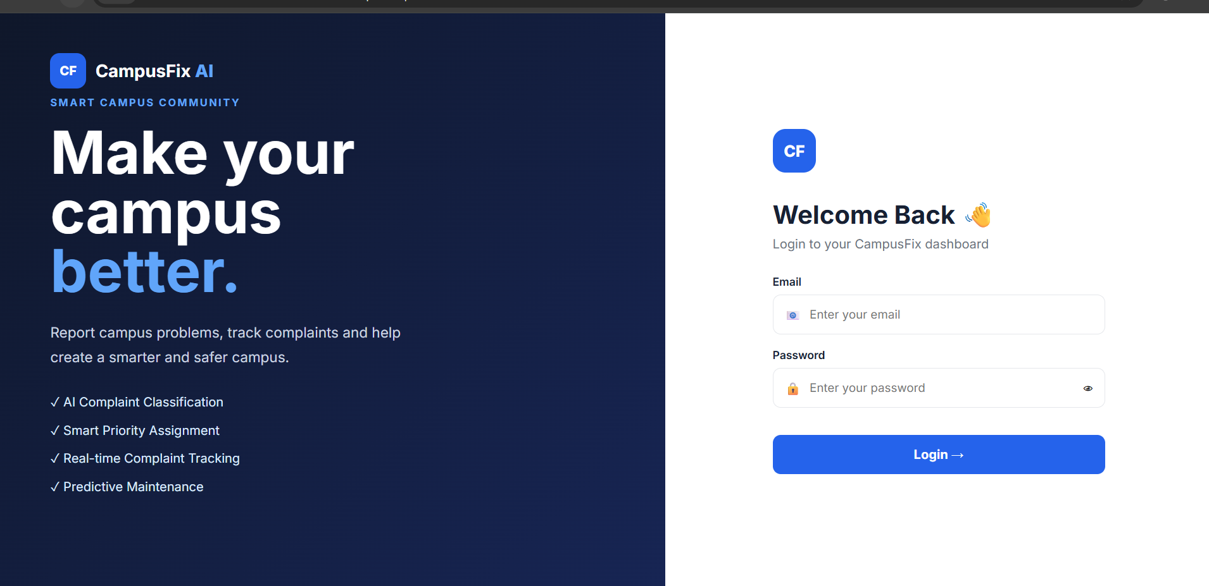

Figure 2: Home page with complaint form
The landing page where a user raises a complaint.
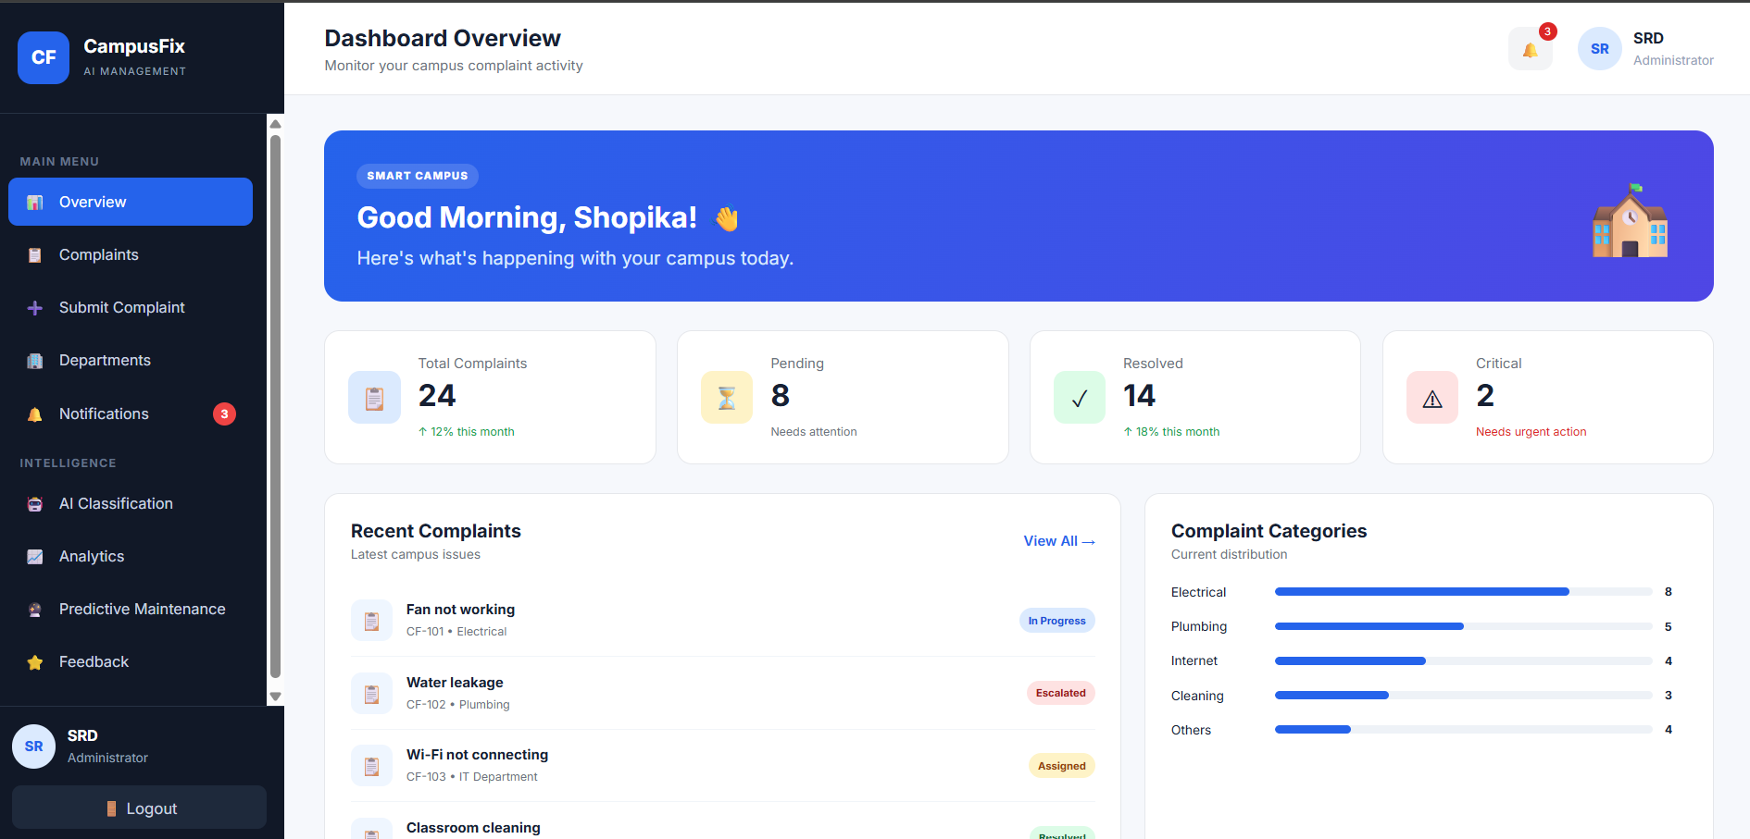
Figure 3: AI analysis of a complaint
The system shows category, department, priority and SLA while the complaint is typed.
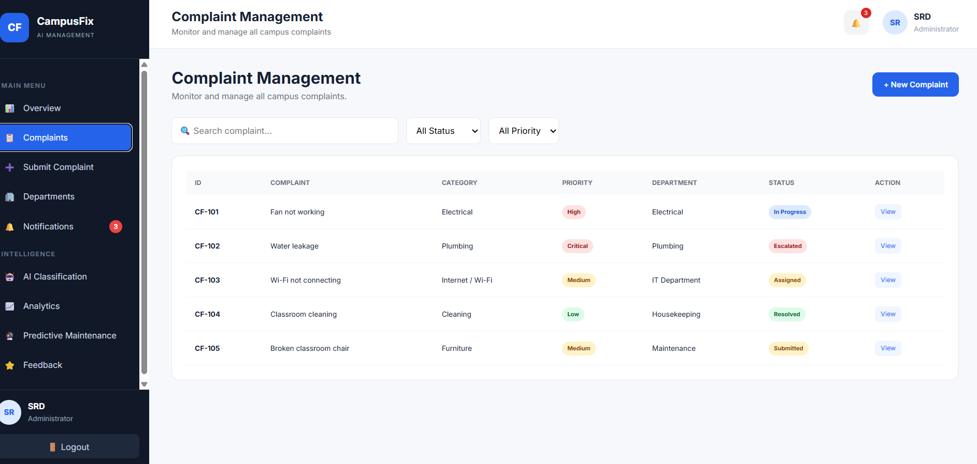
Figure 4: Complaint tracker and statistics
Submitted complaints with priority, status buttons and live counts. 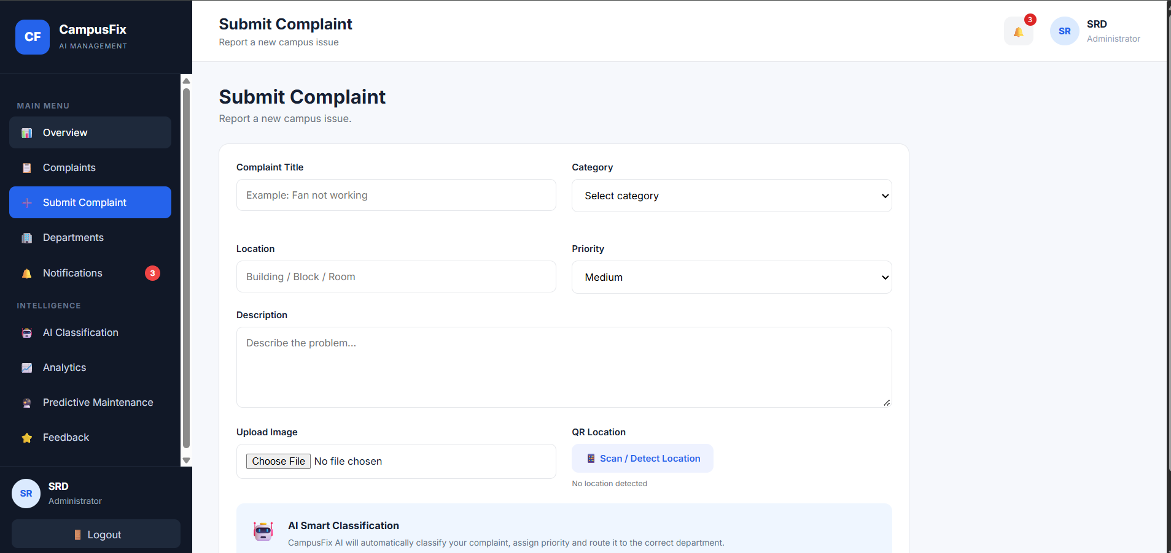

Figure 5: Features and SLA table
The features of the system and the resolution time for each priority. 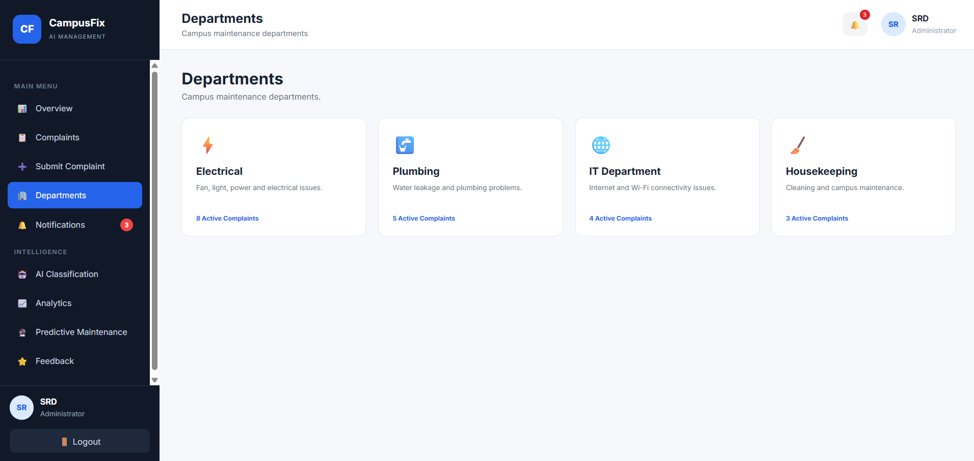

Figure 6: User roles section
The four user roles and what each can do.
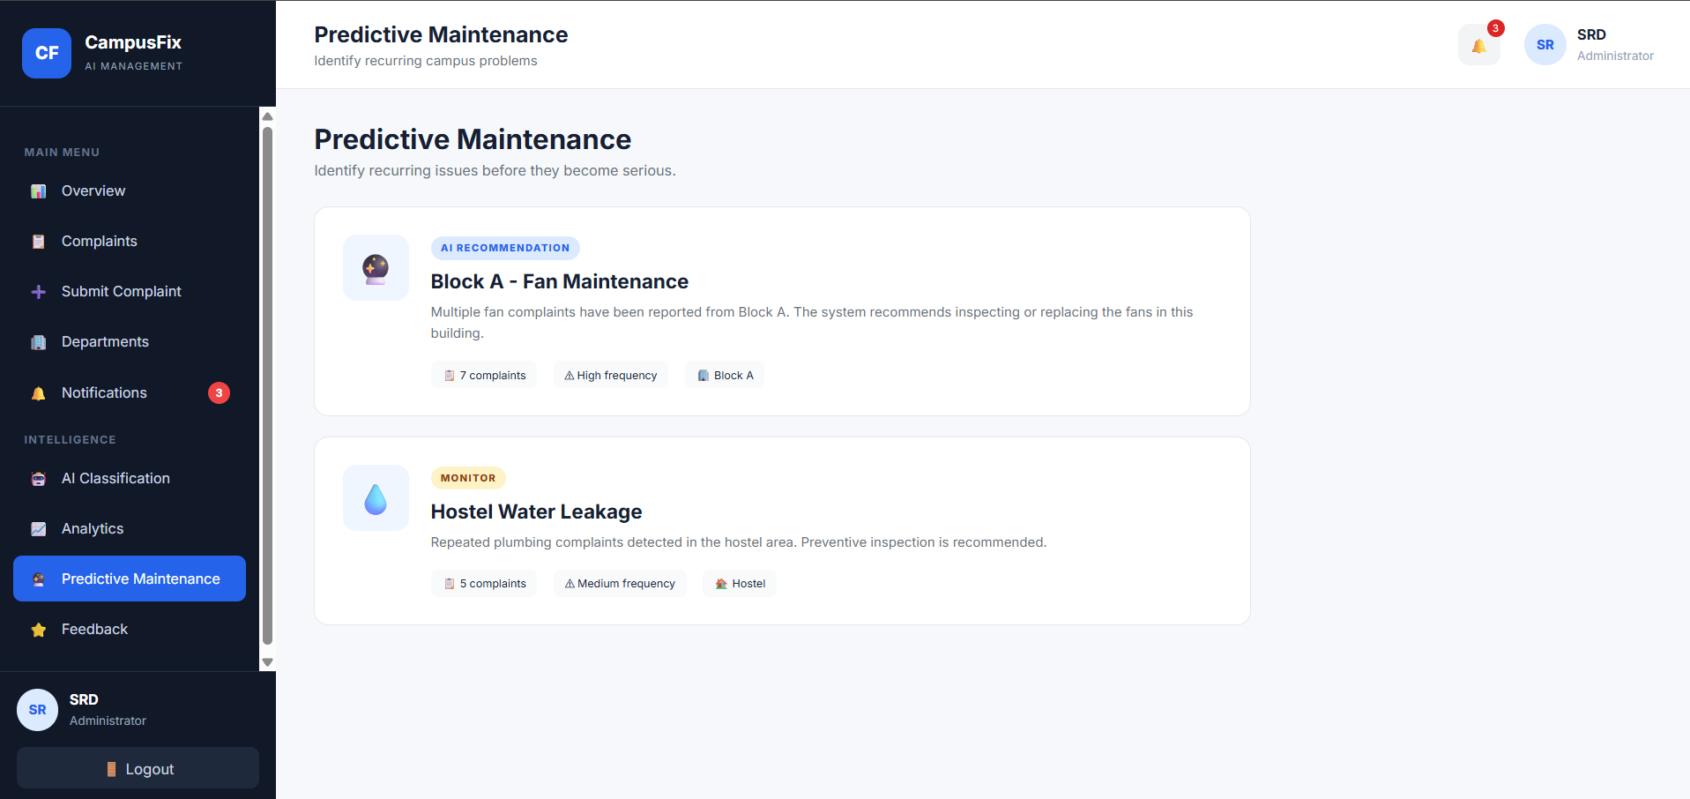

8. GitHub Link
Repository:
The repository is public and contains the source code (index.html, style.css, script.js) and a README with the project title, description, setup steps and usage. Setup: download or clone the repository, keep the three files in one folder and open index.html in a browser. Commits are made regularly for each module.

References
[1] K. Kiruthiga, R. Gobika and V. Kavyashree, "An AI-driven smart grievance analysis and escalation system for educational institutions," EPJ Web of Conferences, vol. 367, art. 04002, RIACT 2026. doi: 10.1051/epjconf/202636704002.
[2] [Authors], "AI-Powered Grievance Management System for Petition Analysis, Prioritization, Routing and Transparent Tracking," ResearchGate, 2026. [Online]. Available: https://www.researchgate.net/publication/403486820
[3] [Authors], "College Complaints and Grievance Management System with Mentor-Mentee Support," ResearchGate, 2026. [Online]. Available: https://www.researchgate.net/publication/408455533
[4] [Authors], "Smart Public Grievance Management System using AI and Geo-Tagging," Int. J. Research Publication and Analysis (IJRPA), 2026. [Online]. Available: https://www.ijrpa.com/myimgup/1776264470IJRPA-3135.pdf
[5] [Authors], "Smart Complaint Management System with AI-Powered Prioritization and Escalation," Int. J. Creative Research Thoughts (IJCRT), 2025, paper IJCRT2510624.
[6] [Authors], "NLP based grievance redressal system for Indian Railways," arXiv:2111.08999, 2021. [Online]. Available: https://arxiv.org/abs/2111.08999

