SOFTWARE REQUIREMENTS SPECIFICATION
EcoTrack
Smart Waste Management & Recycling Analytics System
Big Data Analytics + Machine Learning based Decision Support Platform

Document Type | Software Requirements Specification (SRS)
Project | EcoTrack – Smart Waste Management & Recycling Analytics System
Domain | Smart Agriculture & Environment
Target Users | Municipal Authorities, Waste Management Supervisors, Collection Managers
Team Name | TECHFUSION

Table of Contents
- 1. Introduction
- 2. Problem Statement
- 3. Proposed Solution
- 4. Objectives
- 5. Scope of the System
- 6. Stakeholders and Users
- 7. Functional Requirements
- 8. Data Requirements
- 9. Non-Functional Requirements
- 10. System Architecture
- 11. Technology, Frameworks and Tools
- 12. Algorithms and Analytics
- 13. System Modules
- 14. Prototype / User Interface Design
- 15. Dashboard Design
- 16. Smart Recommendation Logic
- 17. End-to-End Workflow
- 18. Sample Use Cases
- 19. Expected Outcomes
- 20. Advantages
- 21. Limitations
- 22. Future Enhancements
- 23. Testing and Evaluation
- 24. Conclusion

1. Introduction
EcoTrack is a web-based Smart Waste Management and Recycling Analytics System designed to convert municipal waste records into useful insights, predictions and actionable recommendations. The system focuses on the complete decision cycle: understanding how much waste is generated, identifying where and when waste is high, analysing waste composition and recycling performance, predicting future waste generation, and recommending suitable operational actions.
The project is designed to be practical for a first-time hackathon team. The core implementation uses already-categorized waste collection records rather than requiring expensive sensors or complex computer vision. Image-based waste classification can be added later as an optional enhancement.
Core idea
Waste Data → Analysis → Pattern Detection → Prediction → Smart Recommendation → Action → Result Tracking

2.Problem Statement
Municipal and local waste-management operations generate large volumes of data such as daily waste quantity, ward/area, waste type, vehicle trips, collection frequency and recycled quantity. In a basic/manual workflow, these records may be stored separately or viewed only as reports. This makes it difficult to continuously identify high-waste locations, peak days, low-recycling areas and future waste requirements.
- Difficulty identifying high-waste wards/areas quickly.
- Limited visibility into waste-type distribution such as organic, plastic, paper, metal and glass.
- Collection schedules may not dynamically reflect changes in waste generation.
- Vehicle trips and collection resources may be allocated without data-driven prioritization.
- Low recycling areas may not be identified early enough for corrective action.
- Historical data may be available but not converted into future waste forecasts.
- Reports can show what happened, but may not clearly suggest what action should be taken next.

3. Proposed Solution
EcoTrack proposes a centralized analytics and decision-support platform that accepts municipal waste data, cleans and stores it, performs descriptive analytics, predicts future waste generation and generates rule-based smart recommendations. The system does not stop at visualization; every major finding is connected to a possible operational response.
- Analyse ward-wise, time-wise and waste-type-wise waste generation.
- Identify high-waste wards and peak waste days.
- Calculate recycling quantity and recycling rate.
- Analyse vehicle trips and collected quantity.
- Predict future waste generation using a simple, explainable ML model.
- Generate recommendations such as increasing collection frequency, adding bins, prioritizing dry-waste collection or improving recycling support.
- Track the effect of actions through later data and dashboard metrics.
Important design decision
Primary waste-type information comes from categorized collection records. Image-based classification is an optional future/bonus module, so the core hackathon prototype remains simple and reliable.

4. Objectives
- Create a centralized waste analytics dashboard.
- Measure total waste generation and recycling performance.
- Identify high-priority wards/areas.
- Understand waste composition and trends.
- Forecast short-term future waste generation.
- Support better allocation of collection vehicles and trips.
- Provide clear, actionable recommendations instead of only charts.
- Enable data-driven decision making for waste-management authorities.

5. Scope of the System

5.1 In Scope
- CSV/Excel/database based waste-data ingestion.
- Data cleaning and validation.
- Ward/area-wise analytics.
- Waste-type analytics.
- Daily/weekly/monthly trend analysis.
- Recycling-rate analysis.
- Vehicle-trip analysis.
- Short-term waste prediction.
- Rule-based smart recommendations.
- Interactive web dashboard.

5.2 Out of Scope for the First Prototype
- Real-time IoT bin sensors.
- Autonomous garbage vehicles.
- Complex route optimization.
- Payment or citizen grievance systems.
- Fully automated image recognition as a mandatory dependency.

6. Stakeholders and Users
User/Stakeholder | Need | EcoTrack Support
Municipal Officer | Overall monitoring | City/ward KPIs, alerts and recommendations
Waste Supervisor | Collection planning | Ward priority, vehicle and trip analysis
Recycling Coordinator | Improve recycling | Waste-type and recycling analytics
Data/Admin User | Maintain records | Upload, validate and manage datasets
Hackathon/Jury User | Understand impact | Demo-ready dashboard, prediction and actions

7. Functional Requirements
ID | Requirement | Description
FR-01 | Data Upload | System shall accept structured waste data through CSV/Excel or database import.
FR-02 | Data Validation | System shall detect missing, invalid or duplicate records.
FR-03 | Data Cleaning | System shall standardize dates, waste types, ward names and numerical fields.
FR-04 | Dashboard | System shall display major waste and recycling KPIs.
FR-05 | Ward Analytics | System shall compare waste generation across wards/areas.
FR-06 | Waste-Type Analytics | System shall show distribution of organic, plastic, paper, metal, glass and other categories.
FR-07 | Trend Analysis | System shall display daily/weekly/monthly waste trends.
FR-08 | Recycling Analysis | System shall calculate recycled quantity and recycling rate.
FR-09 | Vehicle Analysis | System shall analyse vehicle trips and collected quantity.
FR-10 | Prediction | System shall generate short-term future waste estimates.
FR-11 | Recommendation | System shall convert findings into operational recommendations.
FR-12 | Filtering | User shall filter analytics by date, ward and waste type.
FR-13 | Report/Export | System may export filtered results or summary reports.

8. Data Requirements
Recommended minimum dataset:
Field | Example | Type | Purpose
date | 2026-09-01 | Date | Trend and prediction
ward_area | Ward 5 | Categorical | Location analysis
waste_type | Plastic | Categorical | Composition analysis
waste_quantity_kg | 420 | Numeric | Waste generation
vehicle_id | V-003 | Categorical | Vehicle tracking
vehicle_trips | 4 | Integer | Collection resource analysis
recycled_quantity_kg | 110 | Numeric | Recycling performance
collection_frequency | 3/week | Numeric/Categorical | Operational analysis
population | optional | Numeric | Normalization/future analysis
weather | optional | Categorical/Numeric | Future prediction enhancement
festival_holiday | optional | Categorical | Peak-demand explanation
Minimum viable prototype can work with date, ward/area, waste type, waste quantity, vehicle trips and recycled quantity. Optional population, weather and festival data can improve analysis later.

9. Non-Functional Requirements
- Usability: dashboard should be understandable to non-technical municipal users.
- Performance: common dashboard filters should respond quickly on the prototype dataset.
- Reliability: invalid or missing data should be flagged rather than silently used.
- Scalability: database and analytics pipeline should support increasing record volume.
- Security: authenticated users and protected administrative functions should be used in a deployed version.
- Maintainability: modules for ingestion, analytics, prediction and recommendations should be separated.
- Explainability: prediction and recommendation outputs should display understandable reasons/metrics.

10. System Architecture
Recommended architecture is a simple layered pipeline suitable for a hackathon:
- Data Source – municipal records / prepared CSV or Excel dataset.
- Data Ingestion – upload and validation layer.
- Data Processing – Python + Pandas cleaning, transformation and aggregation.
- Data Storage – MySQL database.
- Analytics – Pandas/NumPy calculations and chart-ready summaries.
- Machine Learning – Scikit-learn prediction model.
- Recommendation Engine – rule-based decision logic.
- Backend API – Flask.
- Frontend – HTML/CSS/JavaScript with Chart.js; React can be used optionally.
- User Dashboard – KPIs, charts, prediction and recommendations.
Architecture flow:
Municipal Data → Ingestion → Cleaning → MySQL → Analytics/ML → Recommendation Engine → Flask API → Web Dashboard

11. Technology, Frameworks and Tools
Layer | Recommended Technology | Purpose
Frontend | HTML, CSS, JavaScript | Web interface
Charts | Chart.js / Plotly | Interactive graphs
Backend | Python Flask | REST APIs and application logic
Data Analysis | Google sheets | Cleaning, aggregation, statistics
Machine Learning | Scikit-learn | Waste prediction
Database | MySQL | Structured data storage
Development | VS Code | Coding and debugging
Version Control | Git + GitHub | Team collaboration
Design/Prototype | HTML-CSS prototype | UI mockups
Deployment | Web browser | Optional deployment

12. Algorithms and Analytics

12.1 Descriptive Analytics
- Sum/average/count for waste quantity.
- Group-by analysis for ward, waste type and date.
- Recycling rate = (Recycled Quantity / Total Waste Quantity) × 100.
- Vehicle productivity = Collected Quantity / Vehicle Trips.

12.2 Waste Prediction
Recommended first model: Linear Regression for short-term forecasting when the dataset is simple. It is easy to implement and explain during a hackathon. If enough historical data is available, Random Forest Regression can be tested as an alternative and compared using MAE/RMSE.

12.3 Ward/Pattern Segmentation
K-Means clustering can optionally group wards based on features such as average waste, plastic percentage and recycling rate. This can help create labels such as high-generation/low-recycling patterns without hard-coding every ward.

12.4 Recommendation Rules
- If waste quantity > defined high-waste threshold → recommend higher collection frequency.
- If plastic percentage is high → recommend additional dry-waste/plastic collection support.
- If weekend/holiday waste is consistently high → recommend extra trips on those days.
- If recycling rate is low → recommend segregation/recycling support.
- If predicted waste exceeds current collection capacity → recommend additional vehicle/trips.
- If a ward repeatedly remains high-priority → recommend long-term infrastructure review.

13. System Modules
Module | Function
1. Admin/Login | Secure access for authorized users.
2. Data Upload | Upload CSV/Excel records and validate columns.
3. Data Processing | Clean, transform and store records.
4. Overview Dashboard | KPI cards and overall waste/recycling summary.
5. Ward Analytics | Rank/compare wards using charts and tables without forcing a political/evaluative judgment; priority is based on defined operational thresholds.
6. Waste-Type Analytics | Organic/plastic/paper/metal/glass/other distribution.
7. Trend Analytics | Daily, weekly and monthly patterns.
8. Vehicle Analytics | Vehicle trips, collected quantity and productivity.
9. Prediction | Future waste estimate.
10. Smart Recommendations | Action suggestions based on rules and predictions.
11. Reports | Export selected insights for operational use.

14. Prototype / User Interface Design
The prototype is designed as a simple web application. The user first logs in, then reaches an overview dashboard. From there the user can open Ward Analysis, Waste Trends, Recycling Analysis, Vehicle Analysis, Prediction and Smart Recommendations.
- Login screen – username/password.
- Dashboard home – total waste, recycled quantity, recycling rate and high-priority wards.
- Ward Analysis – bar chart and table comparing areas.
- Waste Trend – line chart for daily/weekly waste.
- Waste Type – pie/donut chart for composition.
- Vehicle Analysis – trips, collection quantity and productivity.
- Prediction – actual vs predicted waste.
- Recommendations – action cards with reason and expected operational purpose.
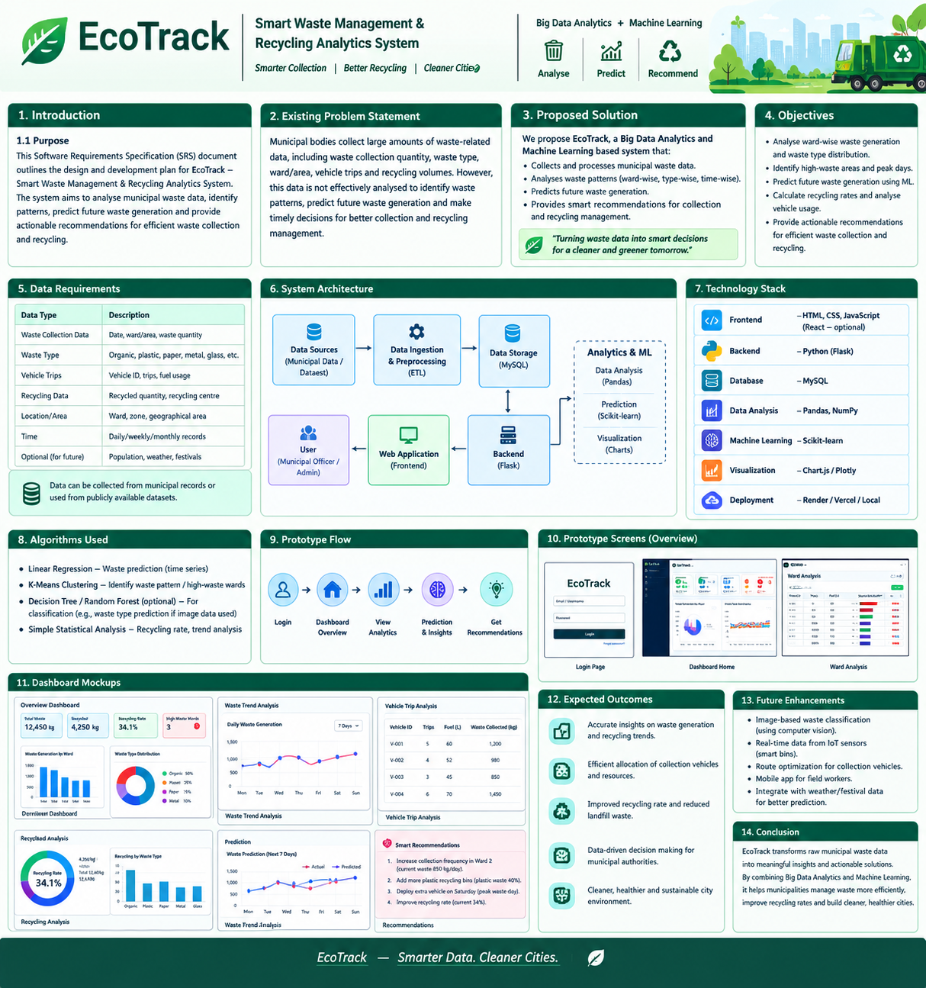
Figure 1. EcoTrack concept board showing prototype and dashboard screens.

15. Dashboard Design
Recommended dashboard layout:
Total Waste | Recycled | Recycling Rate | High-Priority Wards
12,450 kg | 4,250 kg | 34.1% | 3

- Row 2: Ward-wise waste bar chart + waste-type donut chart.
- Row 3: Daily/weekly waste trend line chart + vehicle trip table.
- Row 4: Prediction chart with actual vs predicted values.
- Row 5: Smart recommendation cards showing problem, evidence and action.
Suggested dashboard KPI calculations:
- Total Waste = sum of waste_quantity_kg.
- Total Recycled = sum of recycled_quantity_kg.
- Recycling Rate = Total Recycled / Total Waste × 100.
- High-Priority Wards = wards crossing the configured waste/recycling thresholds.

16. Smart Recommendation Logic
Observed Pattern | Evidence | Recommended Action | Purpose
High waste in Ward 5 | 2,500 kg/week vs threshold 2,000 | Increase collection frequency from 3 to 5 trips/week | Reduce overflow risk
High plastic share | Plastic = 42% | Add dry/plastic collection bins and prioritize recycling pickup | Improve segregation/recycling
Weekend peak | Weekend average > weekday average | Schedule additional weekend trip | Match collection capacity to demand
Low recycling | Recycling rate = 15% | Increase segregation and recycling support | Improve recovery of recyclable waste
Predicted increase | Next-week estimate exceeds current capacity | Pre-plan vehicle/trip capacity | Avoid future collection shortage

17. End-to-End Workflow
- Municipal/admin user uploads waste dataset.
- System validates required columns and data types.
- Python/Pandas cleans duplicates, missing values and inconsistent labels.
- Cleaned data is stored in MySQL.
- Analytics engine calculates KPIs, ward patterns, waste-type distribution, recycling rate and vehicle metrics.
- ML model predicts near-future waste quantity.
- Recommendation engine compares current/predicted values with configured thresholds.
- Flask API sends analytics and recommendations to the frontend.
- Dashboard displays charts, prediction and recommended actions.
- After actions are implemented, new records can be uploaded and the effect can be monitored.

18. Sample Use Cases
ID | Use Case | Flow
UC-01 | Find high-waste area | User selects a date range → dashboard compares wards → high-priority wards are highlighted.
UC-02 | Understand waste composition | User selects Ward 5 → system shows organic/plastic/paper/metal/glass distribution.
UC-03 | Plan collection | User checks ward trend + vehicle trips → recommendation suggests additional trips where threshold is crossed.
UC-04 | Plan for next week | User opens Prediction → system shows predicted waste → capacity-related recommendation is displayed.
UC-05 | Improve recycling | User opens Recycling Analysis → low recycling areas are identified → system suggests segregation/recycling support.

19. Expected Outcomes
- Clear visibility of total waste generation and recycling performance.
- Identification of high-waste areas and peak collection periods.
- Better understanding of waste composition.
- Data-driven planning of vehicle trips and collection frequency.
- Short-term forecast of future waste generation.
- Actionable recommendations instead of analysis-only reports.
- Improved monitoring of recycling performance.
- Reduced manual effort in preparing recurring waste reports.
- A scalable foundation for future IoT, computer vision and route-optimization features.

20. Advantages
- Simple and explainable core architecture.
- Can start with CSV data; no hardware is mandatory.
- Combines Big Data analytics, visualization and ML in one project.
- Easy to demonstrate with a realistic sample dataset.
- Recommendation engine directly connects findings to actions.
- Can be extended to IoT and image classification later.

21. Limitations
- Prediction quality depends on historical data quality and quantity.
- Recommendations are decision-support suggestions, not automatic commands.
- Thresholds need to be configured for each city/operational context.
- Without real-time sensors, the first prototype works on uploaded/periodic data.
- Image-based waste classification is not part of the minimum viable implementation.

22. Future Enhancements
- Computer-vision based waste image classification.
- IoT smart-bin sensors for real-time fill-level data.
- GPS integration for vehicle tracking.
- Route optimization for collection vehicles.
- Mobile app for field workers.
- Weather and festival/holiday features for improved prediction.
- Citizen reporting module.
- Automated alerts through email/SMS/app notifications.
- Advanced time-series models when sufficient historical data is available.

23. Testing and Evaluation
Test | Input/Condition | Expected Result
Data validation | Missing waste quantity | Record flagged; invalid row not silently processed
Duplicate handling | Same record twice | Duplicate identified/removed according to rule
Dashboard KPI | Known sample totals | Displayed totals match calculated values
Ward analysis | Multiple wards | Charts/tables show correct aggregation
Recycling rate | Known waste and recycled values | Correct percentage displayed
Prediction | Historical daily data | Model returns a forecast value
Recommendation | Waste above threshold | Relevant collection recommendation shown
Filtering | Ward/date filter | Only selected records are reflected in charts
UI | Desktop/mobile browser | Core dashboard remains usable

24. Conclusion
EcoTrack transforms raw waste-management records into a practical decision-support workflow. The project moves beyond simply answering 'where is waste high?' by connecting analytics to prediction and action. For each important pattern, the system provides a clear operational recommendation such as increasing collection frequency, adding dry-waste support, planning extra trips during peak periods or improving recycling facilities. This makes the project suitable for a Big Data Analytics hackathon because it demonstrates data ingestion, processing, visualization, machine learning and actionable insights in a single understandable solution.
Hackathon pitch
“EcoTrack turns waste data into decisions — Analyse where waste is high, predict what comes next, and recommend the action needed for smarter collection and better recycling.”

Appendix A – Suggested Sample Dataset
Date | Ward | Waste Type | Waste kg | Vehicle | Trips | Recycled kg | Collection
2026-09-01 | Ward 1 | Organic | 850 | V-001 | 3 | 210 | 3/week
2026-09-01 | Ward 2 | Plastic | 620 | V-002 | 4 | 180 | 4/week
2026-09-01 | Ward 5 | Plastic | 900 | V-003 | 3 | 120 | 3/week
2026-09-02 | Ward 5 | Organic | 780 | V-003 | 3 | 130 | 3/week
2026-09-02 | Ward 5 | Paper | 260 | V-004 | 2 | 190 | 2/week

Note: Sample values are illustrative and should be replaced by the dataset used in the final prototype.

