VIVEKANANDHA COLLEGE OF TECHNOLOGY FOR WOMEN
Artificial Intelligence And Data Science
PROJECT DOCUMENTATION
WhatNext Vision Motors:
Shaping the Future of Mobility with Innovation and Excellence
A Salesforce CRM Implementation
Submitted by
Shree Varshini Karunakaran – 613023243046
Kiruthika.S – 613023243029
Hemamalini.L – 613023243015
Kaviya.C – 613023243025

Academic Year: [2026– 2027]

WhatNext Vision Motors: Shaping the Future of Mobility with Innovation and Excellence

User Story:
WhatsNext Vision Motors is revolutionizing its customer experience and operational efficiency with a cutting-edge Salesforce CRM implementation. The project streamlines the vehicle ordering process by auto-assigning orders to the nearest dealer based on customer location and preventing orders for out-of-stock vehicles. Automated workflows update order statuses dynamically and send scheduled email reminders for test drives. Key technical implementations include Apex triggers for stock validation, batch jobs for stock updates, and scheduled Apex for automated order processing. This initiative enhances customer satisfaction, improves order accuracy, and boosts overall operational efficiency.

1. INTRODUCTION

1.1 Project Overview :
WhatNext Vision Motors implemented a Salesforce-based CRM solution to modernize vehicle ordering and dealership operations. The system automates vehicle order placement, validates stock availability, assigns orders to the nearest dealer, schedules test drive reminders, and updates order statuses dynamically. This transformation replaces manual and disconnected processes with a centralized, automated platform, improving operational efficiency and customer satisfaction.
The solution is built entirely on the Salesforce platform. Business data is modelled using six custom objects (Vehicle, Vehicle Dealer, Vehicle Customer, Vehicle Order, Vehicle Test Drive and Vehicle Service Request) and is presented through a custom Lightning App named "WhatNext Vision Motors". Business rules are enforced through record-triggered Flows, an Apex trigger with a trigger handler, a Batch Apex class and a Scheduled Apex class.

1.2 Purpose :
The purpose of this project is to automate vehicle ordering, stock management, dealer assignment, and customer engagement using Salesforce CRM. The system aims to reduce manual intervention, eliminate order errors, provide real-time tracking, and enhance overall business productivity while delivering a seamless customer experience.

1.3 Use Case Background :
WhatsNext Vision Motors is an automotive company dedicated to transforming the mobility sector with innovative, customer-focused technology. The Salesforce project has the core objective of enhancing the customer experience and streamlining operational processes. The use case defined in the project brief consists of the following elements:
- Nearest dealer suggestion: the system is designed to automatically suggest the nearest dealer location to a customer based on the customer's address, reducing the time and effort required during ordering.
- Stock availability control: the system prevents customers from placing orders for vehicles that are out of stock, avoiding confusion and improving the accuracy of order fulfilment.
- Scheduled status updates: a scheduled process updates the status of bulk order records based on stock availability. The brief states that an order is set to "Pending" when the vehicle is out of stock and to "Confirmed" when the vehicle is in stock (see D-8 regarding how this is realised in the implemented code).
- Expected benefits: a more efficient ordering system with fewer errors, improved customer satisfaction and loyalty, and reduced administrative burden so that staff can focus on tasks requiring human expertise.

2. IDEATION PHASE

2.1 Problem Statement (Customer Problem Statement Template)
Table 1: Customer Problem Statements
PS | I am (Customer) | I'm trying to | But | Because | Which makes me feel
PS-1 | Operations Manager | manage vehicle orders | stock info is manual | systems are disconnected | stressed
PS-2 | Customer | place vehicle orders | availability unclear | delayed updates | uncertain

Existing System
The source files describe the existing (pre-project) way of working only through the problem statements, the empathy map and the problem-solution fit diagram. From these, the existing system is characterised by manual registers, spreadsheet tracking and multiple scattered files, manual stock sheets and disconnected systems. Stock information is maintained manually, availability is unclear to customers, and updates are delayed. As a result, the Operations Manager experiences stress from wrong orders and stock errors, and customers feel uncertain about the status of their orders. [Add any further details of the existing system, such as the name of the legacy tool or dealer count, if required by your guide.]

2.2 Empathy Map Canvas
User Persona: Operations Manager
Table 2: Empathy Map of the Operations Manager
Quadrant | Observation
Think & Feel | Concerned about wrong orders & stock errors
Hear | Dealer and customer complaints
See | Registers & spreadsheets
Say & Do | Manual follow-ups
Pain | Delays & cancellations
Gain | Automation & dashboards

2.3 Brainstorming & Idea Prioritization
Four alternative approaches were considered for the new system. They are compared below, with the level of automation as shown in the project's brainstorming diagram.
Table 3: Ideas Considered
Idea | Level of Automation | Outcome
Manual registers | Manual | Not selected
Spreadsheet tracking | Semi-Automated | Not selected
Standalone portal | Fully Automated | Not selected
Salesforce CRM | Fully Automated | Selected

Final Selection: Salesforce CRM was selected because of its automation capabilities, scalability and real-time visibility.

3. REQUIREMENT ANALYSIS PHASE

3.1 Customer Journey Map
The customer journey for the vehicle order process passes through the following stages: Inquiry → Vehicle Selection → Order Placement → Dealer Assignment → Stock Validation → Test Drive → Confirmation → Reporting.
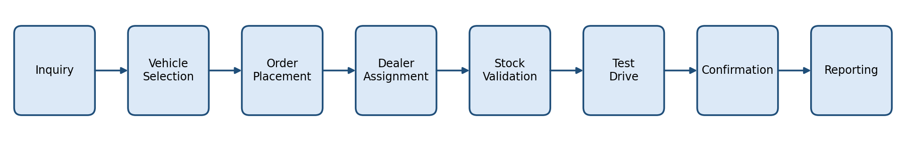
Figure 1: Customer Journey Map – Vehicle Order Process

3.2 Solution Requirements

Functional Requirements
Table 4: Functional Requirements
FR No | Requirement
FR-1 | Vehicle management
FR-2 | Dealer management
FR-3 | Customer order creation
FR-4 | Stock validation
FR-5 | Dealer auto-assignment
FR-6 | Test drive scheduling
FR-7 | Reports & dashboards

Non-Functional Requirements
Table 5: Non-Functional Requirements
NFR | Description
Usability | Lightning UI for easy navigation
Security | Role-based access control
Reliability | Accurate automation
Performance | Fast order processing
Availability | 24/7 cloud access
Scalability | Multi-dealer support

Detailed Requirements from the Project Brief
Table 6: Detailed Requirements
Area | Requirement
Salesforce CRM Implementation | Store and manage vehicle details, stock availability and dealer information in Salesforce. Track customer orders, test drives and service requests efficiently. Automate workflows to assign orders to the nearest dealer based on customer location.
Process Automation | Prevent order placement if the vehicle is out of stock. Auto-assign orders to the nearest dealer based on the customer's location. Send automated email reminders for scheduled test drives.
Apex and Trigger | Implement Apex triggers to enforce business rules such as stock validation and automatic dealer assignment. Use trigger handlers to follow best practices and ensure modularity and maintainability.
Batch Jobs | Develop a batch Apex job to periodically check vehicle stock levels and update availability. Send scheduled email notifications for stock replenishment and order processing.

3.3 Data Flow Diagram
Flow: Customer Input → Order Creation → Stock Validation → Dealer Assignment → Status Update → Reports.
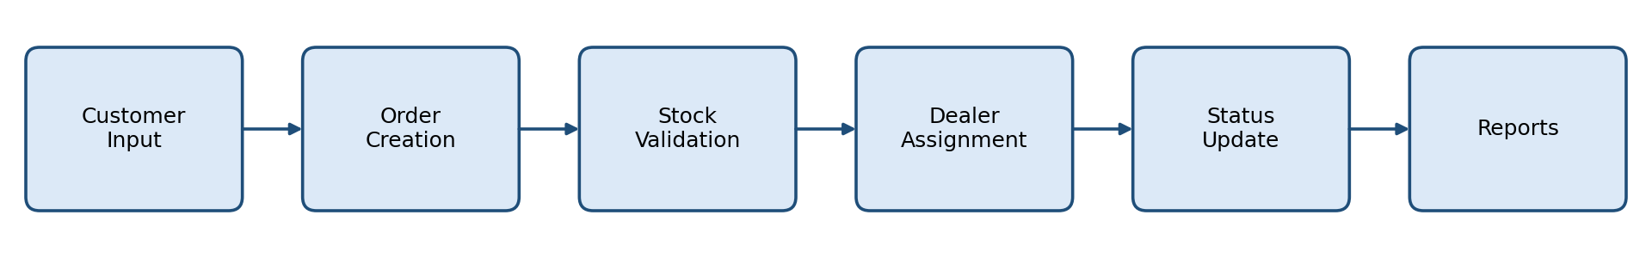
Figure 2: Data Flow Diagram – Vehicle Order Management System

3.4 Technology Stack
Table 7: Technology Stack
Layer | Technology
UI | Salesforce Lightning
Logic | Salesforce Flows
Database | Salesforce Objects
Automation | Validation Rules, Triggers
Processing | Batch Apex, Scheduled Apex
Reporting | Reports & Dashboards

4. PROJECT DESIGN PHASE

4.1 Problem–Solution Fit
The system eliminates fragmented operations by integrating automated stock validation, dealer assignment, and order processing within Salesforce.
Table 8: Problem–Solution Fit
Problem | Solution (Salesforce CRM)
Multiple scattered files | Centralized data in Salesforce objects
Manual stock sheets | Automated stock validation
Disconnected systems | Dealer assignment and order processing within one platform
Stressed manager | Automation, reports and dashboards

4.2 Proposed Solution
Table 9: Proposed Solution
Parameter | Description
Problem | Manual vehicle ordering
Solution | Salesforce CRM
Innovation | Automated dealer assignment
Impact | Faster service
Business Model | Dealer network
Scalability | Multi-location support

4.3 Solution Architecture
The solution architecture consists of the following components: Vehicle Object, Dealer Object, Customer Object, Order Object, Test Drive Object, Service Request Object, Flows, Apex Triggers, Batch Jobs, Reports and Dashboards. The figure below shows how these components are arranged on the Salesforce platform.
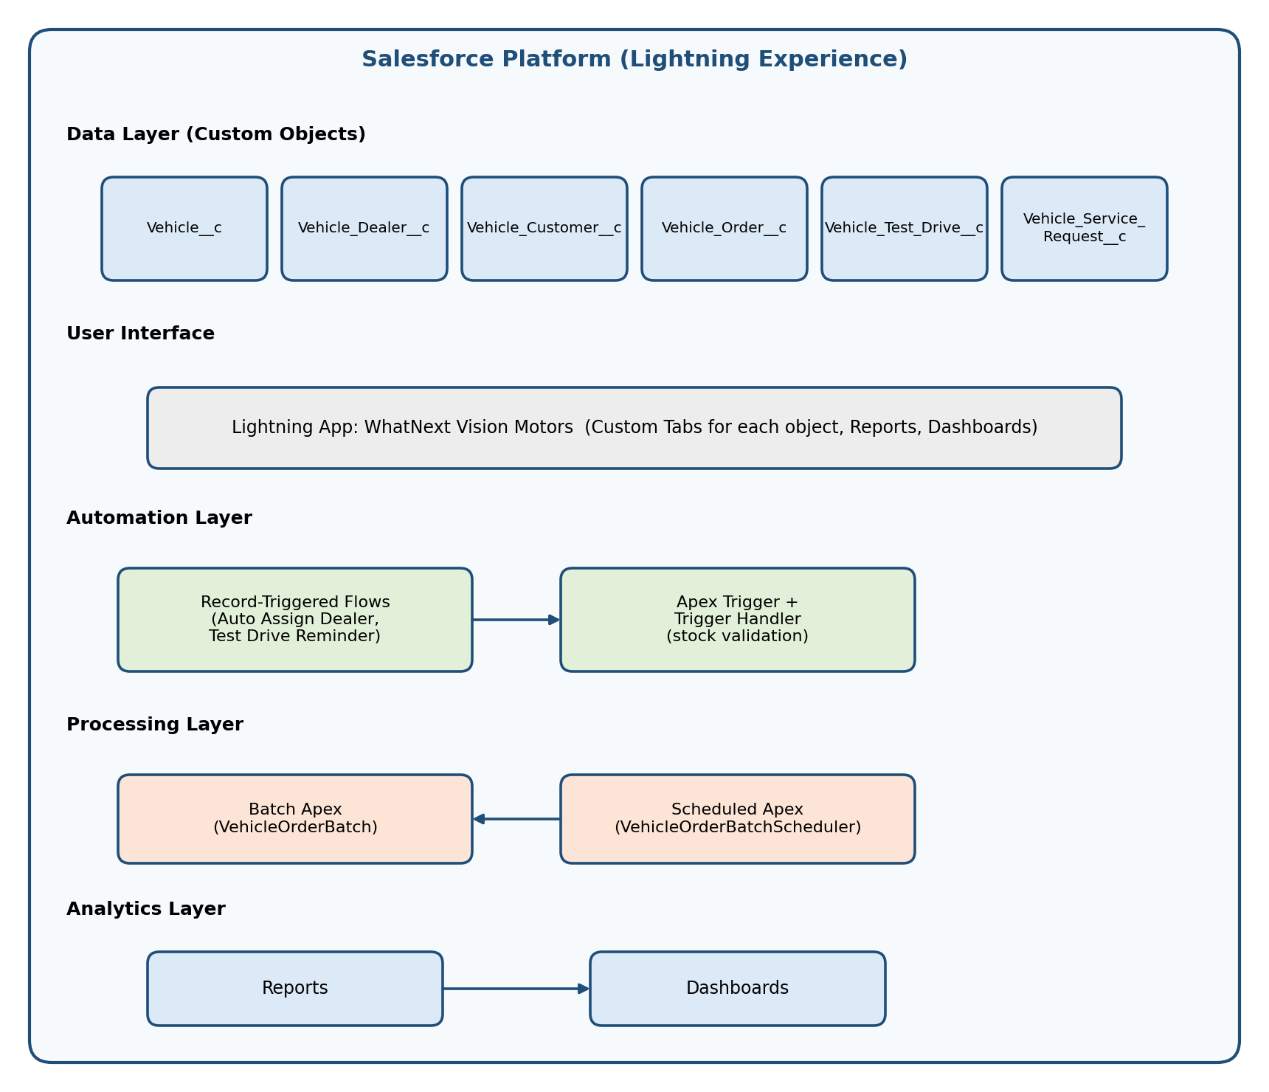
Figure 3: Solution Architecture – Vehicle Order & Dealer Management CRM

4.4 Data Model and Object Relationships
The data model is made up of six custom objects. The Vehicle object has a lookup to the Vehicle Dealer object. The Vehicle Order, Vehicle Test Drive and Vehicle Service Request objects each have lookups to both the Vehicle Customer and Vehicle objects. The figure below summarises these lookups as defined in the key field lists of Milestone 5. (See D-4 for naming differences between the source files.)
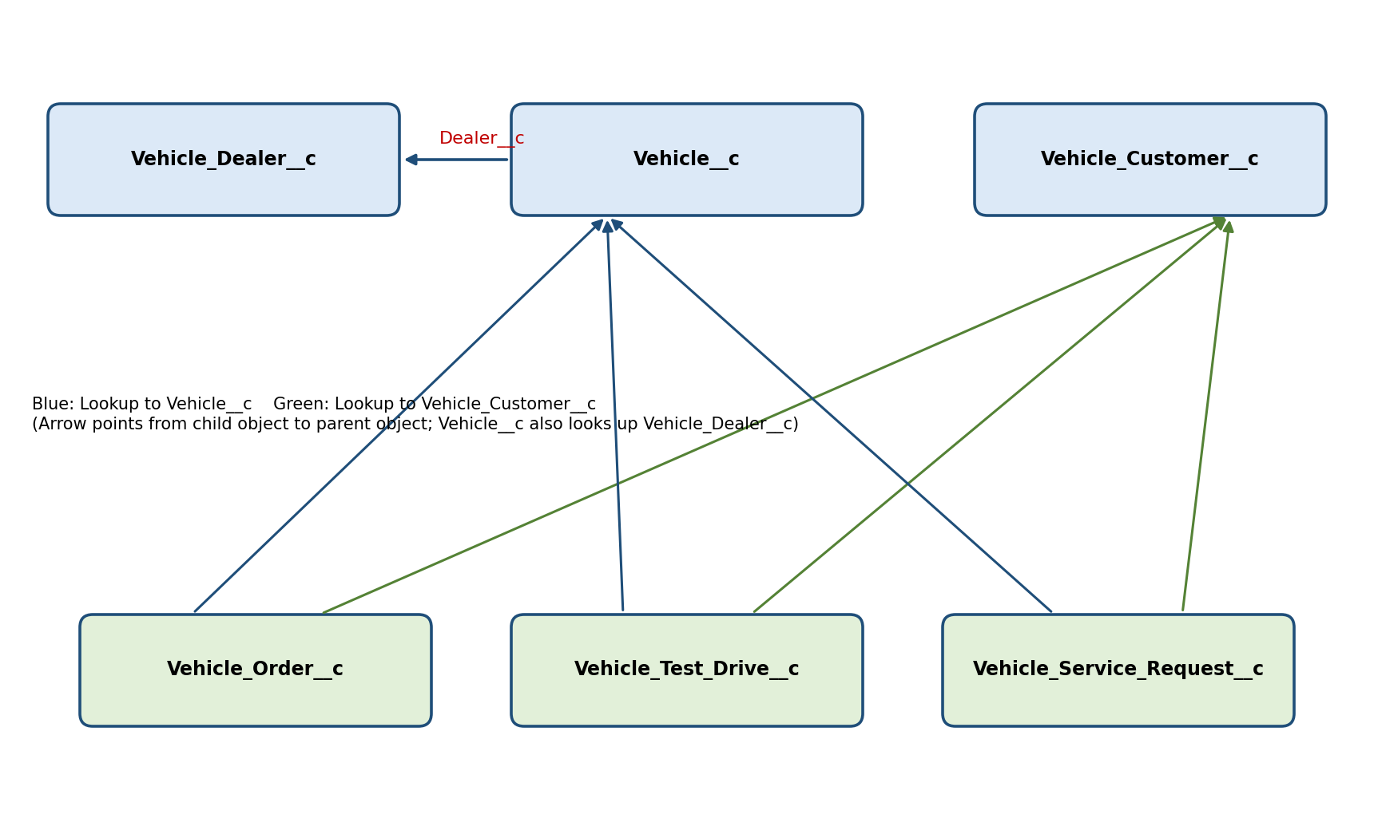
Figure 4: Object Relationship Diagram (Lookup Relationships)

5. PROJECT PLANNING & SCHEDULING

5.1 Project Planning
- Agile methodology
- Epics → Stories → Story Points
- Sprint-based execution
- Velocity calculation used for estimation

Product Backlog, Sprint Schedule, and Estimation
Table 10: Product Backlog and Sprint Schedule
Sprint | Functional Requirement (Epic) | User Story No. | User Story / Task | Story Points | Priority | Team Member
Sprint-1 | Developer Setup | USN-1 | As a system administrator, I want to create and configure a Salesforce developer account so that I can build and deploy the vehicle order management system. | 3 | High | Member1
Sprint-2 | Data Modeling | USN-2 | As an admin, I want to create Vehicle, Dealer, Customer, Order, and Service Request objects with proper relationships so that all business data is stored and managed systematically. | 5 | High | Member2
Sprint-2 | Data Modeling | USN-3 | As a staff member, I want dedicated tabs and a Lightning App for all modules so that I can easily navigate and manage vehicle orders and dealer operations. | 5 | High | Member3
Sprint-3 | Automation | USN-4 | As a system, I want to validate stock availability, mandatory fields, and order inputs so that invalid or incomplete vehicle orders are prevented. | 3 | High | Member4
Sprint-3 | Automation | USN-5 | As a sales coordinator, I want automated flows to assign the nearest dealer and update order status so that processing becomes faster and requires minimal manual effort. | 3 | High | Member4
Sprint-4 | Apex | USN-6 | As a system, I want Apex triggers to automatically perform actions such as order confirmation and dealer assignment so that critical processes occur instantly and accurately. | 5 | High | Member1
Sprint-4 | Apex | USN-7 | As an inventory manager, I want batch jobs to update vehicle stock levels automatically so that inventory data remains accurate and up to date. | 5 | High | Member2
Sprint-5 | Reports | USN-8 | As a manager, I want reports showing order status, dealer performance, and sales metrics so that I can monitor operations and make informed decisions. | 4 | High | Member3
Sprint-6 | Dashboards | USN-9 | As a manager, I want dashboards showing order status, dealer performance, and sales metrics so that I can monitor operations and make informed decisions. | 4 | Medium | Member4

Team member names: Member1 = [Student Name 1], Member2 = [Student Name 2], Member3 = [Student Name 3], Member4 = [Student Name 4].

Project Tracker, Velocity & Burndown Chart
Table 11: Sprint Project Tracker
Sprint | Total Story Points | Duration | Sprint Start Date | Sprint End Date (Planned) | Story Points Completed | Sprint Release Date (Actual)
Sprint-1 | 20 | 6 Days | 24 Oct 2022 | 29 Oct 2022 | 20 | 29 Oct 2022
Sprint-2 | 20 | 6 Days | 31 Oct 2022 | 05 Nov 2022 | [to be filled] | [to be filled]
Sprint-3 | 20 | 6 Days | 07 Nov 2022 | 12 Nov 2022 | [to be filled] | [to be filled]
Sprint-4 | 20 | 6 Days | 14 Nov 2022 | 19 Nov 2022 | [to be filled] | [to be filled]

Velocity (Sprint-1): Using the standard velocity formula (story points completed ÷ sprint duration in days), Sprint-1 velocity = 20 ÷ 6 ≈ 3.33 story points per day. Velocity for the remaining sprints can be calculated once their completed story points are available.
[Insert Screenshot: Burndown chart for Sprints 1–4 (to be added from the project tracker)]
Figure 5: Burndown chart for Sprints 1–4 (to be added from the project tracker) (placeholder)

6. PROJECT DEVELOPMENT PHASE

6.1 Learning Outcomes
The development phase covers the following topics: (1) Data Modelling, (2) Fields and Relationships, (3) Lightning App Builder, (4) Record Triggered Flows, (5) Apex and Apex Triggers, (6) Batch Apex and (7) Scheduled Apex.

6.2 Milestone 1: Salesforce Account

Activity 1: Creating Developer Account
A Salesforce Developer Edition organisation was created at https://developer.salesforce.com/signup. The sign-up form was completed with the following details:
- First name and Last name
- Email
- Role: Developer
- Company: College Name
- Country: India
- Postal Code: pin code
- Username: a combination of the name and company, in the format username@organization.com (this need not be an actual email id)
After filling in the form, the Sign me up button was clicked.
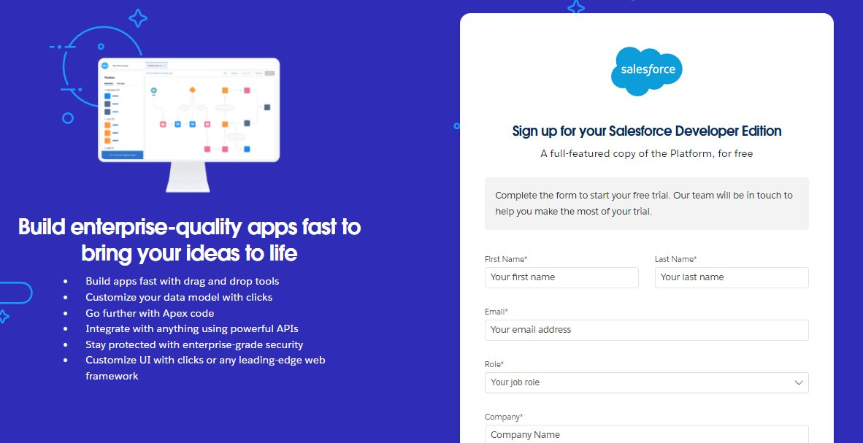
Figure 6: Salesforce Developer Edition sign-up form

Activity 2: Account Activation
- Open the inbox of the email used for signing up and click Verify Account (the email may take 5–10 minutes).
- Provide a password, answer a security question and click Change Password.
- The user is redirected to the Salesforce Setup page.

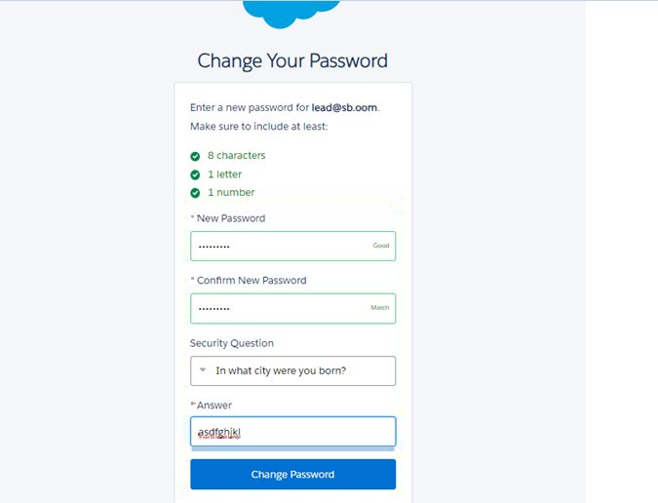
Figure 7: Change Your Password page
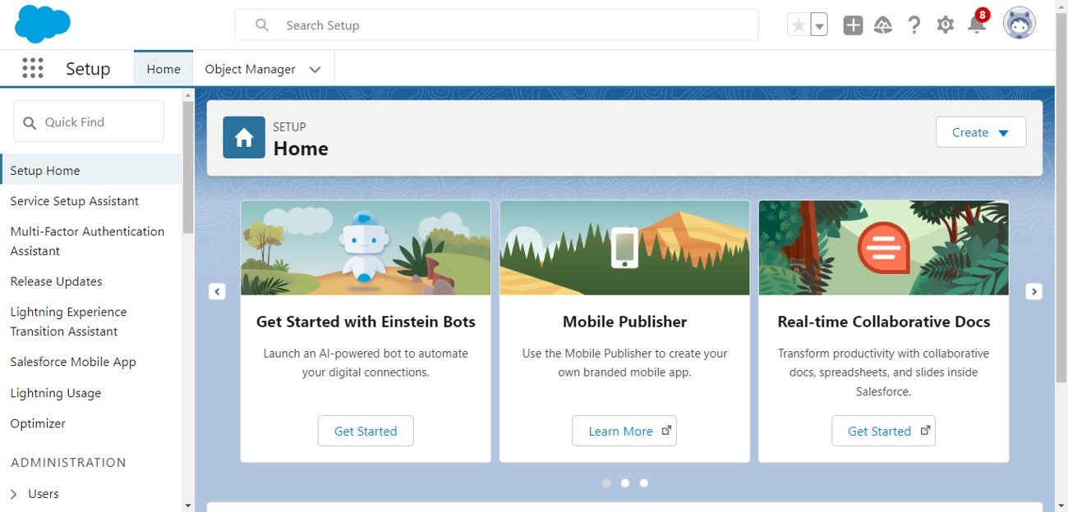
Figure 8: Salesforce Setup home page

6.3 Milestone 2: Data Management – Objects
Six custom objects were created to store and relate the business data.
Table 12: Objects and Relationships
Object Name | Purpose | Relationships
Vehicle__c | Stores vehicle details | Related to Dealer & Orders
Vehicle_Dealer__c | Stores authorized dealer info | Related to Orders
Vehicle_Customer__c | Stores customer details | Related to Orders & Test Drives
Vehicle_Order__c | Tracks vehicle purchases | Related to Customer & Vehicle
Vehicle_Test_Drive__c | Tracks test drive bookings | Related to Customer & Vehicle
Vehicle_Service_Request__c | Tracks vehicle servicing requests | Related to Customer & Vehicle

To navigate to the Setup page: click the gear icon and then click Setup.
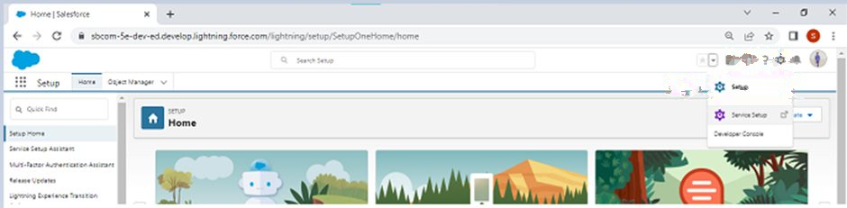
Figure 9: Navigating to the Setup page

Activity 1: Create Vehicle Object
The purpose of creating the Vehicle custom object is to have a clear picture of the vehicle details.
- From the Setup page, click Object Manager → Create → Custom Object.
- Enter the Label as Vehicle and the Plural Label as Vehicles.
- Under Record Name Label and Format, set Record Name to Vehicle Name and Data Type to Text.
- Select Allow Reports and Allow Search, then click Save.

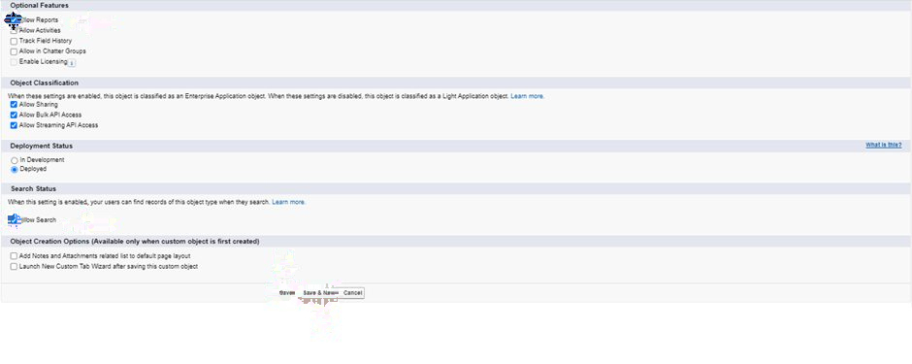
Figure 10: Optional features – Allow Reports and Allow Search

Activity 2: Create Dealer Object
The Dealer object stores detailed information about dealers. It was created using the same steps as above with Label Vehicle Dealer, Plural Label Vehicle Dealers, Record Name Dealer Name and Data Type Text, with Allow Reports and Allow Search selected.

Activity 3: Creating Remaining Objects
The remaining objects listed in the objects table above (Vehicle Customer, Vehicle Order, Vehicle Test Drive and Vehicle Service Request) were created using the same procedure.

6.4 Milestone 3: Data Management – Tabs

Activity 1: Creating a Custom Tab (Vehicle)
- Go to Setup, type Tabs in the Quick Find bar, click Tabs and then click New under Custom Object Tabs.
- Select the object (Vehicle), select any tab style, click Next (Add to profiles) and keep the default, click Next (Add to Custom App) and keep the default, then click Save.
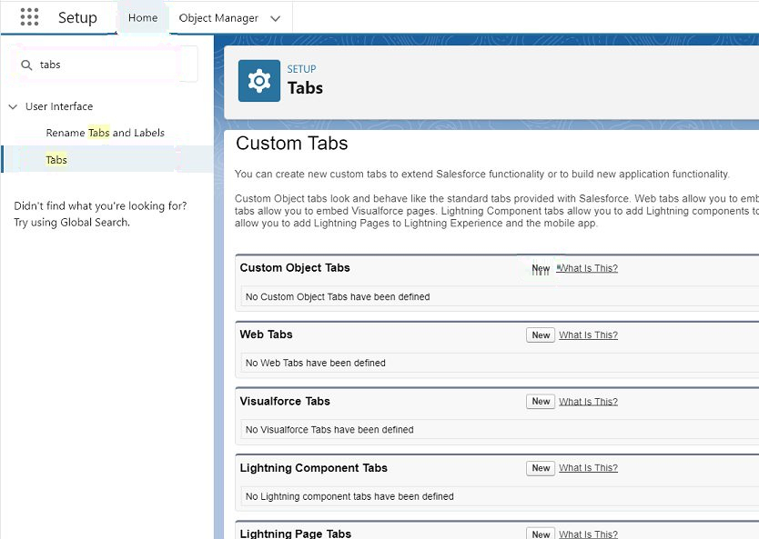
Figure 11: Custom Object Tabs in Setup
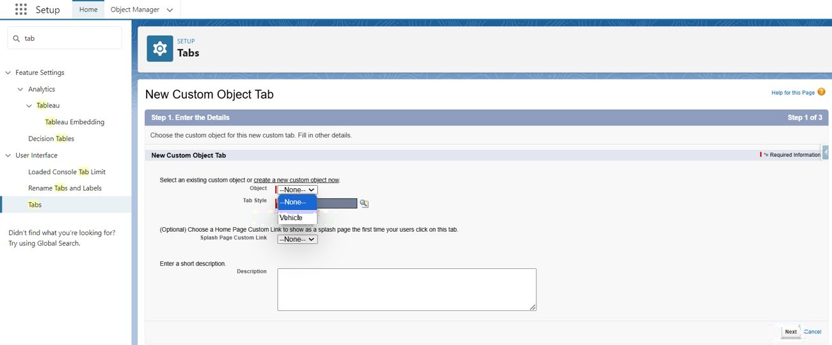
Figure 12: New Custom Object Tab – selecting the Vehicle object

Activity 2: Creating Tabs for Other Objects
Tabs were created in the same way for the other objects created in Milestone 2.

6.5 Milestone 4: Data Management – The Lightning App

Activity 1: Create a Lightning App
- Go to Setup, search for App Manager in Quick Find, select it and click New Lightning App.
- Enter the app details: App Name WhatNext Vision Motors; Developer Name (auto-populated); Description (a meaningful description); Image (optional); Primary colour hex value (keep default).
- Click Next and keep the defaults for the App Options page and the Utility Items page.
- Add Navigation Items: search for Vehicle, Dealer, Customer, Order, Test Drive, Service Request, Reports and Dashboard and move them to the selected list using the arrow button. The custom objects created earlier must be selected.
- Add User Profiles: search for System Administrator, move it to the selected profiles and click Save & Finish.

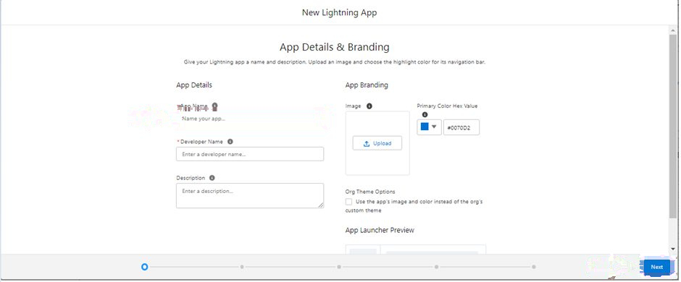
Figure 12: App Details & Branding
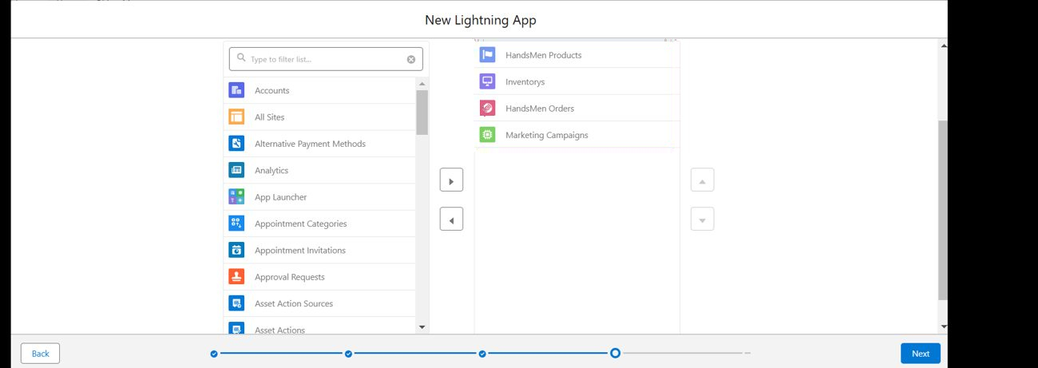
Figure 13: Selecting navigation items
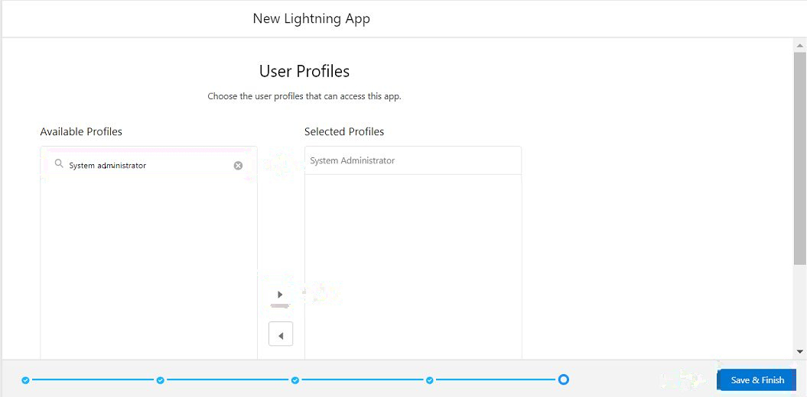
Figure 14: Selecting user profiles

6.6 Milestone 5: Data Management – Fields & Relationships

Key Fields for Each Object
Table 13: Vehicle__c Fields
Field API Name | Data Type
Vehicle_Name__c (Vehicle Name) | Text
Vehicle_Model__c | Picklist: Sedan, SUV, EV, etc.
Stock_Quantity__c | Number
Price__c | Currency
Dealer__c | Lookup to Dealer (Vehicle_Dealer__c)
Status__c | Picklist: Available, Out of Stock, Discontinued

Table 14: Vehicle_Dealer__c Fields
Field API Name | Data Type
Dealer_Name__c | Text
Dealer_Location__c | Text
Dealer_Code__c | Auto Number
Phone__c | Phone
Email__c | Email

Table 15: Vehicle_Order__c Fields
Field API Name | Data Type
Vehicle_Customer__c | Lookup to Vehicle_Customer__c
Vehicle__c | Lookup to Vehicle__c
Order_Date__c | Date
Status__c | Picklist: Pending, Confirmed, Delivered, Canceled

Table 16: Vehicle_Customer__c Fields
Field API Name | Data Type
Customer_Name__c | Text
Email__c | Email
Phone__c | Phone
Address__c | Text
Preferred_Vehicle_Type__c | Picklist: Sedan, SUV, EV, etc.

Table 17: Vehicle_Test_Drive__c Fields
Field API Name | Data Type
Vehicle_Customer__c | Lookup to Vehicle_Customer__c
Vehicle__c | Lookup to Vehicle__c
Test_Drive_Date__c | Date
Status__c | Picklist: Scheduled, Completed, Canceled

Table 18: Vehicle_Service_Request__c Fields
Field API Name | Data Type
Vehicle_Customer__c | Lookup to Vehicle_Customer__c
Vehicle__c | Lookup to Vehicle__c
Service_Date__c | Date
Issue_Description__c | Text
Status__c | Picklist: Requested, In Progress, Completed

Activity 1: Creating a Picklist Field in the Vehicle Object
- Go to Setup → Object Manager, type the object name (Vehicle) in Quick Find and click the object.
- Click Fields & Relationships → New.
- Select the data type Picklist and click Next.
- Enter the Field Label (the source text says "Vehicle Modal"; the field is documented as Vehicle_Model__c) and enter the picklist values (Sedan, SUV, EV, etc.).
- Click Next → Next → Save & New.

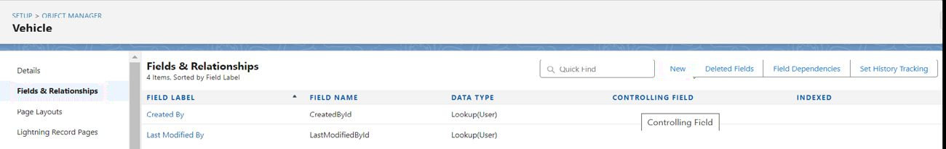
Figure 15: Fields & Relationships – New

Activity 2: Creating the Stock Quantity Field
- Repeat steps 1 and 2 of Activity 1.
- Select the data type Number and click Next.
- Enter the Field Label (the source text says "Stock Quality"; the field is documented as Stock_Quantity__c), then click Next → Next → Save & New.
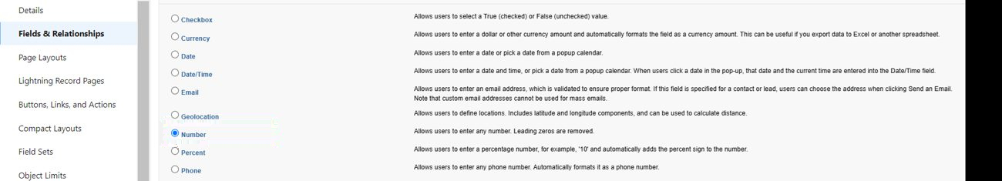
Figure 16: Selecting the Number data type

Activity 3: Creating a Lookup Relationship from Vehicle to Dealer
- Select the data type Lookup Relationship and click Next.
- Select the Dealer object in the Related To field and click Next.
- Enter the Field Label and Field Name (Dealer), then click Next, Next and Save.
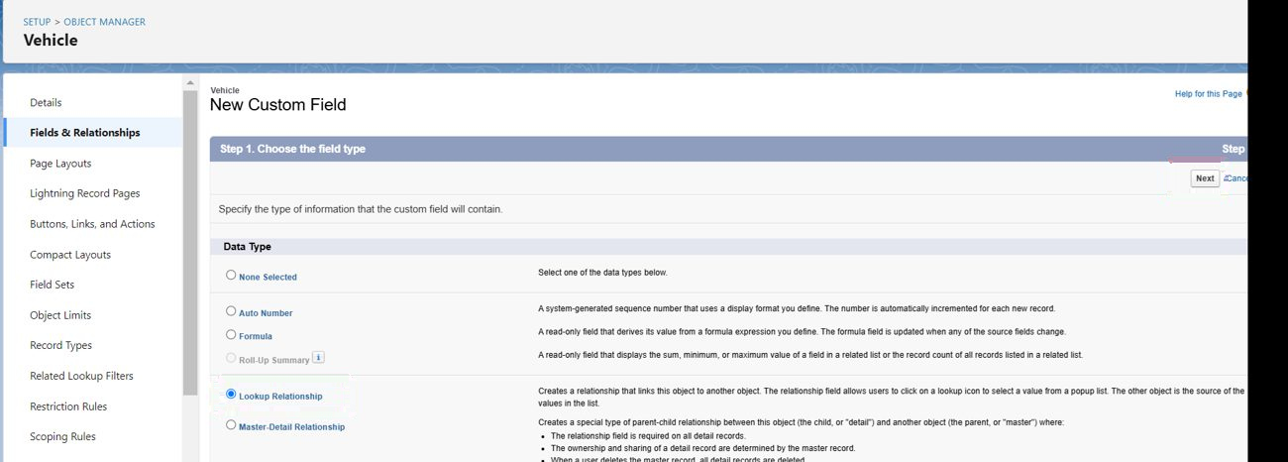
Figure 17: Selecting Lookup Relationship

Activity 4: Creating Remaining Objects and Fields
All remaining fields listed in the key field tables above were created in the same manner.

6.7 Milestone 6: Automation

Flow 1: Record-Triggered Flow to Assign the Nearest Dealer
This flow is intended to assign the nearest dealer to a new vehicle order based on the customer's location.
- In Quick Find, type Flows, click Flows and then click New Flow.
- Select Start From Scratch and click Next.
- Select Record-Triggered Flow and click Create.
- Select the Vehicle Order object and set Trigger the Flow When to "A record is created". Set the entry condition: All Conditions Are Met (AND); Field: Status__c; Operator: Equals; Value: Pending (see D-1).
- Click + and select Get Records. Label: Get Customer Information; Object: Vehicle Customer; Condition: Id Equals {!$Record.Vehicle_Customer__c}.
- Click + and select Get Records. Label: Get Nearest Dealer; Object: Vehicle Dealer; Condition: Dealer_Location__c Equals {!Get_Customer_Information.Address__c}.
- Click + and select Update Records. Label: Assign Dealer to Order; How to find records: "Use the IDs and all field values from a record or record collection"; Record(s) to update: {!Get_Nearest_Dealer}.
- Click Save, enter the Flow Label Auto Assign Dealer and click Save.
- Click Activate.
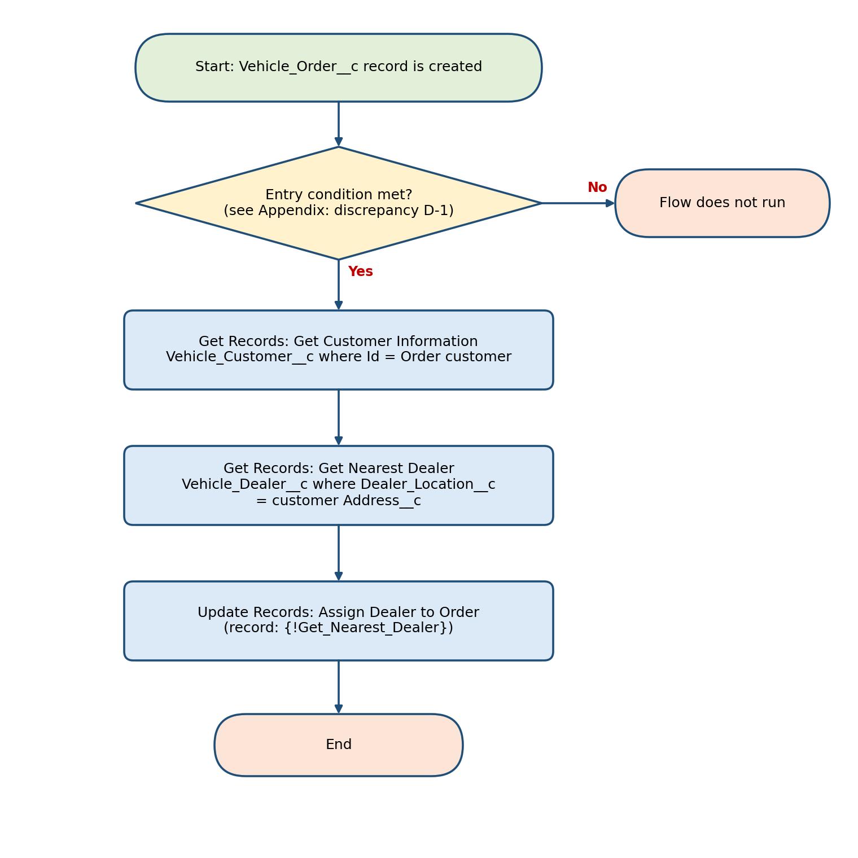
Figure 18: Flowchart of the Auto Assign Dealer flow

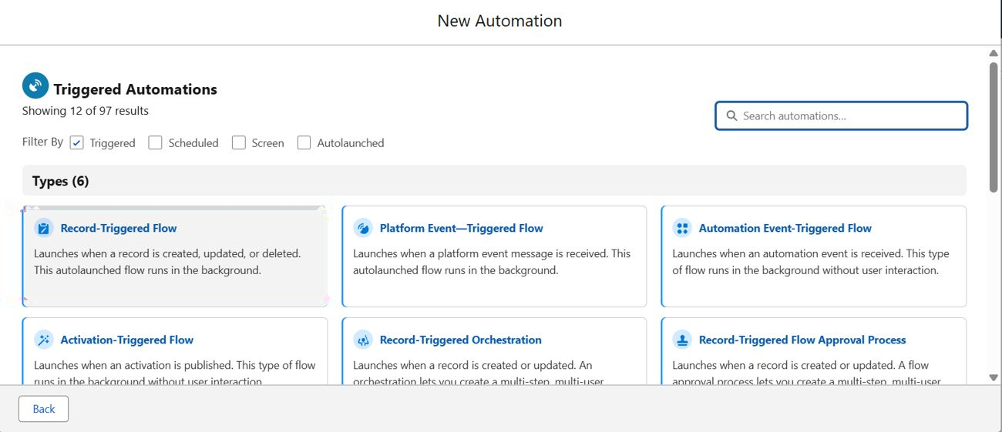
Figure 19: Selecting Record-Triggered Flow
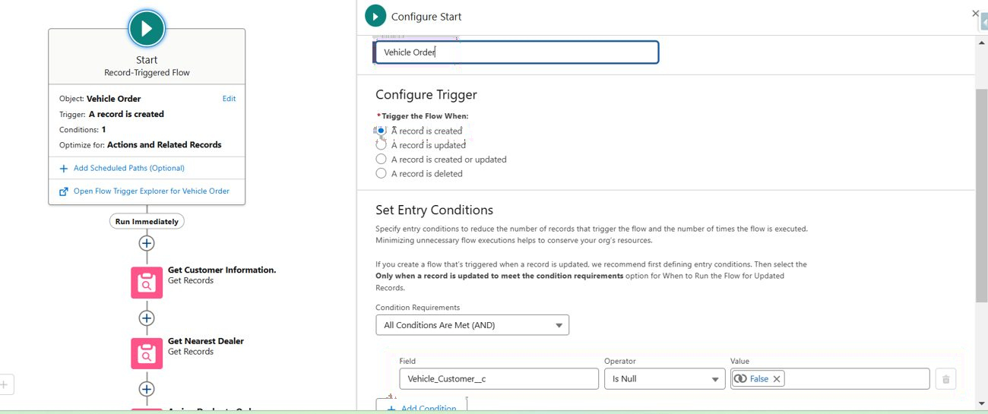
Figure 20: Configure Start – trigger and entry condition as shown in the screenshot

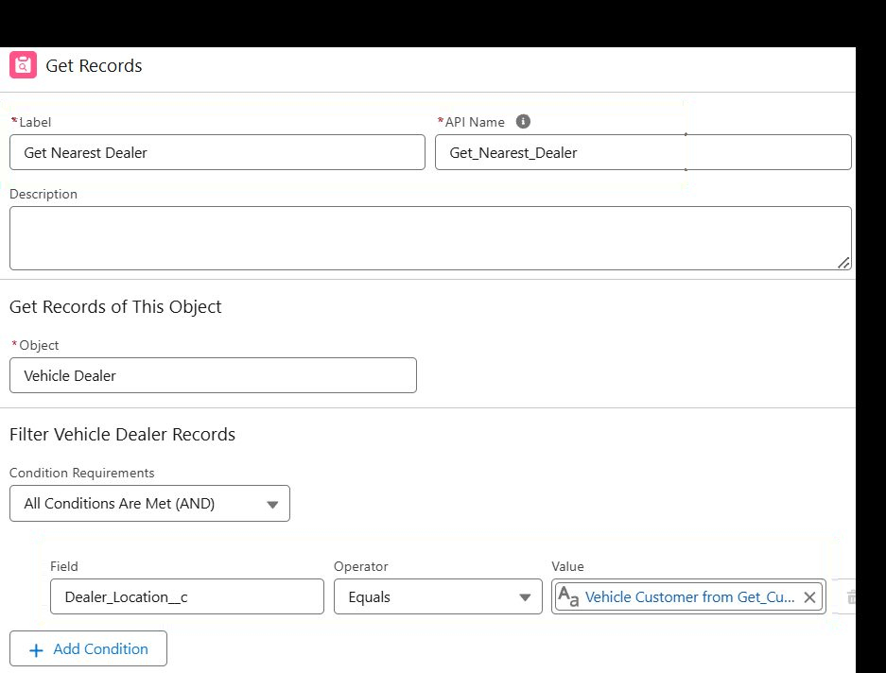
Figure 21: Get Records – Get Nearest Dealer
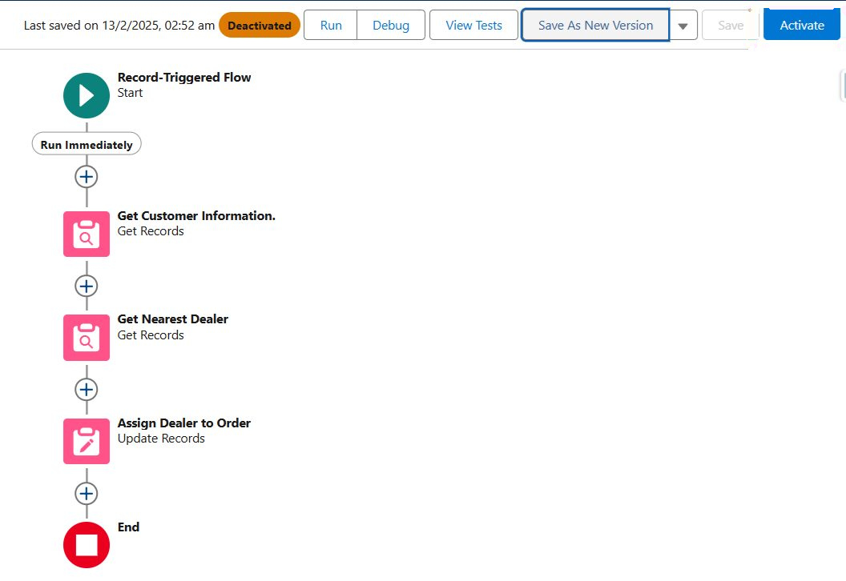
Figure 22: Flow canvas and Activate button

Flow 2: Record-Triggered Flow to Send a Test Drive Reminder Email
- Select Record-Triggered Flow and click Create.
- Select the Vehicle Test Drive object. Trigger the flow when "A record is created or updated". Entry condition: All Conditions Are Met (AND); Field: Status__c; Operator: Equals; Value: Scheduled.
- Click + Add Scheduled Paths below the trigger. Label: Reminder Before Test Drive; Time Source: Test_Drive_Date__c; Offset Number: 1; Offset Options: Days Before. Click Done.
- Click + Add Element → Get Records. Label: Get Customer Information; Object: Vehicle_Customer__c; Filter: Id = {!$Record.Customer__c}; store only the first record; automatically store all fields (see D-4).
- Click + Add Element → Action and choose Send Email. Label: Send Test Drive Reminder; Subject: "Reminder: Your Test Drive is Tomorrow!"; Recipient Address List: {!Get_Customer_Information.Email__c}; Rich-Text-Formatted Body: True.
- For the email Body, create a variable with API Name EmailSent.
- Click Save, enter the Flow Label Test Drive Reminder and save.
- Click Activate.
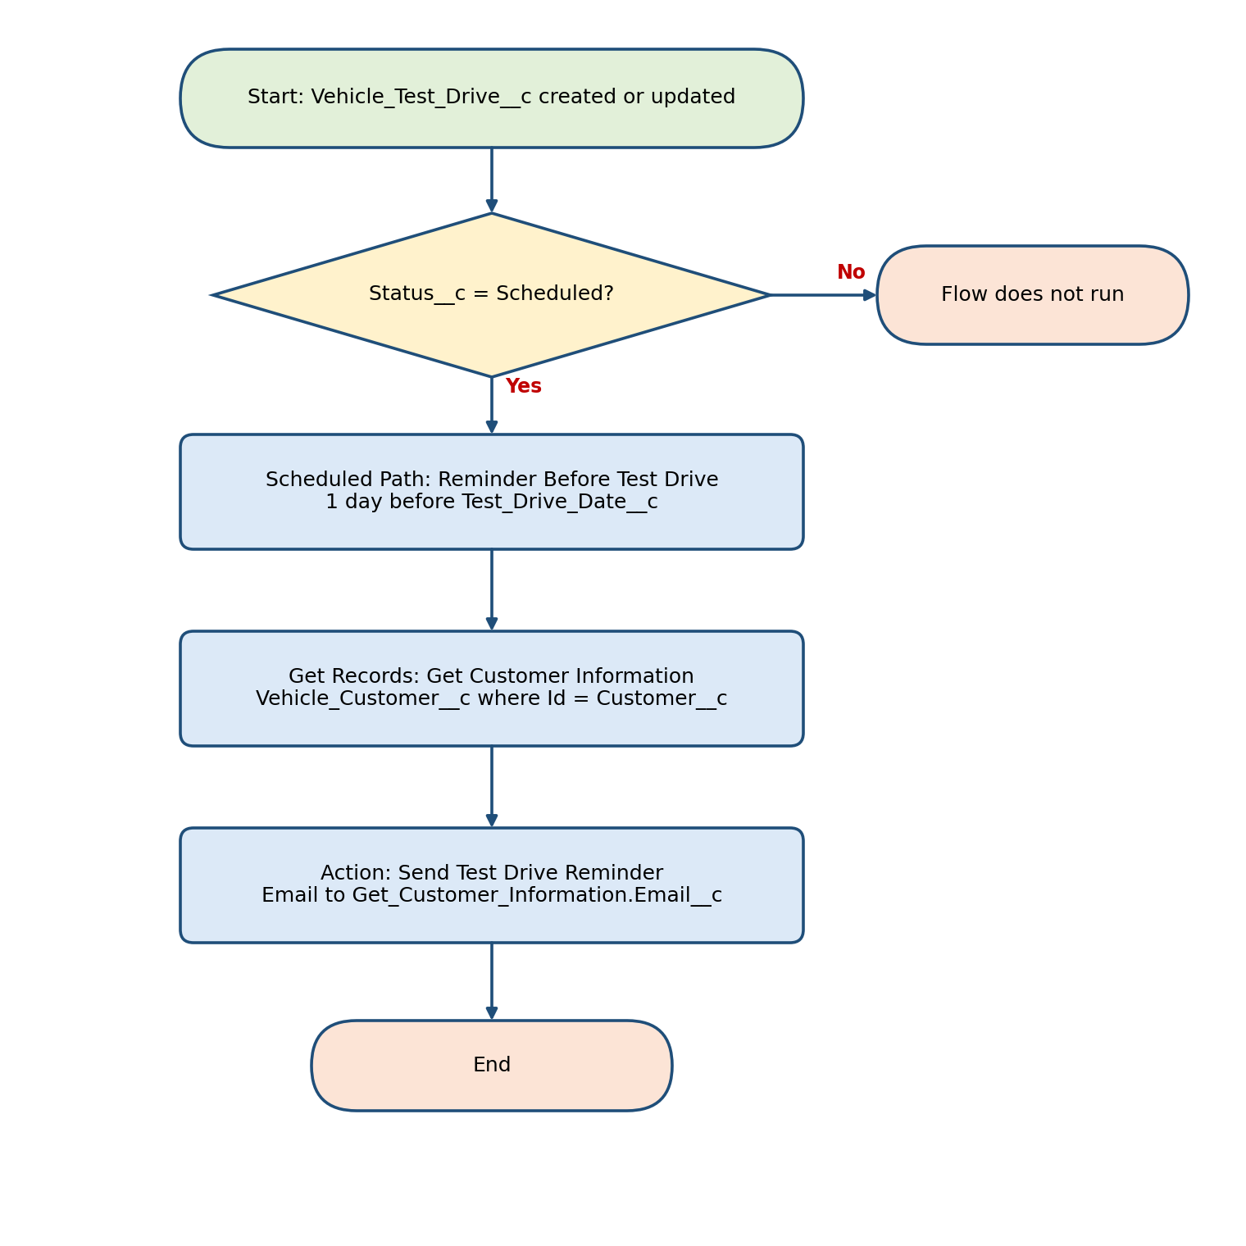
Figure 23: Flowchart of the Test Drive Reminder flow
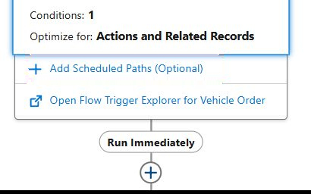
Figure 24: Adding a scheduled path
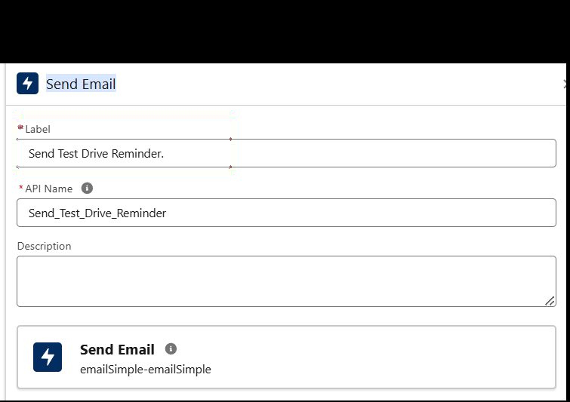
Figure 25: Send Email action
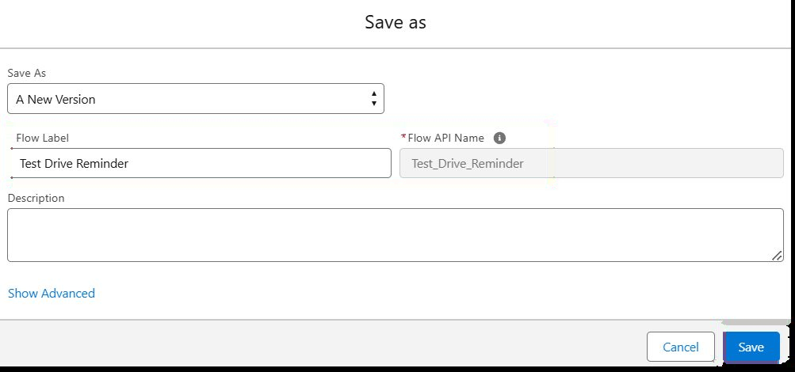
Figure 26: Saving the flow as Test Drive Reminder

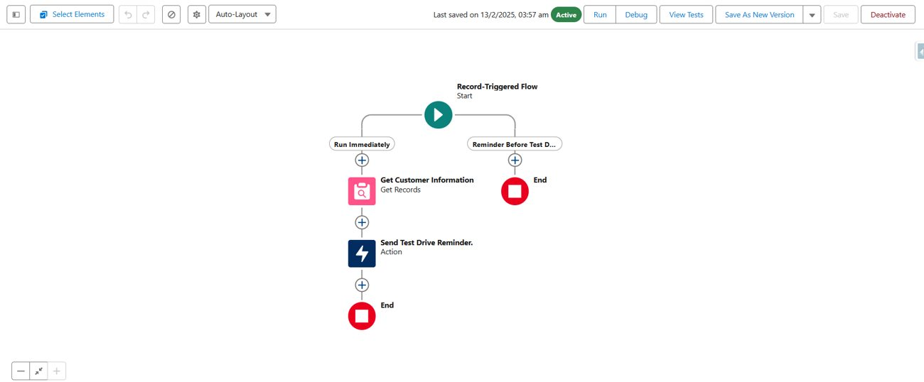
Figure 27: Flow canvas after creation

Testing the Flow
A test drive record was created with the status Scheduled, and the reminder email was received in the customer's mailbox. The email subject and rich-text settings configured in the Send Email action are shown below.
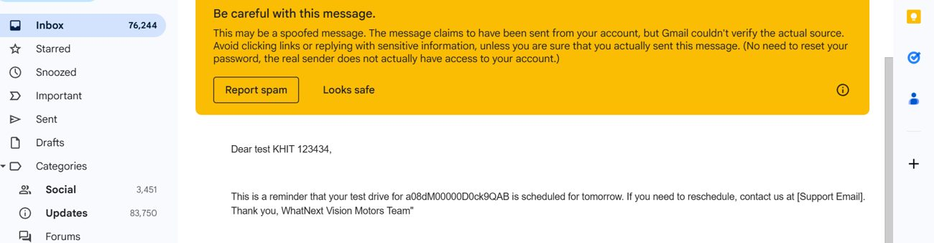
Figure 28: Reminder email received during testing
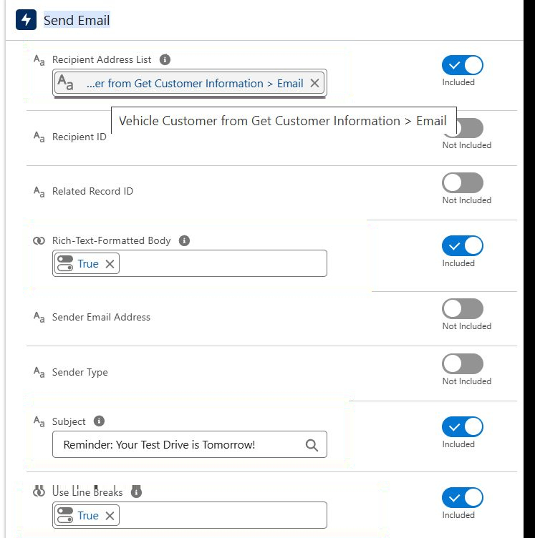
Figure 29: Send Email action settings (recipient, subject, rich-text body, line breaks)

6.8 Milestone 7: Apex and Batch Class

Step 1–3: Opening the Developer Console and Creating the Apex Class
- Click Developer Console from the gear icon.
- Click File → New → Apex Class.
- Enter the class name VehicleOrderTriggerHandler (the source text writes "VehicleOrderTriggerhandler"; the code and screenshot use VehicleOrderTriggerHandler – see D-14).
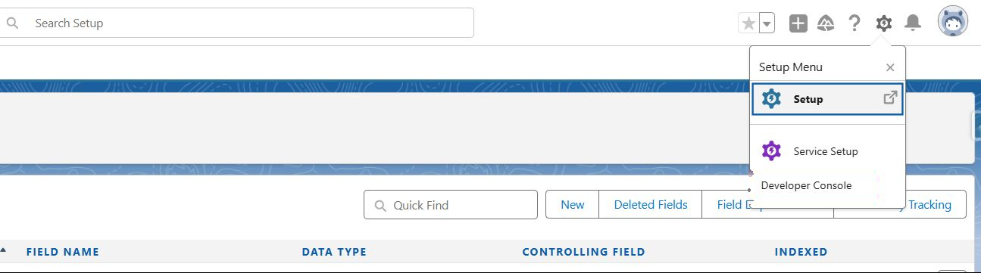
Figure 30: Opening the Developer Console

Step 4: Trigger Handler Apex Class
The handler class contains the business logic for stock validation. Its method handleTrigger() receives the trigger context variables and calls preventOrderIfOutOfStock() before an insert or update, and updateStockOnOrderPlacement() after an insert or update. The first method queries the stock of the ordered vehicles and, if Stock_Quantity__c is zero or less, calls addError() with the message "This vehicle is out of stock. Order cannot be placed." The second method reduces Stock_Quantity__c of the vehicle by one for orders whose status is "Confirmed" and whose vehicle has stock greater than zero.
Source Code: VehicleOrderTriggerHandler
public class VehicleOrderTriggerHandler {

public static void handleTrigger(List<Vehicle_Order__c> newOrders, Map<Id, Vehicle_Order__c> oldOrders,
Boolean isBefore, Boolean isAfter, Boolean isInsert, Boolean isUpdate) {
if (isBefore) {
if (isInsert || isUpdate) {
preventOrderIfOutOfStock(newOrders);
}
}
if (isAfter) {
if (isInsert || isUpdate) {
updateStockOnOrderPlacement(newOrders);
}
}
}

// Method to prevent orders when the vehicle is out of stock
private static void preventOrderIfOutOfStock(List<Vehicle_Order__c> orders) {
Set<Id> vehicleIds = new Set<Id>();
for (Vehicle_Order__c order : orders) {
if (order.Vehicle__c != null) {
vehicleIds.add(order.Vehicle__c);
}
}
if (!vehicleIds.isEmpty()) {
Map<Id, Vehicle__c> vehicleStockMap = new Map<Id, Vehicle__c>();
for (Vehicle__c vehicle : [SELECT Id, Stock_Quantity__c FROM Vehicle__c WHERE Id IN :vehicleIds]) {
vehicleStockMap.put(vehicle.Id, vehicle);
}
for (Vehicle_Order__c order : orders) {
if (vehicleStockMap.containsKey(order.Vehicle__c)) {
Vehicle__c vehicle = vehicleStockMap.get(order.Vehicle__c);
if (vehicle.Stock_Quantity__c <= 0) {
order.addError('This vehicle is out of stock. Order cannot be placed.');
}
}
}
}
}

// Method to update vehicle stock when an order is placed
private static void updateStockOnOrderPlacement(List<Vehicle_Order__c> orders) {
Set<Id> vehicleIds = new Set<Id>();
for (Vehicle_Order__c order : orders) {
if (order.Vehicle__c != null && order.Status__c == 'Confirmed') {
vehicleIds.add(order.Vehicle__c);
}
}
if (!vehicleIds.isEmpty()) {
Map<Id, Vehicle__c> vehicleStockMap = new Map<Id, Vehicle__c>();
for (Vehicle__c vehicle : [SELECT Id, Stock_Quantity__c FROM Vehicle__c WHERE Id IN :vehicleIds]) {
vehicleStockMap.put(vehicle.Id, vehicle);
}
List<Vehicle__c> vehiclesToUpdate = new List<Vehicle__c>();
for (Vehicle_Order__c order : orders) {
if (vehicleStockMap.containsKey(order.Vehicle__c)) {
Vehicle__c vehicle = vehicleStockMap.get(order.Vehicle__c);
if (vehicle.Stock_Quantity__c > 0) {
vehicle.Stock_Quantity__c -= 1;
vehiclesToUpdate.add(vehicle);
}
}
}
if (!vehiclesToUpdate.isEmpty()) {
update vehiclesToUpdate;
}
}
}
}

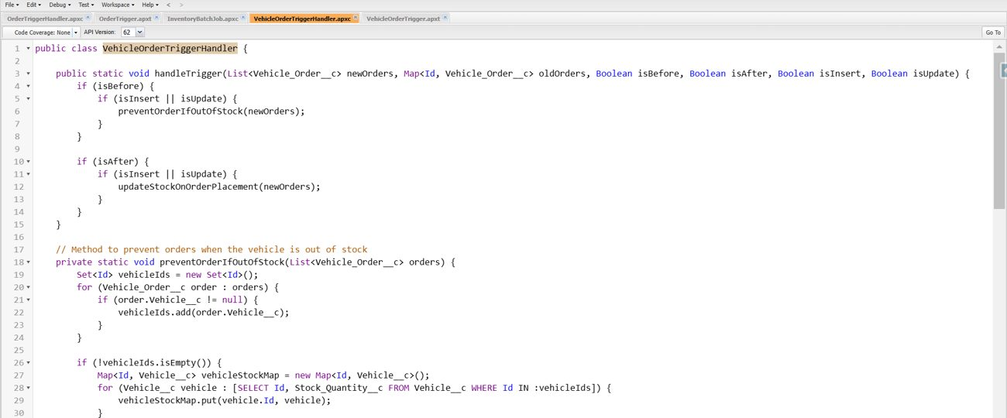
Figure 31: Developer Console – handler class (part 1)
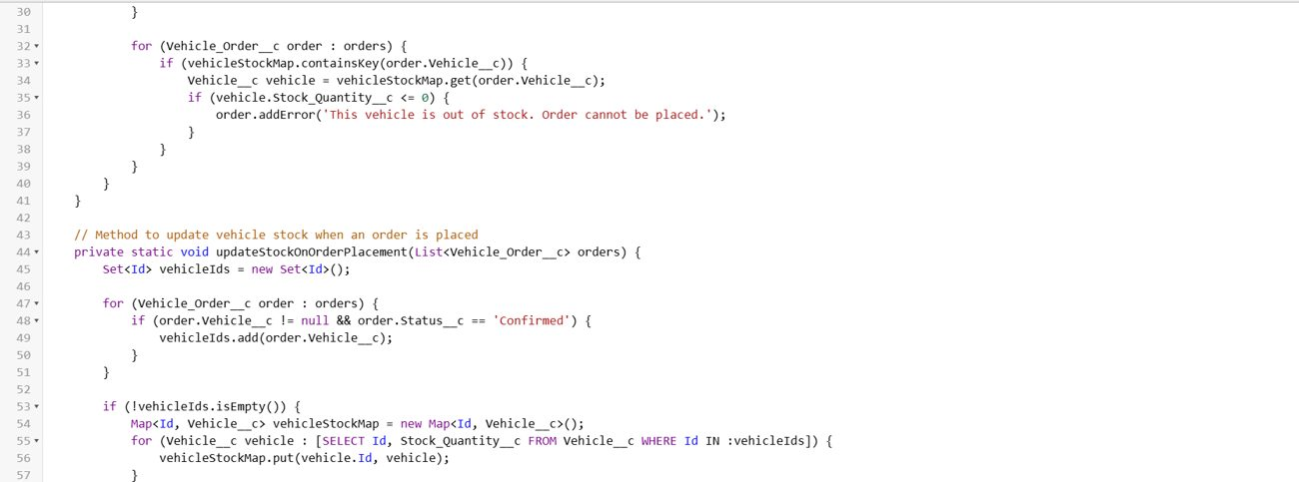
Figure 32: Developer Console – handler class (part 2)
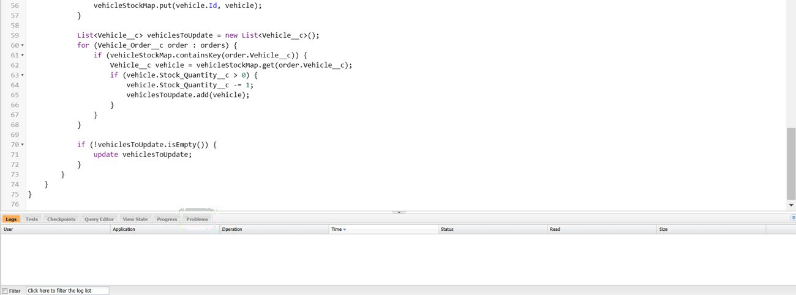
Figure 33: Developer Console – handler class (part 3)
When an order is created for a vehicle whose stock is zero, the trigger blocks the record and displays an error, as shown below.

Steps 5–7: Apex Trigger
A trigger named VehicleOrderTrigger was created on the Vehicle_Order__c object with the contexts before insert, before update, after insert and after update. It delegates all work to the handler class, which follows the trigger-handler best practice stated in the requirements.

Source Code: VehicleOrderTrigger
trigger VehicleOrderTrigger on Vehicle_Order__c (before insert, before update, after insert, after update) {
VehicleOrderTriggerHandler.handleTrigger(Trigger.new, Trigger.oldMap,
Trigger.isBefore, Trigger.isAfter, Trigger.isInsert, Trigger.isUpdate);
}
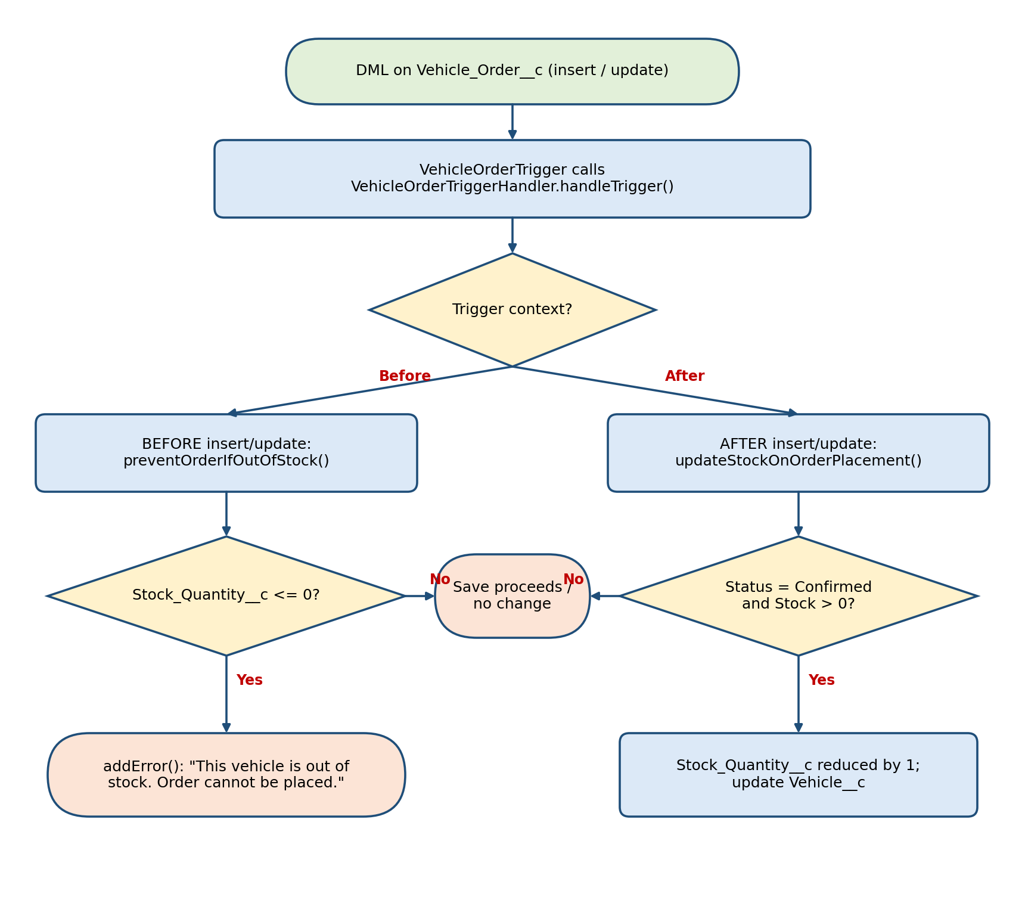
Figure 34: Flowchart of the order trigger and handler logic

Step 8: Batch Apex Class
The scenario handled by the batch job is: a customer places an order, but the vehicle is out of stock; the order remains Pending; after new stock is added, the batch job updates the order to Confirmed. The class VehicleOrderBatch implements Database.Batchable. Its start() method queries all Vehicle_Order__c records with Status__c = 'Pending'. The execute() method collects the vehicle Ids, queries the current stock, and for each order whose vehicle has stock greater than zero sets the order status to 'Confirmed' and reduces the vehicle stock by one before updating both lists. The finish() method writes a debug message.
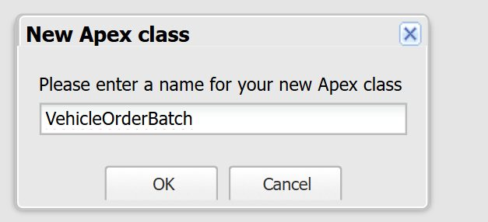
Figure 35: Creating the VehicleOrderBatch class
Source Code: VehicleOrderBatch
global class VehicleOrderBatch implements Database.Batchable<sObject> {

global Database.QueryLocator start(Database.BatchableContext bc) {
return Database.getQueryLocator([
SELECT Id, Status__c, Vehicle__c
FROM Vehicle_Order__c
WHERE Status__c = 'Pending'
]);
}

global void execute(Database.BatchableContext bc, List<Vehicle_Order__c> orderList) {
Set<Id> vehicleIds = new Set<Id>();

for (Vehicle_Order__c order : orderList) {
if (order.Vehicle__c != null) {
vehicleIds.add(order.Vehicle__c);
}
}

if (!vehicleIds.isEmpty()) {
Map<Id, Vehicle__c> vehicleStockMap = new Map<Id, Vehicle__c>();
for (Vehicle__c vehicle : [SELECT Id, Stock_Quantity__c FROM Vehicle__c WHERE Id IN :vehicleIds]) {
vehicleStockMap.put(vehicle.Id, vehicle);
}

List<Vehicle_Order__c> ordersToUpdate = new List<Vehicle_Order__c>();
List<Vehicle__c> vehiclesToUpdate = new List<Vehicle__c>();

for (Vehicle_Order__c order : orderList) {
if (vehicleStockMap.containsKey(order.Vehicle__c)) {
Vehicle__c vehicle = vehicleStockMap.get(order.Vehicle__c);
if (vehicle.Stock_Quantity__c > 0) {
order.Status__c = 'Confirmed';
vehicle.Stock_Quantity__c -= 1;
ordersToUpdate.add(order);
vehiclesToUpdate.add(vehicle);
}
}
}

if (!ordersToUpdate.isEmpty()) {
update ordersToUpdate;
}
if (!vehiclesToUpdate.isEmpty()) {
update vehiclesToUpdate;
}
}
}

global void finish(Database.BatchableContext bc) {
System.debug('Vehicle order batch job completed.');
}
}

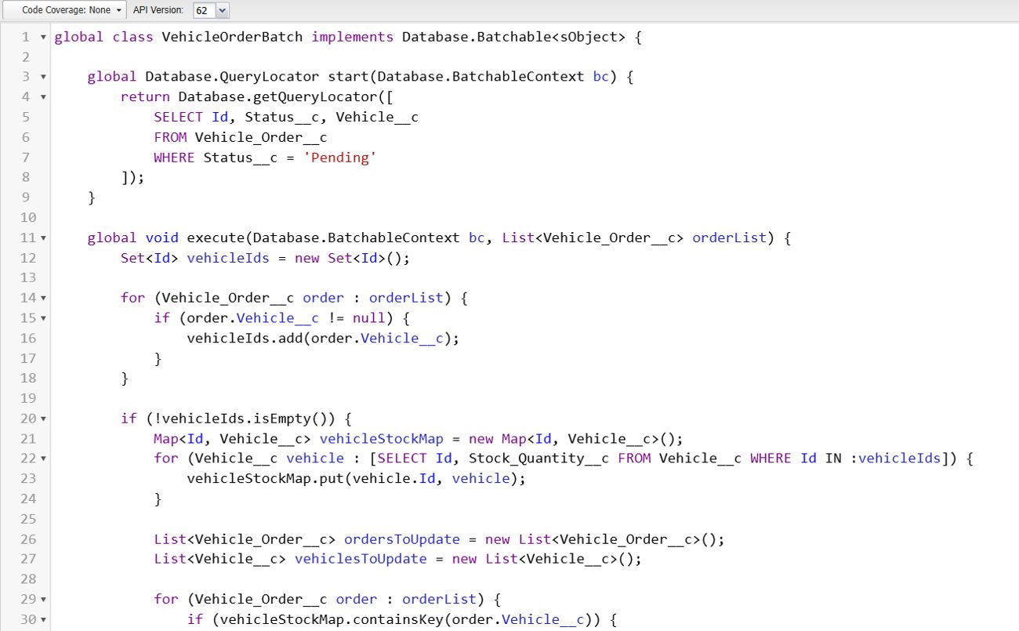
Figure 36: Batch class in the Developer Console (part 1)
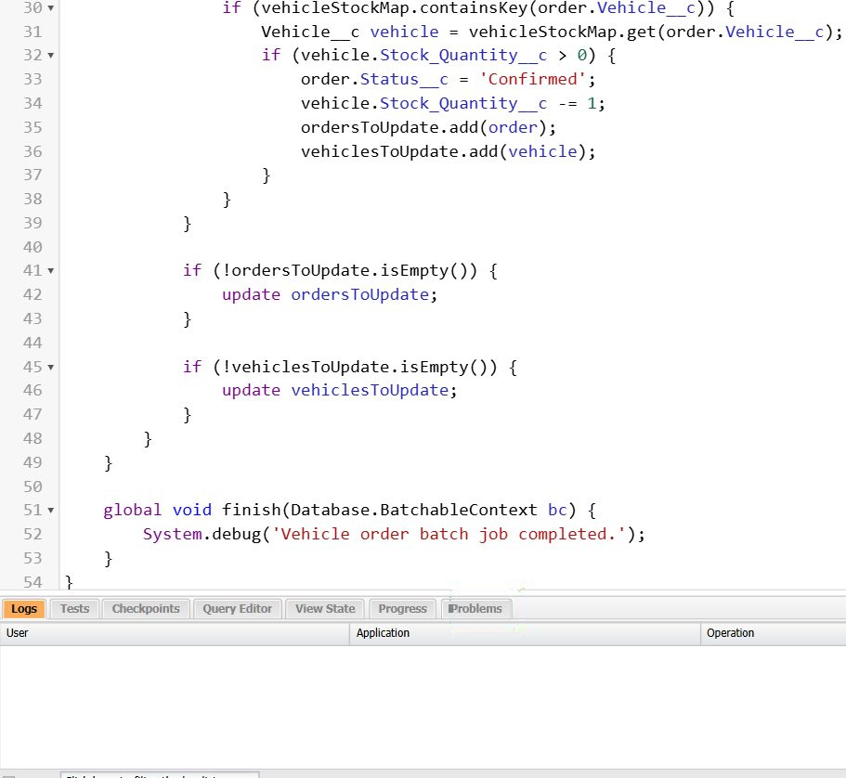
Figure 37: Batch class in the Developer Console (part 2)
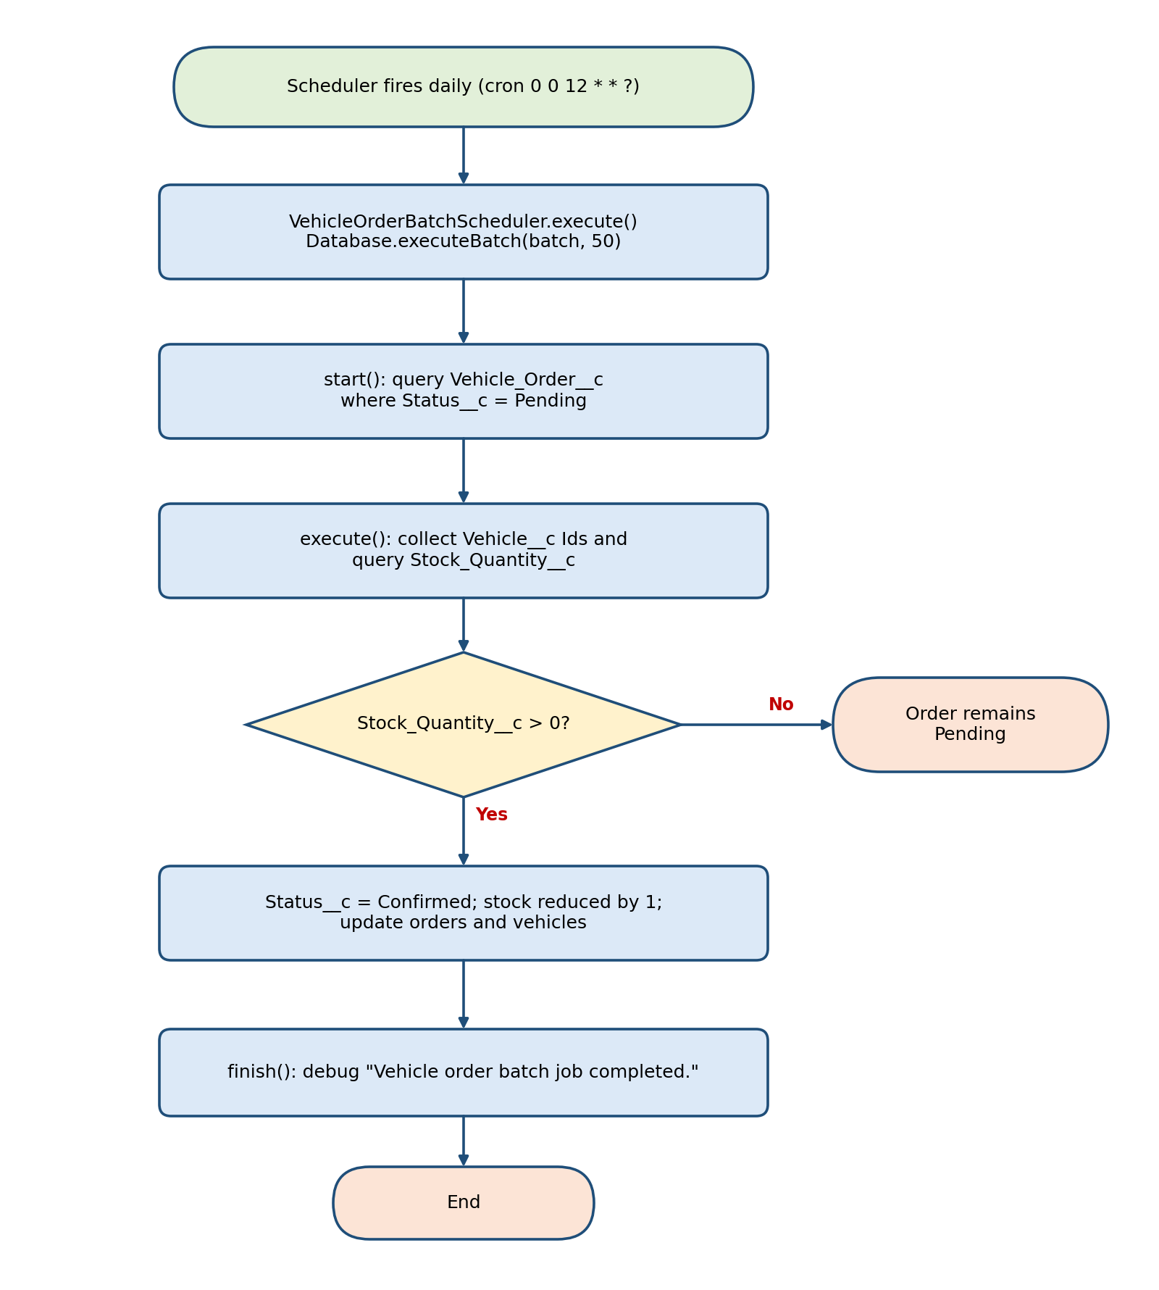
Figure 37: Flowchart of the scheduled batch processing

Step 9: Scheduler Class
The class VehicleOrderBatchScheduler implements the Schedulable interface and starts the batch job with a batch size of 50 records.
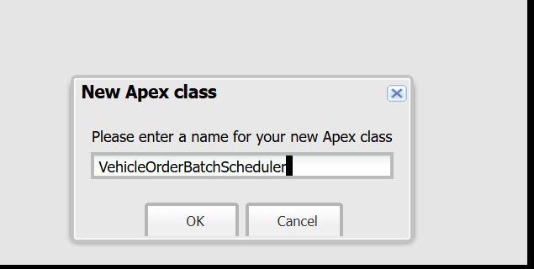
Figure 38: Creating the VehicleOrderBatchScheduler class
Source Code: VehicleOrderBatchScheduler
global class VehicleOrderBatchScheduler implements Schedulable {
global void execute(SchedulableContext sc) {
VehicleOrderBatch batchJob = new VehicleOrderBatch();
Database.executeBatch(batchJob, 50); // 50 is the batch size
}
}

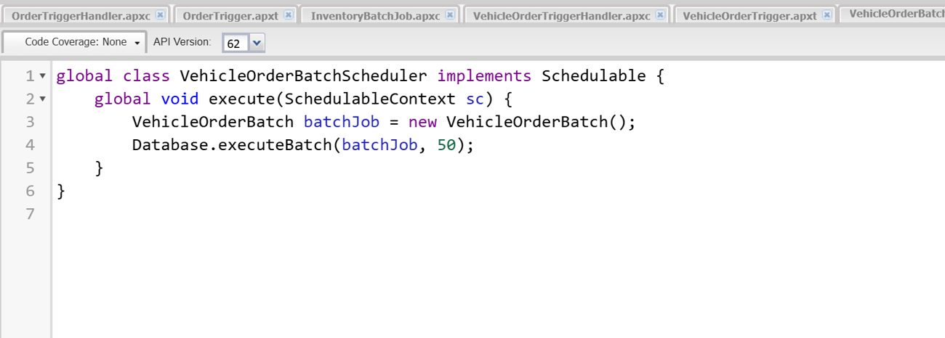
Figure 39: Scheduler class in the Developer Console

Step 10: Scheduling the Batch Job
The job is scheduled by opening Debug → Open Execute Anonymous Window and running the following code. The source text states that the job runs "every night at midnight", but the cron expression used (0 0 12 * * ?) runs every day at 12:00 PM (D-6).
Source Code: Scheduling
String cronExp = '0 0 12 * * ?'; // Runs daily at 12:00 PM
System.schedule('Daily Vehicle Order Processing', cronExp, new VehicleOrderBatchScheduler());
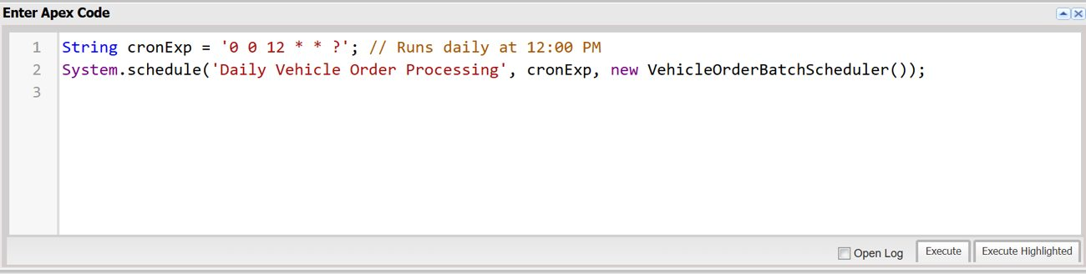
Figure 40: Scheduling code entered in the Execute Anonymous Window

Step 11: Verifying the Scheduled Job
The scheduled job can be checked in Setup by searching for Scheduled Jobs in Quick Find.

7. FUNCTIONAL & PERFORMANCE TESTING
During testing, screenshots were captured from Salesforce to validate vehicle creation, dealer assignment, stock validation triggers, order status updates, batch processing, scheduled reminders, and dashboard analytics. All features were verified to ensure correct functionality and performance.
The table below maps each feature to a test case. The "Evidence" column states only what is supported by the screenshots and text supplied in the source files; where no result was supplied, a placeholder is shown so that the student can attach the screenshot.
Table 19: Functional Test Cases and Results
Test ID | Requirement | Test Scenario | Expected Result | Evidence / Result
TC-01 | FR-4 Stock validation | Create a Vehicle Order for a vehicle with Stock_Quantity__c ≤ 0 | Save is blocked with the message "This vehicle is out of stock. Order cannot be placed." | Pass – error "We hit a snag" shown for order VC-0003 (Figure: out-of-stock error)
TC-02 | FR-6 Test drive scheduling | Create a Test Drive with Status = Scheduled | Customer receives a reminder email one day before Test_Drive_Date__c | Email received in the mailbox (Figure: reminder email). Timing of the 1-day offset: [to be verified]
TC-03 | FR-5 Dealer auto-assignment | Create a Vehicle Order for a customer whose Address__c matches a Dealer_Location__c | Dealer is assigned to the order | [Result screenshot not supplied – insert screenshot]
TC-04 | FR-4 / Batch processing | Run the batch with Pending orders for a vehicle that now has stock | Order Status__c changes to Confirmed and stock is reduced | [Result screenshot not supplied – insert screenshot]
TC-05 | Scheduled Apex | Schedule VehicleOrderBatchScheduler with cron 0 0 12 * * ? | Job "Daily Vehicle Order Processing" is listed as a Scheduled Apex job | Pass – job visible on the Scheduled Jobs page (Figure: Scheduled Jobs)
TC-06 | Flow activation | Activate the Test Drive Reminder and Auto Assign Dealer flows | Flows show status Active | Test Drive Reminder shows "Active" on the flow canvas. Auto Assign Dealer: [activation screenshot of final state to be added]
TC-07 | Stock update on confirmation | Save an order with Status = Confirmed | Vehicle Stock_Quantity__c reduces by 1 | [Result screenshot not supplied – insert screenshot]
TC-08 | FR-7 Reports & dashboards | Open reports and dashboards for order status, dealer performance and sales metrics | Reports and dashboards display the data | [Not documented in the source files – insert screenshots]

[Insert Screenshot: Vehicle record creation (Vehicle__c)]
Figure 41: Vehicle record creation (Vehicle__c) (placeholder)
[Insert Screenshot: Dealer assignment result on a Vehicle Order]
Figure 42: Dealer assignment result on a Vehicle Order (placeholder)
[Insert Screenshot: Batch job result – order status changed from Pending to Confirmed]
Figure 43: Batch job result – order status changed from Pending to Confirmed (placeholder)
[Insert Screenshot: Reports and dashboard analytics]
Figure 44: Reports and dashboard analytics (placeholder)

7.1 Performance Observations
No quantitative performance measurements (for example response time or batch execution time) were supplied in the source files. [Insert batch execution time from Setup → Apex Jobs, number of records processed, and observed order-processing time, if available.] The batch job is configured with a batch size of 50 records per execution, and the non-functional requirements state the goals of fast order processing and 24/7 cloud availability.

8. ADVANTAGES & DISADVANTAGES

Advantages
- Centralized data
- Automated workflows
- Real-time reporting

Disadvantages
- Salesforce dependency
- Requires initial configuration effort

Limitations Observed in the Documented Implementation
The following points are derived from reading the documented configuration and code. They are presented as observations to be verified, not as test results:
- Dealer assignment is based on an exact text match between Dealer_Location__c and the customer's Address__c, so it does not calculate real geographic distance (D-2).
- The out-of-stock check blocks any order save when stock is zero, so the "Pending when out of stock" behaviour described in the brief depends on how orders are created (D-8).
- Stock is reduced in both the trigger handler and the batch class, and the handler does not compare old and new status values (D-9, D-10).
- The batch job runs once a day at 12:00 PM, so Pending orders are not confirmed in real time (D-6).

9. CONCLUSION
The Salesforce CRM implementation at WhatNext Vision Motors successfully modernizes vehicle ordering and dealership management. Automation improves efficiency, accuracy, and customer experience.
The project delivered a data model of six custom objects, a Lightning App with navigation for all modules, two record-triggered Flows (dealer assignment and test drive reminder), an Apex trigger with a handler for stock validation, and a Batch and Scheduled Apex combination for processing Pending orders. Testing evidence confirms the out-of-stock validation, the reminder email and the registration of the scheduled job. The items flagged in Appendix C should be reviewed and resolved before final submission.

10. FUTURE SCOPE
- Mobile ordering app
- Dealer GPS integration
- SMS notifications
- AI-based demand forecasting

11. APPENDIX

Appendix A: Project Resources
- Source Code: Salesforce Configuration (Apex classes and trigger are listed in Section 6.8)
- Dataset: Salesforce Objects (Section 6.3 and Section 6.6)
- GitHub / Demo: Salesforce Developer Org – [GitHub repository link, if any] / [Developer Org login URL]

Appendix B: References
The source files cite only the following resource. Add further references used by your institution's format here.
- Salesforce Developer Edition sign-up page: https://developer.salesforce.com/signup
- [Add Salesforce documentation / textbook references used, if any]

Appendix C: Register of Discrepancies and Unclear Details in the Source Files
The items below were found while preparing this documentation. They have been reported rather than silently corrected, so that the student can confirm the intended behaviour.
Table 20: Discrepancy Register
ID | Area | Observation in source files | How handled here
D-1 | Flow 1 entry condition | Text: Status__c Equals Pending. Screenshot of Start element: Vehicle_Customer__c Is Null = False. | Both reported; student to confirm.
D-2 | Flow 1 "nearest dealer" | Implemented as Dealer_Location__c = customer Address__c (exact match); no distance logic or geolocation field. | Described as implemented.
D-3 | Flow 1 Update Records | Updates {!Get_Nearest_Dealer} (a Vehicle_Dealer__c record). No dealer lookup field is listed on Vehicle_Order__c, so how the dealer is linked to the order is not shown. | Reported; not assumed.
D-4 | Customer lookup name | Customer__c (PDF template, Flow 2 filter) vs Vehicle_Customer__c (Word field lists, Flow 1). | Word names used in tables; Flow 2 text kept as written.
D-5 | Field labels | "Vehicle Modal" and "Stock Quality" in creation steps vs Vehicle_Model__c and Stock_Quantity__c in field lists. Vehicle name is "Vehicle Name" (Word) vs Vehicle_Name__c (PDF). | Field-list names used; typos mentioned in text.
D-6 | Schedule time | Text says every night at midnight; cron 0 0 12 * * ? runs at 12:00 PM. | Cron reproduced as given.
D-7 | Batch code text | Typed code has errors (Status_c, Vehicle___c, missing = and :). Screenshot shows correct code. | Listing follows screenshot.
D-8 | Pending vs blocked orders | Brief: out-of-stock orders become Pending. Trigger: any save with stock ≤ 0 is blocked (screenshot shows a Pending order blocked). | Reported as unclear.
D-9 | Double stock reduction | Stock is reduced by the trigger (Confirmed status) and by the batch; the batch update to Confirmed also fires the trigger. The batch may add the same Vehicle__c to its update list more than once. | Reported; to be tested.
D-10 | Handler logic | oldOrders is unused; every save of a Confirmed order reduces stock again. | Reported; to be tested.
D-11 | Brief vs implementation | Brief mentions trigger-based dealer assignment and stock-replenishment emails; neither is shown. Technology stack lists Validation Rules; none are documented. | Reported; not added.
D-12 | Reports and dashboards | Required by FR-7, USN-8 and USN-9, but no creation steps or screenshots are supplied. | Placeholders inserted.
D-13 | Sprint plan | 37 points / 6 sprints in backlog vs 4 sprints × 20 points in tracker; Sprint-1 = 3 vs 20 points; dates 2022 vs screenshots 2025; USN-8 and USN-9 have identical wording. | Reproduced as given.
D-14 | Handler class name | "VehicleOrderTriggerhandler" in text; "VehicleOrderTriggerHandler" in code and screenshot. | Code spelling used.
D-15 | Stray image in PDF | PDF shows an unrelated Flask code snippet between Flow 1 steps 4 and 5; the Word file shows the flow entry-condition screenshot there. | Word screenshot used.
D-16 | Test email | Body shows record Id and "[Support Email]" placeholder. | Reported.
D-17 | Other items in screenshots | Developer Console tabs (OrderTriggerHandler, InventoryBatchJob) and a "Daily Inventory Sync" scheduled job appear but are not described in the text. | Not documented.

WhatNext Vision Motors:
Shaping the Future of Mobility with Innovation and Excellence

- Vehicles
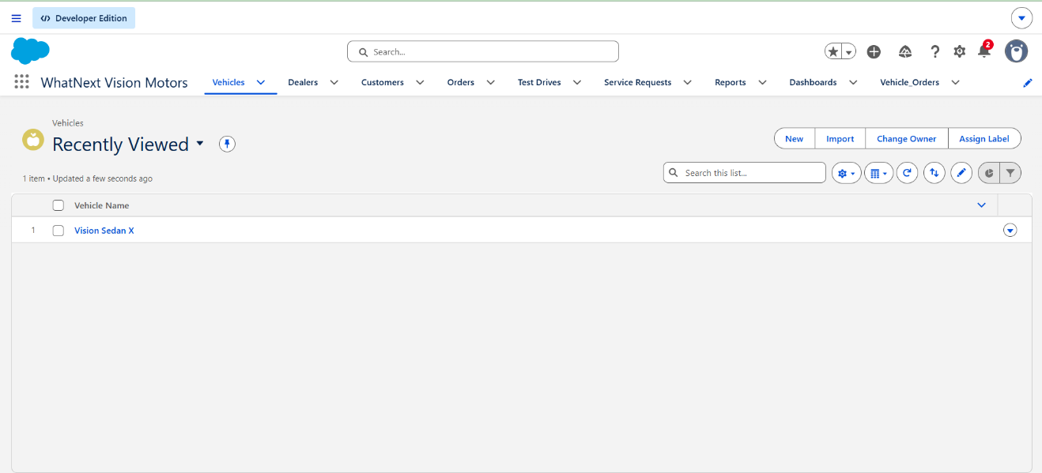

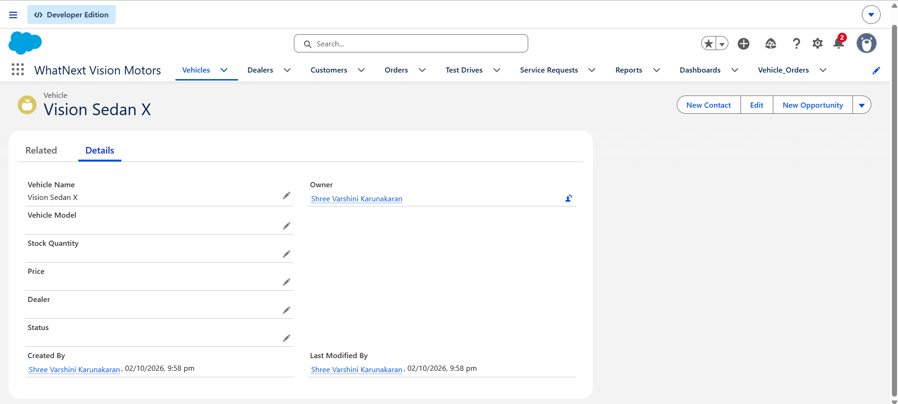

2.Dealers
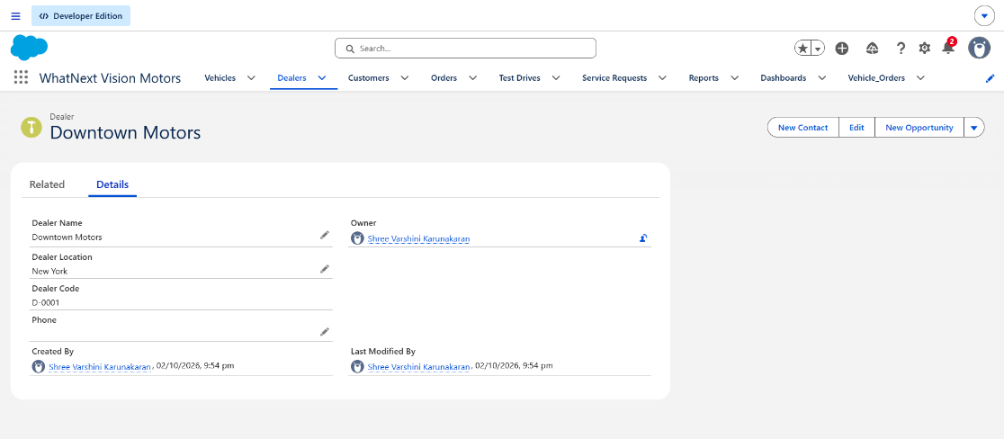

3.Customers
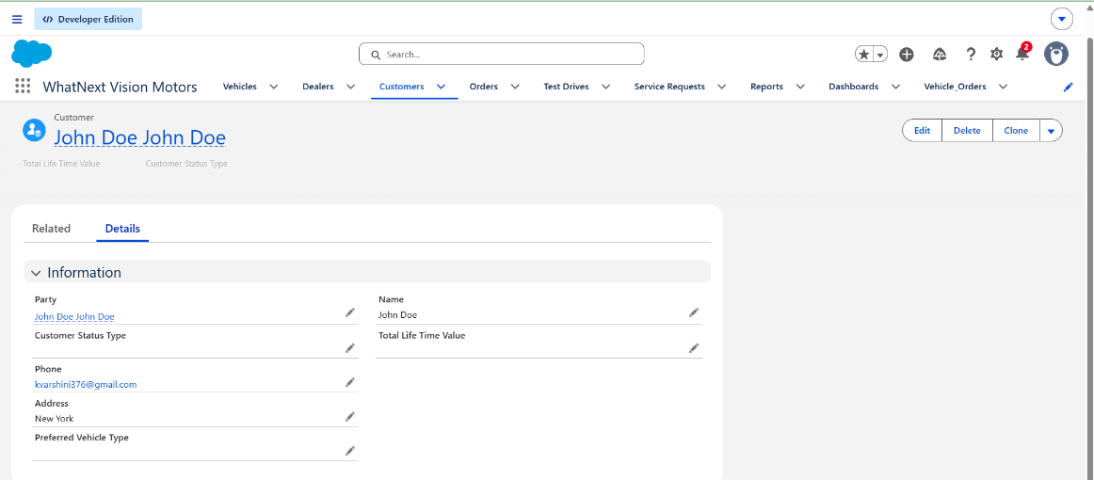
4.Test Drives
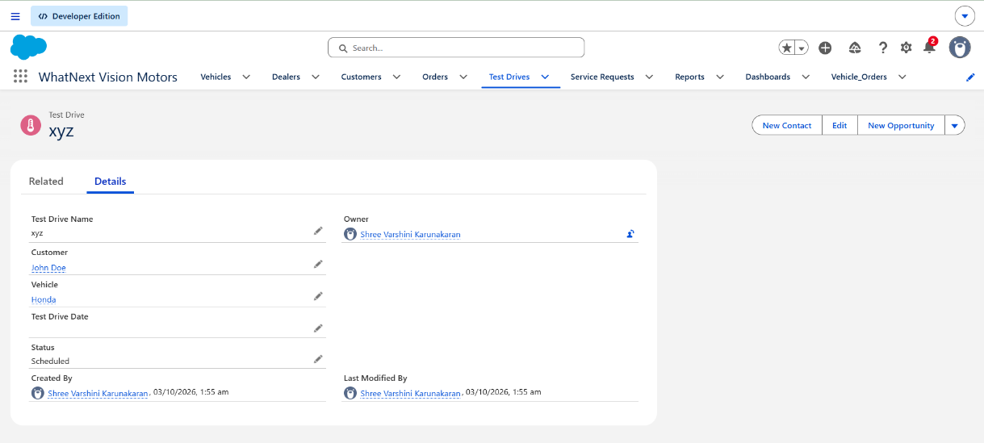
- Service Request
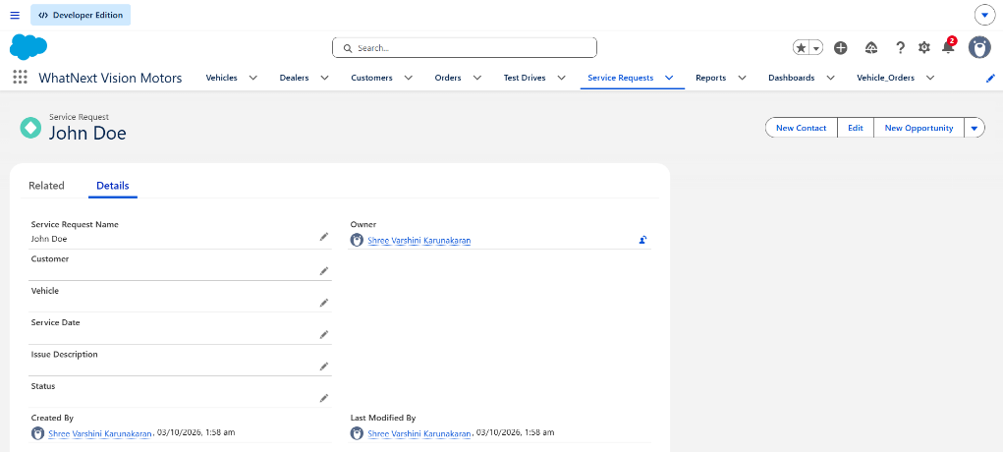

6.Flow Builders
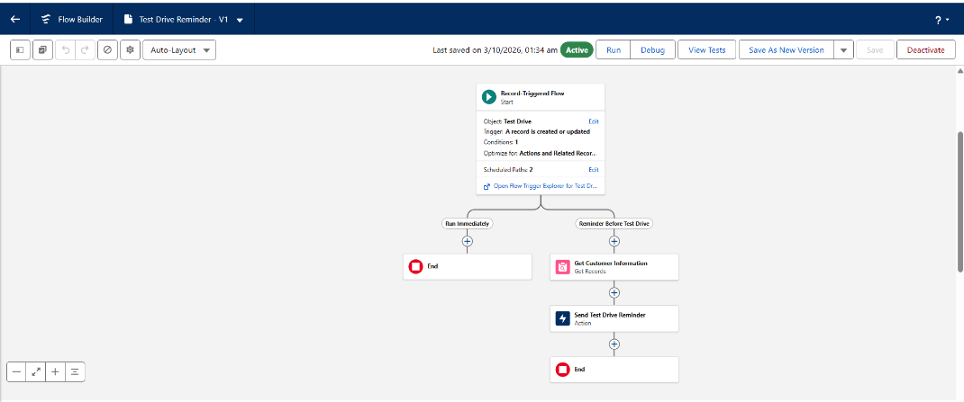

Thank You

