IOT- BASED AIR QUALITY & ALCOHOL DETECTION SYSTEM USING ESP32 WITH THINGS SPEAK

SCHOOL OF ENGINEERING

Subject Code: CSY407
Subject Name: IoT Lab
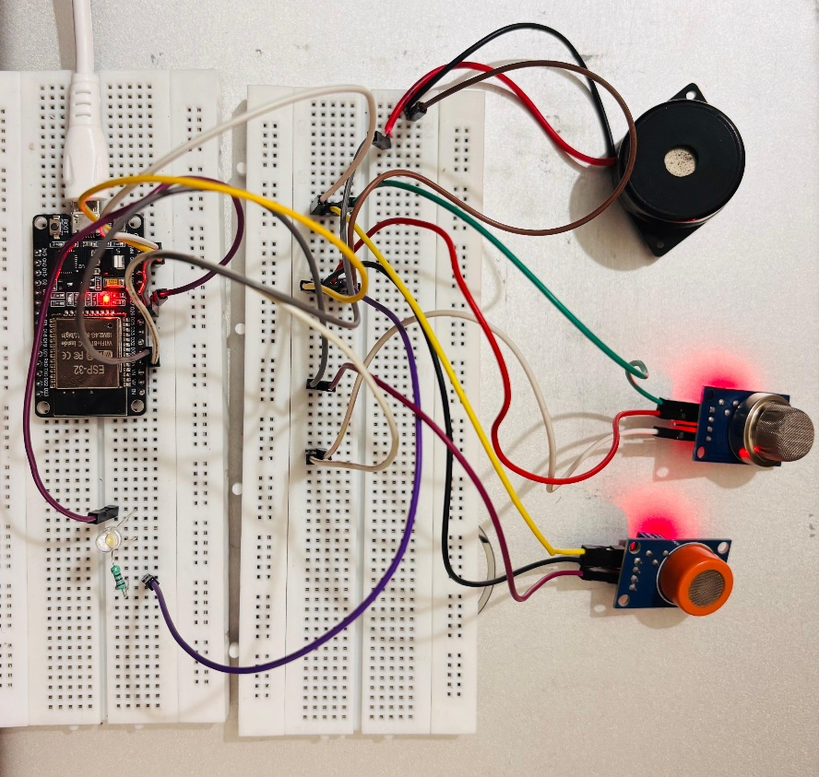
REPORT SUBMITTED BY,
SHREEVATHSA S M
REG NO: CU22BCA023A
BCA Hons.
Chanakya University
ABSTRACT
The Internet of Things (IoT) enables intelligent environmental monitoring systems capable of detecting harmful gases and alcohol levels. This project presents an IoT-based Air Quality and Alcohol Detection System using ESP32, MQ2, and MQ3 sensors. Real-time sensor data is uploaded to ThingSpeak every 15 seconds, while LED and buzzer alerts provide local warnings for smoke and alcohol detection. The system is an efficient and scalable IoT safety solution.

INTRODUCTION
The Internet of Things refers to a network of smart devices capable of sensing, processing and transmitting data over the internet. Embedded systems such as the ESP32 make IoT applications easy to implement, combining hardware and software for real-time monitoring.

SCOPE OF THE PROJECT
- Home safety monitoring
- Vehicle alcohol detection
- Industrial safety
- Public building fire/smoke detection
- Educational IoT demonstration projects

HARDWARE COMPONENTS USED
- ESP32 DevKit V1
- MQ2 Smoke/Gas Sensor
- MQ3 Alcohol Sensor
- LED Indicator
- Buzzer
- Jumper Wires
- Power Supply
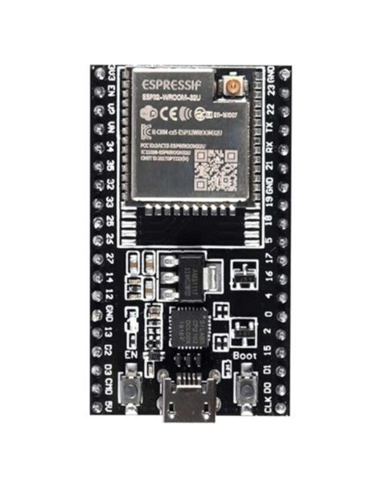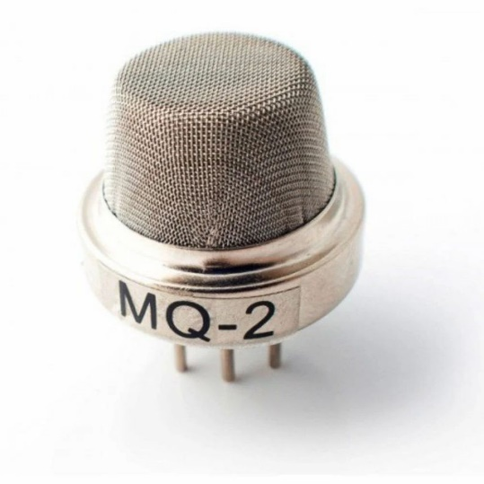
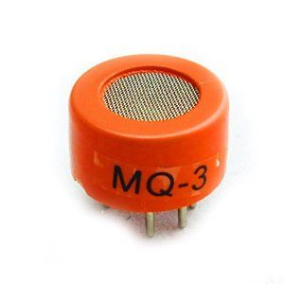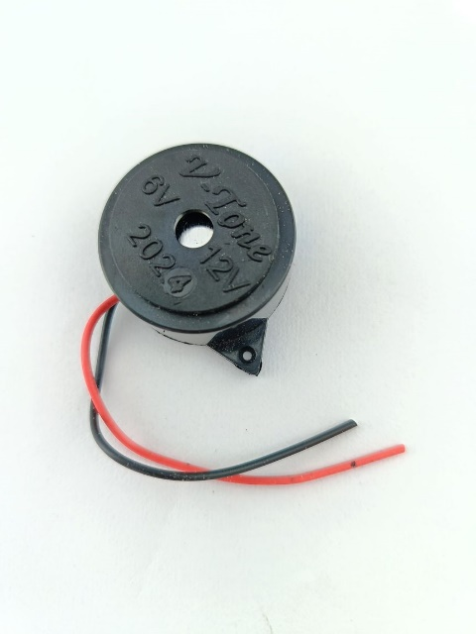
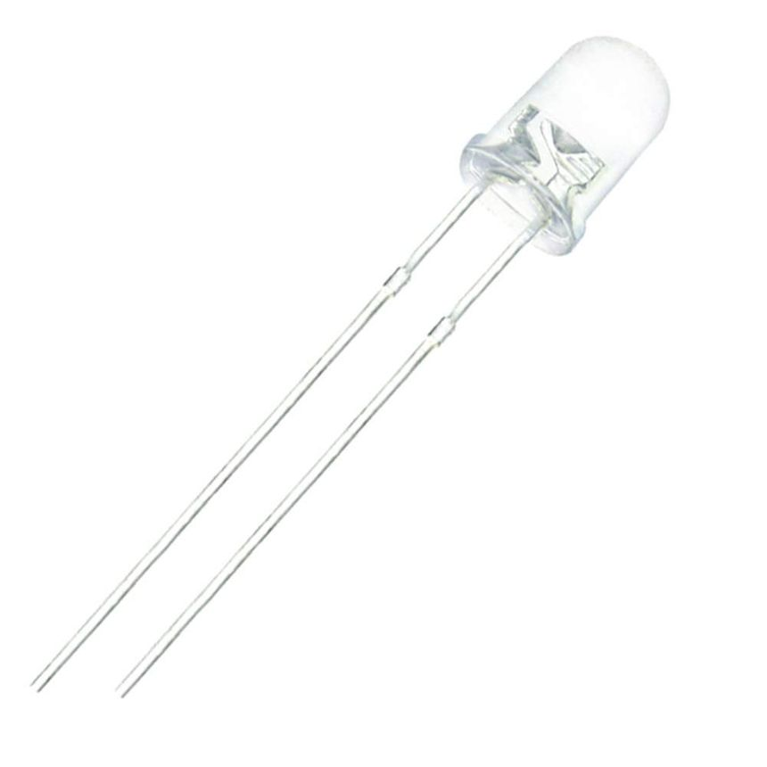

SOFTWARE REQUIREMENTS
- Arduino IDE
- ThingSpeak Cloud Platform
- ESP32 Board Libraries

WORKING PROGRESS
The ESP32 reads real-time analog values from MQ2 and MQ3 sensors. A moving baseline filter stabilizes readings. The system checks for abnormal smoke or alcohol levels and activates alerts accordingly. Every 15 seconds, sensor data is uploaded to ThingSpeak using HTTP GET requests.

CIRCUIT CONNECTIONS

MQ2 → GPIO34
MQ3 → GPIO35
LED → GPIO27
Buzzer → GPIO26
3.3V and GND appropriately connected to all sensors.

CIRCUIT DIAGRAM
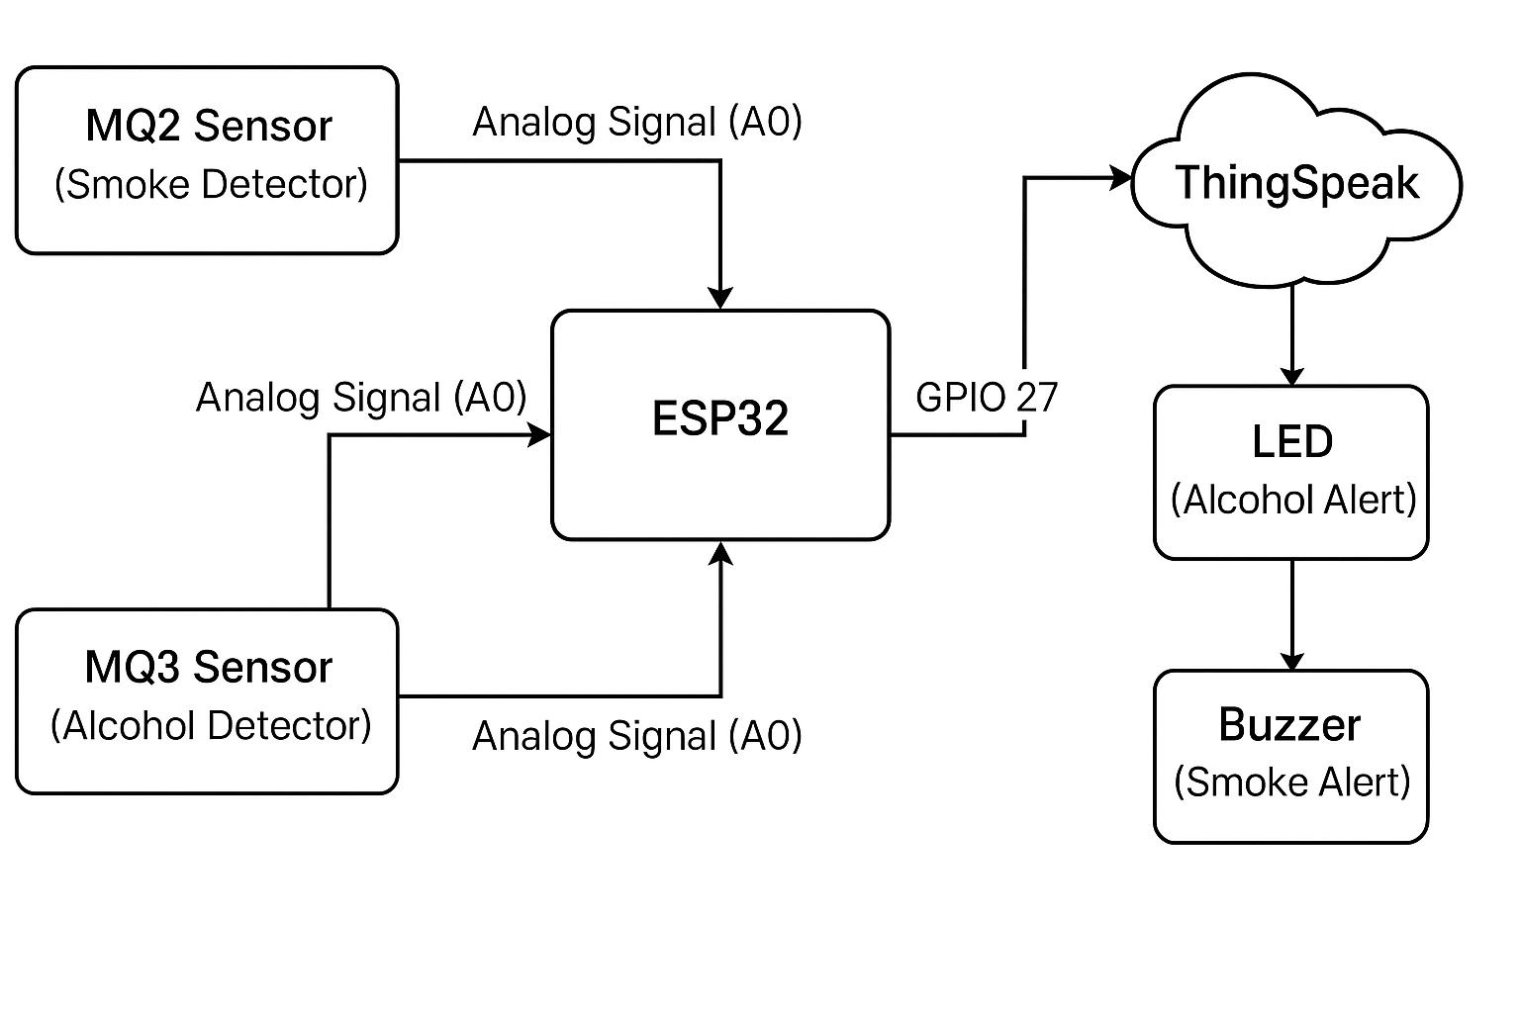

CODE
#include <WiFi.h>
#include <HTTPClient.h>
const char* ssid = "Your_SSID"; // your WiFi name
const char* password = "Your_PASSWORD"; // your WiFi password
const char* serverName = "http://api.thingspeak.com/update";
String THINGSPEAK_API_KEY = "YOUR_THINGSPEAK_WRITE_API_KEY"; // from ThingSpeak
// Sensor & actuator pins
#define MQ2_PIN 34; // MQ2 -> Smoke
#define MQ3_PIN 35; // MQ3 -> Alcohol
#define LED_PIN 27; // LED for Alcohol
#define BUZZER_PIN 26; // Buzzer for Smoke
// Baseline + filter
float mq2Base = 0;
float mq3Base = 0;
const float alpha = 0.95; // smoothing factor (0.90–0.98)
// Margins (tune these if needed)
const int SMOKE_MARGIN = 250;
const int ALCOHOL_MARGIN = 250;
// ThingSpeak rate limit: min 15 sec between updates
unsigned long lastTSUpdate = 0;
const unsigned long tsInterval = 15000; // 15,000 ms = 15 sec
void setup() {
Serial.begin(115200);
pinMode(LED_PIN, OUTPUT);
pinMode(BUZZER_PIN, OUTPUT);
// Initial baseline
mq2Base = analogRead(MQ2_PIN);
mq3Base = analogRead(MQ3_PIN);
// --- WiFi connect ---
Serial.println();
Serial.println("Connecting to WiFi...");
WiFi.begin(ssid, password);
while (WiFi.status() != WL_CONNECTED) {
delay(500);
Serial.print(".");
}
Serial.println();
Serial.println("WiFi connected!");
Serial.print("IP address: ");
Serial.println(WiFi.localIP());
}
void loop() {
// Read sensors
int mq2Value = analogRead(MQ2_PIN);
int mq3Value = analogRead(MQ3_PIN);
// Moving baseline
mq2Base = alpha * mq2Base + (1 - alpha) * mq2Value;
mq3Base = alpha * mq3Base + (1 - alpha) * mq3Value;
// Detection logic
bool smokeHigh = mq2Value > mq2Base + SMOKE_MARGIN;
bool alcoholHigh = mq3Value > mq3Base + ALCOHOL_MARGIN;
// Actuators
digitalWrite(LED_PIN, alcoholHigh ? HIGH : LOW);
digitalWrite(BUZZER_PIN, smokeHigh ? HIGH : LOW);
// Debug prints
Serial.print("MQ2: "); Serial.print(mq2Value);
Serial.print(" | MQ3: "); Serial.print(mq3Value);
Serial.print(" | MQ2 Base: "); Serial.print(mq2Base);
Serial.print(" | MQ3 Base: "); Serial.print(mq3Base);
Serial.print(" | SmokeHigh: "); Serial.print(smokeHigh);
Serial.print(" | AlcoholHigh: "); Serial.println(alcoholHigh);
// --- Send to ThingSpeak every 15 seconds ---
if (WiFi.status() == WL_CONNECTED) {
unsigned long currentMillis = millis();
if (currentMillis - lastTSUpdate >= tsInterval) {
lastTSUpdate = currentMillis;
HTTPClient http;
// Build URL: api.thingspeak.com/update?api_key=...&field1=...&field2=...
String url = String(serverName) +
"?api_key=" + THINGSPEAK_API_KEY +
"&field1=" + String(mq2Value) +
"&field2=" + String(mq3Value);
Serial.print("Sending to ThingSpeak: ");
Serial.println(url);
http.begin(url);
int httpResponseCode = http.GET();
if (httpResponseCode > 0) {
Serial.print("ThingSpeak response code: ");
Serial.println(httpResponseCode);
} else {
Serial.print("Error sending data: ");
Serial.println(http.errorToString(httpResponseCode));
}
http.end();
}
} else {
Serial.println("WiFi disconnected! Trying to reconnect...");
WiFi.reconnect();
}
delay(200); // sensor loop delay
}

PRECAUTIONS
- Allow MQ sensors to preheat for stable readings
- Avoid exposing sensors to liquids
- Maintain WiFi strength for stable ThingSpeak updates
- Prevent sensor exposure to flames

RESULTS AND DISCUSSION
MQ2 and MQ3 responded accurately during testing. ThingSpeak successfully visualized real-time data. LED and buzzer alerts activated correctly based on threshold conditions. WiFi reconnection function ensured stable data transmission.

CONCLUSION
The system successfully detects smoke and alcohol using ESP32 and gas sensors. Real-time cloud monitoring is achieved via ThingSpeak. This project demonstrates IoT’s role in safety automation and can be expanded for industrial and vehicle applications.

