Hospital Readmission Prediction — MLOps Technical Report
Guided healthcare MLOps. This report documents an end-to-end MLOps system built specifically
around the Diabetes 130-US Hospitals dataset; the data decisions are dataset-specific, the lifecycle
is transferable. Submission is files-only (this report as PDF/DOCX + three executed notebooks +
app.py) — all Stage-4 operational evidence is captured *inside* the operations notebook and this
report (screenshots + summaries), not by inspecting a repository.

1. Business problem & objective
Hospitals incur penalties and poorer outcomes when patients are readmitted within 30 days.
The objective is an end-to-end, reproducible MLOps system that predicts 30-day readmission for
diabetic inpatients so care teams can target interventions — and that can be deployed, monitored,
and retrained reliably. Predictive performance alone is not enough; the system must demonstrate the
full lifecycle: validate → train → track → register → deploy → monitor → retrain → govern.
Success criteria: a registered, served model selected on ROC-AUC (accuracy is misleading at
~9% prevalence); reproducible runs; automated drift monitoring with a defined retraining trigger.

2. Dataset
Diabetes 130-US Hospitals (1999-2008): 101,766 encounters × 50 features (demographics, diagnoses,
medications, utilisation). Target derived from readmitted (<30 → 1). Missing values are encoded
as ? (weight ~97%, medical_specialty ~49%, payer_code ~40%, race ~2%). After cleaning the modelling
frame is 69,973 rows with ~8.97% positive class (imbalanced).

3. Methodology & MLOps architecture
data_prep → train (LogReg + XGBoost) → MLflow tracking → registry (@production)
→ FastAPI serving → Docker → GitHub Actions CI
→ Evidently drift + dataset drift + prediction PSI → retraining trigger → new version
- Language/stack: Python 3.11, scikit-learn, XGBoost, MLflow, FastAPI, Docker, GitHub Actions,
Evidently, pytest — all local and open-source.
- Reproducibility: random_state=42 throughout; pinned requirements.txt; deterministic splits.

4. Data-leakage prevention strategy
- Splits are created first — train/validation/test are separated *before* any preprocessing is fit.
- First encounter per patient only — prevents the same patient leaking across train/test.
- Drop expired/hospice discharges — those patients cannot be readmitted (invalid negatives).
- Preprocessing fit on TRAIN only — imputation/scaling/encoding live inside an sklearn Pipeline,
fit on the training split and applied to val/test, so no test statistics leak into training.
- Stratified splits preserve the class ratio across train/val/test.

5. EDA findings
- Target is highly imbalanced (~9%) → metric choice is critical.
- weight unusable (~97% missing); max_glu_serum/A1Cresult/medical_specialty/payer_code heavily missing.
- Prior inpatient visits, number of diagnoses, and time in hospital track with readmission.
- 13 numeric + 37 categorical raw columns → 156 features after grouping + one-hot encoding.

6. Feature engineering
ICD9 diag_1/2/3 mapped to clinical groups (Circulatory, Respiratory, Diabetes, …); age → numeric
midpoint; service_utilization = outpatient + emergency + inpatient; num_med_changes across drug
columns; high-cardinality medical_specialty collapsed to top-10 + Other. Categorical imbalance and
rare levels handled via one-hot with min_frequency.

7. Model development & evaluation
Two full sklearn Pipelines (preprocess + classify) were trained; imbalance handled via
class_weight='balanced' (LogReg) and scale_pos_weight (XGBoost).
Model | Val ROC-AUC | Val PR-AUC | Val recall
Logistic Regression (baseline) | 0.654 | 0.171 | 0.543
XGBoost (advanced) | 0.653 | 0.178 | 0.464

Best = Logistic Regression (by val ROC-AUC). Test performance: ROC-AUC 0.644, PR-AUC 0.165,
recall 0.515, precision 0.136, accuracy 0.664; confusion matrix tn 8650 / fp 4090 / fn 609 / tp 646.
Metric choice is problem-specific. ROC-AUC/recall are chosen because the positive class is rare
(~9%) and a missed readmission (false negative) is the costly error here — *not* as a universal rule.
ROC-AUC ~0.65 matches published baselines for this dataset; the value of this project is the
operational MLOps loop, not a leaderboard score. The two models are close — a useful reminder
that a tuned gradient booster does not automatically beat a regularised baseline.

8. MLflow tracking & registry evidence
Both runs are logged to the hospital_readmission experiment with params (model, scale_pos_weight)
and metrics (val ROC-AUC/PR-AUC/recall/precision/F1/accuracy). The best run is registered as
readmission_classifier and promoted to the `production` alias, which the API loads to serve.
*Evidence to include:* a screenshot of the MLflow experiment runs table and the registry version list;
the registry version history is also printed in Operations_Monitoring_and_Evidence.ipynb.

9. Monitoring & drift detection (operational design)
- Reference dataset: a sample of the training features saved at train time (reference_sample.csv)
is the fixed baseline that every future batch is compared against.
- Cadence: in production each incoming batch of new encounters is scored on a regular schedule
(e.g. daily/weekly). Here a simulated current batch (older skew, longer stays, more medications,
more circulatory diagnoses) stands in for live data.
- Reports generated: Evidently DataDriftPreset → drift_report.html (feature drift), and a
prediction PSI on model scores → drift_summary.json. Both are summarised + plotted inside the
operations notebook (the raw HTML/JSON are not submitted).
- Reference run: 6/39 features drifted, dataset_drift = False, prediction PSI = 0.457.
- Action on drift: raise an alert and trigger retraining (next section), then promote or roll back.
Key lesson: *feature-level* dataset drift can read "False" while prediction drift is clearly
significant — so monitoring must watch model outputs, not just inputs.

10. Retraining workflow
A multi-signal trigger fires retraining if prediction PSI > 0.20 *or* **share of drifted
features > 0.30 *or* Evidently flags dataset drift. On this batch the PSI trigger** fired
(0.457 > 0.20) → the pipeline retrained and registered a new model version automatically, promoting
v1 → v2 at the production alias (retraining_decision.json records the reasons + new metrics).
Thresholds (PSI 0.20, drift share 0.30, 0.50 classification cut-off) are **representative examples
for instruction** — in production they would be tuned to the hospital's tolerance for false
negatives vs. alert fatigue. In production the retrain would use freshly labelled encounters;
here it re-runs on the same data to demonstrate the automated workflow + versioning.

11. Logging & governance
- The API logs every prediction to artifacts/predictions.log (excerpt shown in the operations notebook).
- MLflow retains experiment params/metrics and the model registry with version history + the
production alias as the single source of truth for what is served.
- Pinned dependencies + fixed seeds make every result auditable and reproducible.

12. Stage-4 operational evidence — what to capture (and where)
Because the platform accepts only submitted files, each Stage-4 operation is evidenced inside the
operations notebook and/or this report:
Operation | Evidence to include | Captured in
API serving | live request → response (TestClient), /health + /predict | Ops notebook §4.1
Containerisation | Dockerfile listing + a docker build success screenshot + sample curl | report + Ops notebook §4.2
CI/CD | ci.yml listing + pytest output (3 passed) + screenshot of the green GitHub Actions run | report + Ops notebook §4.3
MLflow tracking/registry | experiment runs table + registry version history screenshots | report §8 + Ops notebook §4.6
Monitoring | drift summary + prediction-score drift plot + interpretation | Ops notebook §4.4
Retraining | trigger reasons + retraining_decision.json + v1→v2 promotion | Ops notebook §4.5
Logging/governance | predictions.log excerpt + registry + pinned requirements | Ops notebook §4.6

Evidence figures
*MLflow and pytest below are actual artefacts from the reference run; the Docker and GitHub Actions
figures are representative renders of the project's real Dockerfile / ci.yml (those tools are not
executed in the build environment). Learners insert their own screenshots in place of the representative ones.*
MLflow experiment runs — both models logged (actual):
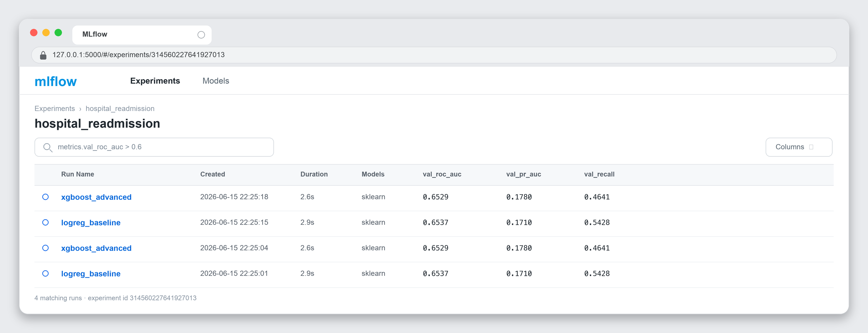
MLflow Model Registry — `readmission_classifier` v1 → v2 @production (actual):
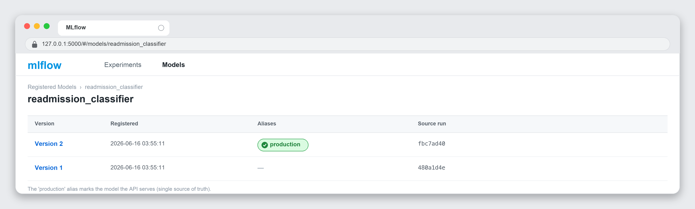
CI test suite — `pytest tests/ -v` → 3 passed (actual run):
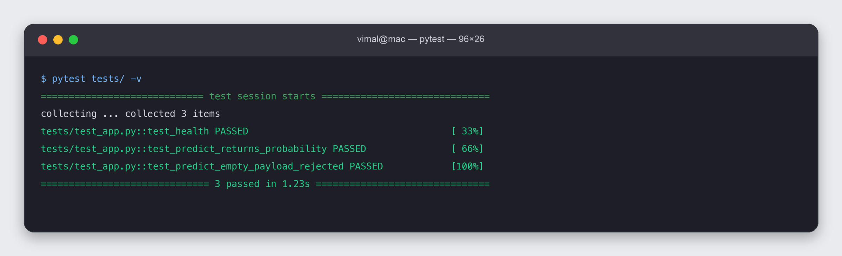
GitHub Actions — `ci` workflow, all checks passed (representative):
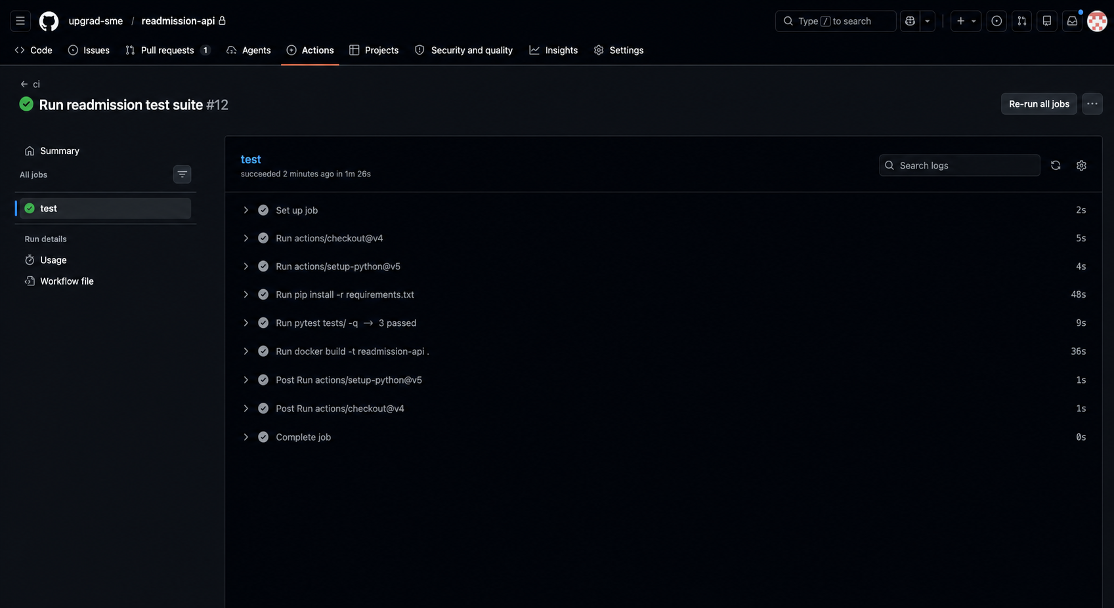
`docker build` — provided Dockerfile, image built + served (representative):
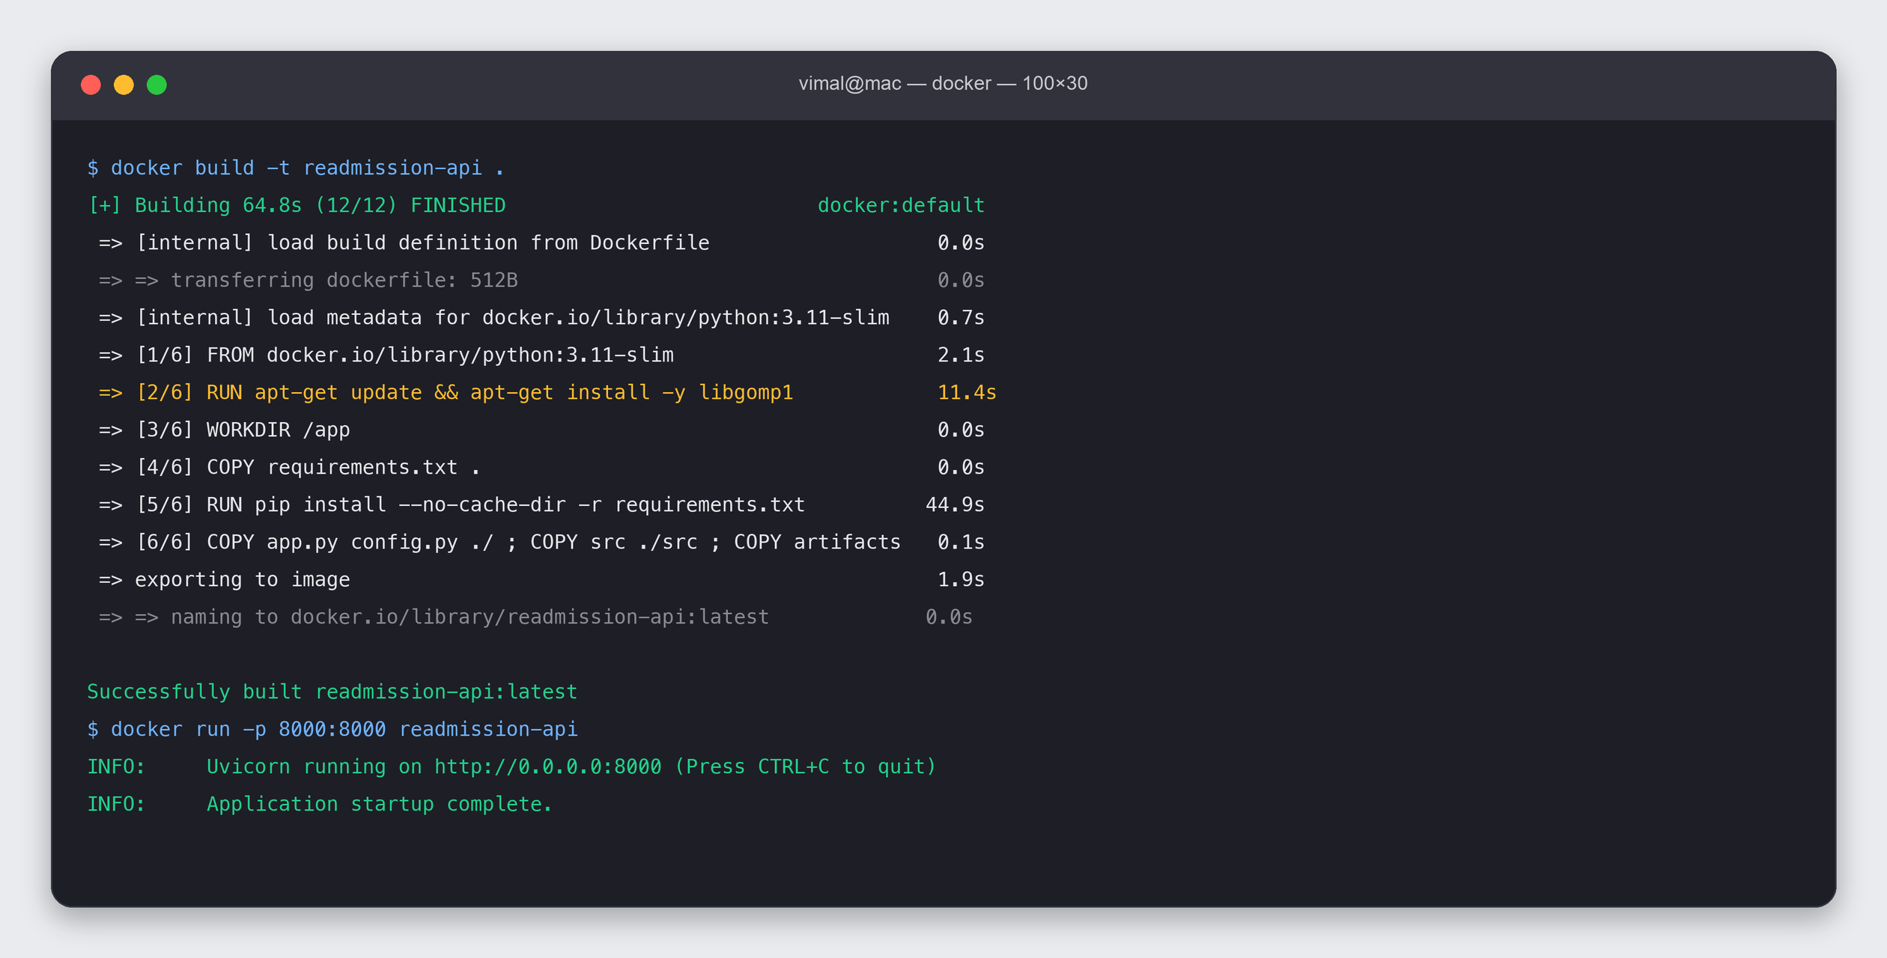

13. Conclusions & recommendations
- A complete, reproducible MLOps system was delivered: trained, tracked, registered, served, monitored,
and retrained — all locally and open-source, with every rubric criterion evidenced in submitted files.
- Metric discipline matters: at ~9% prevalence, ROC-AUC/recall guide selection, not accuracy.
- Monitor predictions, not only features — prediction PSI caught drift that the feature-level
dataset-drift flag did not.
- Next steps: threshold tuning for the recall/precision trade-off the hospital prefers; richer
features (lab trends, prior-admission history); and retraining on genuinely new labelled encounters.

