**VISVESVARAYA TECHNOLOGICAL UNIVERSITY**

**“JnanaSangama”, Belgaum -590014, Karnataka.**



**LAB REPORT**

**on**

**BIG DATA ANALYTICS**

**(20CS6PEBDA)**

***Submitted by***

**S SHREE LAKSHMI (1BM19CS136)**

***in partial fulfillment for the award of the degree of***

**BACHELOR OF ENGINEERING**

***in***

**COMPUTER SCIENCE AND ENGINEERING**



**B.M.S. COLLEGE OF ENGINEERING**

**(Autonomous Institution under VTU)**

**BENGALURU-560019**

**May-2022 to July-2022**

**B. M. S. College of Engineering,**

**Bull Temple Road, Bangalore 560019**

(Affiliated To Visvesvaraya Technological University, Belgaum)

**Department of Computer Science and Engineering**



**CERTIFICATE**

This is to certify that the Lab work entitled “**BIG DATA ANALYTICS**” was carried out by **S SHREE LAKSHMI (1BM19CS136),** who is bona fide student of **B. M. S. College of Engineering.** It is in partial fulfillment for the award of **Bachelor of Engineering in Computer Science and Engineering** of the Visvesvaraya Technological University, Belgaum during the year 2022. The Lab report has been approved as it satisfies the academic requirements in respect of the course **BIG DATA ANALYTICS (20CS6PEBDA)** work prescribed for the said degree.

Name of the Lab-In charge               **ANTARA ROY CHOUDHURY**

Designation Assistant Professor

Department of CSE Department of CSE

BMSCE, Bengaluru BMSCE, Bengaluru

`

**Index Sheet**

|  |  |  |
| --- | --- | --- |
| **Sl. No.** | **Experiment Title** | **Page No.** |
| **1.** | **Cassandra Lab Program 1: -** Create a Data set either structured/Semi-Structured/Unstructured from Twitter/Facebook etc. to perform various DB operations using Cassandra. (Use the Face Pager app to perform real-time streaming) | **4** |
| **2.** | **Cassandra Lab Program 2: -** Create a Data set either structured/Semi-Structured/Unstructured from Twitter/Facebook etc. to perform various DB operations using Cassandra. (Use the Face Pager app to perform real-time streaming) | **7** |
| **3.** | **MongoDB Lab Program 1 (CRUD Demonstration): -** Students should be classifying a dataset into one of the standard forms and apply suitable querying rules to obtain suitable results | **13** |
| **4.** | **MongoDB Lab Program 2 (CRUD Demonstration): -** Students should be classifying a dataset into one of the standard forms and apply suitable querying rules to obtain suitable results | **24** |

**Course Outcome**

|  |  |
| --- | --- |
| CO1 | Apply the concept of NoSQL, Hadoop or Spark for a given task |
| CO2 | Analyze the Big Data and obtain insight using data analytics mechanisms. |
| CO3 | Design and implement Big data applications by applying NoSQL, Hadoop or Spark |

**Cassandra Lab Program 1: -**

Perform the following DB operations using Cassandra.

1. Create a key space by name Employee

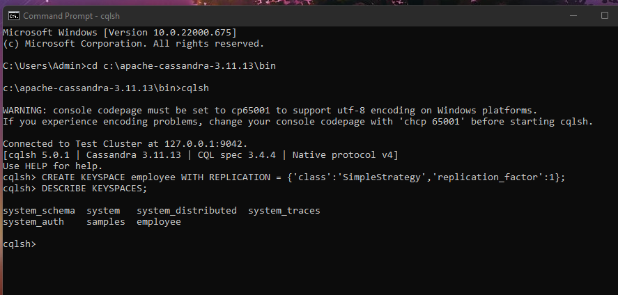

2. Create a column family by name Employee-Info with attributes Emp_Id Primary Key, Emp_Name,

Designation, Date_of_Joining, Salary, Dept_Name

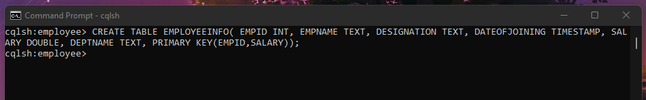

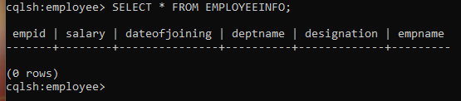

3. Insert the values into the table in batch

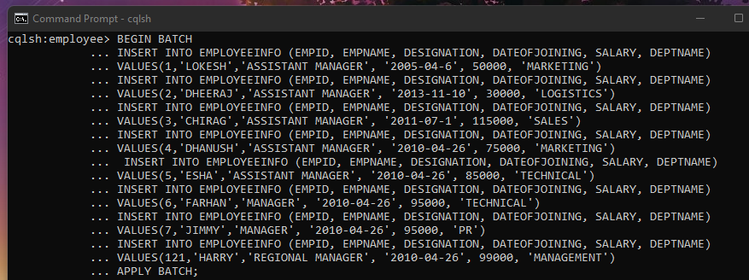

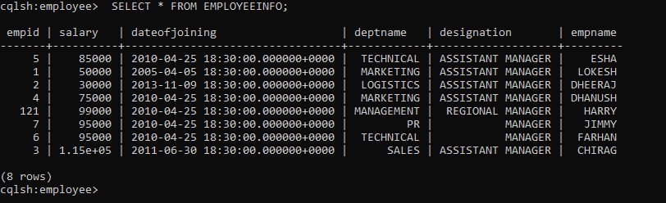

4. Update Employee name and Department of Emp-Id 121

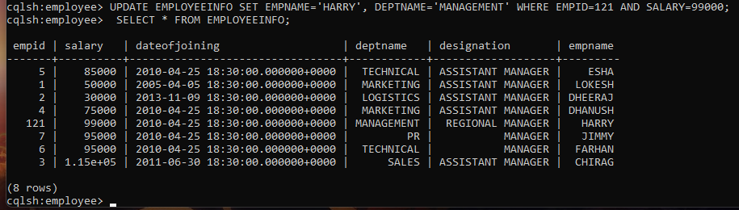

5. Sort the details of Employee records based on salary (Note:- cql>PAGING OFF)

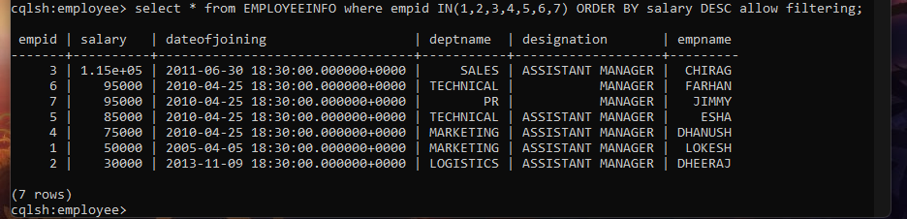

6. Alter the schema of the table Employee_Info to add a column Projects which stores a set

of Projects done by the corresponding Employee.

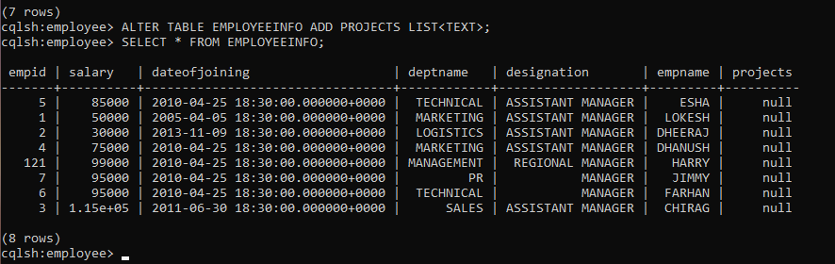

7. Update the altered table to add project names.

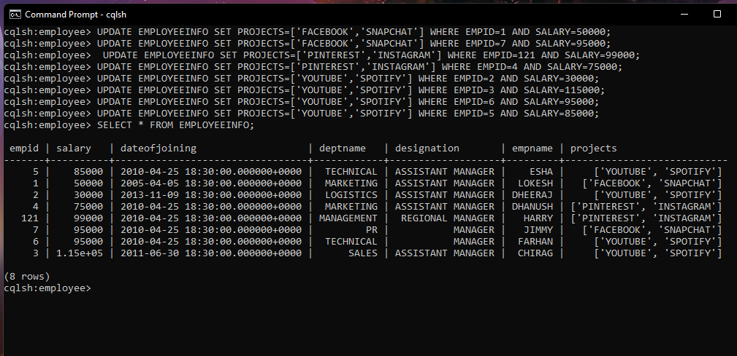

8. Create a TTL of 15 seconds to display the values of Employees.

//BEFORE 15 seconds

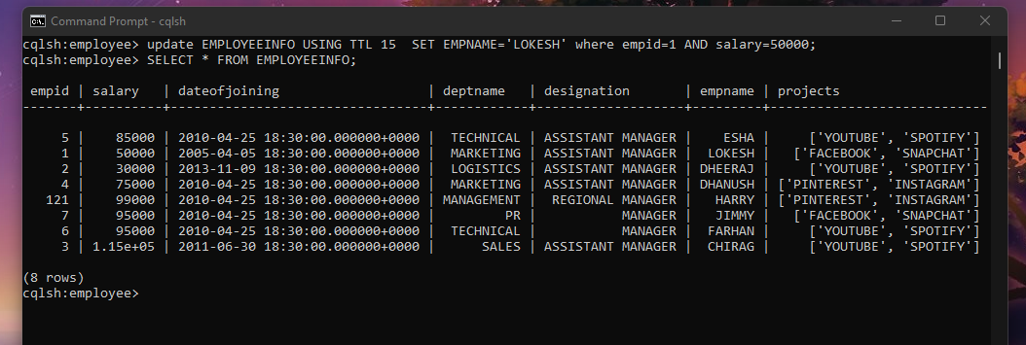

**Cassandra Lab Program 2: -**

Perform the following DB operations using Cassandra.

1.Create a key space by name Library

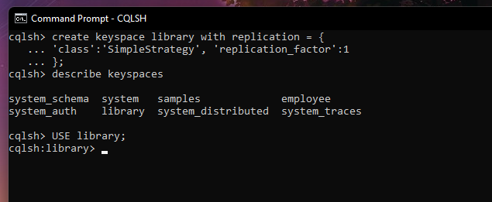

2. Create a column family by name Library-Info with attributes Stud_Id Primary Key,

Counter_value of type Counter,

Stud_Name, Book-Name, Book-Id, Date_of_issue

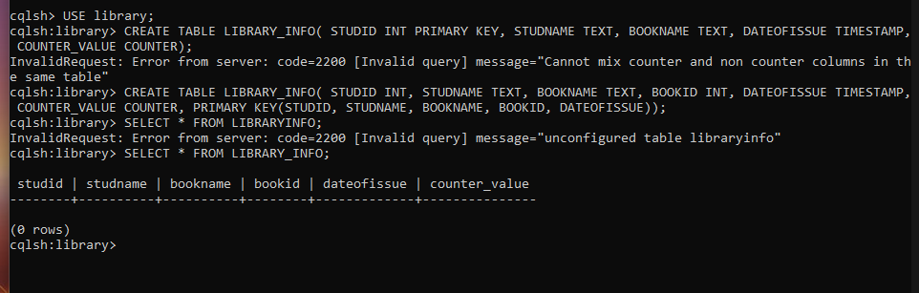

3.Insert the values into the table in batch

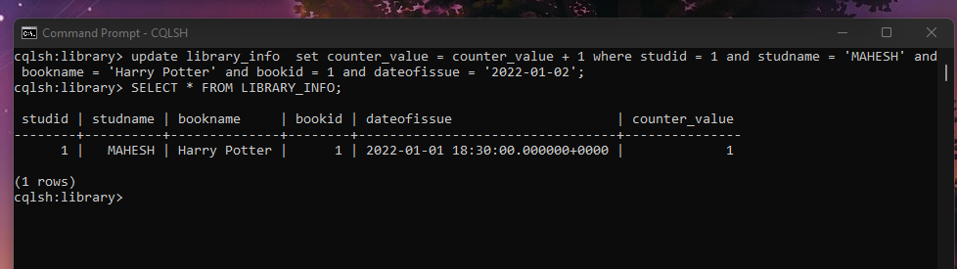

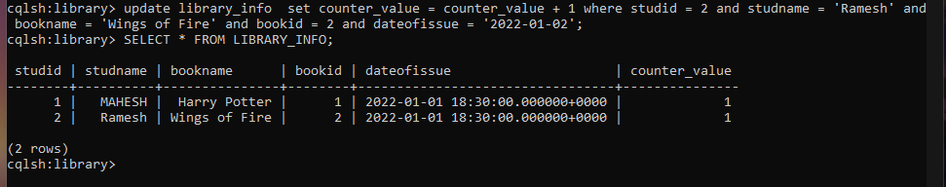

4. Display the details of the table created and increase the value of the counter

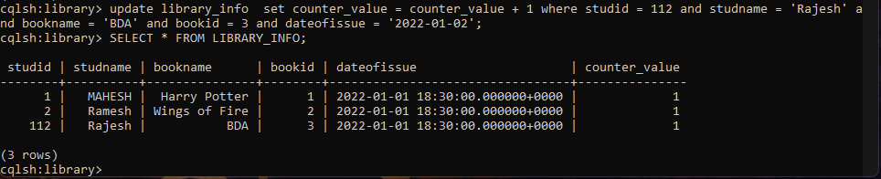

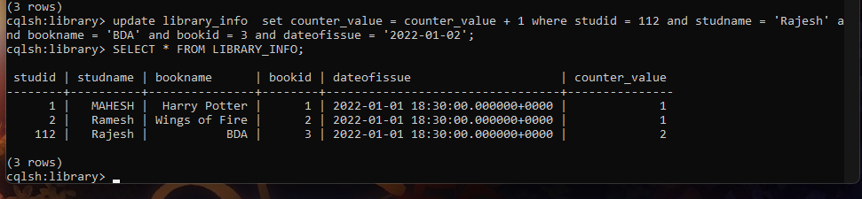

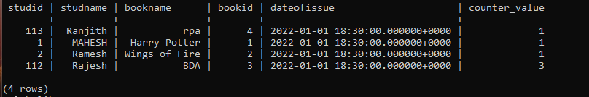

5. Write a query to show that a student with id 112 has taken a book “BDA” 3 times.

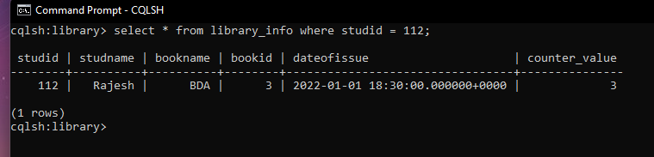

6. Export the created column to a csv file

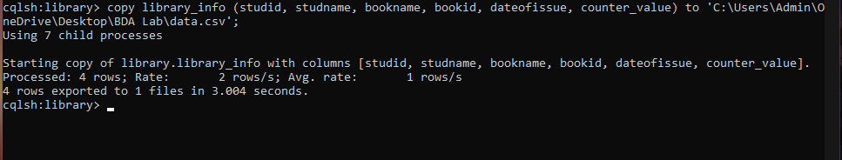

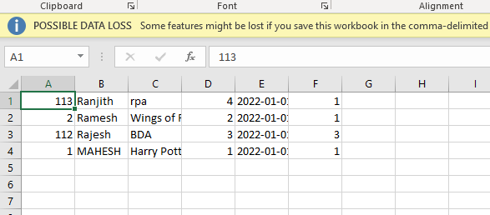

7. Import a given csv dataset from local file system into Cassandra column family

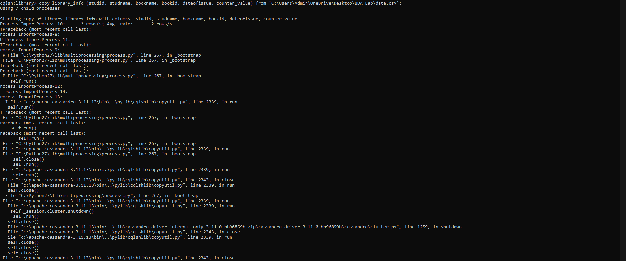

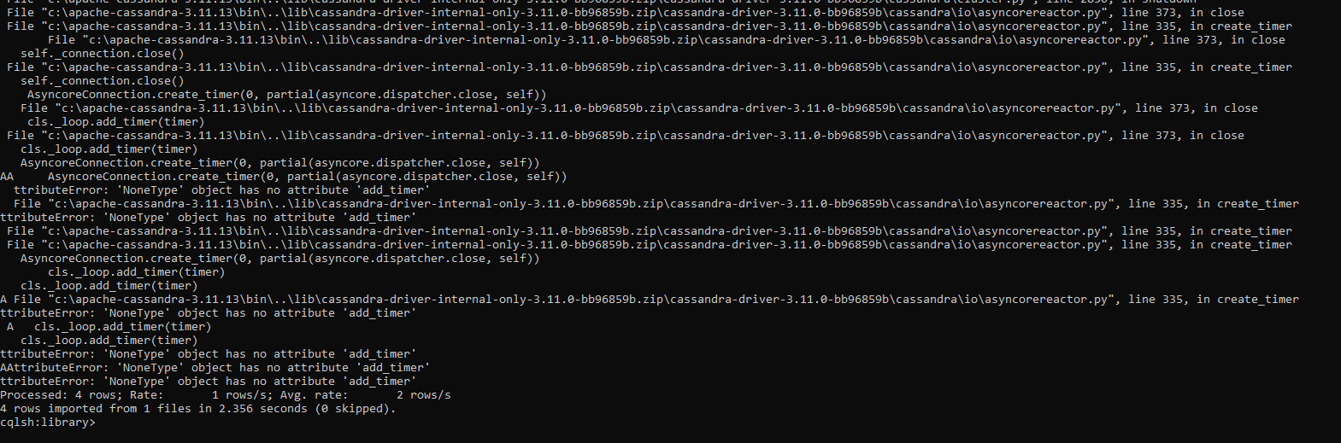

**MongoDB Lab Program 1 (CRUD Demonstration): -**

Execute the queries and upload a document with output.

I. CREATE DATABASE IN MONGODB.

use myDB;

db; (Confirm the existence of your database)

show dbs; (To list all databases) 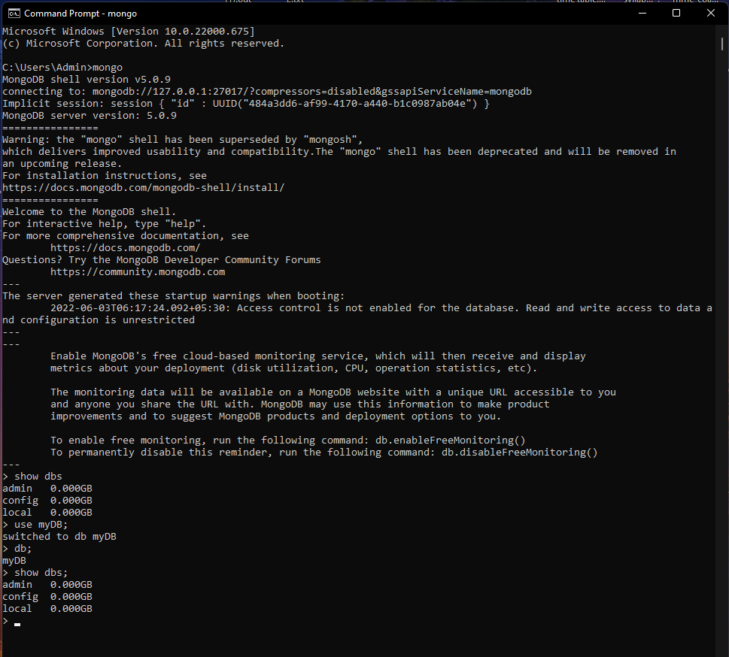

II.CRUD (CREATE, READ, UPDATE, DELETE) OPERATIONS

1. To create a collection by the name “Student”. Let us take a look at the collection list

prior to the creation of the new collection “Student”.

db.createCollection(“Student”); =&gt; sql equivalent CREATE TABLE STUDENT(…);

2. To drop a collection by the name “Student”.

db.Student.drop();

3. Create a collection by the name “Students” and store the following data in it.

db.Student.insert({_id:1,StudName:&quot;MichelleJacintha&quot;,Grade:&quot;VII&quot;,Hobbies:&quot;InternetS

urfing&quot;});

4. Insert the document for “AryanDavid” in to the Students collection only if it does not

already exist in the collection. However, if it is already present in the collection, then

update the document with new values. (Update his Hobbies from “Skating” to “Chess”.

) Use “Update else insert” (if there is an existing document, it will attempt to update it,

if there is no existing document then it will insert it).

db.Student.update({_id:3,StudName:&quot;AryanDavid&quot;,Grade:&quot;VII&quot;},{$set:{Hobbies:&quot;Skatin

g&quot;}},{upsert:true});

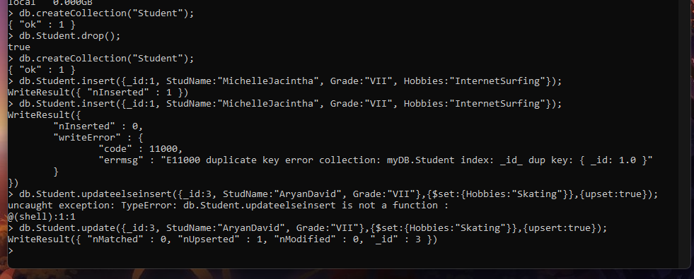

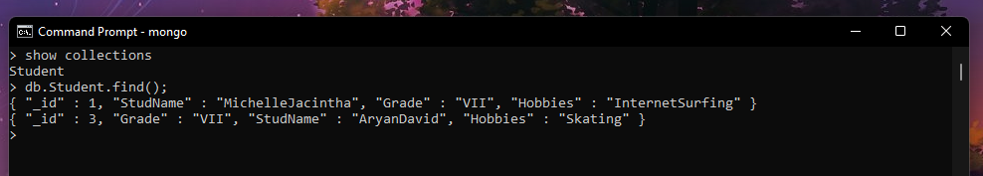

5. FIND METHOD

A. To search for documents from the “Students” collection based on certain search

criteria.

db.Student.find({StudName:&quot;Aryan David&quot;});

({cond..},{columns.. column:1, columnname:0} )



B. To display only the StudName and Grade from all the documents of the Students

collection. The identifier_id should be suppressed and NOT displayed.

db.Student.find({},{StudName:1,Grade:1,_id:0});

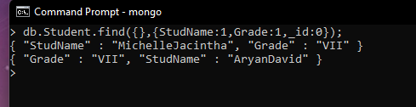

C. To find those documents where the Grade is set to ‘VII’

db.Student.find({Grade:{$eq:&#39;VII&#39;}}).pretty();

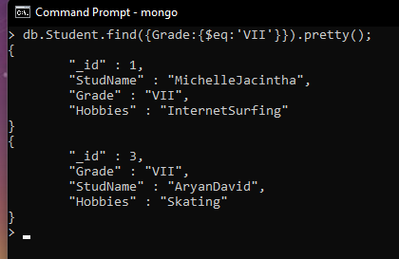

D. To find those documents from the Students collection where the Hobbies is set to

either ‘Chess’ or is set to ‘Skating’.

db.Student.find({Hobbies :{ $in: [&#39;Chess&#39;,&#39;Skating&#39;]}}).pretty ();

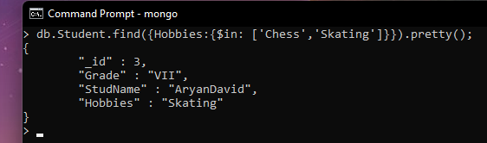

E. To find documents from the Students collection where the StudName begins with “M”.

db.Student.find({StudName:/^M/}).pretty();

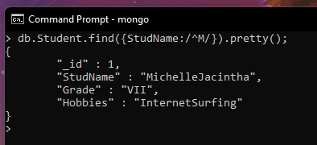

F. To find documents from the Students collection where the StudNamehas an “e” in any

position.

db.Student.find({StudName:/e/}).pretty();

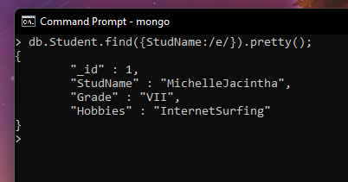

G. To find the number of documents in the Students collection.

db.Student.count();

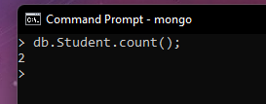

H. To sort the documents from the Students collection in the descending order of

StudName.

db.Student.find().sort({StudName:-1}).pretty();

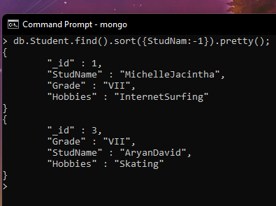

III. Import data from a CSV file

Given a CSV file “sample.txt” in the D:drive, import the file into the MongoDB

collection, “SampleJSON”. The collection is in the database “test”.

mongoimport --db Student --collection airlines --type csv –headerline --file

/home/hduser/Desktop/airline.csv

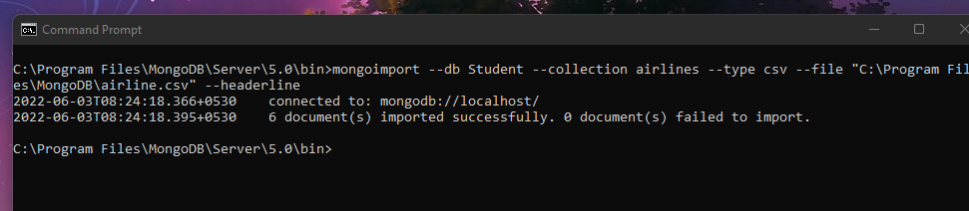

IV. Export data to a CSV file

This command used at the command prompt exports MongoDB JSON documents from

“Customers” collection in the “test” database into a CSV file “Output.txt” in the D:drive.

mongoexport --host localhost --db Student --collection airlines --csv --out

/home/hduser/Desktop/output.txt –fields “Year”,”Quarter”

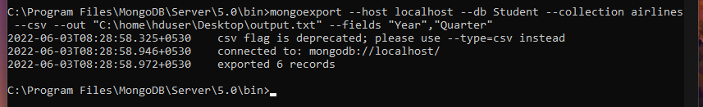

V. Save Method :

Save() method will insert a new document, if the document with the _id does not

exist. If it exists it will replace the exisiting document.

db.Students.save({StudName:”Vamsi”, Grade:”VI”})

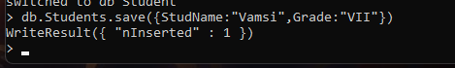

VI. Add a new field to existing Document:

db.Students.update({_id:4},{$set:{Location:”Network”}})

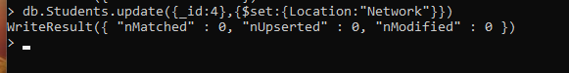

VII. Remove the field in an existing Document

db.Students.update({_id:4},{$unset:{Location:”Network”}})

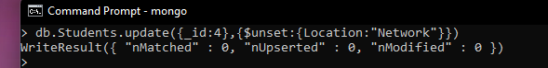

VIII. Finding Document based on search criteria suppressing few fields

db.Student.find({_id:1},{StudName:1,Grade:1,_id:0});

To find those documents where the Grade is not set to ‘VII’

db.Student.find({Grade:{$ne:&#39;VII&#39;}}).pretty();

To find documents from the Students collection where the StudName ends with s.

db.Student.find({StudName:/s$/}).pretty();



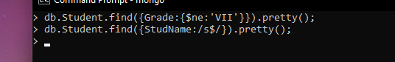

IX. to set a particular field value to NULL

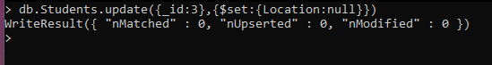

X Count the number of documents in Student Collections



XI. Count the number of documents in Student Collections with grade :VII

db.Students.count({Grade:”VII”})

retrieve first 3 documents

db.Students.find({Grade:”VII”}).limit(3).pretty();

Sort the document in Ascending order

db.Students.find().sort({StudName:1}).pretty();

Note:

for desending order : db.Students.find().sort({StudName:-1}).pretty();

to Skip the 1 st two documents from the Students Collections

db.Students.find().skip(2).pretty()

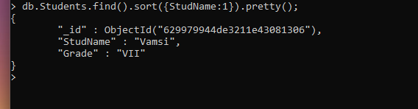

XII. Create a collection by name “food” and add to each document add a “fruits” array

db.food.insert( { _id:1, fruits:[&#39;grapes&#39;,&#39;mango&#39;,&#39;apple&#39;] } )

db.food.insert( { _id:2, fruits:[&#39;grapes&#39;,&#39;mango&#39;,&#39;cherry&#39;] } )

db.food.insert( { _id:3, fruits:[&#39;banana&#39;,&#39;mango&#39;] } )

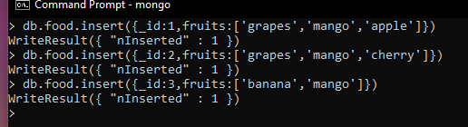

To find those documents from the “food” collection which has the “fruits array”

constitute of “grapes”, “mango” and “apple”.

db.food.find ( {fruits: [&#39;grapes&#39;,&#39;mango&#39;,&#39;apple&#39;] } ). pretty().



To find in “fruits” array having “mango” in the first index position.

db.food.find ( {&#39;fruits.1&#39;:&#39;grapes&#39;} )



To find those documents from the “food” collection where the size of the array is two.

db.food.find ( {“fruits”: {$size:2}} )

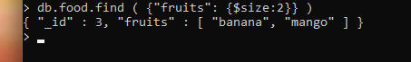

To find the document with a particular id and display the first two elements from the

array “fruits”

db.food.find({_id:1},{“fruits”:{$slice:2}})



To find all the documets from the food collection which have elements mango and

grapes in the array “fruits”

db.food.find({fruits:{$all:[“mango”,”grapes”]}})

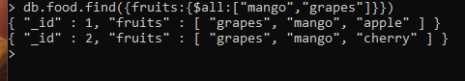

update on Array:

using particular id replace the element present in the 1 st index position of the fruits

array with apple

db.food.update({_id:3},{$set:{&#39;fruits.1&#39;:&#39;apple&#39;}})

insert new key value pairs in the fruits array

db.food.update({_id:2},{$push:{price:{grapes:80,mango:200,cherry:100}}})

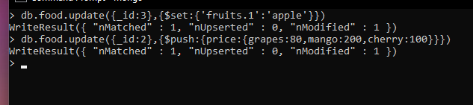

Note: perform query operations using - pop, addToSet, pullAll and pull

XII. Aggregate Function :

Create a collection Customers with fields custID, AcctBal, AcctType.

Now group on “custID” and compute the sum of “AccBal”.

db.Customers.aggregate ( {$group : { _id : “$custID”,TotAccBal : {$sum:”$AccBal”} } } );

match on AcctType:”S” then group on “CustID” and compute the sum of “AccBal”.

db.Customers.aggregate ( {$match:{AcctType:”S”}},{$group : { _id : “$custID”,TotAccBal :

{$sum:”$AccBal”} } } );

match on AcctType:”S” then group on “CustID” and compute the sum of “AccBal” and

total balance greater than 1200.

db.Customers.aggregate ( {$match:{AcctType:”S”}},{$group : { _id : “$custID”,TotAccBal :

{$sum:”$AccBal”} } }, {$match:{TotAccBal:{$gt:1200}}});

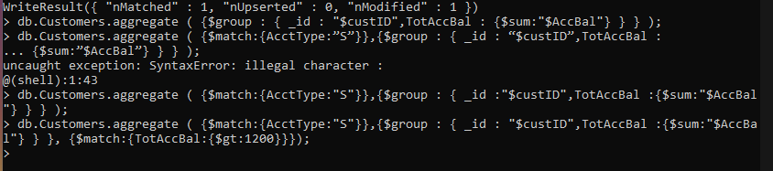

**MongoDB Lab Program 2 (CRUD Demonstration): -**

1) Using MongoDB

1. Create a database for Students and Create a Student Collection (_id,Name, USN, Semester, Dept_Name, CGPA, Hobbies(Set)).
2. Insert required documents to the collection.
3. First Filter on “Dept_Name:CSE” and then group it on “Semester” and

compute the Average CPGA for that semester and flter those documents where the “Avg_CPGA” is greater than 7.5.

1. Command used to export MongoDB JSON documents from “Student” Collection into the “Students” database into a CSV fle “Output.txt”.

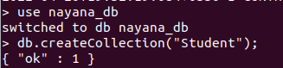

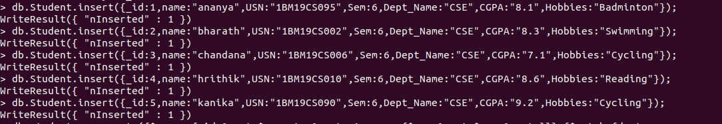

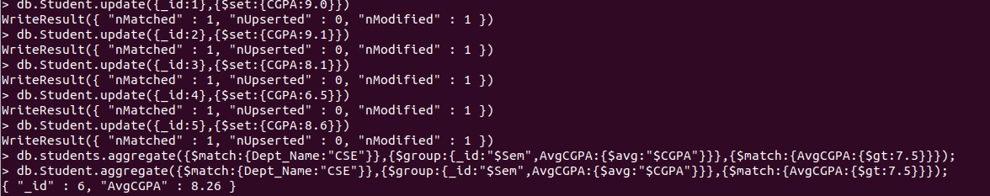

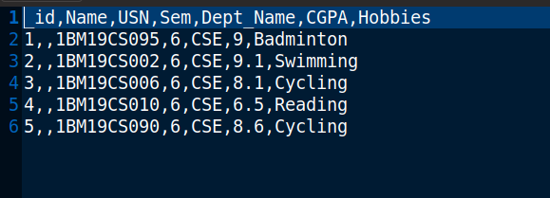

2)Create a mongodb collection Bank. Demonstrate the following by choosing felds of your choice.

1. Insert three documents
2. Use Arrays(Use Pull and Pop operation)
3. Use Index
4. Use Cursors
5. Updation

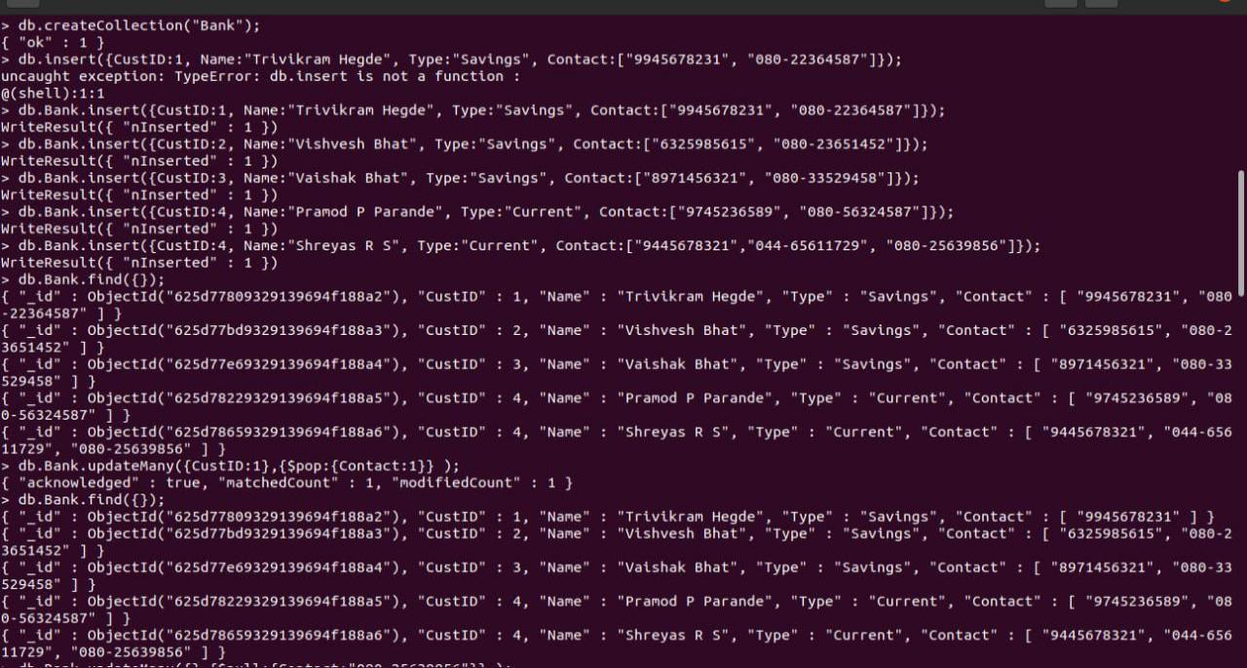

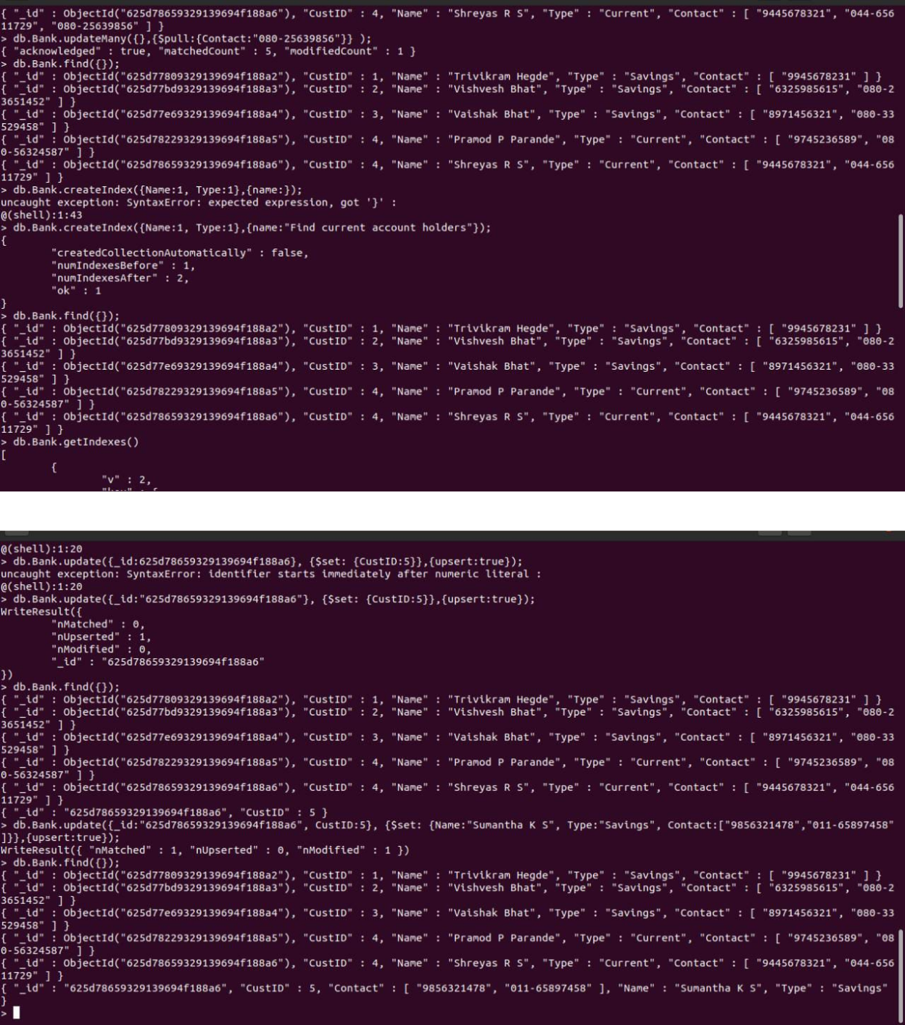

1) Using MongoDB,

1. Create a database for Faculty and Create a Faculty Collection(Faculty_id, Name, Designation ,Department, Age, Salary, Specialization(Set)).
2. Insert required documents to the collection.
3. First Filter on “Dept_Name:MECH” and then group it on “Designation” and

compute the Average Salary for that Designation and flter those documents where the “Avg_Sal” is greater than 650000. iv) Demonstrate usage of import and export commands

Write MongoDB queries for the following:

1)To display only the product name from all the documents of the product collection.

2)To display only the Product ID, ExpiryDate as well as the quantity from the document of the product collection where the _id column is 1.

3)To fnd those documents where the price is not set to 15000.

4)To fnd those documents from the Product collection where the quantity is set to 9 and the product name is set to ‘monitor’.

5)To fnd documents from the Product collection where the Product name ends in ‘d’.

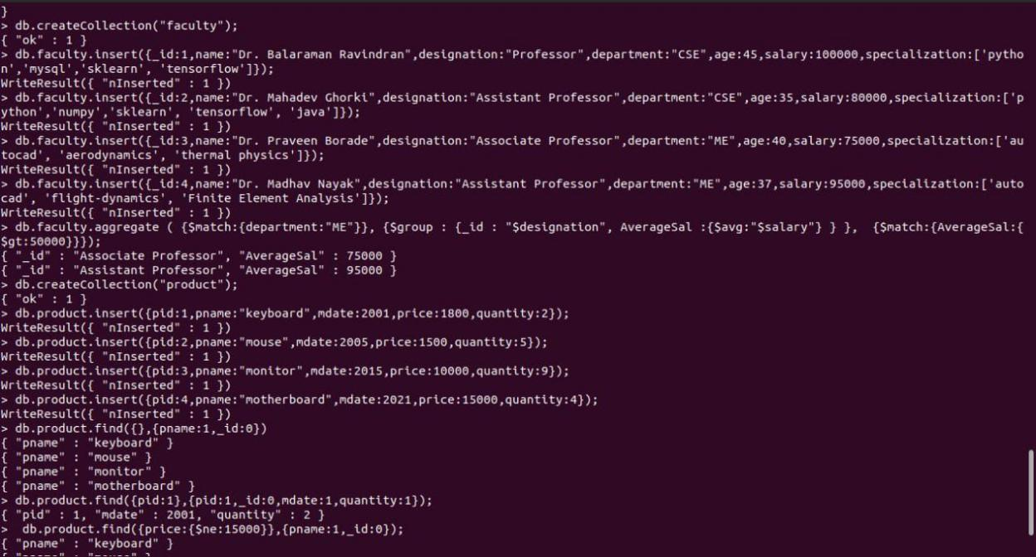

|  |  |
| --- | --- |
| 3)Create a mongodb collection Hospital. Demonstrate the following by choosing felds of | |
| choice. | |
| 1. | Insert three documents |
| 2. | Use Arrays(Use Pull and Pop operation) |
| 3. | Use Index |
| 4. | Use Cursors |
| 5. | Updation |

