

**GlobalCareerConnect**

***An Imaginative International Student Recruitment Agency for Employment in Canada***

**Business Proposal Prepared For**

**Employability Development Skills (UTD002)**

***Created By :***

Shreeya Chatterji

102103447

3CO16

***Submitted To:***

Dr Varleen Kaur

**Table of Contents**

1. Executive Summary ------------------------------------------------------------------------------------------------- 3

2. Introduction ----------------------------------------------------------------------------------------------------------- 3

3. Mission and Vision --------------------------------------------------------------------------------------------------- 4

4. Objectives -------------------------------------------------------------------------------------------------------------- 4

5. Methodology----------------------------------------------------------------------------------------------------------- 5

6. Services Offered-------------------------------------------------------------------------------------------------------- 7

7. Market Analysis -------------------------------------------------------------------------------------------------------- 7

8. Competitive Advantage ---------------------------------------------------------------------------------------------- 8

9. Marketing Strategy ---------------------------------------------------------------------------------------------------- 8

10. Operational Plan ----------------------------------------------------------------------------------------------------- 9

11. Financial Projections ----------------------------------------------------------------------------------------------- 10

12. Risk Analysis ---------------------------------------------------------------------------------------------------------- 11

13. Timeline ---------------------------------------------------------------------------------------------------------------- 12

14. Conclusion ------------------------------------------------------------------------------------------------------------- 12

15. Appendices ------------------------------------------------------------------------------------------------------------ 13

*Appendix I. AI, AR, and VR Integration for GlobalCareerConnect -----------------------------------* 13

*Appendix II. Sample career development plan -----------------------------------------------------------* 13

*Appendix III. Marketing Materials ---------------------------------------------------------------------------* 14

*Appendix IV: Financial Projections and Requirements --------------------------------------------------* 15

*Appendix V: References ---------------------------------------------------------------------------------------* 19



**GlobalCareerConnect**

***Business Proposal Plan***

**To:** XYZ Capital

**From:** GlobalCareerConnect

**Date:** November 8, 2023

**Subject:** Business Proposal Plan

1. **Executive Summary:**

Welcome to the comprehensive business proposal for "GlobalCareerConnect," a groundbreaking international student recruitment agency dedicated to empowering students from around the world in their pursuit of meaningful employment opportunities in Canada. Within the pages of this proposal, we present a thorough and holistic view of our agency, outlining a detailed plan that encompasses every aspect of our venture. Our focus is to provide unparalleled support to international students, guiding them toward successful careers in Canada.

In the following sections, we will delve into the intricacies of our innovative approach and demonstrate how GlobalCareerConnect aims to bridge the gap between talented international students and prospective employers in Canada. By offering a meticulous breakdown of our strategies, services, and operational framework, we present a roadmap for the establishment and flourishing success of our agency.

Join us on this journey as we explore the vision, mission, and core values that underpin GlobalCareerConnect. Together, we will unlock a world of opportunities for international students, foster their growth, and contribute significantly to Canada’s diverse and skilled workforce.



Pressfoto. *Discussing Charts.* Freepik. https://www.freepik.com/free-photo/discussing-charts_5633623

1. **Introduction:**

In response to the substantial surge in international students selecting Canada as their primary destination for higher education, the creation of GlobalCareerConnect is a pivotal solution to address the critical demand for an innovative and all-encompassing recruitment agency. As the number of international students continues to rise, there is a pressing need for a strategic and comprehensive approach to assist them in fulfilling their distinct employment prerequisites.

This proposal presents the blueprint for GlobalCareerConnect, a forward-thinking international student recruitment agency meticulously designed to cater to the unique employment requirements of Canada’s burgeoning international student population. Through meticulous research, strategic planning, and a deep understanding of the challenges faced by international students, GlobalCareerConnect aims to bridge the gap between academic achievement and meaningful employment, ensuring a seamless transition into the Canadian workforce.

Our approach integrates imagination and practicality to address the diverse needs of international students while aligning with the evolving demands of the Canadian job market. By offering tailored services, personalized guidance, and innovative resources, GlobalCareerConnect empowers international students to secure employment opportunities that match their skills and aspirations.

1. **Mission and Vision:**

***Mission:*** To empower international students with the essential resources, valuable connections, and steadfast support necessary to launch thriving careers in Canada. We are dedicated to cultivating talent, embracing cultural diversity, and upholding academic excellence. Through personalized guidance, innovative tools, and a strong network of opportunities, we strive to bridge the gap between education and employment.

***Vision:*** To be the paramount force in propelling international students to become highly coveted professionals within the Canadian job market. Guided by a dedication to excellence, innovative strategies, and a profound understanding of global talent dynamics, we strive to establish unmatched benchmarks for cultivating thriving careers.



Pressfoto. *Business Strategy Target.* Freepik. https://www.freepik.com/free-photo/business-strategy-success-target-goals_1211528

1. **Objectives:**

* **Enhance Soft Skills Development:** Implement tailored programs to enhance students’ soft skills such as communication, teamwork, and cultural intelligence, aiming to improve these skills by at least 20% among program participants annually**.**
* **Promote Diversity and Inclusion:** Increase the diversity of enrolled international students by 15% annually, encouraging students from various backgrounds to share experiences and learn from one another, thereby promoting cultural understanding.
* **Offer Continuous Learning Opportunities:** Conduct a minimum of 10 workshops, seminars, and training sessions annually, ensuring that both students and staff stay updated with the latest industry trends and job market demands.
* **Expand Service Offerings:** Introduce at least 3 additional services annually, such as resume writing workshops, interview preparation sessions, and networking events, to further empower students in their job search endeavours.
* **Monitor Alumni Success:** Establish a robust alumni network and track the professional progress of past clients, aiming to showcase at least 10 success stories annually, inspiring and guiding current students.
* **Contribute to Community Engagement:** Encourage students to engage in a minimum of 20 hours of community service and volunteer opportunities per semester, instilling a sense of social responsibility and showcasing their dedication to contributing positively to Canadian society.
* **Facilitate Workshops on Canadian Workplace Culture:** Conduct workshops to educate at least 500 international students annually about the nuances of Canadian workplace culture, helping them adapt seamlessly and excel in their professional environments.
* **Establish International Networks:** Develop partnerships with a minimum of 5 international recruitment agencies annually, creating a global network that facilitates cross-border opportunities for both students and Canadian businesses.



Pressfoto. *Ariel View Business Team.* Freepik. https://www.freepik.com/free-photo/aerial-view-business-team_17117573.htm#query=Objectives

1. **Methodology:**

* **AI-Powered Career Counselling:** Implement advanced AI algorithms for personalized career counselling. Machine learning is used to analyse students’ academic backgrounds, skills, and career aspirations, providing tailored advice and recommending suitable career paths.
* **Virtual Reality (VR) Job Simulations:** Develop immersive VR job simulations in which students can experience real-life work scenarios in a virtual environment. VR job simulations provide a hands-on learning experience, preparing students for their future roles in a technologically advanced manner.
* **Predictive Analytics for Skill Development:** Implement predictive analytics to identify future skills in demand within the Canadian job market. Use this information to offer proactive skill development programs, ensuring that students are equipped with the most relevant skills, making them highly attractive to potential employers.
* **Collaborative Robotics (Cobots) Training:** Introduce training programs focused on collaborative robotics, preparing students for roles that involve working alongside advanced robotic systems. Cobots training ensures that students are well-positioned for emerging roles in the automation and robotics industries.
* **Global Industry Research and Trend Analysis:** Establish a dedicated research team to monitor global industry trends, emerging job sectors, and evolving skill requirements. Stay abreast of global economic shifts and technological advancements, enabling proactive adjustments to the services offered to align with future job demands.
* **Cultivate innovation and entrepreneurship:** Encourage students to participate in innovation and entrepreneurship programs that foster a culture of creativity and problem-solving. Develop mentorship programs that connect students with successful entrepreneurs and inspire the next generation of innovators.
* **Environmental and Social Responsibility Integration:** Emphasize the importance of environmental and social responsibility in the workplace. Prepare students to contribute positively to organizations that prioritize environmental sustainability, social impact, and community engagement, aligning with the global shift toward responsible business practices.
* **Cross-Cultural Communication Training:** Provide comprehensive training in cross-cultural communication to enhance students’ ability to collaborate in diverse, multicultural workplaces. Proficiency in cross-cultural communication prepares students for international collaborations and business interactions in an interconnected world.
* **Continuous Professional Development:** Facilitates continuous learning through online courses, webinars, and certification programs. Encourage students to acquire new skills and certifications even after employment, thereby promoting lifelong learning and adaptability in an ever-changing job landscape.
* **Gender Equality and Diversity Advocacy:** Promote gender equality and diversity in the workplace by organizing awareness campaigns and diversity-focused events. Collaborate with organizations advocating for gender equality and LGBTQ+ rights.
* **Incorporate emotional intelligence development:** Integrate emotional intelligence workshops into the curriculum, focusing on self-awareness, empathy, and interpersonal skills. Develop tailored training modules to enhance students’ emotional intelligence, enabling them to navigate complex social interactions and build strong professional relationships.
* **Blockchain-based job matching:** Use blockchain technology for transparent and secure job matching. Smart contracts on the blockchain can facilitate seamless, trust less agreements between employers and employees.



Pressfoto. *Scrum Method Concept.* Freepik. https://www.freepik.com/free-vector/scrum-method-concept-illustration_33756690.htm#query=Methodology

1. **Services Offered:**

* **Personalized Career Counselling:** AI algorithms for tailored career guidance aligned with student skills and industry demands.
* **Advanced Job Matching:** Implement AI and AR technology for precise job matching, enhancing student– employer connections.
* **Practical Skill Development:** Offer VR simulations and Cobots training, providing hands-on experience for real-world applications.
* **Continuous Learning:** Facilitates online courses and webinars, encouraging lifelong learning and adaptability.
* **Environmental and Social Responsibility Training:** Conduct workshops on sustainable practices and ethical leadership to foster responsible contributions to organizations.
* **Cross-cultural communication:** Provide language proficiency courses and cultural sensitivity training to enhance collaboration in diverse workplaces.
* **Inclusive workplace initiatives:** Promote gender equality and diversity through scholarships, mentorship programs, and awareness campaigns.



Pressfoto. *Flat Customer Service Banner.* Freepik. https://www.freepik.com/free-vector/flat-customer-service-week-horizontal-banner-template_31149920

1. **Market Analysis:**

* Canada’s welcoming immigration policies have led to a surge in international student enrolment, significantly expanding the market.
* The increasing demand for skilled professionals in various sectors within Canada has created a favourable landscape for international students seeking employment opportunities.
* Existing recruitment agencies lack specialized services catering to the unique needs of international students, leaving an unmet demand for personalized and innovative solutions in the market.
* The rise of technology-driven job markets and the need for diverse skill sets make international students a valuable asset, further driving the demand for tailored recruitment services.
* Canada’s reputation as a global education hub and its strong economy contribute to a stable market for international student recruitment agencies with ample growth potential.



Pressfoto. *People analysing Growth Charts.* Freepik. https://www.freepik.com/free-vector/people-analyzing-growth-charts_12643932.htm#query=Market%20analysis

1. **Competitive Advantage:**

* **Technological Innovation:** GlobalCareerConnect stands out with its integration of cutting-edge technologies such as AI, AR, and VR, offering a unique and immersive experience for both students and employers, thereby setting us apart from competitors.
* **Personalized Guidance:** We emphasize individualized career guidance and mentoring, ensuring tailored support for each student’s specific needs. This personalized approach enhances student satisfaction and puts us ahead in the market.
* **Strategic Partnerships:** Our strong collaborations with educational institutions and local businesses serve as the cornerstone of our competitive advantage, creating a robust network that enriches students’ opportunities and amplifies their learning experiences.
* **Adaptability:** GlobalCareerConnect’ s ability to swiftly adapt to evolving job market demands positions us as a frontrunner. Our agility ensures that our services remain relevant and effective, giving us an edge over competitors who may struggle to keep pace.
* **Global Perspective:** Our emphasis on cross-cultural communication training and international networking initiatives equips students with a global mindset. This global perspective enhances their adaptability and makes them more appealing to multinational employers.
* **Innovation Hub:** GlobalCareerConnect fosters an environment of innovation and entrepreneurship, encouraging students to engage with startup incubators and participate in entrepreneurial ventures. This forward-thinking approach prepares students for roles in emerging industries, giving them a competitive edge in the job market.
* **Data-Driven Decisions:** GlobalCareerConnect uses data analytics to track student progress, industry trends, and market demands. This data-driven approach allows us to make informed decisions, ensuring that our services remain relevant and effective, giving us an edge in understanding the market landscape.

1. **Marketing Strategy:**

* **Market Research:** Analyse student preferences and competitor strategies and identify market gaps and opportunities.
* **Brand positioning:** Emphasize innovative technology and personalized guidance and highlight unique services and competitive advantages.
* **Digital Presence:** Develop a user-friendly website and engage in social media content.
* **Content Marketing:** Create informative content to establish authority in the industry.
* **SEO Optimization:** Optimize website content for search engines.
* **Partnerships and Collaboration:** Forge partnerships with student organizations and influencers.
* **Events and Networking:** Host workshops, webinars, and networking events for students.
* **Email Marketing:** Implement targeted email campaigns to engage prospective students.
* **Online Advertising:** Use Google Ads and social media platforms for advertising.
* **Feedback and referrals:** Gather testimonials and encourage referrals through incentive programs.
* **Data Analysis:** Regularly analyse campaign performance using data analytics.
* **Community Engagement:** Participate in local events and sponsorships to build a positive reputation

1. **Operational Plan:**
2. **Technology Implementation:** Develop a user-friendly website and mobile app, ensuring data security measures.
3. **Student Support Services:** Conduct orientation sessions and create personalized student profiles for guidance.
4. **Career counselling and workshops:** AI-driven counselling, resume workshops, and interview skill sessions are offered.
5. **Skill Development Programs:** Arrange language proficiency and technical skills workshops in collaboration with experts.
6. **Networking and Industry Events:** Host industry-specific networking events, career fairs, and virtual company visits.
7. **Virtual Reality (VR) Initiatives:** Develop VR simulations for workplace experiences and industry-specific training.
8. **Continuous Learning Opportunities:** Partner with online platforms for courses and certifications and organize webinars.



Pressfoto. *Hand drawn illustrated people planning business.* Freepik. https://www.freepik.com/free-vector/hand-drawn-illustrated-people-planning-business_19948931.htm#query=Operation%20Plan

1. **Financial Projections:**

* ***Initial investment requirements: $224,000***

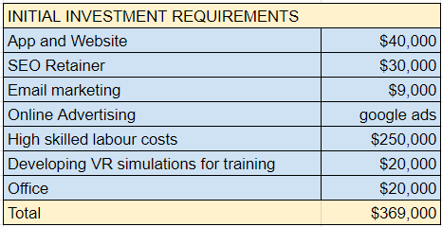

*Sheet for the initial investment requirements for year 1*

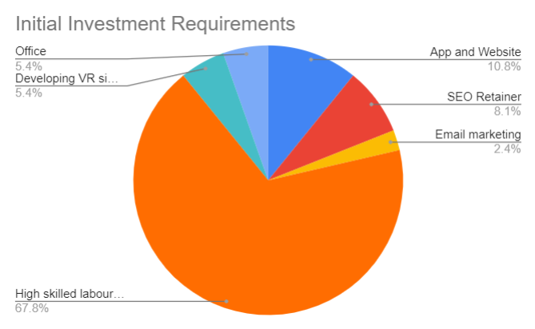

*Pie Chart for the initial investment requirements for year 1*

* ***Revenue projections from service fees, partnerships, and grants.***

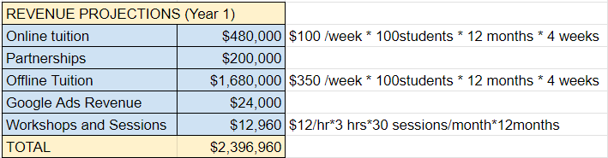

*Sheet for the revenue projections for year 1*

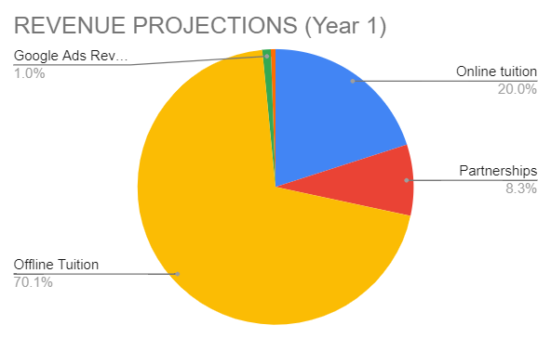

*Pie Chart for the revenue projections requirements for year 1*

* ***Expected breakeven point within: 3months*** 
  + Expected date to start: February 1st 2024
  + Expected breakeven point: May 15th 2024

1. **Risk Analysis:**

***1. Market Fluctuations:***

* **Risk:** Changes in international student enrolment and job market demands may affect revenue streams.
* **Mitigation:** Diversify services, focus on niche markets, and maintain flexibility to adapt offerings based on market needs. Establish long-term partnerships with educational institutions for stable student referrals.

***2. Technological Challenges:***

* **Risk:** Technical glitches or cyber threats could disrupt services and compromise data security.
* **Mitigation:** Invest in robust cybersecurity measures, conduct regular system audits, and have a contingency plan for system failures. Keep technology up-to-date to minimize vulnerabilities.

***3. Regulatory Compliance:***

* **Risk:** Changes in immigration policies or regulations may impact international student recruitment processes.
* **Mitigation:** Stay updated with legal requirements, maintain compliance with immigration regulations, and build relationships with legal advisors to effectively navigate policy changes.

***4. Competition:***

* **Risk:** Intense competition from existing and new recruitment agencies could impact market share.
* **Mitigation:** Offer unique services, emphasize personalized counselling, and continuously innovate. Focus on building a strong brand and reputation through exceptional student outcomes and positive experiences.

***5. Financial Constraints:***

* **Risk:** Insufficient funding or cash flow issues could disrupt operations and hinder growth initiatives.
* **Mitigation:** Implement a rigorous financial management strategy, maintain a cash reserve for contingencies, explore multiple funding sources, and closely monitor expenses to ensure financial stability.

***6. Global Events and Travel Restrictions:***

* **Risk:** Global events (e.g., pandemics) or travel restrictions might impact international student mobility.
* **Mitigation:** Develop contingency plans for remote counselling and virtual services. Stay updated with travel regulations and adopt adaptable recruitment strategies to adapt to changing scenarios.

***7. Reputation and Trust:***

* **Risk:** Negative feedback or unsatisfied clients could harm the agency’s reputation.
* **Mitigation:** Prioritize excellent customer service, respond promptly to feedback, and maintain transparent communication. Showcase success stories and student testimonials to build trust and credibility.

***8. Talent Retention:***

* **Risk:** Staff turnover or the loss of key employees could disrupt operations and service quality.
* **Mitigation:** Invest in employee training and development, offer competitive salaries and benefits, and create a positive work culture to enhance employee satisfaction and retention.

1. **Timeline:**

* ***Agency launch (in next 6 months):***
  + Develop website and mobile app.
  + Conduct counselling and workshops.
  + Host networking events.
* ***Scale-up operations (First year):***
  + Expand services based on feedback.
  + Strengthen partnerships.
  + Launch targeted marketing.
* ***Continuous Improvement and Expansion (Next Five Years):***
  + Monitor progress and trends.
  + Implement feedback loops.
  + Update technology regularly.
  + Collaborate with emerging industries.
  + Expand global outreach efforts.

1. **Conclusion**

In conclusion, GlobalCareerConnect is poised to revolutionize the landscape of international student recruitment and career development in Canada. With a steadfast commitment to empowering international students, bridging the gap between education and employment, and fostering a globally competitive workforce, our agency stands as a beacon of innovative solutions and personalized guidance.

By integrating cutting-edge technology, personalized counselling, and strategic partnerships, GlobalCareerConnect meets and exceeds the unique employment needs of international students. Our holistic approach, coupled with a focus on continuous improvement and adaptability, ensures that we are well-prepared to navigate challenges and capitalize on opportunities in dynamic educational and job markets.

Join us in shaping the future of international student recruitment, where imagination meets practicality and aspirations are transformed into meaningful careers. Together, we can create a brighter, more inclusive, and globally competitive tomorrow for all.

Thank you for reviewing our business proposal. We greatly appreciate your consideration and look forward to your positive response.

1. **Appendices:**

About AI,AR and VR technology integration:

***Appendix I. AI, AR, and VR Integration for GlobalCareerConnect***

In today's rapidly evolving technological landscape, GlobalCareerConnect harnesses the power of cutting-edge innovations, specifically Artificial Intelligence (AI), Augmented Reality (AR), and Virtual Reality (VR), to revolutionize the international student recruitment and career development industry. The seamless integration of these technologies enhances the agency's offerings, ensuring a transformative and personalized experience for both international students and employers.

* **Artificial Intelligence (AI) Integration:** GlobalCareerConnect employs advanced AI algorithms to offer personalized career counselling and guidance. AI-driven data analytics are utilized to track employment trends and analyse market demands continually. By staying ahead of industry trends, the agency can offer timely and relevant support to international students, making them highly attractive to potential employers.
* **Augmented Reality (AR) for Enhanced Experiences:** GlobalCareerConnect leverages Augmented Reality (AR) technology to create interactive and immersive experiences for international students. AR applications are utilized for virtual job interviews and company tours, allowing students to experience their prospective workplaces before joining. AR is also employed in the creation of interactive workshops and training sessions. Through AR-enhanced educational materials, students can engage with content in innovative ways, making the learning process more engaging and effective.
* **Virtual Reality (VR) for Real-World Simulations:** GlobalCareerConnect integrates Virtual Reality (VR) simulations to provide international students with hands-on, real-world experiences in a virtual environment. VR job simulations enable students to practice job-related tasks and scenarios, enhancing their practical skills and confidence. Furthermore, VR technology is utilized to create a unique campus-to-career transition experience.

By seamlessly integrating AI, AR, and VR technologies, GlobalCareerConnect provides international students with unparalleled support and resources, enabling them to navigate the complexities of the job market confidently. This innovative approach not only differentiates the agency in the competitive landscape but also ensures that international students receive the highest quality of guidance and preparation for their future careers in Canada.

***Appendix II. Sample career development plan***

* **Self-Assessment and Goal Setting:** Conduct a self-assessment to identify strengths, skills, interests, and areas for improvement.
* **Academic Excellence:** Maintain a high GPA by dedicating time to studies and actively participating in class.
* **Skill Enhancement:** Identify key skills required for the desired career path (e.g., communication, technical skills, leadership) and work on developing them.
* **Networking and Professional Development:** Attend industry-specific events, seminars, and networking sessions to connect with professionals and peers.
* **Internships and Work Experience:** Seek internships, co-op programs, or part-time jobs related to the field of study.
* **Resume Building and LinkedIn Profile:** Create a professional resume highlighting academic achievements, skills, internships, and relevant experiences.
* **Mock Interviews and Soft Skills Development:** Participate in mock interview sessions to practice answering common interview questions and improve communication skills.
* **Mentorship and Guidance:** Seek guidance from professors, career counsellors, and industry professionals.
* **Continuous Learning and Adaptability:** Stay updated with industry news, emerging technologies, and relevant certifications.

By following this career development plan, the student will be well-equipped to pursue their career goals effectively and confidently transition into the Canadian job market upon graduation.

***Appendix III. Marketing Materials***

Bootcamp sample flyer:
 

*Bootcamp sample flyer* *Career coaching session flyer*

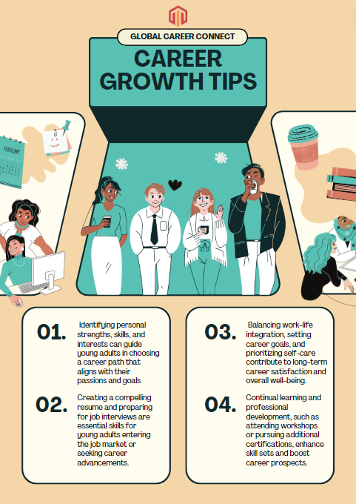 

*Social Media Content Sample Social Media Content Sample*

***Appendix IV: Financial Projections and Requirements***

*5-year Funding Requirements:*

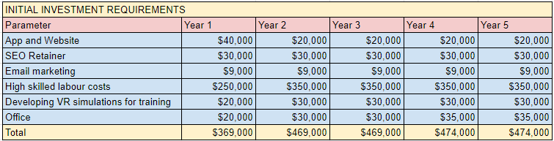

*Sheet describing the 5-year funding documents*

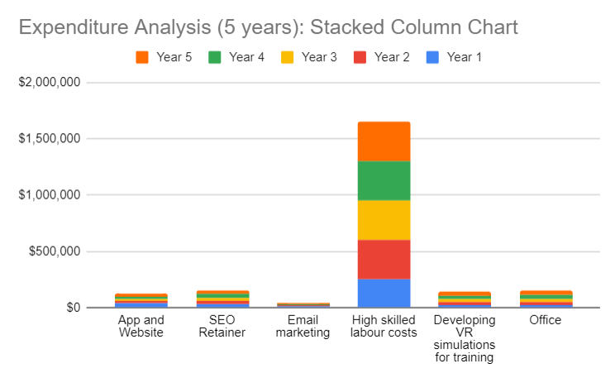*Stacked column chart for the Expenditure Analysis for the next 5 Years*

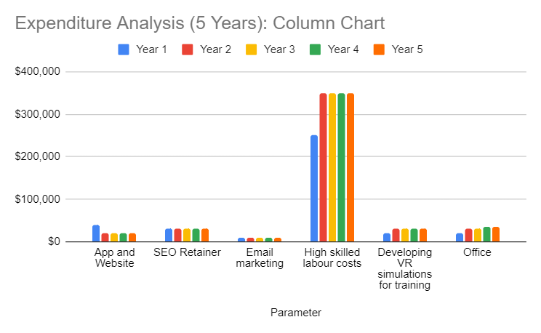

*Column chart for the Expenditure Analysis for the next 5 Years*

*Revenue Projections:*

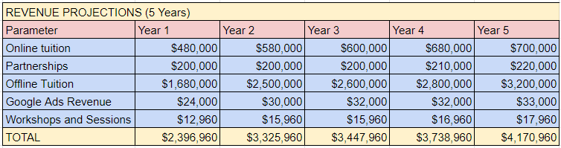

*Sheet describing the 5-year funding documents*

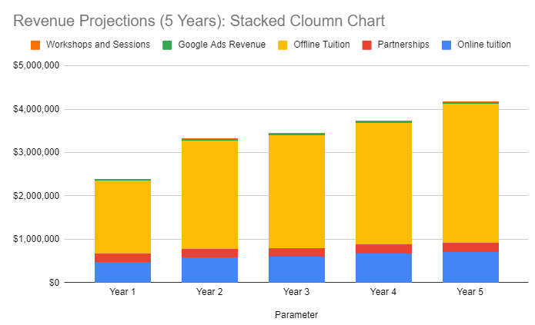

*Stacked column chart for the Revenue Projections for the next 5 Years*

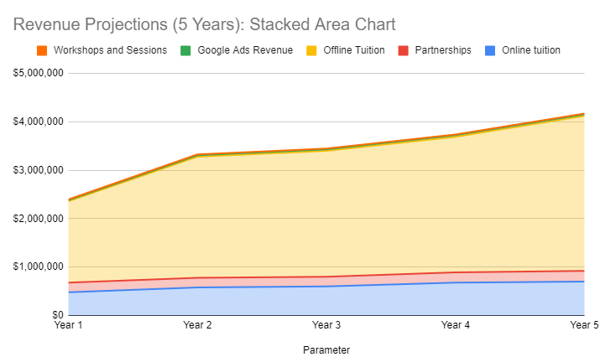

*Stacked area chart for the Revenue Projections for the next 5 Years*

*Profit Margin Analysis:*

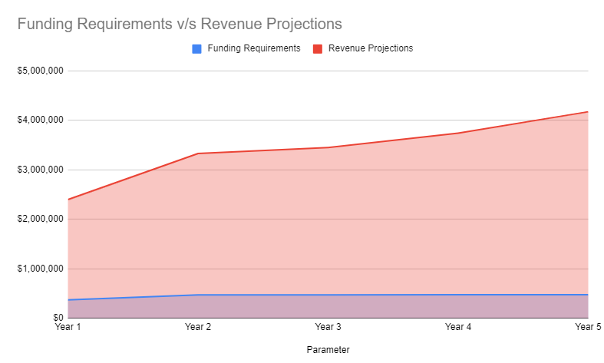

*Stacked area chart for funding requirements v/s revenue projections for the next 5 Years*

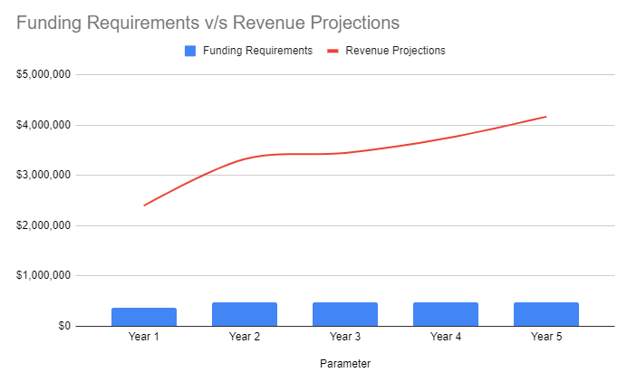

*Combo chart for funding requirements v/s revenue projections for the next 5 Years*

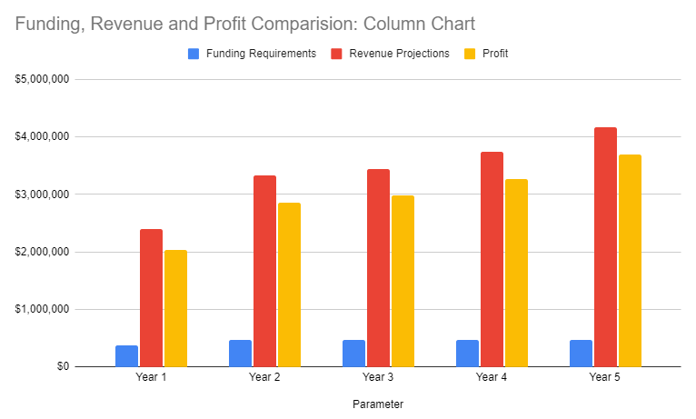

*Column chart for funding requirements v/s revenue projections for the next 5 Years*

The robust financial projections and exceptional profit margins affirm GlobalCareerConnect’ s solid position in the market. With strong returns and prudent financial management, we are well-equipped to expand our services, invest in cutting-edge technologies, and create meaningful impacts on the lives of international students. These results underscore our commitment to excellence, ensuring a prosperous future for our venture and the students we serve.

***Appendix V: References***

*Library Guides: APA 7th referencing: webpages*. (n.d.). <https://libraryguides.vu.edu.au/apa-referencing/7Webpages>

Owen, M. (2023b, November 4). *Canadian Digital Marketing Agency price list*. Asset Digital Communications. <https://assetdigitalcom.com/blog/digital-marketing-agency-price-list-pdf/>

Hardwick, J. (2023, April 28). *SEO pricing: How much does SEO cost in 2023? [Industry Research]*. SEO Blog by Ahrefs. <https://ahrefs.com/blog/seo-pricing/#:~:text=Most%20businesses%20paying%20a%20monthly,per%2Dproject%20is%20most%20common>

Laine, A. (2023, September 7). *Average cost of SEO services in Canada*. Spacebar Collective. <https://spacebarcollective.com/cost-of-seo-services-in-canada/#:~:text=Monthly%20Retainer&text=It%20gives%20you%20more%20predictability,to%20%2415%2C000%20CAD%20per%20month>

Stevens, G. (2023, August 17). *Best Email Marketing Software & services*. hostingcanada.org. <https://hostingcanada.org/email-marketing-services/>

Statista. (2023, July 31). *GoogleAds average monthly CPC in Canada 2023, by industry*. <https://www.statista.com/statistics/1115436/canada-search-advertising-cpc/>

De Guzman, G. (2017, April 18). How to Use Canva: An 8-Step Guide to Creating Visual Content. *Hubspot*. <https://blog.hubspot.com/marketing/how-to-use-canva>

*Headings*. (n.d.). https://apastyle.apa.org. <https://apastyle.apa.org/style-grammar-guidelines/paper-format/headings#:~:text=There%20are%20five%20levels%20of,and%20complexity%20of%20the%20work>.