MASTER OF COMPUTER APPLICATIONS
(Web Technologies)- MCA 312



Submitted To: Submitted By:
Ms. Sunayna Nikita
Roll No. 24158
MCA(B)3rdSem

Department of Computer Science
Himachal Pradesh University
Shimla (H.P.)

Table of Contents
S.NO. |  | Content | Page No. | Signature
1 |  | Create a web page with an appropriate image towards the left hand side of the page, when user clicks on the image another web page should open | 4
2 |  | Create a web page for internal links, when the user clicks on different links on the web page it should go to the appropriate sections in the same page. | 5-6
3 |  | Create a HTML document containing a nested list showing a content page of any book. | 7-8
4 |  | Create a table using HTML and CSS to show your class time table. | 9-13
5 |  | WAP in html to design a Bio-Data. | 14-16
6 |  | Write a HTML program to develop a static Registration Form. | 17-19
7 |  | Write a HTML program to develop a static Login Page. | 20-21
8 |  | Write code for demonstration of cascading stylesheets a. Internal Stylesheets b. External Stylesheets c. Inline Stylesheets | 22-24
9 |  | Write a javascript program for validating REGISTRATION FORM. | 25-29
10 |  | Write a program in Java Script to Perform All Arithmetic Operation. | 30-31
11 |  | Create a program in Javascript that uses a recursive function to calculate the factorial of a number | 32-33
12 | Create a program in Javascript that merges two arrays and removes duplicate elements. |  | 34-35
13 | Create a program in Javascript that changes the text color of a paragraph when a button is clicked. |  | 36
14 | Create a form with fields (e.g., name, email, password) and validate user input when the form is submitted. Display error messages if the input is invalid. |  | 37-40
15 | Create a PHP program for login page with sql connection. |  | 41-44
16 | Write a PHP program for creating and manipulating- a) Indexed array b) Associative array c) Multidimensional array |  | 45-49
17 | Develop a simple PHP application to – a) Enter data into database b) Retrieve and present data from database |  | 50-54
18 | Develop a simple PHP application to Update and Delete table data from database. |  | 55-61
19 | Write simple PHP program to set cookies and read it. |  | 62
20 | Create a PHP page for login system using session. |  | 63-67
21 | Create student registration form using text box, check box, radio button, select, submit button and display the values entered by the user in new PHP page. |  | 68-73
22 | Create a PHP program to demonstrate Cross Join. |  | 74-76
23 | Create a simple XML file to store book information, including title, author, and publication year. |  | 77-79
24 | Create a form (e.g., user registration or login) that submits data using AJAX and displays success or error messages without reloading the page. |  | 80-85

1.
Create a web page with an appropriate image towards the left hand side of the page, when user clicks on the image another web page should open.
1st.html:
<!DOCTYPE html>
<html>
<body>
<a href="file:///C:/Users/OM/Desktop/webtech/1st.a.html" target="_blank">
<img src="file:///C:/Users/OM/Downloads/n.jpg" alt="Clickable image">
</a>
</body>
</html>

1st.a.html:
<html>
<body>
<h2>This webpage got opened after clicking on first webpage</h2>
</body>
</html>

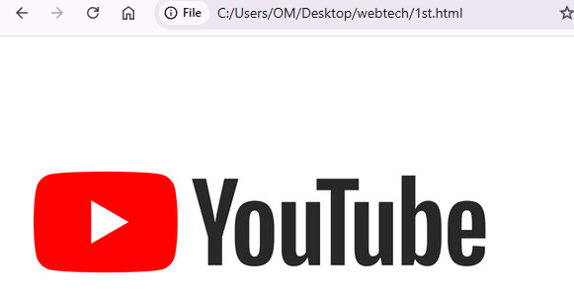


2.
Create a web page for internal links, when the user clicks on different links on the web page it should go to the appropriate sections in the same page.
<!DOCTYPE html>
<html>
<body>
<h2>Sections:</h2>
<ul>
<li><a href="#section1">Go to Section 1</a></li>
<li><a href="#section2">Go to Section 2</a></li>
<li><a href="#section3">Go to Section 3</a></li>
<li><a href="#section4">Go to Section 4</a></li>
<li><a href="#section5">Go to Section 5</a></li>
<li><a href="#section6">Go to Section 6</a></li>
</ul>

<!-- Sections -->
<h3 id="section1">Section 1</h3>
<p>This is the content for section one.</p>
<a href="#top">Back to top</a>

<h3 id="section2">Section 2</h3>
<p>This is the content for section two.</p>
<a href="#top">Back to top</a>

<h3 id="section3">Section 3</h3>
<p>This is the content for section three.</p>
<a href="#top">Back to top</a>

<h3 id="section4">Section 4</h3>
<p>This is the content for section four.</p>
<a href="#top">Back to top</a>

<h3 id="section5">Section 5</h3>
<p>This is the content for section one.</p>
<a href="#top">Back to top</a>
<h3 id="section6">Section 6</h3>
<p>This is the content for section two.</p>
<a href="#top">Back to top</a>
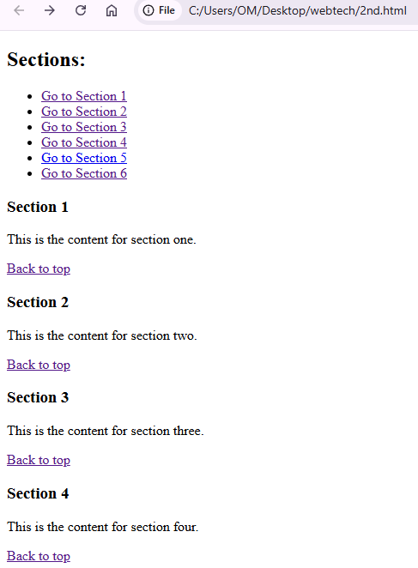
</body>
</html>

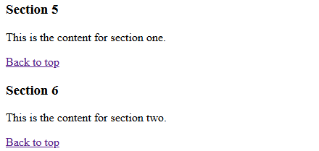

3.
Create a HTML document containing a nested list showing a content page of any book.
<!DOCTYPE html>
<html>
<body>
<h2>Contents</h2>
<li><b>Chapter 1: Data Representation</b>
<ul>
<li>Number Systems</li>
<li>Text, Sound and Images</li>
<li>Data Storage and Compression</li>
</ul> </li>
<li><b>Chapter 2: Data Transmission</b>
<ul>
<li>Types of Data Transmission</li>
<li>Methods of Error Detection</li>
<li>Encryption</li>
</ul> </li>
<li><b>Chapter 3: Hardware</b>
<ul>
<li>Computer Architecture</li>
<li>Input and Output Devices</li>
<li>Data Storage</li>
<li>Network Hardware</li>
</ul> </li>
<li><b>Chapter 4: Software</b>
<ul>
<li>Types of Software and Interrupts</li>
<li>Types of Programming Language, Translators and IDEs</li> </ul></li>
<li><b>Chapter 5: The Internet and its uses</b>
<ul><li>The Internet and the World Wide Web</li>
<li>Digital Currency</li>
<li>Cyber Security</li>
</ul></li>
<li><b>Chapter 6: Automated and Emerging Technologies</b>
<ul><li>Automated Systems</li>
<li>Artificial Intelligence</li>
</ul></li>
</body>
</html>
OUTPUT:

4.
Create a table using HTML and CSS to show your class time table.

<html>
<head>
<link rel="stylesheet" href="styles.css">
</head>
<body>
<table border="2" cellpadding="10">
<tr>
<th colspan="8" class="rept"><center><font size="6">Department Of Computer Science Timetable w.e.f.25/08/2025</font></center></th></tr>
<tr>
<th class="ived"> </th>
<th class="cept"> 10-11 am</th>
<th class="cept">11-12 am</th><th class="cept"> 12-1pm</th>
<th class="cept">1-2pm</th><th class="cept">2-3pm</th>
<th class="cept">3-4pm</th><th class="cept">4-5pm</th></tr>
<tr>
<td class="cept">Monday</td>
<td class="nep"><center>Artificial Intelligence & Expert Systems</center></td>
<td class="pen"><center>Lab Work (R)</center></td>
<td class="epn"><center>Lab Work (Web Technology)</center></td><td class="ived"></td>
<td class="pne"><center>Data Mining Using R</center></td><td class="enp"><center>Information Security</center></td>
<td class="npe"><center>Web Technology</center></td></tr>
<tr>
<td class="cept">Tuesday</td>
<td class="nep"><center>Artificial Intelligence & Expert Systems</center></td>
<td class="pen"><center>Lab Work (R)</center></td>
<td class="epn">Lab Work (Web Technology)</td><td class="ived"></td>
<td class="pne">Data Mining Using R</td><td class="enp"><center>Information Security</center></td>
<td class="npe"><center>Web Technology</center></td></tr>
<tr>
<td class="cept">Wednesday</td><td class="ben"><center>Cloud Computing</center></td>
<td class="pen"><center>Lab Work (R)</center></td>
<td class="epn">Lab Work (Web Technology)</td><td class="ived"></td>
<td class="pne">Data Mining Using R</td><td class="enp"><center>Information Security</center></td>
<td class="npe"><center>Web Technology</center></td></tr>
<tr>
<td class="cept">Thursday</td><td class="ben"><center>Cloud Computing</center></td>
<td class="pen"><center>Lab Work (R)</center></td>
<td class="epn">Lab Work (Web Technology)</td><td class="ived"></td>
<td class="pne">Data Mining Using R</td><td class="enp"><center>Information Security</center></td>
<td class="npe"><center>Web Technology</center></td></tr>
<tr>
<td class="cept">Friday</td><td class="nep"><center>Artificial Intelligence & Expert Systems</center></td>
<td class="ben"><center>Cloud Computing</center></td>
<td class="pen"><center>Lab Work (R)</center></td><td class="ived"></td><td class="epn">Lab Work (Web Technology)</td>
<td class="ived">Games Period</td><td class="ived">Games Period 2.0</td></tr>
<tr>
<td class="cept">Saturday</td><td class="nep"><center>Artificial Intelligence & Expert Systems</center></td>
<td class="ben"><center>Cloud Computing</center></td>
<td class="pen"><center>Lab Work (R)</center></td><td class="ived"></td><td class="epn">Lab Work (Web Technology)</td>
<td class="ived">Games/Bunk</td><td class="ived">Bunk/Games </td></tr>
</table>
</center>

</body>
</html>

styles.css:

td:empty{
border:none;
}
.nep{
background-color:red;
color: white;
}
.pen{
background-color:black;
color: white;
}
.epn{
background-color:brown;
color: white;
}
.pne{
background-color:magenta;
color: white;
}
.enp{
background-color:blue;
color: white;
}
.npe{
background-color:grey;
color: white;
}

.ben{
background-color:goldenrod;
color: white;
}
.cept{
background-color:green;
color:white;
}
.rept{
background-color:purple;
color:white;
}
.eel{
background-color:lightblue;
color:white;
}
.ived{
background-color:beige;
}
.table1, .table2 {
display: inline-block;
vertical-align: top;
margin-right: 100px;
cellpadding:15px;
}

OUTPUT:

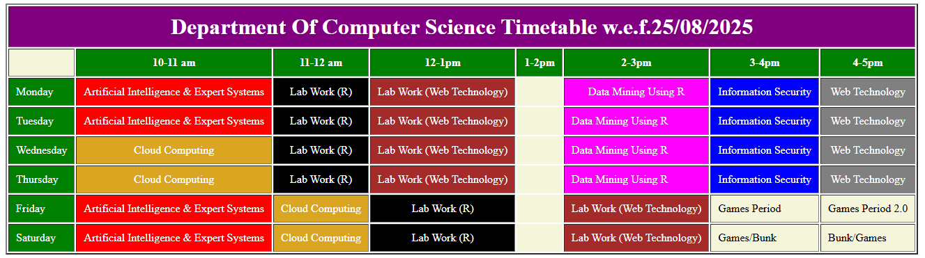

5.
WAP in html to design a Bio-Data

<!DOCTYPE html>
<html>
<body>
<h2>Bio-Data</h2>
<p><strong>Name:</strong> Taylor Betsy Ross Otto</p>
<p><strong>Age:</strong> 21</p>
<p><strong>Gender:</strong>Female</p>
<p><strong>Father's Name:</strong> Mr. Greg Otto</p>
<p><strong>Mother's Name:</strong> Mrs. Katie Otto</p>

<p><strong>Contact Number:</strong> 123-456-7890</p>
<p><strong>Email:</strong> robet21@gmail.com</p>
<p><strong>Address:</strong> 54B Main Street, Westport, Connecticut,USA</p>

<h2>Educational Qualification</h2>
<table border= "1" cellpadding="8" cellspacing="0">
<tr>
<th>Qualification</th>
<th>Board/ University</th>
<th>Year</th></tr>
<tr>
<td>12th</td>
<td>ICSE</td>
<td>2020</td></tr>
<tr>
<td>BTech(CS)</td>
<td>Oxford University</td>
<td>2024</td></tr>
<tr>
<td>MTech(CS)</td>
<td>HPU</td>
<td>2026</td></tr></table>
<h2>Skills</h2>
<ul>
<li>Programming in C, Python.</li>
<li>Web Development.</li>
</ul>

<h2>Interests</h2>
<ul>
<li>Gardening</li>
<li>Writing </li>
</ul>
<p><b> Date:</b>___________</p>
<p><b> Place:</b>___________</p>
</body>
</html>

OUTPUT:
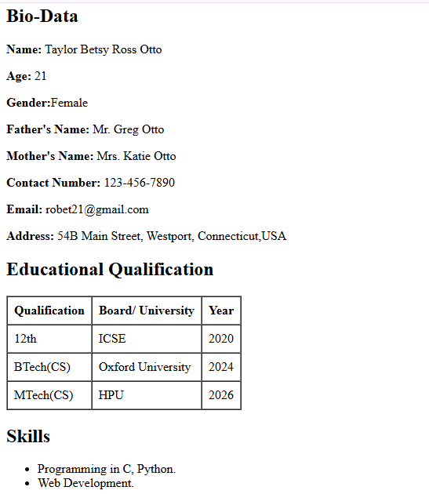
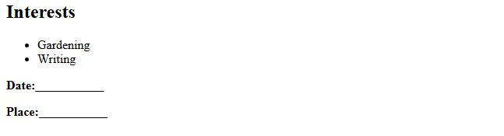
6.
Write a HTML program to develop a static Registration Form.
<!DOCTYPE html>
<html>
<head>
<title>Registration Form</title>
</head>
<body style="font-family: Arial; background-color: #f2f2f2;">
<h2 style="text-align: center;">Registration Form</h2>
<label>Full Name:</label><br>
<input type="text" name="fullname" required><br><br>

<label>Email:</label><br>
<input type="email" name="email" required><br><br>

<label>Password:</label><br>
<input type="password" name="password" required><br><br>

<label>Gender:</label><br>
<input type="radio" name="gender" value="Male"> Male
<input type="radio" name="gender" value="Female"> Female
<input type="radio" name="gender" value="Other"> Other
<br><br>

<label>Date of Birth:</label><br>
<input type="date" name="dob"><br><br>

<label>Phone Number:</label><br>
<input type="tel" name="phone"><br><br>

<label>Address:</label><br>
<textarea name="address" rows="3" cols="30"></textarea><br><br>

<label>Country:</label><br>
<select name="country">
<option value="">Select</option>
<option value="India">India</option>
<option value="USA">USA</option>
<option value="UK">UK</option>
<option value="Australia">Australia</option>
</select><br><br>

<input type="checkbox" name="terms" required> I agree to the Terms and Conditions<br><br>

<input type="submit" value="Register">
<input type="reset" value="Reset">
</form>
</body>
</html>

OUTPUT:

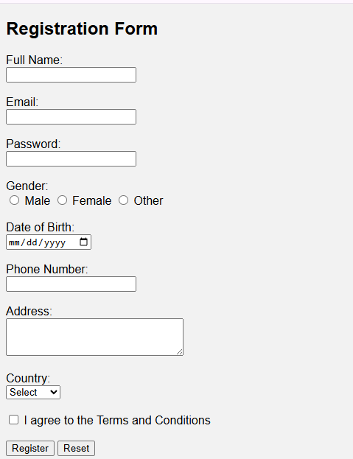

7.
Write a HTML program to develop a static Login Page.

<!DOCTYPE html>
<html>
<head>
<title>Login Page</title>
</head>
<body style="font-family: Arial; background-color: #f2f2f2;">
<h2 style="text-align: center;">Login Page</h2>
<form action="#" method="post"
style="width: 350px; margin: auto; background-color: white; padding: 20px;
border-radius: 8px; box-shadow: 0 0 10px gray;">

<label>Username or Email:</label><br>
<input type="text" name="username" required><br><br>

<label>Password:</label><br>
<input type="password" name="password" required><br><br>

<input type="submit" value="Login">
<input type="reset" value="Reset"><br><br>

<p>Don’t have an account?
<a href="file:///C:/Users/OM/Desktop/webtech/6th.html">Register here</a></p>
</form>
</body>
</html>

OUTPUT:

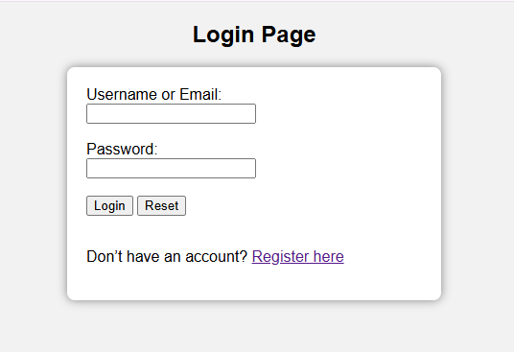

8.
Write code for demonstration of cascading stylesheets
a. Internal Stylesheets
b. External Stylesheets
c. Inline Stylesheets

<!DOCTYPE html>
<html>
<head>

<!-- Internal -->
<style>
body {
background-color: #f0f8ff;
font-family: Arial, sans-serif;
}

h1 {
color: darkblue;
}

p.internal {
color: green;
font-size: 18px;
}
</style>
<!-- External -->
<link rel="stylesheet" href="stylesz.css">
</head>
<body>
<h1>CSS Types</h1>

<p class="internal">Microwave cooks so do other hot things but coffee can not included as it is hot but not equipment to be used to cook something.</p>
<p class="external">Blake says cadel can walk off.</p>

<!-- Inline -->
<p style="color: red; font-weight: bold;">
Anybody who has not walked a mile in my shoe has no right to comment !
</p>
</body>
</html>

stylez.css:
.external {
color: blue;
font-size: 16px;
font-style: italic;
}

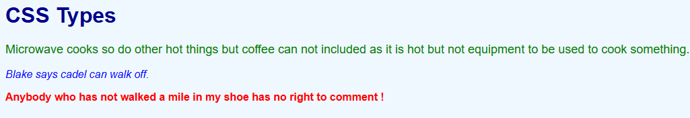

9.
Write a javascript program for validating REGISTRATION FORM.

<!DOCTYPE html>
<html>
<head>
<title>Registration Form Validation</title>
<style>
.error { color: red; }
</style>
<script>
function validateForm() {
const name = document.getElementById("name").value;
const email = document.getElementById("email").value;
const password = document.getElementById("password").value;
const course = document.getElementById("course").value;
const agree = document.getElementById("agree").checked;

let isValid = true;

// Clear previous error messages
document.getElementById("name-error").textContent = "";
document.getElementById("email-error").textContent = "";
document.getElementById("password-error").textContent = "";
document.getElementById("course-error").textContent = "";
document.getElementById("agree-error").textContent = "";

// Validate name
if (name === "" || /\d/.test(name)) {
document.getElementById("name-error").textContent = "Enter your name";
isValid = false;
}

// Validate email
if (email === "" || !email.includes("@") || !email.includes(".")) {
document.getElementById("email-error").textContent = "Enter a valid email address.";
isValid = false;
}

// Validate password
if (password === "" || password.length < 6) {
document.getElementById("password-error").textContent = "Field cannot be empty ";
isValid = false;
}

// Validate course selection
if (course === "") {
document.getElementById("course-error").textContent = "Please select a course.";
isValid = false;
}

// Validate agreement checkbox
if (!agree) {
document.getElementById("agree-error").textContent = "You must agree to the terms.";
isValid = false;
}

if (isValid) {
alert("Form submitted successfully!");
return true;
} else {
return false;
}
}
</script>
</head>
<body>
<h2>Registration Form</h2>
<form onsubmit="return validateForm()">
<label for="name">Name:</label><br>
<input type="text" id="name" name="name"><br>
<span id="name-error" class="error"></span><br>

<label for="email">Email:</label><br>
<input type="text" id="email" name="email"><br>
<span id="email-error" class="error"></span><br>

<label for="password">Password:</label><br>
<input type="password" id="password" name="password"><br>
<span id="password-error" class="error"></span><br>

<label for="course">Select Course:</label><br>
<select id="course" name="course">
<option value="">--Select--</option>
<option value="cs">Computer Science</option>
<option value="it">Information Technology</option>
<option value="ece">Electronics</option>
</select><br>
<span id="course-error" class="error"></span><br>

<input type="checkbox" id="agree" name="agree">
<label for="agree">I agree to the terms and conditions</label><br>
<span id="agree-error" class="error"></span><br>

<input type="submit" value="Register">
</form>
</body>
</html>

OUTPUT:
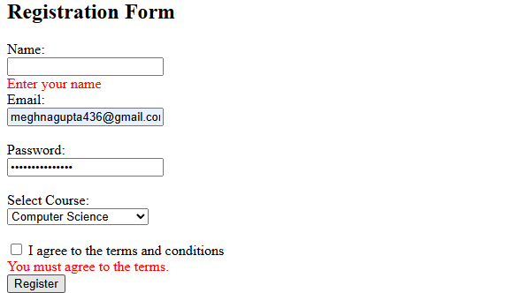

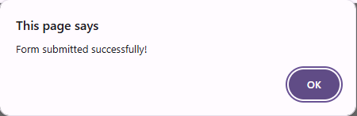

10.
Write a program in Java Script to Perform All Arithmetic Operation.

<!DOCTYPE html>
<html>
<head>
<title>Arithmetic Operations in JavaScript</title>
<script>
function performOperations() {
let num1 = parseFloat(document.getElementById("num1").value);
let num2 = parseFloat(document.getElementById("num2").value);

if (isNaN(num1) || isNaN(num2)) {
alert("Please enter valid numbers.");
return;
}
document.getElementById("resultAdd").innerText = "Addition: " + (num1 + num2);
document.getElementById("resultSub").innerText = "Subtraction: " + (num1 - num2);
document.getElementById("resultMul").innerText = "Multiplication: " + (num1 * num2);
if (num2 !== 0) {
document.getElementById("resultDiv").innerText = "Division: " + (num1 / num2);
document.getElementById("resultMod").innerText = "Modulo: " + (num1 % num2);
} else {
document.getElementById("resultDiv").innerText = "Division: Cannot divide by zero";
document.getElementById("resultMod").innerText = "Modulo: Cannot modulo by zero";
}
}
</script>
</head>
<body>
<h2>Arithmetic Operations</h2>
<label>Number 1: <input type="text" id="num1"></label><br><br>
<label>Number 2: <input type="text" id="num2"></label><br><br>
<button onclick="performOperations()">Calculate</button>
<p id="resultAdd"></p>
<p id="resultSub"></p>
<p id="resultMul"></p>
<p id="resultDiv"></p>
<p id="resultMod"></p>
</body>
</html>
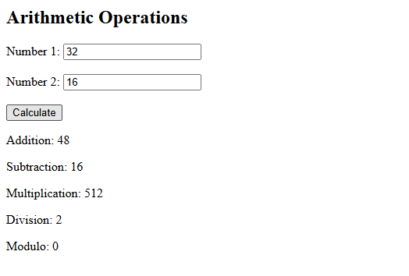
11.
Create a program in Javascript that uses a recursive function to calculate the factorial of a number.

<!DOCTYPE html>
<html>
<body>

<h2>Factorial Calculator</h2>

<label for="numInput">Enter a non-negative integer:</label>
<input type="number" id="numInput" min="0" />
<button onclick="calculateFactorial()">Calculate</button>

<p>Factorial: <span id="result"></span></p>

<script>
function factorial(n) {
if (n === 0) return 1;
return n * factorial(n - 1);
}

function calculateFactorial() {
const input = document.getElementById('numInput').value;
const number = parseInt(input);
const resultElem = document.getElementById('result');

if (isNaN(number) || number < 0) {
resultElem.textContent = 'Please enter a valid non-negative integer';
} else {
const fact = factorial(number);
resultElem.textContent = fact;
}
}
</script>

</body>
</html>

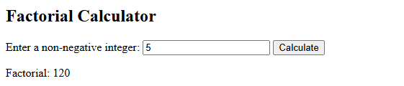

12.
Create a program in Javascript that merges two arrays and removes duplicate elements.

<!DOCTYPE html>
<html>
<body>

<h2>Merge Two Arrays and Remove Duplicates</h2>

<label>Enter first array (comma separated):</label><br>
<input type="text" id="array1Input" placeholder="e.g. 1,2,3"><br><br>

<label>Enter second array (comma separated):</label><br>
<input type="text" id="array2Input" placeholder="e.g. 3,4,5"><br><br>

<button onclick="mergeArrays()">Merge Arrays</button>

<h3>Result:</h3>
<p id="result"></p>

<script>
function mergeArrays() {
const arr1 = document.getElementById('array1Input').value.split(',').map(item => item.trim());
const arr2 = document.getElementById('array2Input').value.split(',').map(item => item.trim());

// Merge arrays and remove duplicates using Set
const merged = [...new Set([...arr1, ...arr2])];

document.getElementById('result').textContent = merged.join(', ');
}
</script>

</body>
</html>

OUTPUT:

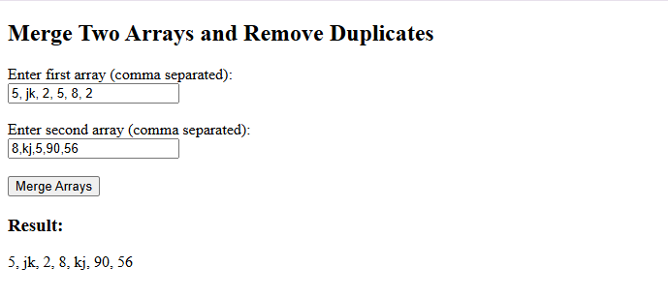

13.
Create a program in Javascript that changes the text color of a paragraph when a button is clicked.

<!DOCTYPE html>
<html>
<body>
<p id="myParagraph">This is a sample paragraph.</p>
<button onclick="changeTextColor()">Change Text Color</button>
<script>
function changeTextColor() {
const para = document.getElementById('myParagraph');
para.style.color = 'blue'; // Change the color to blue (you can choose any color)
}
</script>
</body>
</html>
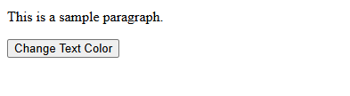
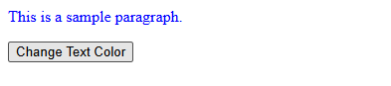

14.
Create a form with fields (e.g., name, email, password) and validate user input when the form is submitted. Display error messages if the input is invalid.

<!DOCTYPE html>
<html>
<head>
<style>
.error { color: red; font-size: 0.9em; }
input.success { border-color: green; }
input.error { border-color: red; }
</style>
</head>
<body>

<form id="form" novalidate>
<label>Name:</label><br>
<input id="name" type="text"><div id="nameErr" class="error"></div><br>

<label>Email:</label><br>
<input id="email" type="email"><div id="emailErr" class="error"></div><br>

<label>Password:</label><br>
<input id="pass" type="password"><div id="passErr" class="error"></div><br>

<button type="submit">Submit</button>
</form>

<script>
const form = document.getElementById('form');
form.addEventListener('submit', e => {
e.preventDefault();
clearErrors();
let valid = true;

const name = form.name.value.trim();
const email = form.email.value.trim();
const pass = form.pass.value.trim();

if (!name || /\d/.test(name)) {
showError('nameErr', 'Valid name required');
form.name.classList.add('error');
valid = false;
} else form.name.classList.add('success');

const emailRegex = /^[^\s@]+@[^\s@]+\.[^\s@]+$/;
if (!email || !emailRegex.test(email)) {
showError('emailErr', 'Valid email required');
form.email.classList.add('error');
valid = false;
} else form.email.classList.add('success');

if (!pass || pass.length < 6) {
showError('passErr', 'Password min 6 chars');
form.pass.classList.add('error');
valid = false;
} else form.pass.classList.add('success');

if (valid) alert('Form submitted!');
});

function showError(id, msg) {
document.getElementById(id).textContent = msg;
}

function clearErrors() {
['nameErr','emailErr','passErr'].forEach(id => {
document.getElementById(id).textContent = '';
});
['name','email','pass'].forEach(id => {
form[id].classList.remove('error','success');
});
}
</script>

</body>
</html>

OUTPUT:
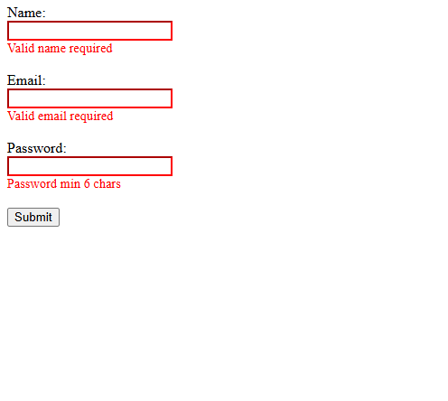
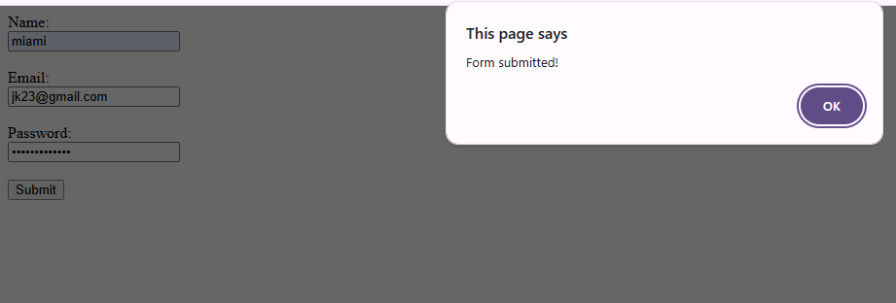

15.
Create a PHP program for login page with sql connection.
db.html:

<!DOCTYPE html>
<html>
<body>
<form action="sql.php" method="post">
<br><center><table border=2" bordercolor="red">
<tr>
<td>
<table> <tr font face="white">
<th colspan="2" bgcolor="crimson" align="center">
<h3>LOGIN FORM</th></tr>
<tr><th align="left">UserName</th>
<td><input type="text" name="u">
</td>
</tr>
<tr><th align="left">Password</th>
<td><input type="password" name="p">
</td> </tr>
<tr align="center"><br><td><input type="submit" value=" LOGIN "></td>
<td><input type="reset" value=" CLEAR ">
</td> </tr>
</table>
</td>
</tr> </table>
</center>
</form>
</body>
</html>

sql.php:

<?php
$un = $_POST['u'];
$pd = $_POST['p'];
$con = 0;

// Create connection using mysqli
$conn = new mysqli("localhost", "root", "nik@123N", "vaidoo");
if ($conn->connect_error) {
die("Connection failed: " . $conn->connect_error);
}

// Select all users
$sql = "SELECT name, password FROM riya";
$result = $conn->query($sql);

if ($result->num_rows > 0) {
while ($row = $result->fetch_assoc()) {
if ($un == $row["name"] && $pd == $row["password"]) {
$con = 1;
break;
}
}
}

if ($con == 1) {
echo "<font color='blue' size='5' align='center'>Welcome to this pc</font>";
} else {
echo "<font color='red' size='5' align='center'>Invalid Username or Password</font>";
}

$conn->close();
?>
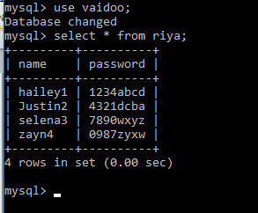
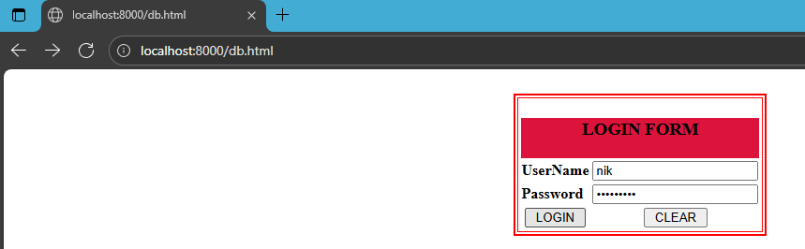

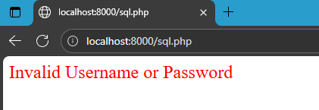
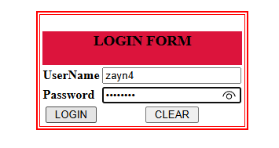
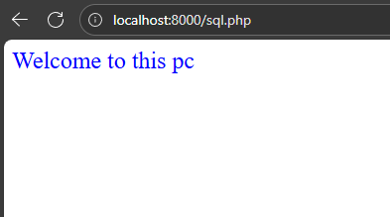
16.
Write a PHP program for creating and manipulating
a) Indexed array
b) Associative array
c) Multidimensional array
a) Indexed Array:
<!DOCTYPE html>
<html>
<body>
<h2>Indexed Array Manipulation</h2>
<?php
// Creating an indexed array
$name = array("Devi", "Fabiola", "Eleanor", "Trent");

// Adding a new name
$name[] = "Paxton";

// Display first name
echo "<p>First name: <b>" . $name[0] . "</b></p>";

// Display all name
echo "<p>All name:</p><ul>";
for ($i = 0; $i < count($name); $i++) {
echo "<li>" . $name[$i] . "</li>";
}
echo "</ul>";
?>
</body>
</html>
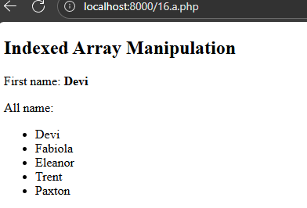

b) Associative Array:
<!DOCTYPE html>
<html>
<head>
<title>PHP Associative Array Example</title>
</head>
<body>
<h2>Associative Array Manipulation</h2>
<?php
// Creating an associative array
$person = array(
"name" => "Paresh",
"age" => 23,
"city" => "New York"
);

// Modifying age
$person["age"] = 24;

// Adding profession
$person["profession"] = "Cook";

// Display person's name
echo "<p>Name: <b>" . $person["name"] . "</b></p>";

// Display all details
echo "<p>Person details:</p><ul>";
foreach ($person as $key => $value) {
echo "<li>" . ucfirst($key) . ": " . $value . "</li>";
}
echo "</ul>";
?>
</body>
</html>
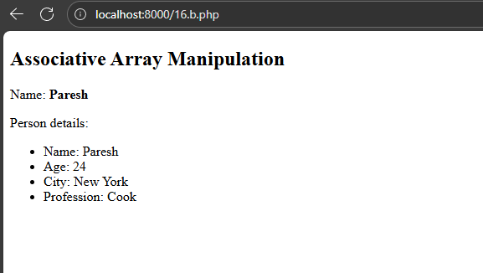
c) Multidimensional Array:
<!DOCTYPE html>
<html>
<head>
<title>PHP Multidimensional Array Example</title>
</head>
<body>
<h2>Multidimensional Array Manipulation</h2>
<?php
// Creating a multidimensional array of student marks
$students = array(
"Raghav" => array("Maths" => 95, "Physics" => 90),
"Sayli" => array("Maths" => 88, "Physics" => 92)
);

// Adding a new student
$students["Dev"] = array("Maths" => 80, "Physics" => 85);

// Display all students and marks
echo "<p>All students and their marks:</p>";
foreach ($students as $name => $subjects) {
echo "<strong>" . $name . "</strong>:<ul>";
foreach ($subjects as $subject => $marks) {
echo "<li>" . $subject . ": " . $marks . "</li>";
}
echo "</ul>";
}
?>
</body>
</html>

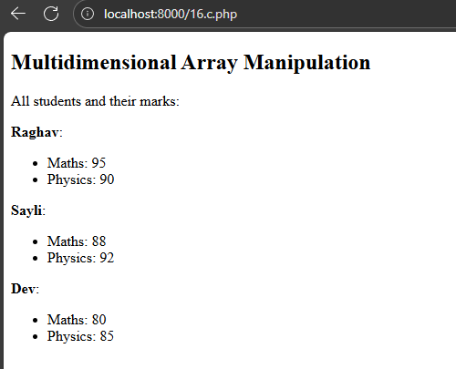

17.
Develop a simple PHP application to –
a) Enter data into database
b) Retrieve and present data from database
SQL :
CREATE DATABASE simpledb;
USE simpledb;

CREATE TABLE users (
id INT AUTO_INCREMENT PRIMARY KEY,
name VARCHAR(50),
email VARCHAR(50)
);
a)
<!DOCTYPE html>
<html>
<head>
<title>Insert Data into Database</title>
</head>
<body>
<h2>Enter User Data</h2>
<form method="post">
Name: <input type="text" name="name" required><br><br>
Email: <input type="email" name="email" required><br><br>
<input type="submit" value="Submit">
</form>

<?php
if ($_SERVER["REQUEST_METHOD"] == "POST") {
// Connect to MySQL database
$conn = new mysqli("localhost", "root", "nik@123N", "simpledb");

if ($conn->connect_error) {
die("Connection failed: " . $conn->connect_error);
}

$name = $conn->real_escape_string($_POST['name']);
$email = $conn->real_escape_string($_POST['email']);

// Insert data into users table
$sql = "INSERT INTO users (name, email) VALUES ('$name', '$email')";

if ($conn->query($sql) === TRUE) {
echo "<p>New record created successfully!</p>";
} else {
echo "Error: " . $sql . "<br>" . $conn->error;
}

$conn->close();
}
?>
</body>
</html>
OUTPUT:
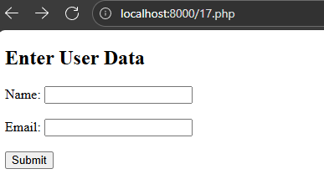
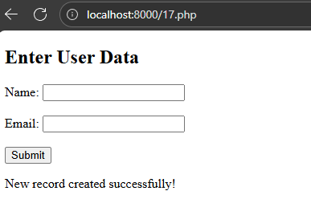

b)
<!DOCTYPE html>
<html>
<head>
<title>View Data from Database</title>
</head>
<body>
<h2>Users List</h2>

<?php
// Connect to MySQL database
$conn = new mysqli("localhost", "root", "nik@123N", "simpledb");

if ($conn->connect_error) {
die("Connection failed: " . $conn->connect_error);
}

// Select all data
$sql = "SELECT id, name, email FROM users";
$result = $conn->query($sql);
if ($result->num_rows > 0) {
echo"<table border='1' cellpadding='5'><tr><th>ID</th><th>Name</th><th>Email</th></tr>";
while ($row = $result->fetch_assoc()) {
echo "<tr><td>" . $row["id"] . "</td><td>" . htmlspecialchars($row["name"]) . "</td><td>" . htmlspecialchars($row["email"]) . "</td></tr>";
}
echo "</table>";
} else {
echo "No records found.";
}

$conn->close();
?>
</body>
</html>
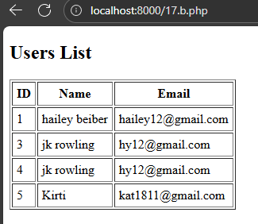

18.
Develop a simple PHP application to Update and Delete table data from database.

SQL :
CREATE DATABASE simpledb;
USE simpledb;

CREATE TABLE users (
id INT AUTO_INCREMENT PRIMARY KEY,
name VARCHAR(50),
email VARCHAR(50)
);

- Update:
<!DOCTYPE html>
<html>
<head>
<title>Update User Data</title>
</head>
<body>
<h2>Update User Data</h2>

<?php
// Connect to MySQL database
$conn = new mysqli("localhost", "root", "nik@123N", "simpledb");
if ($conn->connect_error) {
die("Connection failed: " . $conn->connect_error);
}

// Check if form is submitted for update
if (isset($_POST['update'])) {
$id = intval($_POST['id']);
$name = $conn->real_escape_string($_POST['name']);
$email = $conn->real_escape_string($_POST['email']);

$sql = "UPDATE users SET name='$name', email='$email' WHERE id=$id";
if ($conn->query($sql) === TRUE) {
echo "<p>Record updated successfully.</p>";
} else {
echo "Error updating record: " . $conn->error;
}
}

// If id is passed via GET, show the form with data to edit
if (isset($_GET['id'])) {
$id = intval($_GET['id']);
$result = $conn->query("SELECT * FROM users WHERE id=$id");
if ($result->num_rows == 1) {
$row = $result->fetch_assoc();
?>
<form method="post">
<input type="hidden" name="id" value="<?php echo $row['id']; ?>">
Name: <input type="text" name="name" value="<?php echo htmlspecialchars($row['name']); ?>" required><br><br>
Email: <input type="email" name="email" value="<?php echo htmlspecialchars($row['email']); ?>" required><br><br>
<input type="submit" name="update" value="Update">
</form>
<?php
} else {
echo "No record found with that ID.";
}
} else {
echo "No user selected to update.";
}

$conn->close();
?>
</body>
</html>
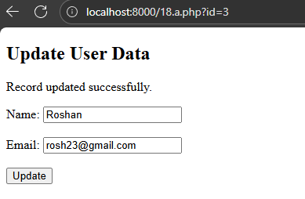
- Delete:
<?php
$conn = new mysqli("localhost", "root", "nik@123N", "simpledb");
if ($conn->connect_error) {
die("Connection failed: " . $conn->connect_error);
}

if (isset($_GET['id'])) {
$id = intval($_GET['id']);
$sql = "DELETE FROM users WHERE id=$id";

if ($conn->query($sql) === TRUE) {
// Redirect back to view page after deletion
header("Location: 18.c.php");
exit();
} else {
echo "Error deleting record: " . $conn->error;
}
} else {
echo "No ID specified.";
}

$conn->close();
?>

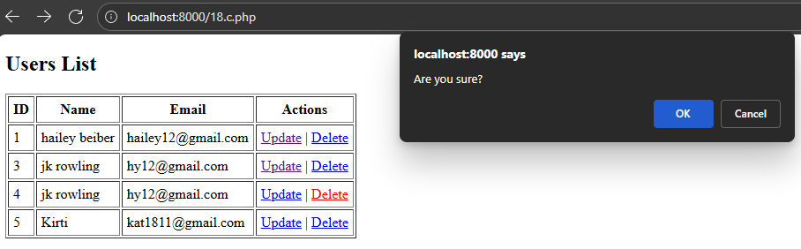
- View:
<!DOCTYPE html>
<html>
<head>
<title>View Users</title>
</head>
<body>
<h2>Users List</h2>

<?php
$conn = new mysqli("localhost", "root", "nik@123N", "simpledb");
if ($conn->connect_error) {
die("Connection failed: " . $conn->connect_error);
}

$sql = "SELECT * FROM users";
$result = $conn->query($sql);

if ($result->num_rows > 0) {
echo "<table border='1' cellpadding='5'><tr><th>ID</th><th>Name</th><th>Email</th><th>Actions</th></tr>";
while ($row = $result->fetch_assoc()) {
echo "<tr><td>" . $row["id"] . "</td>";
echo "<td>" . htmlspecialchars($row["name"]) . "</td>";
echo "<td>" . htmlspecialchars($row["email"]) . "</td>";
echo "<td>
<a href='18.a.php?id=" . $row["id"] . "'>Update</a> |
<a href='18.b.php?id=" . $row["id"] . "' onclick='return confirm(\"Are you sure?\");'>Delete</a>
</td></tr>";
}
echo "</table>";
} else {
echo "No records found.";
}

$conn->close();
?>
</body>
</html>

OUTPUT:

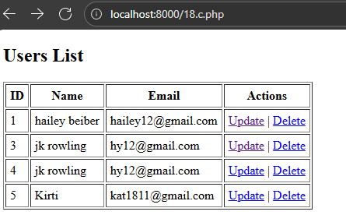
After updating and deleting:
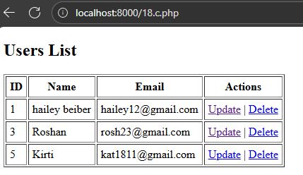

19.
Write simple PHP program to set cookies and read it.

<!DOCTYPE html>
<html>
<body>
<?php
$cookie_name = "userFavoriteLanguage";
$cookie_value = "Python with AI & Automation";
// Set the cookie for whole website, expires in 7 days
setcookie($cookie_name, $cookie_value, time() + (7 * 24 * 60 * 60), "/");

if (!isset($_COOKIE[$cookie_name])) {
echo "Cookie '{$cookie_name}' is not set yet. Refresh after setting it.";
} else {
echo "Welcome back! Your favorite coding language is <strong>" . htmlspecialchars($_COOKIE[$cookie_name]) . "</strong>.";
}
?>
</body>
</html>
OUTPUT:
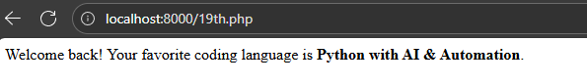
20.

Create a PHP page for login system using session.

a)
<?php
session_start();

if (isset($_SESSION['user'])) {
header("Location: 20.b.php");
exit;
}

$error = "";

if ($_SERVER["REQUEST_METHOD"] == "POST") {
$username = $_POST['username'] ?? "";
$password = $_POST['password'] ?? "";

// Dummy user data for demonstration
$valid_username = "katy perry";
$valid_password = "secretsuperstar1"; // In real apps, use hashed passwords

if ($username === $valid_username && $password === $valid_password) {
$_SESSION['user'] = $username;
header("Location: 20.b.php");
exit;
} else {
$error = "Invalid username or password!";
}
}
?>

<!DOCTYPE html>
<html>
<head>
<title>Login</title>
</head>
<body>
<h2>Login System with Session</h2>
<?php if ($error) { echo "<p style='color:red;'>$error</p>"; } ?>

<form method="post">
Username: <input type="text" name="username" required><br><br>
Password: <input type="password" name="password" required><br><br>
<input type="submit" value="Login">
</form>
</body>
</html>

OUTPUT:
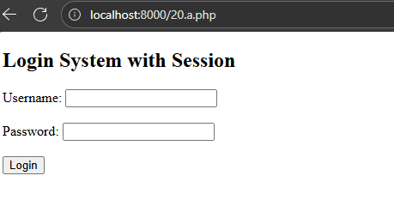
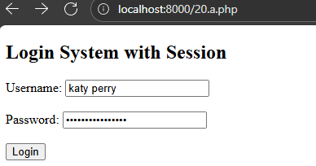

b)
<?php
session_start();

if (!isset($_SESSION['user'])) {
header("Location: 20.a.php");
exit;
}

$username = htmlspecialchars($_SESSION['user']);
?>

<!DOCTYPE html>
<html>
<head>
<title>Welcome</title>
</head>
<body>
<h2>Welcome, <?php echo $username; ?>!</h2>
<p>You have successfully logged in.</p>
<a href="20.c.php">Logout</a>
</body>
</html>
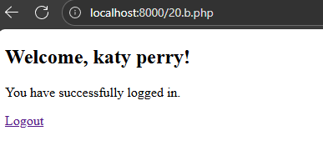

c)
<?php
session_start();
session_unset();
session_destroy();
header("Location: 20.a.php");
exit;
?>

21.

Create student registration form using text box, check box, radio button, select, submit button and display the values entered by the user in new PHP page.

register.php:

<!DOCTYPE html>
<html>
<head>
<title>Student Registration Form</title>
</head>
<body>
<h2>Student Registration Form</h2>
<form method="post" action="display.php">
<label for="name">Name:</label><br>
<input type="text" name="name" id="name" required><br><br>

<label for="email">Email:</label><br>
<input type="email" name="email" id="email" required><br><br>

<label>Gender:</label><br>
<input type="radio" id="male" name="gender" value="Male" required>
<label for="male">Male</label><br>
<input type="radio" id="female" name="gender" value="Female" required>
<label for="female">Female</label><br><br>

<label>Hobbies:</label><br>
<input type="checkbox" id="sports" name="hobbies[]" value="Sports">
<label for="sports">Sports</label><br>
<input type="checkbox" id="reading" name="hobbies[]" value="Reading">
<label for="reading">Reading</label><br>
<input type="checkbox" id="music" name="hobbies[]" value="Music">
<label for="music">Music</label><br><br>

<label for="course">Course:</label><br>
<select id="course" name="course" required>
<option value="">--Select a course--</option>
<option value="Computer Science">Computer Science</option>
<option value="Mathematics">Mathematics</option>
<option value="Physics">Physics</option>
</select><br><br>

<input type="submit" value="Register">
</form>
</body>
</html>

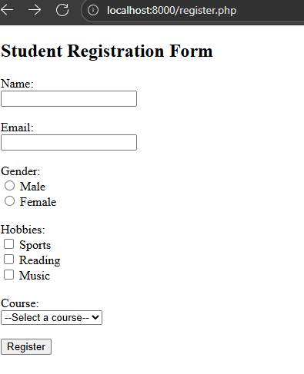
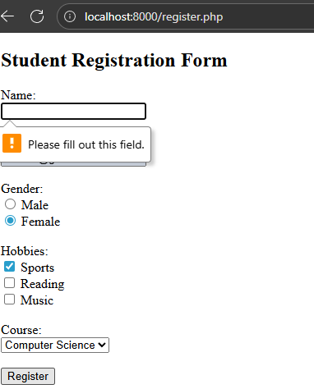

display.php:

<!DOCTYPE html>
<html>
<head>
<title>Registration Details</title>
</head>
<body>
<h2>Your Registration Details</h2>

<?php
if ($_SERVER["REQUEST_METHOD"] == "POST") {
$name = htmlspecialchars($_POST['name']);
$email = htmlspecialchars($_POST['email']);
$gender = htmlspecialchars($_POST['gender']);
$course = htmlspecialchars($_POST['course']);

echo "<p><strong>Name:</strong> $name</p>";
echo "<p><strong>Email:</strong> $email</p>";
echo "<p><strong>Gender:</strong> $gender</p>";

if (!empty($_POST['hobbies'])) {
$hobbies = $_POST['hobbies'];
// Sanitize each hobby value
$hobbies = array_map('htmlspecialchars', $hobbies);
echo "<p><strong>Hobbies:</strong> " . implode(", ", $hobbies) . "</p>";
} else {
echo "<p><strong>Hobbies:</strong> None selected</p>";
}
echo "<p><strong>Course:</strong> $course</p>";
} else {
echo "<p>No data received.</p>";
}
?>
</body>
</html>

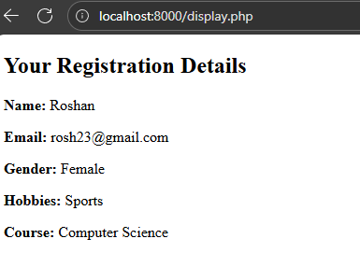

22.

Create a PHP program to demonstrate Cross Join
sql:
create database testdb;
use testdb;

cross join:
<?php
$servername = "localhost";
$username = "root";
$password = "nik@!23N";
$database = "testdb";

// Connect to database
$conn = new mysqli($servername, $username, $password, $database);
if ($conn->connect_error) {
die("Connection failed: " . $conn->connect_error);
}

// Create colors table if not exists
$conn->query("CREATE TABLE IF NOT EXISTS colors (
id INT PRIMARY KEY,
color_name VARCHAR(20)
)");

// Create shapes table if not exists
$conn->query("CREATE TABLE IF NOT EXISTS shapes (
id INT PRIMARY KEY,
shape_name VARCHAR(20)
)");

// Insert sample values if not already present
$conn->query("INSERT IGNORE INTO colors (id, color_name) VALUES
(1, 'Red'), (2, 'Green'), (3, 'Blue')");

$conn->query("INSERT IGNORE INTO shapes (id, shape_name) VALUES
(1, 'Circle'), (2, 'Square')");

// CROSS JOIN query
$sql = "SELECT colors.color_name, shapes.shape_name
FROM colors
CROSS JOIN shapes";

$result = $conn->query($sql);

echo "<h2>CROSS JOIN Result</h2>";
if ($result && $result->num_rows > 0) {
echo "<table border='1' cellpadding='5'><tr><th>Color</th><th>Shape</th></tr>";
while ($row = $result->fetch_assoc()) {
echo "<tr><td>" . htmlspecialchars($row['color_name']) . "</td><td>" . htmlspecialchars($row['shape_name']) . "</td></tr>";
}
echo "</table>";
} else {
echo "No results found or query error: " . $conn->error;
}

$conn->close();
?>?>
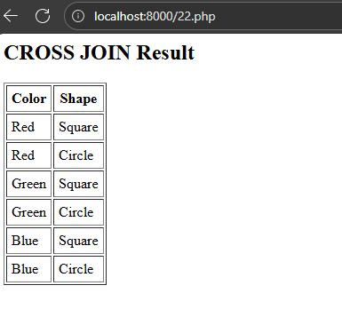

23.

Create a simple XML file to store book information, including title, author, and publication year.

<?xml version="1.0" encoding="UTF-8"?>
<books xmlns:xsi="http://www.w3.org/2001/XMLSchema-instance" xsi:noNamespaceSchemaLocation="books.xsd">
<book>
<h3> The Bravehearts</h3>
<author>Rachna Bisht Rawat</author><br>
<isbn>81-7371-146-1</isbn><br>
<publisher>Penguin Random House India</publisher><br>
<edition>1st</edition><br>
<price>180</price><br>
</book>
<book>
<h3>The Concise Laws of Human Nature</h3>
<author>Robert Greene</author><br>
<isbn>58-9402-236-1</isbn><br>
<publisher>Penguin Books</publisher><br>
<edition>1st</edition><br>
<price>620</price>
</book>
</books>

.xsd:
<?xml version="1.0" encoding="UTF-8"?>
<xs:schema
xmlns:xs="http://www.w3.org/2001/XMLSchema">
<xs:element name="books">
<xs:complexType>
<xs:sequence>
<xs:element name="title" type="xs:string" />
<xs:element name="author" type="xs:string" />
<xs:element name="isbn" type="xs:string" />
<xs:element name="publisher" type="xs:string" />
<xs:element name="edition" type="xs:string" />
<xs:element name="price" type="xs:decimal" />
</xs:sequence>
</xs:complexType>
</xs:element>
</xs:schema>
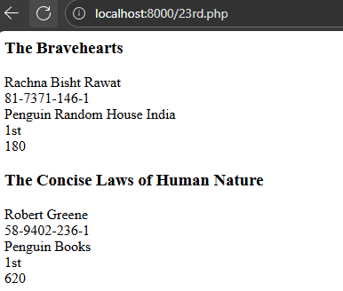

24.

Create a form (e.g., user registration or login) that submits data using AJAX and displays success or error messages without reloading the page.

index.html:
<!DOCTYPE html>
<html>
<head>

<script src="https://code.jquery.com/jquery-3.6.0.min.js"></script>
<style>
#emailError {
color: red;
font-size: 0.9em;
margin-top: -10px;
margin-bottom: 10px;
}
#message {
margin-top: 10px;
}
</style>
</head>
<body>
<h2>Register</h2>
<form id="registrationForm" novalidate>
<label>Name:</label><br>
<input type="text" id="name" name="name" required><br><br>

<label>Email:</label><br>
<input type="email" id="email" name="email" required><br>
<span id="emailError"></span><br>

<label>Password:</label><br>
<input type="password" id="password" name="password" required><br><br>

<input type="submit" value="Register">
</form>

<div id="message"></div>

<script>
$(document).ready(function(){
$("#registrationForm").submit(function(event){
event.preventDefault();

$("#message").html("");
$("#emailError").text("");

var email = $("#email").val().trim();
var name = $("#name").val().trim();
var password = $("#password").val();

var emailPattern = /^[^\s@]+@[^\s@]+\.[^\s@]+$/;

if (!emailPattern.test(email)) {
$("#emailError").text("Invalid email address.");
$("#email").focus();
return;
}

$.ajax({
type: "POST",
url: "process_registration.php",
data: { name: name, email: email, password: password },
dataType: "json",
success: function(response) {
if(response.success) {
$("#message").html("<span style='color:green'>" + response.message + "</span>");
$("#registrationForm")[0].reset();
} else {
$("#message").html("<span style='color:red'>" + response.message + "</span>");
}
},
error: function(xhr, status, error){
$("#message").html("<span style='color:red'>AJAX error: " + error + "</span>");
console.log("AJAX error details:", status, xhr.responseText);
}
});
});
});
</script>
</body>
</html>

process_registration.php:

<?php
header('Content-Type: application/json');

$name = $_POST['name'] ?? '';
$email = $_POST['email'] ?? '';
$password = $_POST['password'] ?? '';

if (empty($name) || empty($email) || empty($password)) {
echo json_encode(['success' => false, 'message' => 'Please fill in all fields.']);
exit;
}

if (!filter_var($email, FILTER_VALIDATE_EMAIL)) {
echo json_encode(['success' => false, 'message' => 'Invalid email address.']);
exit;
}

// Here you can add code to save user info in a database

echo json_encode(['success' => true, 'message' => 'Registration successful!']);
