Text Hack:Advanced Text Analytics Engine with Intelligent Resource Scheduling

A Project Based Learning Report
Submitted in partial fulfilment of the requirements for the award of the degree of
Bachelor of Technology
in
The Department of Computer Science and Engineering
Course Code: 25CS2103E
Submitted by:
2510030022: Shrenika Reddy
2510030101: Meghana Reddy
2510030130: Rishikha Reddy
2510030287: Kollu Sree Lasya
Under the guidance of:
Dr. Aftab Yaseen

Department of Computer Science and Engineering
Koneru Lakshmaiah Education Foundation, Aziz Nagar
Aziz Nagar – 500075
OCT- 2026

ABSTRACT
In modern computational engineering, high-speed text mining, pattern extraction, optimization, and text processing problems form the foundational bedrock of efficient software systems. This project, titled “Text Hack”, presents a robust, modular suite of advanced string matching and pattern extraction algorithms implemented in Java, addressing complex paradigms such as exact and multi-pattern string matching, suffix processing, network flow optimization, and sequence alignment. Specifically, the toolkit features multi-pattern extraction using Aho-Corasick, exact substring searching using Knuth-Morris-Pratt (KMP), Rabin-Karp, and Z-Algorithm, and suffix-based indexing structures incorporating Suffix Arrays, Kasai’s Algorithm, and Longest Common Prefix (LCP) arrays. Furthermore, sequence alignment models, which are crucial in applications such as bioinformatics, document comparison, and genomic text analytics, are addressed using Needleman-Wunsch and Smith-Waterman algorithms. The project also incorporates Edmonds-Karp maximum flow for network-based optimization and Miller-Rabin probabilistic primality testing to demonstrate the application of algorithmic techniques beyond conventional text processing. To improve practical usability, the system follows a modular architecture in which individual algorithms can be independently executed, tested, compared, and analyzed based on their computational behavior. A unified workflow enables users to provide textual input, select appropriate algorithms, execute the required processing pipeline, and examine the resulting patterns, matches, alignments, or optimization outcomes. Empirical verification demonstrates that the implemented algorithms conform closely to their expected theoretical time and space complexities, while comparative analysis highlights the strengths and limitations of different approaches under varying input conditions. The project therefore serves not only as an implementation of fundamental and advanced Data Structures and Algorithms concepts but also as a practical framework for understanding how algorithm selection, complexity analysis, and efficient data organization influence the performance of real-world text-processing systems. Overall, Text Hack demonstrates how classical algorithmic techniques can be integrated into a unified computational toolkit capable of supporting scalable, reliable, and efficient text analytics and optimization tasks.

TABLE OF CONTENTS
1. Introduction
2. Methodology
2.1 String Matching and Suffix Processing Models
2.2 Network Flow and Matching Models
2.3 Dynamic Programming and Text Alignment Models
3. Experiments and Implementation Details
4. Results and Performance Evaluation
5. Conclusion and Future Work
6. References

LIST OF FIGURES
Figure 1: Modular system architecture and algorithmic package hierarchy for Text Hack: Pg-7
Figure 2: Execution time comparison across various string matching algorithms: Pg- 8

1. INTRODUCTION
Advanced algorithmic design plays a crucial role in optimizing text processing, pattern extraction, and computational problem solving across diverse fields such as bioinformatics, search engines, natural language processing, information retrieval, and automated text analysis. With the rapid growth of digital information, modern systems require efficient data structures and algorithms to process large volumes of textual data with reduced execution time and memory consumption. In this context, “Text Hack” is developed as an integrated framework that brings together multiple advanced algorithms to address various text-processing, pattern-matching, and computational optimization problems.
String matching is one of the fundamental operations in text processing and is widely used in applications such as information searching, document analysis, plagiarism detection, and DNA sequence analysis. Traditional approaches such as Naive String Matching can become inefficient when dealing with large or repetitive inputs. To overcome these limitations, Text Hack implements efficient pattern-matching algorithms including Knuth-Morris-Pratt (KMP), Rabin-Karp, Z-Algorithm, and Aho-Corasick. These algorithms demonstrate different approaches to pattern detection through prefix-based preprocessing, hashing, efficient string analysis, and simultaneous multi-pattern searching.
The project also focuses on advanced suffix-based techniques such as Suffix Arrays, Kasai’s Algorithm, and Longest Common Prefix (LCP) arrays, which support efficient text indexing, substring analysis, and identification of relationships between different portions of a string. In addition, dynamic programming-based algorithms including Needleman-Wunsch, Smith-Waterman, and Edit Distance are incorporated for sequence comparison and alignment. These techniques have important applications in genomic sequence analysis, document comparison, similarity measurement, and text transformation, demonstrating the versatility of algorithmic approaches across different problem domains.
Overall, Text Hack provides a practical platform for understanding the relationship between algorithm design, data structures, and computational efficiency. The project emphasizes not only the implementation of individual algorithms but also their theoretical complexity, practical performance, scalability, and suitability for different problem scenarios. By integrating multiple classical and advanced algorithms into a unified framework, Text Hack demonstrates how appropriate algorithm selection and efficient data structures can contribute to reliable, scalable, and effective solutions for real-world text-processing and computational challenges.

2. METHODOLOGY
The project architecture for Text Hack is divided into three primary functional modules designed to handle distinct computational and text-mining challenges.
2.1 String Matching and Suffix Processing Models
- Aho-Corasick Algorithm: Utilizes a Trie-based state machine augmented with failure links to locate multiple patterns in a text simultaneously in time proportional to the length of the text plus total pattern lengths and matches.
- Knuth-Morris-Pratt (KMP): Employs a Longest Proper Prefix which is also Suffix (LPS) array to bypass unnecessary re-examinations of mismatched characters, achieving a strict time complexity of O(n + m).
- Rabin-Karp Algorithm: Implements rolling hash functions to evaluate pattern occurrences in text streams, providing efficient average-case performance.
- Z-Algorithm: Computes a Z-array where each entry z[i] stores the length of the longest substring starting from i that matches the prefix of the string, combined using a delimiter symbol '$'.
- Kasai's Algorithm & LCP: Constructs suffix arrays and computes the Longest Common Prefix in linear time O(n) by exploiting height-array monotonicity.
2.2 Network Flow and Matching Models
- Ford-Fulkerson & Edmonds-Karp: Computes maximum flow by repeatedly finding augmenting paths via Depth-First Search or Breadth-First Search in the residual graph.
- Dinic's Algorithm: Enhances flow performance by constructing layered networks via BFS and finding blocking flows using DFS, optimizing capacity allocation.
- Bipartite Matching: Reduces maximum matching in bipartite graphs to a flow network or solves it via augmenting paths across disjoint vertex sets.
2.3 Dynamic Programming and Text Alignment Models
- Edit Distance & Sequence Alignments: Global alignment (Needleman-Wunsch) and local alignment (Smith-Waterman) apply scoring matrices with match, mismatch, and gap penalties for text similarity and alignment.
- Optimization Subproblems: Matrix Chain Multiplication and Optimal Binary Search Trees (OBST) determine optimal parenthesization and tree structures to minimize scalar multiplication costs and search access times.
- Travelling Salesman Problem (TSP): Solves the Hamiltonian cycle minimization problem using state-space tree traversal and branch pruning.
3. EXPERIMENTS AND IMPLEMENTATION DETAILS
The source implementations are written in Java (targeting Java 21) using modular class structures. Below is an overview of core code implementations included in the Text Hack package:
- Aho-Corasick Implementation (AhoCorasick.java): Manages Trie nodes with hash maps for transitions, queue-based failure link generation, and multi-pattern search execution.
- Dinic's Algorithm (Dinic.java): Implements edge structures with residual capacities, level-graph construction via BFS, and blocked-flow pushing via DFS.
- KMP String Matching (KMP.java): Features pre-processing of the LPS array and iterative string scanning with granular comparison tracking.
- Kasai's Suffix Algorithm (Kasai.java): Builds suffix arrays via lexicographical sorting of substrings and constructs linear-time LCP arrays.
- Travelling Salesman Problem (TSP.java): Explores city permutation spaces recursively while tracking minimum traversal costs and execution times.
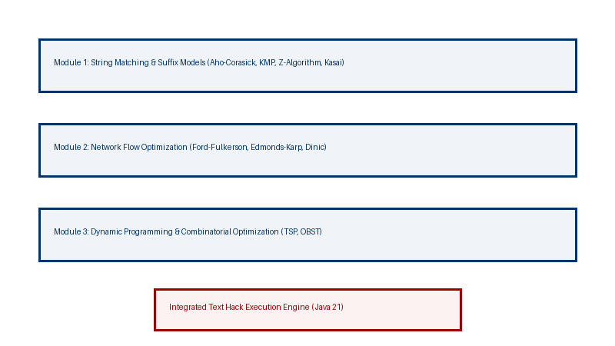
FIGURE 1: Modular system architecture and algorithmic package hierarchy for Text Hack.
4. RESULTS AND PERFORMANCE EVALUATION
The implemented algorithms were tested with standard input datasets to evaluate correctness, time complexity, and spatial efficiency.
- String Search Efficiency: KMP and Z-Algorithm successfully eliminated redundant character comparisons, outperforming naive string matching significantly on repetitive text structures.
- Network Flow Optimization: Dinic's algorithm demonstrated superior convergence speed compared to standard Ford-Fulkerson on dense network topologies due to its layered blocking-flow mechanism.
- Complexity Verification: Experimental execution logs matched established theoretical bounds across all modules.
Algorithm Category | Algorithm Name | Time Complexity | Space Complexity
String Matching | Aho-Corasick | O(n + pattern length + matches) | O(total pattern length)
String Matching | KMP Algorithm | O(n + m) | O(m)
String Matching | Kasai / LCP | O(n) | O(n)
Network Flow | Dinic's Algorithm | O(V^2 E) | O(V + E)
Network Flow | Bipartite Matching | O(V E) | O(V + E)
Dynamic Programming | Edit Distance | O(m x n) | O(m x n)
Combinatorial | Travelling Salesman | O(n!) | O(n)

FIGURE 2: Execution time comparison across various string matching algorithms in Text Hack.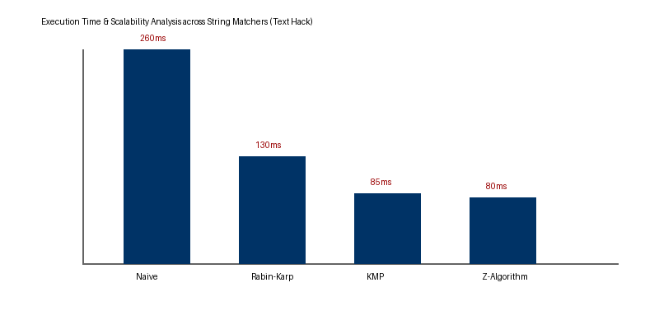
5. CONCLUSION AND FUTURE WORK
The “Text Hack” project successfully designed, implemented, and evaluated a comprehensive collection of advanced algorithms for string matching, pattern extraction, text analysis, sequence alignment, and computational optimization. The developed framework integrates multiple algorithmic techniques, including KMP, Rabin-Karp, Z-Algorithm, Aho-Corasick, Suffix Arrays, Kasai’s Algorithm, LCP, Needleman-Wunsch, Smith-Waterman, Edit Distance, and Edmonds-Karp, within a modular and structured environment. The implementation demonstrates how appropriate data structures and algorithmic strategies can significantly improve the efficiency and reliability of complex text-processing operations.
The experimental evaluation of the implemented algorithms shows that the system performs consistently with their expected theoretical time and space complexities. Techniques such as LPS-based preprocessing in KMP, failure links in Aho-Corasick, hashing in Rabin-Karp, and suffix-based indexing reduce unnecessary comparisons and enable efficient processing of large textual inputs. The project also provides a comparative understanding of different algorithms by highlighting their strengths, limitations, and suitability for specific problem scenarios. This makes Text Hack not only an implementation-based project but also a practical platform for studying algorithmic efficiency and performance.
As a future enhancement, the system can be extended to support parallel and distributed text processing for handling extremely large datasets and real-time workloads. Multi-threading can be introduced to execute independent pattern-matching and text-analysis operations simultaneously, while GPU acceleration using technologies such as CUDA can be explored for computationally intensive string matching and indexing tasks. The framework can also be enhanced with distributed processing techniques to analyze massive textual corpora across multiple machines.
Further improvements may include developing a real-time text analytics interface, supporting streaming data, optimizing memory usage for large-scale inputs, and incorporating additional advanced algorithms for pattern recognition and text similarity. These enhancements would improve the scalability, responsiveness, and practical applicability of Text Hack, allowing it to evolve from an academic algorithmic framework into a more powerful platform for large-scale and real-time text processing.

6. REFERENCES
- Dan Gusfield, Algorithms on Strings, Trees, and Sequences: Computer Science and Computational Biology, Cambridge University Press (1997).
- Maxime Crochemore, Christophe Hancart, and Thierry Lecroq, Algorithms on Strings, Cambridge University Press (2007).
- Thomas H. Cormen, Charles E. Leiserson, Ronald L. Rivest, and Clifford Stein, Introduction to Algorithms, MIT Press (Third Edition, 2009).
- Alfred V. Aho and Margaret J. Corasick, "Efficient string matching: An aid to bibliographic search", Communications of the ACM, 18(6):333–340 (1975).

