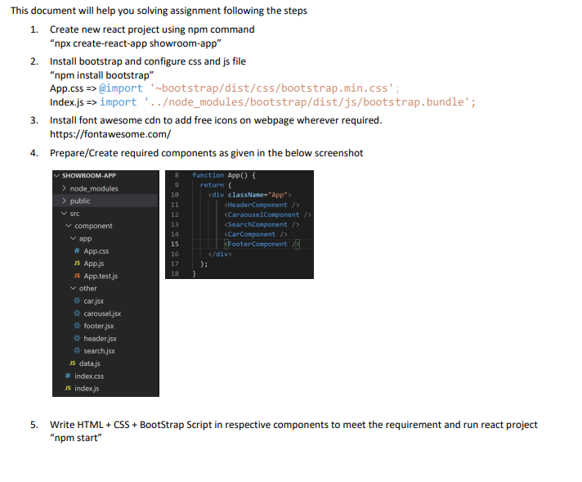
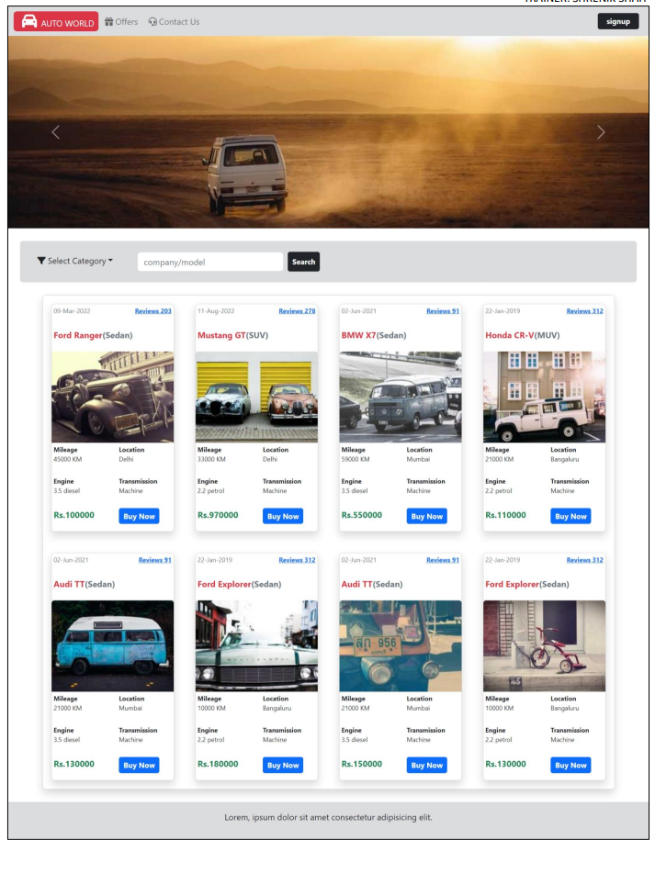
Carousel Sample Code
div className="carousel-item active">
<img src="https://picsum.photos/id/551/1000/300" className="d-block w-100" />
</div>
<div className="carousel-item">
<img src="https://picsum.photos/id/563/1000/300" className="d-block w-100" />
</div>
<div className="carousel-item">
<img src="https://picsum.photos/id/549/1000/300" className="d-block w-100" />
Car types to add filter in search component
let cartypes = () => { return ( [ {id:'81', category:'Hatchback'}, {id:'82', category:'Sedan'}, {id:'83', category:'SUV'}, {id:'84', category:'MUV'}, {id:'85', category:'Coupe'}, {id:'86', category:'Convertibles'}, {id:'87', category:'Pickup Trucks'} ] ) }
car details to prepare card view on webpage in car component
let cars = () => {
return (
[
{date:'09-Mar-2022', carname:'Ford Ranger', reviews:203,
image:'https://picsum.photos/id/111/200/150', mileage:'45000 KM',
location:'Delhi', engine:'3.5 diesel', transmission:'Machine',
type:'Sedan', price:'Rs.100000'},
{date:'11-Aug-2022', carname:'Mustang GT',reviews:278,
image:'https://picsum.photos/id/133/200/150', mileage:'33000 KM',
location:'Delhi', engine:'2.2 petrol', transmission:'Machine',
type:'SUV', price:'Rs.970000'},
{date:'02-Jun-2021', carname:'BMW X7', reviews:91,
image:'https://picsum.photos/id/183/200/150', mileage:'59000 KM',
location:'Mumbai', engine:'3.5 diesel', transmission:'Machine',
type:'Sedan', price:'Rs.550000'},
{date:'22-Jan-2019', carname:'Honda CR-V', reviews:312,
image:'https://picsum.photos/id/514/200/150', mileage:'21000 KM',
location:'Bangaluru', engine:'2.2 petrol', transmission:'Machine',
type:'MUV', price:'Rs.110000'},
{date:'02-Jun-2021', carname:'Audi TT', reviews:91,
image:'https://picsum.photos/id/655/200/150', mileage:'21000 KM',
location:'Mumbai', engine:'3.5 diesel', transmission:'Machine',
type:'Sedan', price:'Rs.130000'},
{date:'22-Jan-2019', carname:'Ford Explorer', reviews:312,
image:'https://picsum.photos/id/1071/200/150', mileage:'10000 KM',
location:'Bangaluru', engine:'2.2 petrol', transmission:'Machine',
type:'Sedan', price:'Rs.180000'},
{date:'02-Jun-2021', carname:'Audi TT', reviews:91,
image:'https://picsum.photos/id/45/200/150', mileage:'21000 KM',
location:'Mumbai', engine:'3.5 diesel', transmission:'Machine',
type:'Sedan', price:'Rs.150000'},
{date:'22-Jan-2019', carname:'Ford Explorer', reviews:312,
image:'https://picsum.photos/id/146/200/150', mileage:'10000 KM',
location:'Bangaluru', engine:'2.2 petrol', transmission:'Machine',
type:'Sedan', price:'Rs.130000'}
]
)

