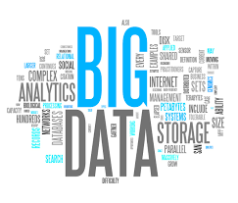

CS322:Big Data

Final Class Project Report

Project (FPL Analytics / YACS coding): FPL Analytics
Date: __________

SNo | Name | SRN | Class/Section
1 | R.Shrenik | PES1201800690 | A
2 | Saket Bubna | PES1201801197 | F
3 | Pranav BG | PES1201801657 | F
4 | Akhilesh A Kabade | PES1201801722 | G

Introduction
The project is aimed at analyzing FPL data to rate and rank players, analyze match event data in real-time, compute team strengths and understand and predict player ratings using Apache Spark and its supporting libraries.

Related work
I’ve gone through Spark’s official documentation to familiarize myself with it.

Design
Talk about the design of the system, algorithms used, and models implemented. Block diagrams are preferred wherever applicable.
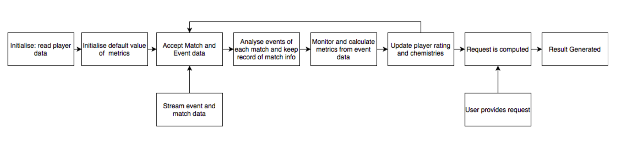

The overall flow of the project analysis is given above.
- Import required libraries, datasets and instantiate a spark context. Create a Player schema and a Teams Schema and create the RDDs. Initialize default values of metrics. We then create a match dataframe and register all dataframes as tables. We stream the match data on port 6100 and read in the match event data. The event JSON object is sent when the match commences and the event JSON objects are sent for that match. Coming to the metric calculation part, I’ve defined all the functions and loaded the RDDs. Based on the Event ID values, we monitor and calculate metrics from the event data.
- At the end of each match, player contribution can be normalized by multiplying with proportion of match played. Player ratings can also be calculated based on the constraints given.
- To predict winning chances, we could use the formula but without the required amount of data on a few players, it would not be possibly to accurately predict so we could opt for a clustering model which involves clustering players into 5 groups and approximate based on player profiles.
- We can make use of a regression model (quadratic) to model the change in player’s rating with age.
- Finally, we can create a user interface to query player profiles, match data using JSON files.

Results:

- Accepting streamed data on streaming spark.
- Metric calculation (O/P printed only for one)

Problems

- ZERO involvement of my other 3 teammates wrt the entire project
- Errors while streaming data (No output, java runtime errors etc)
- Writing efficient code with good style to minimize runtime and maximize readability.
- Obtaining results for all objectives

Conclusion
What was your main learning from this project?
- Familiarizing oneself with a new technology (Spark and associated libraries) within a short span of time using just the official documentation.
- Application of pyspark, streaming spark, a somewhat decent understanding of RDDs.
- Learned how to work with JSON files.
- Learned when to use what kind of machine learning model.
- Gained insight into how real-world semi-structured data looks like + some insight into the kind of work I might be expected to work on in the industry.
- Learned that having the right team that is equally motivated as you is very crucial.

EVALUATIONS:

SNo | Name | SRN | Contribution (Individual)
1 | R.Shrenik | PES1201800690
2 | Saket Bubna | PES1201801197
3 | Pranav BG | PES1201801657
4 | Akhilesh Kabade | PES1201801722

(Leave this for the faculty)

Date | Evaluator | Comments | Score

CHECKLIST:

SNo | Item | Status
1. | Source code documented
2. | Source code uploaded to GitHub – (access link for the same, to be added in status →)
3. | Instructions for building and running the code. Your code must be usable out of the box.

