Week 1 Task
Data Acquisition, Cleaning and Preprocessing
A practical data-quality study of the Titanic passenger manifest

Prepared by | Shreyan Bag
Dataset | Titanic passenger manifest (OpenML dataset id 40945)
Source | https://www.openml.org/data/get_csv/16826755/phpMYEkMl
Dataset size | 1309 rows x 14 columns (115 KB)
Analysis script | src/data_preprocessing.py
Date | 17 September 2026

1. Introduction
This report documents the acquisition, quality assessment, cleaning and preprocessing of a real, publicly available dataset. The objective is to take a raw file exactly as it is published, establish what is actually wrong with it through explicit checks rather than assumption, correct the defects with justified methods, and deliver a dataset that is ready for statistical analysis and machine learning.

Why data quality matters
Analytical results inherit every defect present in their input. Missing values silently shrink the sample of any calculation that touches them; impossible values distort means, variances and correlations; duplicated records give repeated observations double weight; and text categories cannot be consumed by most modelling algorithms at all. A model trained on uncorrected data can appear accurate while having learned an artefact of the recording process rather than a real relationship.

Purpose of preprocessing
Preprocessing converts a human-readable record set into a numerical matrix with consistent types, no gaps and comparable scales, while preserving as much genuine information as possible. Every transformation applied here is recorded together with the reason for it, so that the resulting dataset can be audited and reproduced.

2. Dataset Selection
Property | Value
Dataset name | Titanic passenger manifest (OpenML dataset id 40945)
Source | https://www.openml.org/data/get_csv/16826755/phpMYEkMl
Provider | OpenML, an open public repository of machine-learning datasets
Format | CSV, 117743 bytes
Records | 1309 passengers
Attributes | 14 columns
Target variable | survived (0 = did not survive: 809, 1 = survived: 500)
Table 1: Dataset identification.

Attributes
Column | Description
pclass | Ticket class (1, 2, 3) - a proxy for socio-economic status
survived | Survival outcome, the natural target variable
name | Full passenger name, including an honorific title
sex | Passenger sex
age | Age in years; fractional values are used for infants
sibsp | Number of siblings and spouses aboard
parch | Number of parents and children aboard
ticket | Ticket number, shared by passengers travelling together
fare | Price paid for the ticket
cabin | Cabin identifier, beginning with a deck letter
embarked | Port of embarkation (S, C, Q)
boat | Lifeboat identifier, recorded only for rescued passengers
body | Body-recovery number, recorded only for recovered victims
home.dest | Free-text home town and destination
Table 2: Attributes of the raw dataset.

Reason for selection
The dataset was chosen because it exhibits, in one small file, every category of defect this task is intended to address: substantial and unevenly distributed missing values, non-numeric categorical text, identifier columns of high cardinality, values that are numerically valid but factually impossible, heavily skewed monetary values, and two columns that leak the outcome. It is also small enough that every finding can be traced back to individual records and verified by hand.

3. Data Acquisition
The file was downloaded once, programmatically, from the OpenML distribution of the dataset and stored in the repository as data/titanic.csv so that later runs are reproducible and do not depend on network availability. OpenML publishes the manifest with missing entries encoded as the literal character "?" rather than as empty fields, so that token has to be declared when reading the file; otherwise every affected column is silently loaded as text and no missing value is detected at all.
SOURCE_URL = "https://www.openml.org/data/get_csv/16826755/phpMYEkMl"
if not os.path.exists(RAW_CSV):
urllib.request.urlretrieve(SOURCE_URL, RAW_CSV)
# The OpenML distribution encodes missing entries as the literal string "?".
df_raw = pd.read_csv(RAW_CSV, na_values=["?"])
The load produced a DataFrame of 1309 rows and 14 columns.

4. Initial Data Exploration
Dimensions: 1309 rows x 14 columns. The first five records are shown below.
pclass | survived | name | sex | age | sibsp | parch | fare | cabin | embarked
1 | 1 | Allen, Miss. Elisabeth Walton | female | 29.0 | 0 | 0 | 211.3375 | B5 | S
1 | 1 | Allison, Master. Hudson Trevor | male | 0.9167 | 1 | 2 | 151.55 | C22 C26 | S
1 | 0 | Allison, Miss. Helen Loraine | female | 2.0 | 1 | 2 | 151.55 | C22 C26 | S
1 | 0 | Allison, Mr. Hudson Joshua Creighton | male | 30.0 | 1 | 2 | 151.55 | C22 C26 | S
1 | 0 | Allison, Mrs. Hudson J C (Bessie Waldo Daniels) | female | 25.0 | 1 | 2 | 151.55 | C22 C26 | S
Table 3: First five records of the raw dataset (a subset of columns).
Column data types as loaded:
Column | Dtype | Column | Dtype
pclass | int64 | ticket | object
survived | int64 | fare | float64
name | object | cabin | object
sex | object | embarked | object
age | float64 | boat | object
sibsp | int64 | body | float64
parch | int64 | home.dest | object
Table 4: Data types reported by pandas for the raw dataset.
Descriptive statistics for the numeric columns:
column | count | mean | std | min | 25% | 50% | 75% | max
pclass | 1309.0 | 2.295 | 0.838 | 1.0 | 2.0 | 3.0 | 3.0 | 3.0
survived | 1309.0 | 0.382 | 0.486 | 0.0 | 0.0 | 0.0 | 1.0 | 1.0
age | 1046.0 | 29.881 | 14.413 | 0.167 | 21.0 | 28.0 | 39.0 | 80.0
sibsp | 1309.0 | 0.499 | 1.042 | 0.0 | 0.0 | 0.0 | 1.0 | 8.0
parch | 1309.0 | 0.385 | 0.866 | 0.0 | 0.0 | 0.0 | 0.0 | 9.0
fare | 1308.0 | 33.295 | 51.759 | 0.0 | 7.896 | 14.454 | 31.275 | 512.329
body | 121.0 | 160.81 | 97.697 | 1.0 | 72.0 | 155.0 | 256.0 | 328.0
Table 5: Descriptive statistics of the raw numeric columns.
Three observations follow directly from this table. The count column shows that age is present for only 1046 of 1309 passengers. The minimum fare is 0, which cannot be the price of a purchased ticket. The maximum fare of 512.33 is roughly ten times the third quartile, which signals a strongly skewed monetary distribution.
Missing values by column (columns with no missing values are omitted):
Column | Missing | Missing %
body | 1188 | 90.76%
cabin | 1014 | 77.46%
boat | 823 | 62.87%
home.dest | 564 | 43.09%
age | 263 | 20.09%
embarked | 2 | 0.15%
fare | 1 | 0.08%
Table 6: Missing-value counts and percentages in the raw dataset.
Total missing cells: 3855. Exact duplicate rows: 0.
Categorical value inspection:
Column | Unique | Values and counts
pclass | 3 | 3: 709, 1: 323, 2: 277
survived | 2 | 0: 809, 1: 500
sex | 2 | male: 843, female: 466
embarked | 3 | S: 914, C: 270, Q: 123, missing: 2
name | 1307 | high-cardinality identifier / free text
ticket | 929 | high-cardinality identifier / free text
cabin | 186 | high-cardinality identifier / free text
home.dest | 369 | high-cardinality identifier / free text
boat | 27 | high-cardinality identifier / free text
Table 7: Distinct values of the categorical columns.
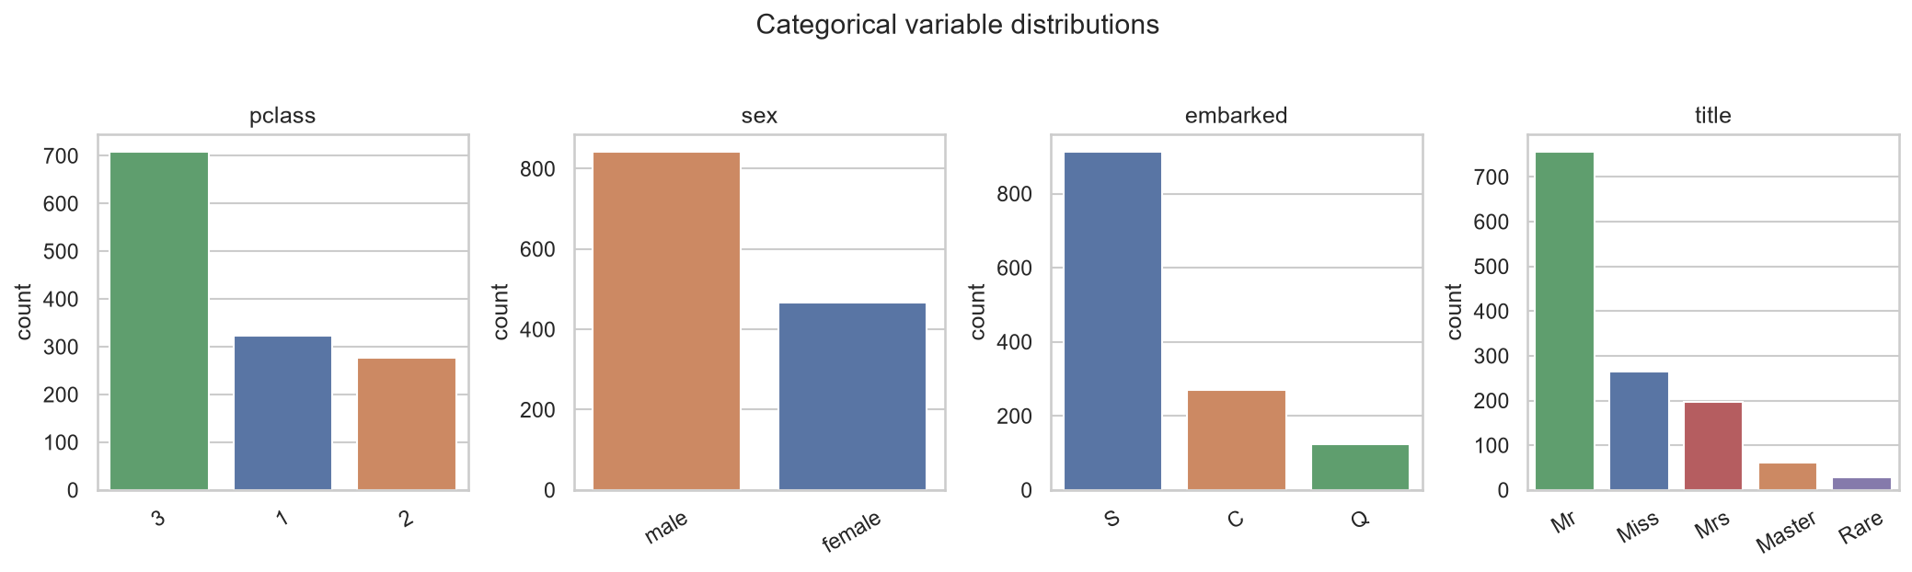
Figure 1: Distributions of the categorical variables. The title column is derived from name during preprocessing and is shown here after consolidation.

5. Data Cleaning

5.1 Missing values
Findings. Seven of the fourteen columns contain missing values, and the extent differs by two orders of magnitude between them.
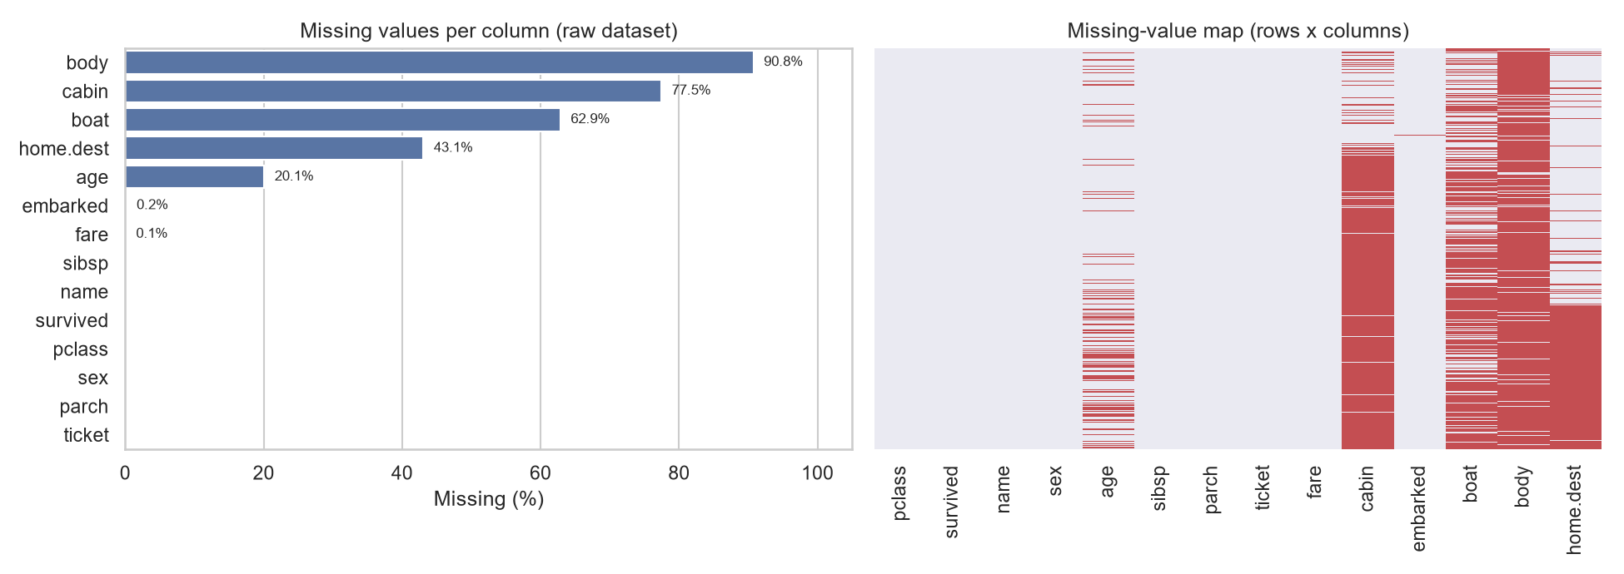
Figure 2: Missing values per column (left) and their position within the file (right). Red marks a missing cell.
The map on the right shows that missingness in body and boat is not random: a lifeboat number exists only for rescued passengers and a body-recovery number only for victims whose remains were recovered. Both columns are therefore recorded after the outcome they would be used to predict. The check confirms it numerically: the survival rate is 98.2% among passengers with a lifeboat number and 2.8% among those without, and none of the 121 passengers carrying a body-recovery number survived.
Missingness in the remaining columns is also structured rather than random. Age is absent for 29.34% of third-class passengers but only 12.07% of first-class passengers, and cabin for 97.74% against 20.74%. Record-keeping was simply better for the higher fares, which means that deleting incomplete rows would remove third-class passengers preferentially and distort every group comparison that follows.
Column | Missing | Treatment | Rationale
body | 1188 (90.76%) | Removed | Recorded only after the disaster and only for victims; using it would leak the target. Almost entirely missing in any case.
boat | 823 (62.87%) | Removed | Recorded only for rescued passengers; it determines the target almost perfectly and cannot exist before the outcome.
home.dest | 564 (43.09%) | Removed | Free text with 369 distinct values and no usable structure; imputing 43% of a free-text field would invent information.
cabin | 1014 (77.46%) | Recoded, not imputed | The deck letter is retained as a new column 'deck'; missing entries become an explicit level 'Unknown' because the absence of a cabin record is itself informative and cannot be guessed.
age | 263 (20.09%) | Median within (pclass, sex, title) | One fifth of the column; deleting those rows would discard 20% of the sample. The median is robust to the right skew of age, and conditioning on class, sex and honorific keeps children and adults distinguishable instead of collapsing everyone onto one global value.
embarked | 2 (0.15%) | Mode ('S') | Only two records. The mode is the standard choice for a nominal variable and, at 0.15%% of the data, cannot bias the distribution.
fare | 1 (0.08%) | Median within pclass | A single record. Fare depends strongly on class, so the class median is more accurate than the overall median and is unaffected by the extreme upper tail.
Table 8: Missing-value treatment decisions, column by column.
The title used for conditioning is extracted from the name column before that column is discarded, and rare honorifics are consolidated so that no group contains too few passengers to yield a stable median.
df["title"] = df["name"].str.extract(r",\s*([^.]*)\.", expand=False).str.strip()
df["title"] = df["title"].replace(title_map) # Mlle/Ms -> Miss, Mme -> Mrs, rare -> Rare
grp_median = df.groupby(["pclass", "sex", "title"])["age"].transform("median")
df["age"] = df["age"].fillna(grp_median)
Titles after consolidation: Mr (757), Miss (264), Mrs (198), Master (61), Rare (29).
Before and after, for the age column:
Statistic | Before imputation | After imputation
count | 1046.0 | 1309.0
mean | 29.881 | 29.267
std | 14.413 | 13.447
min | 0.167 | 0.167
25% | 21.0 | 21.0
50% | 28.0 | 26.0
75% | 39.0 | 36.5
max | 80.0 | 80.0
Table 9: Age distribution before and after group-median imputation.
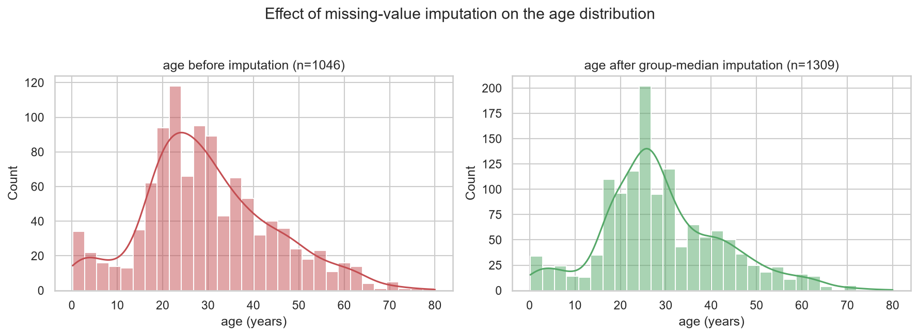
Figure 3: Age distribution before and after imputation. The imputed values concentrate at the group medians, which raises the central bars; the shape of the tails is preserved.
The mean moves only from 29.881 to 29.267 years and the standard deviation from 14.413 to 13.447. The contraction in spread is the expected cost of imputing a fifth of a column with central values, and it is reported here rather than hidden.

5.2 Duplicate records
Findings. The raw file contains 0 exact duplicate rows. Ignoring the identifier columns (name, ticket, cabin, boat, body, home.dest), 195 rows become indistinguishable, and 2 passenger names occur twice.
pclass | survived | name | sex | age | ticket | fare | embarked
3 | 1 | Connolly, Miss. Kate | female | 22.0 | 370373 | 7.75 | Q
3 | 0 | Connolly, Miss. Kate | female | 30.0 | 330972 | 7.6292 | Q
3 | 0 | Kelly, Mr. James | male | 34.5 | 330911 | 7.8292 | Q
3 | 0 | Kelly, Mr. James | male | 44.0 | 363592 | 8.05 | S
Table 10: The two repeated passenger names, shown with their full records.
Treatment: no rows were removed. The repeated names belong to different people - the two passengers named Connolly travelled on different tickets at different fares and had different outcomes, and the two named Kelly embarked at different ports. The 195 subset matches are likewise distinct third-class passengers who happen to share class, sex, age band and family structure. Deleting them would remove real observations and bias survival rates for exactly the group that was most numerous aboard, so the correct action here is to detect, verify and retain.
Rows before: 1309. Rows removed: 0. Rows after: 1309.

5.3 Inconsistent and erroneous values
Findings and corrections. Three issues were confirmed by explicit checks; no issue is reported that the checks did not find.
Issue | Extent | Correction | Rationale
fare = 0 | 17 records (class 1: 7, class 2: 6, class 3: 4) | Replaced with the class median | A purchased ticket cannot cost zero; the entries are placeholders for an unknown or non-commercial fare. They occur in all three classes, so a single global replacement would be wrong. Left untreated they would drag the class means downwards.
Missing token "?" | Present in 7 columns | Declared as a missing marker at load time | Without na_values=["?"] the age, fare and body columns load as text and no missing value is detected.
Rare and equivalent titles | 18 distinct honorifics in name | Mlle and Ms mapped to Miss, Mme to Mrs, the remaining 29 rare forms grouped as Rare | Mlle and Mme are the French equivalents of Miss and Mrs and are the same category. Titles held by one or two passengers cannot support a stable group statistic or a useful indicator column.
Type inconsistencies | survived, pclass as int64; sex, embarked as text | Cast to int8 and encoded numerically | These are categorical variables; storing them as wide integers or free text wastes memory and blocks most modelling libraries.
Table 11: Inconsistent and erroneous values found and corrected.
# a zero fare is treated as unknown, then imputed from the class median
df.loc[df["fare"] == 0, "fare"] = np.nan
fare_medians = df.groupby("pclass")["fare"].median()
df["fare"] = df["fare"].fillna(df["pclass"].map(fare_medians))
Class medians used: class 1 = 61.38, class 2 = 15.05, class 3 = 8.05. In total 18 fare values were imputed (17 zeros and 1 genuinely missing).
Values that were checked and found to be legitimate are equally important. The minimum age of 0.1667 years (12 passengers under one year old) is a deliberate fractional encoding for infants, not a data-entry error, and was left unchanged.

6. Outlier Detection and Treatment

Methodology
Outliers were identified with the interquartile-range rule. The first and third quartiles Q1 and Q3 are computed for each numeric column, the interquartile range is IQR = Q3 - Q1, and any value outside the interval [Q1 - 1.5 x IQR, Q3 + 1.5 x IQR] is flagged. The rule was chosen in preference to a standard-deviation threshold because quartiles are not themselves distorted by the extreme values being searched for, which matters for a fare column whose maximum is an order of magnitude above its own third quartile.
Flagging a value is a question, not a verdict. Each flagged group below was traced back to the underlying records before any decision was taken.
column | Q1 | Q3 | IQR | lower | upper | n_outliers | pct
age | 21.0 | 36.5 | 15.5 | -2.25 | 59.75 | 40 | 3.06
fare | 7.925 | 31.387 | 23.462 | -27.269 | 66.581 | 171 | 13.06
sibsp | 0.0 | 1.0 | 1.0 | -1.5 | 2.5 | 57 | 4.35
parch | 0.0 | 0.0 | 0.0 | 0.0 | 0.0 | 307 | 23.45
Table 12: IQR boundaries and the number of flagged values per numeric column.
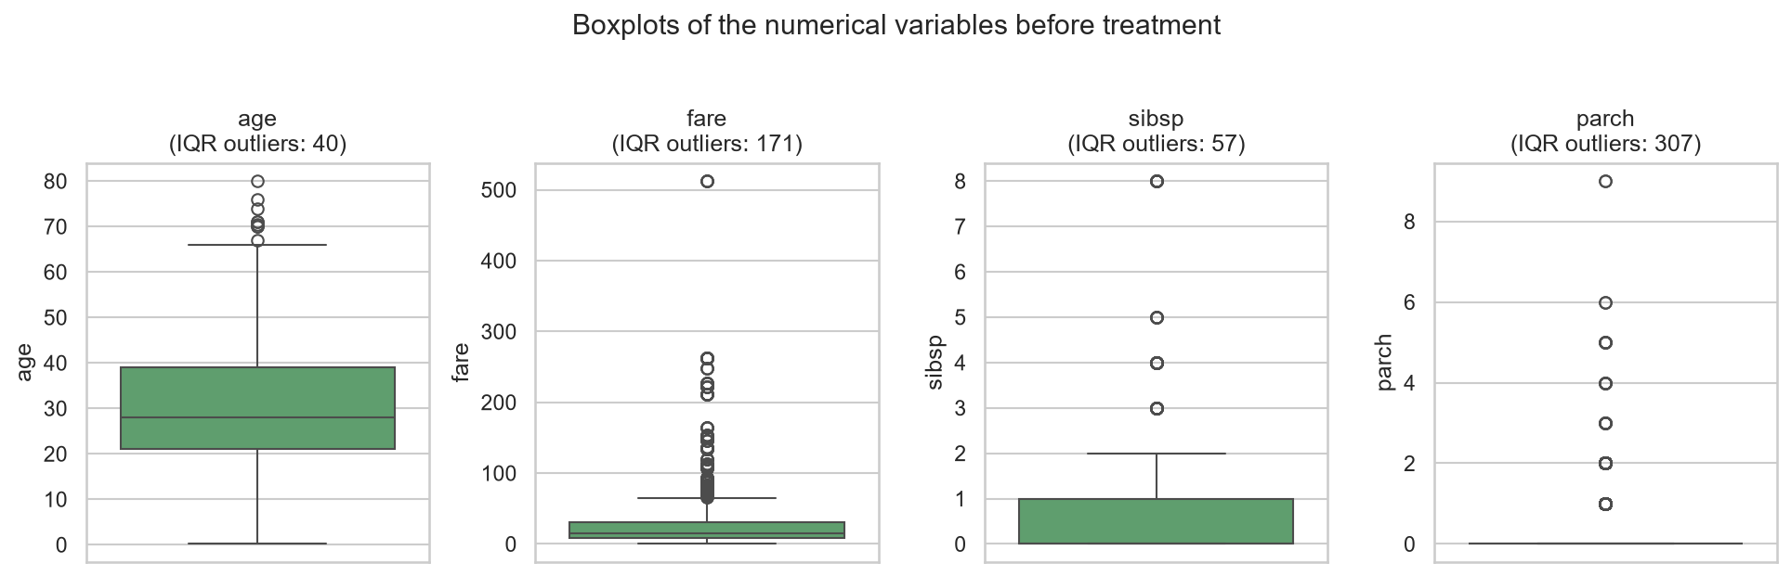
Figure 4: Boxplots of the numeric variables in the raw dataset, with the number of values flagged by the IQR rule.

Findings and decisions
age - 40 values flagged (3.06%), all above the upper bound of 59.75 years.
These are elderly passengers, up to 80 years old, and the lower bound of -2.25 years is negative and therefore vacuous. Ages in this range are biologically ordinary. Decision: retained, untransformed. Removing passengers for being old would delete a real and interesting subgroup.
fare - 171 values flagged (13.06%), the largest group in the dataset.
pclass | name | ticket | fare | sibsp | parch
1 | Cardeza, Mr. Thomas Drake Martinez | PC 17755 | 512.3292 | 0 | 1
1 | Cardeza, Mrs. James Warburton Martinez (Charlotte Wardle Drake) | PC 17755 | 512.3292 | 0 | 1
1 | Lesurer, Mr. Gustave J | PC 17755 | 512.3292 | 0 | 0
1 | Ward, Miss. Anna | PC 17755 | 512.3292 | 0 | 0
Table 13: The highest fares in the dataset.
Inspection explains the tail. The four highest fares of 512.33 are not four individual payments: 4 passengers share the single ticket PC 17755, and the full price of that ticket is repeated on every one of their rows. The fare column therefore measures the cost of a booking, not the cost of a passenger, and the resulting values are genuine but not comparable across rows. Decision: no record was deleted or capped. Instead the fare is divided by the number of passengers sharing the ticket, which makes the values comparable, and a log transform then compresses the residual right tail.
ticket_size = df.groupby("ticket")["ticket"].transform("size")
df["fare_per_person"] = df["fare"] / ticket_size
df["fare_log"] = np.log1p(df["fare_per_person"])
Variable | Skewness | IQR outliers
fare | 4.365 | 171
fare_per_person | 2.981 | 270
log1p(fare_per_person) | 0.963 | 87
Table 14: Effect of the group-fare adjustment and the log transform.
The per-person adjustment reduces skewness from 4.37 to 2.98, and the log transform brings it to 0.96, close to symmetric. The count of flagged values rises to 270 at the intermediate step: dividing by group size also narrows the interquartile range itself, so the 1.5 x IQR fence tightens even as the distribution becomes less distorted. Skewness is the more informative measure of the two here, and after the log transform both agree, with the flagged count falling to 87.
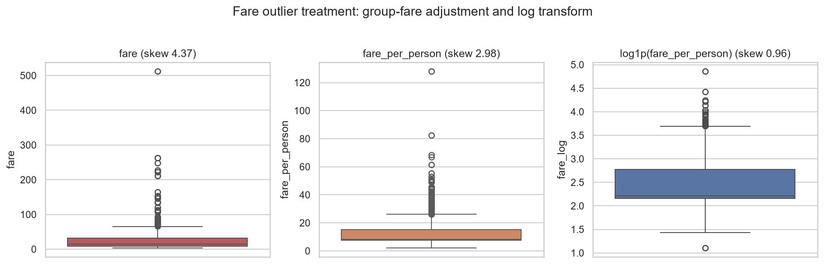
Figure 5: The fare column before treatment, after adjusting for shared tickets, and after the logarithmic transform.
sibsp - 57 values flagged (4.35%); parch - 307 values flagged (23.45%).
name | ticket | sibsp | parch
Goodwin, Master. Harold Victor | CA 2144 | 5 | 2
Goodwin, Master. Sidney Leonard | CA 2144 | 5 | 2
Goodwin, Master. William Frederick | CA 2144 | 5 | 2
Goodwin, Miss. Jessie Allis | CA 2144 | 5 | 2
Goodwin, Miss. Lillian Amy | CA 2144 | 5 | 2
Goodwin, Mr. Charles Edward | CA 2144 | 5 | 2
... | ... | ... | ...
Sage, Mr. Douglas Bullen | CA. 2343 | 8 | 2
Sage, Mr. Frederick | CA. 2343 | 8 | 2
Sage, Mr. George John Jr | CA. 2343 | 8 | 2
Table 15: Passengers with the largest sibsp values (15 records in total); rows omitted for brevity are further members of the same two families.
The extreme values resolve into two large families travelling together on tickets CA 2144 and CA. 2343. For parch the rule degenerates entirely: the first and third quartiles are both 0, so the IQR is zero and every passenger travelling with even one parent or child is flagged. This is a clear illustration that the IQR rule is unreliable on a count variable whose mass sits at zero. Decision: both columns retained unchanged, and the information consolidated into a family_size feature instead.
Summary of outlier treatment: no rows were deleted and no values were capped. Every extreme value in this dataset traces back to a documented passenger. The distortion that genuinely needed correcting was a unit problem in the fare column, and it was corrected by transformation rather than by discarding observations.

7. Data Preprocessing

7.1 Feature engineering
- title, extracted from name and consolidated into 5 groups, which captures sex, marital status and social rank in a single low-cardinality variable and makes the age imputation conditional.
- deck, the first letter of cabin, with missing cabins kept as an explicit 'Unknown' level (1014 passengers) rather than discarded.
- family_size = sibsp + parch + 1, and the derived indicator is_alone, which combine two correlated counts into one interpretable measure.
- fare_per_person and its logarithm fare_log, as described in section 6.
df["family_size"] = df["sibsp"] + df["parch"] + 1
df["is_alone"] = (df["family_size"] == 1).astype(int)
df["deck"] = df["cabin"].str[0].fillna("Unknown")

7.2 Removal of irrelevant columns
name, ticket and cabin were dropped after the features above had been derived from them. As raw text they have 1307, 929 and 186 distinct values respectively; encoding them directly would produce thousands of indicator columns, one of which would identify each passenger individually. boat, body and home.dest were dropped earlier for the reasons given in section 5.1.

7.3 Encoding
sex is binary and was mapped directly to {male: 0, female: 1}; a one-hot expansion would add a redundant, perfectly collinear column. embarked, title and deck are nominal with no meaningful order, so they were one-hot encoded with the first level dropped to avoid the dummy-variable trap. pclass was kept as a single integer because its levels are genuinely ordered, first to third.
df_clean["sex"] = df_clean["sex"].map({"male": 0, "female": 1}).astype("int8")
df_proc = pd.get_dummies(df_clean, columns=["embarked", "title", "deck"],
drop_first=True, dtype="int8")

7.4 Scaling
Standardisation was applied to age, fare_log, family_size only: these are the continuous features whose units differ by orders of magnitude. The binary indicators and the ordinal pclass were deliberately left alone, since scaling a 0/1 column changes nothing of substance and destroys its interpretability. Scaling matters for distance-based and gradient-based methods, which would otherwise let the variable with the widest numeric range dominate; it is irrelevant to tree-based models, which is why the unscaled fare and fare_per_person columns are retained in the output file as well.
scale_cols = ["age", "fare_log", "family_size"]
scaler = StandardScaler()
df_proc[scale_cols] = scaler.fit_transform(df_proc[scale_cols])
stat | age | fare_log | family_size
count | 1309.0 | 1309.0 | 1309.0
mean | -0.0 | 0.0 | 0.0
std | 1.0004 | 1.0004 | 1.0004
min | -2.1648 | -2.2975 | -0.5583
25% | -0.615 | -0.6163 | -0.5583
50% | -0.243 | -0.5333 | -0.5583
75% | 0.5381 | 0.3689 | 0.0734
max | 3.7742 | 3.6915 | 5.7586
Table 16: Descriptive statistics of the standardised columns, confirming zero mean and unit variance.

8. Validation and Before / After Comparison
The checks below were run on the final matrix after all transformations.
Metric | Before | After
Rows | 1309 | 1309
Columns | 14 | 25
Total missing values | 3855 | 0
Columns containing missing values | 7 | 0
Duplicate records (identifiers included) | 0 | 0
Repeated feature vectors (identifiers removed) | 195 | 180
Zero-valued fares | 17 | 0
Text (object) columns | 7 | 0
Numeric / encoded columns | 7 | 25
Ready for modelling | No | Yes
Table 17: Data-quality metrics before and after cleaning and preprocessing.
Two entries deserve comment. The row count is unchanged at 1309: the cleaning strategy corrected values rather than deleting records, so no observation was lost. The count of repeated feature vectors is 180 after preprocessing, but these are not duplicate records - with the identifier columns removed, 180 separate third-class passengers simply share the same remaining attribute values. Measured with identifiers present, the final dataset contains 0 duplicate records, as it did at the start.
Validation check | Result | Status
Remaining missing values | 0 | Pass
Duplicate records (identifiers included) | 0 | Pass
Negative fare values | 0 | Pass
Ages outside (0, 100] years | 0 | Pass
survived outside {0, 1} | 0 | Pass
pclass outside {1, 2, 3} | 0 | Pass
Text columns remaining | 0 | Pass
Final dimensions | 1309 x 25 | Pass
Table 18: Post-preprocessing validation checks.
Final column types: int8 (17 columns), float64 (5 columns), int64 (3 columns).
The first records of the preprocessed matrix:
pclass | survived | sex | age | fare_log | family_size | is_alone | embarked_S | title_Mr | deck_Unknown
1 | 1 | 1 | -0.02 | 2.298 | -0.558 | 1 | 1 | 0 | 0
1 | 1 | 0 | -2.109 | 1.153 | 1.337 | 0 | 1 | 0 | 0
1 | 0 | 1 | -2.028 | 1.153 | 1.337 | 0 | 1 | 0 | 0
1 | 0 | 0 | 0.055 | 1.153 | 1.337 | 0 | 1 | 1 | 0
1 | 0 | 1 | -0.317 | 1.153 | 1.337 | 0 | 1 | 0 | 0
Table 19: First five rows of the preprocessed dataset (a subset of the 25 columns).
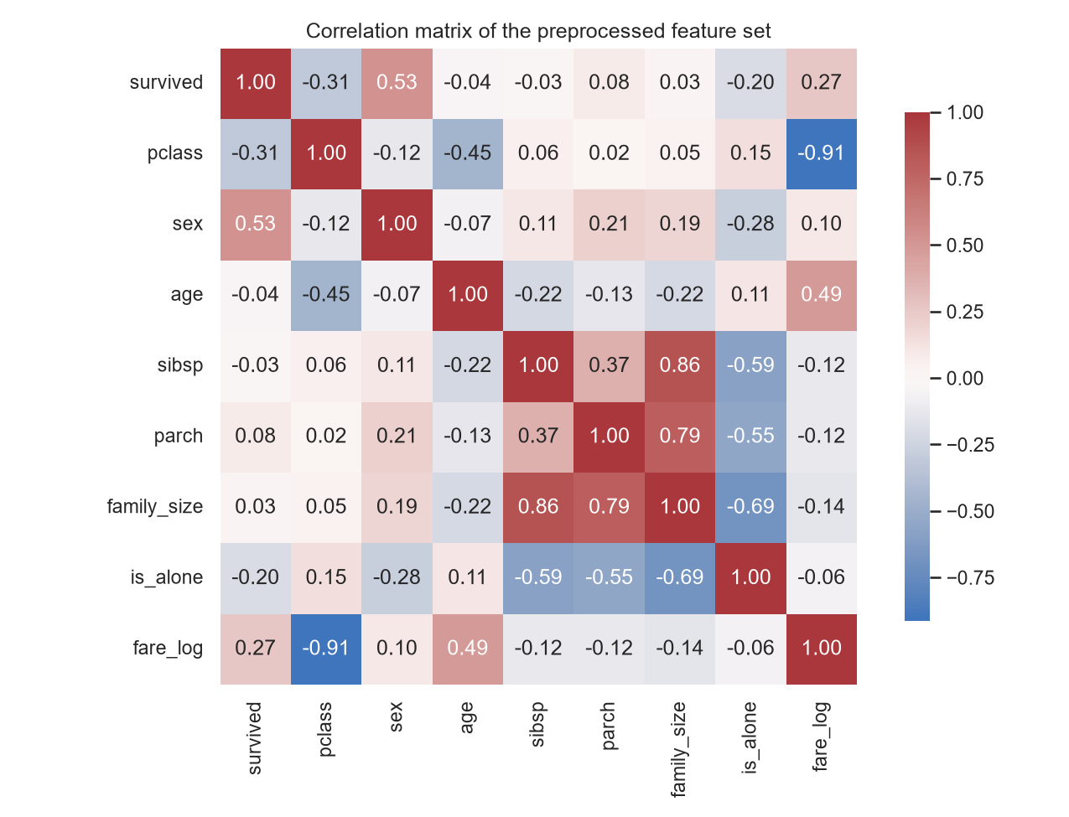
Figure 6: Correlation matrix of the preprocessed features. The relationships are now directly computable because every variable is numeric and complete.

9. Challenges Faced and Solutions
Missing values were invisible on the first read. The OpenML file encodes gaps as the literal string "?". Loaded without na_values, pandas reported zero missing values and typed age and fare as text. The token had to be identified by inspecting the raw lines of the file before the missing-value analysis could begin at all.
Two columns predicted the target almost perfectly. boat and body looked like ordinary sparse columns. Checking survival against them revealed a 98.2% versus 2.8% split - they record what happened after the sinking. They were removed as target leakage rather than imputed.
Apparent duplicates that were not duplicates. Ignoring identifiers produced 195 matching rows and two repeated names, which a routine drop_duplicates call would have deleted. Examining the full records showed different tickets, fares, ports and outcomes. The lesson is that duplicate detection must be followed by verification before removal.
The fare outliers were a unit problem, not bad data. 171 fare values were flagged by the IQR rule. They turned out to be group tickets whose total price is repeated on each passenger's row. Dividing by the number of passengers per ticket fixed the comparability problem without discarding a single record.
The IQR rule broke down on count variables. For parch the first and third quartiles are both zero, so the IQR is zero and the rule flags every non-zero value. This confirmed that the method has to be applied with judgement rather than mechanically, and the counts were consolidated into family_size instead.
Imputing a fifth of the age column narrows its spread. Filling 263 ages with central values reduced the standard deviation from 14.413 to 13.447. Conditioning the median on class, sex and title limited the damage relative to a single global median, and the effect is reported explicitly rather than concealed.

10. Impact of Preprocessing

Statistical analysis
Correcting the 17 zero fares raises the class means to values that reflect what passengers actually paid, and the per-person adjustment changes what the fare variable measures from cost per booking to cost per passenger. Any group comparison of fares is now meaningful in a way it was not before. Conversely, imputing age compresses its variance from 14.413 to 13.447, so confidence intervals and variance-based tests on age are now mildly optimistic; this is a real cost of the decision, not a neutral change.

Visualisation
A boxplot of the raw fare is dominated by a handful of group tickets and compresses the bulk of the distribution into an unreadable band near the axis, as Figure 5 shows. After the per-person and log transforms the same data is legible, and comparisons between classes become visible. Complete columns also mean that plots no longer silently drop the 263 passengers whose age was missing.

Machine-learning models
The raw file cannot be fed to a model at all: 7 of its columns are text and 3855 cells are empty. The processed matrix is fully numeric, complete and standardised where it matters, so it can be passed directly to any estimator. The single most consequential decision for model validity was removing boat and body: a classifier trained with them would report near-perfect accuracy that would collapse on any passenger whose fate was not already known, because those columns encode the answer.

Model reliability
Reliability improved through leakage removal, consistent typing and scale comparability, and through retaining all 1309 observations rather than deleting the 263 rows with a missing age - listwise deletion would have removed a fifth of the sample, and disproportionately third-class passengers, whose age is missing at 29.3% against 12.1% in first class.

Information loss
Six columns were removed. For name, ticket and cabin the loss is partly recovered through title, fare_per_person and deck. home.dest was a genuine loss: geographic origin might carry signal, but 43% of it was absent. Imputation is itself a form of loss, since 263 ages and 18 fares are now estimates rather than observations; both files - cleaned and processed - are saved so that the effect of these choices can be re-examined.

Bias
Two sources of bias deserve explicit acknowledgement. Missingness in age is not random - it is absent for 29.3% of third-class passengers against 12.1% of first-class passengers - so imputing from group medians systematically assigns those passengers their group's central value and understates the variation within the group. Second, treating 'Unknown' as a deck level converts a recording artefact into a feature: cabin is missing for 20.7% of first-class passengers but 97.7% of third-class passengers, so deck_Unknown partly encodes class. It was retained deliberately, because discarding 77% of the rows to avoid it would introduce a far larger selection bias, but any model using that feature should be read with this in mind.

11. Conclusion
A raw public dataset of 1309 passenger records and 14 columns was acquired programmatically, audited, cleaned and preprocessed into a complete numeric matrix of 1309 rows and 25 columns with no missing values, no invalid values and no text columns remaining.
Quality improvements delivered:
- 3855 missing cells eliminated across 7 columns, without losing a single record.
- 17 impossible zero fares replaced with class-conditional medians.
- Two target-leaking columns identified and removed.
- Fare converted from a per-booking to a per-passenger measure, reducing skewness from 4.37 to 0.96.
- 7 text and categorical columns encoded into 25 numeric features.
The decisions that mattered most:
- Removing boat and body, without which any downstream model would have been invalid.
- Verifying apparent duplicates instead of dropping them, which preserved 195 genuine records.
- Conditioning the age imputation on class, sex and title rather than using a single global median.
- Treating the fare outliers as a unit problem to be transformed rather than extreme values to be deleted.
The main lesson is that the useful work in this task was investigative rather than procedural. Every automatic rule applied here - drop the duplicates, delete the outliers, impute the gaps - would have been wrong at least once if it had been applied without first looking at the records behind the numbers. A missing value, a repeated row and an extreme value are each a question about how the data was recorded, and the answer determines the treatment.

Appendix: Analysis Code
The complete analysis is contained in src/data_preprocessing.py, reproduced below. Running it regenerates every figure, table and number used in this report, together with the full console transcript in outputs/analysis_log.txt. This document is generated from that run by src/build_report.py.

"""
Week 1 Task - Data Acquisition, Cleaning and Preprocessing
Dataset : Titanic passenger manifest (OpenML dataset id 40945)
Running this script reproduces the full pipeline:
acquisition -> exploration -> cleaning -> outlier analysis -> preprocessing
-> validation -> figures. All printed output is mirrored to
outputs/analysis_log.txt and every numeric finding is written to
outputs/summary.json (consumed by src/build_report.py).
"""
# ---------------------------------------------------------------------------
# 1. Import libraries
# ---------------------------------------------------------------------------
import json
import os
import urllib.request
from io import StringIO
import matplotlib
matplotlib.use("Agg")
import matplotlib.pyplot as plt
import numpy as np
import pandas as pd
import seaborn as sns
from sklearn.preprocessing import StandardScaler
BASE = os.path.dirname(os.path.dirname(os.path.abspath(__file__)))
DATA = os.path.join(BASE, "data")
OUT = os.path.join(BASE, "outputs")
FIG = os.path.join(OUT, "figures")
for d in (DATA, OUT, FIG):
os.makedirs(d, exist_ok=True)
RAW_CSV = os.path.join(DATA, "titanic.csv")
SOURCE_URL = "https://www.openml.org/data/get_csv/16826755/phpMYEkMl"
sns.set_theme(style="whitegrid")
pd.set_option("display.width", 200)
pd.set_option("display.max_columns", 50)
summary = {}
_log_lines = []
def log(*args):
"""Print to stdout and capture the text for outputs/analysis_log.txt."""
text = " ".join(str(a) for a in args)
print(text)
_log_lines.append(text)
def section(title):
log("\n" + "=" * 78)
log(title)
log("=" * 78)
# ---------------------------------------------------------------------------
# 2. Load dataset (download once, then reuse the local copy)
# ---------------------------------------------------------------------------
section("1. DATA ACQUISITION")
if not os.path.exists(RAW_CSV):
log("Local copy not found - downloading from", SOURCE_URL)
urllib.request.urlretrieve(SOURCE_URL, RAW_CSV)
else:
log("Using local copy:", os.path.relpath(RAW_CSV, BASE))
# The OpenML distribution encodes missing entries as the literal string "?".
df_raw = pd.read_csv(RAW_CSV, na_values=["?"])
df = df_raw.copy()
log("Source URL :", SOURCE_URL)
log("File size :", os.path.getsize(RAW_CSV), "bytes")
log("Shape :", df.shape)
summary["source_url"] = SOURCE_URL
summary["file_bytes"] = os.path.getsize(RAW_CSV)
summary["raw_shape"] = list(df.shape)
# ---------------------------------------------------------------------------
# 3. Initial exploration
# ---------------------------------------------------------------------------
section("2. INITIAL EXPLORATION")
log("\n--- head(5) ---")
log(df.head().to_string())
log("\n--- dimensions ---")
log("rows:", df.shape[0], " columns:", df.shape[1])
log("\n--- columns ---")
log(list(df.columns))
log("\n--- dtypes ---")
log(df.dtypes.to_string())
log("\n--- info() ---")
_buf = StringIO()
df.info(buf=_buf)
log(_buf.getvalue())
log("\n--- describe() numeric ---")
desc_num = df.describe().T
log(desc_num.to_string())
log("\n--- describe() object ---")
log(df.describe(include=["object"]).T.to_string())
miss = pd.DataFrame({
"missing": df.isna().sum(),
"missing_pct": (df.isna().mean() * 100).round(2),
})
miss = miss[miss["missing"] > 0].sort_values("missing", ascending=False)
log("\n--- missing values ---")
log(miss.to_string())
dup_full = int(df.duplicated().sum())
log("\n--- duplicates ---")
log("exact duplicate rows:", dup_full)
log("\n--- categorical value inspection ---")
cat_summary = {}
for c in ["pclass", "survived", "sex", "embarked"]:
vc = df[c].value_counts(dropna=False)
log("\n" + c + " (unique=" + str(df[c].nunique(dropna=True)) + ")")
log(vc.to_string())
cat_summary[c] = {str(k): int(v) for k, v in vc.items()}
for c in ["name", "ticket", "cabin", "home.dest", "boat"]:
log(c + ": " + str(df[c].nunique()) + " unique values")
_head = df.head()
summary["head_cols"] = list(df.columns)
summary["head_rows"] = _head.astype(object).where(_head.notna(), "").values.tolist()
summary["dtypes"] = {c: str(t) for c, t in df.dtypes.items()}
summary["describe_numeric"] = desc_num.round(3).reset_index().values.tolist()
summary["describe_numeric_cols"] = ["column"] + list(desc_num.columns)
summary["missing_rows"] = miss.reset_index().values.tolist()
summary["dup_full_before"] = dup_full
summary["categorical"] = cat_summary
summary["nunique"] = {c: int(df[c].nunique()) for c in df.columns}
# ---------------------------------------------------------------------------
# 4. Data-quality investigation
# ---------------------------------------------------------------------------
section("3. DATA-QUALITY INVESTIGATION")
log("\n[Q1] Columns dominated by missingness or leaking the target")
for c in ["boat", "body", "home.dest", "cabin"]:
log(" %-10s missing=%5d (%5.2f%%) unique=%d"
% (c, df[c].isna().sum(), df[c].isna().mean() * 100, df[c].nunique()))
boat_surv = df.groupby(df["boat"].notna())["survived"].mean().round(4)
log(" survival rate by whether a lifeboat number was recorded:")
log(boat_surv.to_string())
summary["boat_leak"] = {str(k): float(v) for k, v in boat_surv.items()}
body_survivors = int(df.loc[df["body"].notna(), "survived"].sum())
log(" passengers with a body-recovery number who survived: " + str(body_survivors))
summary["body_leak_survivors"] = body_survivors
zero_fare = df["fare"] == 0
log("\n[Q2] fare == 0 : " + str(int(zero_fare.sum()))
+ " records (a purchased ticket cannot cost zero) - by class:")
log(df.loc[zero_fare, "pclass"].value_counts().sort_index().to_string())
summary["zero_fare_count"] = int(zero_fare.sum())
summary["zero_fare_by_class"] = {str(k): int(v) for k, v in
df.loc[zero_fare, "pclass"].value_counts().sort_index().items()}
id_cols = ["name", "ticket", "cabin", "boat", "body", "home.dest"]
dup_subset = int(df.drop(columns=id_cols).duplicated().sum())
name_dupes = df[df["name"].duplicated(keep=False)].sort_values("name")
log("\n[Q3] duplicate check")
log(" exact duplicate rows : " + str(dup_full))
log(" duplicates ignoring identifier columns : " + str(dup_subset))
log(" repeated passenger names : " + str(int(df["name"].duplicated().sum())))
_nd_cols = ["pclass", "survived", "name", "sex", "age", "ticket", "fare", "embarked"]
log(name_dupes[_nd_cols].to_string())
summary["dup_subset"] = dup_subset
summary["name_dupes_cols"] = _nd_cols
summary["name_dupes_rows"] = name_dupes[_nd_cols].fillna("").values.tolist()
age_by_class = (df.groupby("pclass")["age"].apply(lambda x: x.isna().mean() * 100)).round(2)
cabin_by_class = (df.groupby("pclass")["cabin"].apply(lambda x: x.isna().mean() * 100)).round(2)
log("\n[Q3b] is the missingness random? rate (%) by passenger class")
log(" age : " + ", ".join("class %s = %.2f" % (k, v) for k, v in age_by_class.items()))
log(" cabin : " + ", ".join("class %s = %.2f" % (k, v) for k, v in cabin_by_class.items()))
log(" Missingness is concentrated in the lower classes, so it is not")
log(" missing completely at random.")
summary["age_missing_by_class"] = {str(k): float(v) for k, v in age_by_class.items()}
summary["cabin_missing_by_class"] = {str(k): float(v) for k, v in cabin_by_class.items()}
log("\n[Q4] data types needing attention")
log(" survived / pclass stored as int64 but are categorical")
log(" sex, embarked stored as free text and must be encoded for modelling")
log(" body stored as float64 although it is an identifier, not a measurement")
log("\n[Q5] suspicious numeric values")
log(" age min=%.4f max=%.1f" % (df["age"].min(), df["age"].max()))
log(" age below 1 year: " + str(int((df["age"] < 1).sum())) + " records (infants - plausible)")
log(" fare min=%.4f max=%.4f" % (df["fare"].min(), df["fare"].max()))
log(" sibsp max=%d parch max=%d" % (df["sibsp"].max(), df["parch"].max()))
_tf_cols = ["pclass", "name", "ticket", "fare", "sibsp", "parch"]
top_fare = df.loc[df["fare"] > 300, _tf_cols]
log(" highest fares (shared-ticket check):")
log(top_fare.to_string())
log(" passengers sharing ticket 'PC 17755': " + str(int((df["ticket"] == "PC 17755").sum())))
summary["top_fare_cols"] = _tf_cols
summary["top_fare_rows"] = top_fare.round(4).fillna("").values.tolist()
summary["pc17755_group"] = int((df["ticket"] == "PC 17755").sum())
summary["age_min"] = float(df["age"].min())
summary["age_max"] = float(df["age"].max())
summary["infants"] = int((df["age"] < 1).sum())
# ---------------------------------------------------------------------------
# 5. Missing-value treatment
# ---------------------------------------------------------------------------
section("4. MISSING-VALUE TREATMENT")
drop_cols = ["boat", "body", "home.dest"]
df = df.drop(columns=drop_cols)
log("Dropped columns (post-outcome leakage / unusable free text): " + str(drop_cols))
df["deck"] = df["cabin"].str[0].fillna("Unknown")
log("\ncabin -> deck (first letter); missing kept as an explicit 'Unknown' level:")
log(df["deck"].value_counts().to_string())
summary["deck_counts"] = {str(k): int(v) for k, v in df["deck"].value_counts().items()}
df["title"] = df["name"].str.extract(r",\s*([^.]*)\.", expand=False).str.strip()
raw_titles = df["title"].value_counts()
log("\nraw titles extracted from 'name':")
log(raw_titles.to_string())
title_map = {
"Mlle": "Miss", "Ms": "Miss", "Mme": "Mrs", "Lady": "Rare", "Sir": "Rare",
"the Countess": "Rare", "Dona": "Rare", "Don": "Rare", "Jonkheer": "Rare",
"Capt": "Rare", "Col": "Rare", "Major": "Rare", "Dr": "Rare", "Rev": "Rare",
}
df["title"] = df["title"].replace(title_map)
log("\ntitles after consolidating equivalent and rare forms:")
log(df["title"].value_counts().to_string())
summary["raw_titles"] = {str(k): int(v) for k, v in raw_titles.items()}
summary["title_counts"] = {str(k): int(v) for k, v in df["title"].value_counts().items()}
df.loc[df["fare"] == 0, "fare"] = np.nan
fare_medians = df.groupby("pclass")["fare"].median()
log("\nfare medians by pclass used for imputation:")
log(fare_medians.round(4).to_string())
df["fare"] = df["fare"].fillna(df["pclass"].map(fare_medians))
summary["fare_medians"] = {str(k): round(float(v), 4) for k, v in fare_medians.items()}
summary["fare_imputed_total"] = int(summary["zero_fare_count"]) + 1
emb_missing = int(df["embarked"].isna().sum())
emb_mode = df["embarked"].mode()[0]
log("\nembarked: " + str(emb_missing) + " missing -> imputed with the mode '" + emb_mode + "'")
df["embarked"] = df["embarked"].fillna(emb_mode)
summary["embarked_mode"] = emb_mode
summary["embarked_missing"] = emb_missing
age_missing_before = int(df["age"].isna().sum())
age_stats_before = df["age"].describe()
grp_median = df.groupby(["pclass", "sex", "title"])["age"].transform("median")
df["age"] = df["age"].fillna(grp_median)
df["age"] = df["age"].fillna(df["age"].median()) # safety net for empty groups
age_stats_after = df["age"].describe()
log("\nage: %d missing (%.2f%%) -> median within (pclass, sex, title) groups"
% (age_missing_before, age_missing_before / len(df) * 100))
age_cmp = pd.DataFrame({"before": age_stats_before, "after": age_stats_after}).round(3)
log(age_cmp.to_string())
summary["age_missing_before"] = age_missing_before
summary["age_stats_rows"] = age_cmp.reset_index().values.tolist()
log("\nremaining missing values: " + str(int(df.isna().sum().sum())))
# ---------------------------------------------------------------------------
# 6. Duplicate analysis
# ---------------------------------------------------------------------------
section("5. DUPLICATE HANDLING")
rows_before = len(df)
log("rows before duplicate handling : " + str(rows_before))
log("exact duplicate rows detected : " + str(int(df.duplicated().sum())))
log("duplicates on non-identifier subset : " + str(dup_subset))
log("The subset matches and the two repeated names belong to genuinely")
log("different passengers (different tickets, fares or ports), so no rows")
log("were removed - deleting them would discard real observations.")
rows_after = len(df)
summary["rows_before_dup"] = rows_before
summary["dup_removed"] = rows_before - rows_after
summary["rows_after_dup"] = rows_after
# ---------------------------------------------------------------------------
# 7. Outlier analysis (IQR method)
# ---------------------------------------------------------------------------
section("6. OUTLIER ANALYSIS (IQR)")
num_cols = ["age", "fare", "sibsp", "parch"]
iqr_rows = []
for c in num_cols:
q1, q3 = df[c].quantile([0.25, 0.75])
iqr = q3 - q1
lo, hi = q1 - 1.5 * iqr, q3 + 1.5 * iqr
n_out = int(((df[c] < lo) | (df[c] > hi)).sum())
iqr_rows.append([c, round(q1, 3), round(q3, 3), round(iqr, 3),
round(lo, 3), round(hi, 3), n_out, round(n_out / len(df) * 100, 2)])
iqr_cols = ["column", "Q1", "Q3", "IQR", "lower", "upper", "n_outliers", "pct"]
iqr_tbl = pd.DataFrame(iqr_rows, columns=iqr_cols)
log(iqr_tbl.to_string(index=False))
summary["iqr_cols"] = iqr_cols
summary["iqr_rows"] = iqr_rows
log("\nFare outliers are dominated by shared group tickets: the full ticket")
log("price is repeated on every passenger travelling on that ticket.")
ticket_size = df.groupby("ticket")["ticket"].transform("size")
df["fare_per_person"] = df["fare"] / ticket_size
q1, q3 = df["fare_per_person"].quantile([0.25, 0.75])
iqr = q3 - q1
fpp_out = int(((df["fare_per_person"] < q1 - 1.5 * iqr) |
(df["fare_per_person"] > q3 + 1.5 * iqr)).sum())
fare_out_before = int(iqr_tbl.loc[iqr_tbl["column"] == "fare", "n_outliers"].iloc[0])
log("fare outliers before per-person adjustment : " + str(fare_out_before))
log("fare_per_person outliers after adjustment : " + str(fpp_out))
summary["fare_out_before"] = fare_out_before
summary["fare_out_after_pp"] = fpp_out
df["fare_log"] = np.log1p(df["fare_per_person"])
q1, q3 = df["fare_log"].quantile([0.25, 0.75])
iqr = q3 - q1
flog_out = int(((df["fare_log"] < q1 - 1.5 * iqr) |
(df["fare_log"] > q3 + 1.5 * iqr)).sum())
log("log1p(fare_per_person) outliers : " + str(flog_out))
log("Note: the per-person figure also narrows the IQR itself, so the flagged")
log("count rises even though the distribution is less distorted; skewness is")
log("the more informative measure here.")
summary["fare_out_log"] = flog_out
log("skewness fare : %.3f" % df["fare"].skew())
log("skewness fare_per_person : %.3f" % df["fare_per_person"].skew())
log("skewness log1p(fare_pp) : %.3f" % df["fare_log"].skew())
summary["skew"] = {
"fare": round(float(df["fare"].skew()), 3),
"fare_per_person": round(float(df["fare_per_person"].skew()), 3),
"fare_log": round(float(df["fare_log"].skew()), 3),
}
_bf_cols = ["name", "ticket", "sibsp", "parch"]
big_fam = df.loc[df["sibsp"] >= 5, _bf_cols]
log("\nlargest sibsp values (" + str(len(big_fam)) + " records, two real families):")
log(big_fam.to_string())
summary["big_family_cols"] = _bf_cols
summary["big_family_rows"] = big_fam.round(2).fillna("").values.tolist()
summary["big_family_n"] = len(big_fam)
log("\nDecision: no outlier rows were deleted or capped. Every extreme value")
log("traces back to a documented passenger (infants, large families,")
log("first-class group tickets); the skew is handled by the per-person and")
log("logarithmic transforms instead.")
# ---------------------------------------------------------------------------
# 8. Preprocessing
# ---------------------------------------------------------------------------
section("7. PREPROCESSING")
df["family_size"] = df["sibsp"] + df["parch"] + 1
df["is_alone"] = (df["family_size"] == 1).astype(int)
log("engineered features: family_size, is_alone, fare_per_person, fare_log, title, deck")
df_clean = df.drop(columns=["name", "ticket", "cabin"])
log("dropped identifier columns: name, ticket, cabin")
log("(their information is retained through title, fare_per_person and deck)")
df_clean["sex"] = df_clean["sex"].map({"male": 0, "female": 1}).astype("int8")
df_clean["survived"] = df_clean["survived"].astype("int8")
df_clean["pclass"] = df_clean["pclass"].astype("int8")
log("encoded: sex -> {male:0, female:1}; survived and pclass cast to int8")
cat_cols = ["embarked", "title", "deck"]
n_before = df_clean.shape[1]
df_proc = pd.get_dummies(df_clean, columns=cat_cols, drop_first=True, dtype="int8")
log("one-hot encoded (drop_first=True): " + str(cat_cols) + " -> "
+ str(df_proc.shape[1] - n_before + len(cat_cols)) + " indicator columns")
scale_cols = ["age", "fare_log", "family_size"]
scaler = StandardScaler()
df_proc[scale_cols] = scaler.fit_transform(df_proc[scale_cols])
log("standardised to zero mean and unit variance: " + str(scale_cols))
_sd = df_proc[scale_cols].describe().round(4)
log(_sd.to_string())
summary["scale_cols"] = scale_cols
summary["scaled_desc_cols"] = ["stat"] + scale_cols
summary["scaled_desc_rows"] = _sd.reset_index().values.tolist()
summary["encoded_cols"] = list(df_proc.columns)
# ---------------------------------------------------------------------------
# 9. Validation
# ---------------------------------------------------------------------------
section("8. VALIDATION")
log("remaining missing values : " + str(int(df_proc.isna().sum().sum())))
log("exact duplicate rows : " + str(int(df_proc.duplicated().sum())))
log("final shape : " + str(df_proc.shape))
log("\nfinal dtypes:")
log(df_proc.dtypes.to_string())
log("\nfinal describe():")
log(df_proc.describe().T.round(4).to_string())
log("\ninvalid-value checks:")
log(" negative fare_per_person : " + str(int((df["fare_per_person"] < 0).sum())))
log(" age outside (0, 100] : " + str(int(((df["age"] <= 0) | (df["age"] > 100)).sum())))
log(" survived outside {0,1} : " + str(int((~df_proc["survived"].isin([0, 1])).sum())))
log(" pclass outside {1,2,3} : " + str(int((~df_proc["pclass"].isin([1, 2, 3])).sum())))
dup_records_after = int(df.duplicated().sum()) # identifiers still present
dup_vectors_after = int(df_proc.duplicated().sum()) # identifiers removed
log("\nduplicate records with identifiers retained : " + str(dup_records_after))
log("repeated feature vectors after identifier removal : " + str(dup_vectors_after))
log("(these are separate passengers whose remaining attributes coincide,")
log("not duplicated records, so they are retained)")
summary["dup_records_after"] = dup_records_after
summary["dup_vectors_after"] = dup_vectors_after
comparison = pd.DataFrame({
"Metric": ["Rows", "Columns", "Total missing values",
"Columns containing missing values",
"Duplicate records (identifiers included)",
"Repeated feature vectors (identifiers removed)",
"Zero-valued fares", "Text (object) columns",
"Numeric / encoded columns", "Ready for modelling"],
"Before": [df_raw.shape[0], df_raw.shape[1], int(df_raw.isna().sum().sum()),
int((df_raw.isna().sum() > 0).sum()), dup_full, dup_subset,
int((df_raw["fare"] == 0).sum()),
int((df_raw.dtypes == object).sum()),
int((df_raw.dtypes != object).sum()), "No"],
"After": [df_proc.shape[0], df_proc.shape[1], int(df_proc.isna().sum().sum()),
int((df_proc.isna().sum() > 0).sum()), dup_records_after,
dup_vectors_after,
int((df_clean["fare"] == 0).sum()),
int((df_proc.dtypes == object).sum()),
int((df_proc.dtypes != object).sum()), "Yes"],
})
log("\n--- BEFORE vs AFTER ---")
log(comparison.to_string(index=False))
summary["comparison_cols"] = list(comparison.columns)
summary["comparison_rows"] = comparison.astype(str).values.tolist()
summary["final_shape"] = list(df_proc.shape)
_ph = df_proc.head()
summary["proc_head_cols"] = list(df_proc.columns)
summary["proc_head_rows"] = _ph.round(3).astype(str).values.tolist()
summary["final_dtypes"] = {str(k): int(v) for k, v in df_proc.dtypes.value_counts().items()}
df_clean.to_csv(os.path.join(DATA, "titanic_cleaned.csv"), index=False)
df_proc.to_csv(os.path.join(DATA, "titanic_processed.csv"), index=False)
log("\nsaved data/titanic_cleaned.csv and data/titanic_processed.csv")
# ---------------------------------------------------------------------------
# 10. Visualisation
# ---------------------------------------------------------------------------
section("9. FIGURES")
# Figure 1 - missing values
fig, ax = plt.subplots(1, 2, figsize=(13, 4.6))
mp = (df_raw.isna().mean() * 100).sort_values(ascending=False)
sns.barplot(x=mp.values, y=mp.index, ax=ax[0], color="#4C72B0")
ax[0].set_xlabel("Missing (%)")
ax[0].set_ylabel("")
ax[0].set_xlim(0, 105)
ax[0].set_title("Missing values per column (raw dataset)")
for i, v in enumerate(mp.values):
if v > 0:
ax[0].text(v + 1.5, i, "%.1f%%" % v, va="center", fontsize=8)
sns.heatmap(df_raw.isna(), cbar=False, yticklabels=False,
cmap=["#EAEAF2", "#C44E52"], ax=ax[1])
ax[1].set_title("Missing-value map (rows x columns)")
plt.tight_layout()
plt.savefig(os.path.join(FIG, "01_missing_values.png"), dpi=150)
plt.close()
# Figure 2 - boxplots before treatment
fig, axes = plt.subplots(1, 4, figsize=(13, 4))
for a, c in zip(axes, num_cols):
sns.boxplot(y=df_raw[c], ax=a, color="#55A868")
n_out = int(iqr_tbl.loc[iqr_tbl["column"] == c, "n_outliers"].iloc[0])
a.set_title(c + "\n(IQR outliers: " + str(n_out) + ")")
fig.suptitle("Boxplots of the numerical variables before treatment", y=1.03)
plt.tight_layout()
plt.savefig(os.path.join(FIG, "02_boxplots_before.png"), dpi=150, bbox_inches="tight")
plt.close()
# Figure 3 - fare transformation
fig, axes = plt.subplots(1, 3, figsize=(13, 4))
sns.boxplot(y=df_clean["fare"], ax=axes[0], color="#C44E52")
axes[0].set_title("fare (skew %.2f)" % df["fare"].skew())
sns.boxplot(y=df_clean["fare_per_person"], ax=axes[1], color="#DD8452")
axes[1].set_title("fare_per_person (skew %.2f)" % df["fare_per_person"].skew())
sns.boxplot(y=df_clean["fare_log"], ax=axes[2], color="#4C72B0")
axes[2].set_title("log1p(fare_per_person) (skew %.2f)" % df["fare_log"].skew())
fig.suptitle("Fare outlier treatment: group-fare adjustment and log transform", y=1.03)
plt.tight_layout()
plt.savefig(os.path.join(FIG, "03_fare_outlier_treatment.png"), dpi=150, bbox_inches="tight")
plt.close()
# Figure 4 - age before / after imputation
fig, axes = plt.subplots(1, 2, figsize=(12, 4.2))
sns.histplot(df_raw["age"].dropna(), bins=30, kde=True, ax=axes[0], color="#C44E52")
axes[0].set_title("age before imputation (n=%d)" % int(df_raw["age"].notna().sum()))
sns.histplot(df_clean["age"], bins=30, kde=True, ax=axes[1], color="#55A868")
axes[1].set_title("age after group-median imputation (n=%d)" % len(df_clean))
for a in axes:
a.set_xlabel("age (years)")
fig.suptitle("Effect of missing-value imputation on the age distribution", y=1.03)
plt.tight_layout()
plt.savefig(os.path.join(FIG, "04_age_before_after.png"), dpi=150, bbox_inches="tight")
plt.close()
# Figure 5 - categorical distributions
fig, axes = plt.subplots(1, 4, figsize=(14, 4))
for a, c in zip(axes, ["pclass", "sex", "embarked", "title"]):
src = df_raw[c] if c != "title" else df["title"]
sns.countplot(x=src, order=src.value_counts().index, ax=a,
hue=src, legend=False, palette="deep")
a.set_title(c)
a.set_xlabel("")
a.tick_params(axis="x", rotation=30)
fig.suptitle("Categorical variable distributions", y=1.03)
plt.tight_layout()
plt.savefig(os.path.join(FIG, "05_categorical_distributions.png"), dpi=150, bbox_inches="tight")
plt.close()
# Figure 6 - correlation of the processed features
corr_cols = ["survived", "pclass", "sex", "age", "sibsp", "parch",
"family_size", "is_alone", "fare_log"]
plt.figure(figsize=(8.5, 6.5))
sns.heatmap(df_proc[corr_cols].corr(), annot=True, fmt=".2f", cmap="vlag",
center=0, square=True, cbar_kws={"shrink": 0.8})
plt.title("Correlation matrix of the preprocessed feature set")
plt.tight_layout()
plt.savefig(os.path.join(FIG, "06_correlation_processed.png"), dpi=150)
plt.close()
log("figures written to " + os.path.relpath(FIG, BASE))
with open(os.path.join(OUT, "analysis_log.txt"), "w", encoding="utf-8") as f:
f.write("\n".join(_log_lines))
with open(os.path.join(OUT, "summary.json"), "w", encoding="utf-8") as f:
json.dump(summary, f, indent=1, default=str)
log("\nPipeline complete.")

