End-to-End Data Analysis Project (Hotel Reservations) Report
Business Problem
In the recent years, City Hotel and Resort Hotel have seen high cancellation rates. Each hotel is now dealing with a number of issues as a result including fewer revenues and less than ideal hotel room use. Consequently, lowering cancellation rates are both hotels’ primary goal in order to increase their efficiency in generating revenues and for us to offer through business advice to address their problem.
The analysis of hotel booking cancellations as well as other factors that have no bearing on their business and yearly revenue generation are the main topics of this report.
Assumptions:
- No unusual occurrences between 2015 and 2017 will have a substantial impact on the data used.
- The information is still current and can be used to analyse a hotel’s possible plans in an efficient manner.
- There are no unanticipated negatives to the hotel employing any advised techniques.
- The hotels are not currently using any of the suggested solutions.
- The biggest factor affecting the effectiveness of earning income is booking cancellations.
- Cancellation results in vacant rooms for the booed length of time.
- Clients make hotel reservations the same year they make cancellations.
Research Questions:
- What are the variables that affect hotel reservation cancellations?
- How can we make hotel reservations cancellations better?
- How will hotels be assisted in making pricing and promotional decisions?
Hypothesis:
- More cancellations occur when prices are higher.
- When there is a longer waiting list, customers tend to cancel more frequently.
- The majority of clients are coming from offline travel agents to make their reservations.

Analysis and Findings:
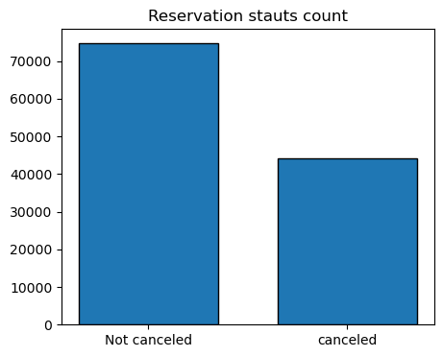
The accompanying bar graph shows the percentage of reservations that are cancelled and those that are not. It is obvious that there are still a significant number of reservations that have been cancelled. There are still 37% of clients who cancelled their reservations, which has a significant impact on the hotels, earnings.
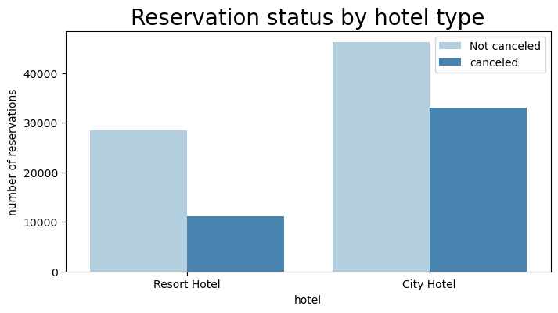
In comparison to resort hotels, city hotels have more bookings. It’s possible that resort hotels are more expensive than those in cities.
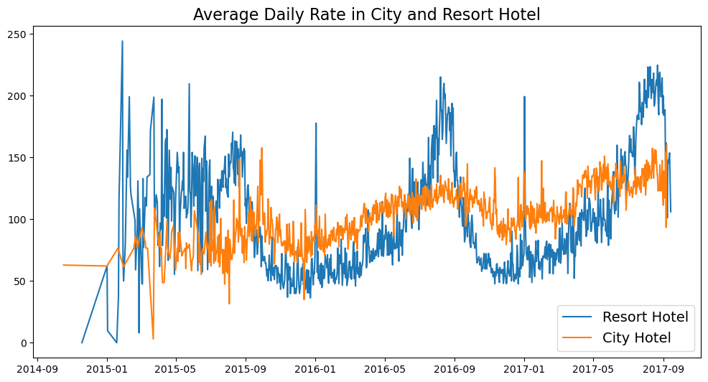
The line graph above shows that, on certain days, the average daily rate for a city hotel is less than that of resort hotel, and on other days, it is even less. It goes without saying that weekends and holidays may see a rise in resort hotel rates.
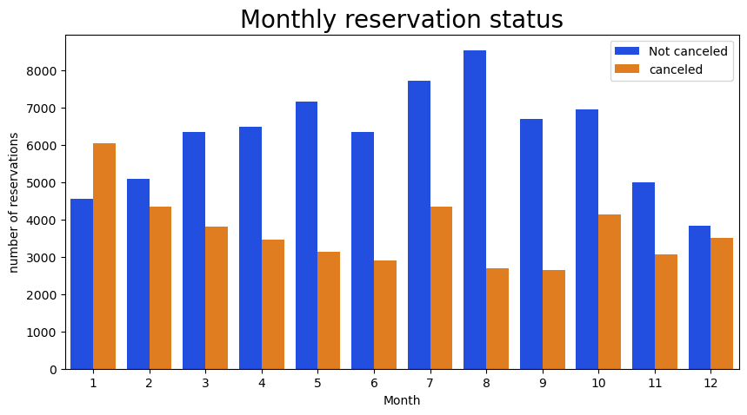
We have developed the grouped bar graph to analyse the months with the highest and lowest reservation levels according to the reservation status. As we can observe, both the number of confirmed reservations and the number of cancelled reservations is more in the month of August, whereas January is the month with the most cancelled reservations.
The bar graph below demonstrates that cancellations are most common when the prices are higher and are least common when they are lower. Therefore, the cost of the accommodation is solely responsible for the cancellations.

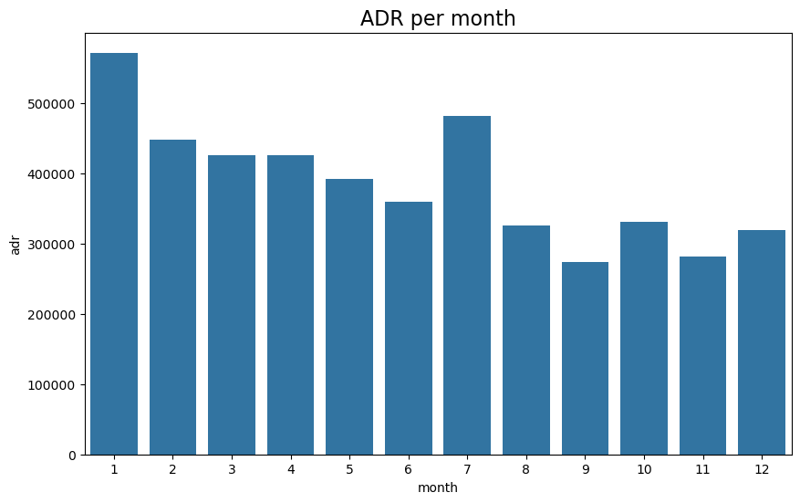
Now let’s observe which country has the highest cancelled reservations.
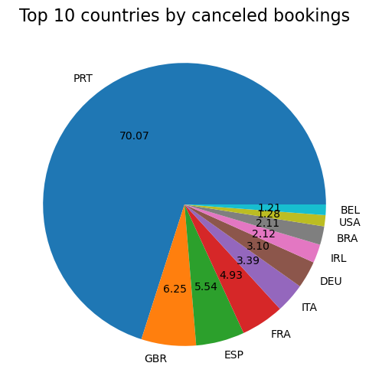
It can be understood that Portugal has the highest number of cancellations.
Let’s check the area from where guests are visiting the hotels and making reservations. Is it coming from Direct booking or through Groups, Online or Offline Travel Agents? Around 46% of the clients come from the Online Travel agents and 27% through Groups. Only 4% of the clients’ book hotels directly by visiting them and making reservations.
As perceived in the graph below, reservations are cancelled when the average daily rates are higher.

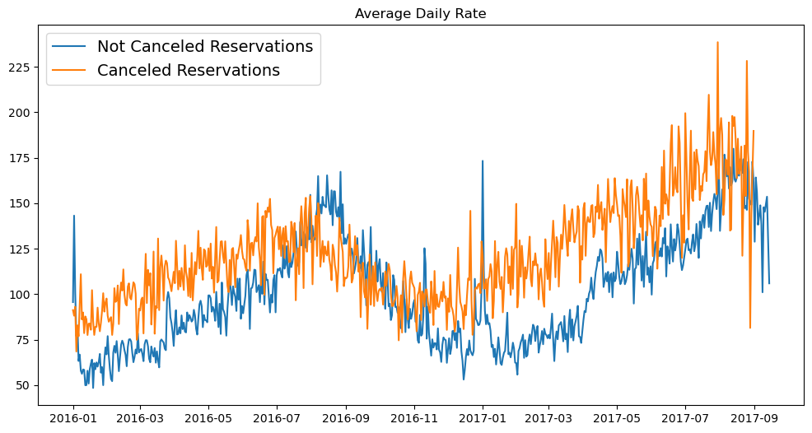
It’s evident from the above analysis, that higher prices lead to a greater number of cancellations.
Suggestions:
- Cancellation rates rise as the price increases. In order to prevent cancellations of reservations, hotels could work on their pricing strategies and try to lower the rates for specific hotels based on locations. They can also provide some discounts to the customers.
- As the ratio of the cancellations and not cancellations of the resort hotels are higher than the city hotels, the resort hotels can consider providing more discounts on weekends or holidays.
- In the month of January, hotels can start campaigns to increase their revenue as the cancelations rates are higher.
- They can also increase the quality and services of their hotels. Also, more focus has to given for the customers from Portugal to reduce their cancellation rates.

