MINI PROJECT REPORT
Traffic Sign and Signal Recognition
in Bad Conditions
Fuzzy-logic image enhancement, neural network classification and YOLO detection
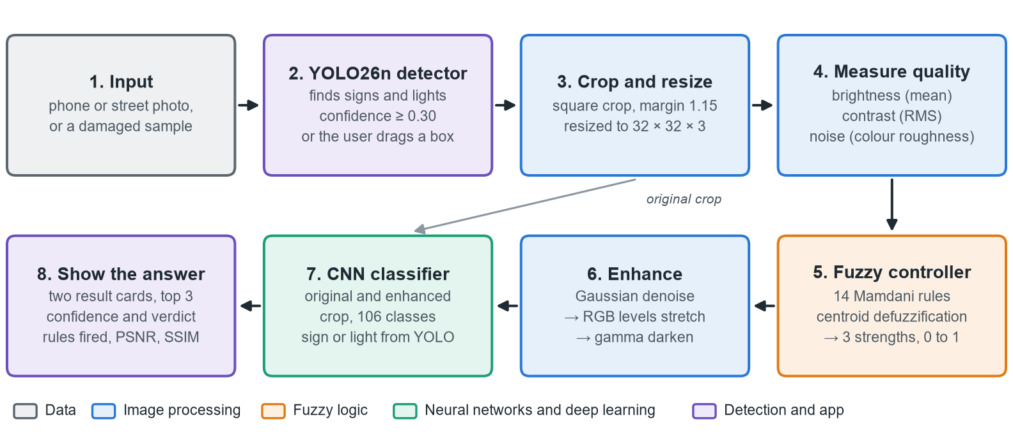
One project submitted to three courses
Deep Learning · Image Processing and Analysis · Neural Networks and Fuzzy Logic
Submitted by | Keshav Kumar
Roll number | 20241CAI0072
Department | Presidency School of Artificial Intelligence and Advanced Computing (PSAIAC)

November 2026

Abstract
Traffic signs and signals have to be read in conditions that damage the image: darkness, haze, noise, blur, rain, snow and worn paint. This project builds one pipeline for that problem. Each image is measured for brightness, contrast and noise, a Mamdani fuzzy controller decides how strongly to denoise, stretch and darken it, and a neural network names the sign or light from the original and the enhanced image side by side. A YOLO detector finds signs and lights in full photos, and a Streamlit app shows every step.
Seven datasets were used, from 2.2 million CURE-TSR images to Mapillary street photos from six continents and two sets of real damaged signs. On 203,374 real CURE-TSR test images the best 17-class CNN reached 89.8% accuracy and 0.819 macro F1, and 97.9% accuracy on 281,547 traffic-light test images. Fuzzy enhancement helped every model trained only on clean images, while training on damaged images helped more. A 106-class CNN that also learned worn paint scored 0.808 on the same real signs and lifted worn real signs from 0.597 to 0.786 macro F1. Every score is the mean of 3 training runs, chosen on validation data, with each test set scored once.
Table 1. Key results at a glance (test sets, mean of 3 seeds).
Result | Value
Best 17-class CNN, 203,374 real CURE-TSR test signs | 89.8% accuracy, 0.819 macro F1
Same CNN on 459,760 simulated signs and 281,547 lights | 0.909 macro F1 and 97.9% accuracy
Fuzzy enhancement on the CNN trained on clean images | real signs 0.683 → 0.715 F1, lights 84.7% → 90.9%
106-class CNN with worn signs, 6 datasets | 0.808 real signs, 0.959 lights, 0.786 worn signs
Fine-tuned YOLO26n detector, test mAP50 | 0.701 signs, 0.680 lights, 0.893 damaged close-ups
Automated checks across the code | 262 passing

Keywords: traffic sign recognition, bad weather and low light, fuzzy logic, Mamdani inference, image enhancement, CNN, MLP, backpropagation, YOLO, robustness, CURE-TSR, LISA, Mapillary.

Contents
Abstract 2
Contents 3
1. Introduction 4
1.1 Problem statement 4
1.2 Objectives 4
1.3 Coverage of the three courses 4
2. System design 4
2.1 Workflow 4
2.2 Architecture 5
2.3 Technology stack 6
2.4 Development protocol 6
3. Datasets 6
3.1 Damage, splits and balance 7
4. Image Processing and Analysis 7
4.1 Operations implemented 8
4.2 Removing noise 8
4.3 Measuring image quality 9
4.4 Enhancement and image quality 9
4.5 Simulating worn paint 9
5. Fuzzy Logic Controller 10
5.1 Design 10
5.2 Rule base 11
5.3 Implementation and checks 11
5.4 Fuzzy enhancement against a fixed setting 11
6. Neural Networks 12
6.1 Models 12
6.2 Backpropagation by hand 12
6.3 MLP settings study 13
6.4 MLP, feature MLP and CNN compared 13
7. Deep Learning 14
7.1 CNN architecture and training 14
7.2 Final 17-class results 15
7.3 Where the best model goes wrong 16
7.4 Traffic lights 16
7.5 Wider models: 84 and 106 classes 16
7.6 Object detection with YOLO 17
7.7 Worn and damaged signs 19
8. The Application 20
9. Testing and Validation 22
10. Limitations and Future Scope 22
11. Summary of All Results 23
12. Conclusion 23
References 23
Appendix A. Running the project 24
Appendix B. Key design decisions 24
Appendix C. Metrics used 25

1. Introduction

1.1 Problem statement
Driver assistance has to recognise signs and lights in the conditions where people struggle too: at night, in haze, rain and snow, through a dirty lens, and on old signs with faded paint. A classifier trained on clean images loses most of its value on damaged ones. In this project the same CNN scored 0.683 macro F1 on real damaged test signs when trained on clean images, against 0.819 when trained on damaged ones. The project asks whether classical image processing, steered by fuzzy logic, can recover enough of a damaged image to help a neural network, how that compares with simply training on damaged images, and how far the result carries to real street photos.

1.2 Objectives
- Image processing: build point operations, histogram methods, filters and convolution, and measure their effect with PSNR and SSIM.
- Fuzzy logic: design a Mamdani controller that measures brightness, contrast and noise and chooses how strongly to denoise, stretch and darken.
- Neural networks: train and compare an MLP on pixels, an MLP on HOG and colour features, and an MLP with hand-written backpropagation.
- Deep learning: train CNNs on clean, damaged and enhanced images, scale them to 106 classes across six datasets, add YOLO detection and handle worn signs.
- Delivery: an app that shows each step, and results reported honestly: 3 seeds, choices made on validation, each test set scored once.

1.3 Coverage of the three courses
Table 2. How the project maps onto each course.
Course | Topics covered in this project | Sections
Image Processing and Analysis | negative, gamma, contrast stretch, histogram equalization, CLAHE, convolution, Sobel, Laplacian, noise models, mean, Gaussian, median, bilateral and non-local means filters, PSNR, SSIM, HOG features, synthetic degradation | 4
Neural Networks and Fuzzy Logic | fuzzy sets, membership functions, Mamdani inference, centroid defuzzification, MLP, backpropagation by hand, activations, optimizers, learning rates | 5, 6
Deep Learning | CNNs, batch normalization, dropout, augmentation, class weighting, training regimes, 106-class transfer to new datasets, YOLO object detection, robustness to wear | 7

2. System design

2.1 Workflow
Figure 1 follows one photo through the system. YOLO finds each sign or light, or the user drags a box. The crop is resized to 32 × 32 pixels and measured, the fuzzy controller sets three strengths, and the enhancement runs in a fixed order: denoise first, because stretching would amplify leftover noise, then stretch, then darken. The CNN classifies both the original and the enhanced crop, so the app can show whether enhancement changed the answer.
Figure 1. End-to-end workflow for one image. Colours show which course each step belongs to.

2.2 Architecture
The code is split into four packages with no circular links: image_processing, fuzzy_logic and deep_learning hold the methods, experiments runs training and scoring, and app.py is the Streamlit interface. Datasets are packed once into 32 × 32 NumPy arrays, which made training on 1.9 million images practical on a laptop GPU.
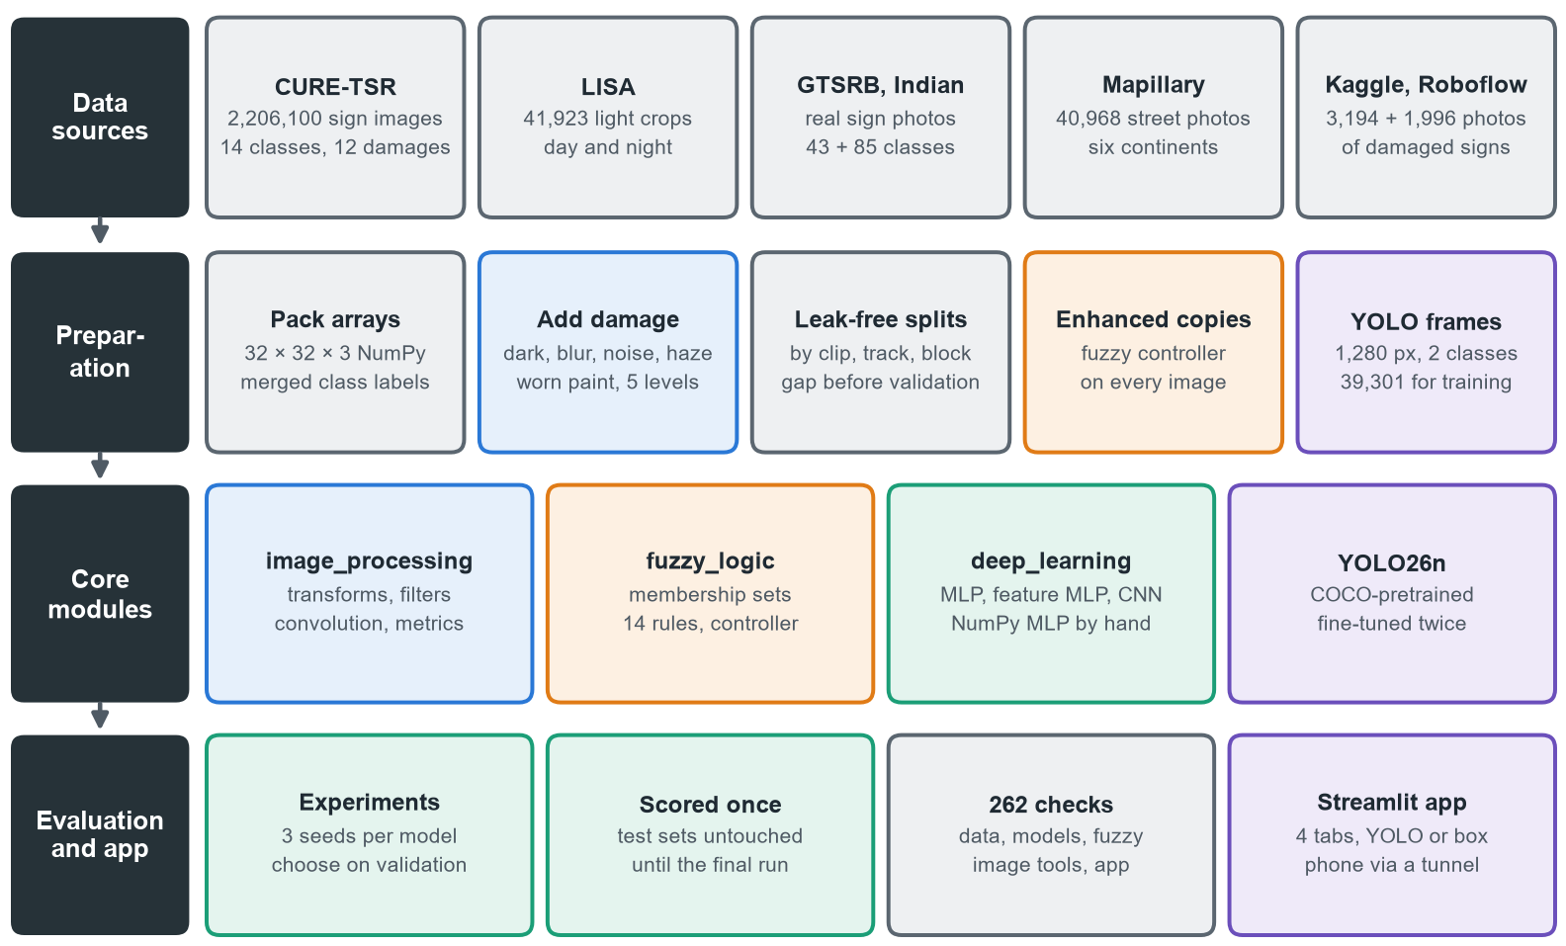
Figure 2. System architecture, from data sources to evaluation and the app.

2.3 Technology stack
Table 3. Technology stack.
Layer | Tools and versions
Language and environment | Python 3.11 in a project virtual environment, Windows 11
Deep learning | PyTorch 2.15 with CUDA 13.4 for training, and PyTorch 2.5.1 with CUDA 12.4 from 11 November, on an NVIDIA RTX 4050 laptop GPU (6 GB)
Object detection | Ultralytics 8.4.198, YOLO26 nano pretrained on COCO
Image processing | OpenCV, scikit-image, NumPy, Pillow
Fuzzy logic | scikit-fuzzy membership functions, inference written in NumPy
Evaluation and charts | scikit-learn metrics, pandas, matplotlib
Application | Streamlit with streamlit-cropper; a Cloudflare quick tunnel for phone tests

2.4 Development protocol
The models grew in four stages (Figure 3). At every stage the rule was the same: train 3 seeds, compare on validation data, record the choice in a decision log, then score the test sets once and change nothing afterwards. This keeps every reported test score free of tuning on the test data.
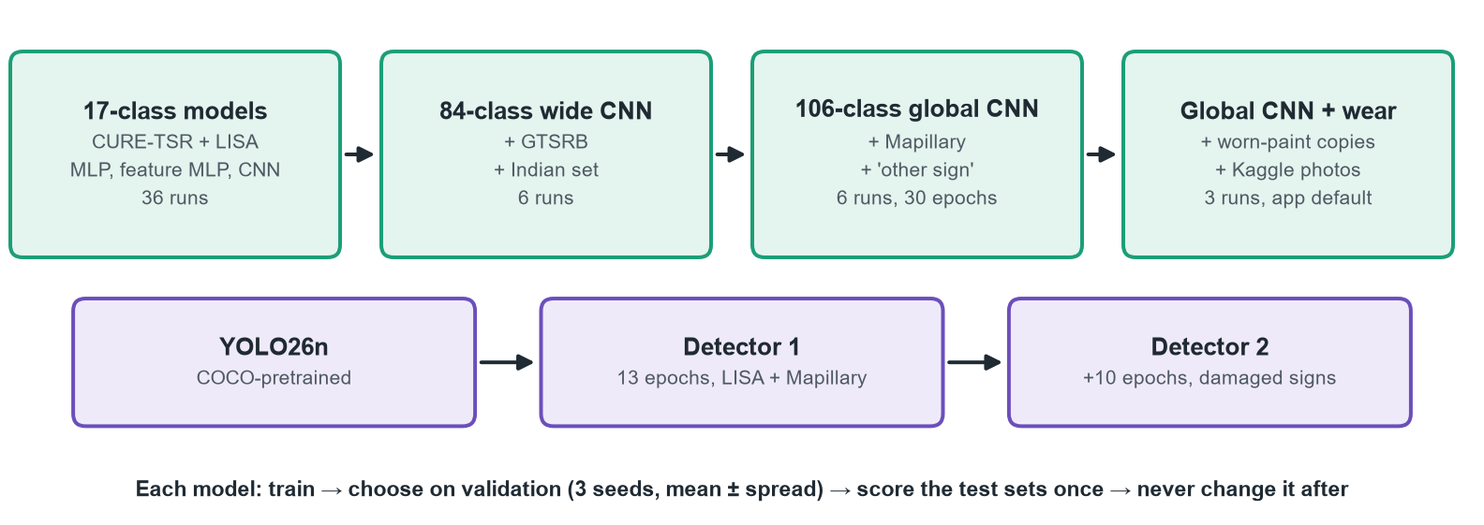
Figure 3. How the classifiers and the detector grew, and the evaluation rule used at every stage.

3. Datasets
Seven datasets were combined. CURE-TSR is the core: every damaged image has a matching clean original, so image quality can be measured exactly. The others widen the classes, add real photos and add real damage.
Table 4. Datasets, what each adds and how many images were used. Crops are 32 × 32 pixels.
Dataset | What it adds | Images used (train / val / test) | Classes
CURE-TSR, real and simulated | 14 sign types, 12 damage conditions at 5 levels, clean originals | 1,542,966 training files; 203,374 real and 459,760 simulated test images | 14
LISA Traffic Light | red, yellow and green lights, day and night, split by whole clips | 41,923 light crops, plus damaged copies (281,547 test images) | 3
GTSRB | real German sign photos; whole tracks held out | 33,329 / 5,880 / 12,630 clean crops | 43, merged
Indian Traffic Sign Classification | real Indian sign photos; near copies kept out of test | 3,307 / 604 / 448 clean crops | 67 used
Mapillary Traffic Sign Dataset | street photos from six continents, with an 'other sign' class | 36,240 / 6,427 / 6,196 crops; 30,397 detection frames | +22
Kaggle Damaged Signs (CC0) | faded, peeled, rusted and vandalised Lisbon signs | 994 / 230 / 230 crops; 2,175 / 460 / 480 frames | 3 named
Roboflow Detection_of_damage_signs (CC BY 4.0) | close-ups labelled by kind of damage, for YOLO | 1,397 / 399 / 200 frames | boxes only

Class lists grew from 17 (14 CURE-TSR signs and 3 lights) to 84 with GTSRB and the Indian set, and to 106 with Mapillary. The same sign from different datasets was merged into one class, such as GTSRB, Indian and CURE-TSR stop signs.
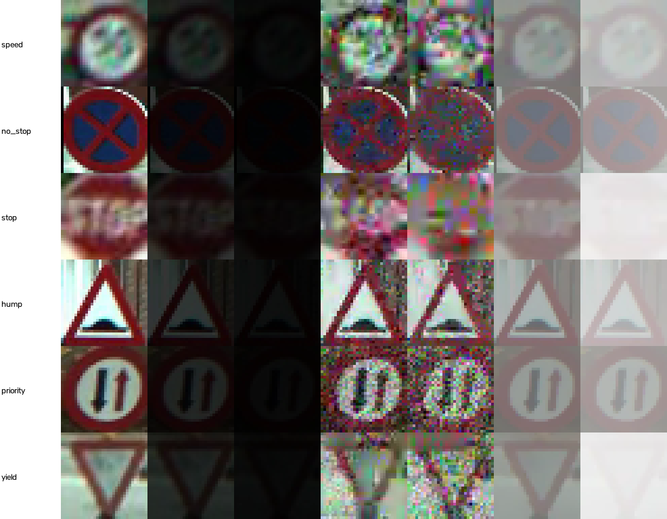 | 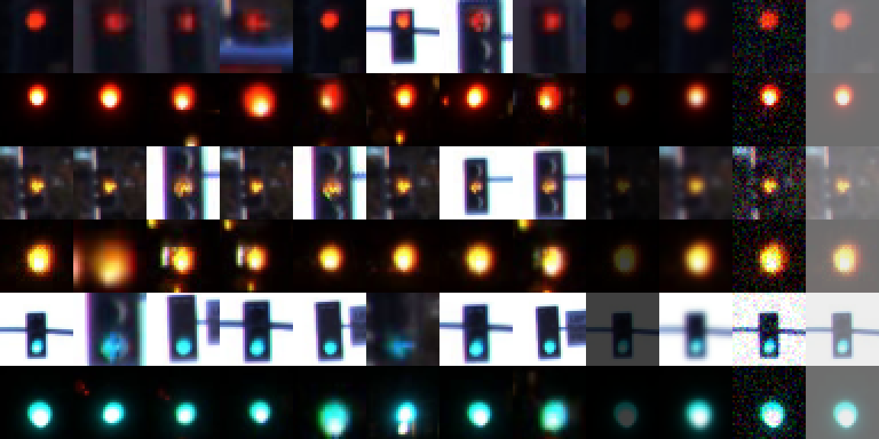
CURE-TSR: clean, then darkening, noise and haze at levels 3 and 5 | LISA: red, yellow and green, day and night, then 4 damages
Figure 4. Samples from the two core datasets, at the 32 × 32 size the models see.

3.1 Damage, splits and balance
- Damage: CURE-TSR supplies 12 conditions (decolorization, lens blur, codec error, darkening, dirty lens, exposure, Gaussian blur, noise, rain, shadow, snow, haze) at 5 levels. LISA, GTSRB, the Indian set and Mapillary get darkening, blur, noise and haze added in code: 4 random damaged copies per training image, and all 20 for validation and test. A 13th condition, worn paint, was added later (Section 4.5).
- No leakage: neighbouring video frames are nearly identical, so validation holds out the last 15% of each sign's frames with a 5% gap, LISA splits by whole clips, GTSRB by whole tracks, and 768 Indian test images that matched training images by an 8 × 8 average hash were removed. The 11 street photos used to try the app turned out to be Kaggle photos, so they and their neighbours were kept out of every split.
- Balance: clean real training signs range from 2,480 parking signs to 38 no stopping signs, so the loss is weighted by inverse class frequency and every score is macro F1.
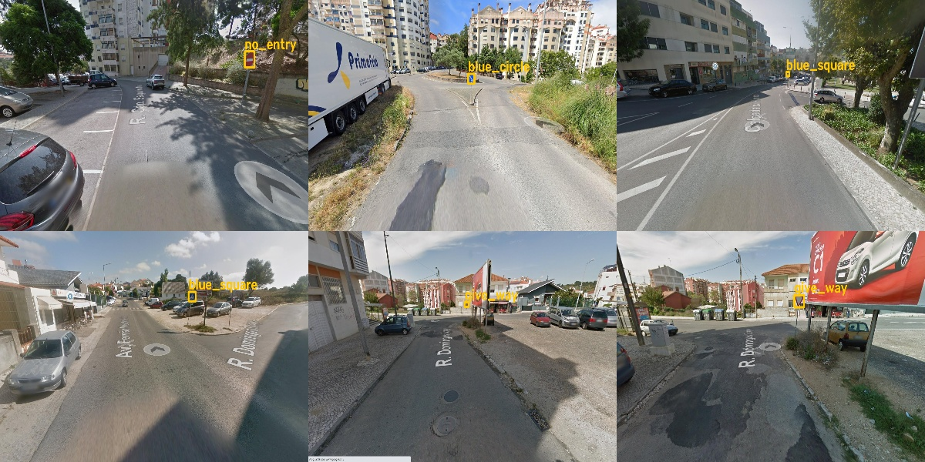 | 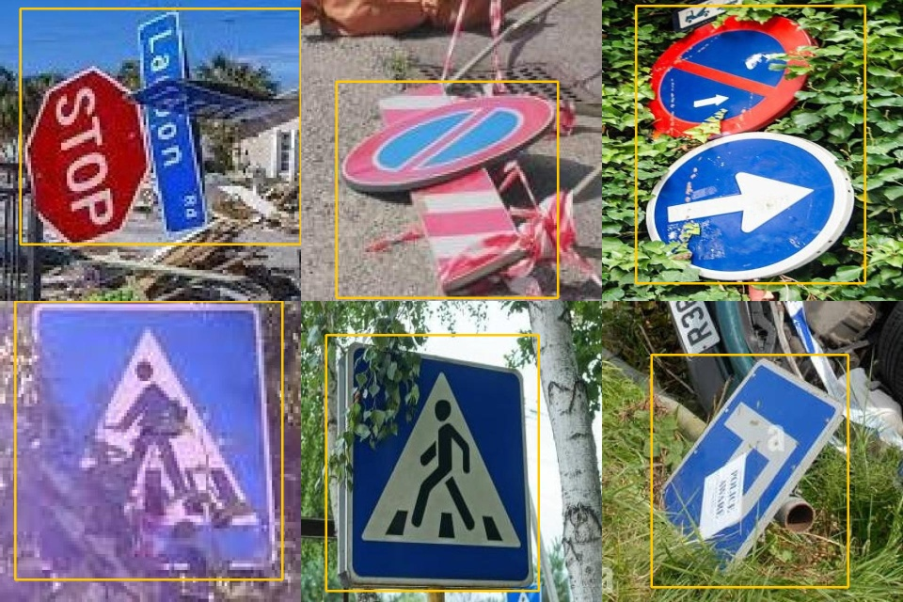
Kaggle: Lisbon Street View frames, 9 sign groups | Roboflow: close-ups boxed by kind of damage
Figure 5. Labelled frames from the two damaged-sign datasets, as YOLO sees them.

4. Image Processing and Analysis
Course highlights: Image Processing and Analysis
- Point operations, histogram methods, 5 restoration filters and a hand-written 2-D convolution that equals OpenCV on six kernels.
- A noise study on 1,000 real signs: the median filter lifts 2% salt-and-pepper noise from 22.16 dB to 34.83 dB.
- A new colour-roughness noise measure, because the standard estimate barely saw CURE-TSR noise.
- Fuzzy-chosen enhancement raises PSNR over all 13 conditions from 17.90 dB to 18.35 dB while leaving clean images almost untouched.

4.1 Operations implemented
Table 5. Image processing operations built for the project.
Category | Operations | Used for
Point operations | negative, gamma correction, percentile contrast stretch, levels stretch on all RGB channels together | enhancement, image tools tab
Histogram methods | histogram equalization and CLAHE on lightness only, so colours do not shift | image tools tab, comparison
Convolution | hand-written 2-D convolution, equal to OpenCV on six kernels; Gaussian, sharpen, Laplacian, Sobel edges | image tools tab, teaching
Noise and restoration | Gaussian and salt-and-pepper noise; mean, Gaussian, median, bilateral and non-local means filters | noise study, denoise step
Quality measures | MSE, PSNR (capped at 60 dB), SSIM; mean brightness, RMS contrast, colour-roughness noise | evaluation, fuzzy inputs
Features | HOG (9 orientations, 8 × 8 cells, 2 × 2 blocks: 324 values) and 3 colour histograms of 8 bins: 348 values | feature MLP
Degradation | darkening, Gaussian blur, noise, haze and worn paint at 5 levels | training data, robustness tests

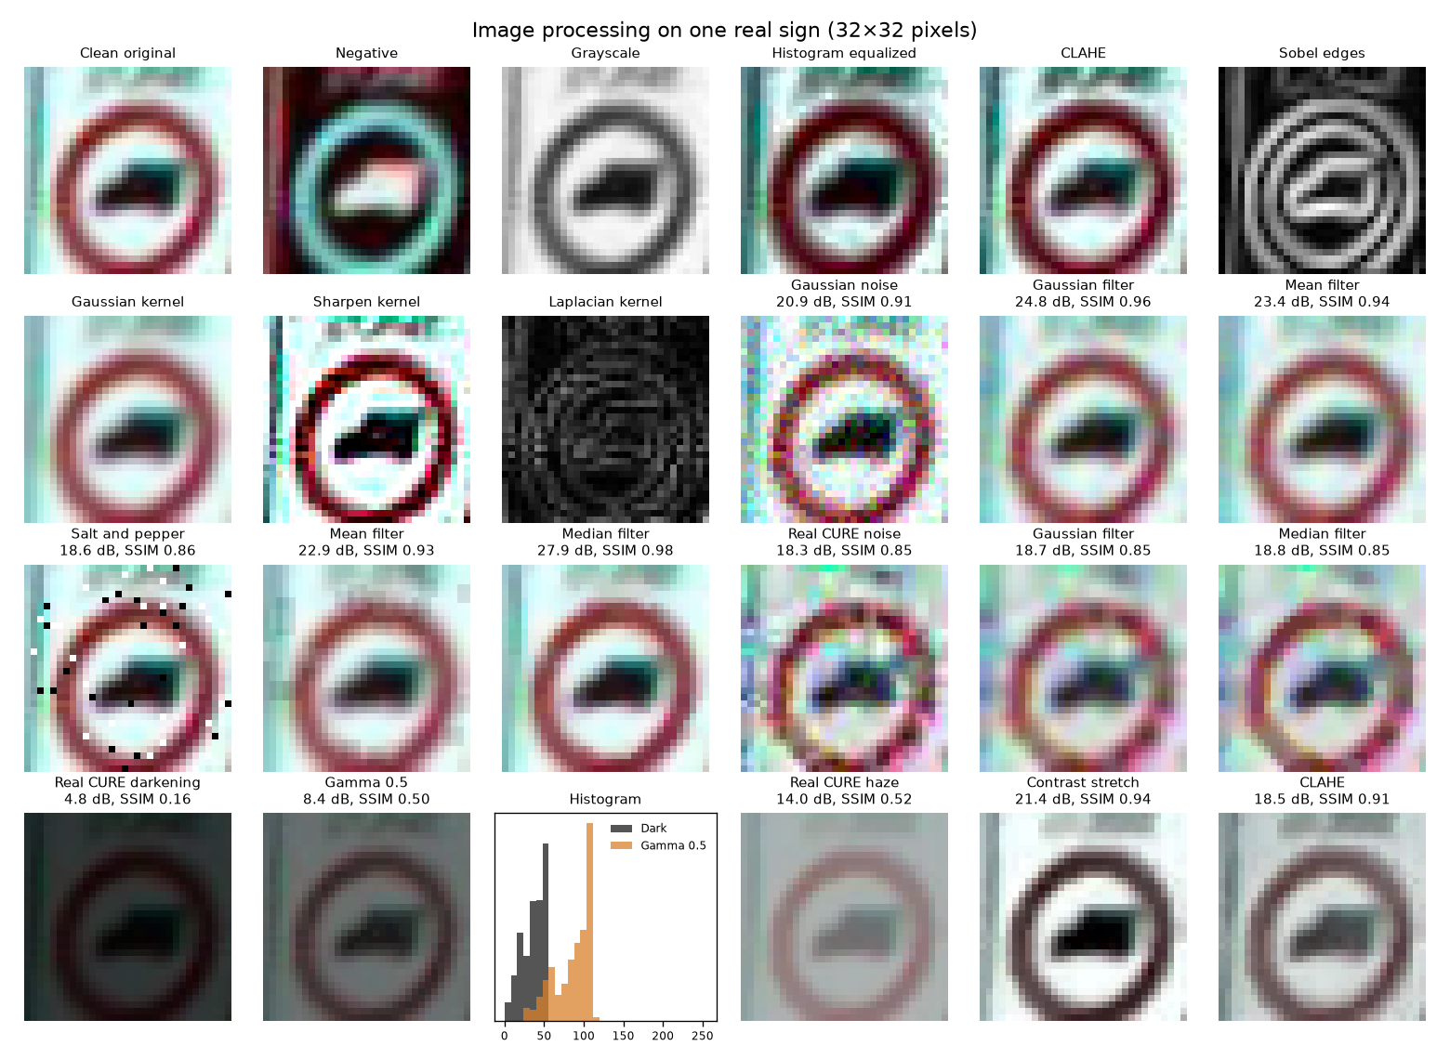
Figure 6. Operations on one real 32 × 32 sign, with PSNR and SSIM against the clean original where damage was added.

4.2 Removing noise
Noise was added to 1,000 clean real test images and each filter's PSNR was measured against the original. The median filter clearly won on salt-and-pepper noise, smoothing filters won on strong Gaussian noise, and non-local means took about 1.4 ms per image, at least 100 times longer than the others, without ever being best.
Table 6. Best filter for each kind of noise, on 1,000 real test signs.
Noise | PSNR before | Best filter | PSNR after | SSIM after
Gaussian, σ = 10 | 28.24 dB | Bilateral | 33.04 dB | 0.965
Gaussian, σ = 25 | 20.51 dB | Gaussian | 26.74 dB | 0.866
Gaussian, σ = 50 | 15.03 dB | Mean | 22.34 dB | 0.725
Salt and pepper, 2% | 22.16 dB | Median | 34.83 dB | 0.968
Salt and pepper, 5% | 18.02 dB | Median | 33.58 dB | 0.964
Salt and pepper, 10% | 14.99 dB | Median | 31.48 dB | 0.955

4.3 Measuring image quality
The fuzzy controller needs three measurements. Brightness is the mean grey level and contrast is the RMS contrast, both from 0 to 1. For noise, the standard Immerkær estimate read 2.0 on clean signs and only 4.0 on level 3 CURE-TSR noise, because that noise is blocky and strongly coloured. The project's measure instead takes the colour channels of the Lab image at half resolution and applies the same Laplacian-style kernel, which separated noise from every other condition far better on training images.

4.4 Enhancement and image quality
Enhanced real test images were compared with their clean originals, using 100 images per condition and level. Fuzzy enhancement raised average PSNR from 17.90 dB to 18.35 dB. A fixed 50% stretch scored 17.40 dB, mainly because it also changes clean images, which the fuzzy controller leaves almost alone (53.37 dB against 28.53 dB).
Table 7. Image quality against the clean original (PSNR in dB, capped at 60).
Condition | PSNR none | PSNR fixed | PSNR fuzzy | SSIM none | SSIM fixed | SSIM fuzzy
All 13 conditions | 17.90 | 17.40 | 18.35 | 0.57 | 0.64 | 0.64
Clean | 60.00 | 28.53 | 53.37 | 1.00 | 0.97 | 0.99
Darkening | 10.44 | 16.81 | 18.16 | 0.33 | 0.78 | 0.79
Haze | 13.45 | 18.77 | 18.22 | 0.52 | 0.81 | 0.76
Exposure | 7.93 | 8.30 | 8.77 | 0.38 | 0.39 | 0.41
Noise | 20.70 | 18.93 | 20.22 | 0.63 | 0.61 | 0.62
Gaussian blur | 17.96 | 16.54 | 16.02 | 0.42 | 0.46 | 0.43

4.5 Simulating worn paint
A phone test showed that no dataset contained old, worn signs (Section 7.7). A 13th damage type was written for it: inside a disc around the sign's centre, it fades the colour towards grey and peels smooth random patches, showing the pale backing sheet, while white paint peels to darker metal and black lettering stays. Levels 3 to 5 add rust spots. Traffic lights never get it, because their colour is their label.
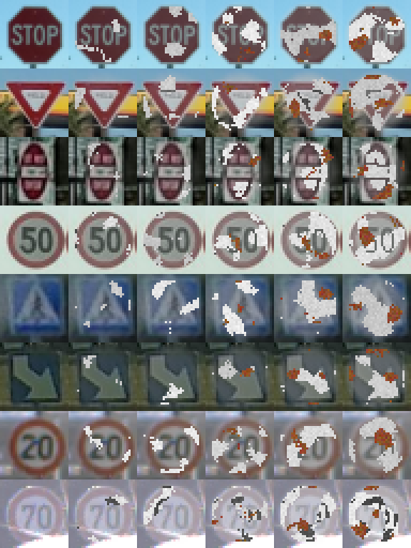 | 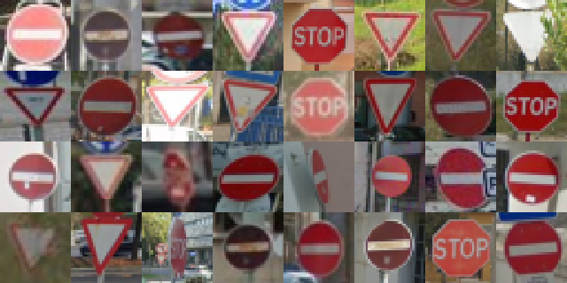
Worn paint at levels 1 to 5 | Real damaged crops from Kaggle's Lisbon photos
Figure 7. Simulated wear beside real worn signs.

5. Fuzzy Logic Controller
Course highlights: Fuzzy Logic
- Three inputs (brightness, contrast, noise) and three outputs (denoise, stretch, darken), each with three fuzzy sets.
- 14 Mamdani rules with min for AND, max aggregation and centroid defuzzification, written in NumPy for whole batches.
- Matches scikit-fuzzy's engine within 0.0001, and shows which rules fired for every image in the app.
- Lifts the clean-trained CNN on real signs from 0.683 to 0.715 macro F1, and lights from 84.7% to 90.9% accuracy.

5.1 Design
Dark, hazy, noisy and overexposed signs need different fixes, so the controller has three separate outputs instead of one strength. It is a Mamdani system: inputs are fuzzified, 14 IF–THEN rules fire with AND as the minimum, each rule clips its output set, the clipped sets are combined with the maximum, and the centroid gives a strength from 0 to 1.
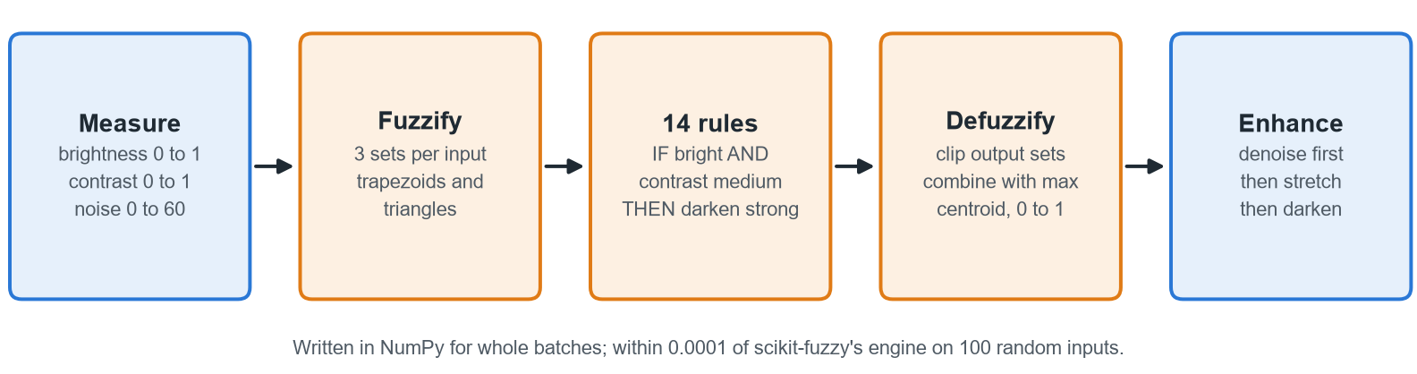
Figure 8. The fuzzy controller, from measurements to enhancement.
Table 8. Linguistic variables.
Variable | Role | Range | Fuzzy sets
Brightness | input | 0 to 1 | dark, normal, bright
Contrast | input | 0 to 1 | low, medium, high
Noise | input | 0 to 60 | low, medium, high
Denoise, stretch, darken | outputs | 0 to 1 | none, weak, strong

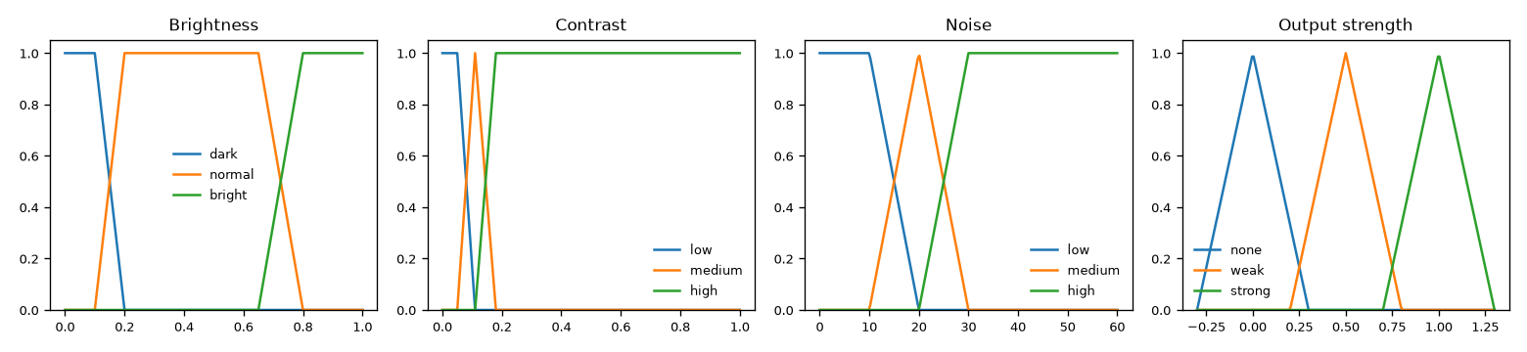
Figure 9. Membership functions for the three inputs and the shared output strength.

5.2 Rule base
Table 9. The 14 rules. Overexposure still has contrast, so bright and flat images are treated as haze and are not darkened.
# | IF | THEN | # | IF | THEN
1 | brightness is dark | stretch strong | 8 | brightness bright AND contrast high | darken strong
2 | contrast is low | stretch strong | 9 | brightness bright AND contrast low (haze) | darken none
3 | brightness normal AND contrast medium | stretch weak | 10 | brightness is normal | darken none
4 | brightness normal AND contrast high | stretch none | 11 | brightness is dark | darken none
5 | brightness bright AND contrast medium | stretch none | 12 | noise is low | denoise none
6 | brightness bright AND contrast high | stretch none | 13 | noise is medium | denoise weak
7 | brightness bright AND contrast medium | darken strong | 14 | noise is high | denoise strong

5.3 Implementation and checks
- Inference is written in NumPy and runs on whole batches, so every packed image could be enhanced in advance on all CPU cores; it also reports which rules fired, which the app displays.
- Its outputs stay within 0.0001 of scikit-fuzzy's own engine on 100 random inputs, one of 36 automated checks of the controller.
- The ranges were tuned on training images only. The first rules fired too often on clean signs (46.92 dB after enhancement); retuning the noise and contrast ranges raised clean signs to 55.27 dB.
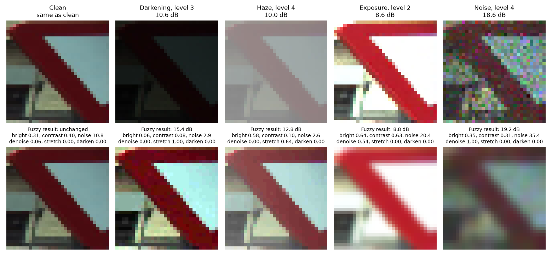
Figure 10. The controller on one real sign under four conditions: measurements, chosen strengths and PSNR before and after.

5.4 Fuzzy enhancement against a fixed setting
To check that fuzzy logic earns its place, 12 fixed settings were tried on validation images with the CNN trained on clean images; the best was a 50% stretch on every image (0.900 validation macro F1, against 0.878 with no enhancement). On the test sets:
Table 10. Fuzzy enhancement against the best fixed setting (test sets, 3 seeds).
Input to the clean-trained CNN | Real signs F1 | Simulated F1 | Lights accuracy | PSNR, all conditions
Original image | 0.683 | 0.757 | 84.7% | 17.90 dB
Fixed 50% stretch | 0.712 | 0.793 | 93.7% | 17.40 dB
Fuzzy enhancement | 0.715 | 0.791 | 90.9% | 18.35 dB

Fuzzy enhancement and the fixed stretch tie on signs, and the fixed stretch wins on lights, especially in haze (85.0% against 73.0%; 52.9% with no enhancement). The fuzzy rules were tuned for image quality, not for classification, and their clearest advantage is leaving clean images almost untouched. Figure 11 shows where the gains come from: darkening rises from 0.603 to 0.855 and haze from 0.647 to 0.840, clean images stay at 0.868, and blur, codec errors and noise, which these steps cannot undo, stay level or drop by up to 0.02.
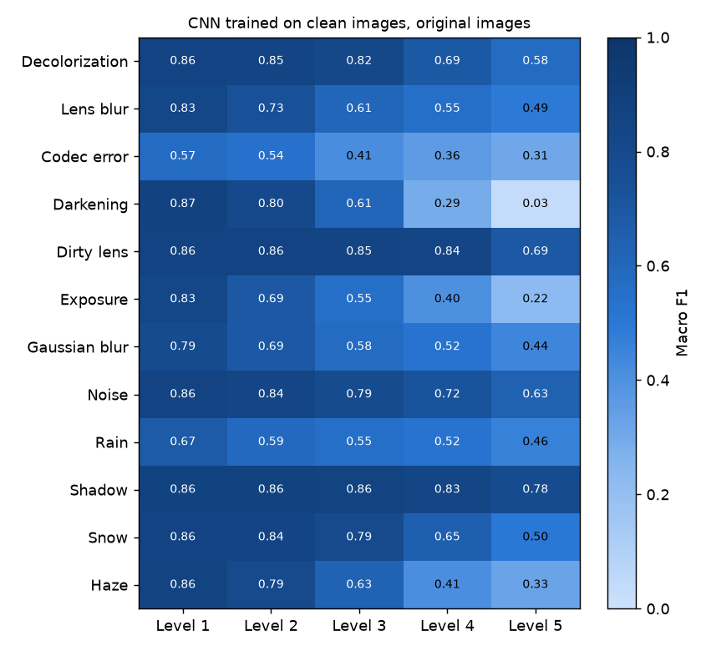 | 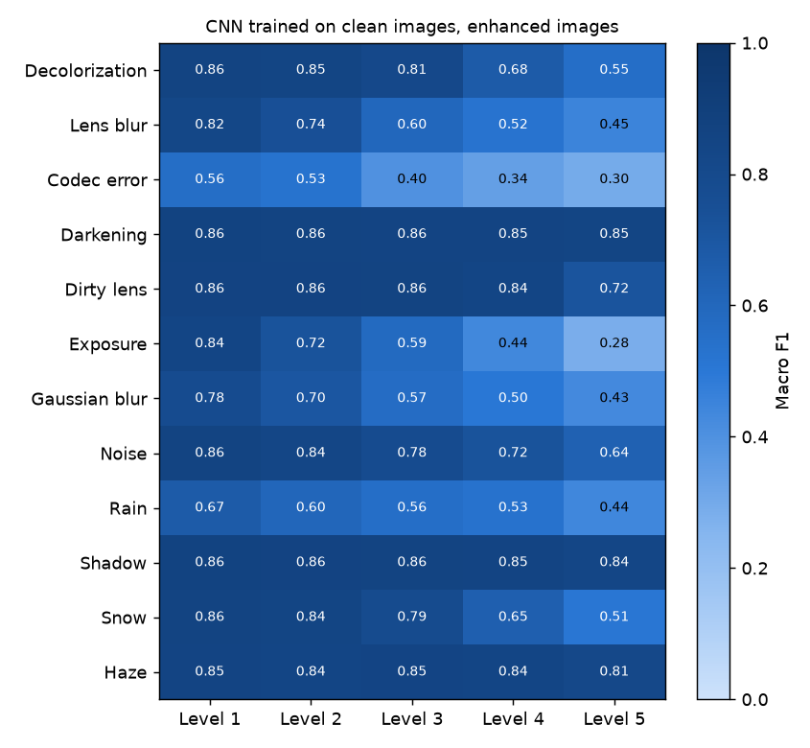
Original images | After fuzzy enhancement
Figure 11. Macro F1 of the clean-trained CNN on real test signs by condition and level, before and after fuzzy enhancement.

6. Neural Networks
Course highlights: Neural Networks
- An MLP on raw pixels, an MLP on 348 HOG and colour features, and an MLP with backpropagation written by hand in NumPy.
- Hand-written gradients pass a finite-difference check with a worst relative error of 5.23 × 10⁻⁷, and match PyTorch step for step.
- A one-at-a-time study of hidden sizes, learning rates, optimizers and activations.
- Raw pixels beat hand-made features: 0.733 against 0.701 macro F1 on real signs when trained on all conditions.

6.1 Models
Table 11. The neural networks compared.
Model | Input | Layers | Weights (17 classes)
MLP | 3,072 raw pixels | 512 → 256, ReLU, dropout 0.3 | 1,709,073
Feature MLP | 348 HOG and colour values | 512 → 256, ReLU, dropout 0.3 | 314,385
NumPy MLP | 1,024 grey pixels | 64 hidden, ReLU, written by hand | 66,510 (14 classes)
Small CNN | 3 × 32 × 32 image | 3 convolution blocks, FC 256 (Section 7.1) | 816,369

6.2 Backpropagation by hand
PyTorch hides backpropagation, so a small MLP was written in NumPy with every gradient derived by hand. For a batch with inputs X, hidden layer h = ReLU(XW₁ + b₁) and softmax output p:
- output error δ₂ = (p − y) / n, so ∂L/∂W₂ = hᵀδ₂ and ∂L/∂b₂ = Σ δ₂;
- hidden error δ₁ = (δ₂W₂ᵀ) ⊙ 1[XW₁ + b₁ > 0], so ∂L/∂W₁ = Xᵀδ₁;
- update W ← W − η ∂L/∂W with η = 0.05, batches of 64, for 30 epochs.
A finite-difference check found a worst relative gradient error of 5.23 × 10⁻⁷, and one training step matched PyTorch's to rounding. Trained on clean signs, it reached about 0.80 validation accuracy, curve for curve with an identical PyTorch model (Figure 12).
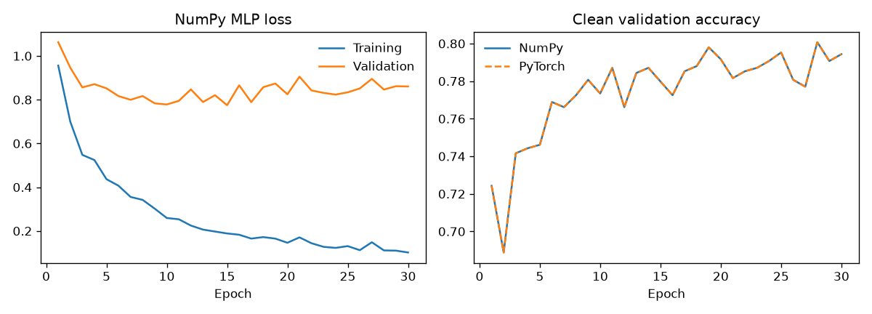
Figure 12. The NumPy MLP: loss, and validation accuracy against the same network in PyTorch.

6.3 MLP settings study
One setting was changed at a time, training on clean images for 30 epochs. A learning rate of 0.01 collapsed to 0.526, and the largest network scored lowest of the sizes. Each setting ran once, so small gaps may be chance.
Table 12. MLP settings study (validation macro F1, one run each).
Setting changed | Value | Best val. F1 | Setting changed | Value | Best val. F1
Baseline | 512-256, Adam, 0.001, ReLU | 0.728 | Learning rate | 0.0001 | 0.745
Hidden sizes | 128 | 0.747 | Learning rate | 0.01 | 0.526
Hidden sizes | 256-128 | 0.738 | Optimizer | SGD, 0.01 | 0.740
Hidden sizes | 512-256-128 | 0.732 | Optimizer | SGD, 0.1 | 0.720
Hidden sizes | 1024-512 | 0.715 | Activation | sigmoid / tanh | 0.745 / 0.736

6.4 MLP, feature MLP and CNN compared
Table 13. The three architectures on the 17-class test sets (original input, 3 seeds).
Model | Trained on | Real signs F1 | Simulated F1 | Lights F1
CNN | all conditions | 0.819 | 0.909 | 0.980
MLP | all conditions | 0.733 | 0.878 | 0.960
Feature MLP | all conditions | 0.701 | 0.825 | 0.898
CNN | clean images | 0.683 | 0.757 | 0.894
MLP | clean images | 0.630 | 0.741 | 0.878
Feature MLP | clean images | 0.591 | 0.671 | 0.838

The CNN wins every comparison. The MLP on raw pixels beat the MLP on HOG and colour features in both regimes, so hand-made features lost more than they gave at 32 × 32 pixels. Training on damaged images lifted every model more than any architecture change.
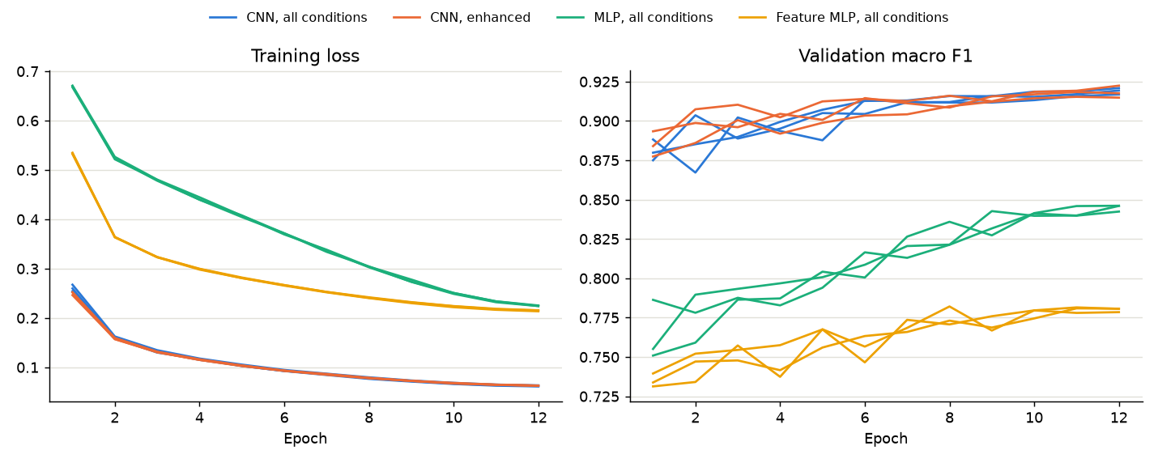
Figure 13. Training loss and validation macro F1 for the models trained on all conditions, 3 seeds each.

7. Deep Learning
Course highlights: Deep Learning
- A CNN with six convolution layers, batch normalization and dropout; 51 classifier runs across 4 class lists, plus 2 YOLO detectors.
- Training on damaged images beats enhancing them: 0.819 against 0.715 macro F1 on 203,374 real damaged test signs.
- Scaled from 17 to 106 classes over six datasets without losing accuracy on the original signs (0.816 against 0.819).
- Worn-sign training raised worn real signs from 0.597 to 0.786, and fine-tuning YOLO raised damaged close-ups from 0.003 to 0.893 mAP50.

7.1 CNN architecture and training
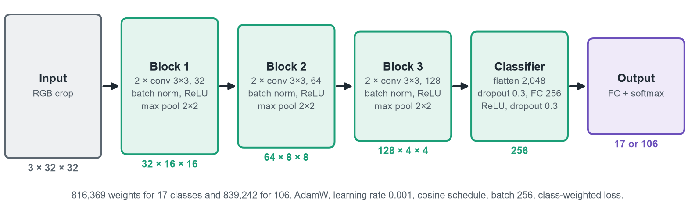
Figure 14. The CNN used for every classifier, from 17 to 106 classes.
Table 14. Training setup.
Setting | Value
Optimizer and schedule | AdamW, learning rate 0.001, weight decay 0.0001, cosine annealing
Batch and loss | 256 images; cross-entropy weighted by inverse class frequency
Augmentation | small random rotation, shift and zoom on the GPU; never flips, which can change a sign's meaning
Regimes | clean images only; all conditions; and fuzzy-enhanced copies of either
Epochs and stopping | 17 classes: 60 clean or 12 all-conditions epochs, patience 12 or 4 on validation macro F1. 106 classes: 30 epochs, patience 10
Seeds and hardware | 3 seeds per model; RTX 4050, about 154 to 171 s per epoch for the 106-class CNN on 1.7 to 1.9 million images

Table 15. Every training run in the project: 51 classifier runs for the results, 12 for the studies, and 2 detectors.
Model family | Data | Classes | Runs | Epochs | Training / validation images
MLP, feature MLP, CNN | CURE-TSR + LISA; clean, all conditions, enhanced | 17 | 36 | 60 or 12 | CURE-TSR's 1.54 million training files, less the validation blocks, plus LISA
Wide CNN | + GTSRB, Indian set | 84 | 6 | 60 or 12 | clean or all-conditions sets of the four datasets
Global CNN | + Mapillary | 106 | 6 | 60 or 30 | 1,725,061 / 406,372 (all conditions)
Global CNN + wear | + worn-paint copies, Kaggle crops | 106 | 3 | 30 | 1,918,825 / 477,955; 93 minutes per run
MLP settings study | CURE-TSR, clean | 14 | 11 | 30 | one run per setting
NumPy MLP | CURE-TSR, clean, grey | 14 | 1 | 30 | compared with PyTorch
YOLO detector 1 | LISA + Mapillary frames | 2 | 1 | 13 | 35,729 frames; 5.0 hours
YOLO detector 2 | + Kaggle and Roboflow frames | 2 | 1 | +10 | 39,301 frames; 4.4 hours

7.2 Final 17-class results
All 24 combinations of model, training regime and input were scored on 944,681 test images: 203,374 real signs, 459,760 simulated signs and 281,547 lights. The main ones:
Table 16. 17-class test results, macro F1 as mean ± spread of 3 seeds.
Model | Trained on | Input | Real signs F1 | Simulated F1 | Lights F1
CNN | all conditions | original | 0.819 ± 0.003 | 0.909 ± 0.001 | 0.980 ± 0.002
CNN | enhanced images | enhanced | 0.814 ± 0.006 | 0.901 ± 0.001 | 0.981 ± 0.003
CNN | all conditions | enhanced | 0.781 ± 0.001 | 0.875 ± 0.002 | 0.979 ± 0.003
MLP | enhanced images | enhanced | 0.745 ± 0.003 | 0.886 ± 0.002 | 0.956 ± 0.015
MLP | all conditions | original | 0.733 ± 0.003 | 0.878 ± 0.001 | 0.960 ± 0.003
CNN | clean images | enhanced | 0.715 ± 0.014 | 0.791 ± 0.004 | 0.936 ± 0.010
Feature MLP | all conditions | original | 0.701 ± 0.002 | 0.825 ± 0.001 | 0.898 ± 0.003
CNN | clean images | original | 0.683 ± 0.009 | 0.757 ± 0.008 | 0.894 ± 0.011

- Training on damage beats enhancing: the CNN rose from 0.683 to 0.819 on real signs when trained on all conditions; fuzzy enhancement alone took it to 0.715.
- Enhancement helps models that never saw damage, and slightly hurts a model that did (0.819 → 0.781), because it changes what that model expects. Training on enhanced images removes most of that cost (0.814).
- Validation was the easier check: the best CNN scored 0.902 on validation, whose frames come from the training videos, and 0.819 on the real test set.
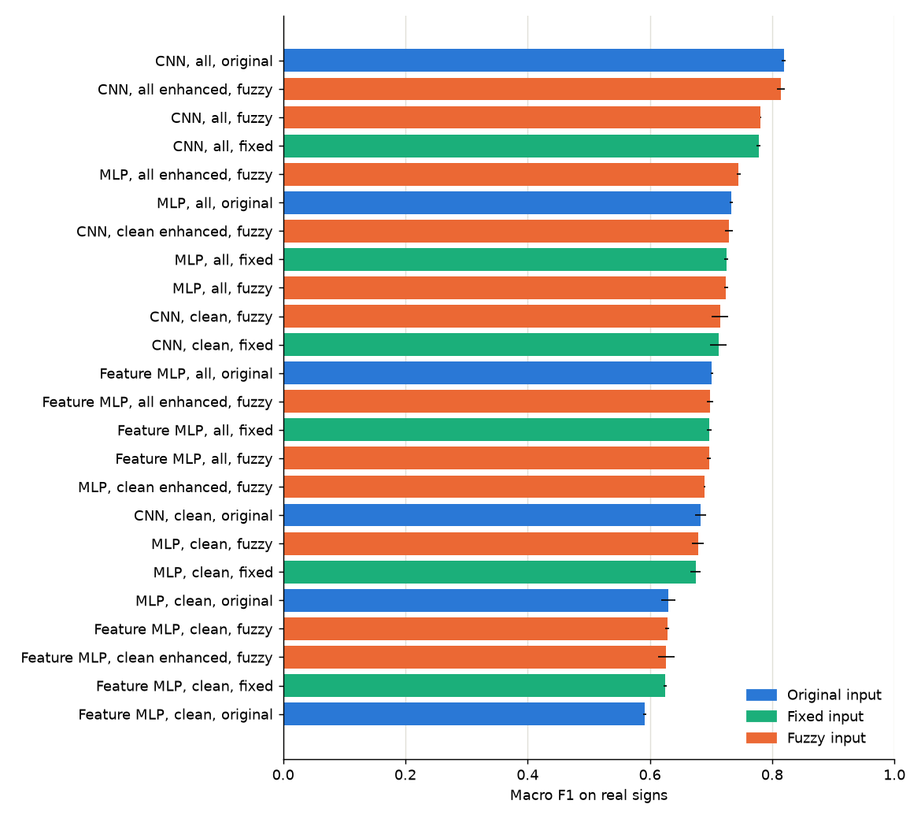 | 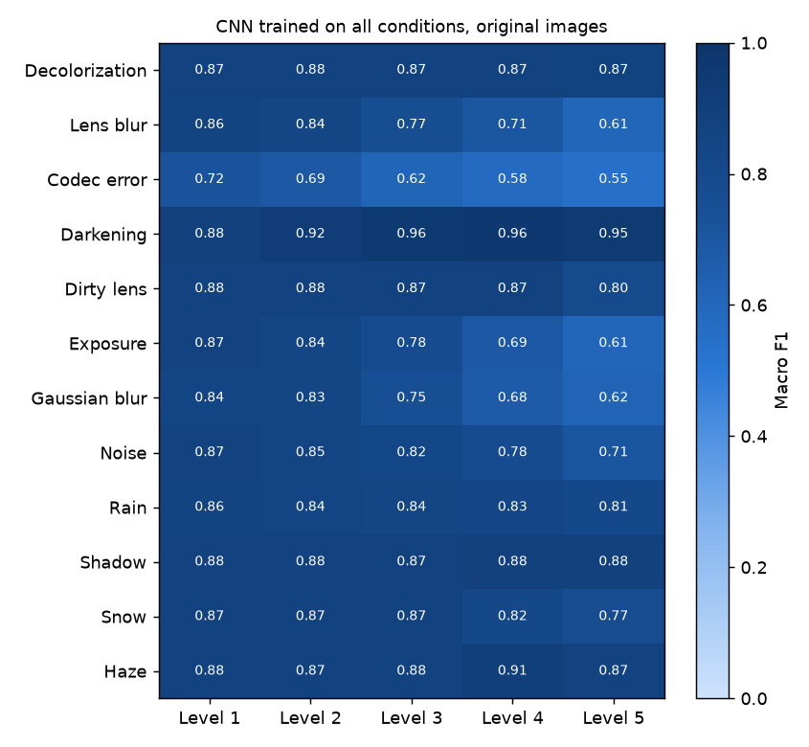
All 24 combinations, real signs | Best CNN by condition
Figure 15. Macro F1 of every combination, and of the best CNN for each of the 13 conditions, on real test signs.

7.3 Where the best model goes wrong
Most of the drop from validation to test comes from one sign. No stopping had only 38 clean training images; on the test set just 8% of its 976 images were read correctly and 43% were read as speed limit. Its F1 of 0.114 pulls the macro average down, while the other ten real signs average 0.889. The same sign explains why darkening (0.941) scores above clean images (0.876) in Figure 15.
Table 17. Per-class results of the best CNN on the real test set.
Class | F1 | Recall | Test images | Class | F1 | Recall | Test images
Green light | 0.989 | 0.984 | 126,000 | No right | 0.896 | 0.880 | 19,154
Red light | 0.987 | 0.981 | 126,000 | Hump | 0.894 | 0.928 | 5,612
Yellow light | 0.963 | 0.955 | 29,547 | Speed limit | 0.884 | 0.896 | 32,818
Parking | 0.946 | 0.970 | 72,895 | Goods vehicles | 0.840 | 0.855 | 3,965
Stop | 0.911 | 0.981 | 2,684 | Bicycle | 0.807 | 0.742 | 23,546
No entry | 0.911 | 0.904 | 2,623 | No stopping | 0.114 | 0.083 | 976
No parking | 0.906 | 0.889 | 22,692 | Yield | 0.900 | 0.871 | 16,409

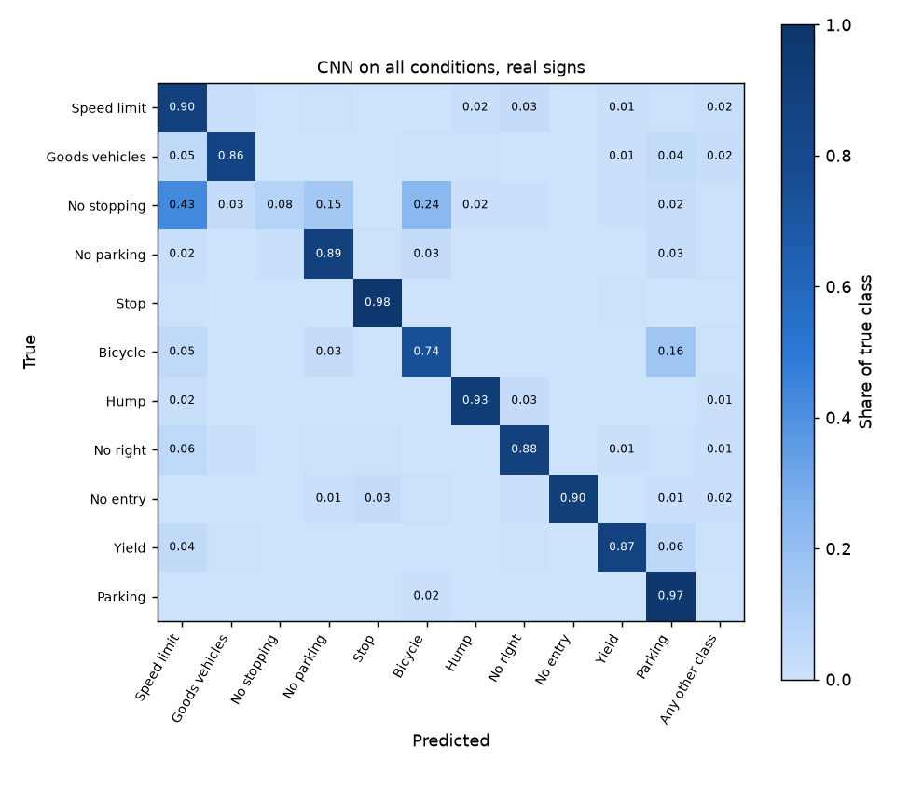 | 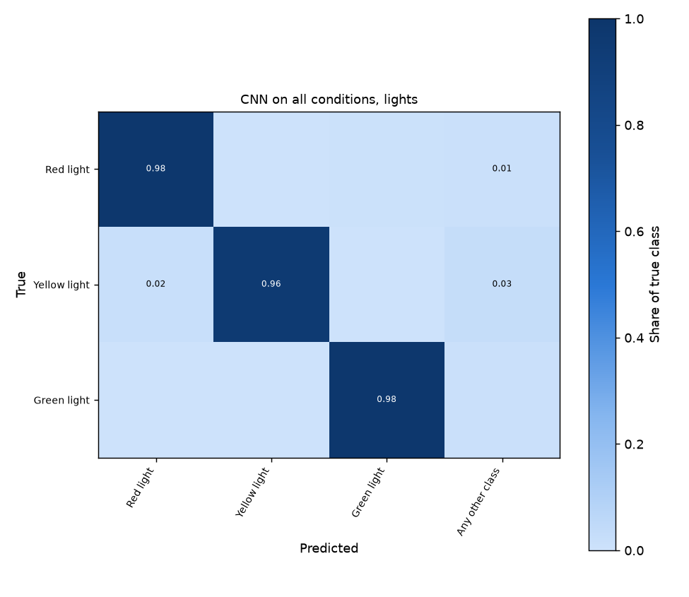
Real test signs | Test lights
Figure 16. Confusion matrices of the best CNN, as shares of each true class.

7.4 Traffic lights
Lights held up on LISA's four unused test sequences, falling from 99.9% on validation to 97.9%. The best CNN read lights about equally well by day (97.4%) and at night (98.3%); yellow was the weakest colour at 95.5% recall, and about 1.2% of lights were mistaken for signs.
Table 18. Signs and lights side by side for the CNN (real signs, test).
CNN trained on | Input | Sign accuracy | Sign macro F1 | Light accuracy
All conditions | original | 89.8% | 0.819 | 97.9%
Enhanced images | enhanced | 89.6% | 0.814 | 97.9%
All conditions | enhanced | 87.5% | 0.781 | 97.4%
Clean images | enhanced | 79.9% | 0.715 | 90.9%
Clean images | fixed stretch | 79.8% | 0.712 | 93.7%
Clean images | original | 75.3% | 0.683 | 84.7%

7.5 Wider models: 84 and 106 classes
Seventeen classes proved too few for street photos, because any other sign got a wrong name. A wide CNN added GTSRB and the Indian set (84 classes), and a global CNN added Mapillary's street signs from six continents and an 'other sign' class (106 classes). The global CNN needed 30 epochs: at 12 it scored only 0.69 on Mapillary validation signs.
Table 19. Macro F1 of the wide and global CNNs on each test set (original input unless stated, 3 seeds).
Test data | Wide CNN, all cond. | Global CNN, all cond. | Global CNN, clean | Global clean + fuzzy | 17-class CNN
Real CURE-TSR signs | 0.757 | 0.816 | 0.713 | 0.745 | 0.819
Simulated signs | 0.881 | 0.888 | 0.769 | 0.800 | 0.909
Traffic lights | 0.946 | 0.951 | 0.839 | 0.941 | 0.980
GTSRB | 0.907 | 0.940 | 0.821 | 0.893 | –
Indian set | 0.613 | 0.719 | 0.742 | 0.742 | –
Mapillary | – | 0.797 | 0.750 | 0.815 | –

Adding Mapillary cost nothing on the old datasets: the global CNN beats the wide CNN everywhere and comes within 0.003 of the 17-class CNN on real signs while knowing 89 more classes. Fuzzy enhancement again helped the clean-trained model on five of six datasets, most on lights (0.839 → 0.941).
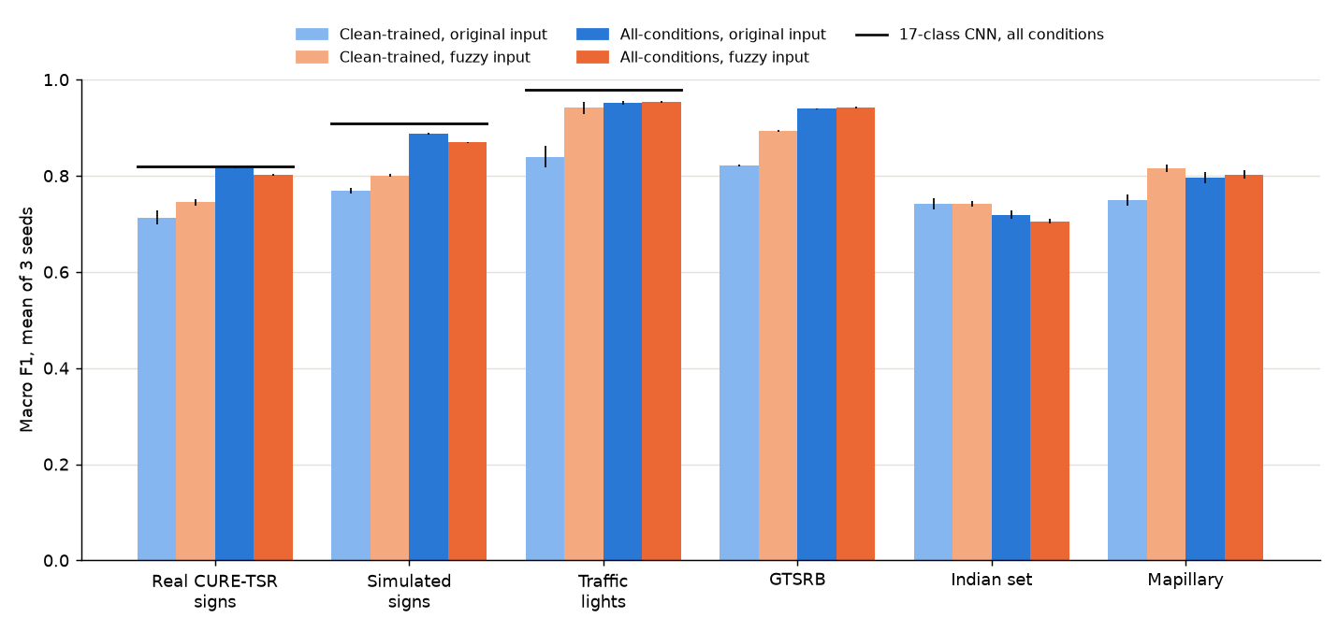
Figure 17. The 106-class global CNN on every test set; black lines mark the 17-class CNN.

7.6 Object detection with YOLO
YOLO26 nano, pretrained on COCO, learned two classes, sign and light, from full frames at 1,280 pixels: LISA frames for lights and Mapillary frames for signs, split exactly as for the classifiers. Mapillary does not label lights, so COCO's model marked lights it was at least 50% sure of in Mapillary's training and validation frames; test frames keep only human labels. It trained for 13 epochs (5.0 hours), and was later fine-tuned for 10 more epochs with the two damaged-sign datasets (4.4 hours). A confidence threshold of 0.30 was chosen from validation F1 curves.
Table 20. YOLO on test frames. A find counts when its box overlaps a labelled box by at least half.
Test data | Frames | Detector 1 precision / recall | Detector 1 mAP50 | Detector 2 precision / recall | Detector 2 mAP50
LISA lights | 18,252 | 0.713 / 0.615 | 0.663 | 0.786 / 0.597 | 0.680
Mapillary signs | 5,210 | 0.803 / 0.618 | 0.694 | 0.805 / 0.625 | 0.701
Kaggle damaged signs | 480 | 0.721 / 0.764 | 0.749 | 0.835 / 0.806 | 0.853
Roboflow damaged close-ups | 200 | 0.414 / 0.005 | 0.003 | 0.872 / 0.798 | 0.893

Detector 2's F1 on validation peaks near 0.30 confidence for signs (0.29 to 0.36 across the three sign sets) and stays flat up to about 0.49 for lights, so the threshold of 0.30 was kept (Figure 18).
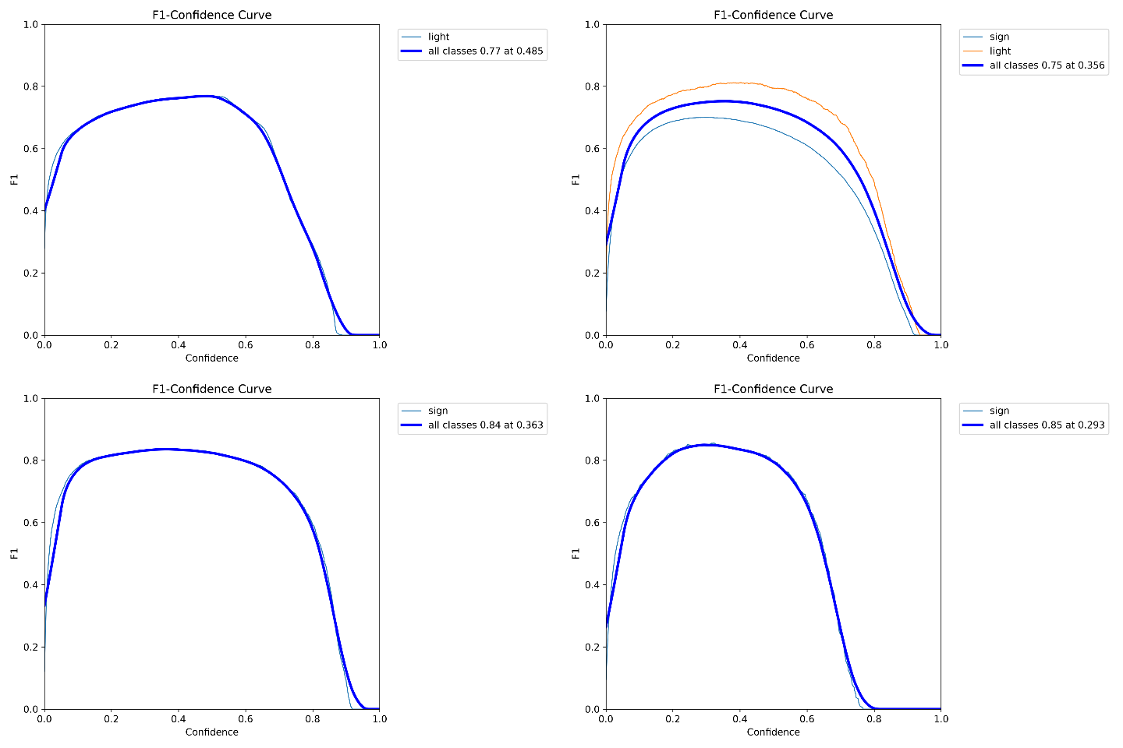
Figure 18. Detector 2's F1 against confidence on the validation frames of LISA, Mapillary, Kaggle and Roboflow.
On 11 street photos, detector 1 found all 18 hand-marked signs and lights. The global CNNs then named two close-up green lights as signs, so the app now lets the classifier choose only among lights when YOLO says light, and only among signs when it says sign; this raised correct names from 12 to 14 of 16 without changing any reported score.
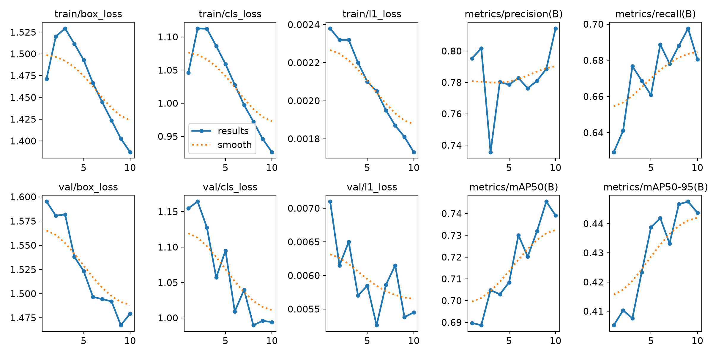 | 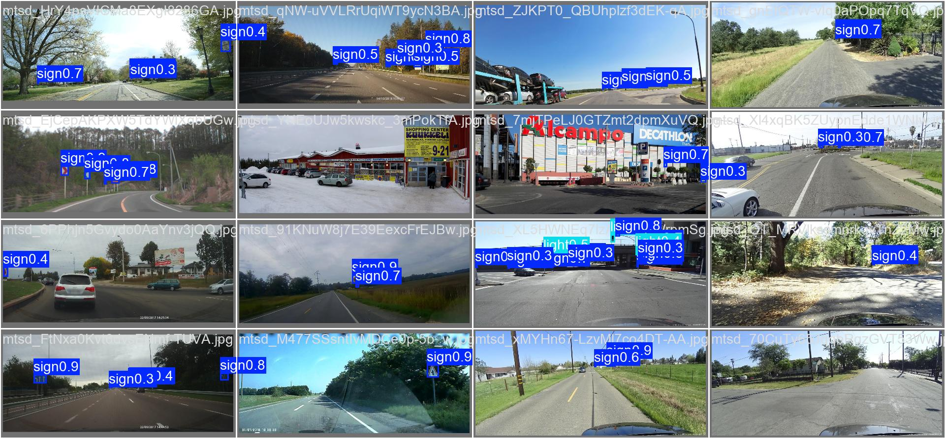
Fine-tuning curves over 10 epochs | Predictions on Mapillary validation frames
Figure 19. YOLO fine-tuning: losses fall and validation mAP50 rises from 0.690 to 0.746; boxes on unseen street frames from several countries.
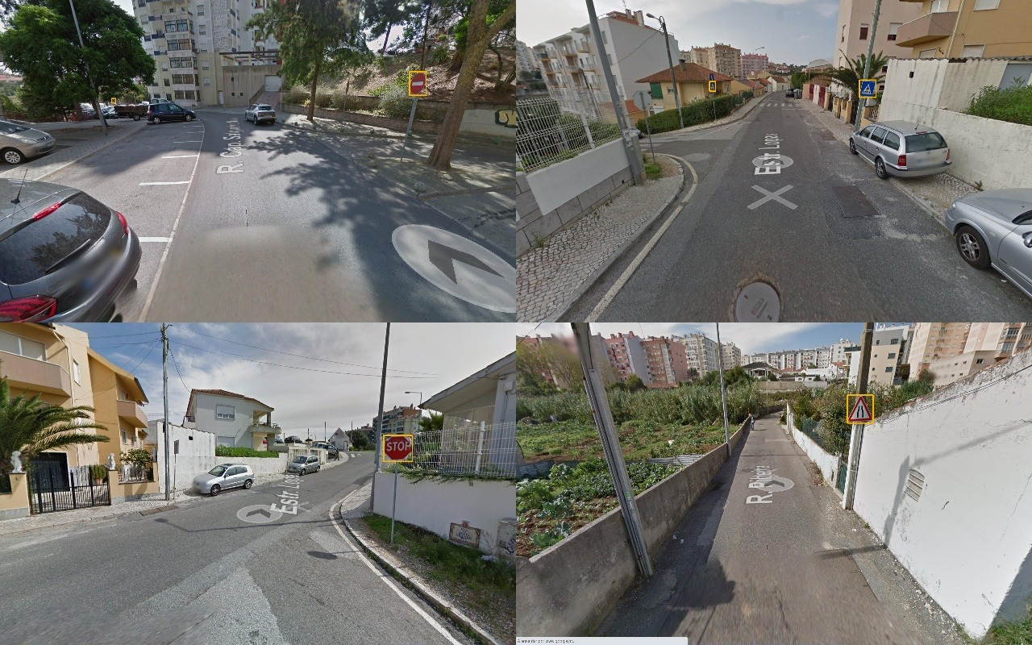
Figure 20. YOLO boxes on four of the downloaded street photos: signs in yellow, lights in green.

7.7 Worn and damaged signs
A phone test found a weakness no test set covered: worn paint. On a photo of an old stop sign with most of its red peeled off, every model named another sign and YOLO found nothing. Painting the peeled areas red again made the clean global CNN answer stop at 87%, so the models were relying on colour. A third global CNN was trained with worn-paint copies of every sign image and the Kaggle crops, and YOLO was fine-tuned with both damaged-sign datasets.
Table 21. The global CNN with and without worn signs (test sets, original input, 3 seeds).
Test data (macro F1) | Global CNN, all conditions | Global CNN + worn signs | Change
Worn real CURE-TSR signs | 0.597 | 0.786 | +0.19
Worn simulated signs | 0.678 | 0.900 | +0.22
Worn GTSRB | 0.629 | 0.867 | +0.24
Worn Indian set | 0.440 | 0.592 | +0.15
Worn Mapillary | 0.469 | 0.649 | +0.18
Real damaged photos (Kaggle) | 0.968 | 0.968 | 0
Real CURE-TSR signs | 0.816 | 0.808 | −0.008
Traffic lights | 0.951 | 0.959 | +0.008

The choice was made on validation before the test sets were touched (Table 22). The worn-sign CNN was far better on worn signs but lower by more than the seed spread on simulated signs, GTSRB and Mapillary, so it missed the stricter rule written before training; it was chosen anyway, openly, because worn signs are common on real roads. Detector 2 was better on every validation set and replaced detector 1 under the rule.
Table 22. Validation scores used for the choice (3 seeds, original input).
Validation set (macro F1) | All conditions | + worn signs | Validation set (macro F1) | All conditions | + worn signs
Real CURE-TSR signs | 0.833 | 0.830 | Worn real signs | 0.633 | 0.855
Simulated signs | 0.889 | 0.881 | Worn simulated signs | 0.734 | 0.911
Traffic lights | 0.996 | 0.996 | Worn GTSRB | 0.644 | 0.875
GTSRB | 0.943 | 0.936 | Worn Indian set | 0.405 | 0.540
Indian set | 0.704 | 0.693 | Worn Mapillary | 0.464 | 0.642
Mapillary | 0.797 | 0.783 | Kaggle damaged photos | 0.963 | 0.962

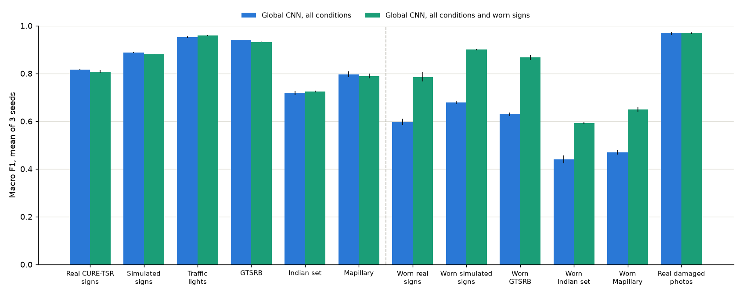
Figure 21. Every test set without (blue) and with (green) worn-sign training; worn and damaged sets are right of the dashed line.
Worn-sign scores rose by 15 to 24 points on the test sets while every usual set moved by under 1 point. The faded stop sign that started this work is now found by YOLO at 73% confidence, but no CNN names it yet: about three quarters of its red is gone and its white letters have turned dark, past the strongest simulated wear. It is kept as a known limitation, rather than tuning the wear to one photo.
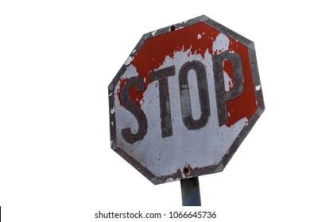 |  | 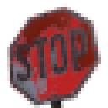
The phone-test photo | What the CNN sees, three crop sizes | Peeled areas repainted
Figure 22. The faded stop sign: every model named it as another sign until the red was painted back, which made the clean global CNN answer stop at 87%.

8. The Application
The Streamlit app runs the classifiers on the laptop's processor, and YOLO on the GPU when one is free; it has four tabs. The sidebar picks a sample image (any of the 17 classes, under any condition and level) or an uploaded photo, and one of four classifiers: the worn-sign global CNN, the clean global CNN, and the 17-class CNN and MLP.
Table 23. The app's four tabs.
Tab | What it shows
Live demo | YOLO's boxes or a drag box, the three measurements, each enhancement stage, both predictions with their top 3 classes, a verdict, and PSNR and SSIM for samples
Fuzzy decision | where the image falls in each membership function, and every rule that fired with its strength
Image tools | negative, gamma, histogram equalization, CLAHE, kernels, noise and filters on the chosen image
Project results | every test table in this report, including both detectors

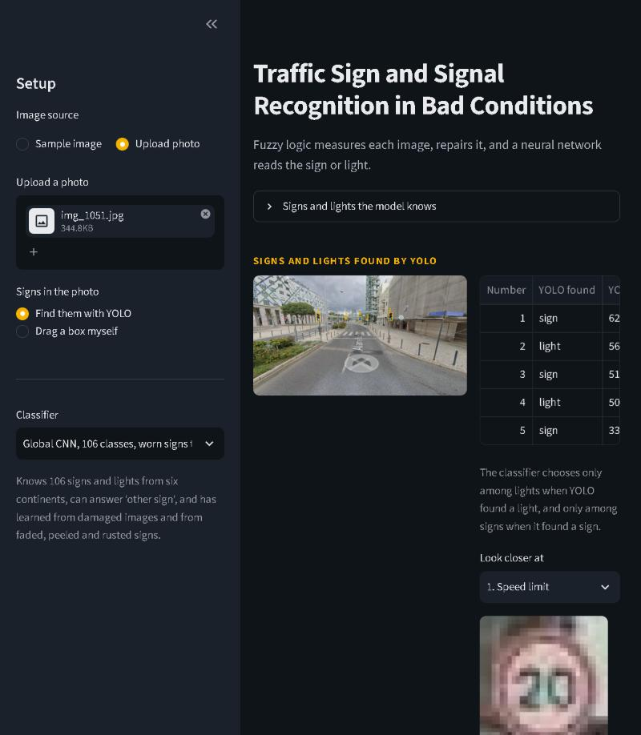 | 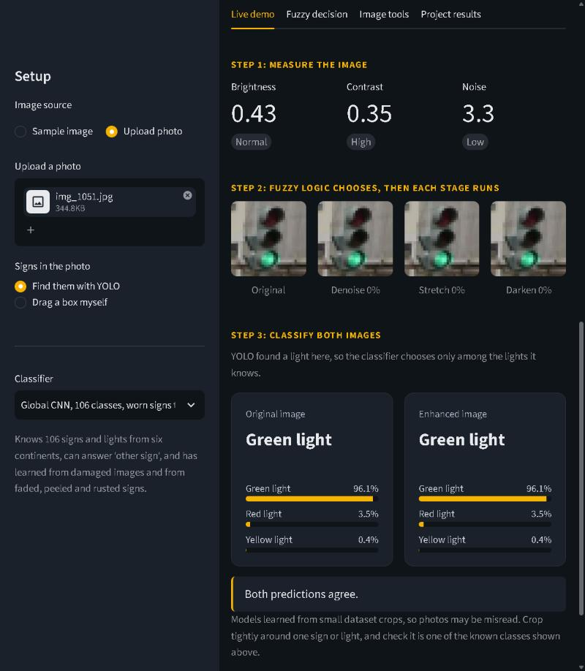
The worn-sign YOLO finds five objects in a street photo | Fuzzy stages and both answers: green light
Figure 23. The working app on a downloaded street photo (screenshots taken on 11 November 2026 with the worn-sign CNN and detector).
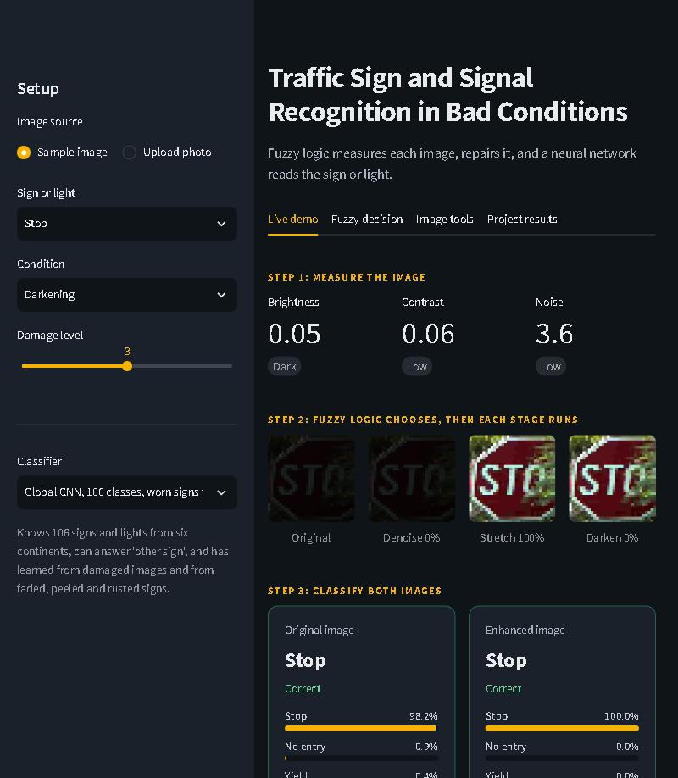 | 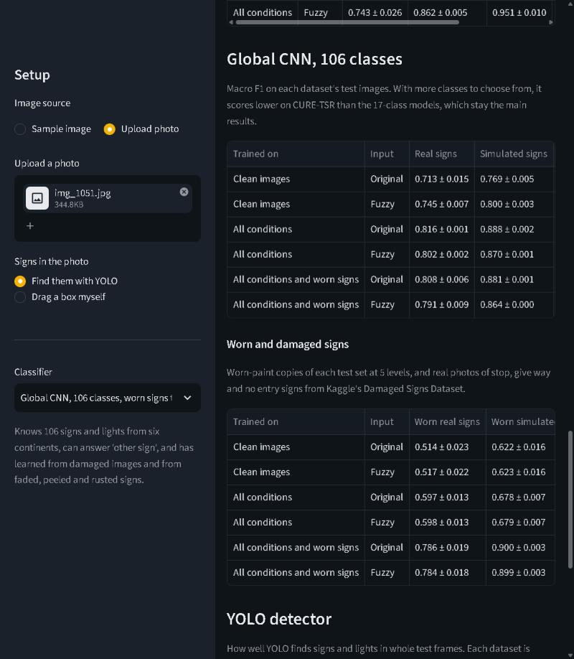
Sample: a darkened stop sign read correctly | Project results tab
Figure 24. A damaged CURE-TSR sample from the sidebar, and the results tab with every test table.
For phone tests the app was opened through a temporary Cloudflare tunnel. The two screenshots below are from that test: YOLO found no sign in a photo of a faded stop sign, so a box was drawn by hand, and every model answered load limit. That wrong answer is what led to the worn-sign work in Section 7.7.
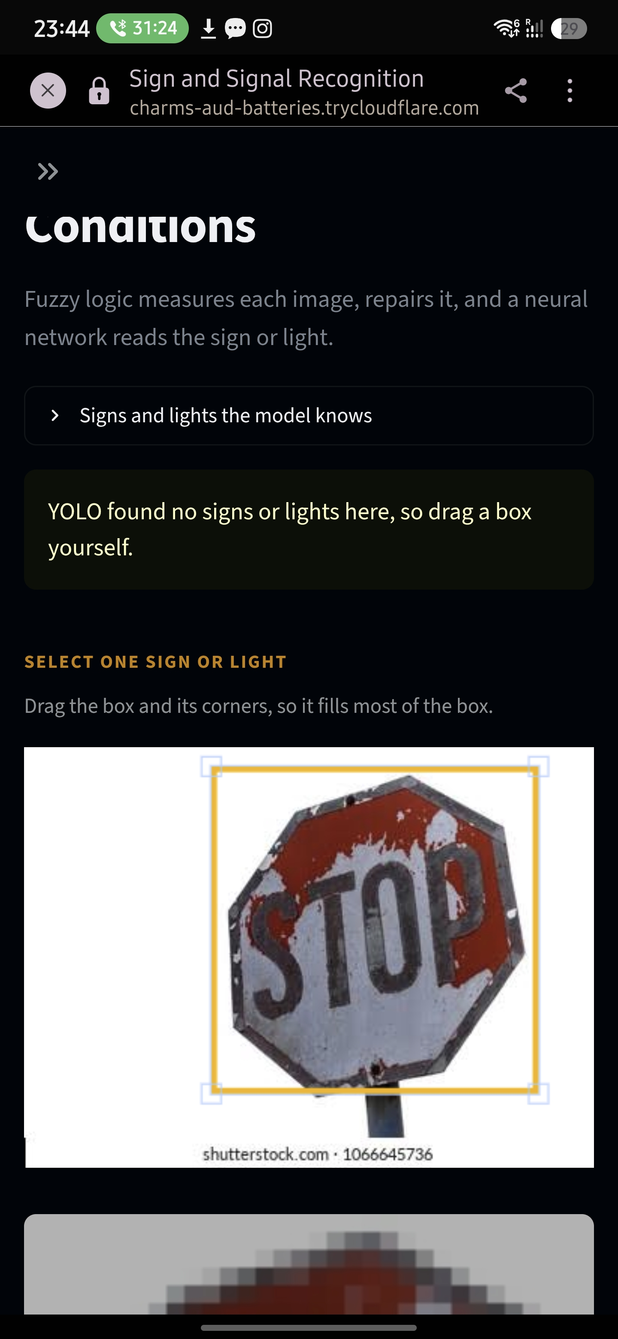 | 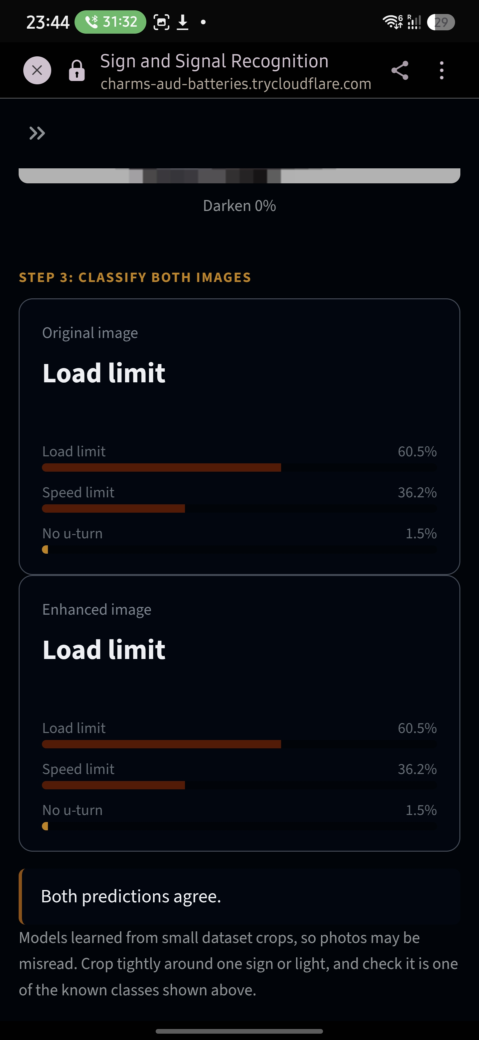
Drawing a box by hand | Both answers: load limit
Figure 25. The app on a phone, in the test that exposed worn signs.

9. Testing and Validation
Table 24. Automated checks: 262 in total, all passing.
Check suite | Checks | What it proves
Image processing | 43 | convolution equals OpenCV on six kernels; filters, metrics and transforms behave as defined
Fuzzy logic | 36 | membership sets, rules and centroid match scikit-fuzzy within 0.0001
Deep learning and detection | 108 | no image on both sides of a split, models train, YOLO finds at least half the labelled objects on all four test sets, worn paint behaves as designed
App | 75 | every tab, classifier, condition and class runs headlessly without errors

Table 25. Problems found in real data, and the fixes.
Problem found | What was done
Standard noise estimate read 2.0 on clean signs and only 4.0 on level 3 CURE-TSR noise | measured colour roughness at half resolution instead
Gamma 0.5 reached about 13 dB on level 3 darkening | stretched all RGB channels together, reaching about 21 dB
Fuzzy rules fired too often: clean signs scored 46.92 dB after enhancement | retuned the noise and contrast ranges, raising clean signs to 55.27 dB
Neighbouring frames are nearly identical | held out whole blocks of frames for validation, with a gap before each block
On 11 November, Windows Smart App Control blocked PyTorch 2.15's library files | moved to PyTorch 2.5.1: every saved model loads unchanged, all 262 checks pass, and the app's CNN scores within 0.001 F1 of its stored validation scores
Real test set lacks no overtaking, no left and priority | kept all 14 signs, and reported real and simulated test results separately
Global CNN undertrained, and early stopping cut one run at epoch 14 | trained 30 epochs with patience 10, reaching 0.80 on Mapillary validation signs
The 11 test street photos were byte-for-byte Kaggle photos | left them and their neighbours, 79 photos, out of every split

10. Limitations and Future Scope
- 32 × 32 input: numbers and words are hard to read, so every speed limit is one class and a faded STOP cannot be read from its letters. A larger input or a pretrained backbone could fix this, at the cost of redoing the comparisons.
- Extreme fading: wear training fixed most worn signs but not a stop sign that lost three quarters of its red. Stronger sun-bleaching or more real photos of old signs are the next step.
- Rare classes: no stopping (38 clean training images) and the Indian set (0.72 macro F1, most classes under 30 photos) need more data.
- Detection in the dark: enhancement runs only after YOLO finds a sign; training YOLO on damaged frames, or enhancing the whole photo first, would help night scenes.
- Real photos in bad conditions: the phone tests so far were daytime photos; night and rain photos are still to be collected.

11. Summary of All Results
Every headline test score in one place. Each is the mean of 3 seeds on original input, macro F1 unless stated, scored once after the choices were made on validation.
Table 26. All classifier test scores.
Model | Classes | Real signs | Simulated | Lights | GTSRB | Indian | Mapillary | Worn real
Feature MLP, all conditions | 17 | 0.701 | 0.825 | 0.898 | – | – | – | –
MLP, all conditions | 17 | 0.733 | 0.878 | 0.960 | – | – | – | –
CNN, clean images + fuzzy | 17 | 0.715 | 0.791 | 0.936 | – | – | – | –
CNN, all conditions | 17 | 0.819 | 0.909 | 0.980 | – | – | – | –
CNN, enhanced images | 17 | 0.814 | 0.901 | 0.981 | – | – | – | –
Wide CNN, all conditions | 84 | 0.757 | 0.881 | 0.946 | 0.907 | 0.613 | – | –
Global CNN, all conditions | 106 | 0.816 | 0.888 | 0.951 | 0.940 | 0.719 | 0.797 | 0.597
Global CNN, clean + fuzzy | 106 | 0.745 | 0.800 | 0.941 | 0.893 | 0.742 | 0.815 | –
Global CNN + worn signs (app) | 106 | 0.808 | 0.881 | 0.959 | 0.932 | 0.724 | 0.789 | 0.786

Table 27. Detection, image quality and other results.
Other result | Value
Best 17-class CNN accuracy | 89.8% on 203,374 real signs; 97.9% on 281,547 lights
YOLO detector 2, test mAP50 | 0.680 LISA lights, 0.701 Mapillary signs, 0.853 Kaggle damaged, 0.893 Roboflow damaged
Fuzzy enhancement, image quality | PSNR 17.90 → 18.35 dB over 13 conditions; clean images kept at 53.37 dB
Best noise filters | median 34.83 dB on 2% salt and pepper; bilateral 33.04 dB on Gaussian σ = 10
NumPy MLP | worst gradient error 5.23 × 10⁻⁷; matches PyTorch step for step
Street photos | 18 of 18 signs and lights found; 14 of 16 named correctly with the sign-or-light rule
Real damaged photos (Kaggle crops) | 0.968 macro F1 for stop, give way and no entry

12. Conclusion
The project built a complete pipeline for reading traffic signs and lights in bad conditions, covering all three courses in one system: image processing that measures and repairs images, a fuzzy controller that decides how, neural networks from a hand-written MLP to a 106-class CNN, and a YOLO detector that finds signs in full photos. The main lesson is clear and measured: training on damaged images is worth more than repairing them afterwards (0.819 against 0.715 macro F1 on real signs), while fuzzy enhancement still helps any model that has not seen damage and does so without harming clean images. The work also showed the value of testing on real photos: they exposed too few classes, close-up lights and worn paint, and each fix was measured before it was kept.

References
[1] D. Temel, G. Kwon, M. Prabhushankar and G. AlRegib, “CURE-TSR: Challenging Unreal and Real Environments for Traffic Sign Recognition,” NeurIPS Workshop on Machine Learning for Intelligent Transportation Systems, 2017.
[2] M. B. Jensen, M. P. Philipsen, A. Møgelmose, T. B. Moeslund and M. M. Trivedi, “Vision for Looking at Traffic Lights: Issues, Survey, and Perspectives,” IEEE Transactions on Intelligent Transportation Systems, 2016 (LISA Traffic Light Dataset).
[3] J. Stallkamp, M. Schlipsing, J. Salmen and C. Igel, “Man vs. computer: Benchmarking machine learning algorithms for traffic sign recognition,” Neural Networks, 2012 (GTSRB).
[4] C. Ertler et al., “The Mapillary Traffic Sign Dataset for Detection and Classification on a Global Scale,” ECCV, 2020.
[5] Indian Traffic Sign Classification dataset, huggingface.co/datasets/kannanwisen/Indian-Traffic-Sign-Classification.
[6] D. Vareta, Damaged Signs Dataset (CC0), kaggle.com/datasets/danielvareta/damaged-signs-dataset; Trafficresearch, Detection_of_damage_signs (CC BY 4.0), universe.roboflow.com.
[7] Ultralytics, YOLO26 models and documentation, docs.ultralytics.com.
[8] E. H. Mamdani and S. Assilian, “An experiment in linguistic synthesis with a fuzzy logic controller,” International Journal of Man-Machine Studies, 1975.
[9] J. Immerkær, “Fast noise variance estimation,” Computer Vision and Image Understanding, 1996.
[10] Z. Wang, A. C. Bovik, H. R. Sheikh and E. P. Simoncelli, “Image quality assessment: from error visibility to structural similarity,” IEEE Transactions on Image Processing, 2004.
[11] N. Dalal and B. Triggs, “Histograms of oriented gradients for human detection,” CVPR, 2005.
[12] D. E. Rumelhart, G. E. Hinton and R. J. Williams, “Learning representations by back-propagating errors,” Nature, 1986.

Appendix A. Running the project
All commands run from the project folder on Windows. Data preparation reads the original zips without extracting them; every training script skips runs that already finished, so it is safe to stop and restart.
Table 28. Commands to rebuild every result in this report.
Step | Command (inside the project's .venv)
Create the environment | python -m venv .venv, then .venv\Scripts\python.exe -m pip install -r requirements.txt
Check GPU and libraries | python -m scripts.check_setup
Pack CURE-TSR and LISA | python -m scripts.prepare_cure_tsr, then scripts.prepare_lisa, scripts.prepare_features, scripts.prepare_enhanced
Add GTSRB, Indian set, Mapillary | python -m scripts.prepare_wide, scripts.prepare_mapillary, scripts.prepare_global
Add worn and damaged signs | python -m scripts.prepare_wear, scripts.prepare_damaged, scripts.label_lights --sources damaged roboflow
Train the 17-class models | python -m experiments.run_training (36 runs), then experiments.mlp_study and scripts.train_numpy_mlp
Train the bigger CNNs | python -m experiments.run_training --wide, then --mapillary, then --wear
Train YOLO | python -m deep_learning.train_detector, then again with --weights models\detector.pt --epochs 10
Score on validation | python -m experiments.final_scores --split val; experiments.wide_scores --wear --split val; experiments.detector_scores --split val
Score the test sets once | the same three commands with --split test, then experiments.summarize and experiments.wide_charts for the charts
Run all checks | python -m scripts.check_image_processing, scripts.check_fuzzy, scripts.check_deep_learning, scripts.check_app
Start the app | python -m streamlit run app.py, then open http://127.0.0.1:8501

Appendix B. Key design decisions
The project kept a log of 34 decisions with the reason for each and what was rejected. The ones that shaped the results most:
Table 29. Key decisions from the project's decision log.
Decision | Why
Enhance first, then classify, and show both answers | classification gives the MLP, backpropagation, F1 and confusion matrices the courses need, and the side-by-side view shows what enhancement changes
CURE-TSR as the main sign dataset | 12 labelled conditions at 5 levels, each with a clean original, so PSNR and SSIM can be measured; GTSRB and others have no condition labels
Three fuzzy outputs instead of one strength | dark, hazy, noisy and overexposed signs need different fixes; denoising goes first because stretching amplifies noise
Hand-written Mamdani inference | runs on whole batches, reports the rules that fired, and was checked against scikit-fuzzy
Train on clean images and on all conditions | the clean model shows what enhancement can do; the all-conditions model shows whether enhancement still adds anything
Weighted loss and macro F1 | clean real training signs range from 2,480 parking to 38 no stopping
No flips in augmentation | a flip can change a sign's meaning, such as no left into no right
Choose on validation, test once, keep weak results | dropping no stopping would raise the best score from 0.819 to 0.889, but that would be choosing what to count after seeing test results
Bigger class lists beside, not instead of, the 17-class results | street photos needed more classes, but the finished 17-class experiments stay the graded results
YOLO finds, the CNN names | keeps fuzzy enhancement and the compared classifiers at the centre; YOLO only needs boxes, so any dataset with boxes can teach it
Worn-sign CNN as the app default, against a stricter pre-written rule | 15 to 24 points better on worn signs for under 1 point lost elsewhere; the override is recorded openly

Appendix C. Metrics used
TP, FP and FN are true positives, false positives and false negatives for one class; macro averages give every class the same weight however rare it is.
Table 30. Metrics used in this report.
Metric | Definition | Used for
Accuracy | correct predictions ÷ all predictions | overall reading rate
Precision | TP ÷ (TP + FP): how many answers of a class were right | classifiers and YOLO
Recall | TP ÷ (TP + FN): how many images of a class were found | classifiers and YOLO
F1 and macro F1 | 2 × precision × recall ÷ (precision + recall), averaged over classes | every classifier score
MSE and PSNR | mean squared error; PSNR = 10 log₁₀(255² ÷ MSE) in dB, capped at 60 | image quality
SSIM | structural similarity of brightness, contrast and structure, from 0 to 1 | image quality
IoU | overlap area ÷ union area of a predicted and a labelled box | matching YOLO boxes
mAP50 and mAP50-95 | mean area under the precision–recall curve at IoU 0.5, and averaged over IoU 0.5 to 0.95 | YOLO
Mean ± spread | mean and sample standard deviation over 3 training seeds | every reported model score

