Software Development Project- ii

**Submitted to:**

S.M Shovan

Lecturer, Dept. of CSE, RUET

**Submitted by:**

Morsheda Siddiqua Jeba,

Shreshtha Sayantika Maitra

**Title:** Software Development Project – II (CSE 3200)

Development of Blood App using Flutter.

**Name and Roll of Teammates:**

Name: Morsheda Siddiqua

Roll: 1603051

Name: Shreshtha Sayantika Maitra

Roll: 1603101

**Objectives:**

Across all over the world, everyday there remains an urgent need for all types of blood groups. This project is mainly for those who need blood in emergencies. Through this app it will be quite easier to find a blood donor. The persons who need blood or willing to donate blood, both can register on this app. After registering they will have their own profile and they can look for the blood group they need. There will be a list of blood banks too in case they could not find any donor.

**Requirements (software/ hardware):**

Hardware-

1. 2.50GHz processor
2. 8 GB RAM
3. 207 GB hard disk

Software-

1. VS Code
2. Android Studio

**Environment setup (Editor/Compiler/Database) and operating systems (the platform where the app/game/code will work):**

We have used VS Code as the editor. Compiler and necessary SDKs were installed with the installation of Flutter and Dart plugins. And we have used Android Studio to preview our outputs through Android emulator.

As Dart is platform independent, the code can be run on Windows, MacOS and Linux with Dart DevTools or Dart VM. And this application will also work on both Android and iOS.

**GitHub link of our project:**

**Screenshot & Design of the prototype:**

Here is the link of the prototype of this application-

<https://xd.adobe.com/view/6f38e31d-346c-45d6-7089-6be117777832-1909/>

And the screenshot is also attached below-

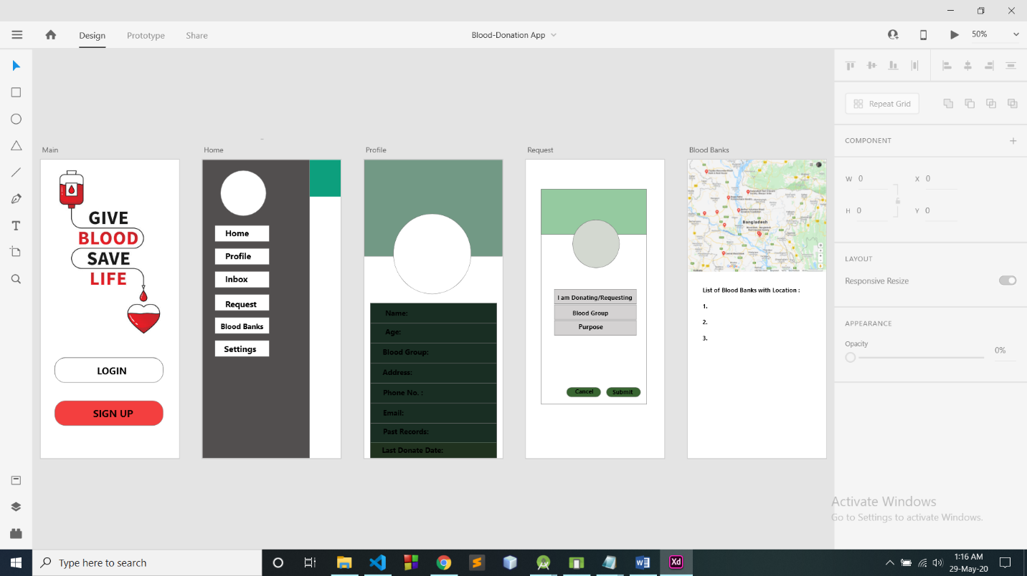

**Goal:**

First of all the person has to register if s/he does not have any id. After getting registered s/he can see the profile, search necessary blood groups and blood banks, request for blood and change the settings. When the user will request for blood, all nearby persons with that particular blood group will be notified and as soon as the donor responds the request won’t be no longer visible. In this way the app can help in case of urgent need of blood.

**Flow chart of achieving the goal:**

My App

Wrapper

If not logged in-

* Login
* Sign up

If logged in-

* Home
* Profile
* Blood banks
* Request
* Settings
* Inbox

Flowchart of the steps of achieving goal:

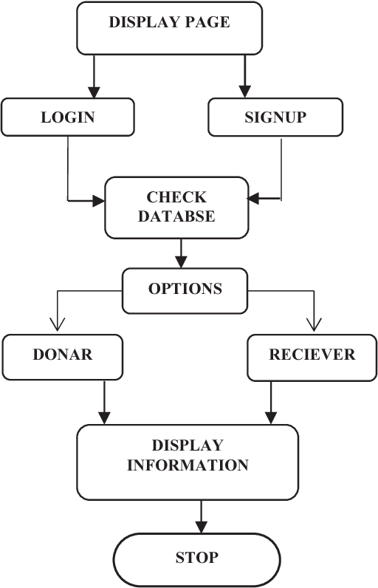

**Achieved progress:**

At the very beginning we have connected our app with Firebase and Firestore database by adding dependencies in pubspec.yaml file. All the information of the user will be stored in Firebase database.

We have used Firebase authentication service for user authentication.

We have used Geolocation marker in the Google Map to pin the location of the user.

Therefore we have reached up to the check database step of the flowchart.

**Obstacles we have overcome till now:**

**Screenshots of the current state:**

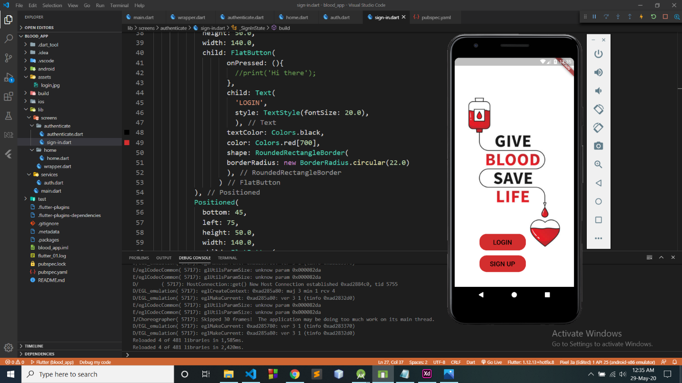

**Socio-economic impacts (Explain how your project will be useful for you/society):**

*anything you want to add*

Conclusion: