**2 SOLUTIONS LIFE CYCLE PROCESS**

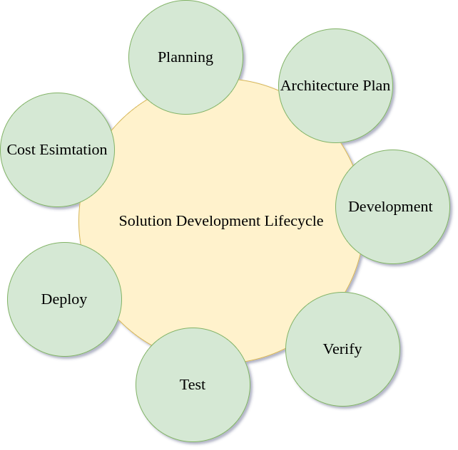

Fig 2.1 Software Development Lifecycle

**2.1 STAGES OF THE LIFE CYCLE**

**2.1.1 Planning**

Often the most crucial stage of the solutions lifecycle, planning involves talking and sitting down with the clients to understand their needs and design solutions accordingly

**2.1.2 Architecture Plan**

Architecture plan is often the courtesy of the solution architect, usually taken up by the most experienced person in the company who has deep knowledge of all the software development trends and best practices. They sit down and build a plan for the software and the tech stack being used so that they can serve their customers better

**2.1.3 Development**

This stage of the lifecycle refers to the actual coding and building of the solution according to the plan developed by the solution architect

**2.1.4 Verify**

This phase verifies if the solution is made according to the requirements of the clients. If the solution is verified, it moves on to testing

**2.1.5 Test**

Testing phase involves challenging your code in variety of domains to make sure that the code works as intended and is safe and optimal

**2.1.6 Deploy**

Deployment refers to the code being deployed on the client’s servers and the actual machines in the real world

**2.1.7 Cost Estimation**

After the code has been running in the real world for a few iterations, next step is to estimate the cost based on previous usage and making sure that the solution stands the test of time at the cheapest rate possible

Thus, the cycle is not a linear process and a lot of the changes can made at any point of the cycle