MALLA REDDY VISHWAVIDYAPEETH
TECHNICAL CAMPUS
Department of [CSE(AI/ML)]

PROJECT REPORT
AUTONOMOUS VEHICLE
ROUTE SIMULATOR

STUDENT NAME | ROLL NO :
A. KUSUMA KUMARI | 25MVCSMR0275
B. SHRESHTHA | 25MVCSMR0284
CH. SURYA TEJA SREE | 25MVCSMR0297
K. LIKHITHA | 25MVCSMR0318

Project Guide: []
Department: [CSE(AI/ML)]
College: [MALLA REDDY TECHNICAL CAMPUS]
Academic Year: [2025-2029]
Table of Contents
1. Cover Page 1
2. Abstract & Introduction 3
2.1 Project Overview 3
2.2 Problem Background 3
2.3 Proposed Solution 4
2.4 Purpose of the Project 4
3. Problem Statement, Objectives & Scope 5
4. Features & Functional Requirements 7
5. Algorithms & Methodology 10
6. Technologies & Implementation 14
7. Results, Testing & Performance 16
8. Conclusion, Future Scope & References 22

2. Abstract & Introduction

Abstract
The Autonomous Vehicle Route Simulator is a browser-based simulation dashboard that demonstrates how a self-driving vehicle can plan a route across a city road network, react to unexpected obstacles, and re-plan while in motion. The system models a twelve-junction road graph with twenty-one roads, applies a multi-factor cost model (distance, travel time, safety risk and energy use), and lets the user choose between three classic search algorithms: A*, Dijkstra and Breadth-First Search (BFS). Users can inject obstacles such as accidents, road construction, pedestrians and blocked roads, change traffic density and weather, and watch the vehicle automatically recalculate its path. Analytics, algorithm comparison, scenario and history views provide quantitative feedback on each run.
In tests on the built-in road network, A* produced the same optimal routes as Dijkstra while exploring about 44% fewer nodes (36 versus 64 across six start–destination pairs), and BFS returned a sub-optimal route in two of those six cases. All data in the project is simulated; no real map, sensor or traffic feed is used.
Keywords: autonomous vehicles, route planning, A* algorithm, Dijkstra, BFS, dynamic rerouting, simulation, Chart.js.

2.1 Project Overview
The project is a single-page web application written in HTML, CSS and JavaScript. It presents a simulated city map drawn on an HTML5 canvas, with a control panel for planning routes, driving the virtual vehicle and adding road events. Six views are provided: Simulator, Analytics, Algorithms, Scenarios, History and Settings. The application runs entirely in the browser and needs no server or installation; the user simply opens index.html.
Every number shown on screen (speed, battery, safety score, ETA, energy) is generated by the simulation model and is labelled as simulated in the interface. The project is therefore an educational and demonstration tool, not a real-world autonomous driving controller.

2.2 Problem Background
Autonomous vehicles must continually answer two questions: “which way should I go?” and “what should I do if the road ahead changes?”. Route planning is classically solved by graph search, where junctions are nodes and roads are weighted edges. In real cities the edge weights are not fixed: congestion, accidents, roadworks, weather and pedestrians change them minute by minute. A route that was best at departure may become slow, unsafe or impossible.
Students and newcomers often study A*, Dijkstra and BFS only on static textbook graphs, so the connection between these algorithms and the behaviour of a moving vehicle that must re-plan on the fly is hard to see. Real autonomous-driving platforms are expensive, complex and unsuitable for classroom demonstration. A lightweight, visual simulator fills this gap.

2.3 Proposed Solution
The proposed solution is an interactive simulator in which the road network, traffic and hazards are modelled explicitly and every decision of the planner is visible. The key ideas are:
- A weighted road graph whose edge cost combines distance, time, risk and energy according to a user-selected objective (Shortest, Fastest, Safest, or Shortest + Safest).
- Three interchangeable search algorithms (A*, Dijkstra, BFS) so that their behaviour and efficiency can be compared on the same map.
- Dynamic re-planning: when an obstacle blocks the road ahead, the vehicle stops briefly, recalculates from its current position and continues on a new route, with the change logged and highlighted on the map.
- Feedback and analysis: live safety score, event log, speed and distance charts, algorithm comparison table, scenario library, what-if analysis and a persistent run history.

2.4 Purpose of the Project
The purpose of the project is to provide a safe, repeatable and visual environment for understanding intelligent route planning and obstacle avoidance in autonomous vehicles. Specifically, it aims to:
- demonstrate how graph-search algorithms behave under changing road conditions;
- compare algorithm efficiency and route quality using measurable outputs;
- serve as a teaching and demonstration aid and as a base that can later be connected to real map and traffic data.

3. Problem Statement, Objectives & Scope

3.1 Problem Statement
Existing learning material on path-finding algorithms mostly shows them on fixed, static graphs. It does not show how an autonomous vehicle should choose between routes when distance, congestion, safety and energy compete, nor how it should recover when an obstacle appears mid-journey. Testing such behaviour on real vehicles is costly and risky. There is a need for a low-cost, easily accessible simulator that models dynamic road conditions, runs standard planning algorithms, and reports clear, comparable results.

3.2 Project Objectives
- To model a city road network as a weighted graph and visualise it on an interactive map.
- To implement A*, Dijkstra and BFS route-planning algorithms and let the user select between them.
- To support multiple routing objectives (Shortest, Fastest, Safest, Shortest + Safest) through a configurable cost function.
- To simulate a moving vehicle and dynamic hazards (eight obstacle types, traffic density, weather) and automatically re-plan when a road becomes blocked.
- To present live status, safety monitoring, event logs, analytics charts and algorithm comparison.
- To store simulation history in the browser and allow earlier runs to be replayed.
- To keep the system lightweight: a single web page with no server, installation or paid services.

3.3 Project Scope

In scope
- A fixed demonstration network of 12 junctions (A–L) and 21 roads with simulated traffic.
- Route planning, alternative routes, vehicle animation, obstacle injection and rerouting.
- Analytics, algorithm comparison, seven predefined scenarios, a what-if simulator, history and settings (theme, default algorithm, notifications).
- Responsive layout for desktop and mobile browsers, with dark and light themes.

Out of scope
- Real maps, GPS, live traffic feeds or real sensor data (LiDAR, camera, radar).
- Vehicle dynamics, perception, control and machine-learning driving models.
- User accounts, multi-user collaboration and server-side storage.
- Certification or any claim of real-world autonomous-driving performance. The interface states that results are simulated.

3.4 Target Users
User group | How they use the system
Students | Learn and visualise A*, Dijkstra and BFS; see how cost functions change routes.
Teachers / trainers | Demonstrate dynamic rerouting and algorithm trade-offs live in class.
Researchers and developers | Prototype routing ideas; the road graph (N and E arrays) can be replaced by real map data.
Technology enthusiasts and evaluators | Explore autonomous-vehicle concepts without special hardware.

4. Features & Functional Requirements

4.1 Main Features
Feature | Description
Interactive road map | Canvas map of 12 junctions and 21 roads with zoom (0.6×–3×), reset, centre-on-vehicle and layer toggles for traffic, obstacles, roads and alternative routes. Traffic is colour coded green–yellow–orange–red.
Route planning | Choose start, destination, algorithm (A*, Dijkstra, BFS) and objective. Shows a main route plus up to two alternatives with distance, time, safety, traffic level and energy.
Vehicle simulation | Start, pause, restart, stop and emergency-stop controls; speed multipliers 0.5×, 1×, 2×, 5× and 10×; live speed, battery, heading, location and ETA.
Obstacles and traffic | Eight obstacle types with three severity levels, traffic-density slider, weather hazard switch; blocked roads trigger automatic rerouting.
Safety monitor | Circular safety score and five factor bars (obstacle proximity, traffic density, road condition, route complexity, vehicle speed).
Event log and notifications | Time-stamped INFO / WARNING / ALERT / SUCCESS events, pop-up toasts and a notification bell.
Analytics | Eight summary statistics plus charts of speed over the journey and planned versus travelled distance.
Algorithm comparison | Table of distance, time, nodes explored and efficiency for A*, Dijkstra and BFS, with a bar chart of nodes explored.
Scenarios and what-if | Seven ready-made scenarios and a what-if tool with sliders for traffic, obstacle count and distance/time/safety/energy weights.
History and settings | Last 30 runs saved in browser storage with “Run again”; dark/light theme, default algorithm, notification toggle, data reset.

4.2 User Functionalities
- Select start and destination junctions and generate a route.
- Switch between Route A (main) and the alternative routes before starting.
- Start, pause, resume, stop, restart or emergency-stop the vehicle and change the simulation speed.
- Add obstacles (type, severity, location or “ahead on route”) and clear them again.
- Change traffic density and weather while the vehicle is moving.
- Load a scenario, run a what-if experiment, or run the algorithm comparison.
- Review analytics and history, re-run a past simulation, change theme and reset data.

4.3 CRUD Operations
The application has no database server; its “records” are routes, obstacles and saved runs held in memory and in the browser’s localStorage. The CRUD operations map as follows.
Operation | Entity | Implementation in the system
Create | Route plan, obstacle, simulation record | “Plan route” builds a route set; “+ Add obstacle” appends an obstacle to a road; reaching the destination saves a run (ID SIM-1001, 1002 …) to history.
Read | Routes, vehicle state, logs, analytics, history | Route cards, status panels, event log, charts, history table and “View details”.
Update | Traffic, weather, algorithm, objective, obstacles, active route | Sliders and selectors re-evaluate the route; reroute replaces the remaining path of the moving vehicle; settings are changed in place.
Delete | Obstacles, history, all data | “Clear obstacles” removes all obstacles; “Reset simulation data” erases history and restores traffic.

4.4 Authentication & Validation
Authentication. The simulator is a single-user, client-side demonstration. It has no login, accounts or roles, because no personal or confidential data is processed. History is stored only in the user’s own browser. Authentication would become relevant if a server back end were added (see Future Scope).
Input and state validation implemented in the code:
- Start and destination must differ; otherwise the message “Choose a different destination.” is shown and no route is planned.
- If every road to the destination is blocked, planning fails with “No route: every road is blocked.” and a running vehicle stops with an ALERT.
- Route switching is refused while the vehicle is navigating, recalculating or paused (“Restart to switch routes.”).
- Obstacle placement checks that a road exists ahead on the route; severity and obstacle type are chosen from fixed lists, so free-text input is avoided.
- Speed is limited to a minimum of 8 km/h and the safety score to a minimum of 40, preventing divide-by-zero and negative values.
- All localStorage reads and writes are wrapped in try/catch, so the application still works when browser storage is unavailable.

4.5 System Requirements
Item | Minimum | Recommended
Processor / RAM | Dual-core, 2 GB | Quad-core, 4 GB or more
Display | 1024 × 600, or a phone screen | 1366 × 768 or higher
Operating system | Windows, Linux, macOS, Android or iOS | Any current desktop OS
Browser | Modern browser with HTML5 Canvas and ES6 support | Latest Chrome, Edge, Firefox or Safari
Network | Needed only to load Chart.js and Google Fonts from CDNs | Internet on first load; charts need Chart.js
Software to build | Any text editor | Code editor such as [VS Code / other]

Non-functional requirements: responsiveness (layout adapts below 860 px width), accessibility (focus outlines, ARIA labels, reduced-motion support), maintainability (road graph isolated in data arrays), and clear labelling of all data as simulated.

5. Algorithms & Methodology

5.1 System Workflow
The workflow below shows how a run proceeds from user input to a saved result. Route planning is repeated automatically whenever a road on the remaining path becomes blocked.
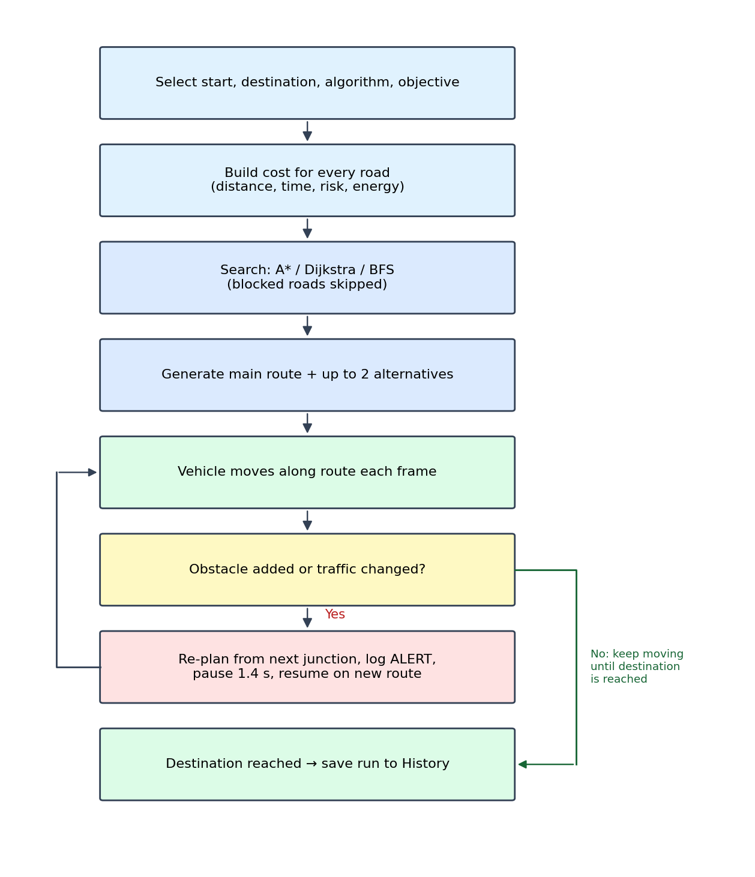
Figure 5.1: Route planning and dynamic rerouting workflow

5.2 Algorithms Used

Road graph and cost model
Junctions are nodes (A–L) with canvas coordinates; roads are undirected edges. Road length is the straight-line pixel distance multiplied by 0.0065 km. Traffic on each road starts from a pseudo-random base value in [0, 0.8) produced by a seeded Lehmer generator (seed 7), so the map is identical on every load. The following relations are used (S = traffic-density slider, in percent):
Quantity | Formula in the code
Traffic level | tl = min(1, base × S/100 × 1.7)
Risk | risk = Σ(severity × 0.5) + 0.4 × tl + 0.4 (if weather hazard)
Speed (km/h) | v = max(8, 50 × (1 − 0.6·tl) × 0.75 [weather] × 0.7 [obstacle])
Travel time (min) | t = length / v × 60
Edge cost | cost = (wd·length + wt·t·0.3 + wr·risk·1.2 + we·length·(1+tl)·0.4) × penalty
Route safety score | max(40, round(100 − Σ risk × 10))
Route energy (kWh) | length × 0.11 × (1 + average traffic × 0.4)

The weights (wd, wt, wr, we) depend on the objective selected by the user:
Objective | Distance | Time | Risk | Energy
Shortest | 1.0 | 0.2 | 0.2 | 0.2
Fastest | 0.3 | 1.0 | 0.2 | 0.2
Safest | 0.3 | 0.3 | 1.0 | 0.2
Shortest + Safest | 1.0 | 0.3 | 0.8 | 0.3

A* search
A* expands the node with the lowest f(n) = g(n) + h(n), where g is the accumulated edge cost and h is the straight-line distance to the destination scaled by 0.0065 km/px and the distance weight. Because every edge cost is at least wd × length, which is not less than the straight-line distance, h never over-estimates, so A* returns an optimal route like Dijkstra while visiting fewer nodes. Blocked roads are skipped.

Dijkstra’s algorithm
Dijkstra uses the same cost function with h(n) = 0, expanding nodes strictly in order of accumulated cost. It guarantees the minimum-cost route but explores in all directions from the start.

Breadth-First Search (BFS)
In this simulator BFS treats every road as cost 1, so it finds the route with the fewest road segments regardless of traffic, risk or length. Its route is then scored with the real cost function so that it can be compared fairly. BFS is included as a baseline to show why weighted search is needed.

Alternative routes and dynamic rerouting
After the main route is found, the roads of that route are penalised by a factor of 2.2 and Dijkstra is run again to obtain a different route; the step is repeated once more using the first alternative. Duplicate paths are discarded, giving up to two alternatives (Routes B and C). During a run, the simulator checks the remaining roads every frame; if one is blocked it calls the planner from the vehicle’s next junction, switches to the new path, records the original and new lengths and the extra time, and resumes after a 1.4 s recalculation pause.
Implementation note: the search keeps an open list that is re-sorted at every step and scans the edge list for neighbours, giving roughly O(V·E) work per search. This is negligible for 12 nodes and 21 edges, but a binary heap and adjacency lists would be used for large maps.

5.3 Development Methodology
The project was developed using an incremental prototyping approach: a working core (graph, planner and map) was built first, and features were added in small increments, each tested before the next was started. [Confirm or replace with the model your team followed, e.g. Agile / Waterfall.]
Phase | Activity | Outcome
1 | Requirement analysis | Defined users, scenarios and the cost factors to be modelled.
2 | Design | Road graph, cost model, screen layout (six views), colour scheme with dark/light themes.
3 | Core implementation | Graph data, A*/Dijkstra/BFS search, route rendering on canvas.
4 | Simulation features | Vehicle movement, obstacles, traffic, weather, rerouting, safety monitor, logs.
5 | Analysis features | Analytics charts, algorithm comparison, scenarios, what-if, history.
6 | Testing and refinement | Scenario testing, validation messages, responsive and accessibility fixes.

5.4 Data Flow
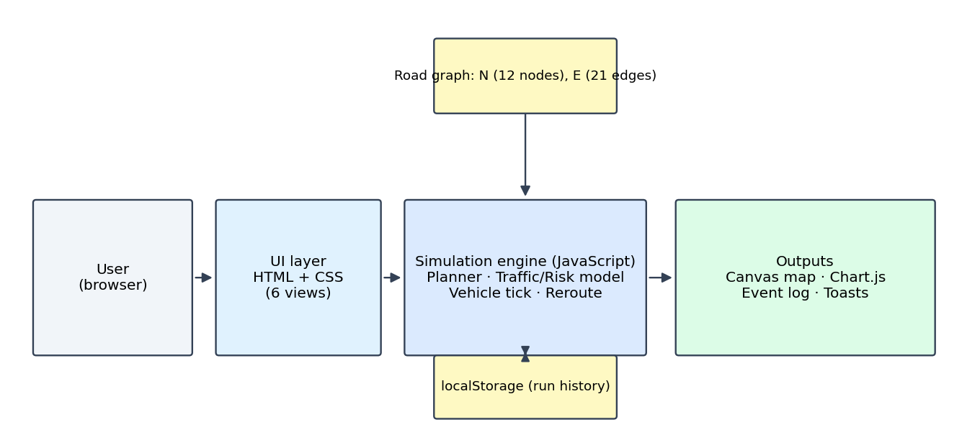
Figure 5.2: System architecture and main data flow
At the top level, the user supplies settings and events and receives a map, statistics, charts and alerts. The internal flows are summarised below.
ID | Process / store | Inputs | Outputs
P1 | Route planning | Start, destination, algorithm, objective, road graph, traffic and obstacles | Main route and alternatives with distance, time, safety, energy
P2 | Traffic and obstacle management | Density, weather, obstacle type, severity, location | Updated road conditions; blocked-road flags
P3 | Vehicle simulation | Selected route, simulation speed, road conditions | Position, speed, battery, events, reroute decisions
P4 | Analytics and history | Vehicle telemetry, completed runs | Charts, comparison table, history table
D1 | Road graph (N, E arrays) | – | Node coordinates, road lengths, base traffic
D2 | Run history (localStorage) | Completed runs (max 30) | Past runs for display and replay

6. Technologies & Implementation

6.1 Frontend Technologies
Technology | Use in the project
HTML5 | Page structure, six view sections, semantic nav, main, section elements and ARIA labels.
CSS3 | CSS variables for theming, Flexbox and Grid layouts, media query at 860 px for mobile, prefers-reduced-motion support, dark and light themes.
JavaScript (ES6) | All application logic: graph, planning, simulation loop, UI rendering and event handling.
Canvas 2D API | Drawing the map, roads, traffic overlay, routes, obstacles and the rotating vehicle marker at display frame rate.
Chart.js 4.4.1 | Line and bar charts in Analytics and Algorithm views (loaded from cdnjs).
Google Fonts (Sora) | Interface typography with system-font fallback.

6.2 Backend Technologies
The system has no server-side back end. The “back end” is the JavaScript simulation engine running in the browser: the planner, traffic and risk model, vehicle update loop and rerouting logic. This keeps the project portable and free to host; it can be opened from a file, a USB drive or any static web host.

6.3 Database
No database management system is used. The road network is held in two JavaScript arrays, N (nodes) and E (edges). Completed simulations are stored as JSON under the localStorage key avh, limited to the 30 most recent runs. Each record holds an ID, date, start, destination, algorithm, distance, duration, obstacle count, number of route changes and status.

6.4 Tools & APIs
- Browser APIs: Canvas 2D, localStorage, requestAnimationFrame for the animation loop, matchMedia for the default theme.
- Libraries and services: Chart.js (charts), Google Fonts (typeface).
- Development tools: [code editor, browser developer tools, Git / GitHub if used].
- No paid or key-based APIs are needed.

6.5 Implementation Details
The application is delivered as one index.html file (about 32 KB) plus a README. The main parts of the script are:
Component | Responsibility
N, E, eOf() | Node list, edge list with length, base traffic and obstacle list; edge lookup.
tl(), risk(), spd(), tmin(), cost() | Traffic, risk, speed, time and weighted cost for an edge.
search(), plan() | Generic A*/Dijkstra/BFS search; builds main and alternative routes.
mk() | Turns a path into a route object (distance, time, safety, traffic, energy, cost).
tick(), startSim(), pauseSim(), estop(), finish() | Vehicle state machine: Ready, Navigating, Recalculating, Paused, Stopped, Destination Reached.
addObs(), reroute() | Obstacle creation and dynamic re-planning with before/after statistics.
cmp(), whatIf(), loadSc() | Algorithm comparison, what-if analysis and scenario loading.
draw(), ui(), renderAna(), renderHis() | Canvas rendering and panel updates, charts and history.

Simulation clock. One real second corresponds to 14 simulated seconds at 1× speed (constant TS = 14), multiplied by the chosen speed factor. The simulated clock starts at 10:32:00.
Blocking rule. A road is closed when an obstacle of type “Blocked road” is added, or when an Accident or Road construction obstacle has severity High. Other obstacles slow the road to 70% speed and raise its risk instead of closing it.
Obstacle types and default severity: Accident (3), Road construction (3), Blocked road (3), Traffic congestion (2), Emergency vehicle (2), Weather hazard (2), Pedestrian (1), Slow vehicle (1).
Scenarios. Normal road, Traffic congestion, Road blockage, Multiple obstacles, Emergency vehicle, Dynamic traffic (density changes every 3.5 s) and Weather hazard.
How to run. Open index.html in a browser. Click “Launch simulator” (start A, destination H, algorithm A*), then add a “Blocked road” obstacle while the vehicle moves and watch the reroute.

7. Results, Testing & Performance
To obtain reproducible results, the simulator’s own planning and vehicle-update code was executed headlessly in Node.js with its default settings (traffic density 35%, objective “Shortest + Safest”, no weather). The results below come from that execution. Items that need the graphical interface are marked “To verify in browser”.

7.1 Project Results
Normal run. For start A and destination H the planner returned route A→B→C→H (4.51 km, estimated 394 s, safety 97%). The two alternatives were A→F→G→H (4.95 km, 421 s) and A→B→G→K→H (6.25 km, 513 s).
Dynamic rerouting. In a live run, the vehicle left A on route A→B→C→H using A*. After it had covered about 0.78 km, a Blocked road obstacle was placed on road C–H ahead of the vehicle. The simulator raised an ALERT, selected A→B→G→H (4.89 km, 0.38 km or 8.4% longer than the original), resumed after the recalculation pause and reached H having travelled 4.90 km with one route change. The run was written to history as SIM-1001.
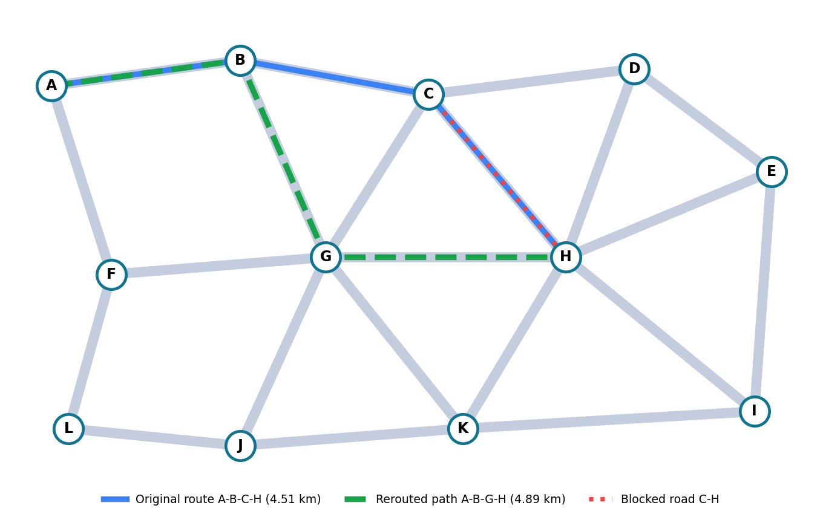
Figure 7.1: Road network showing the original route, blocked road and reroute
Objective comparison (A→H). Shortest, Fastest and Shortest + Safest all selected A→B→C→H, whereas “Safest” chose A→B→G→H (safety 99% instead of 97%, 4.89 km, 383 s). This shows the objective weights change the outcome.

7.2 Test Cases
ID | Test case | Expected result | Actual result | Status
TC01 | Plan A→H with A* | Valid route found | A-B-C-H, 4.51 km | Pass
TC02 | A*, Dijkstra, BFS on A→H | All return a valid route | All return A-B-C-H | Pass
TC03 | Block road B–C on main route | Planner avoids closed road | A-B-G-H, 4.89 km | Pass
TC04 | Obstacle added while vehicle moves | ALERT, reroute, reach destination | 1 reroute; 4.90 km; run saved | Pass
TC05 | All roads into H blocked | No route reported | No route returned | Pass
TC06 | Traffic density 0% → 100% | Travel time rises | 325 s → 475 s; route changes at 70% | Pass
TC07 | Weather hazard on | Slower, lower safety | 394 s → 525 s; safety 97 → 85 | Pass
TC08 | Objective “Safest” | Higher-safety route | A-B-G-H, safety 99 | Pass
TC09 | Alternative routes | Up to 2 distinct alternatives | 3 distinct routes | Pass
TC10 | Start = destination | Message shown, no route | Code returns a toast message | To verify in browser
TC11 | Refresh page after a run | History still listed | Stored in localStorage | To verify in browser
TC12 | Emergency stop | Vehicle stops, ALERT logged | Implemented in estop() | To verify in browser
TC13 | Theme switch and phone width | Layout and colours adapt | Media query at 860 px | To verify in browser

7.3 Testing Methods
- Functional (logic) testing: the planner, cost model and vehicle loop were run headlessly with fixed inputs and the outputs compared with expected behaviour (TC01–TC09).
- Scenario testing: each of the seven built-in scenarios exercises a combination of traffic, obstacles and weather; the Blocked-road case was run end to end (TC04).
- Boundary and negative testing: no-route case, identical start and destination, minimum speed and minimum safety limits.
- Manual user-interface testing: buttons, charts, theme, history and responsive layout checked in a browser (TC10–TC13) [record the date and browsers used].
- Repeatability: because the traffic generator is seeded, the same inputs always give the same results.

7.4 Performance Analysis
Search efficiency. The three algorithms were run on six start–destination pairs. The table lists the nodes expanded and the route chosen.
Pair | A* nodes | Dijkstra nodes | BFS nodes | A* route | BFS route
A→H | 6 | 9 | 8 | A-B-C-H | A-B-C-H
A→I | 8 | 12 | 12 | A-B-C-H-I | A-B-C-H-I
L→E | 7 | 12 | 12 | L-J-K-H-E | L-F-G-H-E
J→D | 6 | 11 | 11 | J-G-C-D | J-K-H-D
F→I | 6 | 12 | 12 | F-G-H-I | F-G-H-I
B→K | 3 | 8 | 8 | B-G-K | B-G-K
Total | 36 | 64 | 63
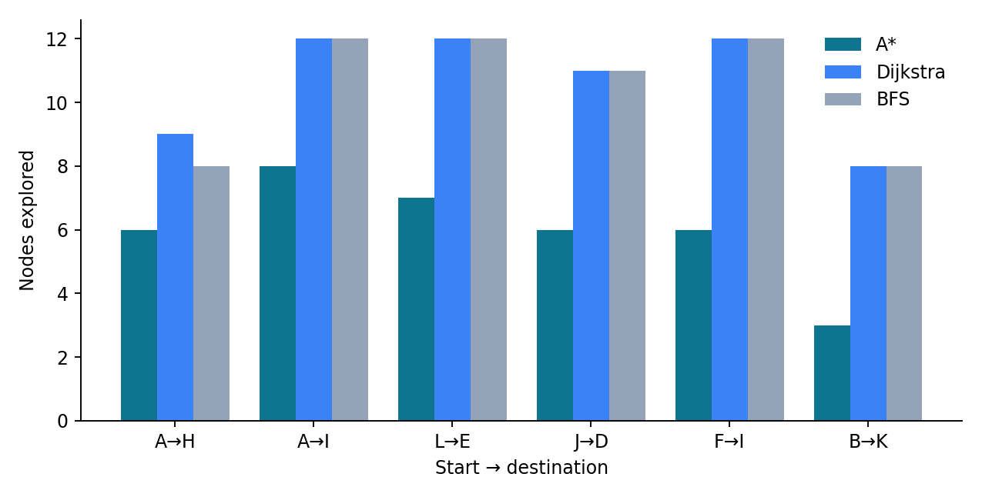
Figure 7.2: Nodes explored by each algorithm
A* expanded 36 nodes against 64 for Dijkstra, a reduction of about 44%, while returning routes with identical cost in every case. BFS expanded 63 nodes and produced a more expensive route for two pairs: L→E (cost 8.53 versus 8.29, +2.9%, 542 s versus 528 s) and J→D (cost 6.53 versus 6.16, +5.9%, 428 s versus 393 s). This confirms that ignoring traffic and distance gives sub-optimal routes.
Computation time. Averaged over 2,000 searches for A→I in Node.js, one search took about 0.030 ms (A*), 0.012 ms (Dijkstra) and 0.007 ms (BFS). All are far below one frame time (16 ms), so planning and rerouting are effectively instant. A* is not faster in wall-clock time on this very small graph because of the heuristic calculation; its advantage is fewer nodes explored, which will matter on larger maps.
Effect of traffic density on route A→H (algorithm A-star):
Density | Route | Time (s) | Safety (%)
0% | A-B-C-H | 325 | 100
35% | A-B-C-H | 394 | 97
70% | A-B-G-H | 425 | 97
100% | A-B-G-H | 475 | 96

Travel time grows by about 46% from empty to fully loaded roads, and above roughly 70% density the planner prefers A-B-G-H because the C–H corridor becomes costlier. Weather raised the 35%-density time from 394 s to 525 s and lowered safety from 97% to 85%.
Limitations. Figures describe this 12-node simulated network; they are not real-world autonomous-driving performance. Animation frame rate was not measured. [Add measured frame rate or browser timings if required.]

7.5 Screenshots / OutputInsert screenshots taken from the running
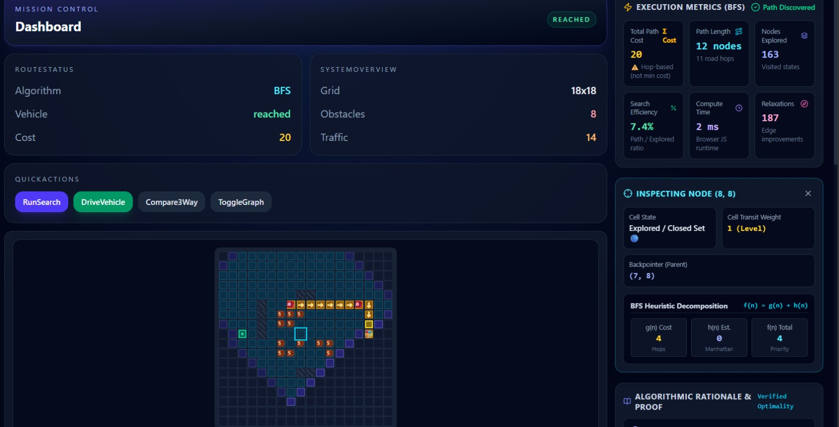
Figure 7.3: Simulator dashboard
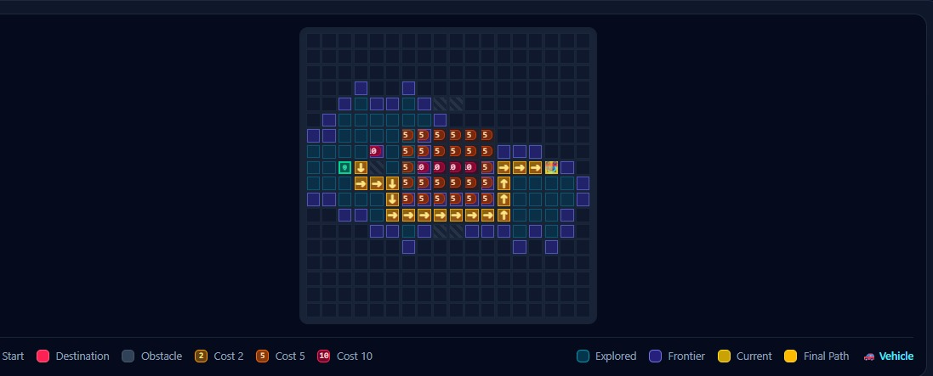
Figure 7.4: Dynamic rerouting after a blocked road
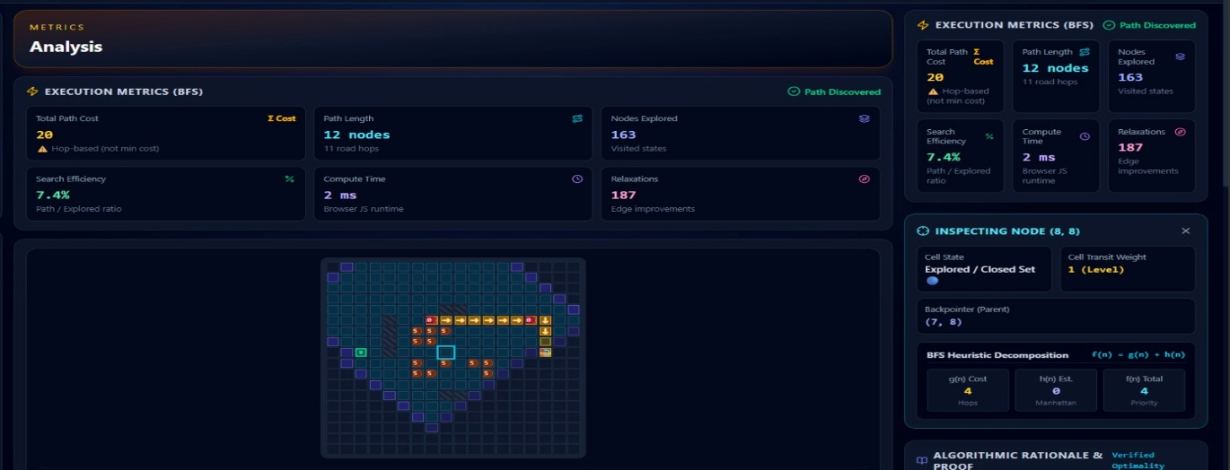Figure 7.5: Analytics view

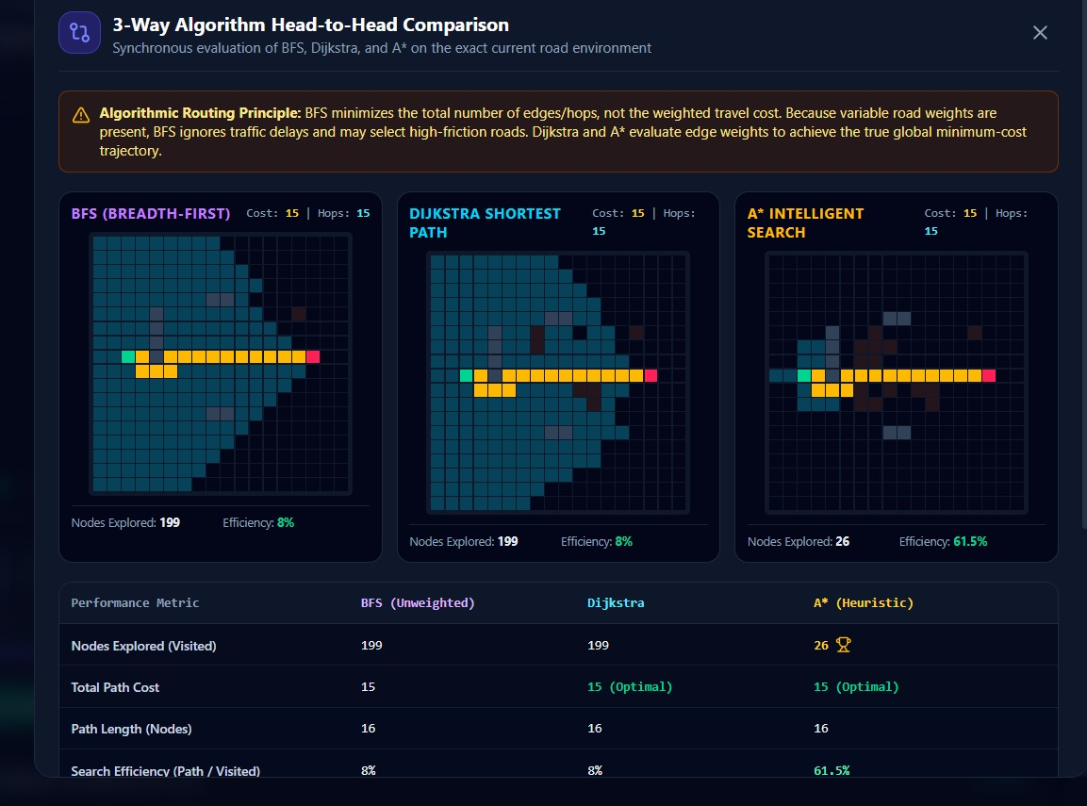
Figure 7.6: Algorithm comparison

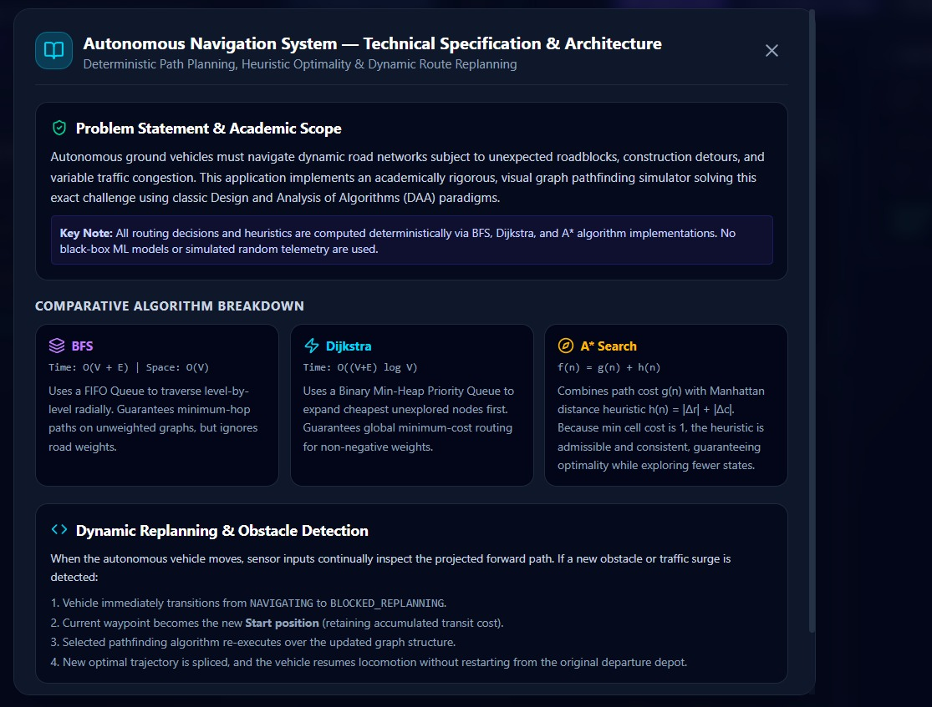

Figure 7.7: Scenarios and what-if
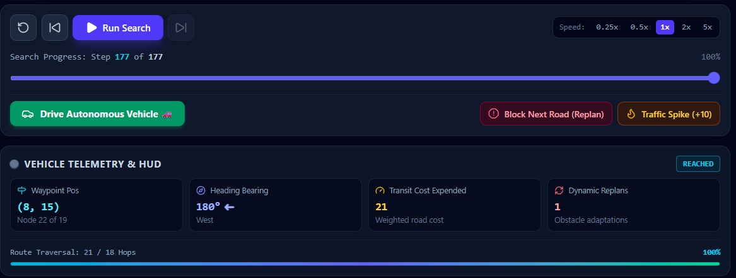
Figure 7.8: History and settings

8. Conclusion, Future Scope & References

8.1 Project Conclusion
The Autonomous Vehicle Route Simulator meets its objectives. It models a road network with a multi-factor cost function, plans routes with A*, Dijkstra and BFS, animates a vehicle, injects hazards, and re-plans automatically when a road is closed. In the tests, A* matched Dijkstra’s optimal routes while exploring about 44% fewer nodes, BFS gave costlier routes for two of six pairs, and an obstacle placed mid-journey was handled by a single reroute that added 0.38 km (8.4%) to the trip. Analytics, comparison, scenario, what-if and history views make the behaviour measurable and repeatable, and the single-file design means it can run on any modern browser without installation.
The project’s limitations are that all data is simulated, the network is small and fixed, and the vehicle model ignores real dynamics and sensor uncertainty. These are deliberate simplifications for a teaching tool, and the code is structured so that they can be relaxed in future work.

8.2 Future Enhancements
- Replace the demo graph with real map data (for example OpenStreetMap) and live traffic feeds through a routing API.
- Add further algorithms such as D* Lite, bidirectional search and Contraction Hierarchies for faster re-planning on large networks; use a priority queue and adjacency lists.
- Simulate sensors (LiDAR, camera, radar) and basic vehicle dynamics for lane keeping and braking distance.
- Support several vehicles, traffic lights and V2X communication.
- Use machine learning to predict congestion and risk from historical data.
- Add a server back end with a database, user accounts and authentication, so that runs can be shared and compared across users.
- Export run reports as PDF or CSV and add automated unit tests for the planner.
- Improve accessibility further with keyboard map control and screen-reader summaries of reroute events.

8.3 References / Documentation
- P. E. Hart, N. J. Nilsson and B. Raphael, “A formal basis for the heuristic determination of minimum cost paths,” IEEE Transactions on Systems Science and Cybernetics, vol. 4, no. 2, pp. 100–107, 1968.
- E. W. Dijkstra, “A note on two problems in connexion with graphs,” Numerische Mathematik, vol. 1, pp. 269–271, 1959.
- T. H. Cormen, C. E. Leiserson, R. L. Rivest and C. Stein, Introduction to Algorithms, 3rd ed., MIT Press, 2009 (graph search chapters).
- S. Russell and P. Norvig, Artificial Intelligence: A Modern Approach, 4th ed., Pearson, 2020 (informed and uninformed search).
- B. Paden, M. Čáp, S. Z. Yong, D. Yershov and E. Frazzoli, “A survey of motion planning and control techniques for self-driving urban vehicles,” IEEE Transactions on Intelligent Vehicles, vol. 1, no. 1, pp. 33–55, 2016.
- Chart.js Documentation, https://www.chartjs.org/docs/ (version 4.4.1 used).
- MDN Web Docs: Canvas API, Web Storage API and requestAnimationFrame, https://developer.mozilla.org/.
- Project files: index.html and README.md of the av-route-simulator package.

