[MALLA REDDY TECHNICAL CAMPUS]
Department of [CSE(AI/ML)]
REPORT
VERIDOX
Digital Document Verification & Trust Platform
“Trust Every Document. Verify Every Detail.”
]
Name | Roll No :
A . Kusuma Kumari | 25MVCSMR0275
B . Shreshtha | 25MVCSMR0284
CH . Surya Teja Sree | 25MVCSMR0297
K . Likhitha | 25MVCSMR0318

Department: [CSE(AI/ML]
College: [MALLA REDDY TECHNICAL CAMPUS]
Academic Year: [2025 – 2029]
Table of Contents
1. Cover Page 1
2. Abstract & Introduction 3
2.1 Project Overview 3
2.2 Problem Background 4
2.3 Proposed Solution 4
2.4 Purpose of the Project 4
3. Problem Statement, Objectives & Scope 5
4. Features & Functional Requirements 7
5. Algorithms & Methodology 10
6. Technologies & Implementation 14
7. Results, Testing & Performance 17
8. Conclusion, Future Scope & References 24

2. Abstract & Introduction

Abstract
VeriDox is a web platform for checking whether a digital document is the same document that an issuing institution registered. When a registrar issues a diploma, transcript or experience letter, the platform computes its SHA-256 fingerprint and stores that fingerprint, with a unique Verification ID, in a trust registry. Anyone who later receives a copy can upload it, or scan a QR code, and the platform recomputes the fingerprint and compares it with the registered one. The result is an integrity match, an integrity mismatch, pending manual review or unable to verify (a fifth value, invalid file, is declared but not yet used); revoked credentials are flagged within a match.
The system has a React 19 / TypeScript front end with 30 screens for four user roles (credential holder, issuer, reviewer and administrator) and a Node.js / Express back end with 19 REST endpoints. Verification requests, an audit trail, analytics, an organisation directory and a public verification page are included. In tests run on the project’s own server code, all six built-in sample documents produced the expected outcome, and a change of one input bit altered on average 127.8 of the 256 output bits (313 trials). The platform is a working prototype with sample data and simulated sign-in; the report lists its limitations explicitly.
Keywords: document verification, SHA-256, digital credentials, tamper detection, QR verification, audit trail, React, Express.

2.1 Project Overview
VeriDox (“Digital Document Verification & Trust Platform”) lets institutions publish trustworthy references for their documents and lets third parties check a copy against them. The platform has three kinds of screens: a public area (landing page, login, registration and a public verification page opened by Verification ID or QR code), a workspace for signed-in users (overview, verify, documents, issue, integrity checker, QR generator, requests, history, audit, analytics, organisations, notifications, profile, security, preferences, help and a dataset browser), and an administration area (users, organisations, verification queue, audit logs and system settings).
A central design rule is stated in the project documentation and reflected in the interface: a matching hash proves that two files are identical byte for byte; it proves the issuer’s identity or legal validity only because the hash was anchored by a vetted institution. For that reason a document that is not in the registry is reported as “unable to verify” rather than “fake”, so the system never makes a false claim of authenticity.
All institutions, people and documents shown in the application (for example the Stanford University registrar, Google LLC and the credential holder “Alex Morgan”) are fictional sample data created for demonstration. No real institution is connected to the system.

2.2 Problem Background
Degree certificates, transcripts and employment letters are normally exchanged as PDFs or scans. A PDF can be edited in minutes, and a recipient such as an employer or university usually cannot tell whether the copy in front of them is the one the institution issued. The common remedy, contacting the issuer by e-mail or post, is slow, hard to audit and does not scale when thousands of candidates are screened.
Existing approaches each have drawbacks for a small institution: paper seals and watermarks are easy to copy; manual verification letters take days; and full blockchain credential systems need specialised infrastructure. A lighter approach is to publish a cryptographic fingerprint of every issued document and let anyone compare a copy against it. Cryptographic hash functions are well suited to this because a change of even one bit in the input produces a completely different output, which is the property the project demonstrates experimentally in Section 7.

2.3 Proposed Solution
The proposed solution is a registry-based verification workflow with the following parts:
- Fingerprinting: every uploaded file is hashed with SHA-256, in the browser with the Web Crypto API and on the server with Node’s crypto module.
- Trust registry: issuers anchor each document’s hash, issuer, recipient, dates and status under a unique Verification ID of the form VDX-YYYY-NNNN-XXX.
- Verification pipeline: a file, a hash string or a Verification ID is matched against the registry and classified into a clear outcome, with six recorded checks (hash calculated, reference located, hash matched, revocation checked, issuer verified, expiry checked).
- Public page and QR code: a read-only page at /verify/:verificationId shows a limited set of fields (issuer, recipient, issue date, status, reference hash) and lets a visitor drop a file to compare it with the registered hash. A QR code for that page can be printed on a resume or certificate.
- Governance: verification requests with reviewer notes, an organisation accreditation queue, document revocation, role-based areas and an audit trail of significant events.

2.4 Purpose of the Project
The purpose of the project is to show that document authenticity can be checked quickly, transparently and without exposing the document itself, using standard cryptography and a simple registry. It aims to:
- give employers, universities and other verifiers an instant, evidence-based answer about a document copy;
- give issuers a way to publish, revoke and track their credentials; and give holders control over what is shared;
- serve as a reference prototype that can later be connected to real institutional systems, digital signatures and a hardened back end.

3. Problem Statement, Objectives & Scope

3.1 Problem Statement
Recipients of academic and professional documents cannot easily determine whether a copy is genuine, unmodified and still valid. Manual confirmation with the issuer is slow and unauditable, while forged or edited PDFs are easy to produce. There is a need for a simple system in which issuers register tamper-evident fingerprints of their documents, verifiers can check any copy in seconds, revoked or unregistered documents are handled honestly, and every check leaves a record.

3.2 Project Objectives
- To compute SHA-256 fingerprints of uploaded documents on the client and the server.
- To let authorised issuers register documents in a trust registry with a unique Verification ID and to revoke them when necessary.
- To verify a document by file upload, hash string or Verification ID and report one of the defined outcomes together with the checks performed.
- To provide a public verification page and a QR code that disclose only a limited set of fields and never the document itself.
- To manage verification requests, reviewer decisions and organisation accreditation for four user roles.
- To record significant events in an audit trail and to present analytics, history and notifications.
- To provide repeatable demonstration scenarios (genuine, tampered, unregistered, revoked and under-review documents) with one-click test files.

3.3 Project Scope

In scope
- A single-page web application with 30 screens and a REST API of 19 endpoints.
- Four demonstration personas with one-click switching, plus registration of new accounts.
- SHA-256 hashing, registry lookup, outcome classification, revocation, QR generation and a side-by-side integrity checker.
- Pre-loaded sample data: 4 documents, 4 organisations, 4 users, sample verification records and requests.
- Responsive layout for desktop and mobile with a sidebar and mobile navigation drawer.

Out of scope
- Real identity proofing, password storage and server-side session management.
- Digital signatures or certificates binding a hash to an issuer’s private key, and any blockchain anchoring.
- Reading or interpreting the content of documents (OCR, template or layout analysis); only the byte-level fingerprint is checked.
- Integration with real institutions, e-mail or SMS delivery, and a production database.
- Legal certification: a match shows identical bytes, not legal validity.

3.4 Target Users
User group | How they use the system
Credential holders (students, job applicants) | Keep a list of their credentials, create QR codes and links, submit verification requests and share verified proof with employers.
Issuers (university registrars, HR departments, accreditation boards) | Issue and anchor new documents, revoke superseded ones and review the registry of what they have issued.
Verifiers and reviewers (employers, auditors) | Upload a received copy or open a public link to check it, inspect mismatches and decide on pending requests.
Platform administrators | Manage users, vet organisations, review flagged cases and set system rules such as upload limits and retention.

4. Features & Functional Requirements

4.1 Main Features
Feature | Description
Document verification | Three methods on one screen: upload a file, paste a hash, or enter a Verification ID. A file larger than 25 MB is rejected with a message. The result shows the outcome, the submitted and reference hashes and the six checks performed.
Integrity checker | Side-by-side comparison of two files with their SHA-256 digests, including a tamper simulation (pristine versus altered file) and a twin-file match.
Issue document | Issuers fill in title, document type, recipient, dates and description and attach a file; the system hashes it, creates a Verification ID and records an audit event.
Document workspace | Table and grid views of the user’s documents; a details page with status timeline, hash, QR code and a revoke action.
QR trust anchors | Generates a QR code that links to the public verification page of a chosen document; supports copy-link and download as PNG.
Public verification page | Read-only page for any Verification ID showing status, issuer, recipient, issue date and reference hash, with an optional file drop to compare a copy.
Verification requests | Holders ask an organisation to verify a document for a stated purpose; reviewers move a request through its statuses and add notes.
Audit trail and history | Chronological list of verification events and administrative actions with filters and an export button.
Analytics and overview | Counts of documents, verifications, matches and mismatches with charts and recent activity.
Organisation directory | Accredited organisations by type (university, enterprise, government, certification authority), with a registration form and an admin approval queue.
Administration | Overview, user and role management, organisation accreditation, flagged-case queue, administrative audit logs and system settings.
Accounts and settings | Registration, login, profile editing, security page, preferences, notifications, help centre and a demo-data reset.

4.2 User Functionalities
Role (demo persona) | Main functions
Individual (Alex Morgan) | View personal credentials; submit verification requests; generate QR codes and share public links; verify documents.
Issuer (Dr. Eleanor Vance) | Issue and anchor new documents; revoke documents; view the institutional issuance registry.
Reviewer (Marcus Sterling) | Inspect mismatches; evaluate pending verification requests; add reviewer notes; open the admin area.
Administrator (Sarah Chen) | Manage users and roles; approve or reject organisations; review the flagged queue; edit system settings; view administrative audit logs.

The routing code protects the /admin area with a guard that allows the administrator and reviewer roles and shows an “unauthorised” page to everyone else. A persona switcher in the header and sidebar lets a reviewer or tester move between the four roles with one click.

4.3 CRUD Operations
Data is handled in two places: the Express server (a JSON file) and the browser (localStorage). The table lists what each entity supports in the code.
Entity | Create | Read | Update | Delete / notes
Document | Issue (UI; API POST /api/documents) | List, details, by ID, by hash | Revoke; verified count; last verified | Delete exists only in the dataset browser (local store); no delete API
Verification record | Created by every verification | History page; GET /api/records | – | Not deleted (history)
Verification request | New request form; POST /api/requests | List, filter by status | Status and reviewer note (PATCH) | Not deleted
Organisation | Registration form; POST /api/organizations | Directory | Approval status (PATCH, admin page) | Not deleted
User | Registration | Admin users list, profile | Profile, role and status edits | Not deleted
Audit event | Appended on key actions | Audit pages; GET /api/audit | – | No update or delete route
System settings | Seeded | Admin settings page | Admin settings page | Reset to demo data

4.4 Authentication & Validation
Authentication (current state). The sign-in and registration screens validate their fields, but authentication is simulated. The login handler looks the user up by e-mail and does not check the password against any stored value (it only requires that a password is entered); an unknown e-mail falls back to a demo user. Registration prevents self-selection of the administrator role (a request for “admin” creates an “individual”). The security page’s password change and two-factor switch update the interface state only. Real credential storage and session handling are listed under Future Enhancements.
Input validation implemented in the code:
- Login: valid e-mail format and non-empty password are required.
- Registration: name and e-mail required; password at least 8 characters; password and confirmation must match; terms must be accepted.
- Verify page: files over 25 MB are rejected in the browser; an empty Verification ID shows a message; the server limits uploads to 25 MB and returns HTTP 400 if neither a file nor a hash is supplied.
- Issue page: title, recipient name and an attached file (or computed hash) are required.
- Verification IDs and hashes are normalised (trimmed; IDs upper-cased; hashes lower-cased) before comparison, so vdx-2026-9041-k8 and the upper-case form of a hash both work.
- Server endpoints return 404 for unknown documents and requests and 400 for an attempt to revoke an unknown document.

4.5 System Requirements
Item | Minimum | Recommended
Processor / RAM | Dual-core, 2 GB | Quad-core, 4 GB or more
Display | 1024 × 600 or a phone screen | 1366 × 768 or higher
Browser | Current Chrome, Edge, Firefox or Safari with Web Crypto and localStorage | Latest version of any of these
Server runtime | A current Node.js LTS release (the project’s type definitions target Node 22) | Node.js 22 LTS
Network | Port 3000 (default) on the host machine | HTTPS reverse proxy for any real deployment
Storage | Space for the project, its npm dependencies and the registry file, which grows with use | SSD storage

Non-functional requirements: responsive layout (desktop sidebar, mobile drawer), clear status colours and labels for every outcome, no exposure of the uploaded document by the public page, and the ability to reset all demonstration data from the Preferences or Dataset screens.

5. Algorithms & Methodology

5.1 System Workflow
The verification workflow below is implemented identically in the server (POST /api/verify) and in the browser fallback. The flowchart shows how an input becomes one of the outcomes.
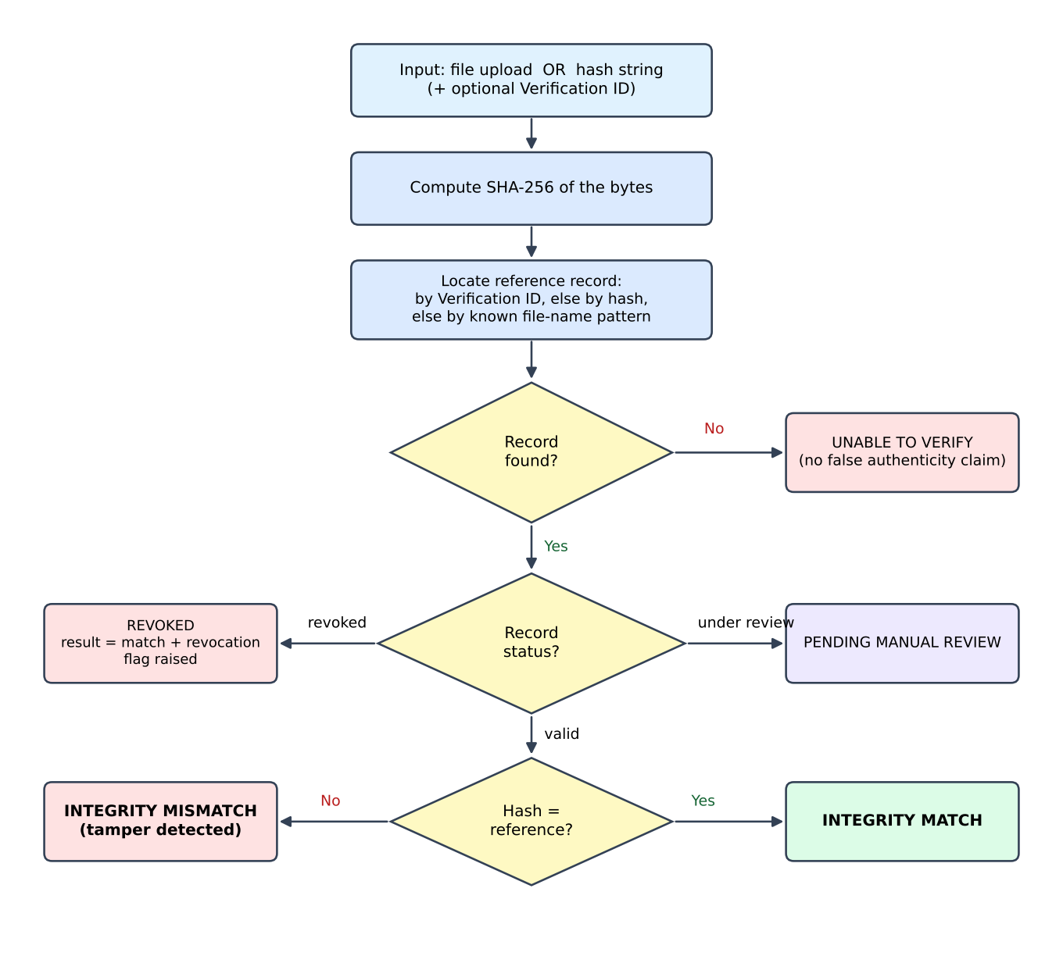
Figure 5.1: Verification decision flow
Outcome meanings. Integrity match: the file’s hash equals the registered hash for a valid record. Integrity mismatch: a record was found but the hash differs. Pending manual review: the record is under review by a registrar. Unable to verify: no record was found, so no claim is made. Revoked: reported as a match with the revocation check flagged false and an explicit notice.

5.2 Algorithms Used

SHA-256 fingerprinting
SHA-256 (Secure Hash Algorithm, 256-bit, FIPS 180-4) maps any input to a 64-character hexadecimal digest. In the browser, crypto.subtle.digest('SHA-256', buffer) is used; on the server, crypto.createHash('sha256'). Both were confirmed to give identical digests for the project’s sample files. The properties relied upon are determinism (same bytes, same digest), the avalanche effect (a tiny change alters about half of the output bits) and practical collision resistance.

Reference lookup and outcome classification
Given a computed hash h and an optional Verification ID, the server finds a reference record in this order: (1) if an ID is supplied, the record with that ID (case-insensitive); (2) otherwise the record whose stored hash equals h; (3) otherwise, as a demonstration shortcut, a record chosen by a pattern in the file name (for example “Stanford_Degree” or “TAMPERED”). It then applies these rules: no record gives *unable to verify*; status revoked gives a match with the revocation flag raised; status under_review gives *pending manual review*; otherwise the result is a match if h equals the stored hash and a mismatch if not. Each verification stores a record with the six check flags, increments the document’s verified count and appends an audit event.

Verification ID generation
IDs have the form VDX-<year>-<4 digits>-<3 characters>, where the digits are random from 1000 to 9999 and the three characters come from a 32-symbol alphabet that omits look-alike characters (I, O, 0, 1). This gives 9,000 × 32³ = 294,912,000 possible IDs per year. The code does not check for an existing ID, so by the birthday approximation about 1,000 documents in one year would have a collision probability of roughly 0.17%; a uniqueness check is therefore recommended (Section 8.2). In 20,000 generated IDs no collision occurred.

Selective disclosure and QR codes
The QR code encodes the URL <origin>/verify/<Verification ID> and is rendered with the qrcode library. The public page shows the status, issuer name, recipient name, issue date and the reference hash, and never shows the file, the e-mail address or the file name. Each document also stores four consent flags (recipient name, issue date, document type, issuer name); in the current version these flags are stored but the public page shows its fixed field set without reading them.

Audit logging
Every verification, issue, revoke, sign-in and profile change creates an audit event (actor, role, action, target, result, timestamp and metadata). The type definition lists eleven action types. In the current code events are stored as an append-only list with generated IDs; they are not linked by hashes. The interface text and the settings screen describe hash-linked (“HMAC”) chaining, and the status banner “Chain integrity: 100% OK” is a static label. Real chaining (each event storing the hash of the previous one) is described as future work.

5.3 Development Methodology
The project followed an incremental prototype approach: the document model and verification pipeline were built first, then the screens for each role, then administration and analytics, with demonstration scenarios used to check each increment. [Confirm or replace with the model your team followed, e.g. Agile / Waterfall.]
Phase | Activity | Outcome
1 | Requirement analysis | Roles, document types, outcomes and the “no false authenticity claim” rule.
2 | Design | Data model (Section 5.4), 30-screen map, colour system (navy, royal blue, cyan).
3 | Core implementation | SHA-256 service, registry store, POST /api/verify, verification page.
4 | Role features | Issue, revoke, QR, requests, organisations, notifications, profile, security.
5 | Administration and insight | Admin console, audit pages, analytics, dataset browser with sample files.
6 | Testing and refinement | Scenario tests with six sample documents and API checks (Section 7).

5.4 Data Flow
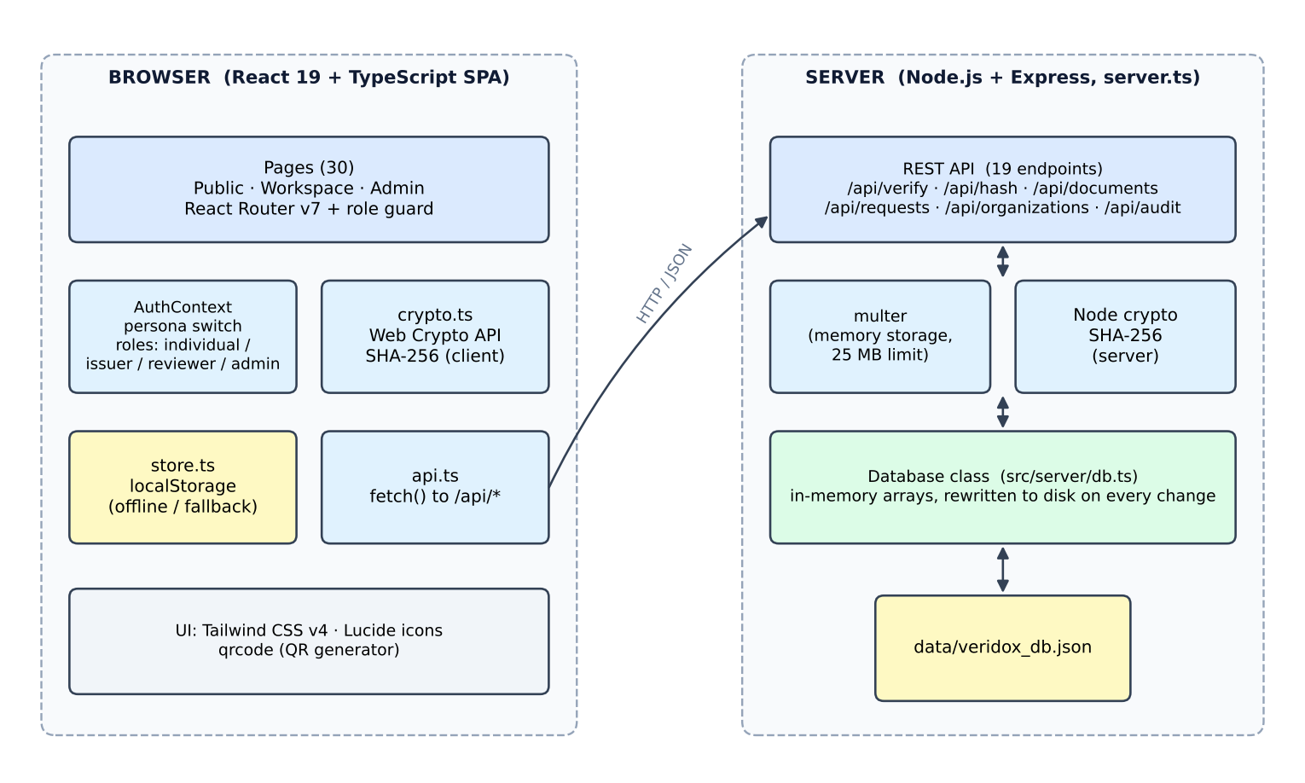
Figure 5.2: System architecture
The browser performs hashing and shows results; for verification it first calls the server and falls back to its own localStorage copy of the registry if the server cannot be reached. The server holds the registry in memory and rewrites a JSON file after each change.
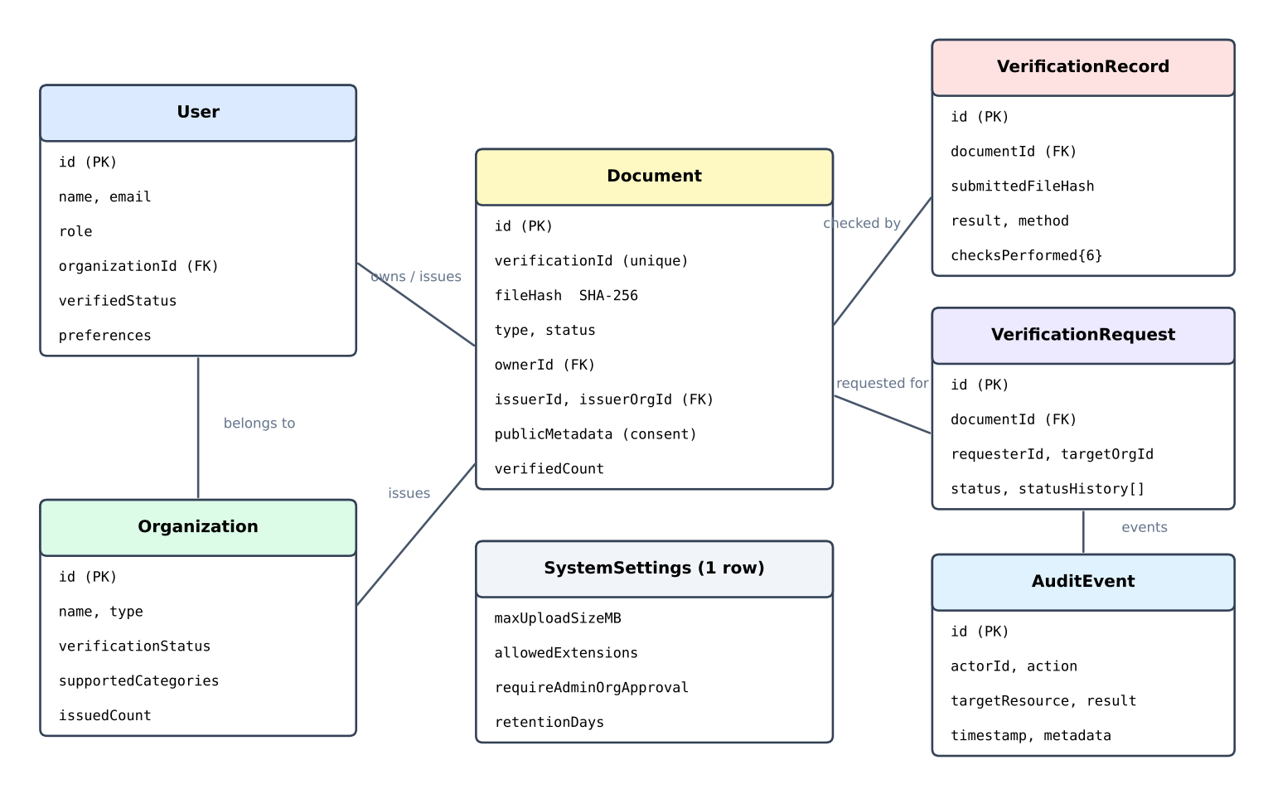
Figure 5.3: Data model (entities and main relationships)
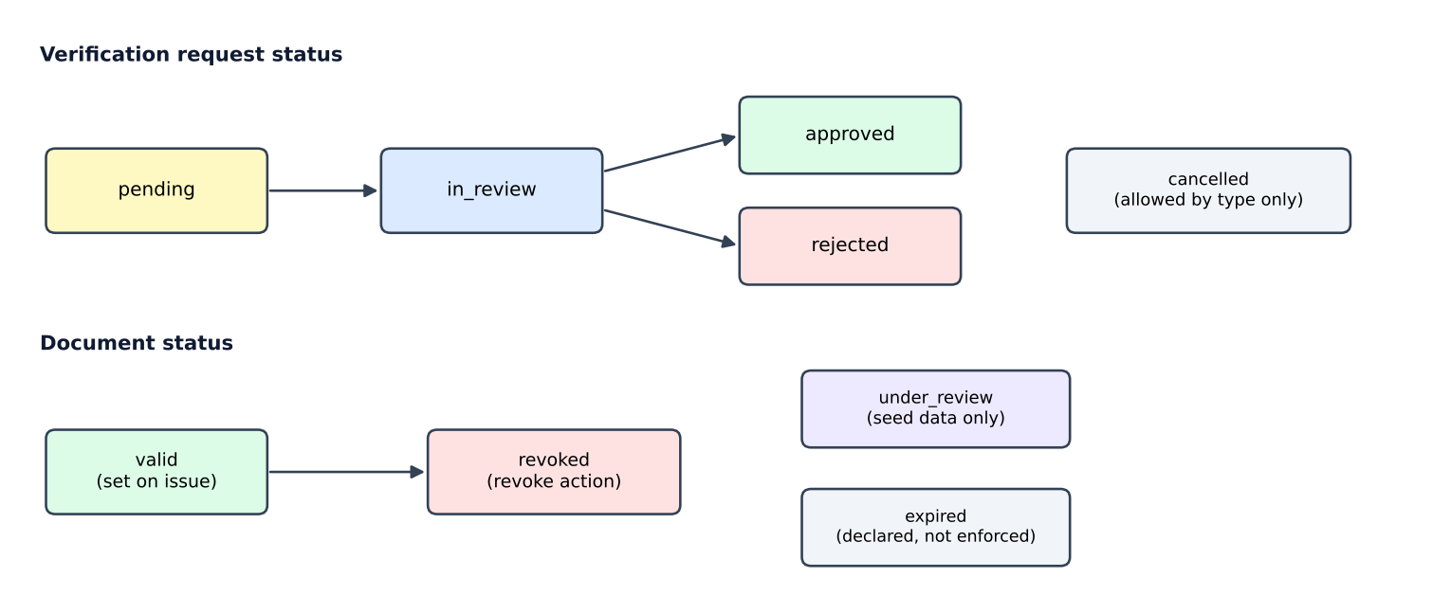
Figure 5.4: Status values for requests and documents
ID | Process / store | Inputs | Outputs
P1 | Fingerprinting | File bytes or text | 64-character SHA-256 digest
P2 | Verification | Digest, optional Verification ID, user | Verification record, outcome, updated counters
P3 | Issuance and revocation | Document details, file, issuer | Document with ID and hash; status changes
P4 | Requests and reviews | Document, organisation, purpose, reviewer decision | Request with status history
P5 | Audit and analytics | Events from P2–P4 | Audit list, counts, charts
D1 | Registry (documents) | From P3 | Hash, status, issuer, recipient
D2 | Records, requests, audit, users, organisations, settings | From P2–P5 | Lists shown on the screens

6. Technologies & Implementation

6.1 Frontend Technologies
Technology | Use in the project
React 19 and TypeScript | Component-based UI with typed data models (src/types/index.ts).
React Router DOM 7 | Public, workspace (/app/*) and admin (/admin/*) routes with a role guard and a 404 page.
Tailwind CSS 4 | Styling with a custom palette: navy #101B33, royal blue #356AE6, cyan #36C5F0.
Lucide React, motion | Icons and animations.
qrcode library | QR code generation as a PNG data URL.
Web Crypto API | Client-side SHA-256 hashing.
Vite 8 | Development server and production build tool.

6.2 Backend Technologies
The back end is a single server.ts file using Node.js and Express 4, started with tsx. It adds CORS and JSON/URL-encoded body parsing (limit 50 MB), uses multer with in-memory storage for uploads (25 MB limit) so that files are hashed and never written to disk, and serves the built front end from dist in production or Vite middleware in development. Hashing uses Node’s built-in crypto module.

6.3 Database
There is no external database. On the server, a Database class (src/server/db.ts) keeps seven collections in memory (documents, records, requests, organisations, audit, users, settings) and writes the whole state to data/veridox_db.json after every change; on first start it seeds sample data. In the browser, src/services/store.ts keeps a separate copy of the same collections in localStorage under keys prefixed veridox_. The project README describes persistence as “LocalStorage-backed”; the code shows both layers, and only the verification screen calls the server API, while the other screens use the local copy.

6.4 Tools & APIs
The server exposes 19 REST endpoints (plus a catch-all that returns the single-page app):
Method | Path | Purpose
GET | /api/health | Service status and timestamp
POST | /api/verify | Verify a file, hash or Verification ID; stores record and audit event
POST | /api/hash | SHA-256 of an uploaded file or text
GET | /api/documents, /api/documents/:id | List documents; get by internal ID or Verification ID
POST | /api/documents | Issue a document and return it with a new Verification ID
POST | /api/documents/:id/revoke | Revoke with a reason and log the action
GET | /api/records | Verification records
GET, POST, PATCH | /api/requests, /api/requests/:id | List, create and update verification requests
GET, POST, PATCH | /api/organizations, /api/organizations/:id/status | List, create and change accreditation status
GET | /api/audit | Audit events
GET | /api/stats | Counts of documents, verifications and organisations
GET, POST | /api/datasets, /api/datasets/reset | All collections plus sample-file hashes; reset to seed data
GET | /api/sample-files/:key | Download one of six sample test files

- Development tools: [code editor, browser developer tools, Git / GitHub if used]. The configuration files (metadata.json, comments in vite.config.ts and .env.example) indicate that the project was scaffolded in Google AI Studio for deployment on Cloud Run.
- The @google/genai package and a GEMINI_API_KEY entry are declared, but no source file uses them; no AI service is called by the current code.
- Package manager: a bun.lock file is included; scripts in package.json are dev, start, build, preview, clean and lint.

6.5 Implementation Details
File / module | Responsibility
server.ts | Express app, 19 endpoints, upload handling, verification pipeline, ID generation.
src/server/db.ts | In-memory registry with disk persistence, seed data, six sample documents and their SHA-256 hashes.
src/services/crypto.ts | Web Crypto hashing helpers, hash comparison, ID generation, sample test files.
src/services/store.ts | localStorage store: users, documents, records, requests, organisations, notifications, audit, settings; reset to demo.
src/services/api.ts | Typed fetch client for the REST API.
src/contexts/AuthContext.tsx | Current user, login, logout, registration, persona switching, profile update.
src/pages/ (30 files) | One component per screen; VerifyDocumentPage.tsx (about 830 lines) is the largest.
src/components/layout/ | Sidebar (role-aware menu), header (persona switcher, notifications) and layout shell.

The project has 43 TypeScript/TSX source files and about 11,000 lines of code. Sample data. Four documents ship with the project: a degree (valid), an experience letter (valid), a cybersecurity credential (revoked) and a Master’s transcript (under review). Six downloadable sample files reproduce the demonstration scenarios; each is a short text file with a PDF header, so their hashes are small and reproducible.
Persona accounts (password password123 in the README): holder alex.morgan@stanford.alumni.edu, issuer e.vance@stanford.edu, reviewer m.sterling@certreview.org, administrator sarah.chen@veridox.security. To run: install dependencies, then npm run dev (Express with Vite middleware on port 3000) or npm run build followed by npm start with NODE_ENV=production.

7. Results, Testing & Performance
To obtain reproducible results, the project’s own server.ts request handlers and db.ts registry were executed headlessly with Node.js against a fresh copy of the seed data, using the six sample files and further inputs. Tests of the user interface need a browser and are marked “To verify in browser”. The package registry was not reachable from the test environment, so the front end was not built or type-checked as a whole; all 44 TypeScript/TSX files were, however, checked for syntax errors with the TypeScript compiler, with no errors.

7.1 Project Results
Table 7.1 shows the outcome of uploading each of the six built-in sample documents to the verification endpoint. All six behaved as designed.
Sample file | Expected outcome | Actual outcome | Detail
Stanford_Degree_Alex_Morgan.pdf | Integrity match | integrity_match | Hash 558309e2… equals registered anchor VDX-2026-9041-K8
…_TAMPERED.pdf | Integrity mismatch | integrity_mismatch | Hash b293916c… differs from 558309e2…
Google_Experience_Letter_Morgan.pdf | Integrity match | integrity_match | Anchor VDX-2026-3819-M4
Stanford_Official_Transcript_Morgan.pdf | Pending review | pending_manual_review | Anchor VDX-2026-7729-T1 is under review
Cloud_Security_Cert_Revoked.pdf | Match, revoked notice | integrity_match, revocation check false | Anchor VDX-2025-1102-REV flagged as revoked
Random_Unregistered_Resume.pdf | Unable to verify | unable_to_verify | No reference hash in the registry
Table 7.1: Results for the six built-in sample documents
Tamper detection. The “tampered” file changes the honours line from “Summa Cum Laude” to “Magna Cum Laude [FORGED TAMPER ATTEMPT]”, making it 337 bytes instead of 313. The two digests differ in 138 of 256 bits (53.9%) and in 61 of 64 hexadecimal characters.
Issue, verify, revoke. A new document issued through the API received ID VDX-2026-6117-6VL (the ID changes every run) and status “valid”. Uploading the same bytes returned a match; changing one character (“v1” to “v2”) while giving the ID returned a mismatch; after revocation, uploading the original bytes returned a match with the revocation check flagged false.
Hash correctness. The five hash constants stored in the client code were recomputed and all five equal the actual SHA-256 digests of the sample texts, and the server’s /api/hash returned ba7816bf…15ad for the text “abc”, the standard SHA-256 test vector.

7.2 Test Cases
ID | Test case | Expected | Actual | Status
TC01 | Verify pristine sample file | Integrity match | integrity_match | Pass
TC02 | Verify tampered sample file | Integrity mismatch | integrity_mismatch | Pass
TC03 | Verify unregistered file | Unable to verify | unable_to_verify | Pass
TC04 | Verify revoked sample file | Match with revocation flag | match; revocationChecked = false | Pass
TC05 | Verify under-review transcript | Pending manual review | pending_manual_review | Pass
TC06 | Verify experience letter | Integrity match | integrity_match | Pass
TC07 | Pristine file with correct ID; ID in lower case | Match | match (both) | Pass
TC08 | Tampered file with correct ID | Mismatch | integrity_mismatch | Pass
TC09 | Hash-only query, upper-case hash | Match | integrity_match | Pass
TC10 | Request with no file and no hash | HTTP 400 | HTTP 400 with message | Pass
TC11 | Unknown ID with unregistered file | Unable to verify | unable_to_verify | Pass
TC12 | Issue document via API | HTTP 201, valid ID format | 201; ID matches pattern; status valid | Pass
TC13 | Issued file verified; one character changed | Match, then mismatch | match, then mismatch | Pass
TC14 | Revoke document, then verify its file | Revocation flagged | match with flag false | Pass
TC15 | Revoke or fetch an unknown document | Error / 404 | 400 / 404 | Pass
TC16 | Create and update request; update unknown request | 201, approved, 404 | 201, approved, 404 | Pass
TC17 | Create organisation, then approve | pending, then verified | pending, then verified | Pass
TC18 | SHA-256 of “abc” via /api/hash | ba7816bf…15ad | ba7816bf…15ad | Pass
TC19 | Client hash constants equal recomputed digests | 5 of 5 equal | 5 of 5 equal | Pass
TC20 | Tampered file submitted with the ID of a revoked record | Mismatch | integrity_match (hash not matched) | Fail (defect D1)
TC21 | Login with a wrong password | Rejected | Accepted (no password check) | Fail (defect D2)
TC22 | Log in, switch persona, QR page, public page | Works on screen | Not run here | To verify in browser
TC23 | Upload over 25 MB on the verify page | Error message | Not run here | To verify in browser
TC24 | Mobile layout and navigation drawer | Layout adapts | Not run here | To verify in browser

Of 24 test cases, 21 were evaluated (all by running the code, except TC21, which was established by reading the login handler): 19 passed and 2 failed; 3 need a browser. The failures are real defects of the current code and are discussed in Section 8.1.

7.3 Testing Methods
- Functional (API) testing: each endpoint’s handler was called with prepared requests and the responses compared with the expected outcome (TC01–TC20).
- Scenario testing: the six sample files reproduce the genuine, tampered, unregistered, revoked and under-review cases.
- Boundary and negative testing: missing input, unknown IDs, lower-case IDs, upper-case hashes and a file renamed to imitate a registered one.
- Cryptographic checks: comparison with the standard test vector for “abc” and an avalanche experiment (Section 7.4).
- Code review: the login, issue, public-page and audit code were read to confirm behaviour not covered by running tests (TC21, Section 8.1).
- Manual UI testing: to be recorded by the team [date, browsers and devices used].

7.4 Performance Analysis

Avalanche effect
The pristine sample file is 313 bytes long. In each of 313 trials one bit (the lowest bit of one byte) was flipped and the digest recomputed. The number of changed output bits ranged from 107 to 150 with a mean of 127.8 and median of 128, very close to the ideal 128 (half of 256).
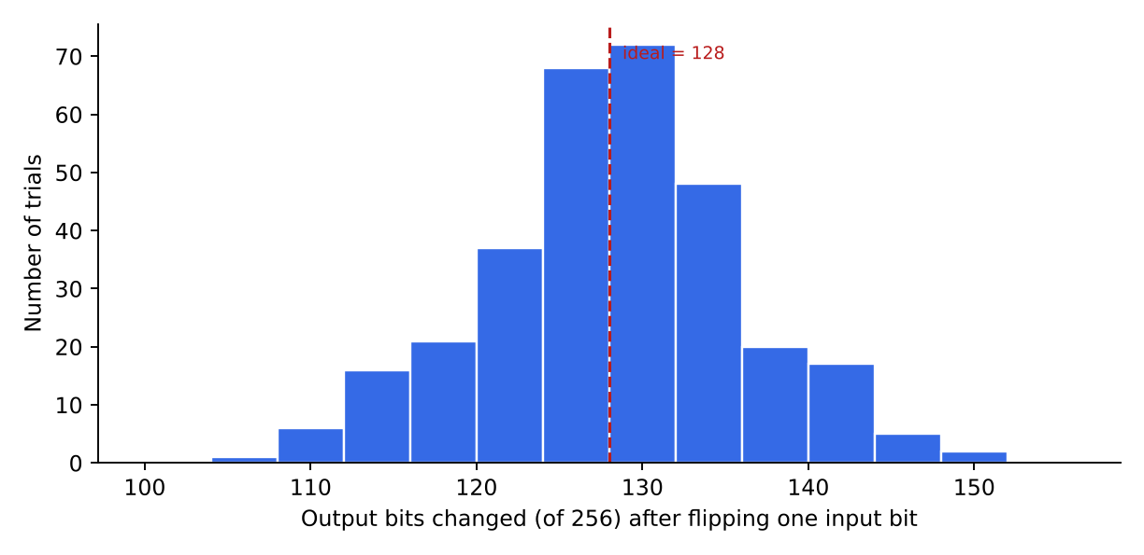
Figure 7.1: Output bits changed per single-bit input change (313 trials)

Speed
Over 300 consecutive verification calls on a small registry, the server handler took a median of 3.3 ms (95th percentile 6.1 ms, maximum 11.1 ms). These timings are in-process and exclude network transfer and file upload. Hashing a 25 MB buffer, the largest accepted file, took about 71 ms in Node.js. The browser’s displayed “average latency” values (198 ms and 240 ms) and the “99.98%” statement on the analytics page are fixed text in the code, not measurements.

Scalability
Because each change rewrites the entire JSON file, and one verification triggers three writes (record, document counter, audit event), the time per verification grows with the amount of stored data:
Records stored | Median (ms) | 95th percentile (ms)
70 | 1.4 | 2.2
560 | 7.4 | 8.7
2,060 | 30.1 | 40.6
5,060 | 80.8 | 95.2
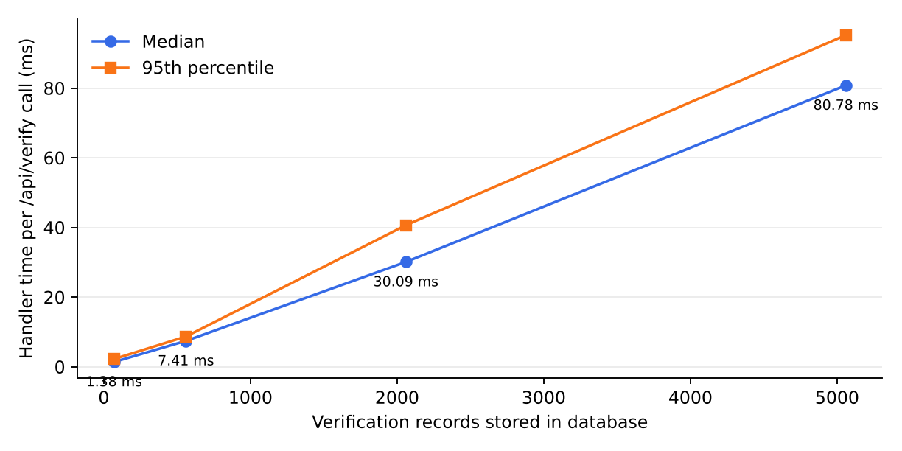
Figure 7.2: Verification handler time versus number of stored records
At 5,060 records the JSON file was 7.5 MB. Latency is roughly proportional to database size, which is acceptable for a demonstration but not for a production registry; replacing the JSON file with an indexed database (Section 8.2) removes this limit.

7.5 Screenshots / Output
Insert screenshots taken from the running application in the frames below.


Figure 7.3: Landing and login
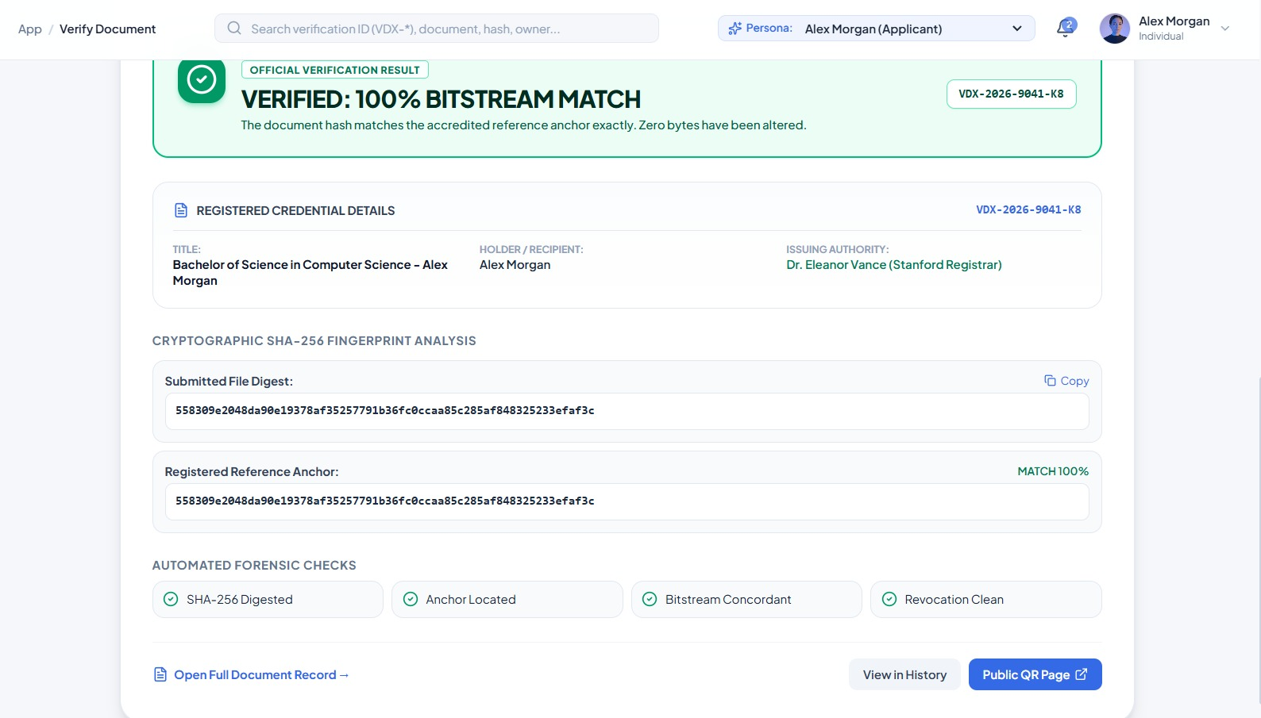
Figure 7.4: Verification result – match

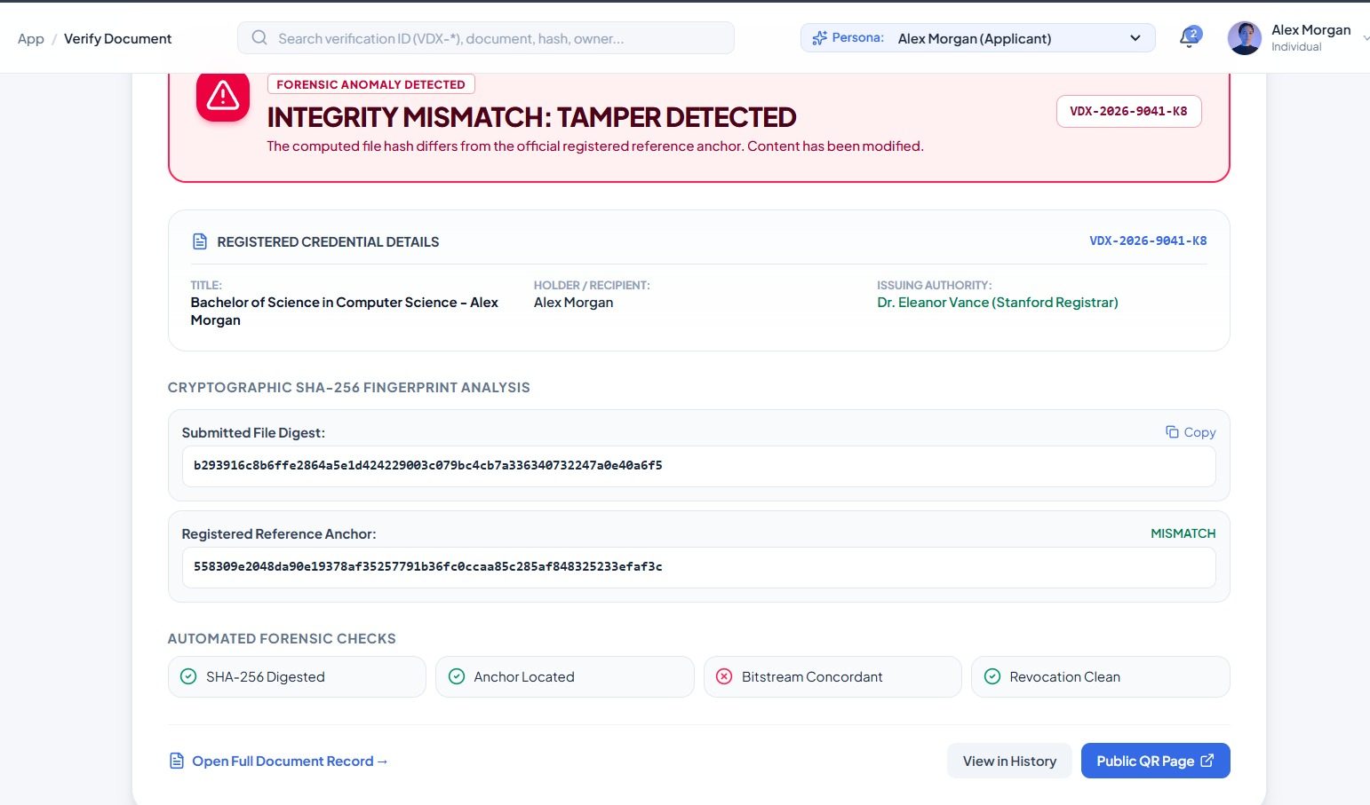
Figure 7.5: Verification result – mismatch / revoked

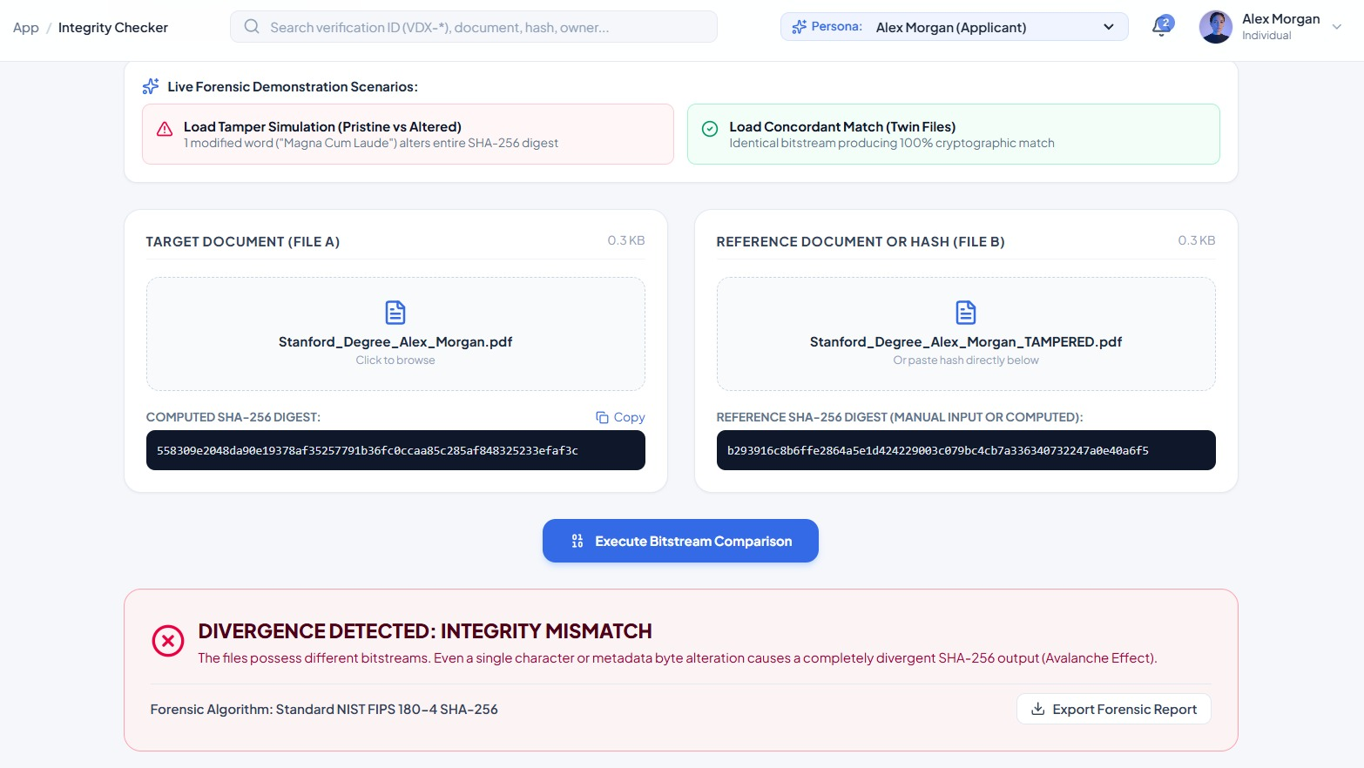
Figure 7.6: Integrity checker

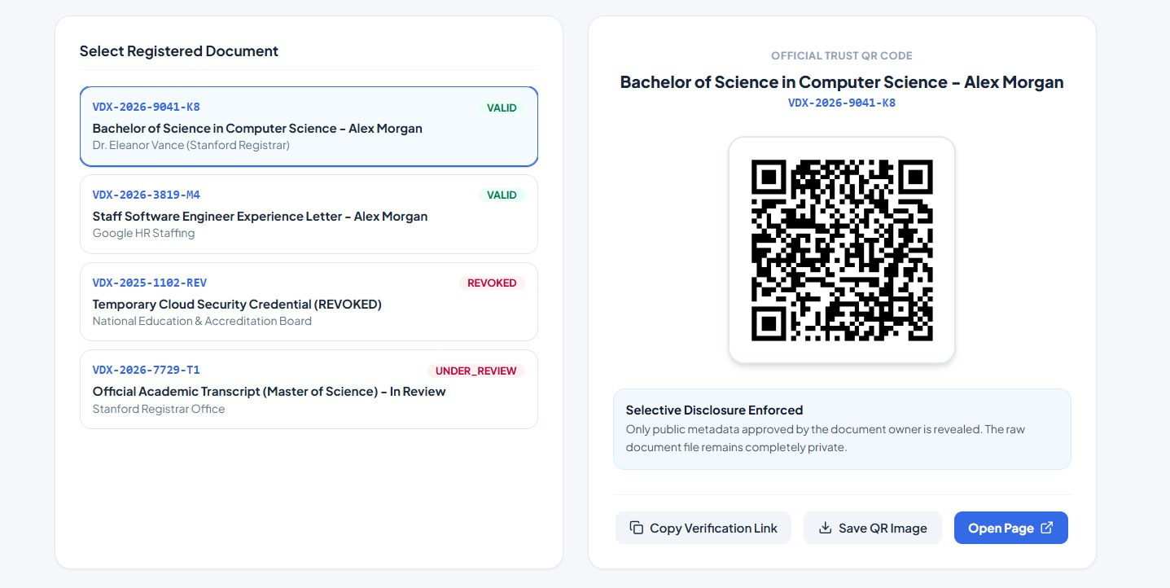
Figure 7.7: QR code and public page
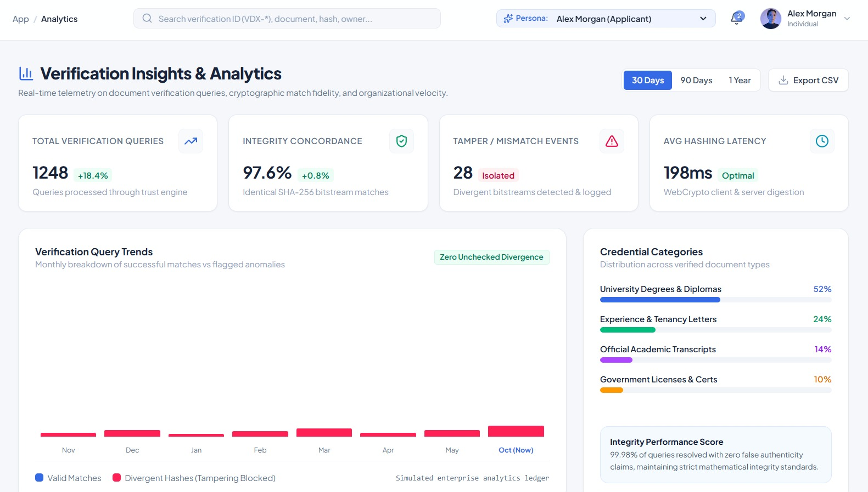
Figure 7.8: Analytics

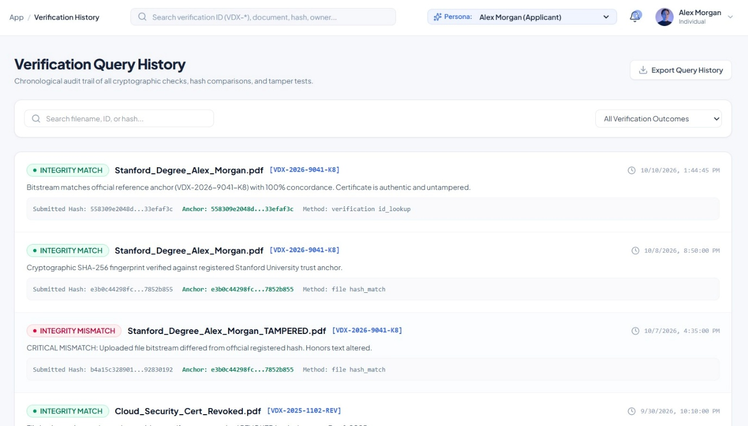
Figure 7.9: History
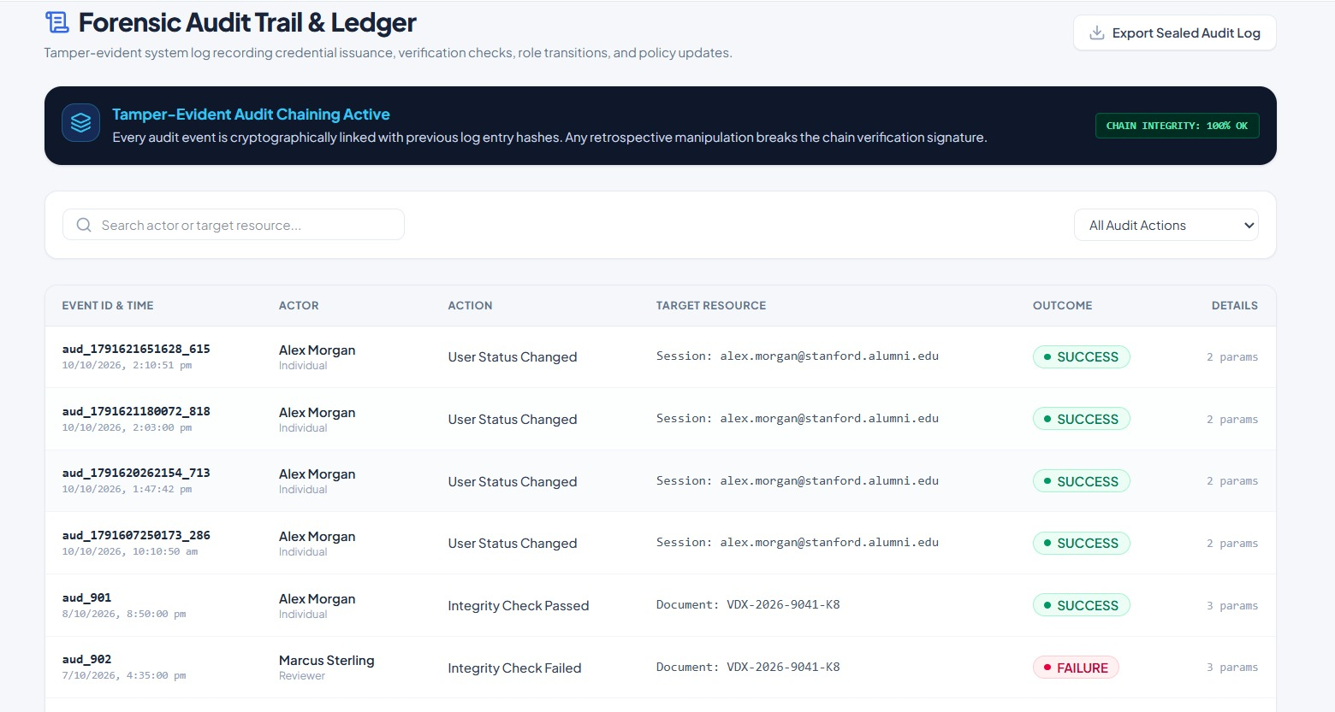
Figure 7.10: Administration screens

8. Conclusion, Future Scope & References

8.1 Project Conclusion
VeriDox demonstrates a complete document-verification workflow: documents are fingerprinted with SHA-256, anchored by issuers in a registry under a unique ID, and later checked by file, hash or ID, with honest outcomes for genuine, altered, revoked, under-review and unregistered documents. In the tests every built-in scenario produced the expected result, the hash implementation matched the standard test vector, and a one-bit change altered about half of the digest, which is why even a small edit to a document is detected.
The review also found limitations that should be stated plainly in any presentation of the project:
- D1 – revoked and under-review records ignore the hash. A tampered file checked against a revoked record’s ID is reported as “integrity match” (with the revocation flag) although its hash does not match; the code should require a hash match first.
- D2 – simulated authentication. The login does not verify passwords, the two-factor and password-change controls update only the screen, and the API endpoints (including issue and revoke) have no authentication or authorisation.
- Audit trail is not hash-chained. Events are appended to a list; the “chain integrity 100%” indicator and the “HMAC seal” export text are not backed by code.
- Two unsynchronised data stores. Documents issued in the interface are saved in the browser only, so while the server is running a file checked through the server will not find them.
- Expiry and consent flags are not enforced. Expiry dates are stored but never compared with the current date, and the per-document disclosure flags are not read by the public page.
- Scalability. Whole-file rewrites make verification time grow with the database size (Section 7.4); the file-name pattern shortcut in the lookup is a demonstration device and should be removed in production.
These are reasonable limits for a prototype, and each has a clear fix, listed below.

8.2 Future Enhancements
- Fix D1 by requiring a hash match for every outcome, and compare expiry dates during verification.
- Add real authentication (hashed passwords, sessions or tokens), role checks on every API endpoint, and rate limiting.
- Implement real tamper-evident audit chaining: store prevHash and hash = SHA-256(prevHash + event) for each event and add a verification routine.
- Use a single data source: move all screens to the API and replace the JSON file with a database such as PostgreSQL with an index on fileHash and verificationId; enforce unique IDs.
- Sign registry entries with the issuer’s private key (digital signatures or X.509 certificates) so that a match also proves issuer identity.
- Honour the per-document disclosure flags on the public page and add holder consent controls.
- Add automated unit and end-to-end tests, e-mail notifications, bulk issuance, a PDF verification receipt, and optional anchoring of registry hashes in an external tamper-evident ledger.
- Use the declared Gemini integration, if desired, for assistive features such as summarising a mismatch report.

8.3 References / Documentation
- National Institute of Standards and Technology, “Secure Hash Standard (SHS),” FIPS PUB 180-4, 2015.
- W3C, “Web Cryptography API,” W3C Recommendation, 2017 (SubtleCrypto.digest).
- M. Bellare and P. Rogaway, Introduction to Modern Cryptography, lecture notes (hash functions and the birthday bound).
- React documentation, https://react.dev/ ; React Router documentation, https://reactrouter.com/ .
- Tailwind CSS documentation, https://tailwindcss.com/docs ; qrcode package, https://www.npmjs.com/package/qrcode .
- Express.js documentation, https://expressjs.com/ ; Multer documentation, https://github.com/expressjs/multer .
- MDN Web Docs: Web Storage API (localStorage) and Crypto API, https://developer.mozilla.org/ .
- Project files: README.md, server.ts, src/server/db.ts, src/services/crypto.ts, src/services/store.ts and src/types/index.ts of the VeriDox package.

