AI-Driven Mental Health Screening
Phase 1 Build Plan — Text NLP Pipeline
NMIMS — Project DE

Scope of this phase
This document lays out every step of building and training the text-based mental health screening model — the first phase of the project, before speech/audio is added in Phase 2. Three decisions were locked in before any of this work started:
- Target labels: multi-class condition classification (Normal, Depression, Anxiety, Bipolar, Stress, Suicidal, Personality disorder), matching the objectives slide.
- Scope order: text NLP first, full pipeline and evaluation, before speech is layered on in Phase 2.
- Data strategy: start from public, already-labeled datasets rather than collecting original data first — our own data collection can be layered in later as a second wave.

Datasets acquired
Three public datasets have been added to the project folder (datasets/text datasets). Together they cover the multi-class target labels plus a dedicated urgency/crisis signal:
Dataset | Rows | Classes
Combined Data.csv | 53,043 | Normal, Depression, Suicidal, Anxiety, Bipolar, Stress, Personality disorder (7)
Emotion_Sentiment_DataSet.csv | 160,000 | love, happiness, sadness, Normal, hate, anger, Depression, fun, surprise, worry (10)
Suicide_Detection.csv | 232,074 | suicide, non-suicide (2, perfectly balanced)
Table 1: Datasets confirmed in D:\bhoomie\NMIMS\DE\datasets\text datasets
Combined Data.csv is the primary training set — it already matches the 7-class target scheme directly. Suicide_Detection.csv is reserved for the urgency/crisis safety-net layer described in Step 0. Emotion_Sentiment_DataSet.csv adds emotion-level granularity (useful for the feature-engineering and “understanding emotion” layer) but its label set will need to be mapped onto the 7 target classes rather than used as-is.

Overall pipeline
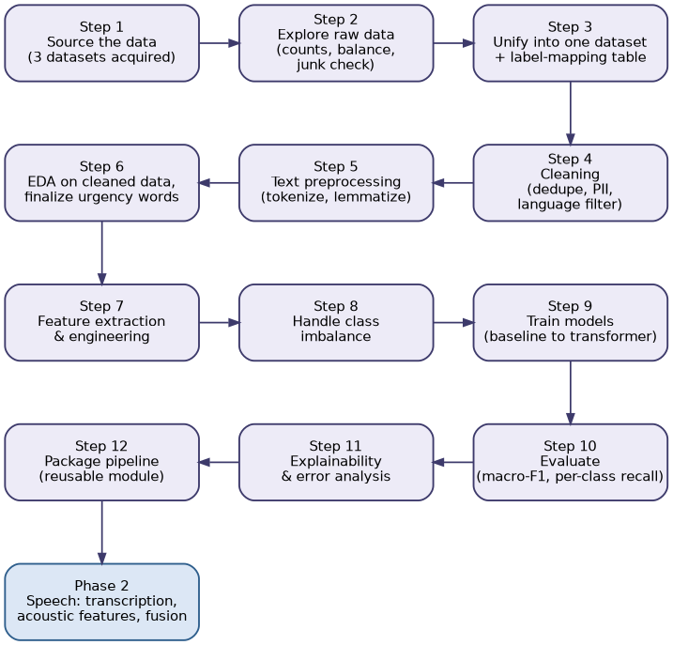
Figure 1: End-to-end Phase 1 pipeline, Step 1 through Step 12, with the handoff into Phase 2

Step-by-step breakdown
Step 0 — Define what “urgency” means, before touching data
- “Urgency” is not one of the seven classes — it is a safety layer that sits on top of the classifier.
- A post can be labeled “Depressed” but not urgent; a two-line post can be extremely urgent even if the classifier is unsure of the broader category.
- Decision: urgency is a rule-based keyword safety net that can override the ML model outright, plus a properly trained flag later — never rely on the multi-class model alone for this.
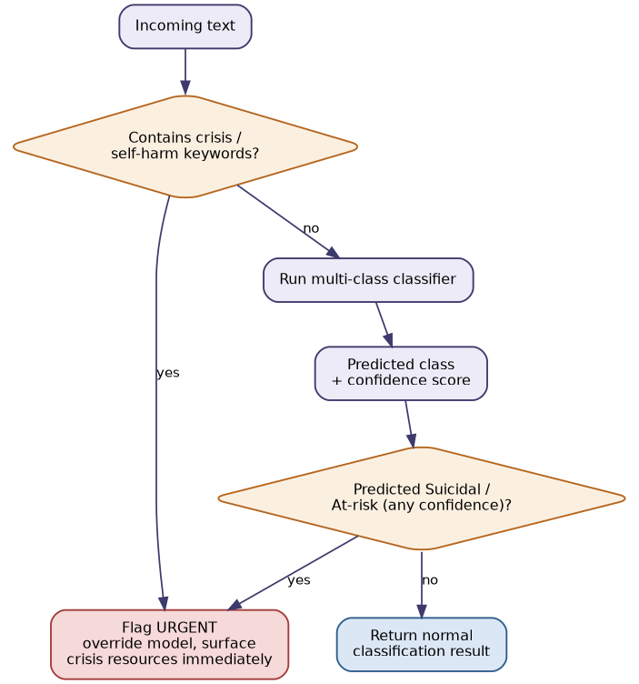
Figure 2: Urgency safety-net logic applied at inference time
Step 1 — Source the data
- Primary: Combined Data.csv (Kaggle “Sentiment Analysis for Mental Health”) — 7-class match, done.
- Urgency layer: Suicide_Detection.csv (Reddit SuicideWatch vs. non-suicide) — done.
- Supplementary emotion signal: Emotion_Sentiment_DataSet.csv — done, needs label mapping onto the 7 target classes.
- License/terms check for each source before any redistribution in the report.
Step 2 — Look at the raw data before deciding anything else
- Row counts, actual label names, and class balance per source (confirmed above).
- Text length distribution — Reddit posts vs. shorter social-media text behave differently.
- Junk check: removed/deleted posts, bot content, duplicates, non-English rows.
- PII check: usernames, other real people named in the text.
Step 3 — Build one unified dataset
- Explicit label-mapping table across sources (e.g. Suicide_Detection “suicide” → “Suicidal” + urgency_flag = 1).
- Final schema: text, source_dataset, label, urgency_flag, split.
- Split by original post/user, not randomly at row level, to avoid the same author leaking across train/test.
Step 4 — Cleaning
- Drop duplicates/near-duplicates and empty or removed posts.
- Language-detect and drop non-English rows.
- Strip usernames, @mentions, URLs, subreddit tags.
- Convert emojis to text descriptions rather than deleting — they carry emotional signal.
- Normalize unicode/encoding artifacts; remove content identifying a real, specific person.
Step 5 — Text preprocessing
- Tokenize, lowercase, expand contractions, lemmatize.
- Do not blanket-remove stopwords — “no,” “not,” “never,” “I,” “me,” “my” are exactly the signal this task depends on.
Step 6 — EDA on cleaned data
- Class distribution, text length and top words per class.
- Manually read a random sample per class to sanity-check labels.
- Finalize the urgency-keyword list from real “Suicidal”-class examples, not guesswork.
Step 7 — Feature extraction and engineering
- Classical/interpretable: TF-IDF n-grams, VADER sentiment score, NRC emotion-lexicon scores, first-person pronoun ratio, negation count, absolutist-word ratio, punctuation patterns, readability score, urgency-keyword hit flag.
- Learned representations: sentence embeddings from MentalBERT/MentalRoBERTa (domain-pretrained).
- Keep both — classical features explain a prediction in the report; embeddings push accuracy.
Step 8 — Handle class imbalance
- Combined Data.csv is meaningfully imbalanced (Normal 16,351 vs. Personality disorder 1,201) — decide between class-weighted loss, SMOTE on engineered features, or capping the majority class.
Step 9 — Train models, increasing complexity
- Baseline: Logistic Regression / Linear SVM on TF-IDF — confirms the pipeline end to end.
- Mid: Random Forest / XGBoost on engineered features.
- Advanced: fine-tuned MentalBERT/DistilBERT on cleaned raw text.
- Keep the baseline in the report — it shows the fancier model earns its complexity.
Step 10 — Evaluate properly
- Macro-F1, not raw accuracy — accuracy alone hides poor performance on small classes.
- Per-class precision/recall and confusion matrix.
- For Suicidal/urgency specifically: recall matters more than precision — use a deliberately low decision threshold there.
Step 11 — Explainability and error analysis
- Run SHAP/LIME to show which words/features drove a prediction.
- Manually read misclassified examples — usually more useful than any single metric.
Step 12 — Package it
- Save trained model + vectorizer/tokenizer + feature-extraction code as one reusable module.
- Single function: raw text in → (predicted class, confidence, urgency flag) out.
- This becomes the exact building block Phase 2 fuses with.
Phase 2 preview (later, not now)
- Audio data (DAIC-WoZ-style or original recordings) → transcription (Whisper) → acoustic features (pitch, jitter, shimmer, speaking rate, pauses via librosa/openSMILE) → fusion with the Phase 1 text model.

Division of labor for this phase
Given the datasets are now staged and everything runs on CPU-friendly libraries up through the mid-tier models, this is what can be built and run directly, versus what needs a GPU environment (Colab/local):
- Done directly: Steps 2–8 in full — raw data exploration, dataset unification, cleaning, preprocessing, EDA, feature engineering, and imbalance handling — plus Step 9's baseline and mid-tier models (Logistic Regression, SVM, Random Forest, XGBoost), Step 10 evaluation, and Step 11 explainability (SHAP/LIME).
- Needs a GPU (Colab or local): fine-tuning MentalBERT/DistilBERT in Step 9's advanced tier — the script will be handed over ready to run, since this sandbox has CPU only.
- Needs the team: final label-mapping sign-off in Step 3, the urgency-keyword list sign-off in Step 6, and reviewing error analysis in Step 11 before anything is called “final.”

