AIM: Implement NOT, AND, OR gates using NAND gate using NAND2TETRIS Simulator
SCHEMATIC DIAGRAM, BOOLEAN EXPRESSION and TRUTH TABLE:

NOT gate using NAND:
Code:
CHIP Not {
IN in;
OUT out;
PARTS:
Nand(a=in, b=in, out=out);
}
Boolean Expression: $out=\overline{in⋅in}=\overline{in}$

SCHEMATIC DIAGRAM and TRUTH TABLE
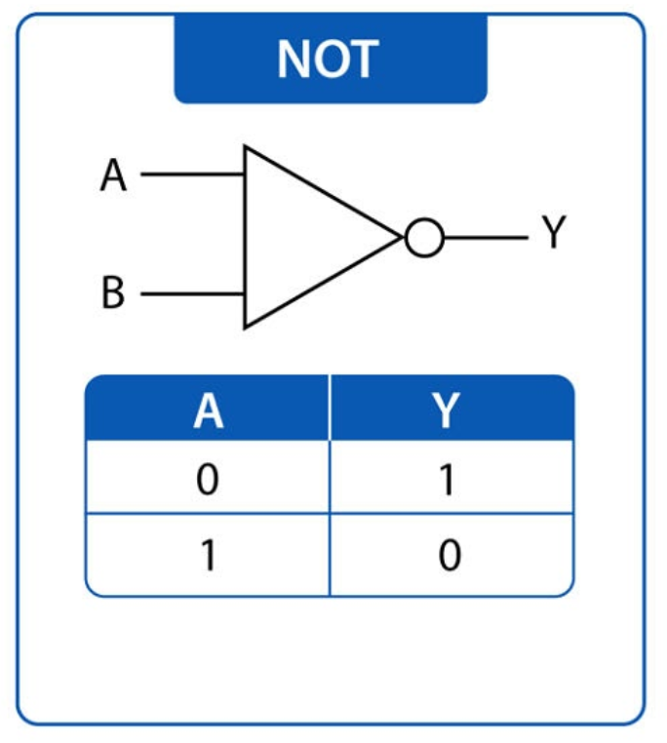

IMPLEMENTATION:
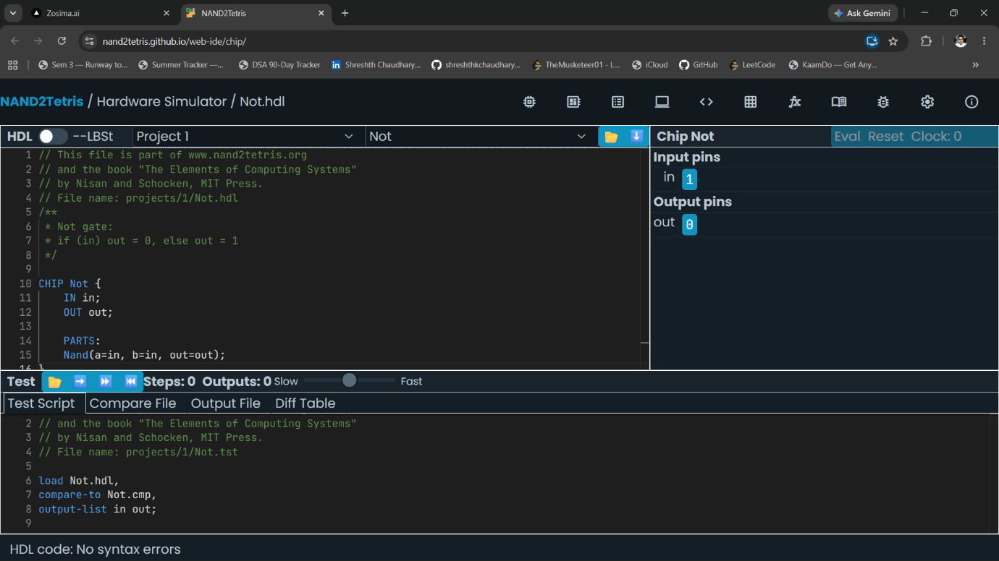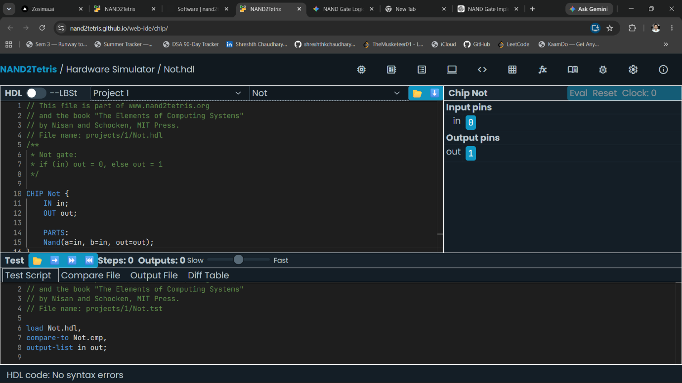

AND gate using NAND:
Code:
CHIP And {
IN a, b;
OUT out;
PARTS:
Nand(a=a, b=b, out=nandOut);
Nand(a=nandOut, b=nandOut, out=out);
}

Boolean Expression: $out=\overline{\overline{a⋅b}}=a⋅b$

SCHEMATIC DIAGRAM and TRUTH TABLE
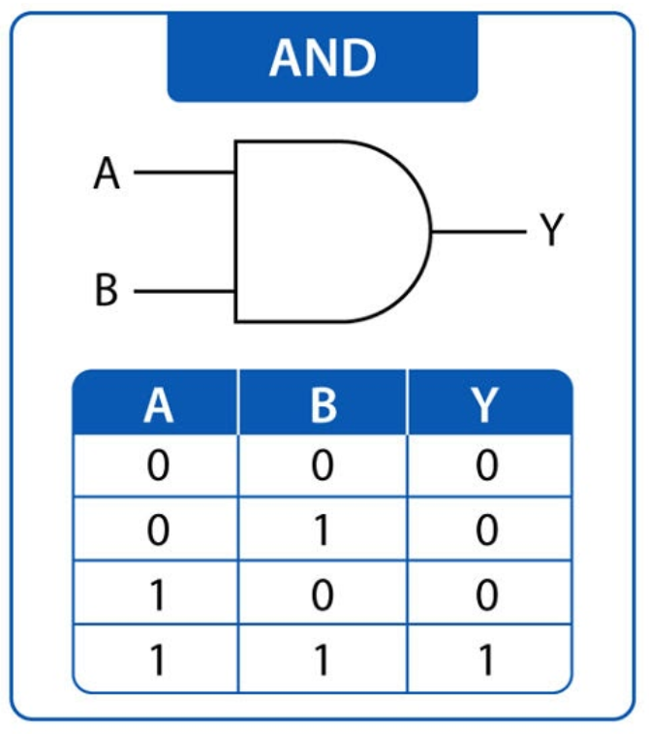

IMPLEMENTATION:
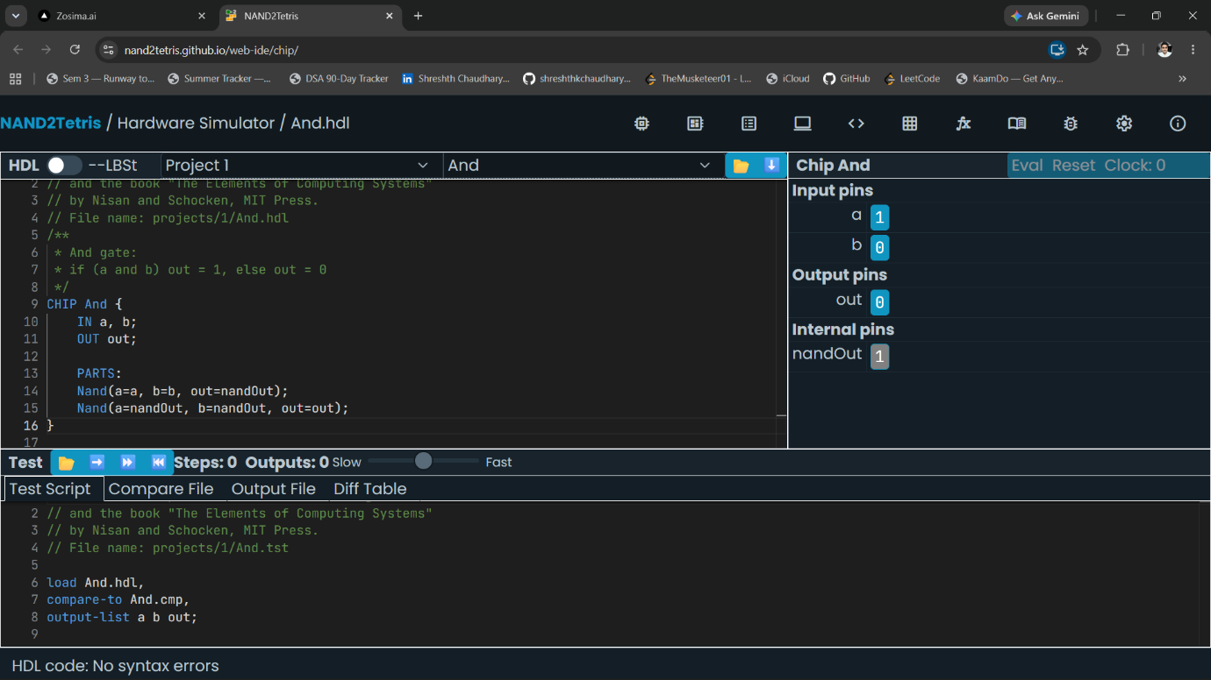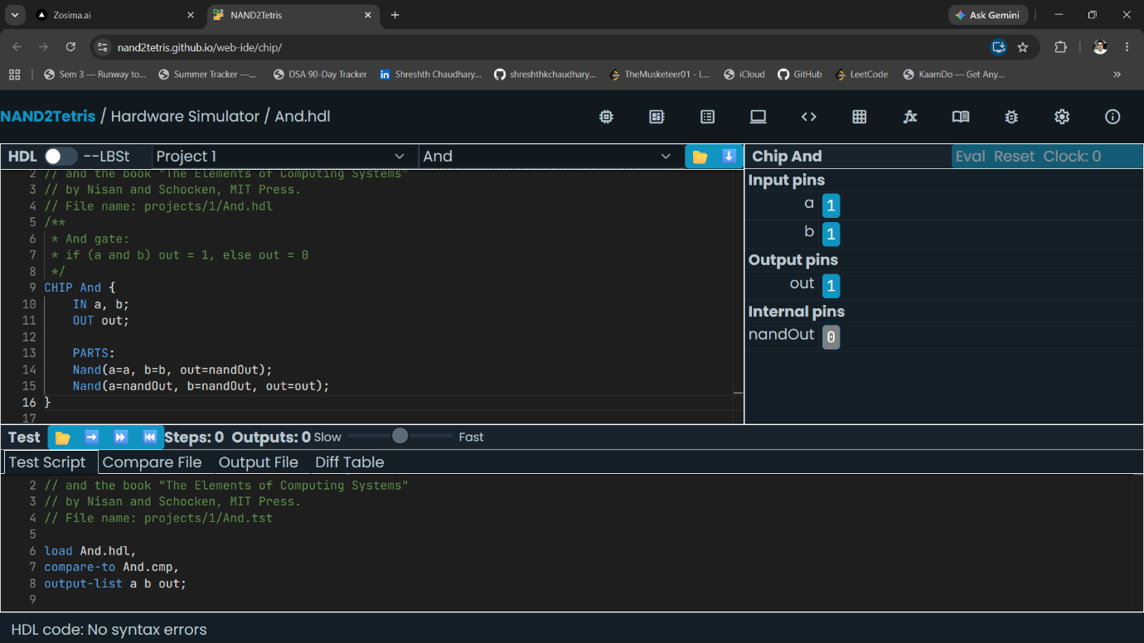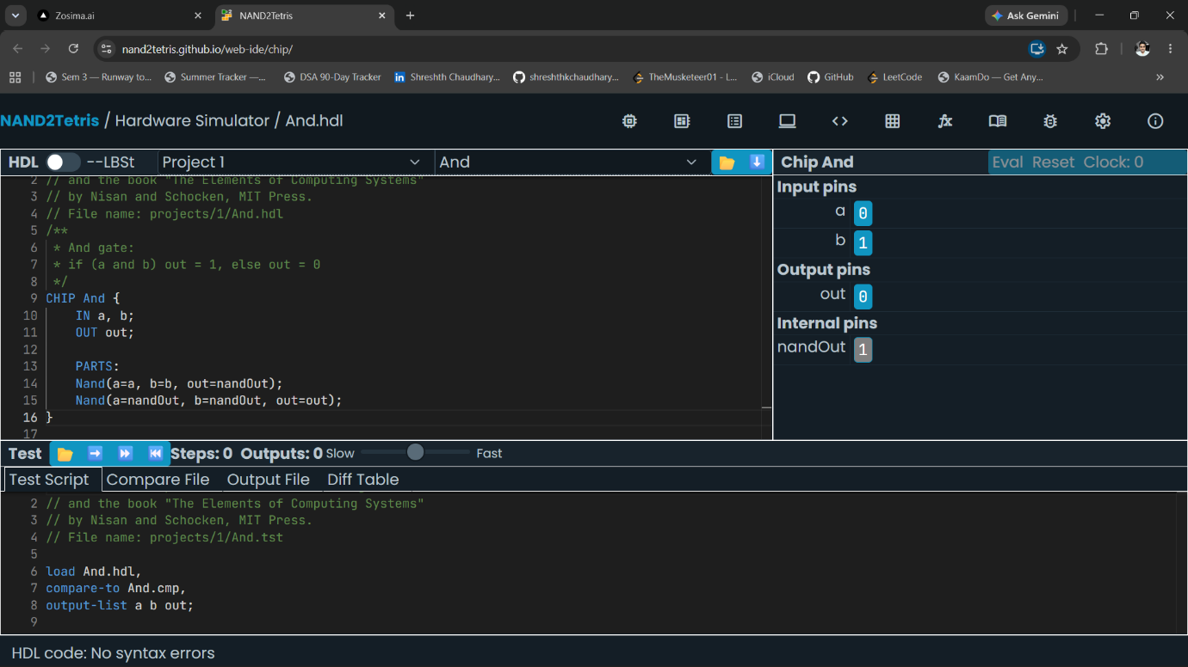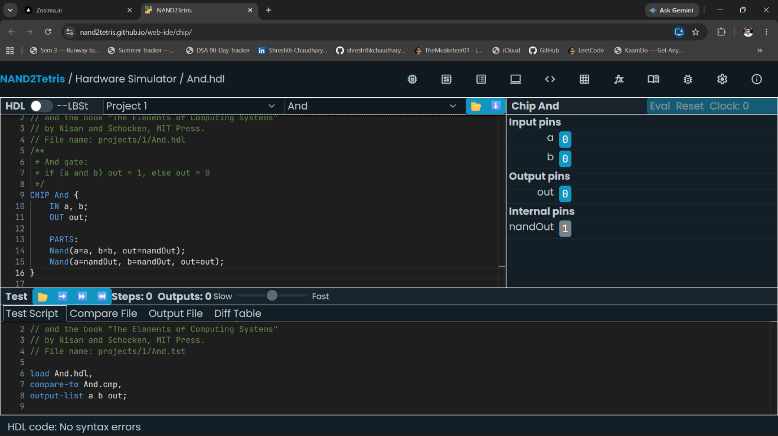

OR gate using NAND:
Code:
CHIP Or {
IN a, b;
OUT out;
PARTS:
Nand(a=a, b=a, out=notA);
Nand(a=b, b=b, out=notB);
Nand(a=notA, b=notB, out=out);
}

Boolean Expression: $out=\overline{\overline{a}⋅\overline{b}}=a+b$

SCHEMATIC DIAGRAM and TRUTH TABLE
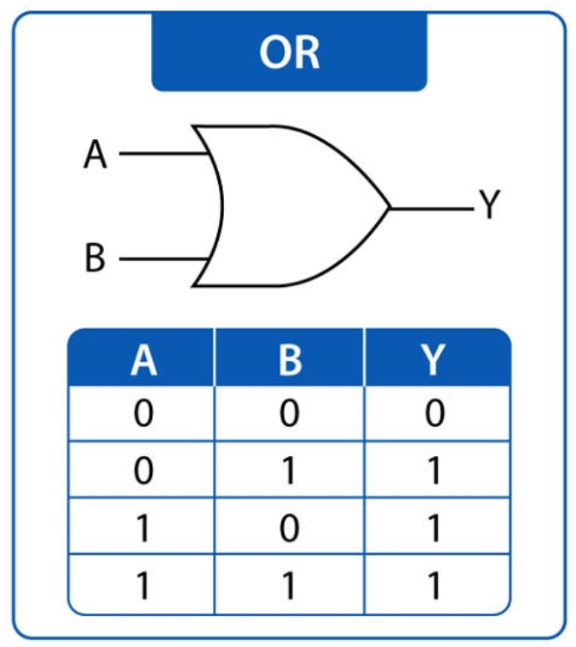

IMPLEMENTATION:

