Build the 16-bit Register chip in HDL. Show read/write operations for three sample inputs and capture simulation output.
CHIP Register {
IN in[16], load;
OUT out[16];
PARTS:
Bit(in=in[0], load=load, out=out[0]);
Bit(in=in[1], load=load, out=out[1]);
Bit(in=in[2], load=load, out=out[2]);
Bit(in=in[3], load=load, out=out[3]);
Bit(in=in[4], load=load, out=out[4]);
Bit(in=in[5], load=load, out=out[5]);
Bit(in=in[6], load=load, out=out[6]);
Bit(in=in[7], load=load, out=out[7]);
Bit(in=in[8], load=load, out=out[8]);
Bit(in=in[9], load=load, out=out[9]);
Bit(in=in[10], load=load, out=out[10]);
Bit(in=in[11], load=load, out=out[11]);
Bit(in=in[12], load=load, out=out[12]);
Bit(in=in[13], load=load, out=out[13]);
Bit(in=in[14], load=load, out=out[14]);
Bit(in=in[15], load=load, out=out[15]);
}

BOOLEAN EQUATION
Qnext​=load⋅in+load⋅Q
TRUTH TABLE
load | in[16] | Operation | out[16]
0 | XXXXX | Hold/Read | Previous value
1 | 0000...0000 | Write 0 | 0000...0000
1 | 1111...1111 | Write 1s | 1111...1111

Simulation Output

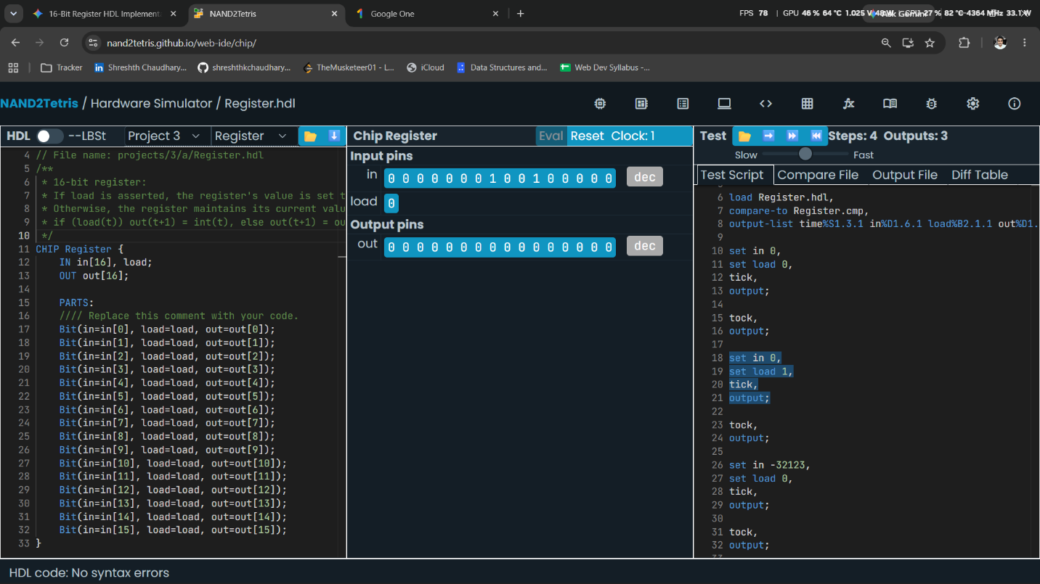

DIAGRAM
load
│
▼
┌────────────────┐
in[16] ───►│ │
│ Mux16 │────► next[16]
out[16] ────►│ │
└────────────────┘

│
▼
┌───────────┐
│ DFF16 │
│ 16 DFFs │
└─────┬─────┘
│
▼

out[16]

​

Build the 8-register Register File chip in HDL. Trace read/write operations for at least four different addresses. Show all register states after each write.

CHIP RegisterFile {
IN in[16], load, address[3];
OUT out[16];
PARTS:
// Select one register for writing
DMux8Way(in=load, sel=address,
a=load0,
b=load1,
c=load2,
d=load3,
e=load4,
f=load5,
g=load6,
h=load7);
// Eight 16-bit registers
Register(in=in, load=load0, out=out0);
Register(in=in, load=load1, out=out1);
Register(in=in, load=load2, out=out2);
Register(in=in, load=load3, out=out3);
Register(in=in, load=load4, out=out4);
Register(in=in, load=load5, out=out5);
Register(in=in, load=load6, out=out6);
Register(in=in, load=load7, out=out7);
// Select one register for reading
Mux8Way16(
a=out0,
b=out1,
c=out2,
d=out3,
e=out4,
f=out5,
g=out6,
h=out7,
sel=address,
out=out);
}

Simulation Output
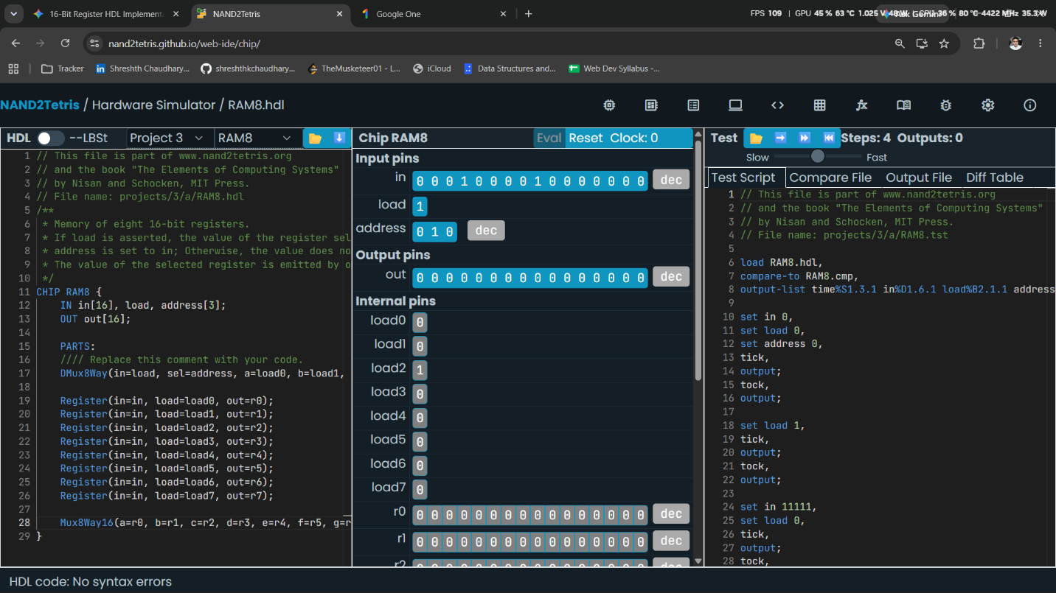
BLOCK DIAGRAM

address[3]
│
┌──────────┴──────────┐
│ │
▼ ▼
┌────────┐ ┌────────────┐
load ──────►│ DMux │ │ Mux │────► out[16]
│ 8-Way │ │ 8-Way 16 │
└───┬────┘ └──────▲─────┘
│ │
┌─────────┼─────────┐ │
▼ ▼ ▼ │
┌────┐ ┌────┐ ┌────┐ │
in ─►│ R0 │ │ R1 │ ...│ R7 │─────────┘
│16bit│ │16bit│ │16bit│
└────┘ └────┘ └────┘

TRUTH TABLE
load | address | Operation
0 | Any | No register is written
1 | 000 | Write to R0
1 | 001 | Write to R1
1 | 010 | Write to R2
1 | 011 | Write to R3
1 | 100 | Write to R4
1 | 101 | Write to R5
1 | 110 | Write to R6
1 | 111 | Write to R7

Boolean Equations
The DMux generates the individual load signals:
$$L_{0}=load⋅\overset{‾}{A_{2}}⋅\overset{‾}{A_{1}}⋅\overset{‾}{A_{0}} \\ L_{1}=load⋅\overset{‾}{A_{2}}⋅\overset{‾}{A_{1}}⋅A_{0}$$
Similarly, each address activates exactly one register.
The output can be represented as:
$$\boxed{out=MUX\left(R_{0} , R_{1} , R_{2} , R_{3} , R_{4} , R_{5} , R_{6} , R_{7}\right)}$$
where the 3-bit address selects the required register.

Build the 1-bit DFF-based register (Bit chip) in HDL. Demonstrate read and write timing with a clock cycle trace showing tick-tock behavior.
CHIP Bit {
IN in, load;
OUT out;
PARTS:
Mux(a=out, b=in, sel=load, out=next);
DFF(in=next, out=out);
}

Simulation Output
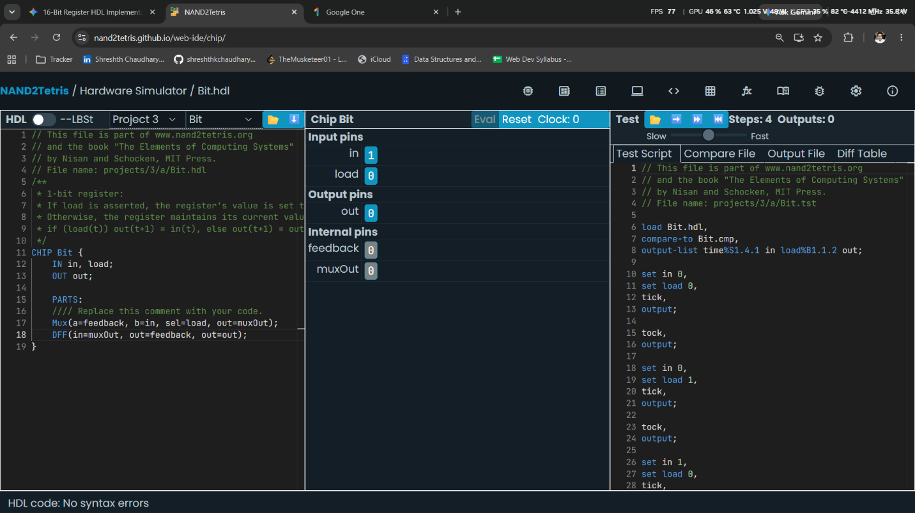

Boolean Equation

BLOCK DIAGRAM
load
│
▼
┌───────────┐
in ──────►│ │
│ MUX │────► next
out ───────►│ │
└───────────┘
│
▼
┌─────────┐
│ DFF │
│ │
└────┬────┘
│
▼
Out

TRUTH TABLE
load | in | Operation | out(next)
0 | 0 | Hold | Previous out
0 | 1 | Hold | Previous out
1 | 0 | Write 0 | 0
1 | 1 | Write 1 | 1

