CAMPUS EVENT & CLUB
MANAGEMENT SYSTEM
Database Design and Implementation Report
MySQL 8.0+ / MariaDB 10.5+
Course: Database Management Systems (CSE3001)
VIT Bhopal University
Team: Shreshth Sharma • Aryan Singh Patel • Krish Salaria • Harshvardhan Swami
A relational database for campus clubs, events, venues, registrations, attendance, budgets, and feedback.

1. Executive Summary
This project models the day-to-day data needs of a university club and event program. The schema keeps student, faculty, department, club, venue, and event facts in separate relations; connector tables represent student memberships and event registrations. InnoDB foreign keys, unique keys, CHECK constraints, triggers, and a stored procedure protect important data rules at the database boundary.
The deliverables are the runnable schema and sample data (campus_event_club_management.sql), this report, an editable Mermaid ER diagram (docs/er-diagram.mmd), and executable constraint checks (tests/constraint_checks.sql). The SQL targets MySQL 8.0+ or MariaDB 10.5+. No execution result is asserted by this report.

2. Objectives and Scope
- Maintain departments, students, faculty coordinators, clubs, club memberships, venues, and scheduled events.
- Record event registrations, attendance, event expenses, and attendee feedback.
- Prevent duplicate memberships and registrations, keep enrollment within event capacity, prevent venue over-capacity and overlapping bookings, and reject expenses above an event budget.
- Offer a single registration procedure and an upcoming-events view for common operations.
The database does not include user authentication, payment processing, waitlists, recurring events, or an application interface. Event conflict prevention applies to time ranges recorded for the same venue; it does not define a campus-wide timezone policy.

3. Relational Schema
Relation | Primary key | Important keys/constraints | Purpose
Department | department_id | department_name unique | Department directory
Student | student_id | registration_no, email unique; department_id → Department; password_hash for app login | Student identity, department, and password hash for the Flask app
Faculty | faculty_id | email unique; department_id → Department | Faculty identity and department
Club | club_id | club_name unique; coordinator_faculty_id → Faculty | Club profile and faculty coordinator
CLUB_MEMBERSHIP | (student_id, club_id) | student_id → Student; club_id → Club | Student–club M:N relationship; member role and join date
Venue | venue_id | venue_name unique; positive venue_capacity | Location and physical capacity
Event | event_id | club_id → Club; venue_id → Venue | Schedule, event capacity, approval state, budget limit, and optional fun fact
EVENT_REGISTRATION | (event_id, student_id) | event_id → Event; student_id → Student | Student–event M:N relationship and registration time
Attendance | (event_id, student_id) | composite FK → EVENT_REGISTRATION | One attendance state per registration
Expense | expense_id | event_id → Event; amount > 0 | Itemized event expenditure
Feedback | feedback_id | unique (event_id, student_id); composite FK → EVENT_REGISTRATION | One 1–5 rating per registered student and event

Foreign-key delete behavior is deliberate: dependent registrations, attendance, memberships, expenses, and feedback cascade when their owning student, club, or event is removed where appropriate. Departments, faculty coordinators, and venues use RESTRICT where deletion could orphan an active organizational or scheduling record.

4. ER Diagram
The overview below shows the entity relationships and key columns. The complete editable entity/attribute diagram is maintained in docs/er-diagram.mmd and can be rendered by Mermaid-compatible tools.

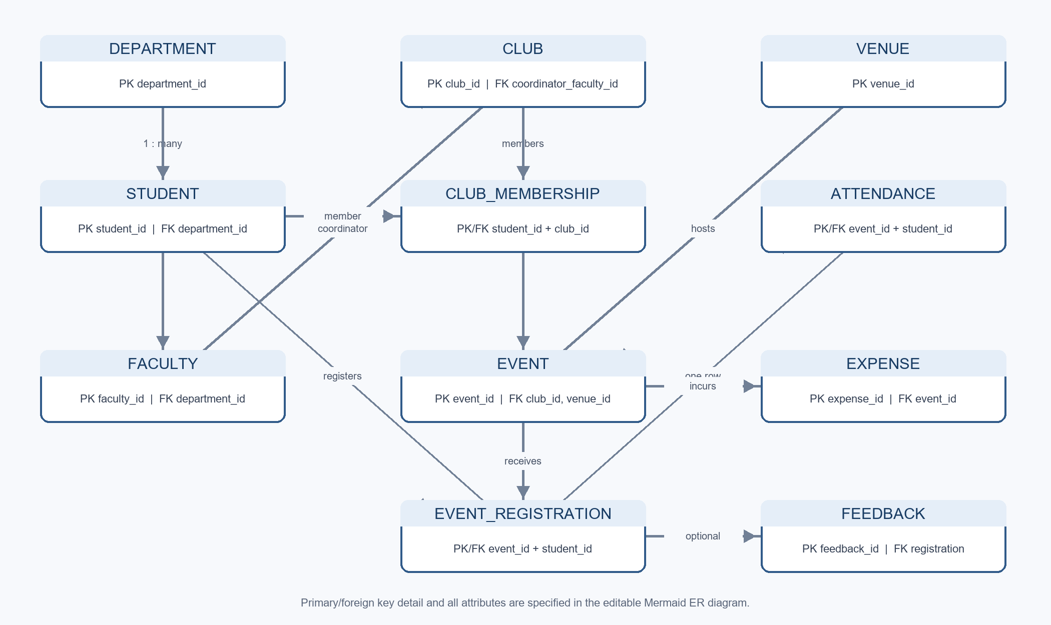

5. Normalization Rationale
The relations are designed to satisfy the usual 1NF, 2NF, and 3NF goals for this domain. Attributes are atomic; repeating lists such as a student’s clubs or an event’s registrants are represented by connector rows. The composite keys on CLUB_MEMBERSHIP and EVENT_REGISTRATION identify each relationship once, and their non-key attributes describe that relationship (role/join date and registration time).
Department names are stored once in Department rather than copied to every student or faculty row. Club coordinator details remain in Faculty; venue details remain in Venue; event-specific schedule and budget facts remain in Event. Expenses, attendance, and feedback are separate event-related facts, avoiding repeating groups and update anomalies. Foreign-key references carry identifiers rather than duplicating descriptive attributes.
The design does not persist derived totals such as current registration count or total expense; the view computes the registration count and budget triggers compare submitted expense rows against the event’s budget. That avoids storing redundant aggregates.

6. Business Rules and Database Enforcement
Rule | Implementation
Entity references must exist | InnoDB foreign keys; restrictive or cascading delete actions are declared per relationship.
Event starts before it ends; capacities are positive; ratings are 1–5 | CHECK constraints on Event, Venue, Feedback, Expense, and Attendance.
Event capacity cannot exceed venue capacity, nor be reduced below the number already registered | BEFORE INSERT/UPDATE Event triggers compare the event capacity to the selected Venue.
A venue cannot host overlapping events | BEFORE INSERT/UPDATE Event triggers check intersecting time ranges and serialize scheduling checks on the venue row.
Only approved events accept registrations; duplicate student/event pairs are rejected | Registration trigger plus composite primary key.
Registrations cannot exceed event capacity | Registration trigger locks the Event row, counts registrations, and rejects a full event.
Registration immediately creates an unmarked attendance row | AFTER INSERT trigger on EVENT_REGISTRATION; Attendance references its registration with a composite FK.
Event expenses cannot exceed the budget; budget cannot be lowered below spend | Expense insert/update triggers lock the event and compare cumulative expenses; an event-update trigger protects the existing total.
Feedback is limited to registered attendees and one rating per event | Composite registration FK and unique (event_id, student_id) constraint.

Budget and registration checks are implemented using InnoDB row locks around their parent event to serialize competing changes. The stored procedure also takes an event lock and owns a transaction. Calls to sp_register_for_event should be made as standalone operations because it issues START TRANSACTION and COMMIT.

7. Stored Procedure and View

Registration procedure
sp_register_for_event(p_student_id, p_event_id) locks the selected event, confirms that it exists, is approved, and has remaining capacity, then inserts the registration. The insert trigger creates attendance in the same transaction. Duplicate registrations or foreign-key violations are surfaced to the caller; SQL exceptions cause the procedure to roll back and re-signal the error.
CALL sp_register_for_event(2, 8); -- seeded example: Isha Patel registers for Annual Innovation Expo
That example pair is initially unregistered in the supplied seed. A repeated call for the same pair is expected to fail because duplicate registration is forbidden.

Upcoming-events view
vw_upcoming_events lists approved events whose start time has not passed, together with club and venue labels, capacity, registration count, and seats remaining. The query is evaluated against the current server time.
SELECT event_name, start_at, club_name, venue_name, registered_count, seats_remaining
FROM vw_upcoming_events
ORDER BY start_at;

8. Setup and Example Queries
Use a MySQL 8.0+ or MariaDB 10.5+ account with permission to create a database, tables, triggers, procedures, and views. The supplied MySQL dump creates campus_event_club_db if needed, then drops and recreates the project tables before inserting sample rows. Running it deletes existing project data; back up anything you need first.
mysql -u root -p < campus_event_club_management.sql

Example: upcoming events
USE campus_event_club_db;
SELECT * FROM vw_upcoming_events ORDER BY start_at;

Example: club membership counts
SELECT c.club_name, COUNT(*) AS members
FROM CLUB_MEMBERSHIP AS m
JOIN Club AS c ON c.club_id = m.club_id
GROUP BY c.club_id, c.club_name
ORDER BY members DESC;

Example: register a student
CALL sp_register_for_event(2, 8);

9. Constraint Check Script
After loading a fresh schema, execute tests/constraint_checks.sql. It runs success and expected-failure checks for procedure registration, automatic attendance creation, capacity enforcement (including rejecting capacity reductions below existing registrations), venue capacity and overlap protection, spending at the exact budget, over-budget expense rejection, and lowering a budget below spend. Expected failures are caught and checked by SQLSTATE; the fixture DML is rolled back. The procedure test temporarily enrolls student 2 in event 8, verifies attendance, and deletes that registration because the procedure commits internally.
mysql -u root -p < tests/constraint_checks.sql
The test file and setup script have been authored for the stated server versions. A compatible MySQL/MariaDB server is required to execute the database-level tests; this report does not claim a successful live-server run.

10. Assumptions and Operational Notes
- The server’s current date/time is used for sample event scheduling and the upcoming-events view. Sample events are placed relative to CURRENT_TIMESTAMP so they remain upcoming on a fresh load.
- Event capacity is a per-event ceiling and must not exceed its venue’s stated capacity. The venue-update trigger rejects reductions below an existing event capacity; operators should still review scheduled bookings when changing venue details.
- The scheduling trigger rejects intersecting intervals at the same venue. Operational deployments should confirm the database server timezone and apply a consistent event-time convention.
- The DDL uses CHECK constraints, InnoDB locking, triggers, and stored-program syntax available in the target MySQL/MariaDB versions; exact behavior should be verified on the selected server release before production use.

11. Repository Deliverables
Path | Description
campus_event_club_management.sql | Database creation, 11 relations, keys/constraints, triggers, stored procedure, view, and realistic sample rows.
Campus_Event_Club_Management_System_Report.docx | This report in editable Word format.
docs/er-diagram.mmd | Complete editable Mermaid ER diagram.
tests/constraint_checks.sql | Runnable SQL checks for primary business-rule guarantees.
README.md | Quick start, examples, and links to deliverables.

