# TASK3: Lab 04 - Implement Virtual Networking

Lab guide:

<https://raw.githubusercontent.com/CloudLabs-MOC/AZ-104-MicrosoftAzureAdministrator/master/Instructions/Labs/LAB_04-Implement_Virtual_Networking.md>

1. Analyze the lab guide and understand & identify what are the Pre-requisite resources and what are the lab steps(resources expected) that will be created/performed by the users

* Pre-requisite

Virtual machine with browser

Roles and policies

1. Decide the subscription type based on the lab requirement.

* Shared subscription

1. Develop/Automate the Azure infrastructure(Pre-requisites) with ARM templates, PowerShell scripts as required.

* ARM : https://otask4.blob.core.windows.net/gvvt/temp4.json
* PARAMETER: https://otask4.blob.core.windows.net/gvvt/par.json

1. Add roles, RBAC, Policies as required, modify the RBAC/Policy files to allow only the required actions for user and apply it over the assignable scopes(RG/Subscription). Apply the minimum permissions required.

* RBAC: <https://otask4.blob.core.windows.net/gvvt/rbac4.json>
* POLICY: <https://otask4.blob.core.windows.net/gvvt/policy4.json>

5)Deploy the ARM template in your subscription and test the lab as per the lab guide

 Github Master Document fileURL:

<https://raw.githubusercontent.com/Sathishhs/task4/main/usag.json>

1. Create CloudLabs templates and ODL’s

After lab launch

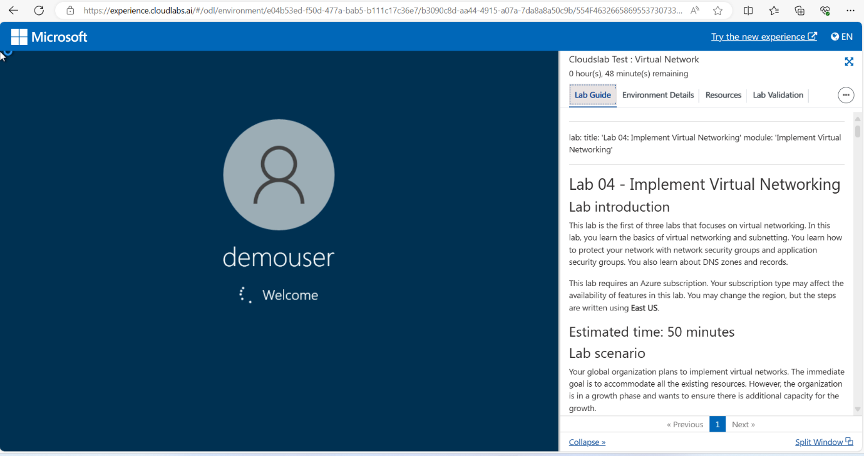

* Task 1: Create a virtual network with subnets using the portal.
* Task 2: Create a virtual network and subnets using a template.

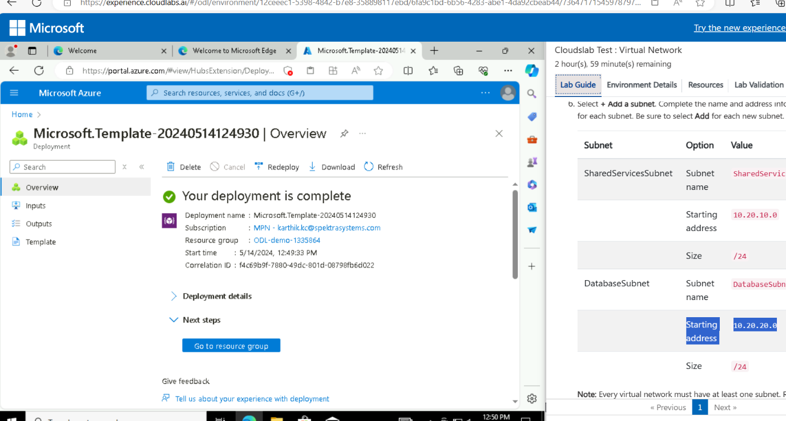

* Task 3: Create and configure communication between an Application Security Group and a Network Security Group.

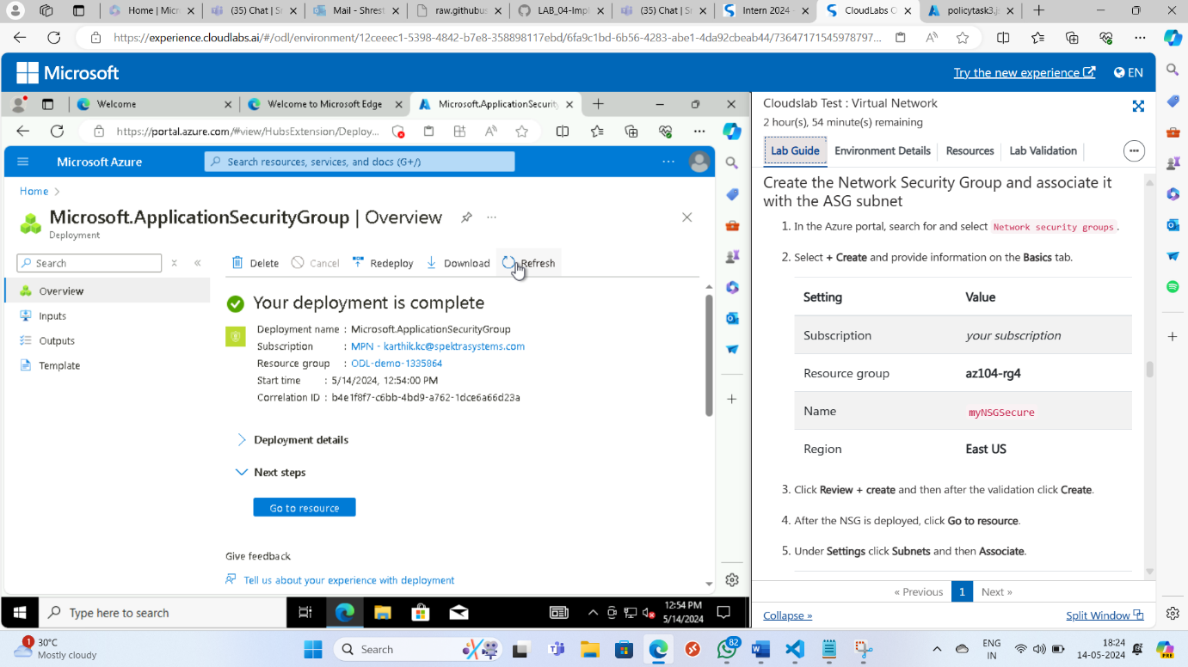

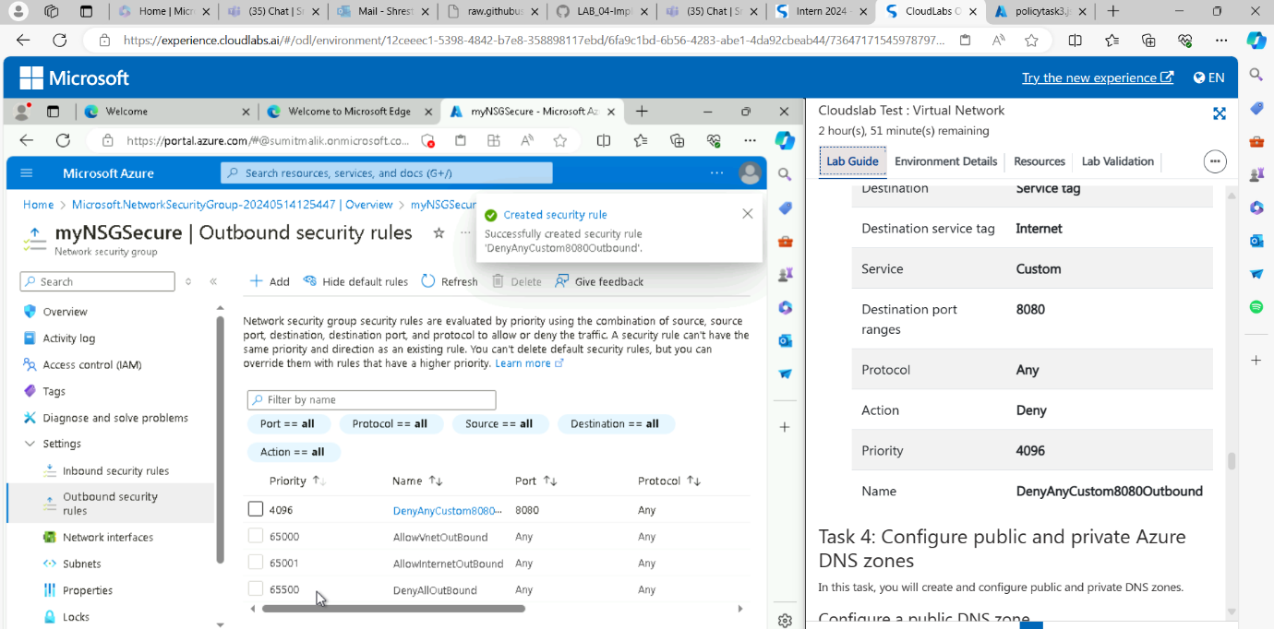

* Task 4: Configure public and private Azure DNS zones.

