Poppleton Dog Show Web Application
Module: CIS2360 – Database-Driven Web Applications
Student: Rahul Shrestha
Academic Year: 2024/2025

1. Introduction
This project implements a dynamic, database-driven web application for the Poppleton Dog Show. The system allows members of the public to view dog show data such as dogs, owners, events, rankings, and competition results without requiring an account. In addition, optional user authentication is provided so registered users can access a personal profile and session-based navigation features.
The application was developed using PHP, MySQL/MariaDB, HTML, CSS, and JavaScript. The primary aim of the project is to demonstrate correct relational database usage, secure server-side programming, and effective SQL querying, while presenting the data through a clear and user-friendly interface. Importantly, the integrity of the original dataset provided for the assignment has been preserved.

2. Tools and Development Environment
The project was developed and tested using the following tools:
- Database and Server: XAMPP (Apache and MariaDB/MySQL)
- Backend: PHP 8 using PDO
- Frontend: HTML5, CSS (custom design tokens), JavaScript
- Editor and Testing: Visual Studio Code and Google Chrome
- Operating System: Zorin OS (Linux)

3. Database Design

3.1 Provided Database Schema
The application is built on the provided Poppleton Dog Show database schema, which includes the following core tables:
- dogs
- owners
- breeds
- entries
- events
- competitions
- judges
These tables represent the original domain model of the dog show. None of these tables were modified, ensuring that the dataset remains consistent with the assignment requirements.

3.2 Additional Tables
To support web application functionality without altering the original domain tables, two additional tables were introduced.
Users Table
The users table supports authentication and role-based access. It stores login credentials, account status, and user roles. Only two roles are defined:
- user – a registered user account
- admin – an administrative account
Owners in the dataset are treated as public domain data and are not directly linked to user accounts. This design avoids assuming that every historical owner has an online account and keeps authentication concerns separate from domain data.
Dog Images Table
The dog_images table stores image URLs associated with dogs. Images are stored as URLs rather than binary data to keep the database lightweight and flexible. Each dog may have multiple images, with one marked as the primary image. If no image is available, a placeholder image is displayed to maintain visual consistency

4. Project File Structure
The project follows a clear and modular directory structure:
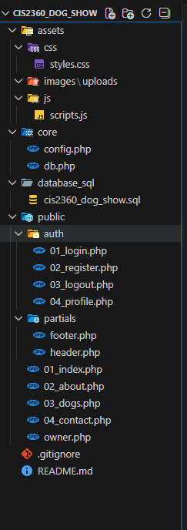

This structure separates configuration, database logic, presentation, assets, and authentication, improving maintainability and readability.

5. Core Functionality and SQL Queries

5.1 Homepage Overview
The homepage acts as the main discovery page and provides:
- Summary statistics (number of owners, dogs, and events)
- A Top 10 Dogs ranking table
- Event winners based on competition scores
- A “Dog of the Day” feature
- Client-side search and filtering
All content is dynamically generated from the database.
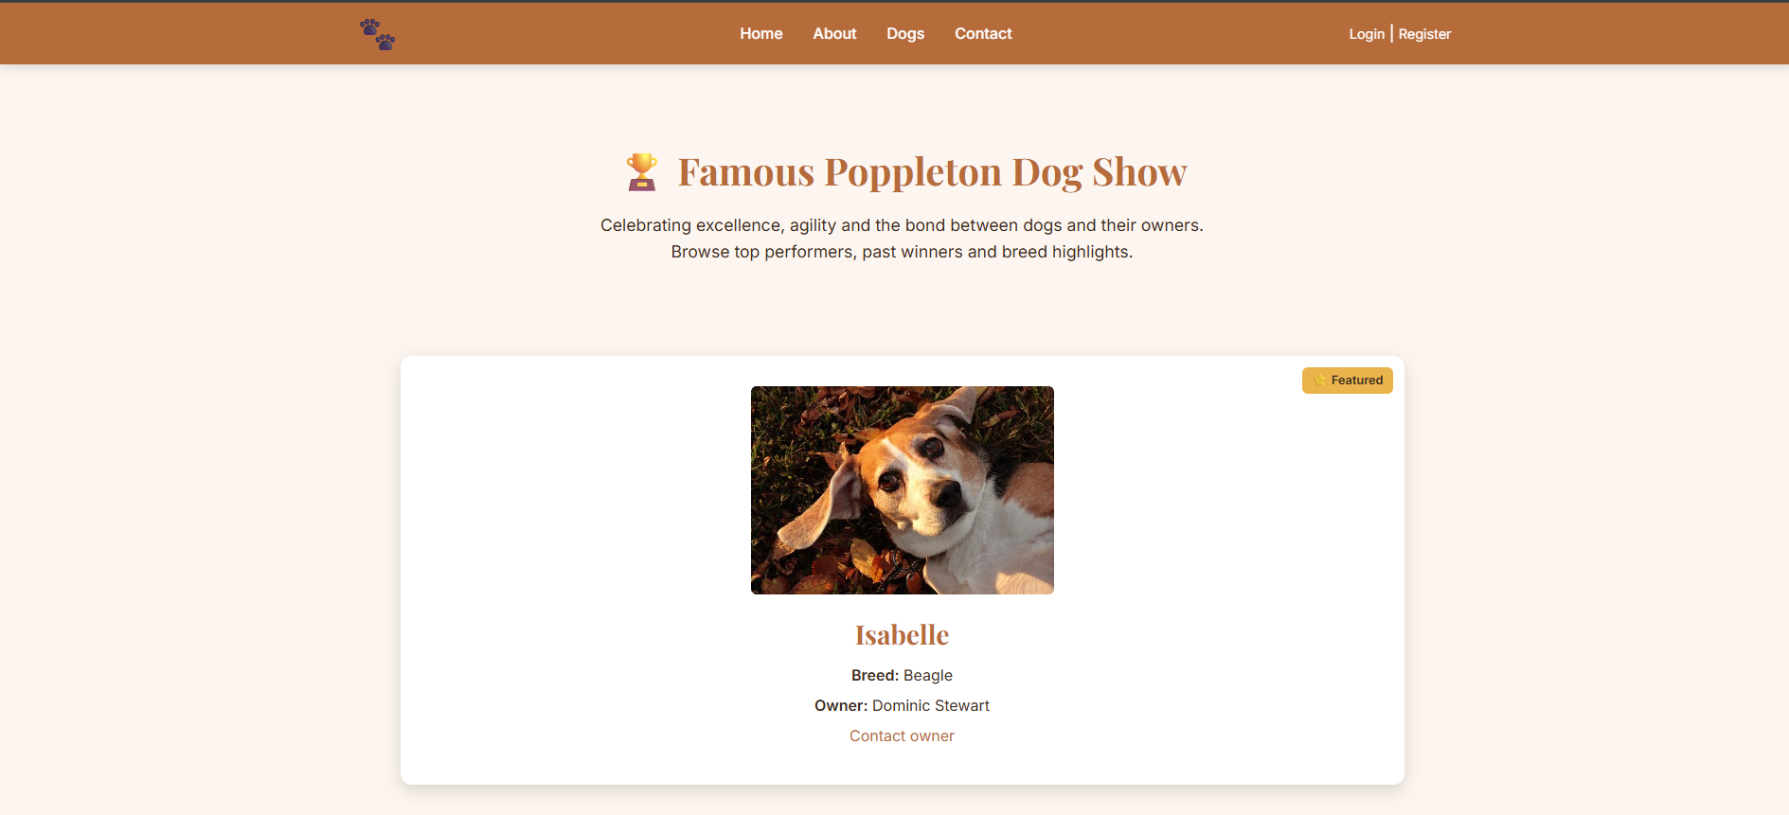

5.2 Summary Statistics
Summary counters provide users with an immediate overview of the dataset. SQL aggregate functions are used to calculate the number of owners, dogs, and events efficiently.


5.3 Top 10 Dogs
The Top 10 Dogs table ranks dogs by their average score across all recorded entries. Only dogs with more than one entry are included, ensuring that rankings are not based on a single performance. Results are ordered in descending order of average score.
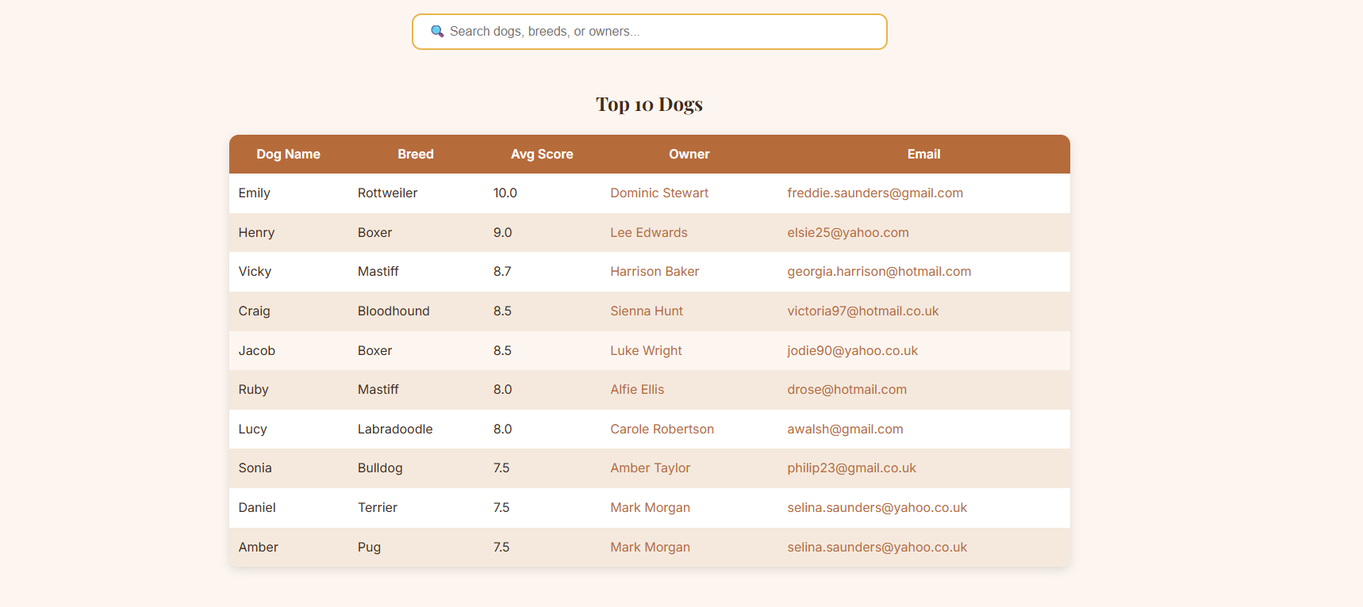

5.4 Event Winners
Event winners are determined by selecting the highest score achieved within each competition. In cases where multiple dogs achieve the same top score, all are displayed as joint winners. This approach reflects fair competition practices and avoids arbitrary tie-breaking.
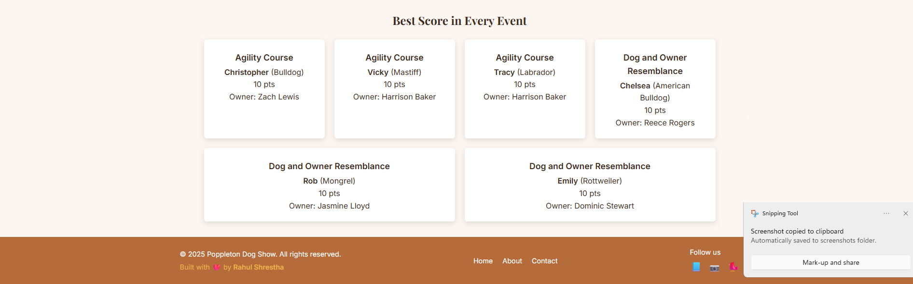

5.5 Owner Profile Page
The owner profile page (owner.php) is publicly accessible and displays:
- Owner contact information
- A list of dogs owned
- Number of entries per dog
- Average score per dog
- Dog image (if available)
Images are retrieved using a left join so that dogs without images are still displayed correctly.
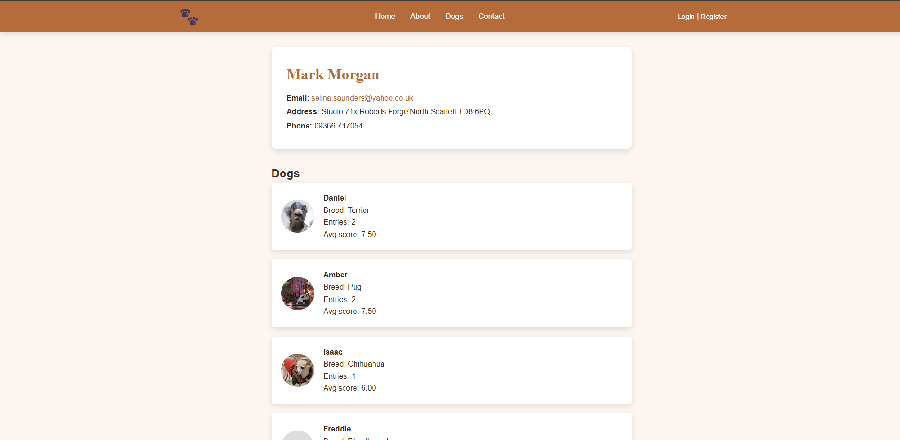

6. Authentication and Security

6.1 Authentication Design
User authentication is implemented using a separate users table. Registration and login are optional, allowing the website to remain fully accessible to the public while supporting account-based navigation.

6.2 Password Security
Passwords are never stored in plain text. The system uses PHP’s password_hash() function to securely hash passwords and password_verify() to validate login attempts.

6.3 SQL Injection Protection
All database queries involving user input are implemented using PDO prepared statements with bound parameters. This prevents SQL injection attacks by separating query structure from user-supplied data.

6.4 Output Escaping and Sessions
Dynamic output is escaped using htmlspecialchars() to reduce the risk of cross-site scripting (XSS). PHP sessions are used to maintain login state and to dynamically display appropriate navigation options (Login/Register or Profile/Logout) without restricting public access.

7. User Interface and User Experience (UI/UX)
The user interface uses a warm colour palette and consistent typography to create a welcoming appearance. A card-based layout and clear spacing improve readability and visual hierarchy.
The website is fully responsive:
- Desktop users see full navigation and multi-column layouts
- Mobile users access content via a hamburger menu and stacked layouts
Search functionality and clear navigation reduce cognitive load and improve usability.

8. Testing
The application was tested using Google Chrome to verify:
- Correct loading of all pages
- Accurate ranking and aggregation of results
- Functionality of search and filtering
- Secure handling of login and registration
- Correct session-based navigation behaviour
- Graceful handling of invalid input (e.g., invalid owner IDs)

9. Reflection Component
Artificial Intelligence (AI) tools have the potential to provide significant benefits in database-driven web application development, particularly in areas such as SQL query generation, debugging, database design, and system integration. AI-assisted tools can help developers quickly generate complex SQL queries involving joins, grouping, and aggregation. This can be especially useful when working with large schemas like the Poppleton Dog Show database, where queries often require multiple table joins and careful use of aggregate functions such as AVG() and COUNT(). AI tools may also assist with identifying syntax errors, suggesting query optimisations, and explaining error messages, which can reduce development time.
In addition, AI can support early-stage database design by suggesting normalised schemas, appropriate foreign key relationships, and indexing strategies. When integrating databases with web systems, AI tools may help generate boilerplate PHP code using PDO, recommend secure authentication practices, and highlight common security risks such as SQL injection. During this assignment, AI assistance could have been beneficial in validating SQL logic, understanding foreign key constraint errors, and refining query structure for features such as ranking dogs by average score or identifying event winners.
However, there are important risks and limitations associated with the use of AI tools. One major concern is accuracy and reliability. AI-generated SQL queries may appear correct but can contain subtle logical errors, such as incorrect grouping, unintended Cartesian joins, or misleading aggregate results. Blindly trusting AI-generated output without understanding the underlying logic could lead to incorrect rankings or unfair competition results. Academic integrity is another key concern; over-reliance on AI to generate substantial portions of code or queries without comprehension may violate coursework guidelines and undermine learning outcomes.
Data privacy is also a potential risk, particularly if real or sensitive data is shared with external AI services. In this assignment, care was taken to work with a local database and avoid exposing personal data to third-party systems. Finally, AI tools may encourage shortcuts rather than deep understanding, which can be problematic when debugging complex issues such as foreign key constraints or data type mismatches.
In conclusion, AI tools can be valuable as a support mechanism for learning, debugging, and validation, but they must be used critically. In this project, human reasoning and manual verification remained essential to ensure correctness, security, and compliance with academic requirements.

10. Conclusion
This project demonstrates the successful development of a secure, database-driven web application using PHP and MySQL. The Poppleton Dog Show website provides meaningful public access to dog show data while supporting optional authentication features. By combining sound database design, secure programming practices, and thoughtful UI/UX decisions, the application fully meets the assignment requirements and presents the dataset in a professional and accessible manner.

