**Work completion report**

**Workshop on Tax Studies for Estimating**

**National Accounts Statistics**

**25-27 Jestha 2081, Dhulikhel, Kavre**

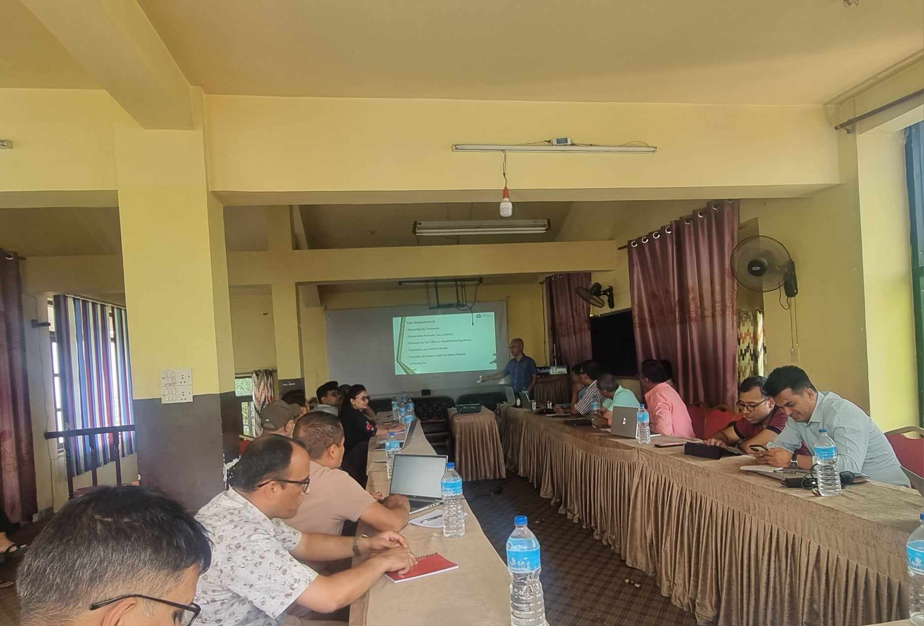

**Conducted by**

National Statistics Office, National Accounts Section

**Report Prepared by**

Avadhesh Kumar Shukla

Statistics Officer

National Accounts Section

**1.1 Introduction**

Taxes and subsidies are essential components in the national accounting framework. The availability of reliable and timely domestic tax data is an important component in the estimation of GDP (in current and constant prices), allowing for the evaluation of annual periodic variations in the major economic sectors. More specifically, Tax less Subsidies on products is used to estimate purchaser's price GDP using Production approach, Taxes less Subsidies on production and imports is used to estimate purchaser's price GDP using Income approach. Furthermore, product-wise tax and subsidy is used to balance Supply and Use tables (SUTs), and province-wise tax and subsidy is required to estimate provincial GDP at purchaser's price.

Because of the lack of product-specific, as well as province-specific tax and subsidy data, National Statistics Office (NSO), Nepal is facing numerous challenges in GDP estimation, balancing SUTs, and estimating provincial GDP. In this regard, a three-day workshop on tax and subsidies has been scheduled in Dhulikhel, Kavre to foster the potential data sources along with difficulties, challenges, and way forward for estimating product-wise tax less subsidies and province-wise tax less subsidies.

**1.2** **Objectives**

The workshop's main objective is to discuss the theoretical background, issues, challenges, and potential data sources to construct the product-wise taxes less subsidies as well as province-wise tax less subsidies

**1.3. Methodology**

This workshop was the three day interaction program with interaction session between NSO officials and Tax data Provider (Department of custom, Inland revenue department and Financial comptroller general office) officials. The following are the main tools and methodologies used in the workshop.

* Power point presentation
* Interaction
* Group work

**2. Detailed report of the workshop**

Procedings of this report is dicussed along with the following sub-headings:

**2.1 Participants/Facilitators:**

The workshop had a total of 27 participants, including Deputy Chief Statistician of NSO, directors and officers from various statistics coordination offfices, officials from Inland Revenue Department (IRD), Department of Custom (DoC) and Financial Comptroller General Office (FCGO), and, officials from the national accounts section and other sections of NSO.The program was chaired by the Deputy chief statistician of NSO, Mr.Dilli Raj Joshi**.**

**2.2 Preparation of the workshop :**

Until the day of the workshop, the Directors and Officers of the National Accounts Section were actively engaged in the preparation of presentations, preparation of workshop materials, and finalization of the subject matter.

**2.3 Session of the programme**

There were three sessions per day. Altogether there are nine sessions over the three days, including theoretical and discussion sessions. National accounts officials, DoC officials, IRD officials and FCGO officials presented on tax related topic. The following are brief summaries of the three day workshop sessions:

**First day-25th Jestha**

*1s tSession- Basics of National Accounts;*

Mr. Dilli Raj Joshi, Deputy Chief Statistician of the National Accounts Division, initiated the workshop with a brief lecture on National Accounts principles, methodologies, and frameworks. Furthermore, he demonstrated how GDP is estimated using the Production, Expenditure, and Income techniques. Finally, he discussed the usage of taxes in the estimation of GDP. Mr.Dilip Kumar Maharjan, FCGO's account officer, and Mr.Nanda Lal Sapkota, Statistics Coordination officer at the Statistics Coordination Office in Kaski, both complements on the presentation. Other participants participated discussion by question and answer session followed by the response made by Deputy Chief Statistician.

*2nd Session-Taxes in System of National Accounts;*

Mr. Ganesh Prasad Acharya, Director of National Accounts Section, leads the second session of the first day, which focuses on the ideas, scope, role, and difficulties related to tax data in National Accounts Estimation. He demonstrated the types of taxes and subsidies required to estimate GDP using the production and income technique. Finally, he discussed various issues associated with tax data. Various queries and comments were arised by, Mr. Hari Om Pokhrel, director from DoC and Mr.Chudamani Dhungana, Director from IRD. These queries were beautifully tackeled by the presenter.

*3rd session –* *Tax and National accounts*

Mr. Rishi Ram Sigdel, Director of National Accounts Section, delivers the third session of the first day. During his presentation, he discussed how taxes and subsidies are employed in national GDP compilation, provincial GDP compilation, and balancing the Supply and Use Tables. Furthermore, he highlighted where we are in terms of tax and subsidy data, as well as the types of tax and subsidy data required. He indicated that we must create a tax less subsidies matrix (product*1) in order to balance the SUTs and province-specific tax less subsidies data in order to estimate provincial GDP. During his presentation, he demonstrated SUTs and PGDP data compiled by the National Accounts Section. Moreover, he emphasized the importance of taxes and subsidies in five economic sectors (households, financial businesses, non-financial firms, governments, and NPISH) in order to construct sequence of accounts. Mr. Hari Om Pokhrel, director from DoC and Mr.Chudamani Dhungana, Director from IRD commented on his presentation. The comments made by two directors were noted as complements and Mr. Sigdel responsed other questions raised by other participants.

**Second day-26th Jestha**

*1stSession-Economic code, accounting and reporting of tax in FCGO*

Mr. Dilip Kumar Maharjan, Account Officer of the Financial Comptroller General Office, leads the opening session of the second day. He concentrated on the availability of tax data in FCGO. During his presentation, he discussed basic tax principles, types, and coding. He explained that FCGO follows the Government Finance Statistics Manual (GFSM-2014) for tax accounting employing the Revenue Management Information System (RMIS) and the Subnational Treasury Regulatory Application (SuTRA). He also talked about revenue assignments and intergovernmental fiscal transfers using federal and provincial depository funds.Various queries and comments were arised by Mr. Hari Om Pokhrel, director from DoC and Mr.Chudamani Dhungana, Director from IRD. These queries were beautifully tackeled by the presenter.

*2nd Session-Tax Data in Inland Revenue Department.*

Mr. Chudamani Dhungana, Director of the Inland Revenue Department, leads the second session on the second day. He focused on the availability of tax data in IRD. During his talk, he discussed tax payer registration, tax assessment, tax collection, and data reconciliation. He noted that the IRD's IT system handles 95 percent of all tax-related activity. During his talk, he addressed the granularity of tax data in IRD. Accordingly, tax data is available for the first NSIC of a primary business up to two or four digits. However, this is not applicable at the local level.Various queries and comments were arised by Mr. Dilip Kumar Maharjan, Account officer from FCGO and Mr.Shiv Narayan Mahato, Statistics Officer from Udaypur Statistics Office. These queries were beautifully tackeled by the presenter.

*3rd Session-Tax Data in Department of Custom.*

Mr. Hari Om Pokhrel, Director from DoC, leads the 3rd session of the second day. He focused on aviability of tax data in DoC. During his presentation, he covered, tax and subsidies data on Export and Import. He demonstrated the tax data trend of last five years as well as revenue data by HS code for the last two year. Various queries and comments were arised by Mr. Dilip Kumar Maharjan, Account officer from FCGO and Mr. Chudamani Dhungana, Director from IRD. These queries were beautifully tackeled by the presenter.

**Third day-27th Jestha**

*1stSession-Construction of Product-wise tax matrix*

Mr. Nanda Lal Sapkota, Statistics Coordination Officer from Statistics Coordination Office, Kaski, leads the 1st session of the third day. He illustrated how to make a product-wise matrix. He indicated that NSIC-level tax data is available from IRD, and we have a mapping between CPC and NSIC that we can use to obtain product-level tax data. Similarly, we can get CPC-specific tax statistics for imports from DOC. Finally, utilizing these two data sources, we can create a product-specific tax matrix. Mr. Dilip Kumar Maharjan, Account Officer from FCGO, and Mr. Hari Om Pokhrel, Director from DoC, both raised questions and made remarks. The presenter handled these questions clearly.

*2nd Session-Construction of Province-wise tax data*

Mr. Jishnu Mohan Bhattrai, Director of the Trade Statistics Section, delivers the second session on the third day. He illustrated how to get province-wise tax data. He stated that province-specific taxes can be calculated using indicators according to recommendations from the National Natural Resources and Fiscal Commission (NNRFC) based on population, area, and per capita income, and other factors. Mr. Dilip Kumar Maharjan, Account Officer from FCGO, and Mr. Hari Om Pokhrel, Director from DoC, both raised questions and made remarks. The presenter handled these questions effectively.

*3rd Session-Construction of Product-wise subsidy data*

Mr. Anil Shrestha, Under Secretary from the Accounts Section, leads the third session of the third day. He demonstrated how to obtain product-specific subsidy data. He stated that product-specific subsidies can be estimated using FCGO expenditure data classified by function of government (COFOG). He stated that by analyzing Cofog expenditure data, we may create indicators based on subsidy rates on input and export products for diverse industries. Finally, utilizing these indications, we may obtain product-specific subsidy information. Mr. Dilip Kumar Maharjan, Account Officer from FCGO, and Mr. Hari Om Pokhrel, Director from DoC, both raised questions and made remarks.Various queries and comments were arised by Mr. Chudamani Dhungana, Director from IRD and Ms. Prabha Baral, Statistics Coordination Officer from Statistics Coordination Office, Kathmandu. These queries were beautifully tackeled by the presenter.

***Closing ceremony***

The third session of the third day course was followed by a closing ceremonial program. Mr. Dilli Raj Joshi, Deputy Chief Statistician of the National Accounts Division, presided over the closing ceremony. During the closing ceremony, Mr. Chudamani Dhungana stated that formerly, IRD generated tax reports based on SITC code, but now IRD follows NSIC code. He also highlighted the importance of top-level management involvement from both the NSO and the IRD in tax reporting. Similarly, Mr. Gyanendra Bajracharya discussed the suitable fiscal year for the rebasing of National Accounts Series. Mr. Bajracharya further stated that NSO should provide a template for tax data. Finally, Mr. Dilli Raj Joshi concluded the workshop with a speech emphasizing the importance of tax data. He explained that a memorandum of understanding (MOU) should be signed by NSO and other tax data suppliers, with NSO taking the lead in providing reliable and timely domestic tax data.

**Annex I (list of Participants)**



**Annex II (Schedule)**



**Annex III (Some pictures of the workshop)**

