CHAPTER 1

**INTRODUCTION**

The Controller Area Network (the CAN bus) is a serial communications bus for real-time control applications; operates at data rates of up to 1 Megabits per second, and has excellent error detection and confinement capabilities.

**1.1 GENERAL INTRODUCTION**

CAN was originally developed by the German company Robert Bosch for use in the car industry to provide a cost-effective communications bus for in-car electronics and as alternative to expensive and cumbersome wiring looms. The car industry continues to use CAN for an increasing number of applications, but because of its proven reliability and robustness, CAN is now also being used in many other industrial control applications.

CAN is an international standard and is documented in ISO 11898 (for high-speed applications) and ISO 11519 (for lower-speed applications).Low-cost CAN controllers and interface devices are available as off-the-shelf parts from several of the leading semiconductor manufacturers. Custom built devices and popular microcontrollers with embedded CAN controllers are also available. There are many CAN-related system development packages and available hardware interface cards and easy-to-use software packages that provide system designers, builders and maintainers with a wide range of design, monitoring, analysis, and test tools.

CAN is the standard in a large variety of networked embedded control systems. The early CAN development was mainly supported by the vehicle industry. CAN is found in a variety of passenger cars, trucks, boats, spacecraft, and other types of vehicles. The protocol is also widely used today in industrial automation and other areas of networked embedded control, with applications in diverse products such as production machinery, medical equipment, building automation, weaving machines, and wheelchairs.

**1.2 REASON FOR CAN DEVELOPMENT**

To satisfy customer requirements for greater safety, comfort, and convenience and to comply with increasingly stringent government legislation for improved pollution control and reduced fuel consumption, the car industry has developed many electronic systems. The development of CAN began when more and more electronic devices were implemented into modern motor vehicles. Examples of such devices include engine management systems, active suspension, ABS, gear control, lighting control, air conditioning, airbags and central locking. All this means more safety and more comfort for the driver and of course a reduction of fuel consumption and exhaust emissions.

The complexities of these control systems, and the need to exchange data between them meant that more and more hard-wired, dedicated signal lines had to be provided. Sensors had to be duplicated if measured parameters were needed by different controllers. Apart from the cost of the wiring looms needed to connect all these components together, the physical size of the wiring looms sometimes made it impossible to thread them around the vehicle (to control panels in the doors, for example). In addition to the cost, the increased number of connections posed serious reliability, fault diagnosis, and repair problems during both manufacture and in service.

To improve the behavior of the vehicle even further, it was necessary for the different control systems (and their sensors) to exchange information. This was usually done by discrete interconnection of the different systems (i.e. Point to point wiring). The requirement for information exchange has then grown to such an extent that a cable network with a length of up to several miles and many connectors was required. This produced growing problems concerning material cost, production time and reliability.

**1.3 CAN HISTORY**

In the past few decades, the need for improvements in automotivetechnology caused increased usage of electronic control systems forfunctions such as engine timing, anti-lock brake systems, and distributor less ignition.

Originally, point-to-point wiring systems connected electronic devices invehicles. More and more electronics in vehicles resulted in bulky wire harnesses that were heavy and expensive. To eliminate point-to-pointwiring, automotive manufacturers replaced dedicated wiring with in-vehiclenetworks, which reduced wiring cost, complexity, and weight. Bosch developed the Controller Area Network (CAN), which has emergedas the standard in-vehicle network.

CAN provides a cheap, durable network that allows the devices to speak through the Electronic Control Unit (ECU). CAN allows the ECU to haveone CAN interface rather than analog inputs to every device in the system.This decreases overall cost and weight in automobiles. Each of the deviceson the network has a CAN controller chip and is therefore intelligent. Alltransmitted messages are seen by all devices on the network. Each devicecan decide if the message is relevant or if it can be filtered.As CAN implementations increased in the automotive industry, CAN (highspeed) was standardized internationally as ISO 11898. Later, low-speedCAN was introduced for car body electronics. Finally, single-wire CAN wasintroduced for some body and comfort devices. Major semiconductormanufacturers such as Intel, Motorola, and Philips developed CAN chips.

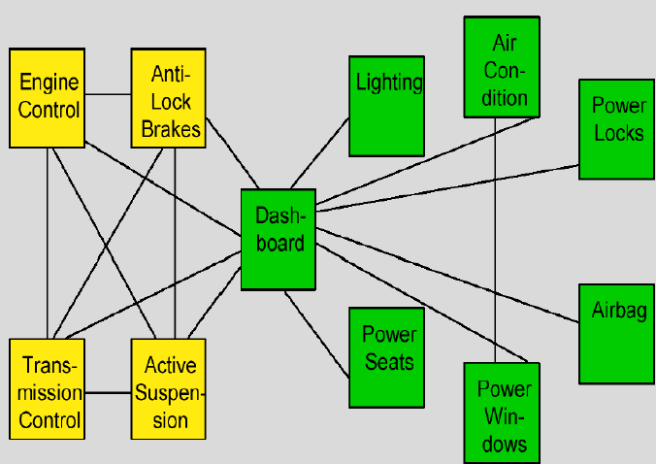

**Fig. 1.1 Connection of control systems before CAN**

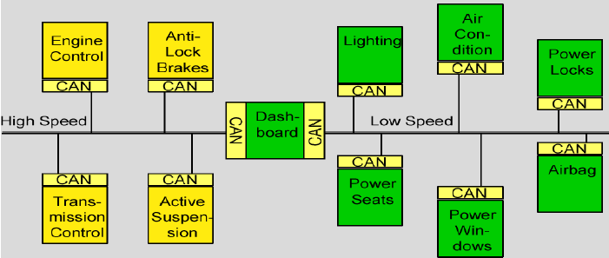

**Fig. 1.2 Connection of control systems with CAN**

The solution to this problem was the connection of the control systems via a serial bus system. This bus had to fulfill some special requirements due to its usage in a vehicle. With the use of CAN, point-to-point wiring is replaced by one serial bus connecting all control systems. This is accomplished by adding some CAN-specific hardware to each control unit that provides the "rules" or the protocol for transmitting and receiving information via the bus is a broadcast type of bus.This means that all nodes can "hear" all transmissions. There is no way to send a message to just a specific node; all nodes will invariably pick up all traffic. The CAN hardware, however, provides local filtering so that each node may react only on the “interesting” messages.

**1.4 NEED FOR SERIAL COMMUNICATION IN VEHICLES**

Many vehicles already have a large number of electronic control systems. The growth of automotive electronics is the result partly of the customer's wish for better safety and greater comfort and partly of the government's requirements for improved emission control and reduced fuel consumption. Control devices that meet these requirements have been in use for some time in the area of engine timing, gearbox and carburetor throttle control and in anti-block systems (ABS) and acceleration skid control (ASC).

The complexity of the functions implemented in these systems necessitates an exchange of data between them. With conventional systems, data is exchanged by means of dedicated signal lines, but this is becoming increasingly difficult and expensive as control functions become ever more complex. In the case of complex control systems in particular, the number of connections cannot be increased much further.

Moreover, a number of systems are being developed, which implement functions covering more than one control device. For instance, ASC requires the interplay of engine timing and carburetor control in order to reduce torque when drive wheel slippage occurs. Another example of functions spanning more than one control unit is electronic gearbox control, where ease of gear- changing can be improved by a brief adjustment to ignition timing.

If we also consider future developments aimed at overall vehicle optimization, it becomes necessary to overcome the limitations of conventional control device linkage. This can only be done by networking the system components using a serial data bus system. It was for this reason that Bosch developed the "Controller Area Network" (CAN), which has since been standardized internationally (ISO 11898) and has been "implemented in silicon" by several semiconductor manufacturers.

Using CAN, peer stations (controllers, sensors and actuators) are connected via a serial bus. The bus itself is a symmetric or asymmetric two wire circuit, which can be either screened or unscreened. The electrical parameters of the physical transmission are also specified in ISO 11898. Suitable bus driver chips are available from a number of manufacturers. The CAN protocol, which corresponds to the data link layer in the ISO/OSI reference model, meets the real-time requirements of automotive applications. Unlike cable trees,the network protocol detects and corrects transmission errors caused by electromagnetic interference. Additional advantages of such a network are the easy configurability of the overall system and the possibility of central diagnosis. The purpose of using CAN in vehicles is to enable any station to communicate with any other without putting too great a load on the controller computer.

**CHAPTER 2**

**CONFIGURATION OF CAN**

**2.1 Basic Concept of CAN**

CAN is a broadcast type of bus. This means that all nodes can "hear" all transmissions. There is no way to send a message to just a specific node; all nodes will invariably pick up all traffic. The CAN hardware, however, provides local filtering so that each node may react only on the “interesting” messages.

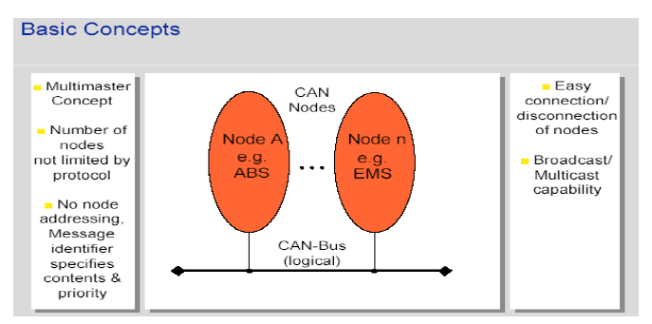

**Fig. 2.1 CAN basic concept**

**2.2The CAN Standard**

CAN is an International Standardization Organization (ISO) defined serial communications busoriginally developed for the automotive industry to replace the complex wiring harness with atwo-wire bus. The specification calls for signaling rates up to 1 Mbps, high immunity to electricalinterference, and an ability to self-diagnose and repair data errors. These features have led to CAN’s popularity in a variety of industries including automotive, marine, medical, manufacturing,and aerospace.The CAN communications protocol, ISO 11898, describes how information is passed between

devices on a network, and conforms to the Open Systems Interconnection (OSI) model that isdefined in terms of layers. Actual communication between devices connected by the physicalmedium is defined by the physical layer of the model. The ISO 11898 architecture defines thelowest two layers of the seven layer OSI/ISO model as the data-link layer and physical layer in Figure 2.2.

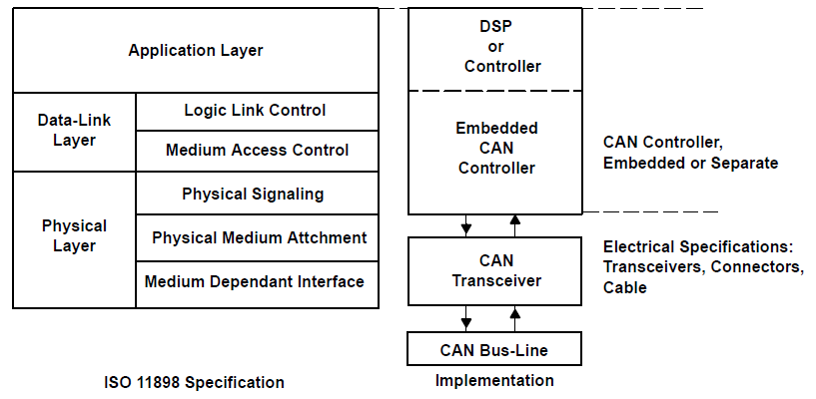

**Fig. 2.2. The Layered ISO 11898 Standard Architecture**

In Figure 2.2, the application layer establishes the communication link to an upper-levelapplication specific protocol such as the vendor independent CANopen protocol. This protocol issupported by the international users and manufacturers group, CAN in Automation (CIA).Additional CAN information is located at the CIA website, can-cia.de. There are many similaremerging protocols dedicated to particular applications like industrial automation or aviation.Examples of industry-standard CAN-based protocols are KVASER’s CAN Kingdom,Allen-Bradley’s DeviceNetand Honeywell’s Smart Distributed System (SDS).

**2.3 Standard CAN or Extended CAN**

The CAN communication protocol is a carrier-sense multiple-access protocol with collisiondetection and arbitration on message priority (CSMA/CD+AMP). CSMA means that each nodeon a bus must wait for a prescribed period of inactivity before attempting to send a message.

Originally, the CAN standard defined the length of the Identifier in the Arbitration Field to eleven (11) bits. Later on, customer demand forced an extension of the standard. The new format is often called **Extended CAN** and allows no less than twenty-nine (29) bits in the Identifier. To differentiate between the two frame types, a reserved bit in the Control Field was used.

The standards are formally called –

* 2.0A, with 11-bit Identifiers only.
* 2.0B, extended version with the full 29-bit Identifiers (or the 11-bit, you can mix them.) A 2.0B node can be
  + "2.0B active"*,* i.e. it can transmit and receive extended frames, or
  + "2.0B passive"*,* i.e. it will silently discard received extended frames.
* 1.x refers to the original specification and its revisions.

New CAN controllers today are usually of the 2.0B type. A 1.x or 2.0A type controller will get very upset if it receives a message with 29 arbitration bits. A 2.0B passive type controller will tolerate, acknowledge and then - discard them; a 2.0B active type controller can both transmit and receive them.

Controllers implementing 2.0B and 2.0A (and 1.x) are compatible - and may be used on the same bus - as long as the controllers implementing 2.0B refrain from sending extended frames.CD+AMP means that collisions are resolved through a bit-wise arbitration, based upon apreprogrammed priority of each message in the identifier field of a message. The higher priorityidentifier always wins bus access.

**2.4 The Bit Fields of Standard CAN and Extended CAN**

**2.4.1 Standard CAN**

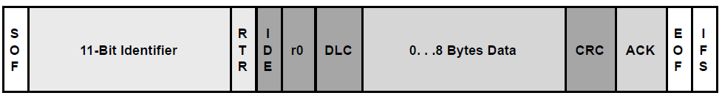

**Fig.2.3 Standard CAN: 11-Bit Identifier**

The meaning of the bit fields of Figure 2.3 are:

* **SOF:** The single dominant start of frame (SOF) bit marks the start of a message, and isused to synchronize the nodes on a bus after being idle.
* **Identifier:**The Standard CAN 11-bit identifier establishes the priority of the message. Thelower the binary value, the higher its priority.
* **RTR:** The single remote transmission request (RTR) bit is dominant when information isrequired from another node. All nodes receive the request, but the identifier determines thespecified node. The responding data is also received by all nodes and used by any nodeinterested. In this way all data being used in a system is uniform.
* **IDE:** A dominant single identifier extension (IDE) bit means that a standard CAN identifierwith no extension is being transmitted.
* **r0:**Reserved bit (for possible use by future standard amendment).
* **DLC:**The 4-bit data length code (DLC) contains the number of bytes of data beingtransmitted.
* **Data:**Up to 64 bits of application data may be transmitted.
* **CRC:**The 16-bit (15 bits plus delimiter) cyclic redundancy check (CRC) contains thechecksum (number of bits transmitted) of the preceding application data for error detection.
* **ACK:**Every node receiving an accurate message overwrites this recessive bit in the originalmessage with a dominate bit, indicating an error-free message has been sent. Should areceiving node detect an error and leave this bit recessive, it discards the message and thesending node repeats the message after arbitration. In this way each node acknowledges(ACK) the integrity of its data. ACK is 2 bits, one is the acknowledgement bit and the secondis a delimiter.
* **EOF:**This end-of-frame (EOF) 7-bit field marks the end of a CAN frame (message) anddisables bit–stuffing, indicating a stuffing error when dominant. When 5 bits of the same logiclevel occur in succession during normal operation, a bit of the opposite logic level is stuffedinto the data.
* **IFS:**This 7-bit inter-frame space (IFS) contains the amount of time required by thecontroller to move a correctly received frame to its proper position in a message buffer area.

**2.4.2 Extended CAN**

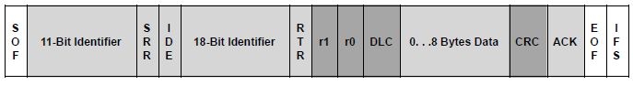

**Fig. 2.4. Extended CAN: 29-Bit Identifier**

As shown in Fig 2.4, the Extended CAN message is the same as the Standard message withthe addition of:

* **SRR:**The substitute remote request (SRR) bit replaces the RTR bit in the standardmessage location as a placeholder in the extended format.
* **IDE:**A recessive bit in the identifier extension (IDE) indicates that there are more identifierbits to follow. The 18-bit extension follows IDE.
* **r1:**Following the RTR and r0 bits, an additional reserve bit has been included ahead of theDLC bit.

**CHAPTER 3**

**A CAN MESSAGE**

**3.1 Arbitration**

A fundamental CAN characteristic shown in Figure 3.1 is the opposite logic state between the bus,and the driver input and receiver output. Normally a logic high is associated with a one, and alogic low is associated with a zero—but not so on a CAN bus. This is why it is desirable to havethe driver input and receiver output pins of a CAN transceiver passively pulled high internally, asin the SN65HVD230. In the absence of any input, the device automatically defaults to arecessive bus state on all input and output pins.

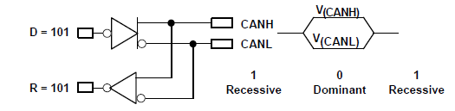

**Fig. 3.1The Inverted Logic of a CAN Bus**

Bus access is event-driven and takes place randomly. If two nodes try to occupy the bussimultaneously, access is implemented with a non-destructive, bit-wise arbitration.Non-destructive means that the node winning arbitration just continues on with the message,without the message being destroyed or corrupted by another node.The allocation of priority to messages in the identifier is a feature of CAN that makes itparticularly attractive for use within a real-time control environment. The lower the binarymessage identifier number, the higher its priority. An identifier consisting entirely of zeros is thehighest priority message on a network since it holds the bus dominant the longest. Therefore, iftwo nodes begin to transmit simultaneously, the node that sends a zero (dominant) while theother nodes send a one (recessive) gets control of the CAN bus and goes on to complete itsmessage. A dominant bit always overwrites a recessive bit on a CAN bus.Note that a node constantly monitors its own transmission. This is the reason for the transceiverconfiguration of Figure 3.1 in which the CANH and CANL output pins of the driver are internallytied to the receiver’s input. The propagation delay of a signal in the internal loop from the driverinput to the receiver output is typically used as a qualitative measure of a CAN transceiver. Thispropagation delay is referred to as the loop time but takes on variednomenclature from vendor to vendor.

**3.1.1 The Bus Arbitration**

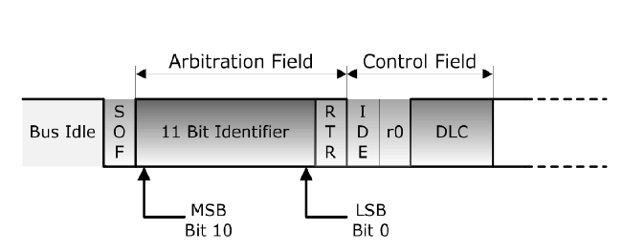

**Fig. 3.2. Bus arbitration**

First of all the arbitration goes bitwise each node that once they have passed access it will send out the start of frame broad and then it won’t send out the most significant(MSB) bit.In this case, pretended up to a bit 0 and within these 11 bits of the message identifier which is the part of the arbitration field. At this point, when the 11 bits have been sending out, it is clear who will win the bus access, how the bus level works and the empty may can standard. We have a dominant bus level of 0 and it called recursive past level of 1.

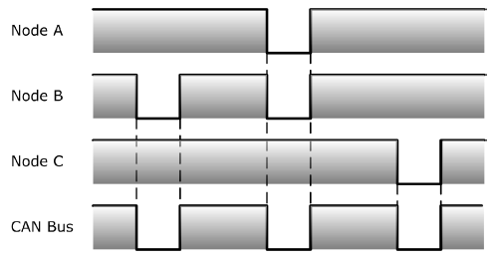**3.1.2Node Output**

**Fig.3.3 Node Output**

There are three nodes network. In this case, here for example we have sending out a 1 bit. Now, bit sends out a 0 and all 1 bit on the bus. There will be a 0 bit and in any other cases it still the same. Again, if any of the node sends out 0 bit into the bus, a dominant bit there will be 0 on the bus.

**3.1.3Resulting Bus Level**

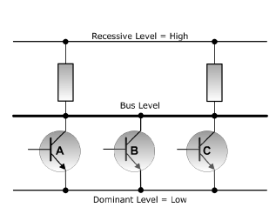

**Fig.3.4 Resulting Bus Level**

There are three switches or transistors and they represent three nodes that are sending out a bus level so first of all if either one of these switches sends a 0 into the bus, the entire bus will be 0 regardless of what the other nodes do if two nodes send out of one level a recursive level and one node only send out a dominant level. There will be a dominant level low on the bus level.

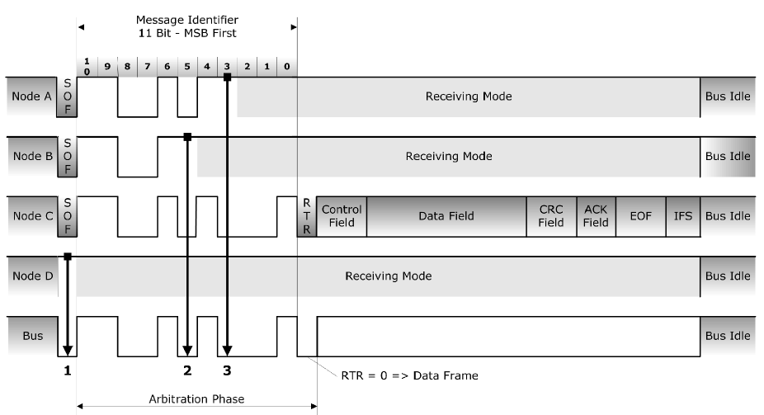

**Fig.3.5 arbitration process**

Figure 3.5 displays the arbitration process. Since the nodes continuously monitor their owntransmissions, when the node B recessive bit is overwritten by node C’s higher priority dominantbit, B detects that the bus state does not match the bit that it transmitted. Therefore, node Bhalts transmission while node C continues on with its message. Another attempt to transmit themessage is made by node B once the bus is released by node C. This functionality is part of theISO 11898 physical signaling layer, which means that it is contained entirely within CANcontroller and is completely transparent to a CAN user.

**3.1.4Bit Monitoring**

The next feature that kick in during bus arbitration is called bit monitoring. It means each node that send out a level into it.

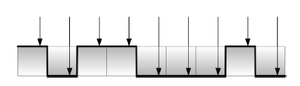

**Fig.3.6Bit monitoring**

The next feature that kick in during bus arbitration is called bit monitoring. It means each node that send out a level into it. The bus will also compared to the bus of the actual bus level that means if a node sends out a 1 on the bus it expect the 1 onto it.If it sends out it expect the same result however if that is not true.

**3.2 Message Types**

There are four different message types, or frames (Fig 3.7 and 3.8) that can be transmitted on aCAN bus: the data frame, the remote frame, the error frame, and the overload frame. Amessage is considered to be error free when the last bit of the ending EOF field of a message isreceived in the error–free recessive state. A dominant bit in the EOF field causes the transmitterto repeat a transmission.

**3.2.1 The Data Frame**

The data frame is the most common message type, and is made up by the arbitration field, thedata field, the CRC field, and the acknowledgement field.



**Fig. 3.7 Data Frame in CAN**

The data frame is the most common message type, and is made up by the arbitration field, thedata field, the CRC field, and the acknowledgement field. The arbitration field determines thepriority of a message when two or more nodes are contending for the bus. The arbitration fieldcontains an 11-bit identifier for CAN 2.0A and the RTR bit, which is dominant for dataframes. For CAN 2.0B in Figure 3.7 it contains the 29-bit identifier and the RTR bit. Next is thedata field which contains zero to eight bytes of data, and the CRC field which contains the 16-bitchecksum used for error detection. Lastly, there is the acknowledgement field. Any CANcontroller that is able to correctly receive a message sends a dominant ACK bit that overwritesthe transmitted recessive bit at the end of correct message transmission. The transmitter checksfor the presence of the dominant ACK bit and retransmits the message if no acknowledge isdetected.

**3.2.2 The Remote Frame**

The intended purpose of the remote frame is to solicit the transmission of data from anothernode.



**Fig. 3.8. Remote Frame**

The intended purpose of the remote frame is to solicit the transmission of data from anothernode. The remote frame is similar to the data frame, with two important differences. First, thistype of message is explicitly marked as a remote frame by a recessive RTR bit in the arbitrationfield, and secondly, there is no data.

**3.2.3 The Error Frame**

The error frame is a special message that violates the formatting rules of a CAN message. It is transmitted when a node detects an error in a message, and causes all other nodes in the network to send an error frame as well.

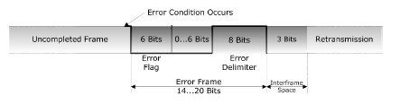

**Fig. 3.9. Error Frame**

The error frame is a special message that violates the formatting rules of a CAN message. It istransmitted when a node detects an error in a message, and causes all other nodes in thenetwork to send an error frame as well. The original transmitter then automatically retransmitsthe message. There is an elaborate system of error counters in the CAN controller whichensures that a node cannot tie up a bus by repeatedly transmitting error frames.

**3.2.4 The Overload Frame**

The overload frame is mentioned here for completeness. It is similar to the error frame withregard to the format, and it is transmitted by a node that becomes too busy. It is primarily used toprovide for an extra delay between messages.

**3.3 Data Transfer Synchronization**

**3.3.1Bit Coding**

Below figure shows a Bit coding according to Non-Return-to-Zero principle. Here NRZ provides highest transport capacity. It has a Constant Bit level over Bit time.

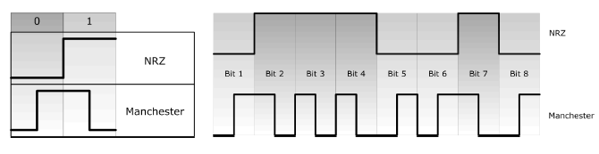

**Fig. 3.10 Bit coding**

It hasainsufficient signal edges for synchronization of Bit stream which required “Bit Stuffing”.

**3.3.2 Bit Stuffing**

In CAN frames, a bit of opposite polarity is inserted after five consecutive bits of the same polarity. This practice is called [bitstuffing](http://en.wikipedia.org/wiki/Bit_stuffing), and is due to the "[Non Return to Zero](http://en.wikipedia.org/wiki/Non-return-to-zero)" (NRZ) coding adopted.

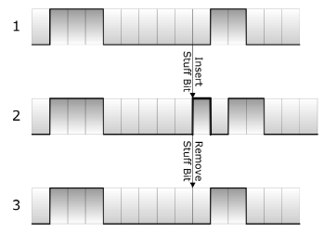

**Fig. 3.11. Bit Stuffing**

In CAN frames, a bit of opposite polarity is inserted after five consecutive bits of the same polarity. This practice is called [bitstuffing](http://en.wikipedia.org/wiki/Bit_stuffing), and is due to the "[Non Return to Zero](http://en.wikipedia.org/wiki/Non-return-to-zero)" (NRZ) coding adopted. The "stuffed" data frames are destuffed by the receiver. Since bit stuffing is used, six consecutive bits of the same type (111111 or 000000) are considered an error. Bit stuffing implies that sent data frames could be larger than one would expect by simply enumerating the bits.

**3.3.3 Partitioning of CAN Bit Time into Four Segments**

A CAN bit time can be partitioning into four segmentsas shown in the below diagram. It contains of normal bit time and bit sample point.

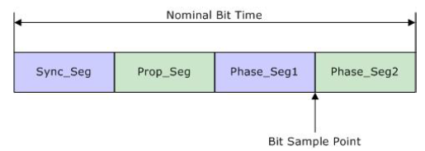

**Fig. 3.12. Partitioning in CAN**

Here is the details of these four segments as given below.

* **Sync_Seg:** Signal edge is expected here. Any deviationwill affect Phase Buffer lengths.
* **Prop_Seg:** Compensates for signal propagation timeswithin the network.
* **Phase_Seg1/2:** Compensate for signal edge phaseerrors by adjusting their length.
* **Resynchronization Jump Width:** Defines the upperlimit to adjust phase buffer lengths.

**3.4 Error Checking and Fault Confinement**

The robustness of CAN may be attributed in part to its abundant error checking procedures. TheCAN protocol incorporates five methods of error checking: three at the message level and two atthe bit level. If a message fails with any one of these error detection methods, it is not acceptedand an error frame is generated from the receiving nodes, causing the transmitting node toresend the message until it is received correctly. However, if a faulty node hangs up a bus bycontinuously repeating an error, its transmit capability is removed by its controller after an errorlimit is reached.At the message level are the CRC and the ACK slots displayed in Fig 3.8and 3.9. The 16-bitCRC contains the checksum of the preceding application data for error detection with a 15-bitchecksum and 1-bit delimiter. The ACK field is two bits long and consists of the acknowledge bitand an acknowledge delimiter bit. Finally, at the message level there is a form check. This checklooks for fields in the message which must always be recessive bits. If a dominant bit isdetected, an error is generated. The bits checked are the SOF, EOF, ACK delimiter, and theCRC delimiter bits.At the bit level each bit transmitted is monitored by the transmitter of the message. If a data bit(not arbitration bit) is written onto the bus and its opposite is read, an error is generated. Theonly exceptions to this are with the message identifier field which is used for arbitration, and theacknowledge slot which requires a recessive bit to be overwritten by a dominant bit. The finalmethod of error detection is with the bit stuffing rule where after five consecutive bits of the samelogic level, if the next bit is not a compliment, an error is generated. Stuffing ensures risingedges available for on-going synchronization of the network, and that a stream of recessive bitsare not mistaken for an error frame, or the seven-bit interframe space that signifies the end of amessage. Stuffed bits are removed by a receiving node’s controller before the data is forwardedto the application.With this logic, an active error frame consists of six dominant bits—violating the bit stuffing rule.This is interpreted as an error by all of the CAN nodes which then generate their own errorframe. This means that an error frame can be from the original six bits to twelve bits long with allthe replies. This error frame is then followed by a delimiter field of eight recessive bits and a busidle period before the corrupted message is retransmitted. It is important to note that theretransmitted message still has to contend for arbitration on the bus.

**CHAPTER 4**

**MAIN CHARACTERISTICS**

Everything that has to do with CAN is based on maximum reliability with the maximum possible performance in mind. After all, CAN was originally designed for automobiles, definitely a very demanding environment for microprocessors, not only in regards to required electrical robustness, but also due to high speed requirements for a serial communication system.

Many companies in the field of medical engineering chose CAN because they have to meet particularly strict safety requirements. Similar problems have been faced by manufacturers of other equipment with very high safety or reliability requirements, including robots, lifts and transportation systems.

The CAN properties can be summarized as:

* Multi-Master priority based bus access
* Non-destructive contention-based arbitration
* Multicast message transfer by message acceptance filtering
* Remote data request
* Configuration flexibility
* System-wide data consistency
* Error detection and error signaling
* Automatic retransmission of messages that lost arbitration
* Automatic retransmission of messages that were destroyed by errors
* Distinction between temporary errors and permanent failures of nodes
* Autonomous deactivation of defective nodes

**4.1 FEATURES OF CAN**

The CAN protocol has the following features.

* **Multimaster:** When the bus is free, all of the units connected to it can start sending a message (multimasters). The unit that first started sending a message to the bus is granted the right to send (CSMA/CR method*1). If multiple units start sending a message at the same time, the unit that is sending a message whose ID has the highest priority is granted the right to send.
* **Message transmission:** In the CAN protocol, all messages are transmitted in predetermined format. When the bus is unoccupied, all units connected to the bus can start sending a new message. If two or more units start sending a message at the same time, their priority is resolved by an identifier (hereafter the ID). The ID does not indicate the destination to which a message is sent, but rather indicates the priority of messages in which order the bus is accessed. If two or more units start a message at the same time, contention for the bus is arbitrated according to the ID of each message by comparing the IDs bitwise. The unit that won the arbitration (i.e., the one that has the highest priority) can continue to send, while the units that lost in arbitration immediately stop sending and go to a receive operation.
* **System flexibility:** The units connected to the bus have no identifying information like an address. Therefore, when a unit is added to or removed from the bus, there is no need to change the software, hardware, or application layer of any other unit connected to the bus.
* **Communication speed:** Any communication speed can be set that suits the size of a network. Within one network, all units must have the same communication speed. If any unit with a different communication speed is connected to the network, it will generate an error, hindering communication in the network. This does not apply to units in other networks, however.
* **Remote data request:**Data transmission from other units can be requested by sending a “remote frame” to those units.
* **Error detection:**All units can detect an error (error detection function). The unit that has detected an error immediately notifies all other units of the error simultaneously (error notification function). If a unit detects an error while sending a message, it forcibly terminates message transmission and notifies all other units of the error. It then repeats retransmission until the message is transmitted normally (error recovery function).
* **Error confinement:**There are two types of errors occurring in the CAN: a temporary error where data on the bus temporarily becomes erratic due to noise from the outside or for other reasons, and a continual error where data on the bus becomes continually erratic due to a unit’s internal failure, driver failure, or disconnections. The CAN has a function to discriminate between these types of errors. This function helps to lower the communication priority of an error-prone unit in order to prevent it from hindering communication of other normal units, and if a continual data error on the bus is occurring, separate the unit that is the cause of the error from the bus.
* **Connection:**The CAN bus permits multiple units to be connected at the same time. There are no logical limits to the number of connectable units. However, the number of units that can actually be connected to a bus is limited by the delay time and electrical load in the bus. A greater number of units can be connected by reducing the communication speed. Conversely, if the communication speed is increased, the number of connectable units decreases.

**4.2 HARDWARE FEATURES**

* + 1. **Bus Medium**

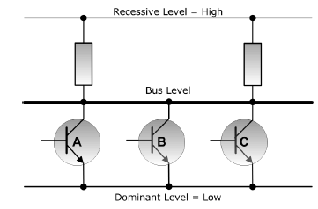 Physical media must support “dominant” and “recessive” bus level.Dominant level always overrules recessive level, especially during busarbitration.

**Fig. 4.1 Bus medium**

Two-wire bus terminated with line impedance to avoid signalreflections.

* + 1. **BusTopology**

The bus tropology according to ISO11898 in fig. 4.2 and it has a number of nodes, two terminationresistors, two lines CAN High and CAN Low.Here CAN High doesn’t mean there is a high level and CAN Low doesn’t mean there is a low level on the line.

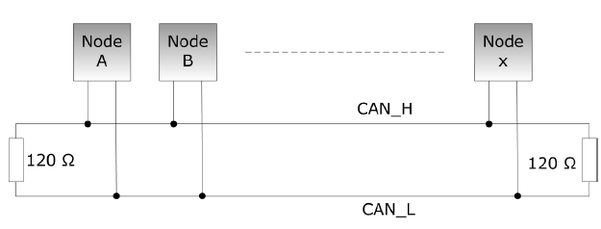

**Fig. 4.2. Bus Topology according to ISO 11898**

* + 1. **Bus Level**

Can bus actually have a differential voltage which also contributes to the reliability of the protocol in between CAN controller and the Bus. There is a transceiver chip where it converts from TTL into the differential voltage.

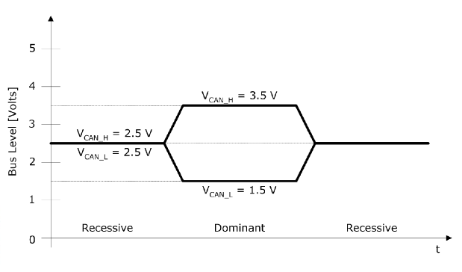**Fig. 4.3. Bus Levels according to ISO 11898**

When the differential voltage between CAN high and low is 0, ideally both lines will be zero as shown in the fig. 4.3. If it’s a dominant bit then the voltage on CAN Low will be 1.5v and the voltage on CAN high will be 3.5 volts.

**4.2.4 Bus Connection**

Node B has a CAN controller or a microprocessor integrated CAN controller and CAN transceiver.

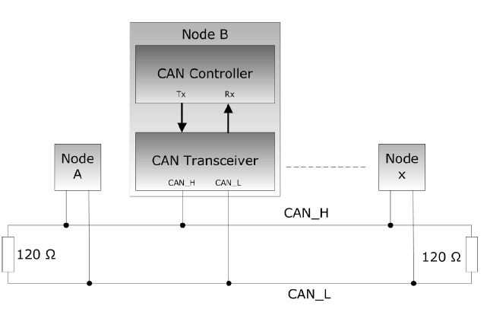

**Fig 4.4. Bus Connection diagram.**

The CAN transceiver is always a separate ships. It has to do with the power requirements. So, there are always two different ships shown in above fig.

**4.2.5CAN Controller Chips**

Two different types of CAN applications:

* Stand-Alone CAN Controller
* Microprocessor with integrated CAN Controller

Many major semiconductor manufacturers, such as Motorola,Philips, Intel, Infineon, and many more, sell CAN chips.Most semiconductor manufacturers who usually integrated a UARTwith their microprocessor design, in order to support serialcommunication for RS 232/485, nowadays tend to integrate CANinstead.

**4.2.6THE CAN BUS**

The data link and physical signaling layers, which are normally transparent to asystem operator, are included in any controller that implements the CAN protocol, such as TexasInstruments’ TMS320LF2407 3.3-V DSP with integrated CAN controller. Connection to thephysical medium is then implemented through a line transceiver such as TI’s SN65HVD2303.3-V CAN transceiver to form what the ISO–11898 standard refers to as an electronic controlunit (ECU) in Fig.4.5.

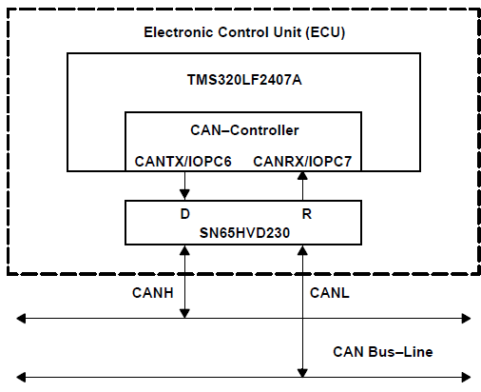

**Fig. 4.5. Details of an Electronic Control Unit**

Signaling is differential which is where CAN derives its robust noise immunity and faulttolerance. Balanced differential signaling reduces noise coupling and allows for high signalingrates over twisted-pair cable. Balanced means that the current flowing in each signal line isequal but opposite in direction, resulting in a field-canceling effect that is a key to low noiseemissions. The use of balanced differential receivers and twisted-pair cabling enhance thecommon-mode rejection and high noise immunity of a CAN bus.

The two signal lines of the bus, CANH and CANL, in the quiescent recessive state, are passivelybiased to ≈2.5 V. The dominant state on the bus takes CANH ≈1 V higher to ≈3.5 V, and takesCANL ≈1 V lower to ≈1.5 V creating a typical 2-V differential signal as displayed in Fig.4.6.

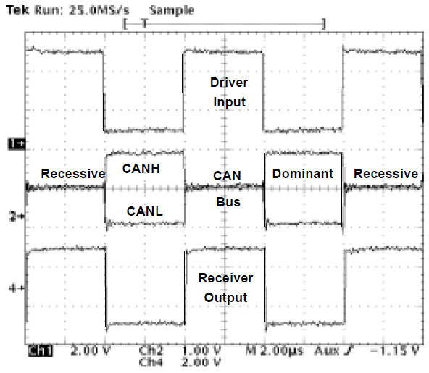

**Fig. 4.6. CAN Dominant and Recessive Bus States of the SN65HVD230**

The CAN standard defines a communication network that links all the nodes connected to a busand enables them to talk with one another. There may or may not be a central control node, andnodes may be added at any time, even while the network is operating (hot-plugging).The nodes could theoretically be sending messages from smart sensing technology and a motorcontroller. An actual application may include a temperature sensor sending out a temperatureupdate that is used to adjust the motor speed of a fan. If a pressure sensor node wants to senda message at the same time, arbitration assures that the message is sent. For instance, Node Ain Fig 4.7 finishes sending its message as nodes B and C acknowledge a correctmessage being received. Nodes B and C then begin arbitration-node C wins the arbitration andsends its message. Nodes A and B acknowledge C’s message, and node B then continues onwith its message. Again note the opposite polarity of the driver input and output on the bus.

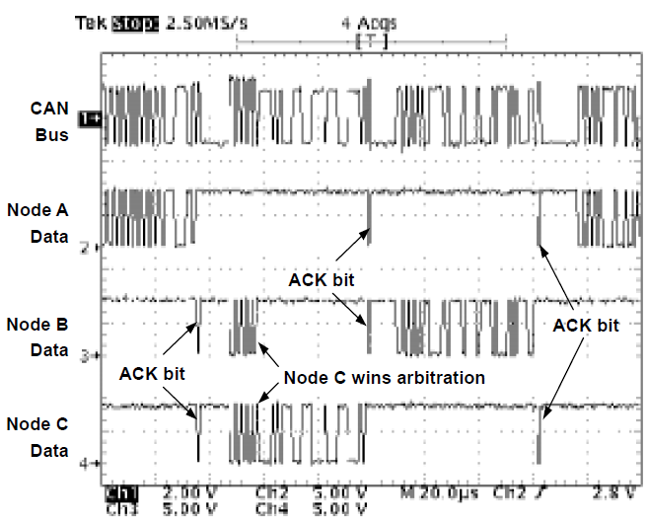

**Fig. 4.7. CAN Bus Traffic**

**4.3 CAN Transceiver Features**

**4.3.1 Supply Voltage**

Most CAN transceivers like the SN65HVD251 require a 5-V power supply to reach the signallevels required by the ISO 11898 standard. By superior attention to high-efficiency circuit design,the Texas Instruments SN65HVD23x CAN transceiver family operates with a 3.3-V powersupply, and is fully interoperable with 5-V CAN transceivers on the same bus. This allowsdesigners to reduce total node power by 50% or more (Fig 4.8).

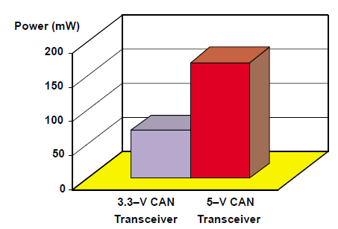

**Fig. 4.8, 3.3-V CAN Transceiver Power Savings**

For applications using 3.3-V technology, such as the Texas Instruments TMS320C240x_ familyof DSPs with integrated CAN controllers, the need for a 5 V power supply can be eliminated. Inaddition to the inherent power savings of using a 3.3-V transceiver, this lowers the overall partcount for the node, thereby reducing system cost and increasing system reliability.For designers with an existing system design requiring a 5-V powered transceiver, theSN65HVD251 is available as an improved alternate for the commonly-used PCA82C250 andPCA82C251. While the ’HVD251 is a drop-in replacement for the ‘82C250 and ‘82C251, it offersthe additional features of higher ESD protection, shorter loop delay, and wider common-moderange.

**4.3.2 High Short-Circuit Protection**

The CAN standard recommends that a transceiver survive bus wire short-circuits to each other, to the power supply, and to ground. This ensures that transceivers are not damaged by buscable polarity reversals, cable crush, and accidental shorts to high power supplies. While the‘HVD23x can survive short-circuits to voltages in the range of –4 V to 16 V, the ‘HVD251provides an extended short-circuit protection to voltages in the –36 V to 36 V range.

**4.3.3 High ESD Protection**

Static charge is an unbalanced electrical charge at rest, typically created by the physical contactof different materials. One surface gains electrons, while the other surface loses electrons. Thisresults in an unbalanced electrical condition known as a static charge. When a static chargemoves from one surface to another, it is referred to as an electrostatic discharge (ESD). It canoccur only when the voltage differential between the two surfaces is sufficiently high to breakdown the dielectric strength of the medium separating the two surfaces.ESD can occur in any one of four ways: a charged body can touch an IC, a charged IC cantouch a grounded surface, a charged machine can touch an IC, or an electrostatic field caninduce a voltage across a dielectric sufficient to break it down. It becomes readily apparent thata high ESD rating not only indicates a robust transceiver, but a robust circuit design as well.While the earliest CAN transceivers on the market have only a 2 kV or 4 kV ESD maximum onthe bus pins, the HVD2xx families of CAN transceivers have ESD ratings as high as 16 kV onthe bus pins when tested in accordance with the human body model (HBM) of JEDECStandard 22, Test Method A114-A. With these ESD ratings, the TI HVD2xx CAN transceiversare much better suited to the harsh electrical environments of automotive and industrialapplications than the earlier transceiver versions of other vendors.

**4.3.4 Wide Common-Mode Range**

Common-mode noise is the difference in potential between grounds of sending and receivingnodes on a bus. This is often the case in the networked equipment typically found in a CANapplication. Possible effects of this problem are intermittent reboots, lockups, bad data transfer,or physical damage to the transceiver.Network interface cards, parallel ports, serial ports, and especially transceivers are prime targetsfor some form of failure if not designed to accommodate high levels of ground noise and powersupplyimbalance between typical CAN nodes.With this in mind the ‘HVD230 family is designed to operate with complete safety over the busvoltage range of –2 V to 7 V required by the standard. However, the ‘HVD251 extends this safeoperating range even farther with operation from –7 V to 12 V.

**4.3.5 Common-Mode Rejection**

Common-mode noise of varied magnitudes exists within the networks associated with CANapplications. Noise from pulsing motor controllers, switch-mode power supplies, or fromfluorescent lighting are the typical sources of noises that couple onto bus lines (displayed inFigure 4.12).

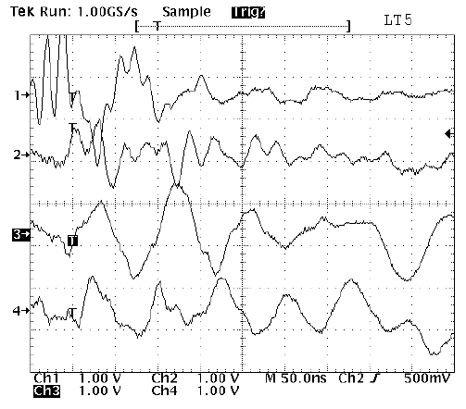

**Fig. 4.9. Common-Mode Noise Coupled onto 4 Twisted-Pair Bus Lines**

A CAN transceiver not specifically designed to reject this coupled noise can respond tocommon-mode noise as if it were data on a bus and send meaningless data to a controller. The‘HVD23x and ‘HVD251 are specifically designed and tested for their ability to reject thiscommon-mode noise.

**4.3.6 High Input Impedance**

High bus input impedance increases the number of nodes that can be added to a bus abovethe standard’s 30 nodes. The high impedance restricts the amount of current that a receiversinks or sources onto a bus over common-mode voltage conditions. This ensures that a drivertransmitting a message into such a condition is not required to sinkor source an excessiveamount of current from the sum of the receiver currents on the bus.

**4.3.7 Controlled Driver Output Transition Times**

Controlling driver output slew-rate dampens the rise-time of a dominant bit to improve signalquality and provides for longer stub lengths and a better bit-error rate.

**4.3.8 Low Current Standby and Sleep Modes**

Many applications are looking to lower-power opportunities as more electronics are added todesigns. The standby mode of the ‘HVD230 is generally referred to as the listen onlymode,since in standby, the ‘HVD230’s driver circuitry is switched off while the receiver continues tomonitor bus activity. In the occurrence of a dominant bit on the bus, the receiver passes thisinformation along to its DSP/CAN controller which in turn activates the circuits that are instandby.The difference between the ‘HVD230 and ‘HVD231 is that both driver and receiver circuits canbe switched off in the ‘HVD231 to create an extremely low-power sleep mode.

**4.3.9 Thermal Shutdown Protection**

Another desirable safety feature for a CAN transceiver is the thermal shutdown circuitry of the‘HVD23x and ‘HVD251. This feature protects a device against the destructive currents andresulting heat that can occur in a short–circuit condition. Once thermal shutdown is activated,the device remains shut down until the circuitry is allowed to cool.

**4.3.10 Glitch Free Power Up and Power Down**

This feature provides for hot–plugging onto a powered bus without disturbing the network. The‘HVD23x’s and ‘HVD251’s driver and receiver pins are passively pulled high internally while thebus pins are biased internally to a high-impedance recessive state. This provides for a power-upinto a known recessive condition without disturbing ongoing bus communication.

**4.3.11 Unpowered Node Does Not Disturb the Bus**

Several CAN transceivers on the market today have very low output impedance when

un–powered. This low impedance causes the device to sink any signal present on the bus and

shuts down all data transmission. The ‘HVD23x and ‘HVD251 have a very high outputimpedance in powered and unpowered conditions, and maintain the integrity of the bus when

Power or ground is removed from the circuit.

**4.4 The Relationship between Bus Length and Signaling Rate**

The basics of arbitration require that the front wave of the first bit of a message travel to themost remote node on a network and back again before the bit is designated by the receiver ofthe sending node as dominant or recessive (typically this sampleis made at about two–third the bit width). With this limitation, the maximum bus length and signaling rate are determined bynetwork parameters.Factors to be considered in network design include the ≈5 ns/m propagation delay of typicaltwisted-pair bus cable, signal amplitude loss due to the loss mechanisms of the cable, and theinput impedance of the bus transceivers. Under strict analysis, variations among the differentoscillators in a system also need to be accounted for with adjustments in signaling rate and buslength. Maximum signaling rates achieved with the SN65HVD230 in high-speed mode withseveral bus lengths are listed in Table 4.1.

**Table 4.1. Maximum Signaling Rates for Various Cable Lengths**

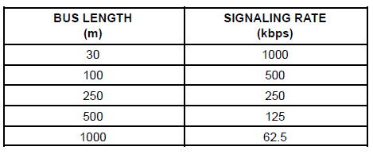

The ISO 11898 standard specifications are given for a maximum bus length of 40 m andmaximum stub length of 0.3 m with a maximum of 30 nodes. However, with careful design,longer cables, longer stub lengths, and many more nodes can be added to a bus—always with atrade-off in signaling rate. A transceiver with high input impedance such as the HVD230 isneeded to increase the number of nodes on a bus.The cable is specified to be a shielded or unshielded twisted-pair with a 120-characteristicimpedance (Z0). The standard defines the interconnection to be a single twisted-pair cable. Theinterconnection is terminated at both ends with a resistor equal to the characteristic impedanceof the line to prevent signal reflections. Nodes are then connected to the bus with un-terminateddrop cables, or stubs, which should be kept as short as possible to minimize signal reflections.Connectors, while not specified by the standard should not affect standard operating parameterssuch as the minimum VOD. Although unshielded cable is used in many applications, datatransmission circuits employing CAN transceivers are used in applications requiring a ruggedinterconnection with a wide common-mode voltage range. Therefore, shielded cable isrecommended in these electronically harsh environments, and when coupled with the standard’s–2 V to 7 V common-mode range of tolerable ground noise, helps to ensure data integrity.

**CHAPTER 5**

**ADVANTAGES, DISADVANTAGES AND APPLICATIONS**

**5.1 ADVANTAGES**

**5.1.1 ADVANTAGES OF CAN IN AUTOMOTIVEAPPLICATIONS**

* Lower cost at vehicle construction
* Increased flexibility and reusability of design
* Reduces time to market
* Facilitates drive by wire which reduces cost further
* Facilitates advanced features in vehicles
* Enhances debug at point of service
  1. **DISADVANTAGES**
* It has high software expenditure
* Undesirable interaction more probable.

**5.3 VEHICLE APPLICATIONS OF CAN**

**5.3.1 CAN-based Solution for Anti-theft**

We use a single board computer (SBC), Soekris Net4801, to act as a core platform. D-Link DWL-G520 wireless card andiTegno GPRS modem are connected to Soekris Net4801. Soekris Net4801 also has serial port interface that connects to networked ECUs inside a vehicle. Finally, Gentoo Linux is adopted as OS (operating system) for the SBC because of its ease of usage, configuration and updatability. C programs is been developed to realize the communication between ECUs to SBC and SBC to GPRS modem.

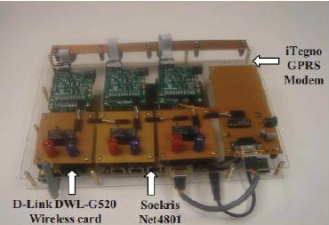

**Fig. 5.1 Prototype of the circuit board**

The purpose of this circuit board is to make security in CAN bus systems by using embedded device security and cryptography. This solution provides vehicle physical security through tamper-resistant software in embedded devices for the protection of vehicle components and their ECUs. This circuit board is used to monitoring and control vehicle itself to against the theft. Once an owner realizes his vehicle is lost, all the needs to do is to send a “Stop engine” SMS from his mobile phone to a secret and specific phone number which is dedicated to the electronics in the vehicle. The circuit board will send the disable CAN message to the CAN bus so that the vehicle cannot be started again after it stops. If someone tampers the security system in a vehicle, the circuit board will send an alert message to inform the owner. The owner mobile phone can also automatically forward the alert message to inform the Control Center. With our solution, the owner has the monitoring and control capability even after his vehicle is lost.

**5.3.2 The Intelligent Control of car doors and windows**

An intelligent control system based on the CAN-bus for car windows and doors has been proposed. The car doors and windows with anti-pinched control functions at normal working mode and quickly take-off and landing windows control functions at emergency (abnormal working mode) can be achieved by this design. Therefore, the control management of the doors and windows in the vehicle has become more intelligent and humane, and the security, flexibility and reliability of car electronics have been enhanced .Each door of a car has a window glass lifting body with deceleration function which drive by DC permanent magnet motor. Motor size is very small, can be installed inside the door. By changing the polarity of the input voltage, to change rotation direction of motor (that is, mobile windows upper and lower). The speed of take- off and landing depends on the input voltage. System uses a small resistance (about 1Ω) as a current sensor and in series with the motor. The voltage drop is proportional to motor operating current. The motor current can be detected by detecting the voltage across the resistance. The motor constantly operates until the sensor voltage arrives at preset threshold value. Once the voltage drop of the sensor reaches threshold, motor will stop rotating. And the detection of window location begins. If the window does not meet the final position means that the window has obstacles, and it will return to initial position automatically. If the window position arrives at the destination, the motor electrical circuits will disconnect. In order to complete this control operation, real time control of the location of windows is required and piezoelectric sensors are respectively installed at the top and bottom rail in window. According to the voltage of the pressure generated to determine whether the window is at the pre-set limit positions. Each node module of the system designed a single-pole, three home keys (Ki, i = 1, 2, 3 ...). The master node element, that is left-front node module, not only control the on / off of local door and the take-off and landing of windows, but also control all nodes’ synchronized action of car doors and windows.

**5.3.3 Wireless extension of CAN-bus based on GPRS**

CAN-bus is applied widely in many industrial systems and vehicles. Nevertheless, in some cases, two or more distant CAN-bus segments are needed to transfer data. If the distance is too long, utilizing twisted wire pairs are impossible. In wireless method, GPRS is so far the reliable style. With the increasing popularity of 3G networks, GPRS which can always be online, reasonable charging and larger bandwidth, is paid close attention to and also can be used for data transfer.

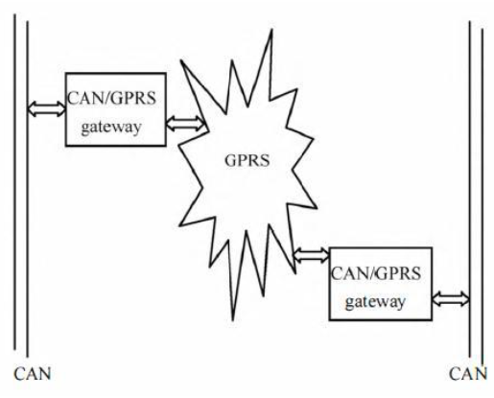

**Fig. 5.2 The structure of wireless extension of CAN-bus based on GPRS**

There are kinds of methods of the extension of CAN. Compared with others, GPRS is a better method for wireless extension of CAN network. With the experiments for debugging are carried out, the normal velocity for communicating is very stable.

**5.3.4 OTHER APPLICATIONS**

CAN is used wherever two or more microprocessor units need to communicate with each other.

* Passenger Cars (multiple separate CAN networks)
* Trucks & Buses, Construction Vehicles, Agricultural Vehicles(SAE J1939 protocol)
* Semiconductor Industry (Wafer Handlers, etc.)
* Robotics, Motion Control Applications
* Passenger/Cargo Trains (Brake Control, Wagon Communication)
* Aircrafts (AC, Seat Adjustment)
* Elevators (e.g. Otis)
* Building Technologies (Light & Door Control Systems, Sensors, etc.)
* Medical Equipment (X-Ray, CAT scanners, etc.)
* Household Utilities (Coffee Machine, Washer, etc.)
* Aerospace (Satellites)

**CONCLUSION**

CAN is ideally suited in applications requiring a high number of short messages in a short periodof time with high reliability in rugged operating environments. Since CAN is message based andnot address based, it is especially suited when data is needed by more than one location andsystem-wide data consistency is mandatory.Fault confinement is also a major benefit of CAN. Faulty nodes are automatically dropped fromthe bus, which prevents any single node from bringing a network down, and assures thatbandwidth is always available for critical message transmission. This error containment alsoallows nodes to be added to a bus while the system is in operation, otherwise known ashot-plugging.

**REFERENCES**

[1]. Dai Qiang Wang, “Intelligent Control System Based on CAN-bus For Car Doors and

Windows”

[2]. Ming-Yi Dai, “A Safety System for Intelligent Portable Hybrid Electric Bicycle”,

2013 International Conference on System Science and Engineering, pp 379-384

[3]. Hu Huangshui, Qin Guihe, “Online Fault Diagnosis for Controller Area Networks”.

[4]. XUE Xu, “The Wireless Extension of CAN-bus Based on GPRS”, 2015 Second

International Conference on Communication Systems, Networks and Applications

pp.281-283

[5]. FengGuo-sheng,“CAN Bus Application in Automotive Network Control”, 2014

International Conference on Measuring Technology and Mechatronics Automation

pp.779-782.

[6]. Controller Area Network, Basics Protocols, Chips and Applications; Dr. Konrad

Etschberger; ISBN 3–00–007376–0.

[7]. CAN Systems Engineering, From Theory to Practical Applications; Wolfhard

Lawrenz, ISBN 0–387–94939–9.

[8]. http://www.can-cia.org

[9]. [www.ixxat.com](http://www.ixxat.com)