**CHAPTER ONE: INTRODUCTION**

* 1. **Background**

Courier Service is an important business which is required for people to make goods travel from one place to another. Courier services usually boast faster delivery times than any alternative method of transporting documents, and many services in the modern world rely on it. The idea of couriers and a courier service has been around almost as long as civilization, with rulers in antiquity using couriers as a means to make new laws and edicts known throughout their lands.

The largest courier service in the world is the United Parcel Service (UPS), which delivers more than 12 million packages globally each day. UPS had its roots as a courier service in the beginning of the 20th century, when it was known as the American Messenger Company. UPS survived the depression and the World Wars, and went on to thrive in the global age. Federal Express (FedEx) and Dalsey Hillblom Lynn, now Deutsche post AG (DHL) are other well-known global examples of the courier service, both with their roots in the early 1970s [1].

There is also a type of courier service which utilizes the extra baggage allotment of airline passengers to transport documents quickly and easily, with less hassle, through the Customs office of a country. These courier services offer greatly discounted fares on commercial tickets to foreign locations in exchange for the use of the passenger's baggage space.

* 1. **Statements of Problem**

Keeping record of parcels in a courier service company and their delivery information is carried out manually in most cases even today. A lot of files are opened for daily record of parcels received or delivered. This litters the office with much paper documents. Most often records are misplaced and when a client comes to collect his parcel, s/he spends some hours waiting for confirmation of the parcel. Hence delay is bound to occur while delivering parcel to customers. Also, customers must visit the post office before they can purchase stamps or any other item.

* 1. **Objectives**

The main objective of our project is :

* To create a platform between sender and traveller.
* Traveller can earn money and goods can be transported in reasonable price and quick time.

**1.4 Scope and Applications**

We are making this web based Online Courier Service application, which have the following scopes and applications in today’s scenario.

* The web based application can be used for finding a proper way to transport goods from one place to another.
* Easy service and management will be available for proper process such as online registration, booking, etc.

**CHAPTER TWO: LITERATURE REVIEW**

**2.1 Courier Service Company**

A courier is a person or company employee to deliver messages, packages and mail. Couriers are distinguished from ordinary mail services by features such as speed, security, tracking, signature, specialization and individualization of services, and committed delivery times, which are optional for most everyday mail services. As a premium service, couriers are usually more expensive than usual mail services, and their use is typically restricted to packages where one or more of these features are considered important enough to warrant the cost. Over time, demand for a new type of representative courier has emerged. With the increase in fuel prices and productivity goals monitored closely by companies, this new type of all-in-one courier has been developed to "take care of business" [2]. Workers in companies have more work and less time to be out of the office. Operating largely using independent contractors that have gone through a screening process and background checks have found a niche in the courier industry.

Large couriers often require an account to be held (and this can include daily schedule collections). Senders are therefore primarily in the commercial/industrial sector (and not the general public); some couriers such as DHL do however allow public sending (at higher cost than regular senders). The Courier industry in the United States is a $59 billion industry, with 86% of the business shared by only four companies, including DHL, FedEx and UPS. The remaining 14% shared among almost 11,900 other small businesses ranging in size from 1 employee to over 600 [3]. These businesses comprise of mostly same day deliveries and are strong offline businesses like Diamond Express and strong online businesses like Naparex.

**2.2 E-Commerce**

E-commerce has a much broader scope and encompasses many more business activities other than just web shopping. Some people and businesses use the term electronic business (or e-business) when they are talking about e-commerce in this broader sense. Businesses also have been engaging in a form of e-commerce, known as electronic data interchange (EDI), for many years. They also realized that they were spending a good deal of time and money entering these data into their computers, printing paper forms, and then re-entering the data on the other side of the transaction. Although the purchase order, invoice, and bill of lading for each transaction contained much of the same information, each paper form had its own unique format for presenting that information.

The following are the characteristics of e-commerce technologies:

1. Ease of automated processing
2. Immediacy of result
3. Openness and accessibility
4. Loss of collateral information
5. Globalization
6. New business models

**CHAPTER THREE: RELATED THEORY**

**3.1 Ruby on Rails**

Ruby is a programming language. It was created 20 years ago by Yukihiro “Matz” Matsumoto. By most measures of programming language popularity, Ruby ranks among the top ten, though usually as tenth (or so) in popularity, and largely due to the popularity of Rails. Like Java or the C language, Ruby is a general-purpose programming language, though it is best known for its use in web programming. Rails is a software library that extends the Ruby programming language. David Heinemeier Hansson is its creator. He gave it the name “Ruby on Rails,” though it is often just called “Rails.”

It is software code that is added to the Ruby programming language. Technically, it is a package library (specifically, a RubyGem), that is installed using the operating system command-line interface Rails is a framework for building websites. As such, Rails establishes conventions for easier collaboration and maintenance. These conventions are codified as the Rails API (the application programming interface, or directives that control the code). The Rails API is documented online and described in books, articles, and blog posts. Learning Rails means learning how to use the Rails conventions and its API.

Rails combines the Ruby programming language with HTML, CSS, and JavaScript to create a web application that runs on a web server. Because it runs on a web server, Rails is considered a server-side, or “back end,” web application development platform (the web browser is the “front end”). Later, this article will describe web applications in greater depth and show why a web development framework is needed to build complex websites.[6]

.

**3.2 PostgreSQL**

PostgreSQL is an object-relational database management system (ORDBMS) based on Postgres v.4.2, developed at the University of California at Berkeley CS Department. PostgreSQL provides SQL92/SQL99 language support and numerous powerful features making it well-suited for diﬀerent scientiﬁc and technological tasks. A lot of object-relational concepts assisting in modern commercials were pioneered in Postgres. By using PostgreSQL, we can experience rapid developing open source freely distributed DBMS, SQL support and object-relational concepts, simple and handy front-end interfaces for diﬀerent software platforms, extensibility of the DB server functions, i.e. developing of custom data, types and data access methods. These features allow PostgreSQL to be used in diﬀerent scientiﬁc project.[7]



**CHAPTER FOUR: METHODOLOGY**

**4.1 Approach**

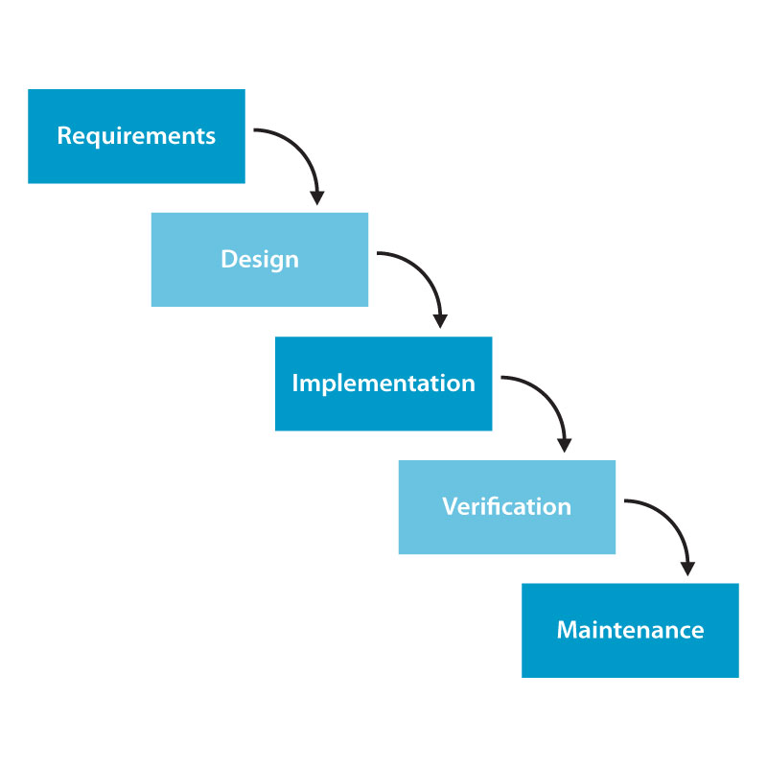The software development approach used in the design of this project is the top-down approach. A top-down approach (also known as stepwise design or waterfall model) which essentially breaks down a system to gain insight into its compositional subsystems. It is a non-iterative practice of model in which progress is seen as flowing steadily downwards (like a waterfall) through the phases of conception. The waterfall model provides a structured approach; the model itself progresses linearly through discrete, easily understandable and explainable phases and thus is easy to understand; it also provides easily identifiable milestones in the development process.

Figure 4.1: Waterfall Model

**4.2 Data Analysis**

**I. General Analysis of the Existing System**

The existing system in a courier service company is manual. Documents for delivery are documented in a file and a payment receipt is issued. These packages are categorized according to their destination, state or country. Arrangement is made for their transportation down to their destination. On arrival, these documents are distributed to the owners and a manual record is prepared for each delivery. Sometimes customers come to the office to claim their parcel and a manual search operation is carried out to locate the parcel for the customer.

And for online service the company individual have to deal with each customer for their service and people have to pay a huge amount of money for their service.

**II. Input Analysis**

Data analysis and restructuring was based on the identification of the basic needs and the structure required for the project. The information gathered were analyzed and restructured in such a way that the subsystems and the modules were achieved efficiently. The analysis and restructuring of these data were such that the system is capable of entering the data to the input form.

**III. Process Analysis**

The information gathered was processed into a more meaningful format for entry into the system. The processing was basically on the parcel records.

**IV. Output Analysis**

The output from the system designed is generated from the system inputs. More of the output generated is on parcel received and delivery information.

**4.3 Limitations of existing system**

Due to the manual means being used by courier Service Company in keeping parcel records information, lots of problems was encountered which includes:

a. Delay in processing parcel files.

b. Loss of vital documents as the filing system is manual.

c. Damage of documents due to fire incident.

d. Illegal removal of files by fraudulent staff leading to insecurity.

Main problem in existing system is company has to take each and every responsibility for transportation. Company has to invest their large money in their own mediator for courier transportation [4].

**4.4 Overview of the envisaged system**

The new system is designed to solve problems affecting the manual system in use and even the online system with more different manner. It is designed to be computerized thereby relieving both the customers and staff from much stress as experienced in the manual system. Not only this, this system would create platform for the people who wants to send their goods and who would help them to make goods travel form one place to another. This system will do the analyzing and storing of information interactively. The proposed system will also have some other feature like:

* Accuracy in the handling of data.
* Fast rate of operation and excellent responses time.
* Better storage and faster retrieval system.
* Creates platform or junction where people who would act as mediator and people who wants to courier their goods.

**4.5 Flow Chart**

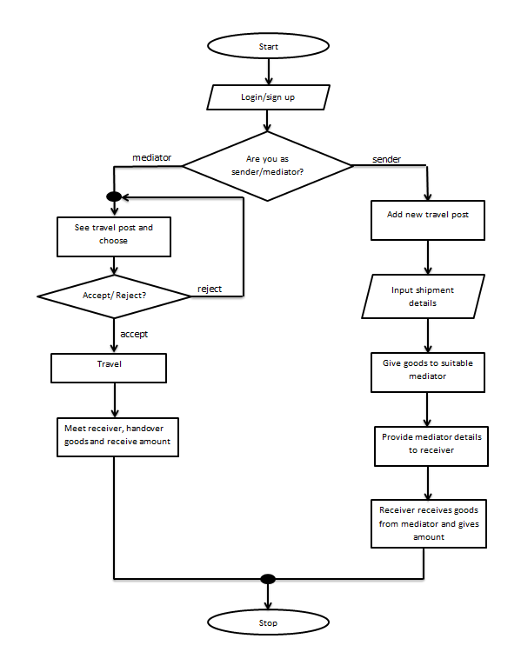

Figure 4.5: Flow chart

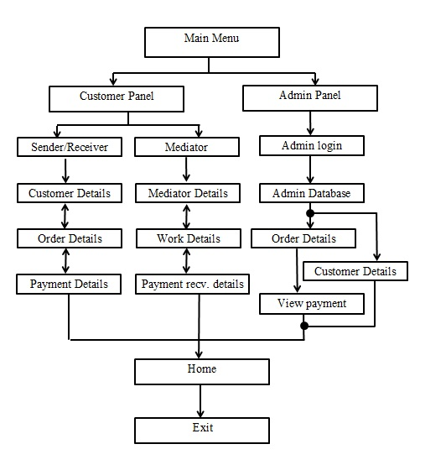**4.6 Block Diagram**

Figure 4.6: Block Diagram of Working Model

**4.7 Entity Relationship Diagram**

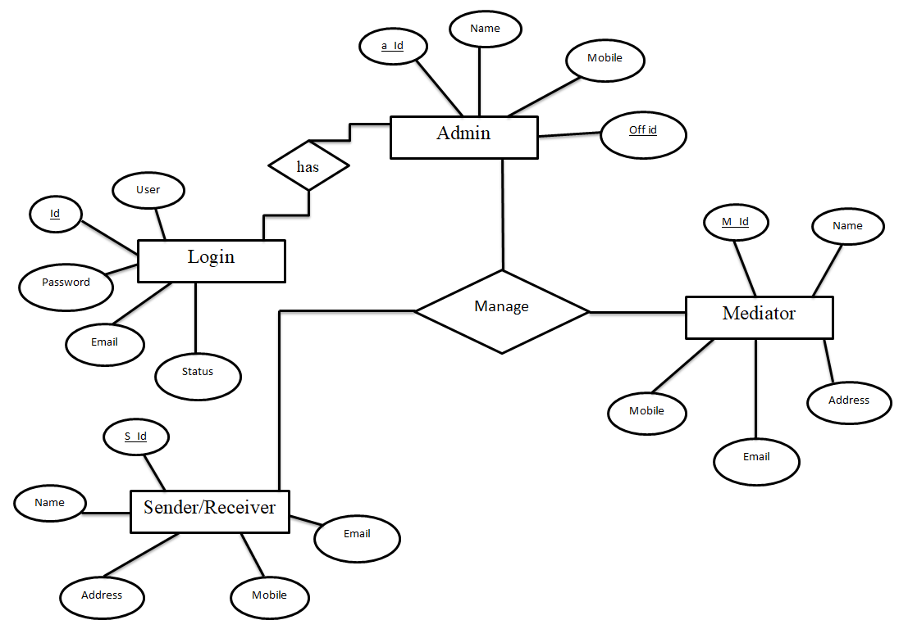

Figure 4.7: Entity Relationship Diagram

**4.8 Data Flow Diagram**

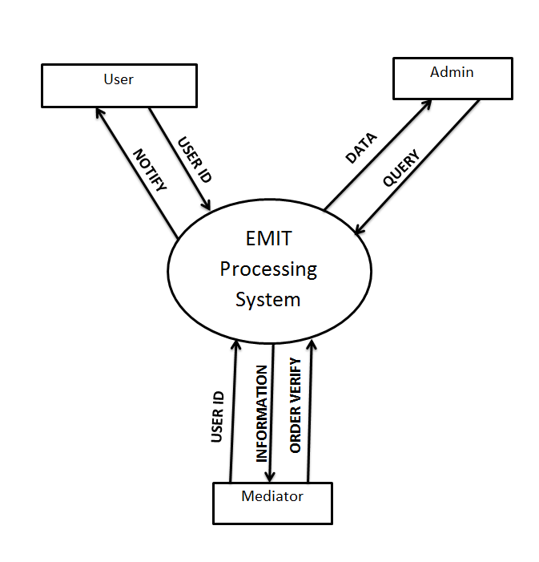

Figure 4.8.1: Zero level data flow diagram

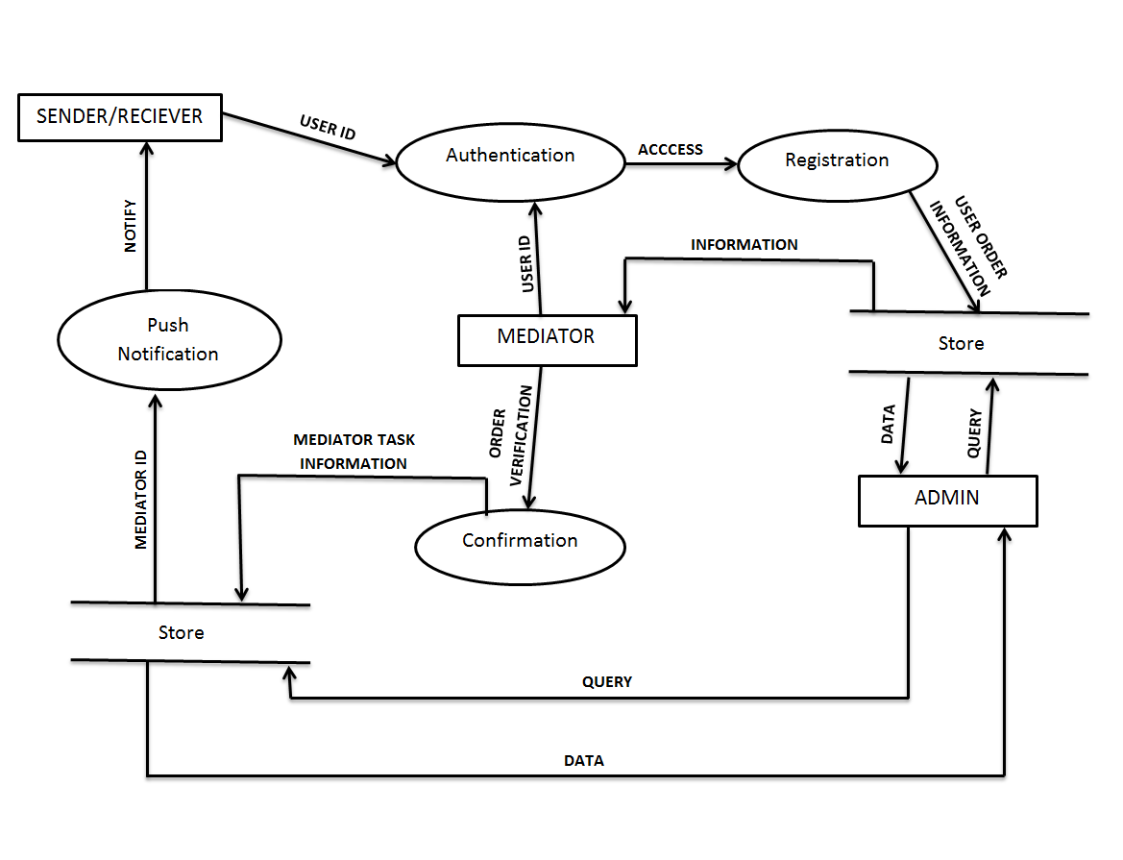Figure 4.8.2: Level 1 Data Flow Diagram

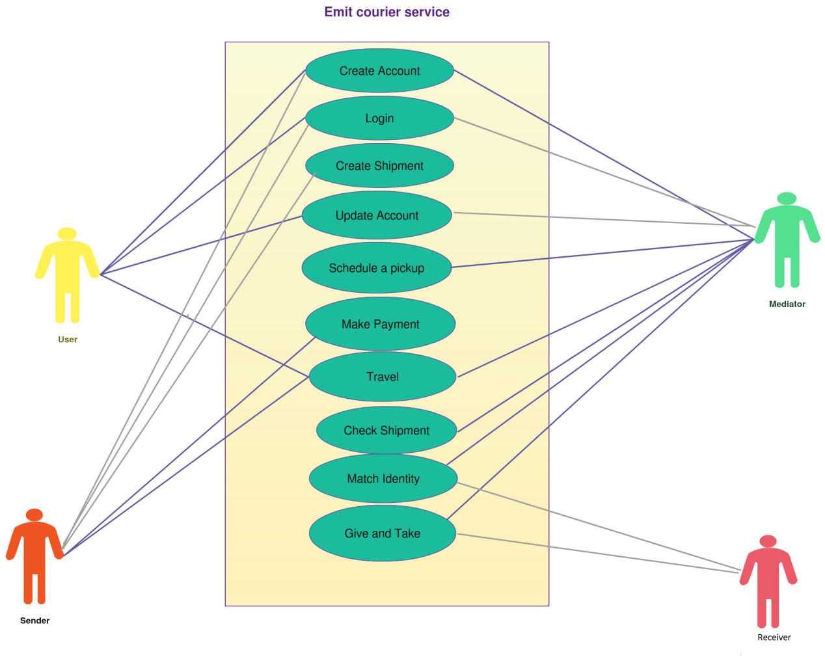**4.9 Use case Diagram**

Figure 4.9: Use Case Diagram

**CHAPTER FIVE**

**5.1 CONCLUSION**

In this minor project, we created a web based application (EMIT-Online Courier Service), which is a web based application that creates communication bridge between sender, mediator and receiver. For the development of the web based application, we have used Ruby on Rails; SQLite database was implemented to store user, sender and traveller information.

* 1. **FUTURE ENHANCEMENT**

We can enhance the system by integrating it for easy courier services. The information of the travellers can be collected and goods can be couriered through them which will be much easier for the sender and the receiver.

**ANNEX**

Some screenshots of the web app:

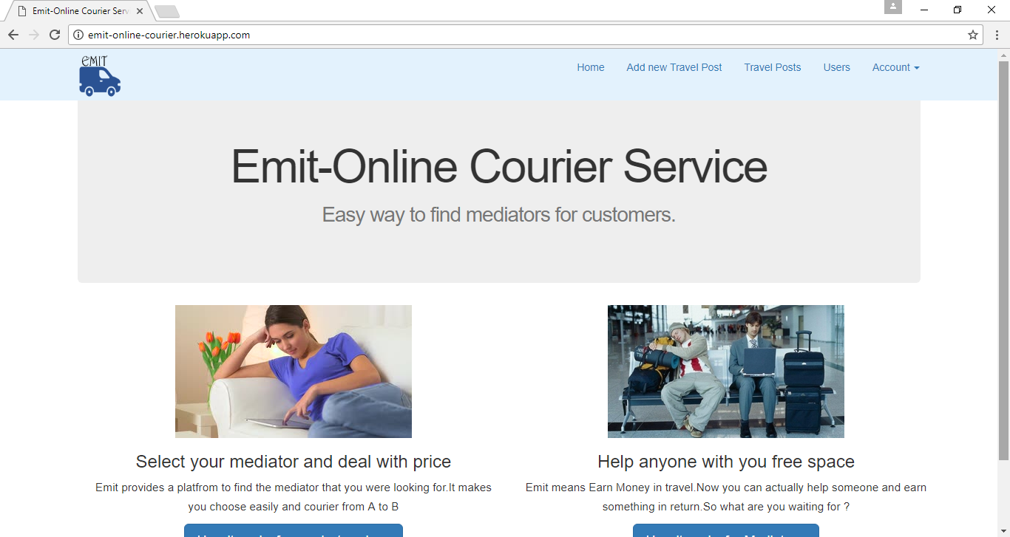

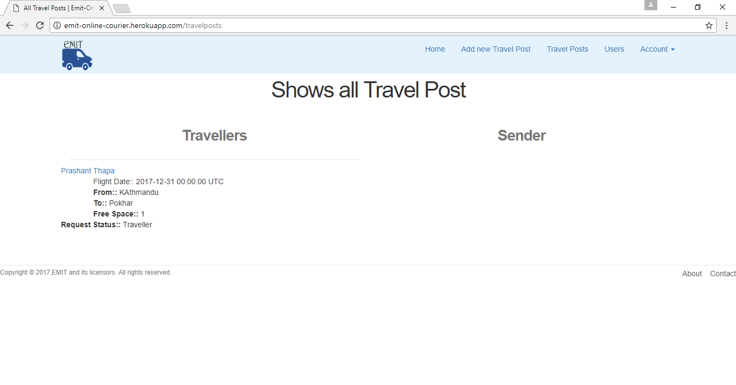

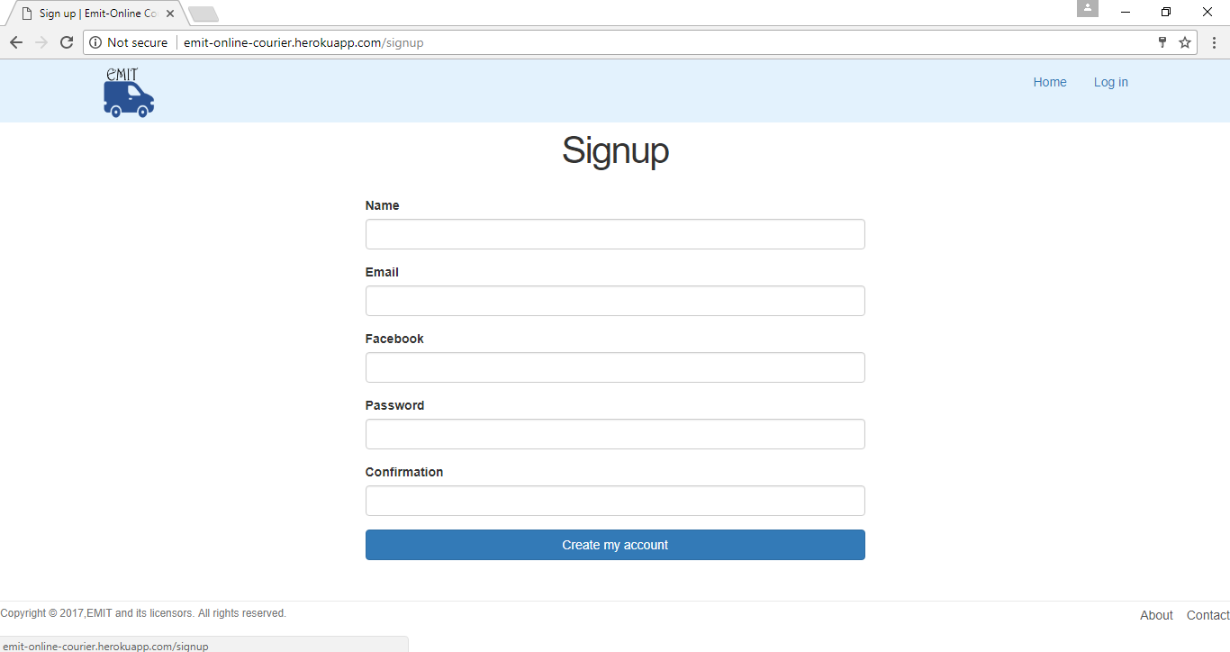**REFERENCES**

[1] Couriers and Messengers - A Historical Perspective - Drivv, powered by Courierboard Blog - Courier Service. Drivv, powered by Courierboard Blog - Courier Service [Online]

[2] Courier, Defination [Online]

Available: https://www.merriam-webster.com/dictionary/courier

[3] Courier service company, Background, 2016 [Online]

Available: <http://www.courierboard.com/blog/2013/03/06/couriers-and-messengers-a-historical-perspective/>

[4] Courier Services as an E-Courier service. Avnish Chauhan , Satyendra Singh , Ankur Jain and Rajeev Kumar [Online]

Available:<http://www.sciencepub.net/report/report0205/14_3021_report0205_86_93.pdf>

[5] Waterfall Model, Block Diagram [Online]

Available: <http://1.bp.blogspot.com/-gxj9EEmaKCc/UXfs6d3D2ZI/AAAAAAAAAzI/dRepueNwWK0/s1600/waterfall-model-sdlc1.jpg>

[6] Ruby on Rails [Online]

Available: <http://railsapps.github.io/what-is-ruby-rails.html>

[7] PostgreSQL [Online]

Available : https://www.researchgate.net/publication/234328902_PostgreSQL_the_Suitable_DBMS_Solution_for_projects