DESIGN ARTIFACTS

ANDROID APPLICATION DEVELOPMENT

BARCODE AND QRCODE SCANNER
WITH PRODUCT VERIFICATION

SUBMITTED BY:

Shrestha Kumar
Punit Lakshwani
Shivam Bhosle
Siddharth Yadav
Chakradhar Reddy

1.USE CASE DIAGRAM

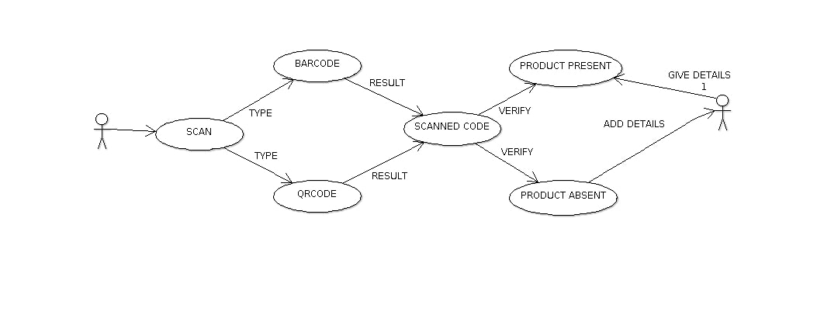

2.CLASS DIAGRAM

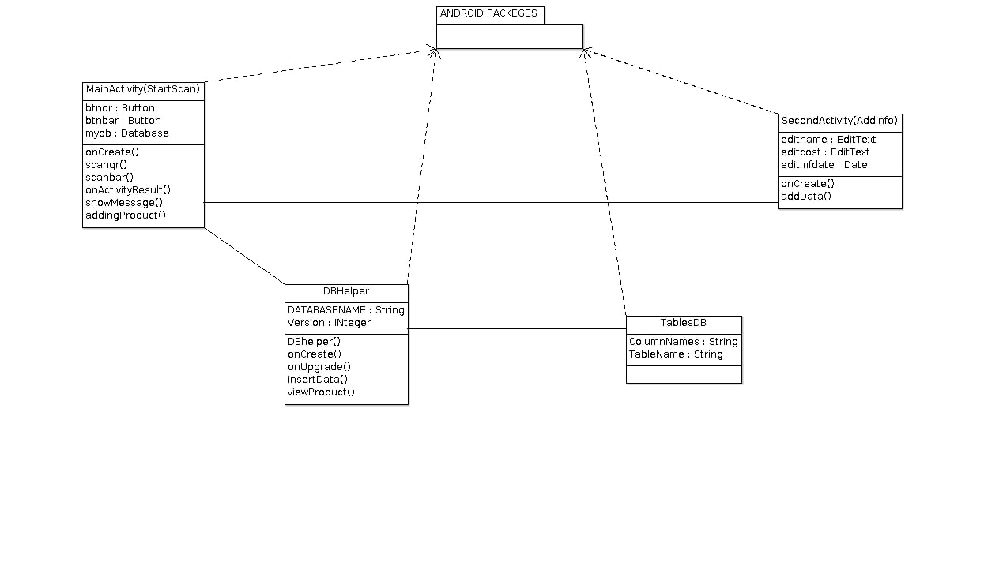

3.SEQUENCE DIAGRAM

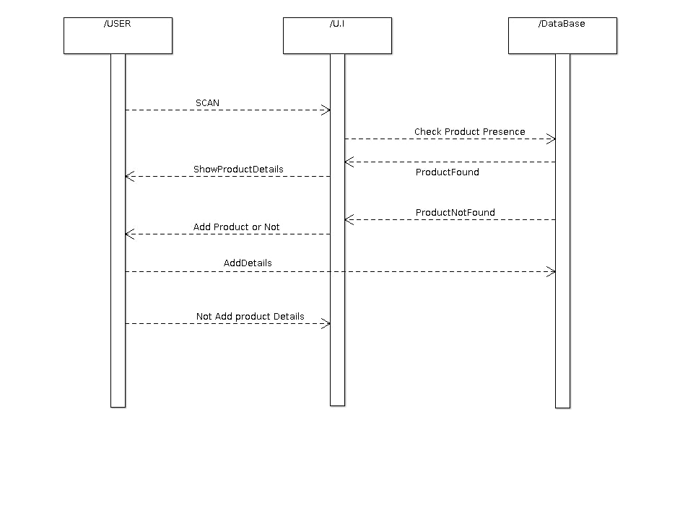

4.STATE CHART DIAGRAM

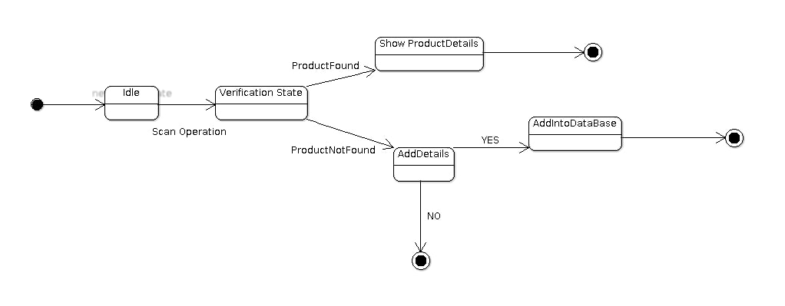

5.COMPONENT DIAGRAM

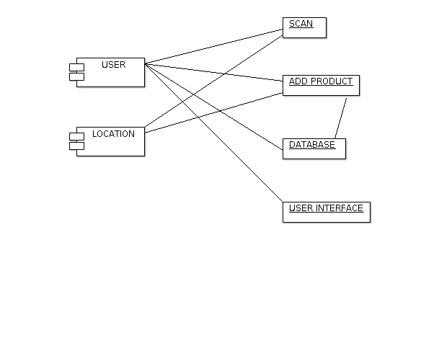
#################THE END#################

