Project Proposal on

HOSTEL MANAGEMENT SYSTEM

SARANCE SHRESTHA

00162792

Computing Project

Level 5 Diploma in Computing

Softwarica College of IT & E-Commerce

Kathmandu, Nepal

9th, April 2017

Table of Contents

1. Introduction: 3

1.1 Aims: 4

1.2 Objectives: 4

1.3 Main Features: 4

1.4 Development methods 5

2. Project plan: 7

2.1 Work Breakdown Structure (WBS) and Time Estimate 7

2.2 Milestone 9

2.3 Schedule: 10

Risk Management: 12

Configuration Management: 14

Conclusion: 15

References: 16

# Introduction:

The project, Hostel Management System, a web based system, puts the lights upon the real scenario about the apt management of the task and structure of Blue bird hostel organization. The project is focus on developing using **PHP** and **sqlplus** for database. The crucial purpose of the project is to keep the records of the customers that is admitted to the hostel as well as about their rooms and related elements and to make the work of the organization somehow easy and flexible with its relevant and reliable features. It helps in dwindling the problem of finding the records of the hostellers in manual way by providing the enhanced features and functions. Therefore, the organization (Hostel) should considered the good system into the practice so that the dwellers would easily gain access to the services and the management of the hostel in short time. It also saves the consuming time of the people by knowing all the facilities related to the significant organization as advertise by the organization owner rather than going place to place in search of hostel.

The problem immensely faced by some of the owner is that they are not able to upgrade their status in the market. Some of the organizations are still backward in the marketing term. Due to the low marketing factor and the unapt location of the organization, visitors are still unknown to it. The well-known fact about any organization in absence of the stable management system is that it would not be able to bestow the complete look up services to the customers willing to be admitted to the organization. In the absence of the appropriate management system, the records of the admitted hostellers may not be confidential and would not be accessed efficiently in lack of proper management system, so with the practice of the newly developing system the records would have been automated and made confidential.

The organization, for which I am interested to build the system, is lagging the similar problem as mentioned above. The appropriate management is lacked by the hostel. After the so many years of the establishment of the organization, till now the owner are still not aware about the proper efficient management system that would handle and administrate the transaction of the hostellers. The customers in search of the hostel may find it easy if they would locally see all the features and facilities through the internet wherever might be the location of the organization. They would not have to visit manually the permanent venue of the organization. Since, they would catch up all the necessary requirements locally, which will be hosted through the multiple pages of that organization. They would get all the services just like **the fee structures, location of the organization, the type of the food item they would be getting after enrolling to the organizations, the features to book the bed if it is free among the rooms of organization**. It would also provide the customers for the inquiry of the rooms and the services and allow them to book if they are interested to be admitted. Nevertheless, after the booking for the room they have to pay the admission fee visiting directly to the owner of the organization.

Similarly, it will also assist the owner of the organization directly by not dealing individually to the customers, as customers themselves would already have known the basic services and the features after going thoroughly to the modules of the system. After the implementation of the product able management system, both of the parties (owner of organization as well as the customers) would find it operative and flexible for finding the apt and appropriate hostel with the class of the services as well as the environment without any huddles and difficulties. They would be vividly clear about any significant organization after the certain look-up, upon the proper management system of the related organization.

## 1.1 Aims:

Some of the reliable aims of the system that it will pertain are as follows:

* To build the web based system for managing the hosteller’s information of certain organization.
* To build the system that may be more user efficient with productive results.
* To build the system that provides ease of access through multiple queries.

## 1.2 Objectives:

Objectives are consider as the set of the related activities that should be performed in order to meet the probable aims of the developing system. Some of the considered objectives to resolve the stated aims are listed below:

* To simplify the manual admission or booking of the customers.
* To collect the information of the hostellers in easy way and make it to be accessed smoothly.
* To design the page, which helps to visualize the services of hostel easily to the customers, related to the organization.
* To dwindle the manual work of the admin.
* To ensure that the person in a room may not exceed its accommodation.
* To ensure the number of features bestowed to the individual hostellers.
* To govern the fee payment status of the hostellers.
* To modify each single details of the hostellers records.

## 1.3 Main Features:

Some of the main features that will contain by the system are listed beneath:

* It provides the login frame for the authentication purposes.
* It provides the registration frame for the booking or admission purposes.
* It provides the different frames for the looking-up the different specific related operations and features.
* It stores the huge amount of information of the admitted hostellers.
* It assists the admin to control and inspect the activities of the admitted hostellers.
* It keeps the time of the leaving and the entry of the hostellers.
* It helps restrict to allot the significant element to the hostlers during their dwelling span.
* It keeps the vital records of the hostellers confidentially.
* It restricts the hostellers to get access to the admin panel.
* It manages the records of hostellers through the CRUD operations.
* It provides the friendly user interface and interactions.

## 1.4 Development methods

The project may pertain different developing phases during its development. Therefore, to develop the project in better convenience form, I have choose **Waterfall model** as the suitable development methods for the project.

The project is branched into the specific tasks to perform in the serial manner. Likewise, the waterfall model also performs the same hierarchical steps, which is to be followed during any project development. It is the non-iterative, management methodology where the progress is map in regularly downwards phases of **feasibility study, requirement analysis, design implementation, testing and maintenance**. All the steps of the model is must to be followed steps by steps so that it wouldn’t face the error while in the verge of the completion of the project because if only one of the phase of the progress is missed then all the project should re-started from the beginning. It is considered as one of the easiest means of the development methods but along with its easiness, it also import the huddles in development progress. Therefore, each phases should be ponder appropriately in order to achieve the suitable and complete package of the project. It is considered as the drop of water, which goes on falling and falling once it is dropped and cannot be stopped unless it touches any surface

This model initiates to test software unless the development of the project is completed totally. It provides the certainty about each phase must be completed in order to initiate another phase. During the development of the project using the model, a little participation of user is required. This model could be effective in my project as the requirements are clear and well known. There is not any ambiguous requirements, and the resources for the system is easily achievable without any problem. The development of project becomes more suitable to understand and use. All the phases are concluded at a single time without overlapping, resulting in the well-functioning management system. The required technology, for the development progress is also understood without any inconvenient. The only unmanageable part in the model is that the maintenance cost for the developed system/project goes to be expensive, since all the phases or steps needed to be initiated from the beginning as done while during the development of the project.

So considering upon the logical advantages of the waterfall model, I technically choosed this effective and milestone focused development model. The different phases of the model are described below:

Feasibility study: This phase consists of analyzing the cost benefit analysis and project is technically and socially feasible.

Requirement analysis: This phase consists the analyzing part of the hardware and software and lastly requirement specification is generated.

Design: This phase consists the designation part of the whole project along with the significant code of the project.

Implementation: This phase finalize the implementation part of the project direct running to the organization with the existing system.

Testing: This phase consists the testing part of the project, which contrast and ensure if the system is more reliable and robust.

Maintenance: This phase consists of maintaining the project repeatedly if any bug appears in the run time of the project.

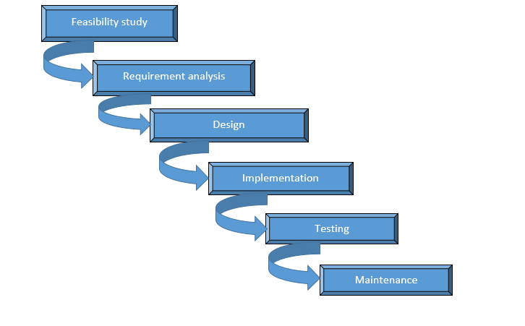

Fig: Phases of waterfall model

# 2. Project plan:

## 2.1 Work Breakdown Structure (WBS) and Time Estimate

A work breakdown structure is a vital model, which divides the oriented project into the smaller output components. It visualizes the whole outline of the project and divides the deliverables into further sub-deliverable components. It generates the specific model, which show that the deliverable functioning task of the project is needed to be completed in hierarchical order to achieve the completeness in project.This model shows the breaking down of the project into sub-components along with the estimated time it will be taking to provide the integrity to the project.

The work breakdown structure and time estimation is shown below:

|  |  |  |
| --- | --- | --- |
| **WBS** | **Task name** | **Days** |
| 0 | **Hostel Management System** | 75 |
| 1 | **Feasibility study** | 8 |
| 1.1 | Brainstorming | 2 |
| 1.2 | Market assessment | 4 |
| 1.3 | Planning | 1 |
| 1.4 | Interview | 1 |
| 2 | **Requirement analysis** | 6 |
| 2.1 | User requirement | 2 |
| 2.2 | System requirement | 2 |
| 2.3 | Stakeholder analysis | 2 |
| 3. | **Design** | 30 |
| 3.1 | Static design model | 12 |
| 3.1.1 | Use case diagram | 5 |
| 3.1.2 | Class diagram | 7 |
| 3.2 | Dynamic design model | 18 |
| 3.2.1 | Collaboration diagram | 9 |
|  |  |  |
| 3.2.2 | Sequence diagram | 9 |
| 3.3 | **UI design** | 7 |
| 3.4 | **Database design** | 8 |
| 4 | **Implementation** | 22 |
| 5 | **Testing** | 6 |
| 5.1 | Unit testing | 2 |
| 5.2 | Black-box testing | 2 |
| 5.3 | White-box testing | 2 |
| 6 | **Reporting** | 3 |
| 7 | **Maintenance** |  |

Fig: WBS and time estimation

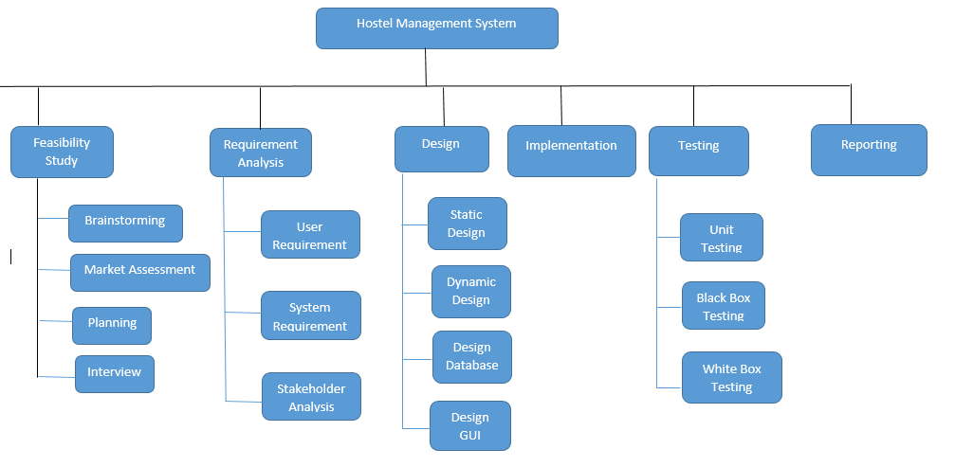

Fig: Work Breakdown Strucuture

## 2.2 **Milestone**

Milestones are the symbolic phases with a fix delivery date, which is measured by referencing the work breakdown structure. It is not an activity rather it is an output of the certain activity.

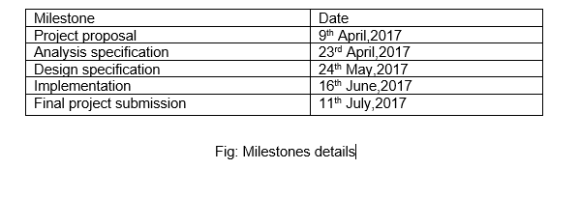

## 2.3 Schedule:

The scheduling plan for the project in shown in the Ganttchart:

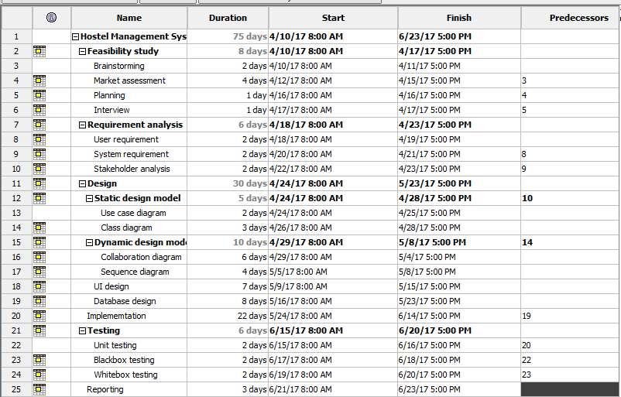

Fig: 1Gantt chart

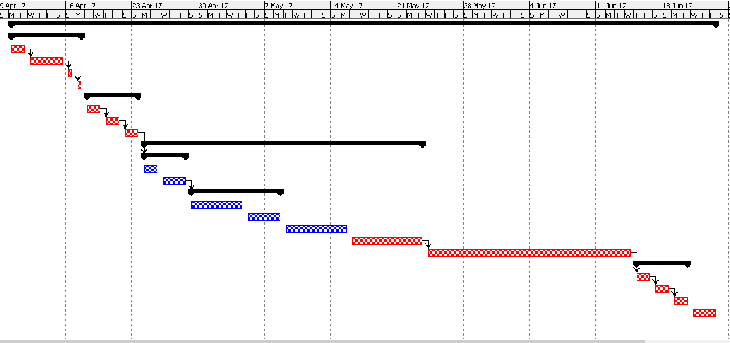

Fig: 2 Schedule details

# Risk Management:

Risk management is a crucial aspect in the project development, which should be formulated carefully in order to alleviate the risks that we confront in the development phase of the project. The main theme of the risk management is to compromise with the risk and errors that might occur during our project work. To calculate the effect of risk in the project, we can use the beneath equation:

Impact=likelihood * consequences

Where likelihood refers to the likeable risk that may occur in the project and consequences refers the subsequent result of the risk.

The beneath table shows the risk values:

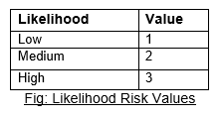

The beneath table shows the consequences values done by risk:

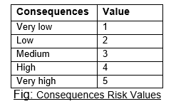

The risk management table with the identified risk, likelihood and consequences along with the action or control measures is shown in the tabular format:

|  |  |  |  |  |
| --- | --- | --- | --- | --- |
| **Risk** | **Likelihood** | **Consequences** | **Impact =**  **Likelihood * Consequences** | **Control measures** |
| Bad estimation | 2 | 4 | 8 | Appropriate estimation of cost and functions should be performed |
| Back-up delete | 1 | 4 | 4 | Reliable software should be used for back-up storage |
| Scheduling risk | 2 | 3 | 6 | Decent planning should be performed for better scheduling task |
| Cost | 1 | 3 | 3 | Apt amount of budget should be allotted for the better development |
| Sudden growth of requirement | 2 | 5 | 10 | Use of proper prototypes and document the clear and complete requirements. |
| Natural calamities | 1 | 5 | 5 | Back-up strategy should be implemented in proper scheduling |

# Configuration Management:

Configuration management analyze individual configuration items, its physical attributes and functional capabilities relevant to the services and includes the typical versions and updates of the system. It also helps to store artefacts efficiently.

GitHub is a similar code-hosting platform, which is widely used for version control and collaboration. It also allows us and others to work on combinely on projects anytime, everywhere. It contains the necessary items for configuring the directories and files for the project such as repositories, branches, commits and pull requests. While using GitHub, Version control is defined as the management of changes that occurs to documents, programs and other information stored as computer files. Here, if any changes occur to the username under the repositories of the old username then it automatically changes to new username.

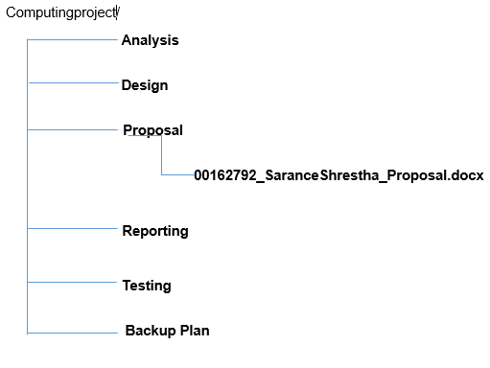

Fig: configuration items

# Conclusion:

The building system was planned to automate and manage the manual work of any organization in the simplify way. The management of the organization usually remains in unmanaged conditions in the absence of the genuine management system, which may lead to the failure of the manual and the data handling work of the organizations. The bulk work of the organization may not be as simple as we think, unless the effective and efficient management system is not manage to use. The proposed management system will be functioning each work of the organization in managed way along with handling the different perspective of the organization. So that the organization would conduct and upgrade its manual work to the technical level management. The system would be able to dwindle the risk towards the data handling, and would manage the execution time of the system for handling of the records of the hostellers that are admitted to the specific organization. To build the concern management system php, sqlplus was used as database store. The system was able to perform the registration part through the online way and check out the every services of the organization. It also helps the admin panel by managing all the records of the admitted hostellers and denying the authorization of hostellers to the admin panel. The system will also be able to provide the ease of access with multiple queries and provides the capable human computer interface, which makes the users much easy and intractable to use the system.

# References:

Anon., 2015. *Configuration Management.* [Online]   
Available at: <http://searchitoperations.techtarget.com/definition/configuration-management-CM>

* [Accessed 09 April 2017].

Anon., 2015.Top 10 Software Development Risks*.* [Online]   
Available at: <http://searchitoperations.techtarget.com/definition/configuration-management-CM>

* [Accessed 09 April 2017].

Anon., 2015.Hostel management*.* [Online]   
Available at: <https://www.slideshare.net/hemusajwan/hostel-management-54611747>

* [Accessed 09 April 2017].

<https://guides.github.com/activities/hello-world/>

<http://stackoverflow.com/questions/tagged/version-control>