1. Financial Trading Analysis/Prediction
In the world of foreign exchange trading, it is commonly observed that the initial price action of the first candle in the market opening hours often sets the trend for the following few hours. This trend is considered a crucial aspect of forex analysis, and many traders use it to make informed decisions. In this Python exercise, we will delve into this concept by analysing and visualising the relationship between the first candle movement and the subsequent price action. By the end of this exercise, you will have a better understanding of how to use this information to make informed trades.

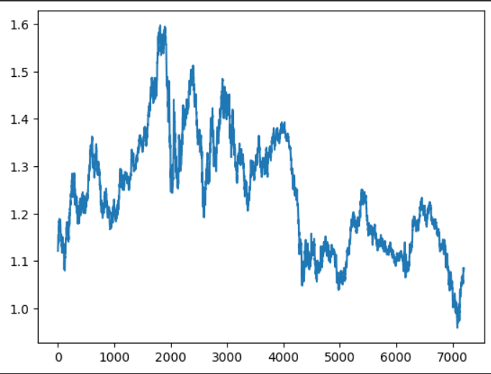

We need to verify this. We are given a csv file of historical data for the candle prices of EURUSD. The file contains the date column, opening, closing, high and low prices for each candle, and the volume of trades during each hour.
  - Load the data into a dataframe.
  - Get the columns names and observe the data content.
  - The opening day of the market is characterized by the first candle that is formed after a period of no trading volume (the week-end). To better understand the significance of these candles, we will add a new column to our dataframe. In this column, all values will be set to 0, except for the first candle of each week. If a candle is the first of the week, its corresponding value in the new column will be set to 1. This will help us differentiate and analyze the first candles of each day and their impact on the overall trend.
  - To analyse the future of the trend we will compute the mean value of the next few closing candles, for example the next 4 candles. The number of future candles to be considered can be left as a variable which we can experiment on later in this study. Add a new column to the dataframe showing 1 if the future average closing price is lower than the current candle close price, and 2 in the opposite case.
  - We also need the market opening candle direction, add a new column showing 1 if it’s bearish candle (closing price is lower than the opening price) and 2 in the opposite case.
  - So now we can compare if the current candle direction is related to the future average trend by counting the number of times these trends are the same versus the opposite occurrence.
  - Print all the rows where the initial assumption of this problem in not true.

2. Financial Trading: analysing the engulfing candles
In this exercise, we will be using Python's Pandas library to load historical price data of a FOREX pair. The objective is to analyse the occurrence of the "engulfing candle" pattern and its effect on the future trend of the price.
The "engulfing candle" pattern occurs when a large candle either fully covers the body of the previous candle or extends beyond both the high and low of the previous candle. This pattern is often considered a reversal pattern and is used by traders to make decisions about entering or exiting trades. The final result of this exercise should be a Python program that can load historical price data, detect the presence of the engulfing candle pattern, and analyse its effect on the future trend of the price.
To complete this exercise, follow the steps below:
  - Load the historical price data of the desired FOREX pair into a Pandas dataframe. The data should include the date, open, high, low, and close prices.
  - Create a new column in the dataframe to store the information about the occurrence of the engulfing candle pattern. This column should have a value of 1 if a bearish engulfing candle pattern is present, 2 if a bullish pattern is present and 0 otherwise.
  - Analyse the data to determine the frequency of the engulfing candle pattern.
  - Study the effect of the engulfing candle pattern on the future trend of the price. To do this, calculate the average price change in the following candles after an engulfing candle pattern is detected, just like we did in the previous exercise.
  - Count the number of trends that were “predictable” or agree with the engulfing pattern signals.

3. Financial Trading: Visualising Bullish and Bearish Trends

In this exercise, we will use Python and Pandas to analyse and visualise EUR/USD historical price data using candlestick charts. The objective is to visually identify bearish and bullish price movements and understand how the direction of the initial candle relates to the subsequent trend.
We will create a candlestick visualization showing:
- Bearish/downward trend
- Bullish/upward trend
- Opening candle direction
- Subsequent price movement
- Trend annotations using arrow.

