DATABASE MANAGEMENT SYSTEM
Class: 12
Name: Saurya Yogal Shrestha
Project: School Database Management System
Database: school_db

PROJECT REPORT

INTRODUCTION
This project is a simple relational database implementation using MariaDB. The database used in the project is school_db and it contains a students table. The students table stores student identification, name, age, gender and course information.
The report presents the actual database commands and results shown in the supplied screenshots. The screenshots are placed in the same practical sequence: database/table creation, table description, insertion of records, displaying records, selecting particular fields, filtering, sorting and counting records.
OBJECTIVES
- To create and use the school_db database.
- To create the students table with appropriate fields.
- To insert student records into the table.
- To display and retrieve stored data using SELECT queries.
- To filter records using WHERE conditions.
- To sort records using ORDER BY.
- To count the total number of student records.

ER DIAGRAM
The project contains one main entity, students. The primary key student_id uniquely identifies each student. The entity also contains name, age, gender and course attributes.
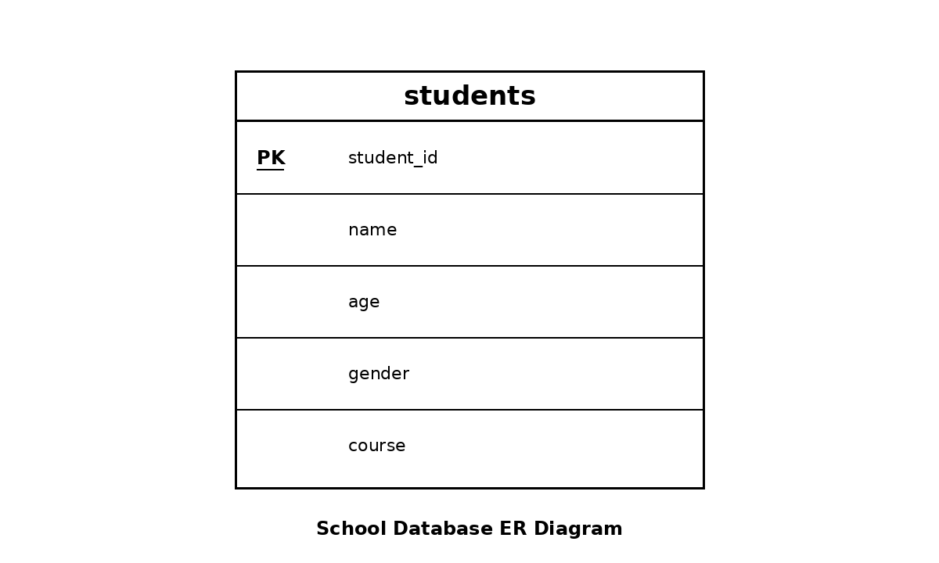

TABLE STRUCTURE
The actual DESCRIBE students output shows student_id as int(11) with PRI key and NOT NULL, name as varchar(100), age as int(11), gender as varchar(10), and course as varchar(50).

Database selection, database listing and table creation
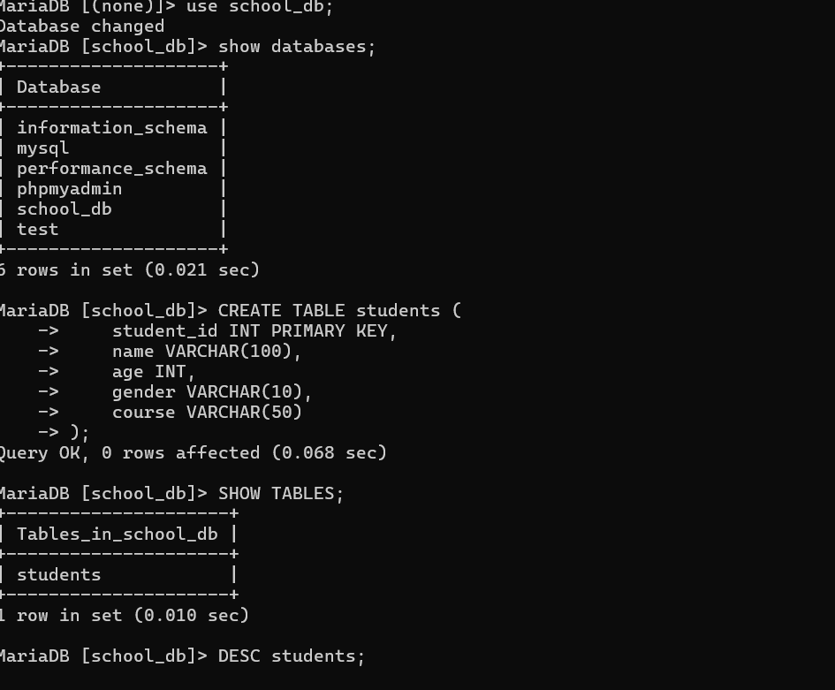

The first screenshot shows the use of school_db, the list of available databases, and the CREATE TABLE students command. The table is created with student_id as the primary key.

SHOW TABLES, DESCRIBE students and INSERT records
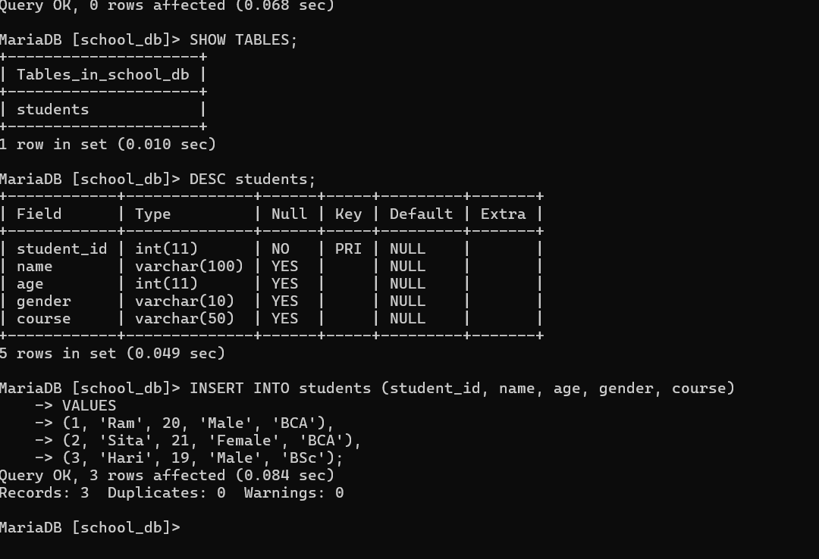

The second screenshot confirms that the students table exists. DESCRIBE students displays the field definitions. Three records are then inserted: Ram, Sita and Hari.

Displaying all records with SELECT *
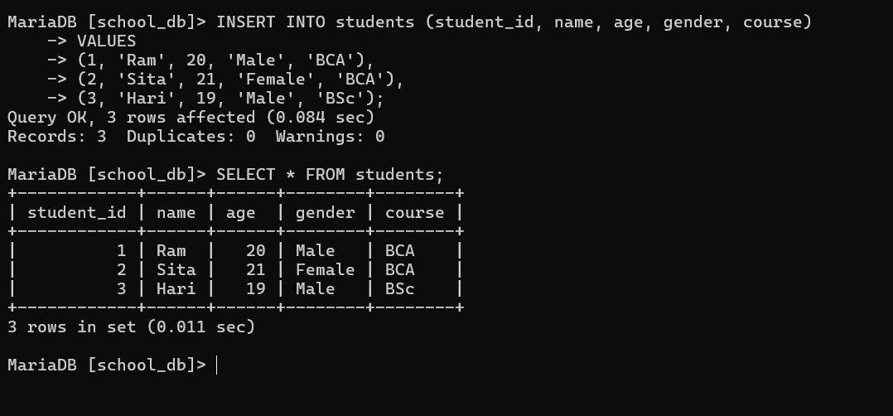

The SELECT * FROM students query displays all three records. Ram is 20 years old and studies BCA, Sita is 21 years old and studies BCA, and Hari is 19 years old and studies BSc.

Displaying all records
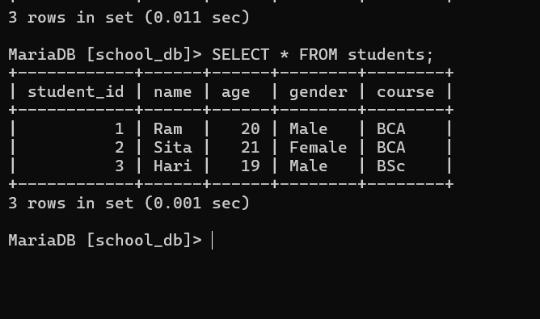

This screenshot again shows the complete contents of the students table after insertion. It confirms that three records are stored successfully.

Selecting student name and course
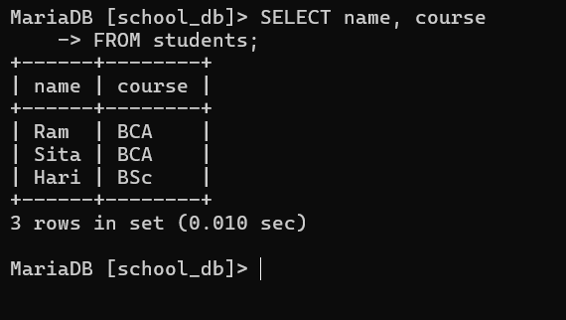

The query SELECT name, course FROM students retrieves only the name and course columns. This demonstrates selecting specific attributes instead of displaying every column.

Filtering students whose age is greater than 20
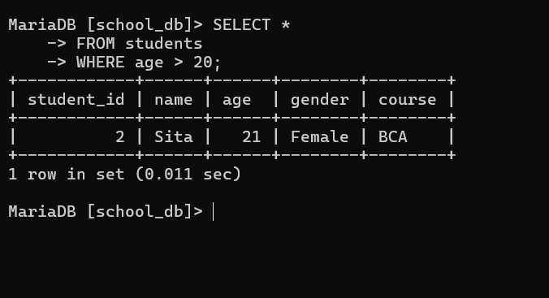

The WHERE condition age > 20 returns only Sita, whose age is 21. This demonstrates conditional retrieval of records.

Filtering students by BCA course
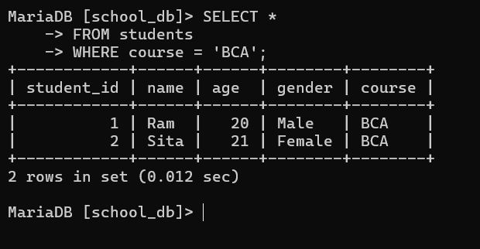

The query WHERE course = 'BCA' returns Ram and Sita. Both students are enrolled in the BCA course.

Sorting students by age
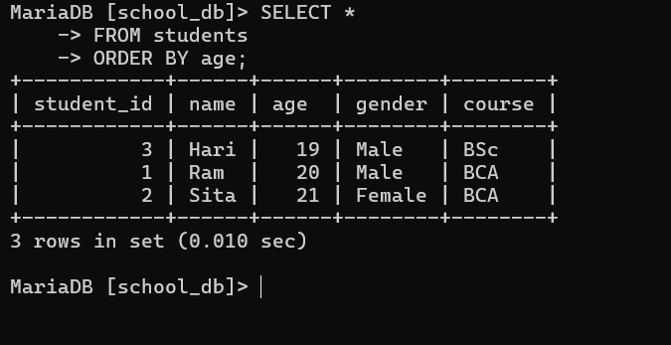

The ORDER BY age query arranges the students in ascending order of age: Hari (19), Ram (20), and Sita (21).

Counting the total number of students
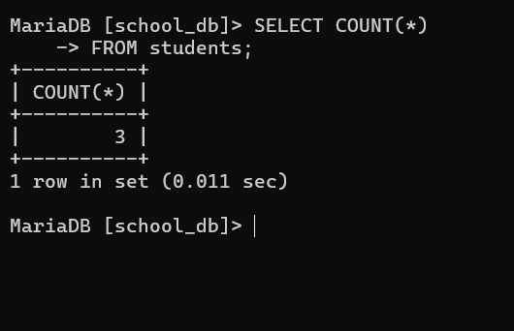

The COUNT(*) query returns 3, showing that three student records are currently stored in the students table.

SQL QUERIES USED IN THE PROJECT
1.
USE school_db;
2.
SHOW DATABASES;
3.
CREATE TABLE students (
student_id INT PRIMARY KEY,
name VARCHAR(100),
age INT,
gender VARCHAR(10),
course VARCHAR(50)
);
4.
SHOW TABLES;
5.
DESC students;
6.
INSERT INTO students (student_id, name, age, gender, course)
VALUES
(1, 'Ram', 20, 'Male', 'BCA'),
(2, 'Sita', 21, 'Female', 'BCA'),
(3, 'Hari', 19, 'Male', 'BSc');
7.
SELECT * FROM students;
8.
SELECT name, course
FROM students;
9.
SELECT *
FROM students
WHERE age > 20;
10.
SELECT *
FROM students
WHERE course = 'BCA';
11.
SELECT *
FROM students
ORDER BY age;
12.
SELECT COUNT(*)
FROM students;

CONCLUSION
The School Database Management System project demonstrates the basic operations of a relational database using MariaDB. The school_db database contains the students table with five fields: student_id, name, age, gender and course.
The project successfully demonstrates table creation, data insertion, data retrieval, column selection, conditional filtering, sorting and aggregate counting. The screenshots provide direct evidence of the commands and their outputs.
The database can be extended in the future by adding tables such as teachers, classes, subjects and attendance, and by establishing relationships using foreign keys.
REFERENCES
1. MariaDB / MySQL command-line database environment used for the project.
2. Supplied school_db project screenshots.
3. GitHub repository: shresthasaurya9-coder/DBMS-Project.

