GRADE 12 COMPUTER SCIENCE
DATABASE MANAGEMENT PROJECT
Project Report: School Management System Database
Project Title: Relational Database Design and Implementation for a School Management System
Name:
Saurya Yogal Shrestha
Date: 16th Aug
Database Platform: MariaDB / MySQL using XAMPP

1. Introduction
This project report details the design and implementation of a relational database for a School Management System. The system is designed to efficiently manage and track data related to students, courses, teachers, and student enrollments.
The project was implemented using MariaDB/MySQL through XAMPP and demonstrates the complete lifecycle of a database application, from conceptual design and relational structure to implementation, data population, and querying. The primary goal is to showcase the principles of relational database design, including data integrity, relationships, constraints, and the use of Structured Query Language (SQL).

2. Entity-Relationship (ER) Diagram
The database design is based on the following entities and their relationships:
- Student: Represents a student enrolled in the school.
- Teacher: Represents a teacher employed by the school.
- Course: Represents a course offered by the school, taught by a specific teacher.
- Enrollment: Represents the relationship between Students and Courses. A student can take many courses, and a course can have many students.
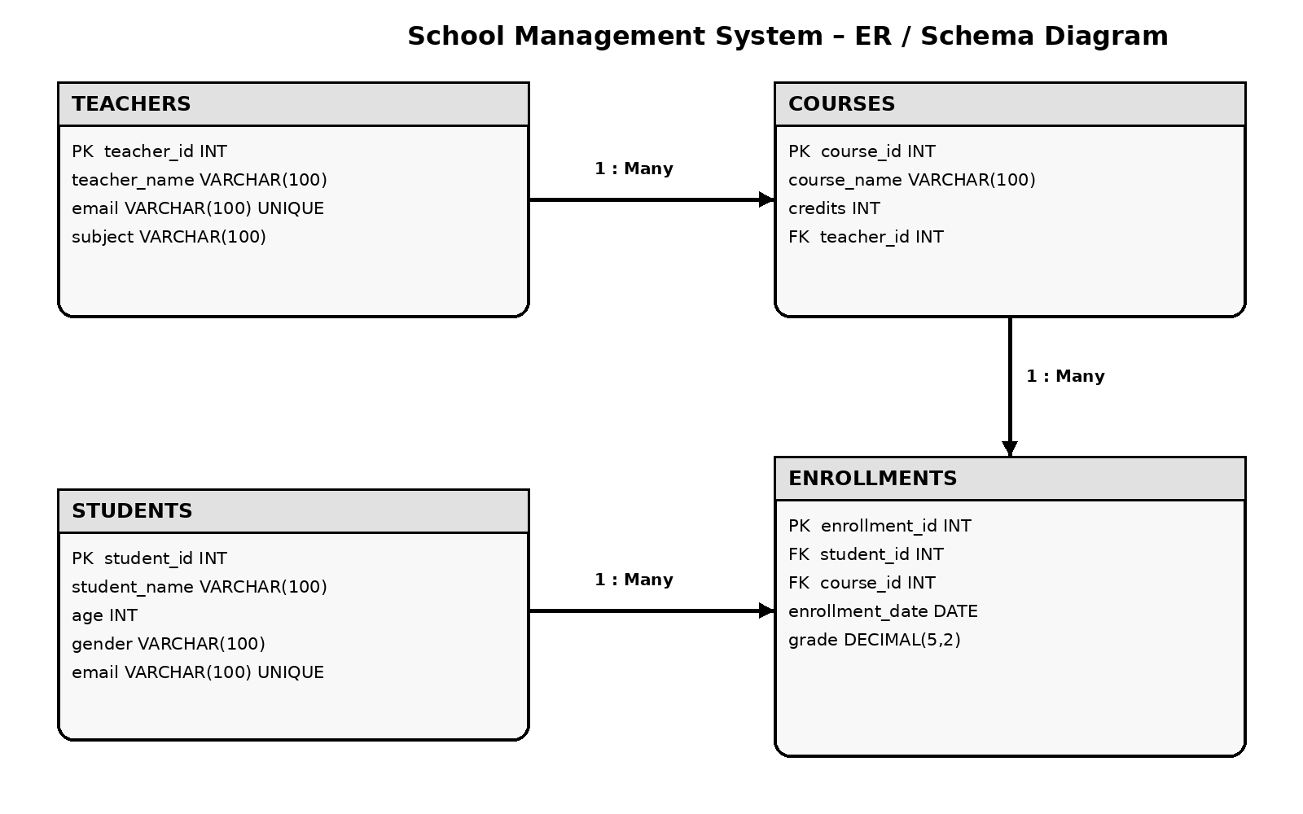

3. Table Structure, Data Types, and Constraints
The following tables were created to implement the ER diagram. Constraints are defined to help ensure data integrity.

Table 1: teachers
Column Name | Data Type | Constraints | Description
teacher_id | INT | PRIMARY KEY | Unique identifier for each teacher.
teacher_name | VARCHAR(100) | NOT NULL | Teacher's full name.
email | VARCHAR(100) | UNIQUE, NOT NULL | Teacher's email address.
subject | VARCHAR(100) | NOT NULL | Subject taught by the teacher.

Table 2: courses
Column Name | Data Type | Constraints | Description
course_id | INT | PRIMARY KEY | Unique identifier for each course.
course_name | VARCHAR(100) | NOT NULL | Name of the course.
credits | INT | NOT NULL, CHECK (credits > 0) | Number of credits assigned to the course.
teacher_id | INT | FOREIGN KEY, NOT NULL | ID of the teacher assigned to the course.

Table 3: students
Column Name | Data Type | Constraints | Description
student_id | INT | PRIMARY KEY | Unique identifier for each student.
student_name | VARCHAR(100) | NOT NULL | Student's full name.
age | INT | NOT NULL, CHECK (age >= 16) | Age of the student.
gender | VARCHAR(100) | NOT NULL | Gender of the student.
email | VARCHAR(100) | UNIQUE, NOT NULL | Student's email address.

Table 4: enrollments
Column Name | Data Type | Constraints | Description
enrollment_id | INT | PRIMARY KEY | Unique identifier for each enrollment record.
student_id | INT | FOREIGN KEY, NOT NULL | ID of the student enrolled.
course_id | INT | FOREIGN KEY, NOT NULL | ID of the course in which the student is enrolled.
enrollment_date | DATE | NOT NULL | Date on which the student enrolled.
grade | DECIMAL(5,2) | DEFAULT 0, CHECK (0–100) | Numeric grade for the course.

4. Database Implementation (SQL Script)
The database_setup.sql file contains all the SQL code used to create and populate the database.

4.1. Database and Table Creation
-- Create and use the database
CREATE DATABASE IF NOT EXISTS school_db;
USE school_db;
-- Create teachers table
CREATE TABLE teachers (
teacher_id INT PRIMARY KEY,
teacher_name VARCHAR(100) NOT NULL,
email VARCHAR(100) UNIQUE NOT NULL,
subject VARCHAR(100) NOT NULL
);
-- Create courses table
CREATE TABLE courses (
course_id INT PRIMARY KEY,
course_name VARCHAR(100) NOT NULL,
credits INT NOT NULL CHECK (credits > 0),
teacher_id INT NOT NULL,
FOREIGN KEY (teacher_id) REFERENCES teachers(teacher_id)
);
-- Create students table
CREATE TABLE students (
student_id INT PRIMARY KEY,
student_name VARCHAR(100) NOT NULL,
age INT NOT NULL CHECK (age >= 16),
gender VARCHAR(100) NOT NULL,
email VARCHAR(100) UNIQUE NOT NULL
);
-- Create enrollments table
CREATE TABLE enrollments (
enrollment_id INT PRIMARY KEY,
student_id INT NOT NULL,
course_id INT NOT NULL,
enrollment_date DATE NOT NULL,
grade DECIMAL(5,2) DEFAULT 0
CHECK (grade >= 0 AND grade <= 100),
FOREIGN KEY (student_id) REFERENCES students(student_id),
FOREIGN KEY (course_id) REFERENCES courses(course_id),
UNIQUE (student_id, course_id)
);
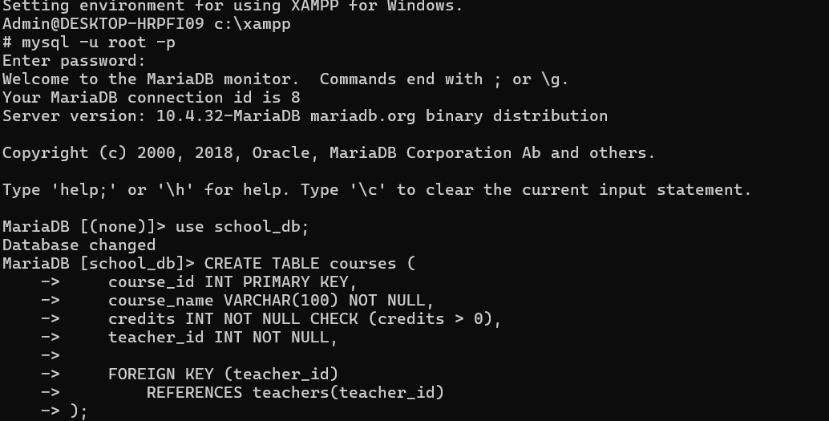

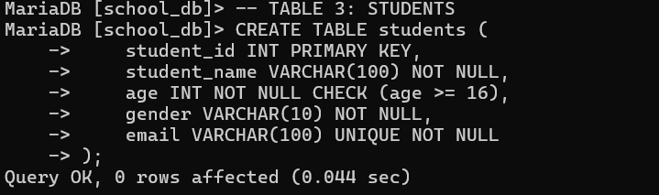

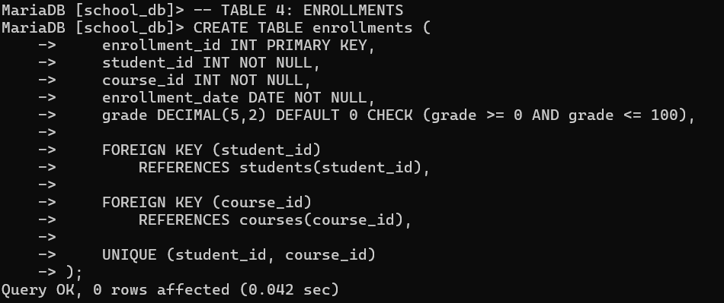

4.2. Data Insertion
-- Insert sample data into teachers
INSERT INTO teachers
(teacher_id, teacher_name, email, subject)
VALUES
(1, 'Anil Sharma', 'anil.sharma@school.edu', 'Computer Science'),
(2, 'Maya Thapa', 'maya.thapa@school.edu', 'Mathematics'),
(3, 'Ramesh Gurung', 'ramesh.gurung@school.edu', 'Physics'),
(4, 'Sita Rai', 'sita.rai@school.edu', 'English'),
(5, 'Bikash Karki', 'bikash.karki@school.edu', 'Chemistry');
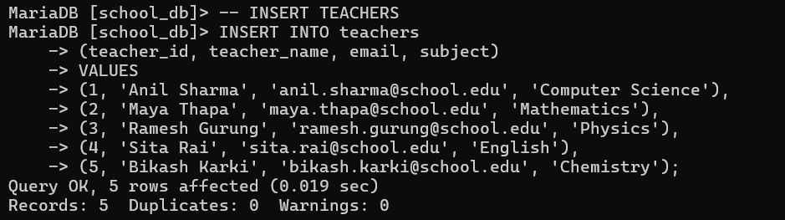

-- Insert sample data into courses
INSERT INTO courses
(course_id, course_name, credits, teacher_id)
VALUES
(101, 'Computer Science', 4, 1),
(102, 'Mathematics', 3, 2),
(103, 'Physics', 4, 3),
(104, 'English', 2, 4),
(105, 'Chemistry', 4, 5);
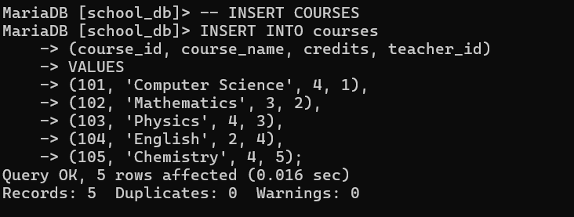

-- Insert sample data into students
INSERT INTO students
(student_id, student_name, age, gender, email)
VALUES
(1, 'Ram Sharma', 17, 'Male', 'ram@example.com'),
(2, 'Sita Thapa', 18, 'Female', 'sita@example.com'),
(3, 'Hari Gurung', 17, 'Male', 'hari@example.com'),
(4, 'Anita Rai', 18, 'Female', 'anita@example.com'),
(5, 'Bikash Tamang', 17, 'Male', 'bikash@example.com'),
(6, 'Puja Shrestha', 18, 'Female', 'puja@example.com'),
(7, 'Suman Karki', 17, 'Male', 'suman@example.com'),
(8, 'Nisha Adhikari', 18, 'Female', 'nisha@example.com'),
(9, 'Rohan KC', 17, 'Male', 'rohan@example.com'),
(10, 'Mina Gurung', 18, 'Female', 'mina@example.com');
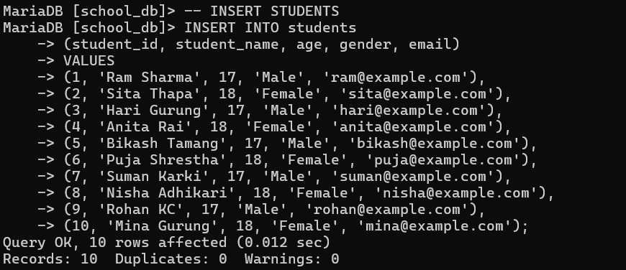

-- Insert sample data into enrollments
INSERT INTO enrollments
(enrollment_id, student_id, course_id, enrollment_date, grade)
VALUES
(1, 1, 101, '2026-01-10', 88.50),
(2, 1, 102, '2026-01-10', 91.00),
(3, 2, 101, '2026-01-11', 94.00),
(4, 2, 103, '2026-01-11', 87.50),
(5, 3, 102, '2026-01-12', 76.00),
(6, 3, 104, '2026-01-12', 82.00),
(7, 4, 101, '2026-01-13', 96.00),
(8, 4, 105, '2026-01-13', 89.00),
(9, 5, 103, '2026-01-14', 73.50),
(10, 5, 105, '2026-01-14', 79.00);
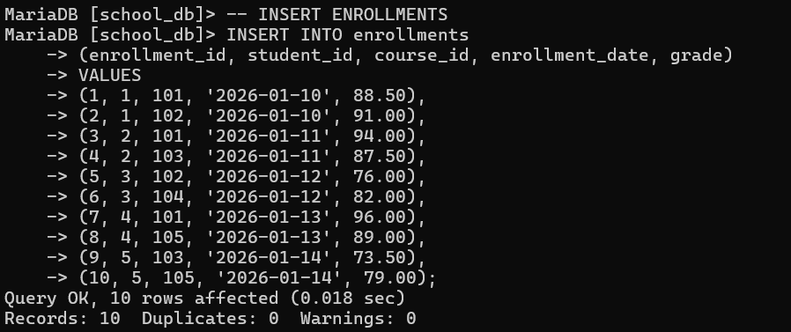

5. Database Querying & Analytics
The following SQL queries are included in the script to extract meaningful information from the database.

Query 1: Basic Retrieval
This query retrieves students who are 18 years or older, orders them by age in descending order, and limits the results to the first 5 records.
-- Basic Retrieval: students aged 18 or above
SELECT *
FROM students
WHERE age >= 18
ORDER BY age DESC
LIMIT 5;
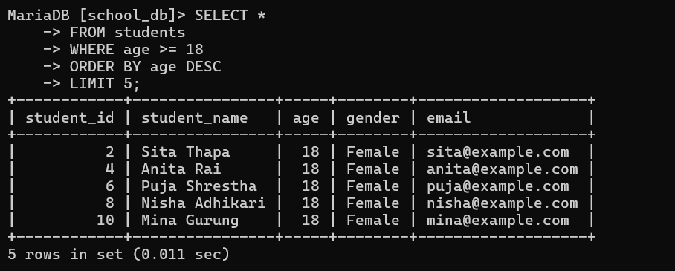

Query 2: Aggregate Functions with GROUP BY and HAVING
This query calculates the average grade for each course and shows only courses whose average grade is greater than 80.
-- Aggregate Function: average grade per course
SELECT
course_id,
AVG(grade) AS average_grade
FROM enrollments
GROUP BY course_id
HAVING AVG(grade) > 80;
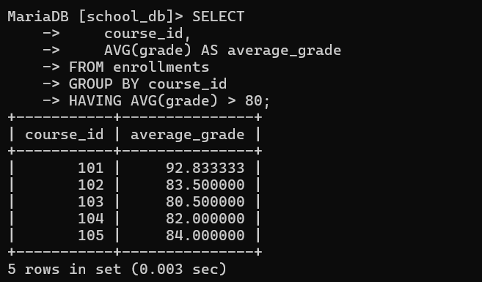

Query 3: Subquery
This query finds students whose age is greater than the average age of all students. It demonstrates a nested query.
-- Subquery: students older than the average age
SELECT
student_id,
student_name,
age
FROM students
WHERE age > (
SELECT AVG(age)
FROM students
);
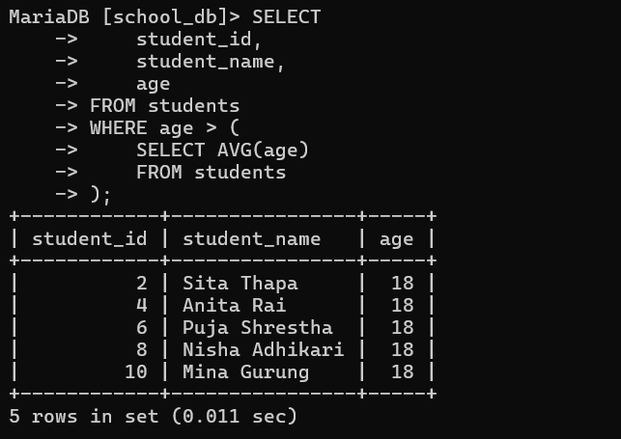

Query 4: Table Joins
INNER JOIN: This query links students, enrollments and courses to display the student, course, enrollment date and grade.
-- INNER JOIN: student enrollment details
SELECT
s.student_name,
c.course_name,
e.enrollment_date,
e.grade
FROM students s
INNER JOIN enrollments e
ON s.student_id = e.student_id
INNER JOIN courses c
ON e.course_id = c.course_id;
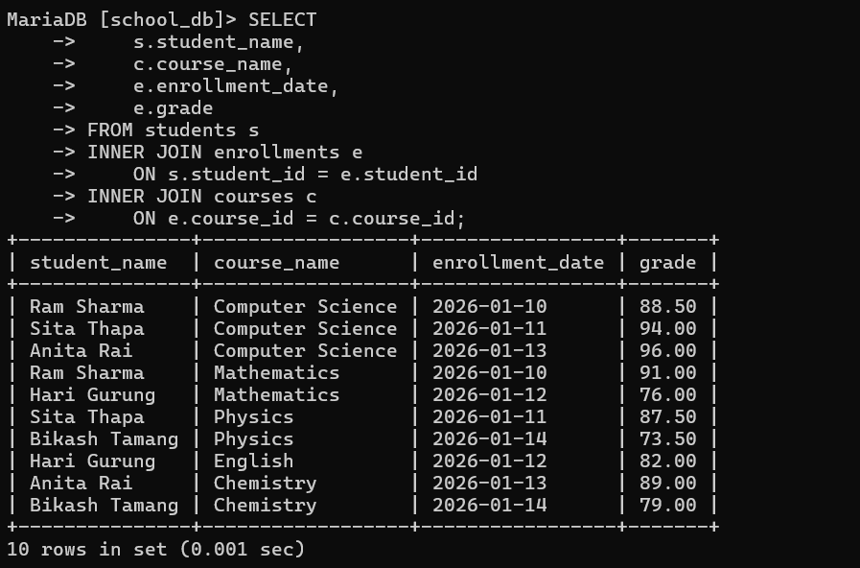

LEFT JOIN: This query shows all students, including students who do not have an enrollment record.
-- LEFT JOIN: all students and their course information
SELECT
s.student_id,
s.student_name,
c.course_name,
e.grade
FROM students s
LEFT JOIN enrollments e
ON s.student_id = e.student_id
LEFT JOIN courses c
ON e.course_id = c.course_id;
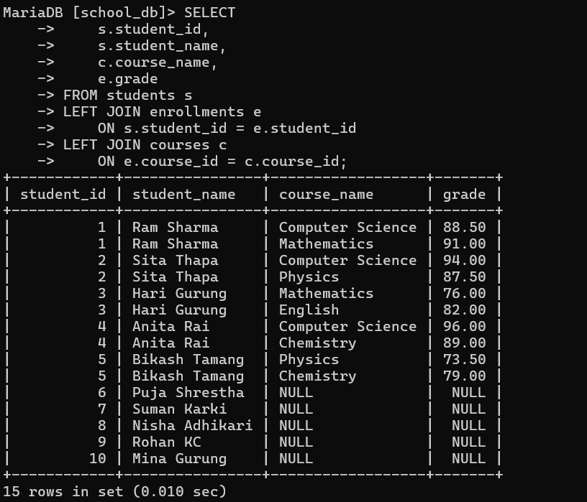

Query 5: Data Modification
UPDATE Statement: This query updates the grade for enrollment ID 1. The WHERE clause ensures that only the intended record is changed.
-- UPDATE: change the grade for enrollment ID 1
UPDATE enrollments
SET grade = 90.00
WHERE enrollment_id = 1;
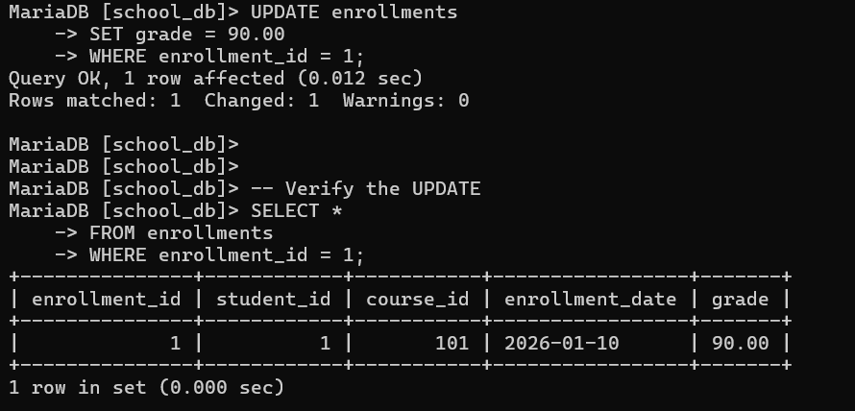

DELETE Statement: This query deletes enrollment ID 10. The WHERE clause prevents accidental deletion of other enrollment records.
-- DELETE: remove one specific enrollment
DELETE FROM enrollments
WHERE enrollment_id = 10;
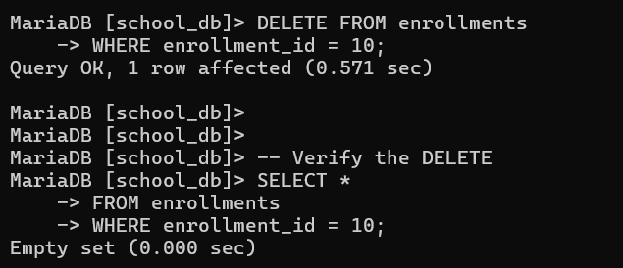

6. Proof of Successful Execution
The following screenshots provide evidence that the SQL commands and queries were executed successfully in the MariaDB terminal through XAMPP.
- Database Connection: MariaDB was successfully started and the school_db database was selected.
- Table Creation: The students and enrollments tables were successfully created with the required keys and constraints.
- Data Insertion: Teacher, course, student and enrollment records were inserted successfully.
- Query 1 Output: Five students aged 18 or above were retrieved using WHERE, ORDER BY and LIMIT.
- Query 2 Output: Course averages greater than 80 were displayed using AVG(), GROUP BY and HAVING.
- Query 3 Output: Students older than the average student age were returned by the subquery.
- Query 4 INNER JOIN Output: Student names, course names, enrollment dates and grades were displayed across related tables.
- Query 4 LEFT JOIN Output: All students were displayed, including students without enrollments.
- Query 5 UPDATE: Enrollment ID 1 was successfully changed from 88.50 to 90.00.
- Query 5 DELETE: Enrollment ID 10 was successfully deleted and verification returned an empty result.
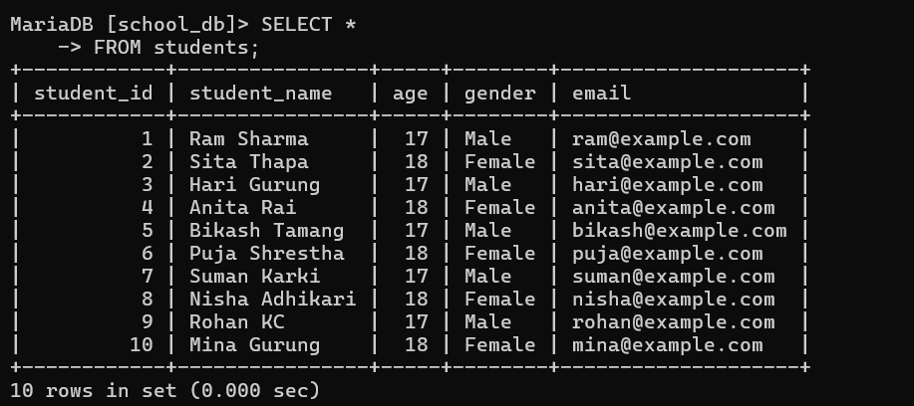

7. Conclusion
This project successfully designed, implemented, and queried a relational database for a School Management System using MariaDB/MySQL. The database meets the specified requirements by using four related tables, primary and foreign keys, appropriate data types, and integrity constraints.
The project also demonstrates the practical use of SQL through basic retrieval, aggregate functions with GROUP BY and HAVING, subqueries, INNER JOIN and LEFT JOIN operations, and safe UPDATE and DELETE statements. The screenshots provide evidence of successful execution in the MariaDB terminal using XAMPP.
Overall, the project demonstrates the practical application of relational database concepts and provides a structured foundation for managing information about students, teachers, courses, and enrollments in a school environment.

