Dart Script needs a **main ()** function.

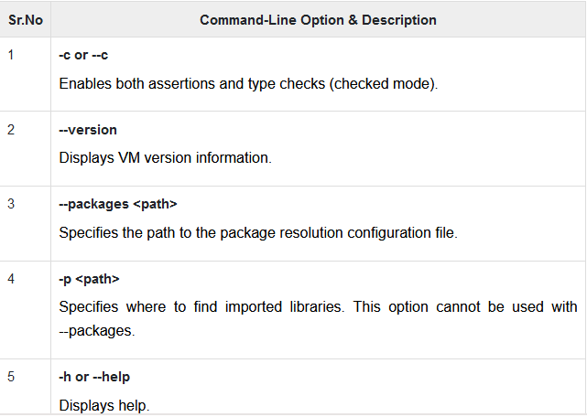

**List and Map**

* The data types list and map are used to represent a collection of objects.
* A **list** is the ordered group of objects. It is synonymous to array.
* The **Map** data type represents the set of values as key-value pair.
* The **dart: core** library enables the creation and manipulation of these collections through predefined **List** and **Map** classes respectively.

*If the key word of data type is not explicitly defined the variable’s type is dynamic type.*

**Variable**

* A variable is the “named space in the memory” that stores value.
* It acts like a container.

**Rules for declaring the variables name:**

1. Identifier cannot be keyword.
2. Can contain alphabets and numbers.
3. Cannot contain space and special characters, except the underscore (_) and the dollar ($) sign.
4. Cannot begins with number.

**Syntax**

* Variable name must be declared before it used.
* ‘**Var’** keyword is used to achieve the name.

var name =” Smith”;

* All variables in dart stores the reference to the value rather than containing the value.

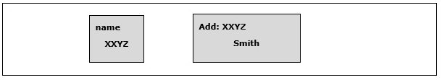

* Dart supports the **Type-checking.**
* Type-checking ensures that a variable holds only data specified to data type.

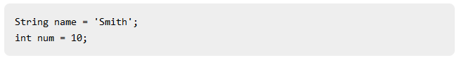

* All uninitialized variable have an initial value null.

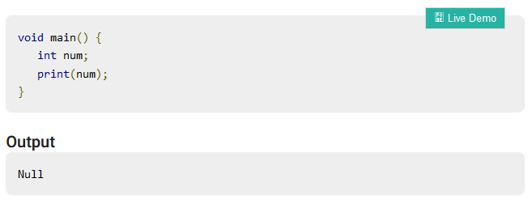

**The Dynamic Keyword**

* Variables declared without a static type are implicitly declared as dynamic.
* Variables can also be declared using the dynamic keyword in place of var.

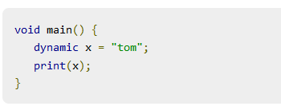

* The **final** and **const** keyword are used to declare constants.
* Modifying the values of variable declared using final or const keyword is prevented.

**Syntax: final keyword**

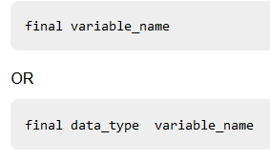

**Syntax: const keyword**

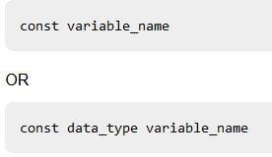

* Only **const** variables can be used to compute the compile time constant.
* Compile-time constants are constants whose value will be declared at compile time.

**Assignment Operator**

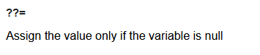

**Logical Operator**

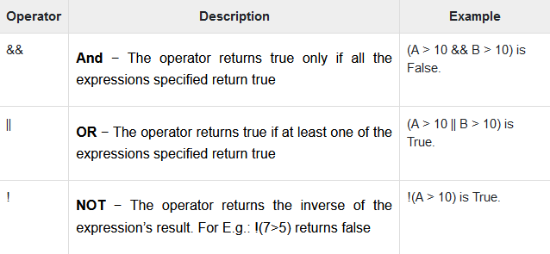

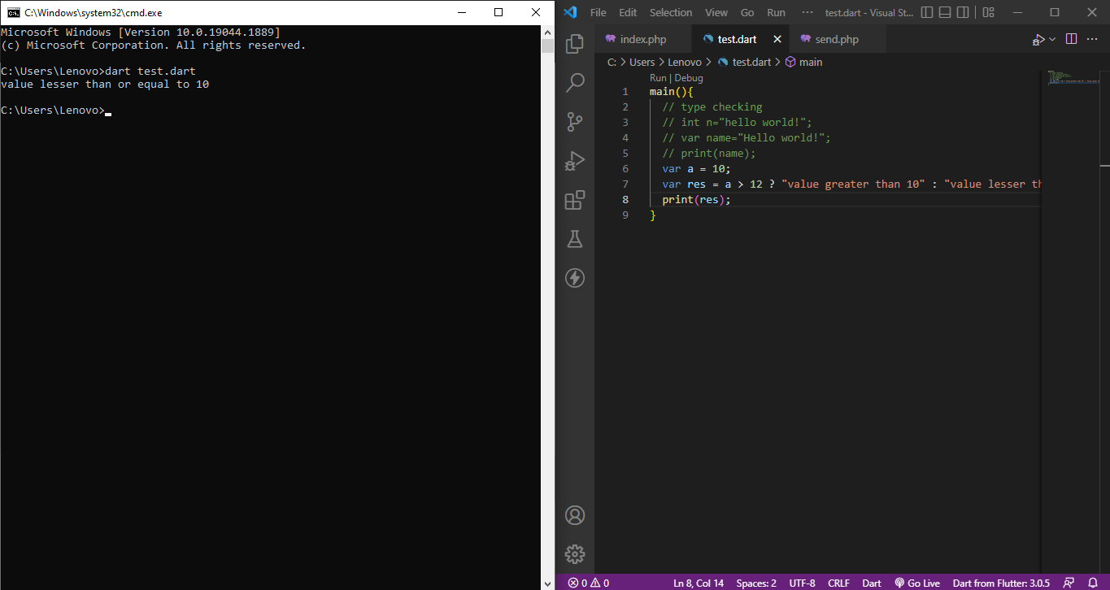

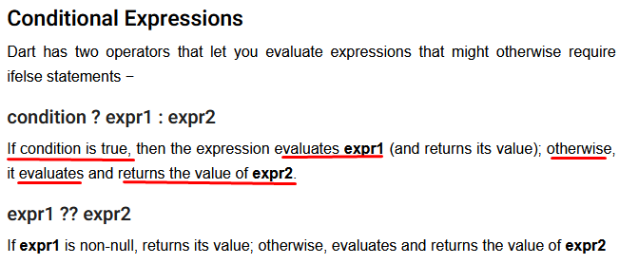

**Loop**

