# **Findings:**

### **Knowing the shape and exploring the dataset.**

* *Shape of the dataset.*

Train: X=(60000, 28, 28), y=(60000,)

Test: X=(10000, 28, 28), y=(10000,)

* *Exploring the unique values in the dataset.*

|  |  |  |
| --- | --- | --- |
| Labels | Count Train | Count Test |
| 0 | 5923 | 980 |
| 1 | 6742 | 1135 |
| 2 | 5958 | 1032 |
| 3 | 6131 | 1010 |
| 4 | 5842 | 982 |
| 5 | 5241 | 892 |
| 6 | 5918 | 958 |
| 7 | 6265 | 1028 |
| 8 | 5851 | 974 |
| 9 | 5949 | 1009 |

* *Sample images from the dataset.*

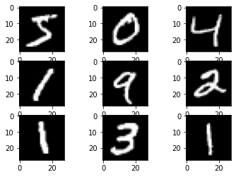

### **Keras Model Training.**

Epoch 1/5

469/469 [==============================] - 41s 87ms/step - loss: 0.1749 - accuracy: 0.9502 - val_loss: 0.0692 - val_accuracy: 0.9784

Epoch 2/5

469/469 [==============================] - 42s 89ms/step - loss: 0.0569 - accuracy: 0.9830 - val_loss: 0.0606 - val_accuracy: 0.9800

Epoch 3/5

469/469 [==============================] - 41s 87ms/step - loss: 0.0342 - accuracy: 0.9897 - val_loss: 0.0615 - val_accuracy: 0.9807

Epoch 4/5

469/469 [==============================] - 42s 90ms/step - loss: 0.0214 - accuracy: 0.9936 - val_loss: 0.0531 - val_accuracy: 0.9835

Epoch 5/5

469/469 [==============================] - 41s 88ms/step - loss: 0.0119 - accuracy: 0.9967 - val_loss: 0.0521 - val_accuracy: 0.9847

<tensorflow.python.keras.callbacks.History at 0x7f3c80a9acc0>

### 

### **Observations.**

* The CNN model is able to get 98%+ accuracy with just a single convolution layer.
* We can also add more Conv2D layers, and also play around with the hyperparameters of the CNN model to increase the accuracy furthermore.

### **Prediction of individual values.**

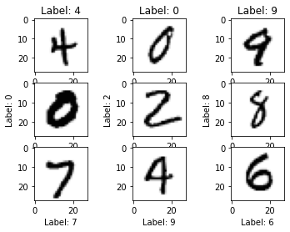

### **Time taken by Keras model on an average.**

Keras inferences with 0.05274093151092529 second in average

[[7.6969547e-10 6.5950162e-10 2.2239202e-08 2.7859372e-05 2.2992467e-06

3.4237412e-06 2.6487391e-12 1.2932930e-04 5.7199271e-05 9.9977988e-01]]

Predicted value: 9

Correct prediction !

### **Time taken by an ONNX model on average.**

ONNX inferences with 0.002775883674621582 second in average

ONNX predicted value: 9

Correct prediction !

The ONNX's and keras' prediction are matching !