Capstone Project Milestone 2: Working System and Preliminary Results
DataSage: An Agentic System for Data Quality, Cleaning, and Analysis · Group 25 · Repository: https://github.com/shrey-Bish/cse598-group25-datasage

Basic Information
Project title: DataSage: An Agentic System for Data Quality, Cleaning, and Analysis
Stakeholder name: Vyshanth Buddani Meeting date: October 19, 2026 (written review October 28, 2026)
Student name | Email | GitHub
Shrey Bishnoi | sbishno2@asu.edu | shrey-Bish
Arsha Jindal | ajinda20@asu.edu | Arshajindal
Ritik Agarwal | ragarw68@asu.edu | ritwiz06
Vatsal Nirmal | vnirmal3@asu.edu | vatsal-prog
Maulik Jadav | mjadav@asu.edu | maulik-jadav

Section 1 Stakeholder Follow Up and Final Deliverables
Meeting. October 19, 2026, 2:00 to 2:45 PM MST, on Zoom. Participants: Vyshanth Buddani (stakeholder) and all five team members: Shrey Bishnoi, Arsha Jindal, Ritik Agarwal, Vatsal Nirmal and Maulik Jadav. Notes: the team walked through the plan and design (no working system yet). Vyshanth praised the planned replay script and change log and asked us to keep the defaults simple so users are not asked unnecessary questions. Because nothing was running yet, his review of the working system and results was done in writing afterwards.
Review of the working system (October 28, 2026). Once the system was built we sent Vyshanth the demo on his file (Section 4), the results (Section 3) and a decision form; he answered in writing and signed off that he reviewed both. Useful: the replay script, the change log and the approvals, which he said give full auditability and would make him trust an answer; 3 questions on his file is ideal and the report layout can stay. Still unmet: inconsistent date strings and negative refund rows. The small model's speed (about 15 s) convinced him it should be the default.
Table 1 lists his feedback, what we did about it and what comes next. Rows 1 to 5 come from the Milestone 1 meeting on September 28, 2026; rows 6 to 9 come from his October 28 review.
Table 1: Feedback → Team response → Next action.
# | Feedback | Team response | Next action
1 | Correctness first: never change the original, log every change, ask before uncertain changes. | Original kept read-only; every fix is a new version with a logged reason, rows and cells touched, risk and approval. Risk is set in code, not by the model. | Done; he confirmed the outputs give full auditability.
2 | Only simple formatting fixes may run without asking. | Trimming, case or space merges and clean parses run on their own; everything else asks (3 times on his file). | Keep; he finds 3 questions ideal.
3 | Stay focused on CSV/Excel and common tabular issues. | 8 issue types, 7 check tools, 9 fix tools; no new formats. | Scope agreed (below).
4 | Rules file first; trusted-document retrieval later. | lookup_rules reads a JSON rules file. Retrieval not built. | Retrieval stays optional.
5 | Treat the numeric targets as initial goals; adjust after testing. | All targets measured (Section 3); speed with the large model misses 60 s. | Adjusted targets agreed (below).
6 | Make the small model the default and keep the 60 s target; let users switch to the large model. | Small model with the rule: about 15 s, 90% / 80% on held-out tasks (Table 7). | Make 30B the default with an option for 235B; close the gap to 90%.
7 | Blank unreadable dates and convert clear date formats automatically; ask only on ambiguous dates. | Today an unreadable date asks first (medium risk) and only YYYY-MM-DD is accepted. | Make both low risk and logged; ask only for dates like 03/04/2026.
8 | Let a rules file mark negative quantities as refunds (allow_negative_quantities). | Not supported yet; negatives are always treated as rule breaks. | Add the rule key; keep such rows without asking.
9 | Keep checking only question columns; drop near-duplicates; skip the code sandbox. | Matches the current design. | Removed from remaining work (Section 6).

Final deliverables and scope (agreed October 28): (1) the DataSage command-line tool for one CSV or Excel table, a question and an optional rules file, with the five Milestone 1 outputs (quality report, change log, cleaned copy, answer with caveats, replay script); (2) a Streamlit page for the demo; (3) reusable cleaning recipes; (4) a final evaluation on the held-out tasks plus real messy files; and (5) his ratings of 10 reports and an acceptance test. Out of scope: joins across tables, unstructured data, machine learning, writing back to the source, near-duplicate rows and the code sandbox; trusted-document retrieval only if time allows.
Success criteria (agreed): answer accuracy ≥ 90% on the held-out tasks, zero damaged valid data, detection precision ≥ 0.85 and recall ≥ 0.80, planted errors handled ≥ 80%, completion and tool-call success ≥ 95%, at most 3 approvals per question, and ≤ 60 s per question with the small model. Cost is reported in tokens. The acceptance test passes if 3 test files reach ≥ 90% answer accuracy with no valid data corrupted.

Section 2 Implemented Agentic System
DataSage is a single planner agent that calls tools in a loop: the model makes the judgment calls (what to check, which fix fits, when the data is clean enough) and plain Python does every computation. In Figure 1, solid boxes are built, dashed boxes are planned, and NEW marks changes since Milestone 1.
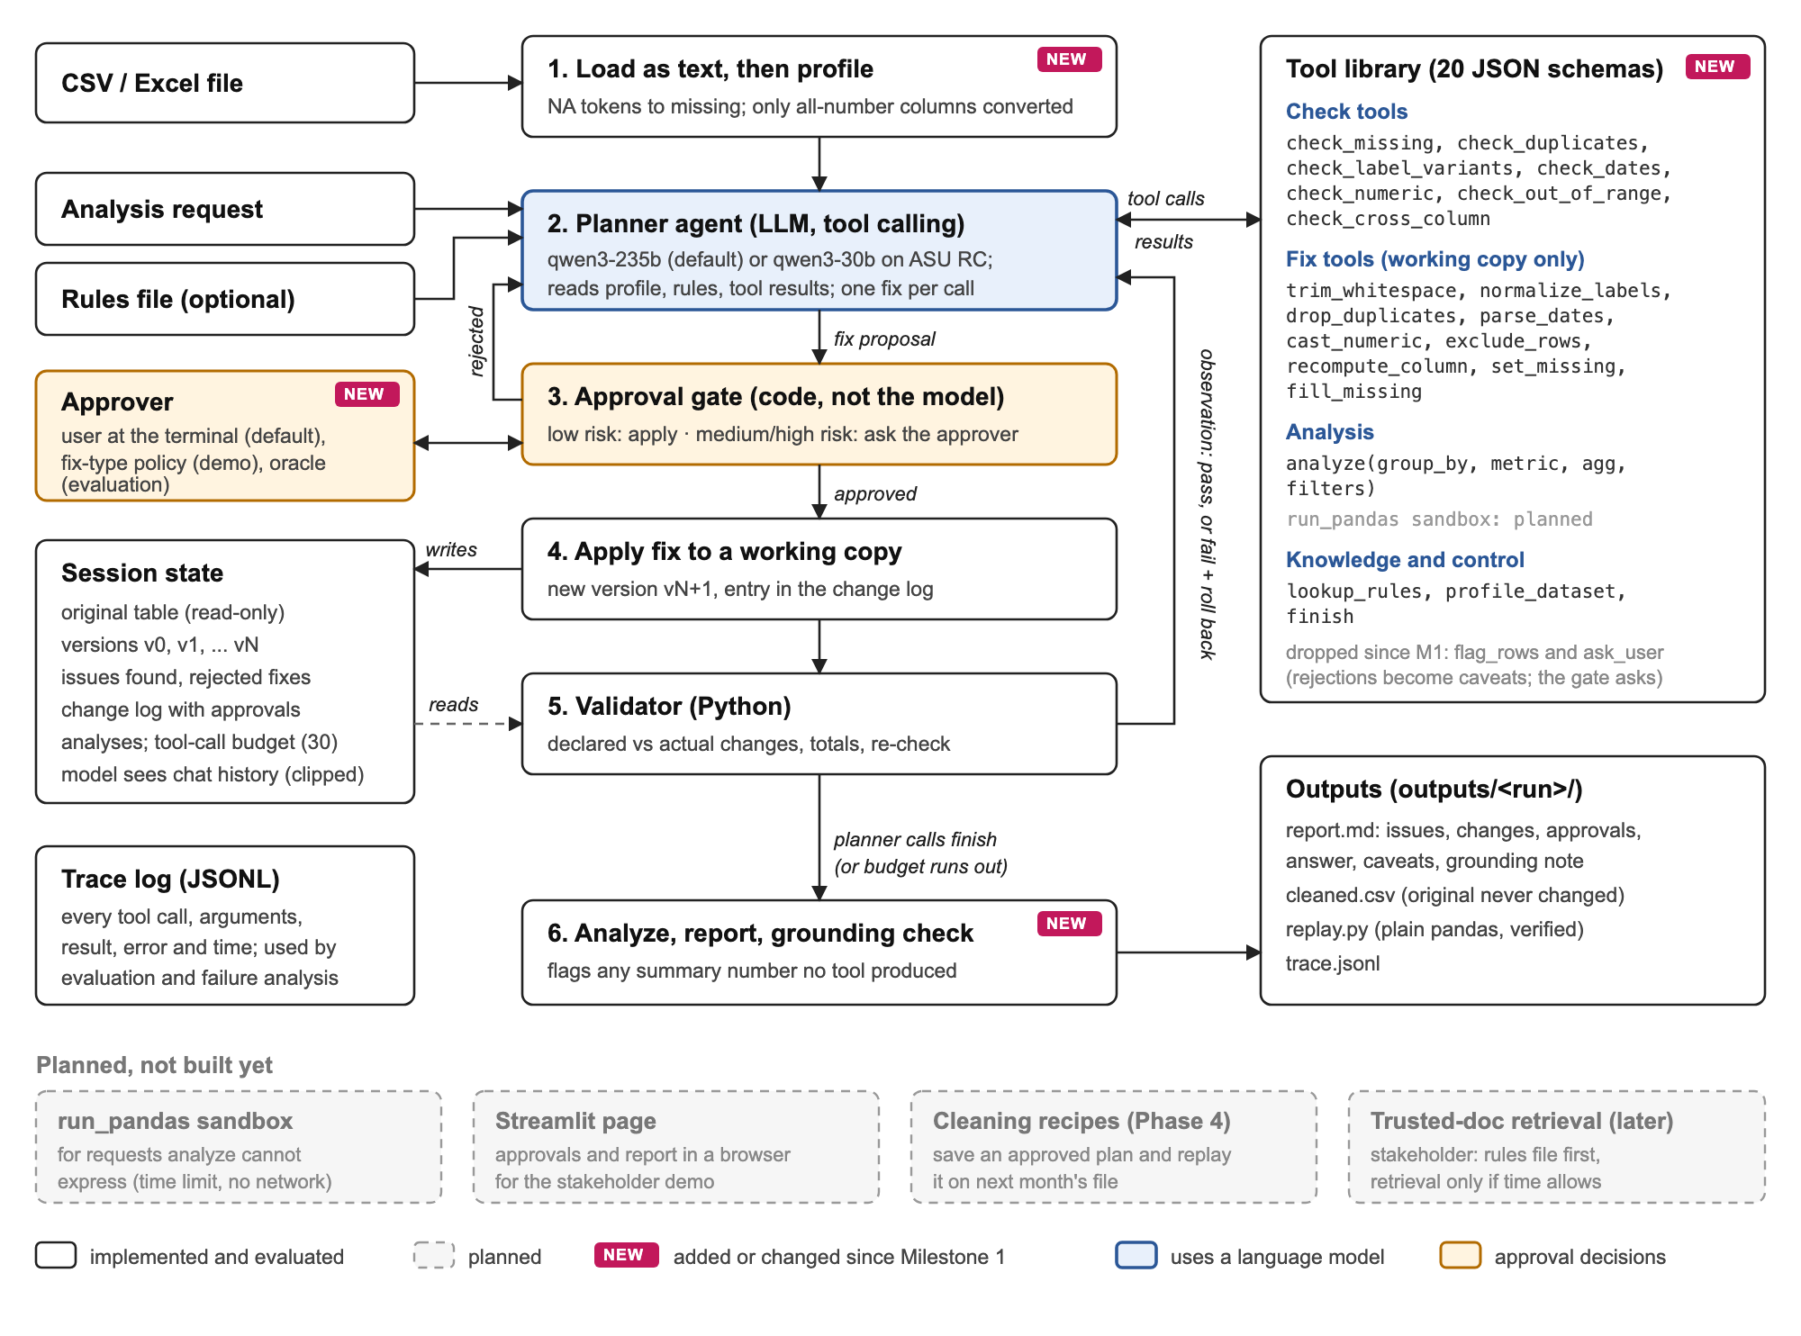
Figure 1: DataSage architecture as implemented for Milestone 2. Only the planner (blue) uses a language model. The approval gate and approver (orange) decide on risky fixes. Dashed boxes are not built yet. Full size: docs/milestone2/architecture.png.

2.1 Workflow from input to output
A user runs python -m datasage --input file.csv --request "..." --rules rules.json. Step numbers match Figure 1:
- Load and profile. The file is read as text; blank, "NA" and "null" become missing, and a column becomes numeric only if every value is a plain number. The original is kept read-only as version v0.
- Plan. The model gets the question, a profile of each column (type, missing count, distinct values, parse rates, case or space variants) and up to 12 sample rows, unusual rows first; it never sees the full table. It reads the rules and runs checks on the columns the question uses. Findings go into the issue list.
- Approval gate. The model proposes one fix per call, with a reason. The fix runs as a dry run on a copy, and code sets its risk from the fix type and what changed. Low risk goes through; medium and high risk go to the approver with the table before and after. A rejected fix becomes a caveat and must not be retried.
- Apply. An accepted fix becomes a new version (v1, v2, ...) with a change-log entry.
- Validate. Before the commit, removed rows must match the declared rows, no other column may change, cell counts and totals must reconcile, and the original check is re-run. On failure the change is dropped and the problems go back to the model.
- Analyze, report, ground. The model calls analyze (group by, metric, aggregation, filters), which refuses to add up a text column, then finish. The run writes report.md, cleaned.csv, replay.py (plain pandas that repeats the approved fixes) and trace.jsonl, and flags any summary number no tool produced.
Changes since Milestone 1. (a) The sandboxed run_pandas tool is not built yet, so analysis is structured only; every benchmark question fits that form. (b) We dropped flag_rows and ask_user: asking now happens inside each fix call through the gate, and a rejection becomes a caveat, so the model never decides on its own whether to ask. (c) The model sees the chat history with each tool result cut to 6,000 characters, not a compact state summary rebuilt every step. Runs are short (median 12 tool calls), so the history fits, but it costs tokens (Section 5). (d) After the failure analysis we added one rule to the system prompt about rule-breaking rows (Section 5); results are reported with and without it. (e) Dates are accepted only as YYYY-MM-DD, so a different format such as 03/04/2026 is flagged as invalid, not converted (planned, Section 6). Near-duplicate rows are not detected; the stakeholder dropped them from scope.

2.2 Agentic mechanisms
Table 2 lists each mechanism, when it runs, what it reads or updates, and how it changes what happens next.
Table 2: Agentic mechanisms in the implemented system.
Mechanism | When it is used | Reads / updates | Effect on the next action
Planner agent (one LLM with tool calling) | Every turn until finish or 30 tool calls | Reads the question, profile, sample rows and all earlier tool results | Picks the next check, fix, analysis or finish. Hitting the budget ends the run with a partial report.
Tools (20 JSON schemas: 7 checks, 9 fixes, analyze, lookup_rules, profile_dataset, finish) | Each call | Arguments validated with pydantic; bad calls return an error as text, for example the list of real column names | The model corrects the call instead of the run crashing. Outputs stay short (counts, a few row ids).
Session state (memory within a run) | Every check and fix | Read-only original, versions v0 to vN, issue list, rejected fixes, change log, analyses | Later checks and analyze run on the newest version. The report and replay script are built from the change log.
Rules file (knowledge) | lookup_rules, called first in every evaluated run | Allowed labels, ranges, formulas, date format | Supplies the ranges and formulas the model passes to check_out_of_range and check_cross_column, and the correct spellings for label fixes.
Approval gate with code-set risk tiers | Every fix | The dry-run result: rows removed, cells changed, new missing values | Rejected: not applied, becomes a caveat. Approved or low risk: goes to the validator.
Validator (verification during execution) | Every fix that passed the gate | Declared vs actual rows and cells, untouched columns, totals, re-run of the check | Fail: the change is discarded and the problems become the observation. Pass: new version.
Grounding check and trace | End of run; every call | Numbers in the summary vs tool outputs; each call, arguments, output and time | Unsupported numbers are listed as a warning. The trace drives scoring and eval/failures.py.

Why one agent. The work is sequential on one shared table, so a single planner avoids coordination cost. The validator and the risk tiers are plain code because row counts and totals must be checked exactly. The failures we found came from choosing the wrong fix, not from missing a second opinion, so we did not add the reviewer model mentioned in Milestone 1.
Models, frameworks and services. The planner is Qwen3-235B-A22B-Instruct-2507 by default, with Qwen3-30B-A3B-Instruct-2507 as the small model. Both are served by ASU Research Computing through an OpenAI-compatible API, called with the openai Python SDK at temperature 0. The rest is Python 3.13, pandas 3.0.5, pydantic 2, openpyxl and python-dotenv. We wrote the agent loop ourselves (datasage/agent.py, under 200 lines) instead of using an agent framework, so we control the state, the gate and the logging. Error handling: invalid arguments, unknown tools and validator failures go back to the model as text; API errors get the SDK's two retries with backoff and then end the run with a partial result. The repository has 13 unit tests (checks, fixes, risk tiers, validator, analysis, grounding), all passing.

Section 3 Preliminary Evaluation Results and Analysis

3.1 Datasets
Our planted-error benchmark (eval/generate.py) gives every task an exact answer. It plants errors in a clean table and records each one (row, column, type, messy and clean value, and the correct resolution: restore, exclude the row, set or keep missing, or drop the copy). Applying the resolutions gives a reference table, and each reference answer is computed on it with the same analyze code the agent uses. Each table has a rules file and two questions (counts, sums or means by group, some filtered) that touch the planted errors (Table 3).
Table 3: Datasets. Rows are per table; all systems ran on every task listed.
Dataset / split | Source | Tables | Rows | Tasks | Planted errors
Sales, dev | Synthetic orders with the same columns as the stakeholder's messy_sales.csv | 10 | 41 to 65 | 20 | 96
Penguins, dev | Rows sampled from the public Palmer Penguins table (344 rows, CC0) | 10 | 44 to 68 | 20 | 95
Sales, held-out | Same generator, new seed (101), made after the fix in Section 5 | 10 | 43 to 72 | 20 | 108
Penguins, held-out | Same generator, new seed (101) | 10 | 43 to 67 | 20 | 88

What each one tests. Sales follows the stakeholder's file and use scenario: case variants and misspellings, duplicates, unreadable dates, text prices ("$1,200.00"), negative quantities and Revenue ≠ Quantity × Price. Penguins is a real public table from another domain (misspelled species and islands, impossible measurements, text numbers, duplicates), so DataSage is not tuned to one schema. Splits: the 40 dev tasks were used for all development and the failure analysis; the 40 held-out tasks were generated after the fix and run unchanged. Limitations: small tables, one generator for both splits, and no real messy files yet.

3.2 Baselines
Table 4: Baselines. None of them is DataSage.
Baseline | What it does | Why it is a fair comparison
B0: stakeholder baseline | Vyshanth's run_baseline.py, unchanged: five fixed checks, no cleaning. It has one built-in analysis, so we answer each question on the uncleaned file with our analyze code. | What a user gets today by trusting the raw file.
B1: fixed cleaning script | No model. Trims and merges case variants to the most common form, drops exact duplicates, converts mostly-numeric text, blanks invalid dates in columns named "date", drops rows with negative numbers. It is handed the question already structured. | Tests whether per-file decisions beat a careful fixed script. B1 gets the parsed question for free.
B2: single model call | The same 235B model gets the profile, sample rows, rules and question in one prompt and returns issues plus pandas code (clean, answer). We run the code once in a separate process (60 s limit); no checks, retries or approvals. | Tests whether the loop, tools, gate and validator add value over just asking the model.

3.3 Metrics and evaluation conditions
Table 5: Metrics, how we score them (eval/scoring.py) and the Milestone 1 targets.
Metric | Definition | M1 target
Answer correct | Same groups as the reference, every value within 0.5% (0.01 minimum) | ≥ 90%
Completed (done) | An answer was produced within the budget | ≥ 95%
Detection P / R | Reported (type, column) pairs vs planted ones. Milestone 1 said row level; checks report per column, so we score per column | ≥ 0.85
Errors handled | Planted errors whose row ends in the right state (value restored, row removed, value blank, one copy left) | ≥ 80%
Damage | Valid cells changed plus valid rows removed, compared with the reference table | 0
Tool-call OK / recovery | Calls without an error; errors followed by a successful call | ≥ 95% / ≥ 80%
Approvals | Approval requests per task (median) | ≤ 3
Latency / tokens | Wall-clock seconds and prompt + completion tokens per task (median) | ≤ 60 s / -

Conditions. All systems ran on the same tasks. Model calls use temperature 0. DataSage has a budget of 30 tool calls and 180 s per model call. Automated runs need someone to answer approvals, so an oracle built from the planted-error records (eval/oracle.py) stands in for the user: it approves a medium or high risk fix only if every removed row should be excluded or is a duplicate copy, and every changed cell gets its reference value. Anything else, such as filling a missing value, is rejected. B0, B1 and B2 never ask. DataSage and B2 must parse the question themselves; B0 and B1 get the structured form. Many tasks ran in parallel against a shared endpoint, so latency includes queueing. Each task ran once. No human or model-based grading is used; all scores are computed from the reference data.

3.4 Results
Table 6: Main results on the dev tasks. DataSage rows use the prompt without the exclusion rule from Section 5. Damage counts cells plus rows over all 20 tasks. Held-out accuracy for every system is in Table 7.
System | Answer correct | Done | Detect P / R | Errors handled | Damage | Tool OK | Approvals | Time (s) | Tokens
Sales, dev (20 tasks)
B0 stakeholder baseline | 0% | 95% | 0.80 / 0.61 | 19% | 0 | - | - | < 1 | 0
B1 fixed script | 70% | 100% | 0.74 / 0.80 | 80% | 0 | - | - | < 1 | 0
B2 single model call (235B) | 30% | 80% | 0.70 / 0.75 | 68% | 195 | - | - | 23 | 2k
DataSage, 235B | 85% | 100% | 0.84 / 0.85 | 89% | 0 | 100% | 3 | 152 | 56k
DataSage, 30B | 65% | 100% | 0.78 / 0.76 | 75% | 0 | 100% | 3 | 16 | 55k
Penguins, dev (20 tasks)
B0 stakeholder baseline | 5% | 80% | 1.00 / 0.60 | 24% | 0 | - | - | < 1 | 0
B1 fixed script | 45% | 100% | 1.00 / 0.81 | 80% | 0 | - | - | < 1 | 0
B2 single model call (235B) | 45% | 100% | 0.86 / 0.74 | 79% | 25 | - | - | 28 | 2k
DataSage, 235B | 85% | 100% | 0.88 / 0.78 | 84% | 0 | 100% | 2 | 197 | 52k
DataSage, 30B | 70% | 100% | 0.88 / 0.79 | 85% | 0 | 100% | 2 | 15 | 57k

Table 7: Answer accuracy on dev and held-out tasks (20 each), for the baselines and for DataSage before and after the exclusion rule (Section 5). The strict approver also rejects edits to rows that should be excluded.
System | Sales dev | Penguins dev | Sales held-out | Penguins held-out | Held-out damage
B0 stakeholder baseline | 0% | 5% | 0% | 5% | 0
B1 fixed script | 70% | 45% | 40% | 30% | 0
B2 single model call (235B) | 30% | 45% | 85% | 35% | 31
DataSage, 235B | 85% | 85% | 80% | 45% | 0
DataSage, 235B + exclusion rule | 100% | 100% | 80% | 95% | 0
DataSage, 30B | 65% | 70% | 95% | 40% | 0
DataSage, 30B + exclusion rule | 95% | 85% | 90% | 80% | 0
DataSage, 30B + rule + strict approver | 100% | 85% | 90% | 65% | 0

Table 8: Ablations (235B, first 10 dev tasks of each dataset, the same tasks for all three rows).
Dataset, system | Answer correct | Tasks | Damage
Sales, DataSage, 235B | 100% | 10 | 0
Sales, DataSage, all risky fixes rejected | 30% | 10 | 0
Sales, DataSage, no validator | 100% | 10 | 0
Penguins, DataSage, 235B | 90% | 10 | 0
Penguins, DataSage, all risky fixes rejected | 0% | 10 | 0
Penguins, DataSage, no validator | 80% | 10 | 0

3.5 Analysis
Where DataSage improves. On the dev tasks the 235B agent answers 85% of sales and 85% of penguin questions, against 70% and 45% for B1 and 30% and 45% for B2, with no damage. On the held-out tasks the same agent scores 80% and 45%: held-out penguins has the most rule-breaking rows, which trigger the main failure in Section 5. With the exclusion rule it reaches 80% and 95%, against 40% and 30% for B1 and 85% and 35% for B2. Over all 40 held-out tasks that is 88% against 35% for B1 and 60% for B2, which clears the Milestone 1 bar of a 15-point gain over both baselines but not the 90% accuracy target. It beats B1 because it reads the rules file: allowed labels let it fix most misspellings, such as "Electornics" and "Dram", and ranges let it drop impossible values such as a 4,750,000 g penguin, which B1 keeps because it only drops negatives. It beats B2 because B2 sees only 12 sample rows and cannot check its code: on held-out penguins 11 of its 13 wrong programs never filter impossible values; on sales dev 4 programs crashed, 11 of 14 wrong answers come from code that silently flips negative quantities with abs() (deciding the refund question without asking), and 5 tasks damaged valid data, for example by filling every missing Region with "Unknown".
Where it is similar or worse. The one place a baseline wins is held-out sales, where B2 scores 85%. In 3 of DataSage's 4 misses there, the check found misspellings such as "Furnture" and "Wst", but the model merged only the case variants and never proposed the spelling fix, which needs approval; 1 more ran out of its 30-call budget. B1 handles about 80% of planted errors with zero damage in under a second. DataSage's detection recall (0.85 and 0.78) is close to B1's and below target because it checks only the columns the question uses, a deliberate trade-off. Most of its false positives are a scoring artifact: with a minimum of 1 in the rules, check_out_of_range also reports negative rows as "out_of_range". Speed and size are the clear weak points: 152 to 197 s and about 56k tokens per task, against the 60 s target and about 2k tokens for B2.
Model size and the exclusion rule. The 30B model takes about 16 s but scored 65% and 70% on dev, with the same kind of mistakes as the 235B model. With the rule it reaches 95% and 85% on dev and 90% and 80% on held-out; on held-out tasks it fixed 10 and broke 3, with the biggest gain on penguins, which has the most rule-breaking rows. With the 235B model the rule raised dev accuracy from 85% and 85% to 100% and 100% (6 tasks fixed, 0 broken), but those are the tasks the rule was written on, so the held-out numbers are the fair test. The strict approver made no consistent difference: on 78 tasks where it rejected nothing, so approvals were identical, 6 still came out differently between the two runs, a measure of single-run noise.
Ablations and tool use (Table 8). Rejecting every risky fix lowers accuracy, as expected, but damaged nothing; across 20 runs the agent was told "no" 44 times and never retried a rejected fix. Turning the validator off changed only a few answers, within run-to-run noise, because the validator never failed a fix in any run: the fix tools are plain code and always did what they declared. It guards against bugs in those tools, which only the unit tests trigger. Over 474 tool calls the 235B model made 0 invalid calls (30B: 1 in 495), both read the rules first in every run, and approvals stayed at a median of 2 to 3 per task.
Not yet measured: real messy files, the stakeholder's ratings and acceptance test, cost in dollars and repeated runs (Section 6).

Section 4 Demo: Vyshanth's Sales File
Task and expected outcome. The input is the stakeholder's own baseline/examples/messy_sales.csv (8 rows) and the question "What was total revenue by category?", with a rules file (examples/messy_sales_rules.json) that lists the allowed categories and regions, says Quantity is at least 1, gives Revenue = Quantity × Price and the date format. His baseline reports Accessories $1,350 because a duplicate row is counted twice and "accessories" stays separate. In Milestone 1 we worked out the right answer by hand: Accessories $830, and Electronics $2,185 if the negative webcam row is a refund or $2,245 if it is an error. To act out a user who treats that row as a refund, we ran with --approve tools --allow drop_duplicates,parse_dates, which approves those two fix types and rejects everything else.
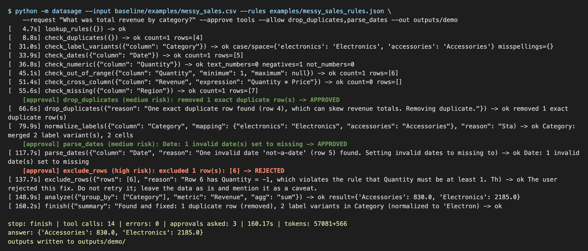
Figure 2: Console output of the actual run. Each line is one tool call with its arguments and result. Indented lines are approval decisions (green approved, red rejected). The last lines give the stop reason, call count, approvals, time and tokens.
Walkthrough (Figure 2). The model reads the rules first, then runs one check per relevant column. check_duplicates finds row 4. check_label_variants finds "electronics" and "accessories" as case variants. check_dates finds the unreadable date in row 5. check_numeric and check_out_of_range (with the rules' minimum of 1) both point at row 6, Quantity −1. check_cross_column with the rules' formula finds no Revenue mismatch, so no recompute is proposed. check_missing finds the blank Region in row 7, which the question does not use, so it is left alone and reported. Then it fixes the problems one at a time:
- drop_duplicates removes a row, so the gate rates it medium risk and asks. Approved, and the validator confirms that exactly the declared row was removed: version v1.
- normalize_labels merges two labels that differ only by case. Low risk, applied with no question: v2.
- parse_dates turns one value into a missing value, which raises it to medium risk. Approved: v3.
- exclude_rows on row 6 is high risk. The approver rejects it, the tool answers "Do not retry it; leave the data as is and mention it as a caveat", and the model moves straight to analyze.
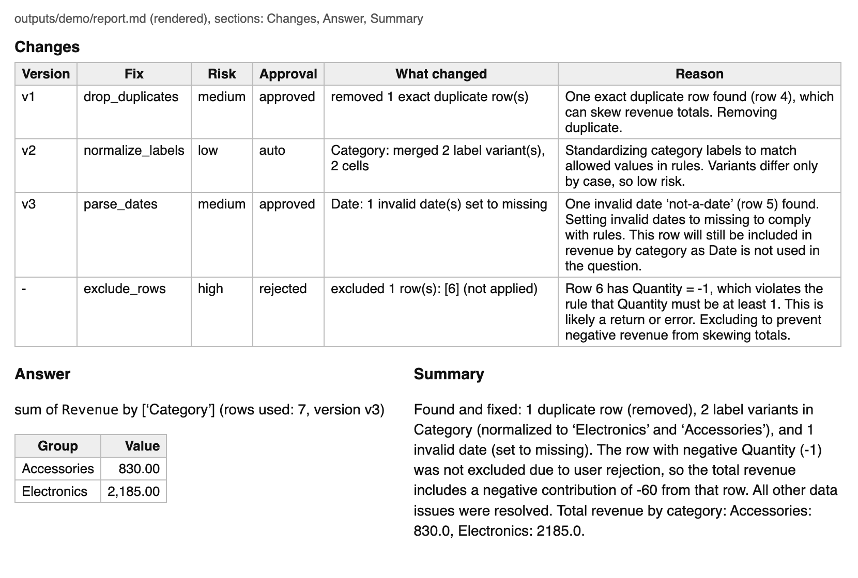
Figure 3: Part of the report.md written by the same run: the change log with the risk and approval of each fix (including the rejected one), the answer table and the model's summary with the caveat. The full report also lists every problem found (docs/milestone2/demo/report.md).
Result. analyze runs on v3 and returns Accessories 830 and Electronics 2,185, the expected answer for the refund reading. The summary states that the −1 row was kept because the user rejected excluding it. The run used 14 tool calls with no errors, asked 3 questions (the Milestone 1 limit) and took 160 s, well over the 60 s target. We re-ran the generated replay.py without the agent and it produced exactly the same 7 rows and 56 cells as cleaned.csv.
Link to the architecture. The run shows every implemented box in Figure 1: planning with the rules file (steps 1 and 2), the gate setting risk in code and the approver deciding (step 3), versions and the change log in the session state (step 4), the validator passing each applied fix (step 5), and the report, replay script and caveat (step 6). It also shows why the task needs an agent: whether the −1 row stays depends on the user's answer, and the model adapted its plan to the rejection instead of repeating the fix.

Section 5 Failure Analysis and Current Limitations
eval/failures.py lists the likely cause of every wrong task from its trace and planted errors (for example "never ran a check for out_of_range"); we confirmed the main cases by reading the traces.

Case 1: rule-breaking rows blanked instead of removed (main failure)
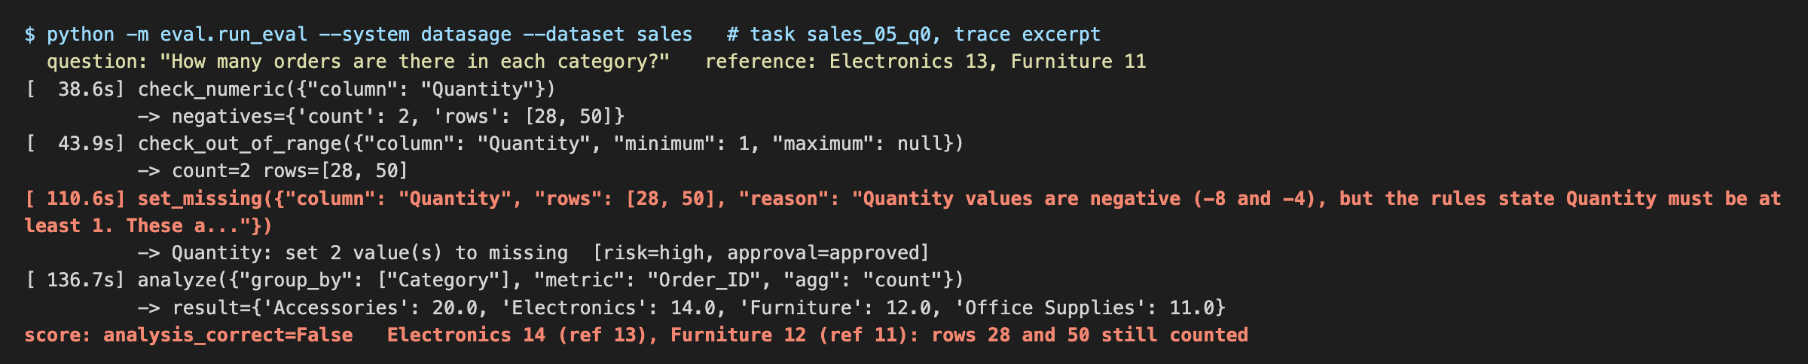
Figure 4: Trace excerpt from task sales_05_q0 (DataSage, 235B, dev). Both checks point at rows 28 and 50; the planner blanks Quantity in those rows instead of excluding them, so the count still includes them.
Where it occurred: in planning, when choosing the fix, and it got past our approval oracle. Observed (Figure 4): the question is "How many orders are there in each category?". check_numeric and check_out_of_range both report rows 28 and 50, whose Quantity (−8 and −4) breaks the rule "Quantity must be at least 1". The planner calls set_missing on those two cells instead of exclude_rows. This is high risk, so the oracle is asked, and it approves: it only rejected edits to rows that should be kept, and these rows were going to be excluded anyway. The validator passes because the fix did exactly what it declared. analyze then counts rows per category and the two rows still count: Electronics 14 instead of 13 and Furniture 12 instead of 11. Evidence across the benchmark: this pattern is the first-listed cause for 6 of the 6 wrong dev tasks for the 235B model and 11 of 13 for the 30B model. It only hurts questions that count rows or use another column of the bad row; a sum of Quantity skips the blank anyway. Suspected cause (not proven): the prompt asks for "the smallest correct fix" and says not to change values it is unsure about, which pushes the model toward a one-cell edit.
Fix: one rule added to the system prompt (EXCLUSION_RULE in datasage/agent.py): when a row breaks a rule, propose exclude_rows and let the user reject it; use set_missing only for unreadable values in rows that are otherwise valid. We also tried a stricter approver that rejects any edit to such rows, like a user whose policy is "drop rows that break a rule". How we checked it: we re-ran all 40 dev tasks, and because the fix was found on dev tasks we also ran it on the 40 held-out tasks generated afterwards (Table 7). With the 30B model the rule fixed 10 dev tasks and broke 1 (penguins_00_q0), and the blanking pattern went from 11 failures to 0. With the 235B model it fixed 6 dev tasks and broke 0.

Case 2: partial success, the metric column was never checked
Where it occurred: planning (which columns to check). Observed: in task penguins_00_q0 ("What is the average body mass for each sex?") the 30B model with the new rule did several things right. It merged " Adelie" and "Chinstrap ", fixed "Bisco" and "Dram", removed a duplicate, and correctly excluded the two rows with negative flipper lengths. But it never ran a check on body_mass_g, the column it was averaging. Two planted values of 4,750,000 g and 3,550,000 g (grams typed as milligrams) stayed in, and the female average came out as 254,991 g instead of 3,700 g. The answer is obviously wrong to a person, but nothing in the run looked at it. Evidence: the trace lists every call, and no check names body_mass_g; eval/failures.py gives the same cause for 2 of the 4 remaining 30B failures after the fix. Proposed fix: a coverage check in code before analyze runs: every column the call uses (group by, metric, filters) must have been checked at least once, with a range check when the rules give a range; otherwise analyze returns an error naming the column, so the model checks it first. How we will check it: re-run the failed tasks and the full held-out set; success means no "never checked" failures and no lower accuracy elsewhere.

Broader limitations
- Speed and token use. The 235B agent needs a median of 152 s and about 56k tokens per sales task; the 30B model takes 16 s. Most tokens come from resending the whole conversation to the model on every turn of a run (a median of about 12 tool calls). A compact state summary (Section 6, item 3) should cut this.
- Coverage and data. Only group-by, aggregate and filter questions on one table (enough for the stakeholder), and dates only as YYYY-MM-DD. All errors are planted by our own generator into small tables, so real messy files (Section 6, item 4) are needed before we can say the numbers carry over.
- Simulated user. The oracle knows the right answer. A real user may approve a wrong fix or reject a right one. The reject-all ablation covers one extreme; the stakeholder's ratings will show real behavior.
- Verification gaps. The validator never failed a fix in any evaluated run, so only unit tests show that it catches a bad one. It checks that a fix did what it declared, not that it was the right fix (Case 1). The grounding check only warns and does not block a report.
- Single runs on a shared service. Temperature 0 does not make runs repeat exactly, so a difference of one or two tasks is within noise until we repeat runs. If the ASU endpoint is slow or down, DataSage stops with a partial result.

Section 6 Remaining Work Before the Final Submission
Table 9 lists the remaining work in priority order. Items 1 to 8 are required; trusted-document retrieval is optional. Near-duplicate rows and the code sandbox were dropped from scope by the stakeholder. Owners are [to be agreed by the team].
Table 9: Remaining work.
# | Item | Current gap | Planned work or experiment | Owner | Done when
1 | Small model as default | 30B with the rule: 90% / 80% on held-out | 30B default, 235B optional; compact state summary instead of full history | [owner] | ≥ 90% on held-out in ≤ 60 s
2 | Coverage check, spelling merges | Metric never checked (case 2); misspellings not merged | Check columns in analyze; rule to propose merges into allowed labels | [owner] | No such failures on held-out
3 | Dates and refunds (his unmet needs) | Unreadable dates ask; YYYY-MM-DD only; negatives always rule breaks | Auto-blank and convert clear formats, ask on ambiguous; allow_negative_quantities | [owner] | His two files answered correctly
4 | Real messy files | Planted errors only | His two files, questions and draft rules (sending summaries to ASU allowed), plus public files | [owners] | Results for all systems
5 | Repeated runs | One run per task | 3 runs of DataSage and B2 on held-out | [owner] | Mean and range
6 | Ratings and acceptance test | Not started | He rates 10 reports (Nov 16 to 20); 3 test files | [owner] | ≥ 90% accuracy, no corrupted data
7 | Streamlit page, cleaning recipes | Command line only | Upload, approve, read the report in a browser; save and replay an approved plan | [owners] | Shown at Demo Day with the replay script
8 | Review, final report, demo | - | Review on Nov 20, 2026, 2:00 PM MST (Zoom); final report and slides | All | Submitted

Section 7 GitHub Repository and Team Contributions
Repository: https://github.com/shrey-Bish/cse598-group25-datasage (public). Branch: main. Commit for this submission: 0b06910. The README gives setup (Python 3.11+, pip install -r requirements.txt, an .env with the ASU endpoint key), the demo command from Section 4, and the commands that regenerate the benchmark and every table in Section 3. All per-task results and traces are in eval/results/; the demo outputs are in docs/milestone2/demo/.
Table 10: Team contributions.
Member (GitHub) | Contributions | Commits / PRs
Shrey Bishnoi (shrey-Bish) | Code: the agent, tools, approval gate, validator, analysis and report builder (datasage/); baselines B1 and B2; benchmark generator, scoring, oracle, failure classifier and held-out split; tests; evaluation runs; diagram and demo. | 0246a25, 0c83405, e54a845, ffa7f5a, a0a7003, 5717203, 52ccaa1, 0b06910
Arsha Jindal (Arshajindal) | Report writing. | No commits (non-code work)
Ritik Agarwal (ritwiz06) | Stakeholder communication and meeting notes. | No commits (non-code work)
Maulik Jadav (maulik-jadav) | Reviewing the evaluation results. | No commits (non-code work)
Vatsal Nirmal (vatsal-prog) | Team coordination. | No commits (non-code work)

