All data cleaning and profiling for my dataset was conducted using Map-Reduce in homeworks 7 and 8. Here are screenshots of evidence of completion/compilation of the codes outlined in so_readme:



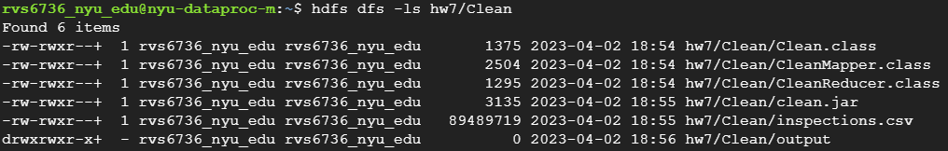

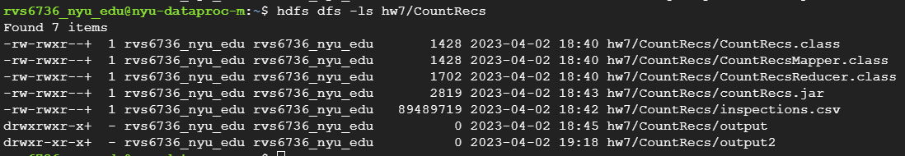

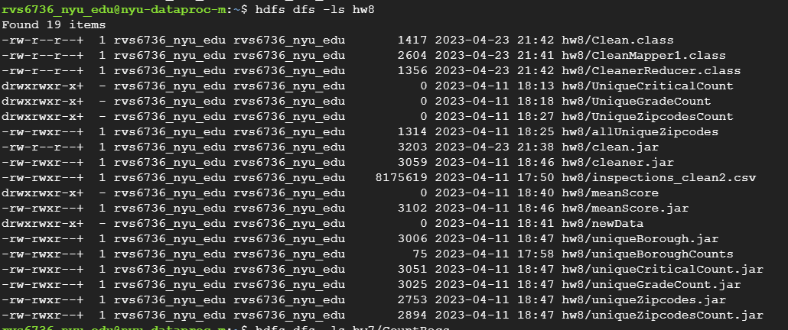





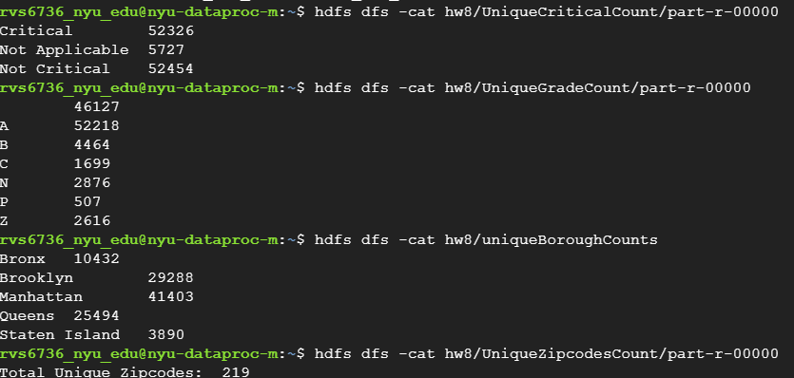



Running UniqueCriticalCount.jar on clean data to profile data:

