ABSTRACT
Operating systems keep the pages a program is using in a small, fast main memory (RAM) and the rest on a slow disk. When a requested page is not in RAM, the program stops until the page is read from disk: a page fault. Classical paging only reacts to faults and decides which page to evict (FIFO, LRU, Clock). This project studies predictive paging: guessing the next pages and loading them early (prefetching), together with a decision engine that decides when a guess is worth the risk, because on a full memory every prefetch evicts a page and a wrong guess can cause a fault.
We built a trace-driven simulator in Python with six eviction policies (FIFO, LRU, Clock, LRU-2, ARC and Belady’s optimal OPT), six predictors (stride, order-1 and order-2 Markov chains, a hybrid, a delta-Markov predictor and Linux-style readahead) and nine decision engines, and evaluated them on 22 real benchmark traces (SPEC CPU 2006 and GAP graph workloads) at two memory sizes (44 configurations). We found that confidence and prefetch precision are misleading feedback signals, and that the measured fault delta (faults without prefetching minus faults with prefetching) works best; we obtain it exactly and cheaply with a shadow directory that stores page identifiers only and can be hash-sampled.
The final system, Linux-style readahead combined with a delta-Markov predictor and steered by shadow-directory feedback, removes on average 55.0% of LRU’s page faults (readahead alone 50.7%, Markov prediction alone 7.7%) and is worse than LRU in only 1 of 44 configurations. An I/O time model shows that this becomes an estimated 1.43× speed-up over LRU on a parallel SSD, level with readahead (1.44×), while on a single-channel hard disk every prefetcher is slower than LRU. Fewer page faults therefore do not automatically mean faster programs: prefetch timeliness, extra disk reads and device parallelism decide the outcome.
Keywords: virtual memory, demand paging, page replacement, prefetching, Markov predictor, readahead, feedback control, trace-driven simulation.

Chapter 1: Introduction

1.1 Background
A computer’s main memory (RAM) is fast but small; secondary storage (a hard disk or an SSD) is large but thousands of times slower. The operating system divides memory into fixed-size blocks called pages (4 KB in this project) and keeps only the pages currently in use in RAM, in slots called frames. When a program requests a page that is not resident, a page fault occurs: the program waits while the page is read from disk. When RAM is full, a resident page must be removed to make room; the rule that chooses it is the page replacement (eviction) policy.
Classical policies such as FIFO, LRU and Clock are reactive: they act only after a fault. Belady’s optimal policy (OPT), which evicts the page needed furthest in the future, is the best any eviction policy can do, but it requires knowledge of the future and still pays for the first access to every page (a compulsory fault).

1.2 Motivation
If the operating system could predict which pages a program will need next, it could load them before they are requested (prefetching) and avoid faults, including compulsory faults that no eviction policy can avoid. Prefetching is, however, a bet: on a full memory every prefetched page evicts another page, so a wrong guess can evict a page that is needed soon and create a fault that would not otherwise have happened. A useful predictive paging system therefore needs both a predictor and a component that decides when acting on a prediction is worth the risk.

1.3 Problem statement
To design and evaluate a predictive paging system that (i) predicts future page requests cheaply from the access stream, (ii) decides for each prediction whether to prefetch, using feedback on whether prefetching is actually reducing page faults, and (iii) is compared fairly against classical and modern baselines on real program traces, including an estimate of whether fewer page faults translate into shorter run time.

1.4 Objectives
- Build a correct, reproducible trace-driven simulator of paging with FIFO, LRU, Clock, OPT, ARC and LRU-2.
- Build lightweight predictors (stride, Markov, hybrid, delta-Markov) and a Linux-style readahead baseline.
- Build and compare decision engines, and identify which feedback signal a cost-aware prefetcher should use.
- Make the feedback deployable without a full second copy of memory.
- Evaluate on many real traces at several memory sizes without tuning on the evaluation data.
- Estimate run time, not only page-fault counts, and report limitations honestly.

1.5 Scope
The project is a simulation study. It uses recorded memory-access traces of real programs, replays them through software models of memory, and counts page faults and estimated time. It does not modify an operating-system kernel. The traces are last-level-cache (LLC) load traces mapped to 4 KB pages, which approximate, but are not identical to, operating-system paging behaviour.

1.6 Organisation of the report
Chapter 2 reviews related work. Chapter 3 describes the system design and architecture. Chapter 4 describes the implementation and the experimental method. Chapter 5 describes testing and verification. Chapter 6 presents and discusses the results. Chapter 7 concludes and outlines future work. The appendices explain how to run the project and define the terms used.

Chapter 2: Literature Survey

2.1 Page replacement
Belady [1] defined the optimal replacement policy, which evicts the page whose next use is furthest in the future; it is used as a lower bound in this project. LRU, FIFO and the Clock (second-chance) approximation of LRU are the standard practical policies. LRU-K [2] evicts the page whose K-th most recent access is oldest, which resists one-time scans; we implement LRU-2. ARC [3] balances recency and frequency adaptively using “ghost” lists of recently evicted page identifiers.

2.2 Adapting to the fault rate
The Page Fault Frequency algorithm [4] adjusts the memory allocated to a process according to its measured fault rate. Our decision engine uses a related idea, feedback on faults, but applies it to the prefetching threshold and measures the fault difference caused by prefetching rather than the fault rate.

2.3 Prefetching
Joseph and Grunwald [5] introduced prefetching with Markov predictors, which learn the probability of the next address given the current one; our Markov predictor is a bounded version of this idea. Operating systems use sequential readahead: the Linux page cache fetches a growing window of pages when it detects sequential access; we implement a Linux-style readahead as a baseline. PACMan [6] showed that prefetched cache lines should be inserted with low priority so that wrong prefetches are evicted early. Linux’s workingset code keeps “shadow entries” for evicted pages to detect refaults. SHARDS [7] samples page identifiers by hash to estimate cache behaviour with a small fraction of the memory; we use it to shrink our shadow directory.

2.4 Recent work
Table 1: Recent work and how this project differs
Reference | Focus | Gap relative to this project
[8] Workload-Aware Buffer Prefetching for Database Systems (2026) | database buffer pools | specific to database structures; we target general paging
[9] Learning-based Page Replacement for Efficient I/O (2025) | learned eviction | eviction only, no prefetching
[10] To Cross, or Not to Cross Pages for Prefetching? (2025) | spatial prefetching across pages | spatial patterns only
[11] Beyond VABlock: Aggressive Prefetching for Transformer Workloads (2025) | GPU unified memory | high overhead when the workload deviates; no cost control
[12] Graph Analytics with Attention-Based Prefetcher (2024) | learned prefetcher for graphs | graph-specific, no cost awareness
[13] ML-Based Runtime Prefetcher Selection (2024) | choosing among hardware prefetchers | hardware caches, not OS pages
[14] Tyche: Prefetcher for Indirect Memory Accesses (2024) | pointer chasing | no system-wide cost awareness
[15] Prefetching Indexing Scheme for In-Memory Databases (2024) | in-memory databases | needs application knowledge
[16] EXTMEM: Application-Aware Virtual Memory (2024) | application-directed memory | requires modifying the application
[17] RPG2: Profile-Guided Runtime Prefetch Generation (2024) | profile-guided prefetching | struggles with phase changes

2.5 Research gap
Most prior work proposes a better predictor or a better eviction policy and reports hit rates or fault counts. Less attention is given to (a) which feedback signal should control a prefetcher so that it does not cause harm under memory pressure, (b) how to obtain that signal cheaply in a real system, and (c) whether fewer faults actually mean shorter run time on a given storage device. This project addresses these three questions. Its building blocks (Markov prediction, readahead, fault-based feedback, ghost and shadow lists) are known; the contribution lies in their combination and in the evaluation.

Chapter 3: System Design and Architecture

3.1 Overview
The system is a trace-driven simulator. A recorded list of page requests is replayed one request at a time. For each request the memory engine reports a hit or a fault; the predictor learns from the request and proposes candidate pages; the decision engine accepts or rejects each candidate; accepted candidates are loaded into memory. Periodically a feedback controller compares the faults of the real system with those of a no-prefetch shadow and adjusts how cautious the decision engine is.
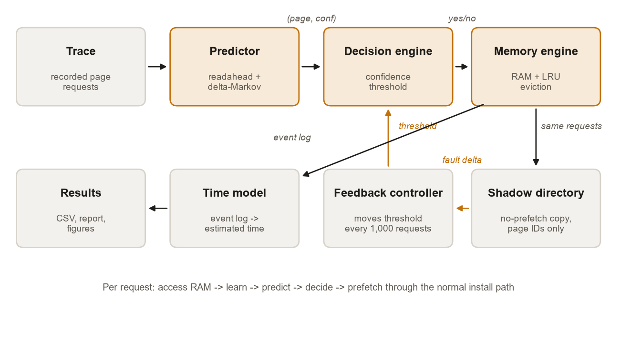
Figure 1: System architecture

3.2 Modules
Table 2: Modules of the system
Module (file) | Responsibility | Input | Output
Traces (traces.py) | Generate synthetic traces; convert real traces; load them | trace files | ordered page numbers, 25% warm-up split
Memory engine (engine.py) | Model RAM; the single path by which pages enter memory | requests and prefetches | hit/fault, counters, event log
Eviction policies (engine.py) | Choose which page leaves | insert/hit/evict notifications | victim page
Predictors (predictors.py) | Guess the next pages | recent request history | (page, confidence) candidates
Decision engines (deciders.py) | Accept or reject candidates; adapt the threshold | candidate, confidence, memory state, feedback | yes/no
Simulators (simulate.py) | Run the per-request loop with the chosen feedback | trace, frames, policy, predictor, decider | statistics
Time model (timing.py) | Turn events into estimated time | event log, device parameters | estimated run time
Final system (final.py, config.py) | Frozen configuration of the best system | trace, frames | statistics

3.3 Per-request processing flow
- Receive the next requested page p.
- Memory engine: if p is resident, record a hit; otherwise record a fault, evict a victim if memory is full (chosen by the eviction policy), and load p.
- Predictor: learn the transition just observed (previous pages → p).
- Every epoch (1,000 requests in the final system): compute the fault delta from the shadow directory and move the decision threshold.
- Predictor: propose candidates for the next request.
- For each candidate not already resident, the decision engine decides whether to prefetch it.
- Approved candidates are loaded through the same path as demand faults.
- Repeat until the trace ends; return the counters.
Two design rules matter. First, prefetched pages enter memory only through the same install routine as demand faults, so a faulty predictor can make the system slower but never incorrect. Second, the predictor sees only the request history and the decision engine sees only (page, confidence, memory state); this separation makes it possible to compare decision engines on identical predictions.

3.4 Predictor design
Table 3: Predictors
Predictor | Mechanism | Strength | Weakness
Stride | If the last three gaps are equal, continue the gap | regular strides | irregular access
Markov (order 1 / 2) | Counts of next page after the last one / two pages; 256 contexts, 2 successors, counts halved every 25,000 updates | repeating patterns | cannot predict pages never seen
Hybrid | Order 2, then order 1, then stride; all tables learn on every request | combines the above | still page-number based
Delta-Markov | Markov table over gaps between pages | patterns in new regions of memory | random access
Readahead | Linux-style: two consecutive pages start a stream; the window doubles at its midpoint, capped at a quarter of RAM | sequential reading of new data | jumping access
Final | Readahead window first, then the delta-hybrid Markov guess | both cases | more prefetch reads

3.5 Decision engine design
When free frames exist, any candidate with confidence of at least 0.15 is accepted, since a wrong prefetch then evicts nothing. When memory is full, a candidate is accepted only if its confidence is at least an adaptive threshold (between 0.15 and 0.95). Every epoch the controller computes the delta rate = (faults without prefetching − faults with prefetching) / epoch length. If it is above +0.002 the threshold is lowered by one step (prefetch more); if below −0.002 it is raised (prefetch less); in between it is left unchanged.

3.6 Obtaining the fault delta
Table 4: Ways of measuring the fault delta
Method | How "faults without prefetching" is obtained | Deployable?
Oracle | A full second copy of memory runs the same requests without prefetching | No (needs a second copy of memory)
Ghost list | Remember pages a prefetch evicted (256 entries); count those that fault back within 2,000 requests; estimate = used prefetches − harmful refaults | Yes (about 4 KB), but biased upward on some workloads
Shadow directory (adopted) | A no-prefetch copy of the eviction policy holding page identifiers only, optionally for a hash sample of pages | Yes (8 bytes per tracked frame, about 0.2% of RAM; samplable)

3.7 Time model
Each run can record an event log of demand faults, prefetches and first uses of prefetched pages. The time model replays it: every request costs a compute time (swept over 0.1, 1 and 10 µs because it is unknown for these traces) and a prediction cost (0.2 µs); every read takes 80 µs on an NVMe SSD with 8 parallel channels or 5 ms on a hard disk with one channel; demand faults block, possibly behind earlier prefetch reads; a prefetched page used before its read completes stalls the program for the remainder.

Chapter 4: Implementation

4.1 Tools and environment
Table 5: Tools used
Tool | Use
Python 3.9+ | all code (developed on Python 3.14, Windows 11; first stages on Google Colab)
NumPy, pandas | trace arrays, result tables
matplotlib | figures
pytest | automated tests
Python standard library | lzma (trace decompression), urllib (download), collections.OrderedDict (LRU, Markov tables, ARC), heapq (LRU-2, disk channels), bisect (OPT)
Git and GitHub | version control: github.com/shrey1-1/Predictive-memory-paging-system-

4.2 Project structure
Table 6: Repository layout
Path | Contents
src/paging/ | library: config, traces, predictors, engine, deciders, simulate, timing, final
scripts/01–17 | one script per experiment: data generation and download, predictor quality, baselines, decision-engine ablation, head-to-head, ghost list, Phase 8 baselines, improvements, robustness, break-even cost, report, time model, tuning, component comparison; run_all.py runs them in order
tests/test_core.py | 24 automated tests
docs/ | results with provenance, design decisions, roadmap, review preparation, paper draft
results/ | CSV results and the self-contained HTML report

4.3 Key implementation details
- MemoryEngine keeps the resident pages in a set; the policy object keeps its own ordering. `_install` is the only routine that adds a page; it evicts a victim if memory is full and marks prefetched pages so that their later use (or waste) can be counted.
- LRU uses an ordered dictionary: a hit moves the page to the end; the victim is the first entry. OPT precomputes the positions of every page and uses binary search for each resident page’s next use.
- MarkovPredictor stores contexts in an ordered dictionary of at most 256 entries (least recently used context evicted), keeps two successors per context, and halves counts every 25,000 updates. Confidence is the best successor’s share of the counts; with two successors it is never below 0.5.
- ReadaheadPredictor is a small state machine (last page, run length, window, highest page requested) implementing the stream detection and window doubling described in Section 3.4.
- CostAwareFaultDelta implements the threshold rule; the ghost-list and shadow-directory variants differ only in how the delta is estimated.
- run_prefetch_sim_dir runs the real engine and a shadow-directory engine on the same requests; the directory sees only sampled pages and has a proportional number of frames.
- run_final builds the final configuration in one call: readahead (confidence = run/(run+1)) plus delta-hybrid Markov, the directory decider with the frozen controller (epoch 1,000, step 0.1, dead band 0.002, no prefetch budget cap) and LRU.

4.4 Experimental method
- Traces: 22 real traces from the ML-Based Data Prefetching Competition LoadTraces: SPEC CPU 2006 (bwaves s0–s2, leslie3d s0–s2, milc, libquantum, mcf, soplex, omnetpp, astar, GemsFDTD, lbm, sphinx3) and GAP (bfs-3, bfs-10, pr-3, pr-10, bc-3, cc-5, sssp-3); 200,000 requests each; addresses mapped to pages by a 12-bit shift. Six synthetic traces with known structure are used as correctness tests.
- Memory size: a fraction (1% and 5%) of each trace’s working set, at least 8 frames. With large fixed memories every policy behaves identically.
- No tuning on evaluation data: every parameter was chosen using only the first 25% of each trace, with the selection rule written down before each sweep.
- Metrics: vs_LRU = (LRU faults − faults) / LRU faults (positive = better); prediction “useful rate” = coverage × accuracy; break-even prefetch cost; estimated speed-up = time(LRU) / time(system).

Chapter 5: Testing and Verification

5.1 Testing strategy
Correctness of a simulator cannot be judged by its results alone, so three kinds of evidence are used: automated tests that encode properties any correct implementation must satisfy, independent re-implementations, and exact reproduction of earlier results. The test suite (24 tests, run with pytest) passes in full.
Table 7: Automated test cases
Group | Test cases | Scenario type
Invariants | OPT is never beaten by any policy; LRU and OPT never get worse with more memory; with ample memory, faults equal the number of distinct pages; a sequential scan without prefetching faults on every request | normal and boundary
Equivalence | the ghost-list engine equals the plain engine without prefetching; experimental policy switched off equals LRU; new options switched off reproduce the old behaviour exactly | regression
Pinned numbers | fault counts of FIFO, Clock, LRU, OPT, LRU-2, ARC, readahead, the ghost decider, the directory decider and the final system on a fixed synthetic trace | regression
Component behaviour | ARC ghost lists stay bounded; stride needs three equal gaps; delta-Markov predicts unseen pages; a full shadow directory equals the true fault delta in every epoch; the time model charges late prefetches and queueing | normal
Invalid use | a ghost-list decider passed to the plain simulator is rejected with an error instead of silently behaving as the oracle | invalid input

5.2 Additional verification
- Independent straightforward implementations of LRU, FIFO and OPT gave identical fault counts to the simulator on 40 random traces (0 mismatches).
- An independent implementation of LRU-2 matched the simulator on three real traces, confirming that LRU-2’s poor results are genuine.
- The decision-engine ablation rerun on freshly downloaded traces reproduced all 48 rows of the original Google Colab results exactly.
- Long experiments save results after every configuration; reruns reproduced earlier result columns bit for bit.

5.3 Problems found by testing
- A ghost-list decider passed to the wrong simulator silently behaved as the oracle; now rejected.
- The observation that “confidence is never below 0.5” was found to be a structural property of keeping two successors, not a property of the workloads; documents were corrected.
- A prefetch budget cap of 35% inherited from the first design blocked the system on one trace (omnetpp) while it was winning every epoch; it was removed after a warm-up-only check.

Chapter 6: Results and Discussion
All results below are page-fault counts or quantities derived from them, produced by the project’s scripts and stored in the results folder. Traces are deterministic, so each configuration was run once; robustness comes from many traces and memory sizes rather than repeated runs.

6.1 Prediction quality
Table 8: Useful prediction rate (coverage × accuracy)
Trace | Stride | Markov o1 | Markov o2 | Hybrid
bwaves-s0 | 25.6% | 78.8% | 76.1% | 80.4%
leslie3d-s0 | 0.2% | 84.3% | 81.6% | 84.4%
bfs-3 | 0.0% | 66.9% | 67.3% | 70.6%
pr-3 | 0.0% | 45.8% | 88.1% | 89.2%
clustered | 0.0% | 9.7% | 8.1% | 9.9%
cyclic | 80.0% | 100.0% | 100.0% | 100.0%
sequential | 100.0% | 0.0% | 0.0% | 100.0%
random | 0.0% | 0.0% | 0.0% | 0.0%

The hybrid predictor guesses the next page exactly 81.2% of the time on the first four real traces. Markov tables score zero on the sequential trace because its working set exceeds the 256-entry table; the stride fallback covers it.

6.2 Eviction policies alone
Table 9: Page faults without prefetching (RAM = 1% of working set)
Trace | Frames | FIFO | LRU | Clock | OPT
clustered | 9 | 5,729 | 5,803 | 5,676 | 2,637
bwaves-s0 | 30 | 3,380 | 3,140 | 3,214 | 3,112
leslie3d-s0 | 21 | 15,608 | 15,313 | 15,126 | 5,881
bfs-3 | 58 | 6,959 | 6,766 | 6,802 | 6,179
pr-3 | 40 | 5,867 | 5,812 | 5,820 | 5,346

On leslie3d, OPT has 62% fewer faults than LRU, so there is large room for improvement; on bwaves there is almost none. ARC and LRU-2 (Section 6.5) did not close the gap on the real traces.

6.3 Decision engines
Table 10: Fault reduction versus LRU by decision engine (original Markov predictor)
Configuration | Always | Fixed 0.6 | Fixed 0.85 | Precision | Fault delta
leslie3d-s0 @ 21 | +35.00% | +33.59% | +28.90% | +34.13% | +34.98%
bwaves-s0 @ 30 | +37.29% | +37.29% | +37.29% | +37.29% | +37.29%
clustered @ 6 | −0.87% | −0.98% | −0.81% | −0.96% | −0.72%
clustered @ 9 | +0.09% | −0.93% | −0.19% | −1.22% | −0.48%
bfs-3 @ 20 | −1.50% | −0.41% | −0.05% | −0.45% | −0.28%
bfs-3 @ 58 | −0.27% | −0.06% | +0.01% | −0.06% | −0.19%
pr-3 @ 15 | +0.51% | +0.63% | +0.59% | +0.63% | +0.51%
pr-3 @ 40 | +0.74% | +0.69% | +0.67% | +0.69% | +0.74%

Table 11: Summary over the eight configurations
Decision engine | Mean gain | Worst case | Total harm
cost-aware-fd | +8.98% | −0.72% | −1.67%
fixed-0.85 | +8.30% | −0.81% | −1.05%
fixed-0.6 | +8.73% | −0.98% | −2.38%
cost-aware | +8.76% | −1.22% | −2.69%
always | +8.87% | −1.50% | −2.64%
fixed-0.3 | +8.87% | −1.50% | −2.64%

Confidence could not separate good from bad predictions (no prediction had confidence below 0.5, so a 0.3 threshold equals always prefetching). Precision misled: on the clustered trace four engines had precision 81–86% while faults increased, because a used prefetch can still evict a page needed sooner. The fault-delta engine halved the worst case (−0.72% against −1.50% for always prefetching) while keeping almost all of the benefit.

6.4 Head-to-head with classical policies
Table 12: Page faults with Markov prediction added to LRU
Trace | Frames | FIFO | LRU | Clock | LRU + prediction | OPT
leslie3d-s0 | 21 | 15,608 | 15,313 | 15,126 | 9,956 | 5,881
bwaves-s0 | 30 | 3,380 | 3,140 | 3,214 | 1,969 | 3,112
clustered | 9 | 5,729 | 5,803 | 5,676 | 5,831 | 2,637
bfs-3 | 20 | 7,614 | 7,394 | 7,390 | 7,415 | 6,349
pr-3 | 15 | 5,945 | 5,905 | 5,933 | 5,875 | 5,591

Prediction removed 35% of LRU’s faults on leslie3d and 37% on bwaves; on bwaves it even beats OPT, because prefetching avoids compulsory faults that OPT must pay. The ghost-list estimate matched the oracle (mean gain +9.03% against +8.98%).

6.5 Stronger baselines
Table 13: Phase 8: page faults with ARC, LRU-2 and Linux-style readahead
Trace | Frames | LRU | ARC | LRU-2 | Readahead | Markov | OPT
clustered | 9 | 5,803 | 6,207 | 6,512 | 7,645 | 5,798 | 2,637
leslie3d-s0 | 21 | 15,313 | 16,553 | 26,188 | 11,624 | 9,956 | 5,881
bwaves-s0 | 30 | 3,140 | 3,147 | 5,460 | 204 | 1,969 | 3,112
bfs-3 | 20 | 7,394 | 7,368 | 7,969 | 2,924 | 7,427 | 6,349
pr-3 | 15 | 5,905 | 5,825 | 5,822 | 2,905 | 5,872 | 5,591

Linux-style readahead beat Markov prediction on three of the four real traces because it fetches new pages in a sequential run, which a page-number Markov model cannot predict. This motivated combining the two predictors.

6.6 Final system on 22 real traces
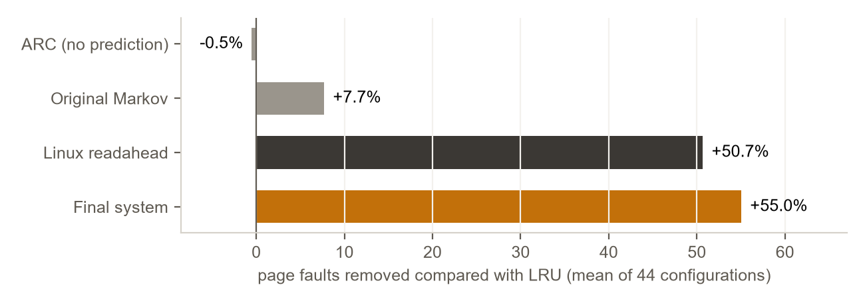
Figure 2: Mean fault reduction versus LRU over 44 configurations
Table 14: Fault reduction versus LRU, all configurations
System | Mean | Median | Worst case | Worse than LRU
ARC (eviction only) | −0.5% | −0.1% | −8.2% | 22 of 44
Original Markov system | +7.7% | +1.5% | −0.3% | 1 of 44
Linux-style readahead | +50.7% | +55.0% | −19.3% | 2 of 44
Final system | +55.0% | +59.3% | −3.3% | 1 of 44

The final system has fewer faults than readahead in 34 of 44 configurations, the same in 8 and more in 2, and fewer faults than OPT in 30. Its one loss to LRU is bwaves-s2 at 1% memory (8 frames). The largest loss to readahead is sphinx3, where the decision engine holds back useful readahead.
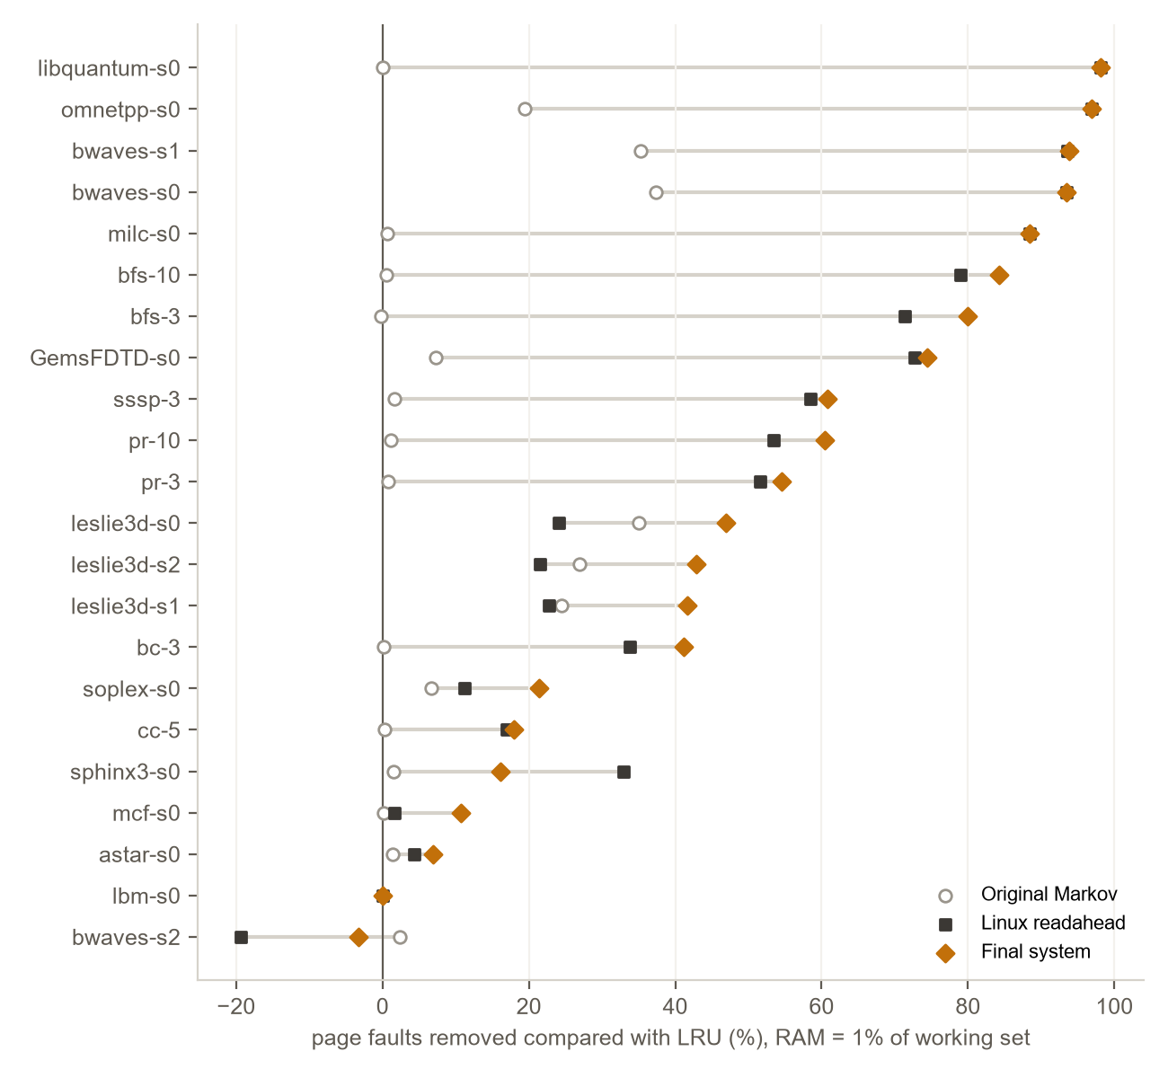
Figure 3: Fault reduction per trace at 1% memory
Table 15: Per-trace results at 1% memory (faults; then reduction versus LRU)
Trace | Frames | LRU | OPT | Final | Final | Readahead | Markov
bwaves-s0 | 30 | 3,140 | 3,112 | 205 | +93.5% | +93.5% | +37.3%
bwaves-s1 | 30 | 3,140 | 3,111 | 195 | +93.8% | +93.6% | +35.3%
bwaves-s2 | 8 | 631 | 449 | 652 | −3.3% | −19.3% | +2.4%
leslie3d-s0 | 21 | 15,313 | 5,881 | 8,133 | +46.9% | +24.1% | +35.0%
leslie3d-s1 | 22 | 11,771 | 4,740 | 6,873 | +41.6% | +22.7% | +24.4%
leslie3d-s2 | 22 | 11,760 | 4,744 | 6,715 | +42.9% | +21.6% | +27.0%
milc-s0 | 232 | 23,269 | 23,269 | 2,700 | +88.4% | +88.4% | +0.7%
libquantum-s0 | 31 | 3,126 | 3,126 | 58 | +98.1% | +98.1% | +0.0%
mcf-s0 | 31 | 194,263 | 173,418 | 173,441 | +10.7% | +1.6% | +0.2%
bfs-3 | 58 | 6,766 | 6,179 | 1,356 | +80.0% | +71.3% | −0.3%
bfs-10 | 56 | 6,220 | 5,915 | 982 | +84.2% | +79.0% | +0.6%
pr-3 | 40 | 5,812 | 5,346 | 2,643 | +54.5% | +51.6% | +0.7%
pr-10 | 40 | 5,559 | 5,206 | 2,201 | +60.4% | +53.5% | +1.2%
soplex-s0 | 43 | 24,906 | 17,032 | 19,582 | +21.4% | +11.2% | +6.7%
omnetpp-s0 | 203 | 121,090 | 120,012 | 3,716 | +96.9% | +96.9% | +19.4%
astar-s0 | 48 | 110,547 | 82,922 | 102,867 | +6.9% | +4.3% | +1.4%
GemsFDTD-s0 | 29 | 3,760 | 3,314 | 960 | +74.5% | +72.7% | +7.2%
lbm-s0 | 31 | 3,136 | 3,128 | 3,136 | +0.0% | +0.0% | +0.0%
sphinx3-s0 | 20 | 13,425 | 10,501 | 11,263 | +16.1% | +33.0% | +1.4%
bc-3 | 23 | 31,644 | 30,762 | 18,635 | +41.1% | +33.8% | +0.2%
cc-5 | 13 | 141,398 | 129,935 | 116,086 | +17.9% | +16.9% | +0.3%
sssp-3 | 20 | 70,286 | 66,712 | 27,545 | +60.8% | +58.5% | +1.6%

6.7 Effect of the feedback signal
With the combined predictor, the ghost-list estimate reported “winning” on the synthetic clustered trace while the system was 21.5% worse than LRU. The shadow directory measures the true delta exactly; with it the same configuration is only 2.5% worse than LRU, and over the real traces it gives the best worst case of all systems. Sampling one page in eight left fault counts unchanged on 9 of 10 traces tested at 5% memory.

6.8 Contribution of each component
Table 16: Predictors compared with everything else fixed (1% memory)
Predictor (same decision engine) | Exact next-page guesses | Mean vs LRU | Worst | Worse than LRU | SSD speed-up
stride | 2.7% | +5.8% | +0.0% | 0 | 1.01×
markov-o1 | 50.1% | +4.9% | −0.8% | 3 | 1.01×
markov-o2 | 53.3% | +2.4% | −1.1% | 3 | 1.00×
hybrid | 57.3% | +9.4% | −0.3% | 1 | 1.01×
delta-hybrid | 58.9% | +20.9% | +0.0% | 0 | 1.02×
readahead | 2.6% | +46.5% | −2.5% | 1 | 1.51×
final (readahead + delta-hybrid) | 56.2% | +51.2% | −3.3% | 1 | 1.49×

Table 17: Decision engines compared with everything else fixed (1% memory)
Decision engine (final predictor) | Mean vs LRU | Worst real trace | Clustered (synthetic) | SSD speed-up
no-prefetch | +0.0% | +0.0% | +0.0% | 1.00×
always | +51.2% | −6.3% | −21.5% | 1.49×
fixed-0.3 | +51.2% | −6.3% | −21.5% | 1.49×
fixed-0.6 | +28.8% | +0.0% | −5.5% | 1.21×
fixed-0.85 | +19.8% | +0.0% | −0.2% | 1.07×
precision (cost-aware) | +26.8% | +0.0% | −5.2% | 1.16×
fault-delta oracle | +49.1% | +0.0% | −1.7% | 1.39×
ghost list | +47.9% | −3.2% | −21.5% | 1.39×
shadow directory | +49.0% | −1.4% | −2.5% | 1.39×
directory + frozen controller (final) | +51.2% | −3.3% | −2.4% | 1.49×

Prediction accuracy and fault reduction rank the predictors almost in opposite order: readahead is exactly right about the next page only rarely but removes the most faults of any single predictor, because it fetches pages never seen before. Always prefetching captures the full benefit on real traces but is badly hurt on the clustered trace; fixed thresholds are safe but lose half or more of the benefit; the final decision engine keeps the benefit and limits the harm.

6.9 Estimated run time
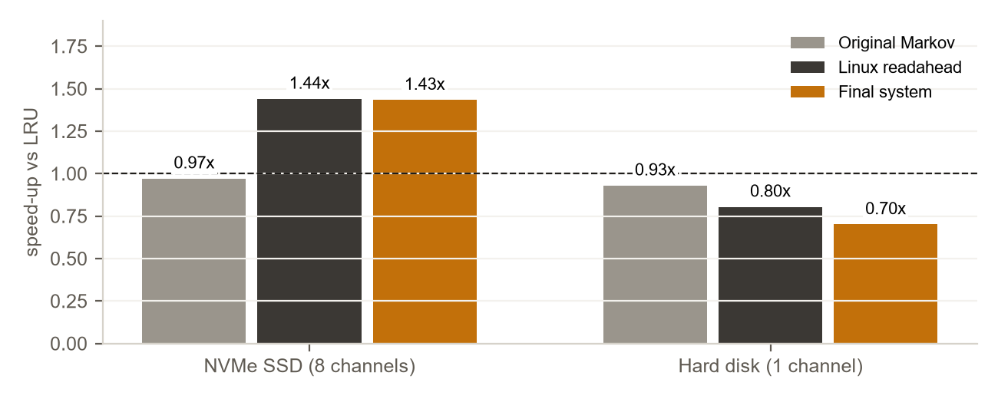
Figure 4: Estimated speed-up versus LRU (1 µs compute per request, 0.2 µs prediction cost)
Table 18: Geometric-mean estimated speed-up versus LRU
System | NVMe SSD (8 channels) | Hard disk (1 channel)
Original Markov | 0.97× (slower on 18 of 22) | 0.93×
Linux-style readahead | 1.44× (slower on 2 of 22) | 0.80×
Final system | 1.43× (slower on 3 of 22) | 0.70×

6.10 Discussion
- Fewer faults are not the same as faster. The final system removes the most faults, yet on the SSD model it only ties readahead, because the extra faults it removes cost extra prefetch reads.
- Timeliness matters as much as accuracy. Markov prediction alone removes 35–37% of faults on leslie3d and bwaves but is not faster: it prefetches one request ahead, so its pages often arrive late.
- The storage device decides. On a single-channel hard disk each prefetch costs as much as the fault it tries to save, so every prefetcher is slower than LRU.
- The feedback signal matters. Signals that count used prefetches as wins (precision, the ghost list) can report success while prefetching is causing harm; the measured fault delta does not.

Chapter 7: Conclusion and Future Work

7.1 Conclusion
This project built and evaluated a predictive paging system in a reproducible trace-driven simulator. On 22 real benchmark traces the final system, which combines Linux-style readahead with a delta-Markov predictor and steers prefetching with an exact fault-delta signal from a page-identifier-only shadow directory, removes on average 55.0% of LRU’s page faults and is rarely harmful. The evaluation also shows the limits of fault counts as a measure: in estimated time the system is about 1.4 times faster than LRU on a parallel SSD, level with readahead, and slower than LRU on a hard disk.

7.2 Contributions
- An evaluation of feedback signals for cost-aware prefetching at page granularity: confidence cannot discriminate, precision and ghost-list estimates can mislead, and the measured fault delta works.
- A shadow directory that provides the exact fault delta at about 0.2% of memory and can be hash-sampled without changing decisions in our tests.
- A combination of readahead and delta-Markov prediction with the lowest fault count of all systems tested.
- A time model and break-even analysis showing when fewer faults lead to faster programs.
- Documented negative results (prediction-aware eviction, predictor protection, smoothed confidence, an off switch) with their causes.

7.3 Limitations
- Cache-level traces mapped to pages approximate, but are not, operating-system paging; the predictor sees every request, which a kernel does not.
- Time results come from a model with stated latencies and a swept compute time, not from hardware measurements; demand-read priority, write-back and I/O merging are not modelled.
- 200,000 requests per trace and small simulated memories (8 to 1,163 frames).
- ARC omits the textbook tie-break; LRU-2 has no correlated-reference period; the readahead window is a quarter of memory.

7.4 Future work
- Evaluate on operating-system page-fault traces or inside a kernel.
- Add demand-read priority and prefetch-distance control to the time model, and measure real hardware.
- Compare with a learned (LSTM or attention-based) predictor under the same time model.
- Validate shadow-directory sampling at realistic memory sizes.
- Recover the gains the cautious decision engine leaves on workloads such as sphinx3.

References
[1] L. A. Belady, “A study of replacement algorithms for a virtual-storage computer,” IBM Systems Journal, vol. 5, no. 2, 1966.
[2] E. J. O’Neil, P. E. O’Neil and G. Weikum, “The LRU-K page replacement algorithm for database disk buffering,” Proc. ACM SIGMOD, 1993.
[3] N. Megiddo and D. S. Modha, “ARC: A self-tuning, low overhead replacement cache,” Proc. USENIX FAST, 2003.
[4] W. W. Chu and H. Opderbeck, “The page fault frequency replacement algorithm,” Proc. AFIPS Fall Joint Computer Conference, 1972.
[5] D. Joseph and D. Grunwald, “Prefetching using Markov predictors,” Proc. ISCA, 1997.
[6] C.-J. Wu et al., “PACMan: Prefetch-aware cache management for high performance caching,” Proc. IEEE/ACM MICRO, 2011.
[7] C. A. Waldspurger et al., “Efficient MRC construction with SHARDS,” Proc. USENIX FAST, 2015.
[8] “Workload-Aware Buffer Prefetching for Database Systems,” 2026. [authors and venue to be added]
[9] “Learning-based Page Replacement for Efficient I/O,” 2025. [authors and venue to be added]
[10] “To Cross, or Not to Cross Pages for Prefetching?,” 2025. [authors and venue to be added]
[11] “Beyond VABlock: Aggressive Prefetching for Transformer Workloads,” 2025. [authors and venue to be added]
[12] “Graph Analytics with Attention-Based Prefetcher,” 2024. [authors and venue to be added]
[13] “ML-Based Runtime Prefetcher Selection,” 2024. [authors and venue to be added]
[14] “Tyche: Prefetcher for Indirect Memory Accesses,” 2024. [authors and venue to be added]
[15] “Prefetching Indexing Scheme for In-Memory Databases,” 2024. [authors and venue to be added]
[16] “EXTMEM: Application-Aware Virtual Memory,” 2024. [authors and venue to be added]
[17] “RPG2: Profile-Guided Runtime Prefetch Generation,” 2024. [authors and venue to be added]
[18] J. L. Henning, “SPEC CPU2006 benchmark descriptions,” ACM SIGARCH Computer Architecture News, vol. 34, no. 4, 2006.
[19] S. Beamer, K. Asanović and D. Patterson, “The GAP benchmark suite,” arXiv:1508.03619, 2015.
[20] ML-Based Data Prefetching Competition LoadTraces, download list in github.com/Quangmire/ChampSim.

