**Question 3**

Use computer vision techniques to count the number of table cells in the ‘Table.JPG’ image. Image file can be found in the same folder holding this instruction. Please submit your source code along with a documentation explaining the techniques used.

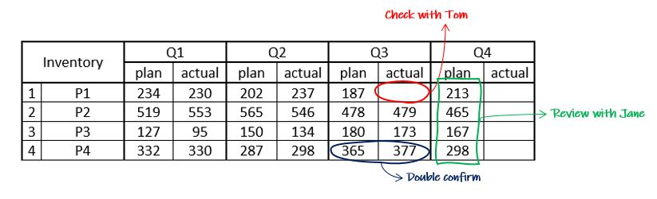

Remarks:

* You should use Python to complete this exercise
* Usage of Jupyter notebook for completing this exercise is preferred but if you are not comfortable, feel free to provide source code and summary in email
* Please submit your source code along with a documentation explaining methodology used and why you choose this method.