UNIT 2
Data Structures and Collection Management
Smart Library Management System: Solution Document
Extends the Unit 1 project using Strings, Lists, Tuples, Sets and Dictionaries
Every deliverable below follows the seven-stage workflow: Problem Understanding, Algorithm, Flowchart, Pseudocode, Python, Testing, Documentation.

Contents of This Submission
# | Deliverable | Where
1 | Data Structure Selection Report | Section 1
2 | Problem Analysis Document | Section 2
3 | Algorithm Design Document | Section 3
4 | Flowchart Collection | Section 4
5 | Pseudocode Document | Section 5
6 | String Processing Programs | Section 6 (structure_demos.py)
7 | List Management Programs | Section 7 (structure_demos.py)
8 | Tuple Demonstration Programs | Section 8 (structure_demos.py)
9 | Set Operations Programs | Section 9 (structure_demos.py)
10 | Dictionary-Based Library Programs | Section 10 (structure_demos.py, library_system.py)
11 | Collection Integration Report | Section 11 (library_system.py)
12 | Program Testing Report | Section 12 (test_library.py, 27 of 27 passing)
13 | Updated Git Repository | Section 13

Files supplied with this document: library_system.py, structure_demos.py, test_library.py, README.md.

1. Data Structure Selection Report
The table records which structure was chosen for each kind of library data and the reason. The deciding questions were: Is it one piece of text (String)? An ordered, changing collection (List)? A fixed group that must not change (Tuple)? Only unique values (Set)? Labelled fields looked up by name (Dictionary)?
Library data | Structure | Why this structure
Book title, author, category, publisher | String | Pure text; needs cleaning (strip, title) and searching (lower, find). Immutable is fine because edits create a new string.
One complete book record | Dictionary | Each field is labelled (title, price, available) so it is read by name, not by remembering a position.
Full catalogue of books | List (of dictionaries) | Ordered, grows and shrinks as books are added or withdrawn, duplicates allowed, easy to loop, sort and filter.
ISBN (prefix, code) | Tuple | Must never be edited by accident. Tuples are immutable and unpack cleanly into prefix and code.
Publication details (year, edition, publisher) | Tuple | Fixed group of related values that does not change once published.
Library configuration (fine per day, loan days) | Tuple | Constants that the program should only read, never modify.
Unique categories | Set | Thousands of books but few categories; a set removes repeats automatically.
Unique authors | Set | Same reason: only distinct names are needed and order does not matter.
Member IDs | Set | Fast membership test (in) and duplicate registrations are impossible.
Borrowed / available lists | List | Ordered subsets of the catalogue that change every time a book is borrowed or returned.
Books grouped by genre | Dictionary of lists | Category is the key and the list of titles is the value, so lookup by genre is instant.
Messages and report lines | String | Built with f-strings and join() for clean, readable output.

2. Problem Analysis Document
Each of the eight core problems is broken down with the template from Section 4 of the brief: Inputs, Expected Output, Required Data, Appropriate Data Structure, Processing Steps.

2.1 Store details of multiple books
Question | Answer
Inputs | Book details entered by user (ID, title, author, category, ISBN, price)
Expected Output | A stored collection holding every book's full record
Required Data | All fields of every book
Appropriate Data Structure | List of dictionaries (list = collection, dictionary = one record)
Processing Steps | Read details > check ID not already used > build dictionary > append to list

2.2 Search books by title
Question | Answer
Inputs | A title typed by the user
Expected Output | The matching book record, or "Book Not Found"
Required Data | The title field of every record
Appropriate Data Structure | List (traversed) + String methods (lower(), strip())
Processing Steps | Clean search text > loop through list > compare lowercase titles > display or report not found

2.3 Display all available books
Question | Answer
Inputs | None (uses stored catalogue)
Expected Output | Every book whose available flag is True
Required Data | The available field of every record
Appropriate Data Structure | List of dictionaries; list comprehension filters it
Processing Steps | Loop through list > keep records where available is True > display them

2.4 Remove duplicate book categories
Question | Answer
Inputs | A list of category strings, one per book (with repeats)
Expected Output | Each category exactly once
Required Data | The category field from every record
Appropriate Data Structure | Set (discards duplicates automatically)
Processing Steps | Collect categories into a list > convert to set > display set

2.5 Maintain author information
Question | Answer
Inputs | Author names from book records
Expected Output | Unique authors, and all books by a chosen author
Required Data | The author field of every record
Appropriate Data Structure | Set for unique authors; list for the books found
Processing Steps | Collect authors into a set > for a chosen author, loop and append matches to a list

2.6 Count the number of books available
Question | Answer
Inputs | None (uses stored catalogue)
Expected Output | A single integer
Required Data | The available flag of every record
Appropriate Data Structure | List of dictionaries + an integer counter
Processing Steps | Set count to 0 > loop > add 1 when available is True > display count

2.7 Organize books according to genre
Question | Answer
Inputs | None (uses stored catalogue)
Expected Output | Each genre with its list of titles
Required Data | Category and title of every record
Appropriate Data Structure | Dictionary mapping category (key) to list of titles (value)
Processing Steps | Create empty dictionary > loop > create key if missing > append title > display

2.8 Maintain complete book information using dictionaries
Question | Answer
Inputs | Field name and value for each book attribute
Expected Output | One labelled record per book that can be read and updated by key
Required Data | book_id, title, author, publisher, category, available, price, shelf_number
Appropriate Data Structure | Dictionary (key-value fields), nested in the catalogue list
Processing Steps | Create dictionary with labelled keys > read with [] or get() > change with update() > delete with pop()

3. Algorithm Design Document
Plain-language numbered steps for every operation, with no Python syntax.

3.1 Add a New Book
- Accept the book's information from the user.
- Check whether a book with the same ID already exists in the collection.
- If it does not exist, validate the ISBN, clean the text fields and store the new record.
- If it already exists, reject the entry and warn the user.
- Display a confirmation message.

3.2 Search for a Book by Title
- Accept the title to search for.
- Compare it (ignoring case) against every stored record's title.
- If a match is found, display that record's details and stop searching.
- If no match is found after checking every record, display "Book Not Found".

3.3 Update Book Details
- Accept the Book ID to update.
- Search for the record with that ID.
- If found, ask which field to update and its new value.
- Overwrite that field and confirm the update.
- If not found, display "Book Not Found".

3.4 Remove Duplicate Categories
- Read the category field from every book record into a list.
- Convert that list into a set to discard duplicates.
- Display the unique categories.

3.5 Count Available Books
- Set a counter to zero.
- For each book, if its availability is True, increase the counter by one.
- Display the final count.

3.6 Find Books by Author
- Accept the author's name.
- Build a list of every book whose author field matches.
- If the list is not empty, display all matches.
- If the list is empty, display "No books found for this author".

3.7 Sort Books Alphabetically
- Read all book titles into a list.
- Sort the list alphabetically.
- Display the sorted list.

3.8 Remove a Book (assigned operation)
- Accept the Book ID to remove.
- Search the collection for a record with that ID.
- If found, delete the record and confirm the removal.
- If not found, display "Book Not Found".

3.9 Organise Books by Genre (assigned operation)
- Create an empty dictionary called groups.
- For each book, read its category.
- If the category is not yet a key in groups, create it with an empty list.
- Append the book's title to the list under that category.
- Display the groups.

4. Flowchart Collection
Symbols: rounded green box = Start/Stop, blue rectangle = process, yellow diamond = decision, purple parallelogram = input/output.

4.1 Add a New Book
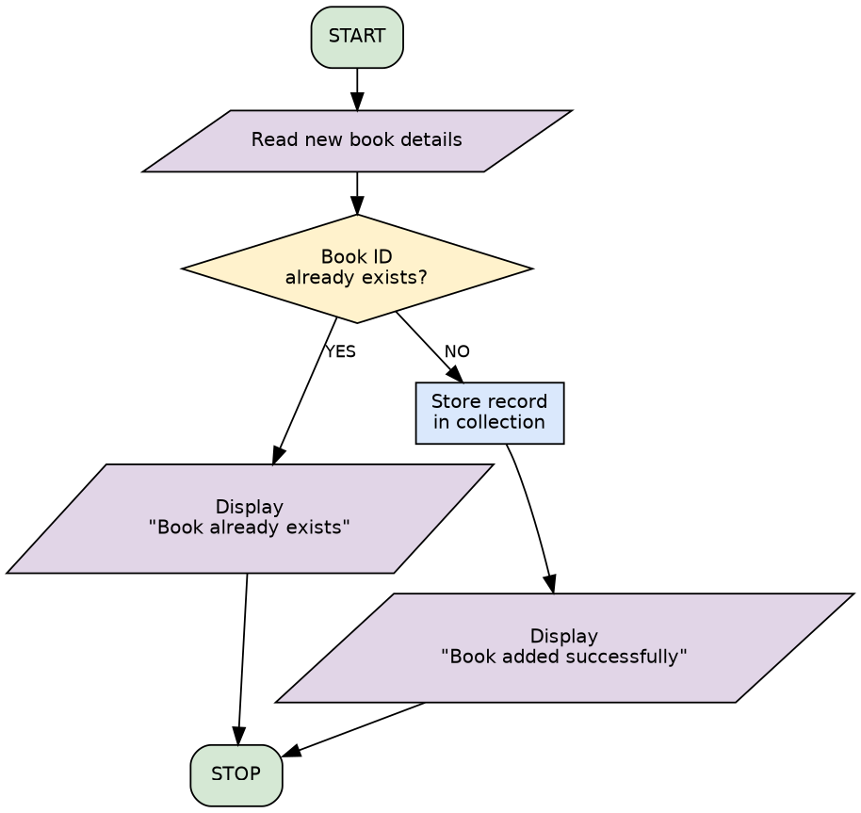

4.2 Search for a Book by Title
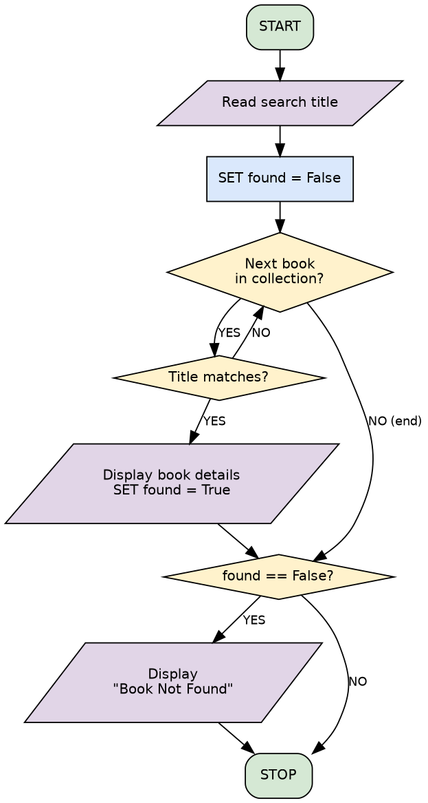

4.3 Update Book Details
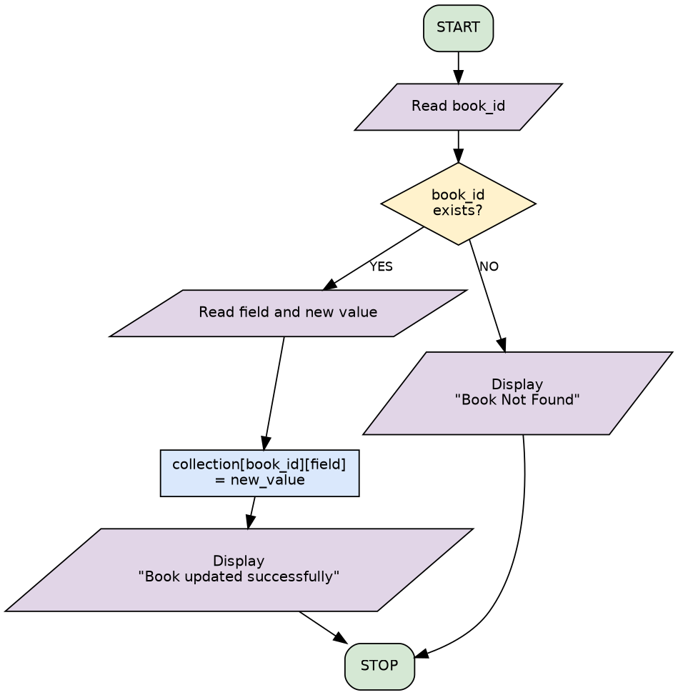

4.4 Remove Duplicate Categories
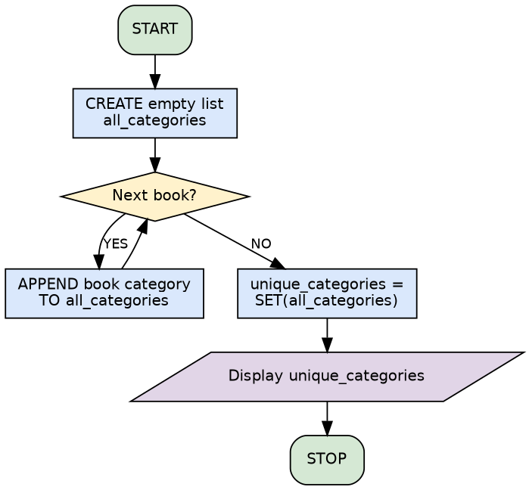

4.5 Count Available Books
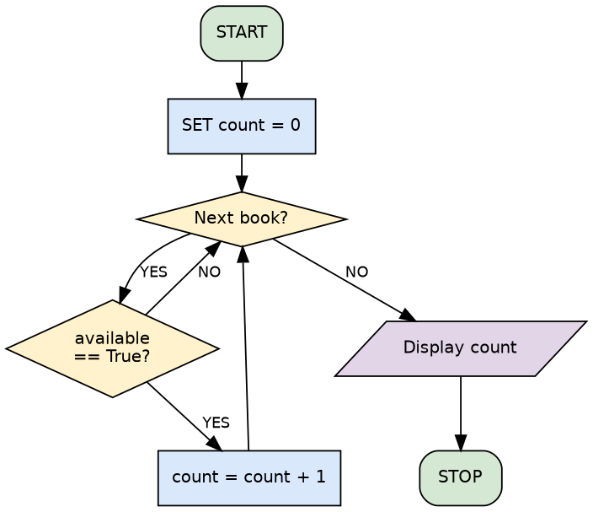

4.6 Find Books by Author
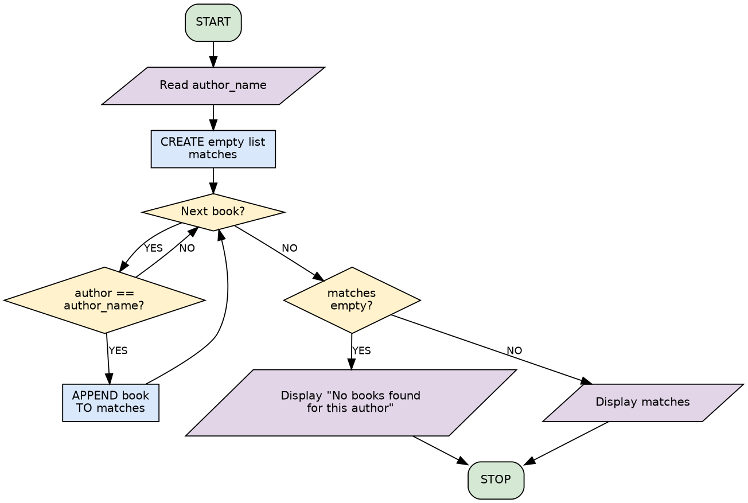

4.7 Sort Books Alphabetically
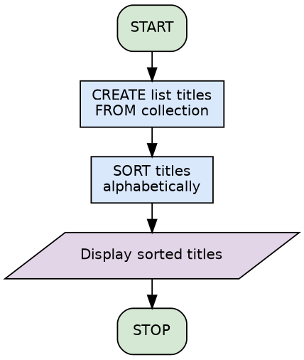

4.8 Remove a Book (assigned operation)
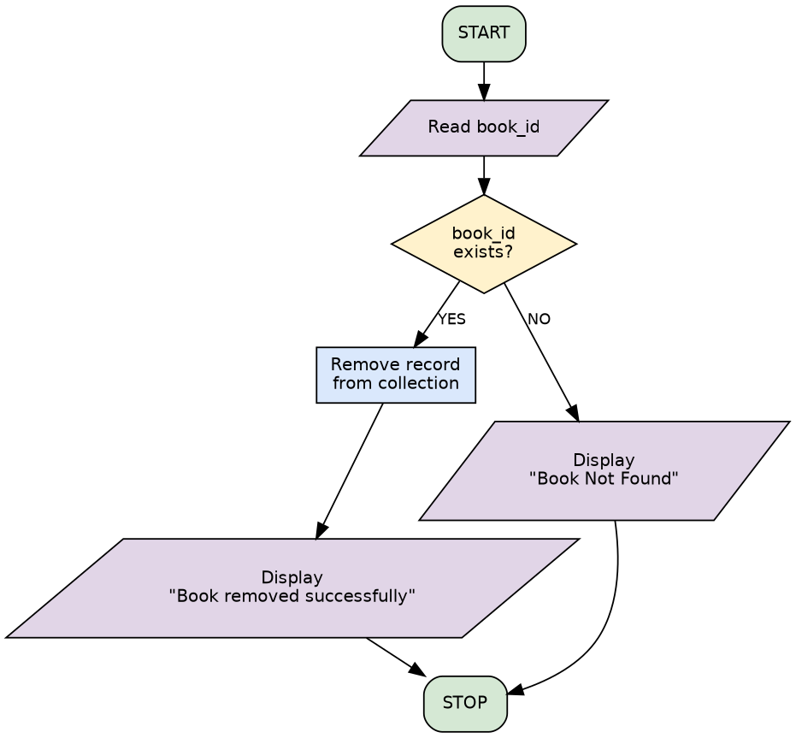

4.9 Organise Books by Genre (assigned operation)
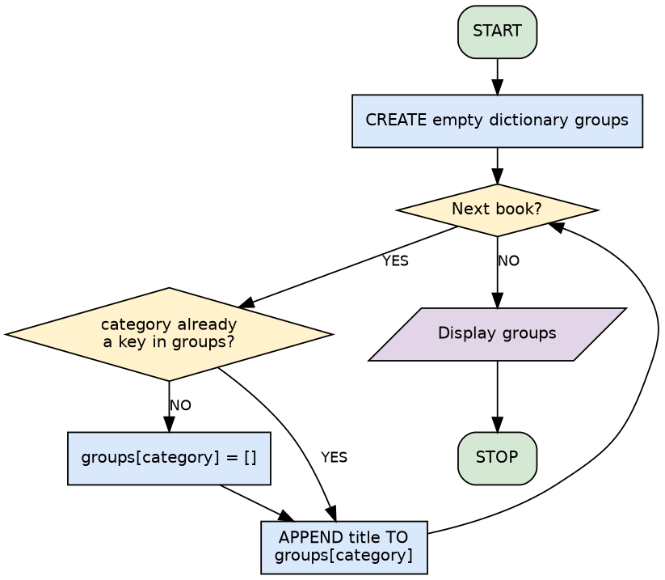

5. Pseudocode Document
Each block matches the flowchart in Section 4 exactly.

5.1 Add a New Book
START
READ book details
IF book ID already exists in collection THEN
DISPLAY "Book already exists"
ELSE
STORE book in collection
DISPLAY "Book added successfully"
END IF
STOP

5.2 Search for a Book by Title
START
READ title
SET found = False
FOR each book in collection
IF book title matches THEN
DISPLAY book details
SET found = True
EXIT loop
END IF
END FOR
IF found == False THEN
DISPLAY "Book Not Found"
END IF
STOP

5.3 Update Book Details
START
READ book_id
IF book_id exists in collection THEN
READ field_to_update, new_value
SET collection[book_id][field_to_update] = new_value
DISPLAY "Book updated successfully"
ELSE
DISPLAY "Book Not Found"
END IF
STOP

5.4 Remove Duplicate Categories
START
CREATE empty list all_categories
FOR each book in collection
APPEND book category TO all_categories
END FOR
SET unique_categories = SET(all_categories)
DISPLAY unique_categories
STOP

5.5 Count Available Books
START
SET count = 0
FOR each book in collection
IF book["available"] == True THEN
count = count + 1
END IF
END FOR
DISPLAY count
STOP

5.6 Find Books by Author
START
READ author_name
CREATE empty list matches
FOR each book in collection
IF book author == author_name THEN
APPEND book TO matches
END IF
END FOR
IF matches is empty THEN
DISPLAY "No books found for this author"
ELSE
DISPLAY matches
END IF
STOP

5.7 Sort Books Alphabetically
START
CREATE list titles FROM collection
SORT titles alphabetically
DISPLAY titles
STOP

5.8 Remove a Book (assigned operation)
START
READ book_id
IF book_id exists in collection THEN
REMOVE record FROM collection
DISPLAY "Book removed successfully"
ELSE
DISPLAY "Book Not Found"
END IF
STOP

5.9 Organise Books by Genre (assigned operation)
START
CREATE empty dictionary groups
FOR each book in collection
IF book category NOT IN groups THEN
SET groups[category] = empty list
END IF
APPEND book title TO groups[category]
END FOR
DISPLAY groups
STOP

6. String Processing Programs
Demonstrates every method in the brief: upper, lower, title, capitalize, strip, split, join, replace, find, count, startswith, endswith, plus indexing, slicing, f-strings, escape characters, ISBN validation and immutability.

Program
def string_demo():
print("=== STRINGS ===")
title = " the great gatsby "
print("original :", repr(title))
print("strip() :", repr(title.strip()))
clean = title.strip()
print("upper() :", clean.upper())
print("lower() :", clean.upper().lower())
print("title() :", clean.title())
print("capitalize():", clean.capitalize())
print("split() :", "a,b,c".split(","))
print("join() :", ", ".join(["Fiction", "Sci-Fi"]))
print("replace() :", "Dune".replace("u", "o"))
print("find() :", "library".find("brar"), "| missing ->", "library".find("zzz"))
print("count() :", "banana".count("a"))
print("startswith():", "1984".startswith("19"))
print("endswith() :", "Emma.pdf".endswith(".pdf"))
print("indexing :", clean.title()[0], "| slicing:", clean.title()[4:9])
print("f-string :", f"{clean.title()} by {'F. Scott Fitzgerald'}")
print("escapes : Title\\tAuthor ->", "Title\tAuthor")
isbn = "978-0-13-468599-1"
digits = isbn.replace("-", "")
print("ISBN valid :", digits.isdigit() and len(digits) == 13)
# Immutability: a method returns a NEW string, original unchanged
s = "dune"
s.upper()
print("immutable : s is still", s)

Output
=== STRINGS ===
original : ' the great gatsby '
strip() : 'the great gatsby'
upper() : THE GREAT GATSBY
lower() : the great gatsby
title() : The Great Gatsby
capitalize(): The great gatsby
split() : ['a', 'b', 'c']
join() : Fiction, Sci-Fi
replace() : Done
find() : 2 | missing -> -1
count() : 3
startswith(): True
endswith() : True
indexing : T | slicing: Great
f-string : The Great Gatsby by F. Scott Fitzgerald
escapes : Title\tAuthor -> Title Author
ISBN valid : True
immutable : s is still dune

Trace table: cleaning a title
Step | Variable / Action | Value / Result
1 | title = " dune " | Two leading spaces, one trailing
2 | title.strip() | "dune"
3 | .title() | "Dune" (new string; original is unchanged)

7. List Management Programs
Demonstrates append, insert, extend, remove, pop, clear, index, count, sort, reverse, negative indexing, nested lists and a list comprehension.

Program
def list_demo():
print("\n=== LISTS ===")
books = ["1984", "Dune", "Emma"]
books.append("Atomic Habits"); print("append :", books)
books.insert(0, "Zen"); print("insert :", books)
books.extend(["Emma", "Ulysses"]); print("extend :", books)
books.remove("Zen"); print("remove :", books)
popped = books.pop(0); print("pop(0) :", popped, books)
print("index :", books.index("Emma"))
print("count :", books.count("Emma"))
books.sort(); print("sort :", books)
books.reverse(); print("reverse :", books)
print("negative index [-1]:", books[-1])
print("comprehension (len>4):", [t for t in books if len(t) > 4])
pairs = [["1984", "Orwell"], ["Dune", "Herbert"]] # nested list
for title, author in pairs:
print("nested :", title, "-", author)
books.clear(); print("clear :", books)

Output
=== LISTS ===
append : ['1984', 'Dune', 'Emma', 'Atomic Habits']
insert : ['Zen', '1984', 'Dune', 'Emma', 'Atomic Habits']
extend : ['Zen', '1984', 'Dune', 'Emma', 'Atomic Habits', 'Emma', 'Ulysses']
remove : ['1984', 'Dune', 'Emma', 'Atomic Habits', 'Emma', 'Ulysses']
pop(0) : 1984 ['Dune', 'Emma', 'Atomic Habits', 'Emma', 'Ulysses']
index : 1
count : 2
sort : ['Atomic Habits', 'Dune', 'Emma', 'Emma', 'Ulysses']
reverse : ['Ulysses', 'Emma', 'Emma', 'Dune', 'Atomic Habits']
negative index [-1]: Atomic Habits
comprehension (len>4): ['Ulysses', 'Atomic Habits']
nested : 1984 - Orwell
nested : Dune - Herbert
clear : []

Trace table: list operations
Step | Variable / Action | Value / Result
1 | books = ["1984", "Dune"] | Two items
2 | books.append("Emma") | ["1984", "Dune", "Emma"]
3 | books.pop(0) | Returns "1984"; list is now ["Dune", "Emma"]

8. Tuple Demonstration Programs
Demonstrates packing, unpacking, nested tuples, count(), index(), constants and the TypeError raised when immutability is violated.

Program
def tuple_demo():
print("\n=== TUPLES ===")
isbn = ("978", "0134685991")
prefix, code = isbn # unpacking
print("unpacked:", prefix, code)
publication = (2020, "3rd Edition", "Pearson") # packing
year, edition, publisher = publication
print("publication:", year, edition, publisher)
nested = ((2020, "3rd"), "Pearson")
print("nested :", nested[0][1])
print("count :", ("a", "b", "a").count("a"), "| index:", ("a", "b").index("b"))
try:
isbn[0] = "979"
except TypeError as err:
print("immutable -> TypeError:", err)
FINE_PER_DAY, LOAN_DAYS = (0.50, 14) # constants
print("config :", FINE_PER_DAY, LOAN_DAYS)

Output
=== TUPLES ===
unpacked: 978 0134685991
publication: 2020 3rd Edition Pearson
nested : 3rd
count : 2 | index: 1
immutable -> TypeError: 'tuple' object does not support item assignment
config : 0.5 14

Trace table: tuple immutability
Step | Variable / Action | Value / Result
1 | isbn = ("978", "0134685991") | Tuple created
2 | prefix, code = isbn | prefix = "978", code = "0134685991"
3 | isbn[0] = "979" | TypeError: 'tuple' object does not support item assignment

9. Set Operations Programs
Demonstrates de-duplication, add, remove, discard, union, intersection, difference, membership testing and duplicate member rejection.

Program
def set_demo():
print("\n=== SETS ===")
categories = ["Fiction", "Sci-Fi", "Fiction", "History"]
unique = set(categories)
print("de-duplicated:", sorted(unique))
unique.add("Science"); print("add :", sorted(unique))
unique.remove("History"); print("remove :", sorted(unique))
unique.discard("Nothing"); print("discard (absent, no error):", sorted(unique))
fiction = {"Aisha", "Ben", "Chen"}
scifi = {"Ben", "Divya"}
print("union :", sorted(fiction | scifi))
print("intersection :", sorted(fiction & scifi))
print("difference :", sorted(fiction - scifi))
print("membership :", "Ben" in fiction)
members = set()
for m in ["M1", "M2", "M1"]:
if m in members:
print("duplicate registration rejected:", m)
else:
members.add(m)
print("members :", sorted(members))

Output
=== SETS ===
de-duplicated: ['Fiction', 'History', 'Sci-Fi']
add : ['Fiction', 'History', 'Sci-Fi', 'Science']
remove : ['Fiction', 'Sci-Fi', 'Science']
discard (absent, no error): ['Fiction', 'Sci-Fi', 'Science']
union : ['Aisha', 'Ben', 'Chen', 'Divya']
intersection : ['Ben']
difference : ['Aisha', 'Chen']
membership : True
duplicate registration rejected: M1
members : ['M1', 'M2']

Trace table: removing duplicate categories
Step | Variable / Action | Value / Result
1 | categories | ["Fiction", "Sci-Fi", "Fiction", "History"]
2 | set(categories) | Fiction added, Sci-Fi added, Fiction already present (ignored), History added
3 | unique_categories | {'Fiction', 'Sci-Fi', 'History'} (3 items; order not guaranteed)

10. Dictionary-Based Library Programs
Demonstrates keys, values, items, get, update, pop, popitem, clear and a nested catalogue keyed by book ID. The full dictionary-based library (add, search, update, remove, borrow, return, reports) is in library_system.py and shown in Section 11.

Program
def dict_demo():
print("\n=== DICTIONARIES ===")
book = {"book_id": "B1042", "title": "The Great Gatsby",
"author": "F. Scott Fitzgerald", "category": "Fiction",
"available": True, "price": 12.99, "shelf_number": "A-14"}
print("keys() :", list(book.keys()))
print("values() :", list(book.values())[:3], "...")
print("items() :", list(book.items())[:2], "...")
print("get() :", book.get("price", 0), "| missing ->", book.get("isbn", "n/a"))
book.update({"available": False, "price": 10.99})
print("update() :", book["available"], book["price"])
print("pop() :", book.pop("shelf_number"))
print("popitem():", book.popitem())
catalogue = {"B1042": book,
"B1043": {"title": "Dune", "author": "Frank Herbert", "available": True}}
for book_id, details in catalogue.items():
print("catalogue:", book_id, "->", details["title"])
book.clear()
print("clear() :", book)

Output
=== DICTIONARIES ===
keys() : ['book_id', 'title', 'author', 'category', 'available', 'price', 'shelf_number']
values() : ['B1042', 'The Great Gatsby', 'F. Scott Fitzgerald'] ...
items() : [('book_id', 'B1042'), ('title', 'The Great Gatsby')] ...
get() : 12.99 | missing -> n/a
update() : False 10.99
pop() : A-14
popitem(): ('price', 10.99)
catalogue: B1042 -> The Great Gatsby
catalogue: B1043 -> Dune
clear() : {}

Trace table: dictionary record
Step | Variable / Action | Value / Result
1 | book = {"title": "Dune", "available": True} | Dictionary with two keys
2 | book["available"] = False | Value for key "available" overwritten
3 | book.get("price", 0) | Key missing, so the default 0 is returned (no error)

11. Collection Integration Report
The Smart Library Management System combines all five structures, each doing the job it does best.
Structure | Role in the program
Dictionary | One book record: book_id, title, author, category, isbn, publication, price, available.
List | library = [] holds every book dictionary, forming the catalogue. Also used for sorted titles, author matches, and borrowed/available subsets.
Tuple | isbn = ("978", "0441172719") and publication = (1965, "1st Edition", "Chilton") inside each record; LIBRARY_CONFIG holds fixed settings.
Set | unique_categories(), unique_authors() and member_ids (duplicate registrations are impossible).
String | Titles and names are cleaned with strip() and title(), searched with lower() and find(), and reports are built with f-strings and join().

How data flows through one call, add_book(...): the strings are cleaned, the ISBN tuple is validated, a dictionary is built, the dictionary is appended to the list, and later the set is built from the list to report distinct categories. The dictionary-of-lists in books_by_genre() shows two structures nested together.

Complete program: library_system.py
"""
Smart Library Management System - Unit 2
Data Structures and Collection Management

Structures used:
Dictionary -> one complete book record
List -> the full catalogue (list of dictionaries)
Tuple -> ISBN (prefix, code) and publication details (year, edition, publisher)
Set -> unique categories, authors, member IDs
String -> titles, names, messages (cleaned with string methods)

Run: python library_system.py
"""

# ---------------------------------------------------------------- constants
FINE_PER_DAY = 0.50 # tuples/constants hold fixed configuration
LOAN_PERIOD_DAYS = 14
LIBRARY_CONFIG = ("Smart Library", FINE_PER_DAY, LOAN_PERIOD_DAYS)

library = [] # LIST of DICTIONARIES - the full catalogue
member_ids = set() # SET - unique membership IDs

# ------------------------------------------------------------ string helpers
def clean_text(text):
"""Strip stray spaces and apply Title Case for consistent display."""
return text.strip().title()

def validate_isbn(isbn):
"""Return True if the ISBN text has exactly 13 digits (hyphens allowed)."""
digits_only = isbn.replace("-", "").strip()
return digits_only.isdigit() and len(digits_only) == 13

def make_isbn_tuple(isbn_text):
"""Convert '978-0-13-468599-1' into an immutable (prefix, code) tuple."""
digits = isbn_text.replace("-", "").strip()
return (digits[:3], digits[3:])

# ------------------------------------------------------------ book functions
def find_by_id(book_id):
"""Return the record with this ID, or None."""
for book in library:
if book["book_id"] == book_id:
return book
return None

def add_book(book_id, title, author, category, isbn, price, publication=None):
"""Add a new book record unless the ID already exists."""
if find_by_id(book_id) is not None:
print("Book already exists")
return False
if not validate_isbn("".join(isbn)):
print("Invalid ISBN")
return False
library.append({
"book_id": book_id,
"title": clean_text(title),
"author": clean_text(author),
"category": clean_text(category),
"isbn": isbn, # tuple
"publication": publication, # tuple (year, edition, publisher)
"price": price,
"available": True,
})
print("Book added successfully")
return True

def find_by_title(title):
"""Case-insensitive title search. Returns the record or None."""
for book in library:
if book["title"].lower() == title.strip().lower():
return book
return None

def search_keyword(keyword):
"""All books whose title contains the keyword (string find())."""
return [b for b in library if b["title"].lower().find(keyword.lower()) != -1]

def find_by_author(author_name):
"""List of every book by the given author."""
return [b for b in library if b["author"].lower() == author_name.strip().lower()]

def update_book(book_id, field, new_value):
"""Overwrite a single field of an existing record."""
book = find_by_id(book_id)
if book is None:
print("Book Not Found")
return False
if field not in book:
print("Unknown field")
return False
book.update({field: new_value}) # dictionary update()
print("Book updated successfully")
return True

def remove_book(book_id):
"""Permanently withdraw a book."""
book = find_by_id(book_id)
if book is None:
print("Book Not Found")
return False
library.remove(book) # list remove()
print("Book removed successfully")
return True

def borrow_book(book_id):
book = find_by_id(book_id)
if book is None:
print("Book Not Found")
elif not book["available"]:
print("Book is already borrowed")
else:
book["available"] = False
print("Book borrowed")

def return_book(book_id):
book = find_by_id(book_id)
if book is None:
print("Book Not Found")
else:
book["available"] = True
print("Book returned")

# ---------------------------------------------------------- report functions
def unique_categories():
"""SET of distinct categories - duplicates discarded automatically."""
return set(book["category"] for book in library)

def unique_authors():
return {book["author"] for book in library}

def count_available():
count = 0
for book in library:
if book["available"] is True:
count += 1
return count

def available_books():
return [b for b in library if b["available"]]

def borrowed_books():
return [b for b in library if not b["available"]]

def sorted_titles():
titles = [b["title"] for b in library]
titles.sort()
return titles

def books_by_genre():
"""Dictionary mapping category -> list of titles."""
groups = {}
for book in library:
groups.setdefault(book["category"], []).append(book["title"])
return groups

def register_member(member_id):
"""Sets reject duplicate registrations."""
if member_id in member_ids:
print("Member already registered")
return False
member_ids.add(member_id)
print("Member registered")
return True

def library_report():
"""Formatted report built with f-strings and join()."""
lines = [f"--- {LIBRARY_CONFIG[0]} Report ---",
f"Total books : {len(library)}",
f"Available : {count_available()}",
f"Borrowed : {len(library) - count_available()}",
f"Categories : {', '.join(sorted(unique_categories()))}",
f"Authors : {', '.join(sorted(unique_authors()))}"]
return "\n".join(lines)

def display_book(book):
if book is None:
print("Book Not Found")
return
prefix, code = book["isbn"] # tuple unpacking
status = "Available" if book["available"] else "Borrowed"
print(f"{book['book_id']} | {book['title']} | {book['author']} | "
f"{book['category']} | ISBN {prefix}-{code} | ${book['price']:.2f} | {status}")

# --------------------------------------------------------------- demo / menu
def load_sample_data():
add_book("B1042", " the great gatsby ", "f. scott fitzgerald", "fiction",
("978", "0743273565"), 10.99, (1925, "1st Edition", "Scribner"))
add_book("B1043", "dune", "frank herbert", "sci-fi",
("978", "0441172719"), 14.50, (1965, "1st Edition", "Chilton"))
add_book("B1044", "1984", "george orwell", "fiction",
("978", "0451524935"), 9.99, (1949, "1st Edition", "Secker"))
add_book("B1045", "animal farm", "george orwell", "fiction",
("978", "0451526341"), 8.99, (1945, "1st Edition", "Secker"))
add_book("B1046", "a brief history of time", "stephen hawking", "science",
("978", "0553380163"), 16.00, (1988, "1st Edition", "Bantam"))

def main():
load_sample_data()
print()
print(library_report())
print("\nSorted titles:", sorted_titles())
print("Unique categories:", sorted(unique_categories()))
print("By genre:", books_by_genre())
print("\nSearch 'DUNE':")
display_book(find_by_title("DUNE"))
print("Search 'Emma':")
display_book(find_by_title("Emma"))
borrow_book("B1043")
print("Available count:", count_available())

if __name__ == "__main__":
main()

Program output
Book added successfully
Book added successfully
Book added successfully
Book added successfully
Book added successfully

--- Smart Library Report ---
Total books : 5
Available : 5
Borrowed : 0
Categories : Fiction, Sci-Fi, Science
Authors : F. Scott Fitzgerald, Frank Herbert, George Orwell, Stephen Hawking

Sorted titles: ['1984', 'A Brief History Of Time', 'Animal Farm', 'Dune', 'The Great Gatsby']
Unique categories: ['Fiction', 'Sci-Fi', 'Science']
By genre: {'Fiction': ['The Great Gatsby', '1984', 'Animal Farm'], 'Sci-Fi': ['Dune'], 'Science': ['A Brief History Of Time']}

Search 'DUNE':
B1043 | Dune | Frank Herbert | Sci-Fi | ISBN 978-0441172719 | $14.50 | Available
Search 'Emma':
Book Not Found
Book borrowed
Available count: 4

12. Program Testing Report
test_library.py runs 27 automated checks. Every operation is tested against normal, boundary (empty catalogue), invalid, duplicate and case-sensitivity input.
ID | Test | Category | Result
T1 | Add a new book | Normal | PASS
T2 | Add book with existing ID is rejected | Duplicate | PASS
T3 | ISBN with wrong length is rejected | Invalid | PASS
T4 | Search existing title | Normal | PASS
T5 | Search 'DUNE' matches 'Dune' | Case sensitivity | PASS
T6 | Search in empty catalogue returns None, no crash | Boundary | PASS
T7 | Search for non-existent title | Invalid | PASS
T8 | Title stripped and title-cased | Normal | PASS
T9 | Update existing field | Normal | PASS
T10 | Update missing book ID | Invalid | PASS
T11 | Update unknown field | Invalid | PASS
T12 | Remove existing book | Normal | PASS
T13 | Remove from empty catalogue | Boundary | PASS
T14 | Duplicate categories removed by set | Normal | PASS
T15 | Unique categories of empty catalogue | Boundary | PASS
T16 | Count available after one borrow | Normal | PASS
T17 | Borrow an already borrowed book | Invalid | PASS
T18 | Return a book restores availability | Normal | PASS
T19 | Find by author returns both books | Normal | PASS
T20 | Find by author - none found | Invalid | PASS
T21 | Titles sorted alphabetically | Normal | PASS
T22 | Keyword search finds 'Emma' | Normal | PASS
T23 | Duplicate member ID rejected by set | Duplicate | PASS
T24 | Books grouped by genre (dict of lists) | Normal | PASS
T25 | validate_isbn accepts hyphenated 13-digit | Normal | PASS
T26 | validate_isbn rejects letters | Invalid | PASS
T27 | ISBN tuple cannot be modified | Normal | PASS

Result: 27 of 27 tests passed.

12.1 Trace table: add_book() on an empty library
Call: add_book("B1042", "1984", "George Orwell", "Fiction", ("978","0451524935"), 9.99)
Step | Variable / Action | Value / Result
1 | library (before) | []
2 | for book in library | Loop body never runs, because the list is empty
3 | library.append({...}) | New dictionary added, with title cleaned to "1984"
4 | print(...) | "Book added successfully"
5 | library (after) | [{book_id: 'B1042', title: '1984', author: 'George Orwell', ...}]

The trace was written before running the code, then confirmed by test T1 and T8.

13. Updated Git Repository
Commands used to commit all deliverables with clear messages:
git add library_system.py
git commit -m "Extend Unit 1 library: dictionary records stored in a list"
git add structure_demos.py
git commit -m "Add string, list, tuple, set and dictionary demonstration programs"
git add test_library.py
git commit -m "Add 27 tests: normal, boundary, invalid, duplicate, case-insensitive"
git add docs/Unit2_Solution_Document.docx README.md
git commit -m "Add Unit 2 design docs: analysis, algorithms, flowcharts, pseudocode, tests"
git push origin main

Suggested repository layout
smart-library/
README.md
library_system.py
structure_demos.py
test_library.py
docs/
Unit2_Solution_Document.docx

README.md (included)
# Smart Library Management System (Unit 2)

Extends the Unit 1 library project so it manages collections of data using
Python's five built-in data structures.

| Structure | Used for |
|------------|----------|
| Dictionary | One complete book record |
| List | The full catalogue (list of dictionaries) |
| Tuple | ISBN, publication details, fixed configuration |
| Set | Unique categories, authors and member IDs |
| String | Titles, names, messages, report lines |

## Run
python library_system.py # demo of the integrated system
python structure_demos.py # every string/list/tuple/set/dict method
python test_library.py # 27 automated tests

Requires Python 3.8+ and no third-party packages.

## Features
Add, search (title, keyword, author), update, remove, borrow and return books;
count available books; sort titles; group by genre; unique categories and
authors; member registration; formatted library report.

