To,
[ADDRESS LINE 1],
[ADDRESS LINE 2]
[CITY]
GSTIN: [GSTIN]

1) [ORIGIN] TO [DESTINATION]
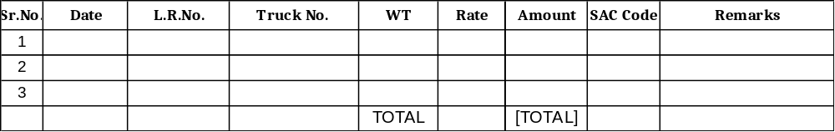

GRAND TOTAL: - [TOTAL] =00
Rupees [AMOUNT IN WORDS] Only.
* The above rates are exclusive of GST.
* Payment to be paid within 07 days of bill date or interest of 18% P.A will be charged extra.

Please pay cheque/D.D in favor of SHREY LOGISTICS, GANDHIDHAM by courier or RTGS. SHREY LOGISTICS, ICICI BANK A/C No. 244305500059 IFSC CODE: ICIC0002443, MICR. CODE 370229002
GSTIN:-24AFKPK3914J2ZE PAN NO. AFKPK3914J

Regards,
Our MSME Details
Udyam Registration No.: UDYAM-GJ-13-0029132
MSME Type: Services
Category: Micro
For, SHREY LOGISTICS,
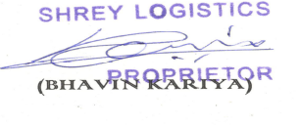
“I/We hereby declare that though our aggregate turnover in any preceding financial year from 2017-18 onwards is more than the aggregate turnover notified under sub-rule (4) of rule 48, we are not required to prepare an invoice in terms of the provisions of the said sub-rule.”

