**Subscart**

Subscart is a cutting-edge subscription management platform designed to seamlessly connect vendors and customers in one ecosystem. From food subscriptions to flexible delivery options, we are redefining how subscriptions are created, managed, and Delivered

### Why Subscart?

The subscription economy is expanding rapidly, but managing subscriptions remains a **complex and fragmented** experience for both businesses and customers. Many vendors struggle with setting up and managing flexible subscriptions, while customers face difficulties in modifying, pausing, or customizing their plans. **Subscart simplifies this process** by offering an all-in-one platform that streamlines subscription management, delivery, and customer interaction.

#### Key Advantages of Subscart:

✅ **Seamless Vendor Management:** Vendors can create and modify subscription plans effortlessly, automate payments, and track deliveries—all in one place.  
 ✅ **Flexible Customer Experience:** Customers can pause, resume, or modify their subscriptions at their convenience, reducing churn.  
 ✅ **Optimized Logistics:** A well-integrated system for staff and drivers ensures smooth order fulfillment and timely deliveries.  
 ✅ **Scalability for Businesses:** Helps small and medium-sized vendors tap into the growing subscription market without needing expensive tech solutions.

### Market Gap & Opportunity

Despite the rise in subscription-based services, there are **significant challenges** in the industry that Subscart aims to solve:

1️⃣ **Lack of an Integrated System:**

* Most businesses use **multiple disconnected tools** for subscription creation, payment processing, and delivery tracking.
* **Subscart** offers an end-to-end solution for vendors, customers, staff, and drivers.

2️⃣ **Rigid Subscription Models:**

* Traditional platforms do not provide **customizable subscription plans**, leading to higher customer churn.
* **Subscart** allows users to modify, pause, or adjust subscriptions without hassle.

3️⃣ **High Operational Costs for Vendors:**

* Small businesses find it expensive to build and manage their own subscription systems.
* **Subscart** provides a cost-effective way for vendors to enter the subscription market with minimal investment.

4️⃣ **Poor Delivery Management & Customer Experience:**

* Many vendors face **logistics challenges**, leading to delays and customer dissatisfaction.
* **Subscart’s driver app** ensures **real-time tracking, optimized routes, and smooth deliveries.**

By **bridging these gaps,** Subscart is not just another subscription platform—it is a **game-changer** that makes subscriptions easier, more flexible, and highly scalable for businesses while enhancing convenience for customers. 🚀

## Key Stakeholders & Their Roles

➡ **Vendors** – Manage subscriptions, deliveries, and payments effortlessly.  
 ➡ **Customers** – Enjoy flexibility in customizing, pausing, and managing subscriptions.  
 ➡ **Staff** – Oversee order preparation and fulfillment.  
 ➡ **Drivers** – Ensure timely and efficient deliveries.

### Before Creating the Workflow

* **Vendor & Customer Registration:**
  + Vendors and customers must **register** on the platform.
  + **Admin approval** is required before vendors can access the dashboard.
* **Outlet Creation:**
  + Once approved, vendors **set up their outlet** to serve customers.
  + Customers can browse and subscribe once the outlet is live.

### Vendor App Workflow

🔹 **A. Account Setup & Login**  
 1️⃣ Vendors sign up and log in after admin approval.  
 2️⃣ They access their dashboard to manage subscriptions and deliveries.

🔹 **B. Subscription Creation Process**

1️⃣ **Add Product Details**

* Upload images from the gallery.
* Enter the subscription name and type.

2️⃣ **Set Delivery Preferences**

* Select delivery type (daily, weekly, etc.).
* Assign products to the subscription.
* Choose delivery days.

3️⃣ **Customize Options**

* Add optional add-ons.
* Set subscription duration.
* Define lead time (preparation time).

4️⃣ **Submit for Approval**

* Admin reviews and approves the subscription.
* Once approved, it becomes visible to customers.

This ensures a **controlled and structured** vendor onboarding process, maintaining service quality and seamless operations. 🚀

## 2. Customer App Workflow

### 🔹 A. Browsing & Selecting a Subscription

1️⃣ Customers browse available plans and select a suitable subscription type.  
 2️⃣ They can view details and choose delivery options.

### 🔹 B. Subscription Management

1️⃣ Pause or resume subscriptions as needed.  
 2️⃣ Modify subscription settings within the defined lead time.

## 3. Staff App Workflow

### 🔹 A. Order Processing

1️⃣ Staff receive orders before the lead time expires.  
 2️⃣ They update the order status through three stages:  
 ✅ **Preparation** – Order is being prepared.  
 ✅ **Ready** – Order is ready for pickup.  
 ✅ **Out for Delivery** – Order is handed over to the driver.

## 4. Driver App Workflow

### 🔹 A. Order Assignment & Delivery

1️⃣ Drivers must be online to receive orders.  
 2️⃣ Once an order is marked "Ready," the driver receives:  
 🔹 Order details.  
 🔹 Navigation to the delivery location.  
 🔹 Customer contact details.

### 🔹 B. Completing the Delivery

1️⃣ After reaching the delivery location, the driver marks the order as "Delivered."  
 2️⃣ Payment is credited to the driver’s wallet.  
 3️⃣ Customers can rate the delivery experience.

To create a subscription for **Subscart Vendor Manage**, follow these steps:

### Step 1: Access the Subscription Section

1. Log in to your **Subscart Vendor Manage** panel.
2. Navigate to the **"Subscription Management"** or **"Create Subscription"** section.

### Step 2: Set Up Subscription Details

1. Click on **"Add New Subscription"**
2. Enter the **subscription name** (e.g., "Weekly Meal Plan," "Monthly Grocery Pack").
3. Select the **subscription category** (e.g., Food & Beverages, Groceries, Fitness, etc.).

### Step 3: Define Subscription Plan

1. Choose the **subscription duration** (e.g., daily, weekly, monthly).
2. Select the **pricing model** (one-time payment or recurring payment).
3. Add details such as **subscription price, discounts, and offers**.

### Step 4: Configure Delivery Settings

1. Allow customers to **select their preferred delivery days**.
2. Enable the **pause option** (if customers want to skip certain days).
3. Let customers **enter their delivery address** and set delivery time preferences.

### Step 5: Add Products & Customization

1. **Select products** available in the subscription.
2. Add **variations & choices** (e.g., meal preferences, extra items).
3. Set **minimum and maximum selection limits**.

### Step 6: Review & Save Subscription

1. Click **"Next"** to review all details.
2. Ensure all **product and pricing details** are correct.
3. Click **"Save"** to activate the subscription.

### Step 7: Manage Orders & Payments

1. Once a customer purchases a subscription, the system will auto-schedule deliveries.
2. The vendor can see new orders and update the **order status** (e.g., preparing, ready, out for delivery).
3. After successful delivery, the payment gets credited to the vendor’s wallet.

To create a subscription for **Subscart Manage Delivery**, follow these steps:

1->First after login we will select Subscription from bottom navigation bar

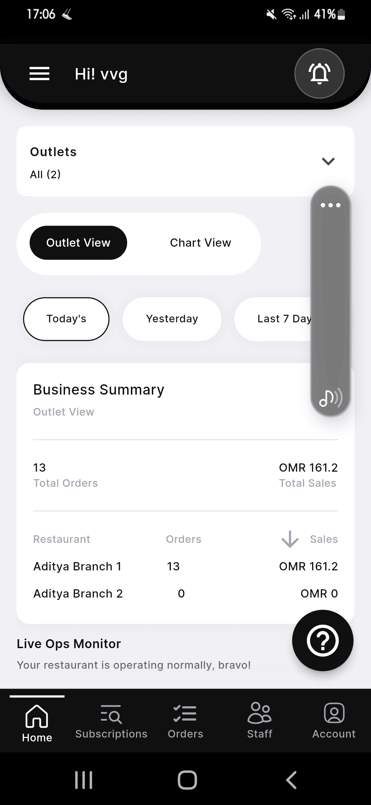

2-> Fill out all the detail here which is given here

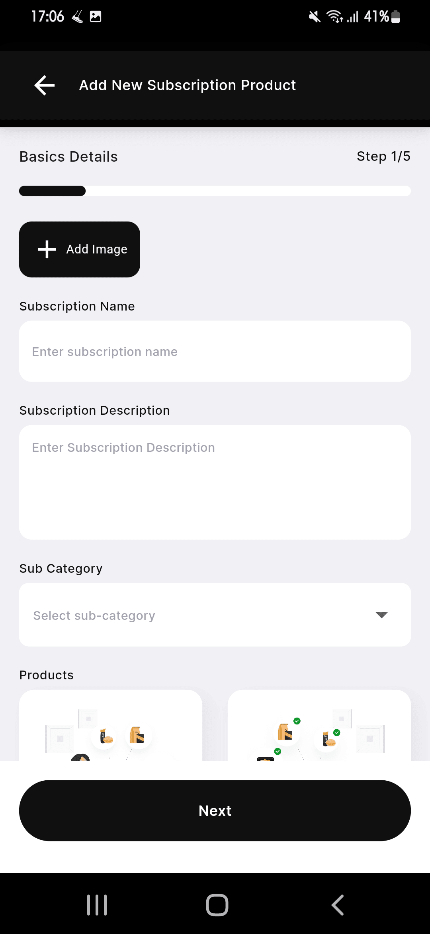

3->After filling out all the details, click on the "Next" button. Here, you will need to enter the complete product details, including name, description, price, and any additional spe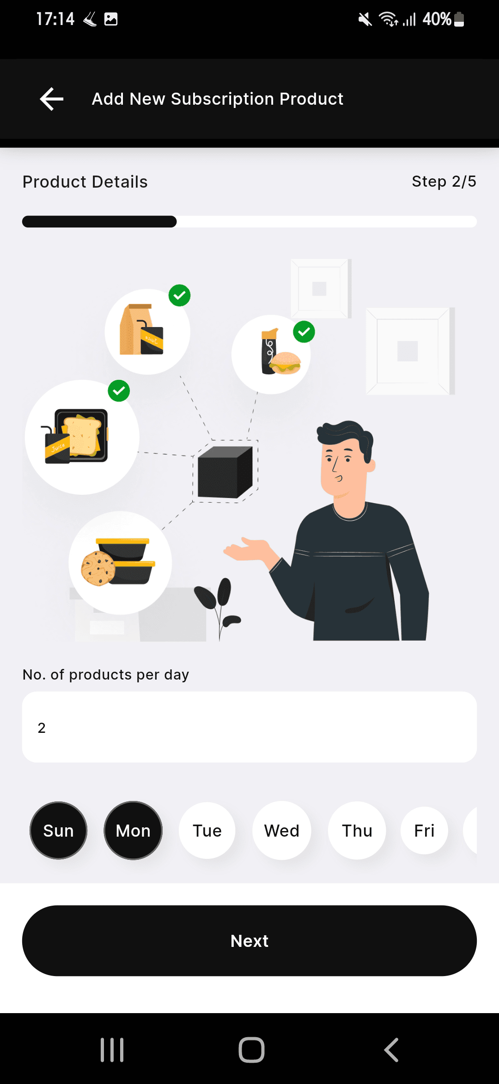

4->The next step is to fill in the details of the products you want to purchase based on the selected days. This includes selecting specific items for each day as per the subscription plan.

4o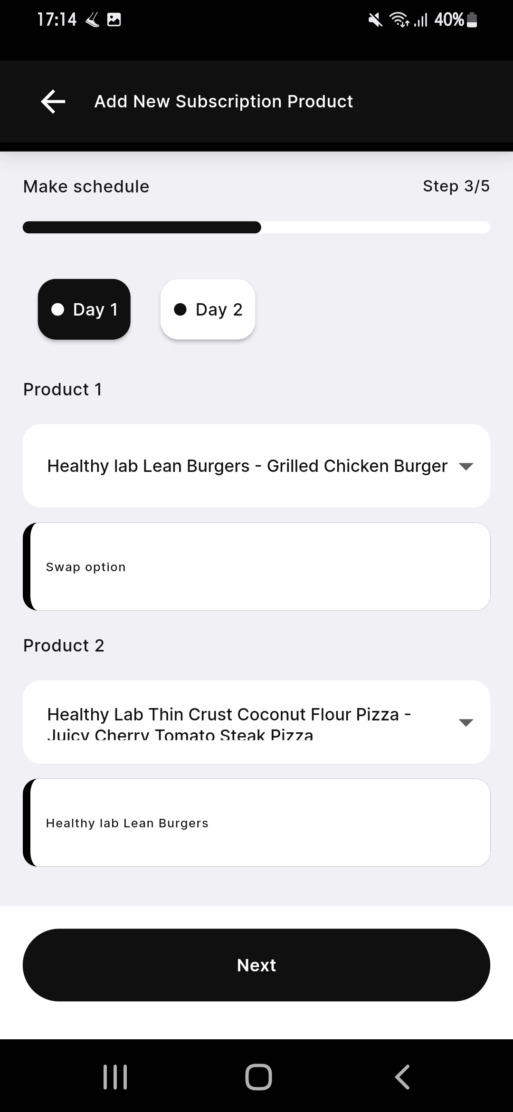

5-> The next step is to fill in the details, where you need to:

1. **Add Variation** – Specify different variations of the food item.
2. **Choice Name** – Define the choice category (e.g., toppings, spice level, etc.).
3. **Minimum & Maximum Choices** – Set the minimum and maximum number of choices a customer can select.
4. **Extra Food Options** – If additional food items are available, include them as optional add-ons.

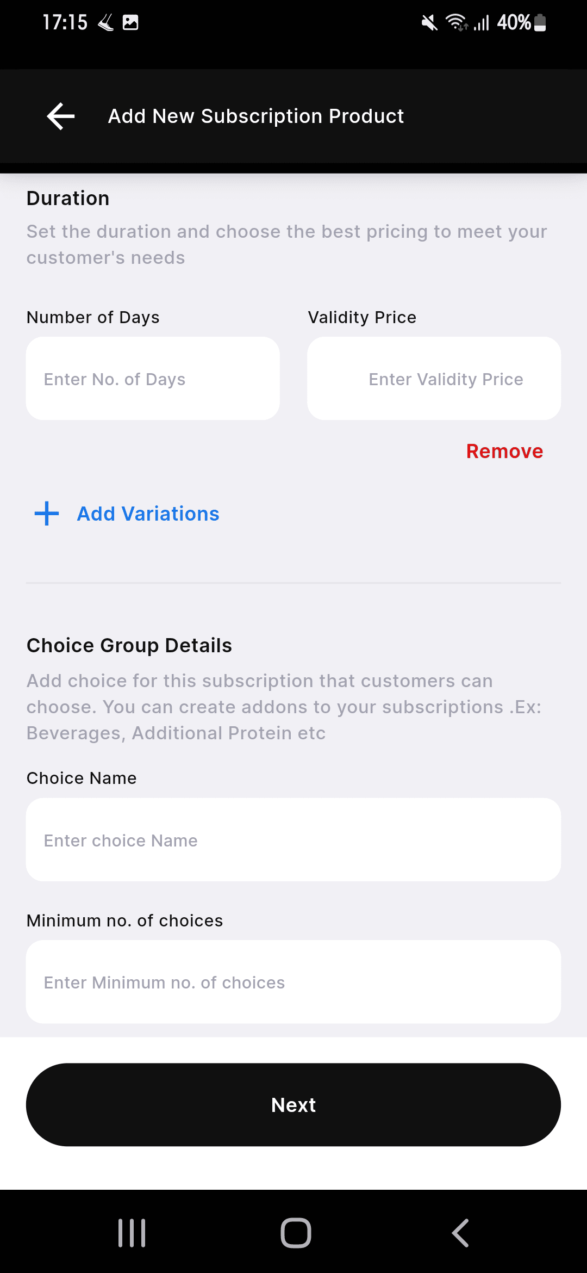

6-> After Selecting this all we have select the the Delivery From here

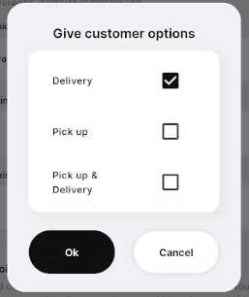

7-> Select Here Yes

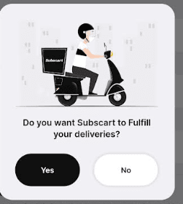

8->After this Select here Lead Time

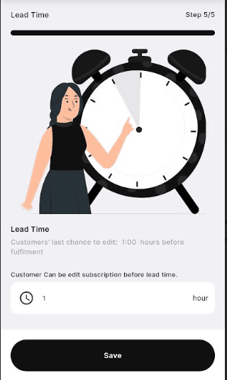

9->After clicking on "Save," click "Yes" if you want to enable the pause option. You can then select the number of days for the pause and choose the respective outlet.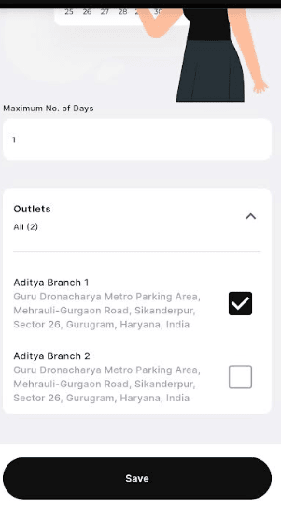

11->After this Clicking on save button Subscription will be created Successfully and Like this Screen will look 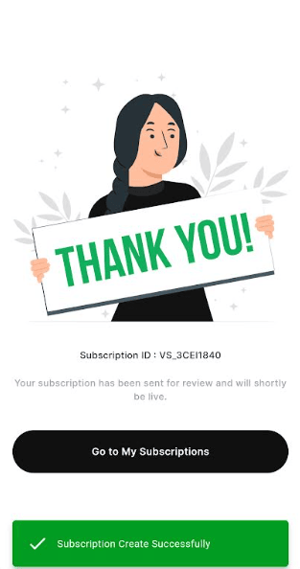

After this We have to give the Approval from the Admin Pannel

After the vendor saves the subscription, customers will be able to make purchases through the app once approved by the admin. When a customer opens the app, they can select their desired category from the available options.

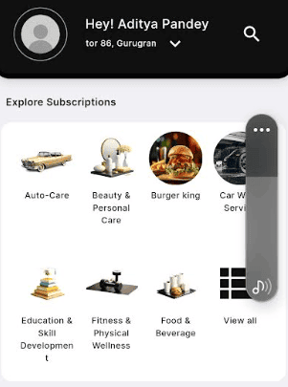

10->After selecting the subscription, the customer can browse and choose whatever they want from the available options.

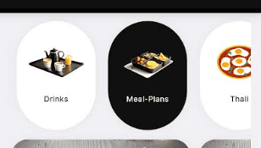

11->After selecting the subscription, the customer can choose their preferred branch, select their meal, and proceed with the purchase.

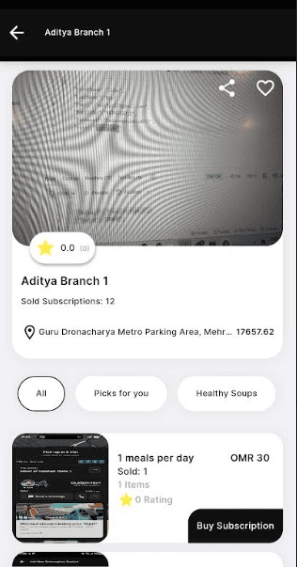

12-> After selecting the meal, the customer can view its details as shown in the image and proceed by clicking on the "Buy Subscription" button.

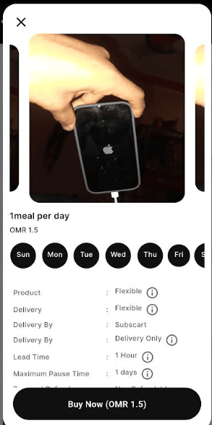

13-> After clicking on "Buy Now," the customer can select the delivery location, as well as add or change the address if needed

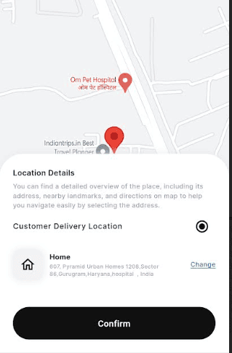

14-> After confirming the location customer can check the prices

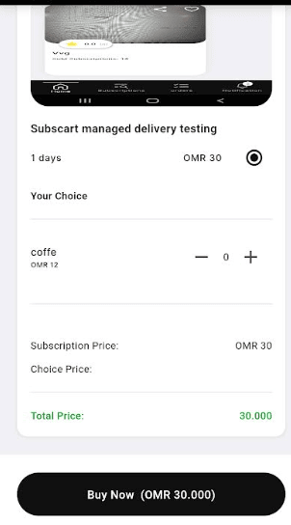

15->After this, the customer selects their preferred pickup or delivery time based on their convenience. Now, they can choose the exact timing for when they want the order and how they would like to receive it.

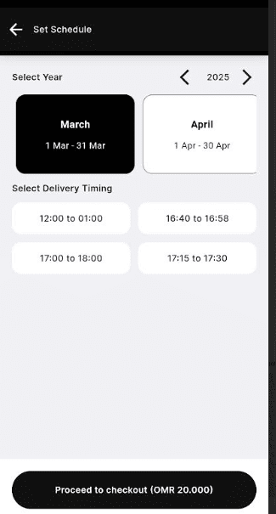

16->Now, the customer can make the payment and click on "Proceed to checkout" Once done, their order will be successfully placed.

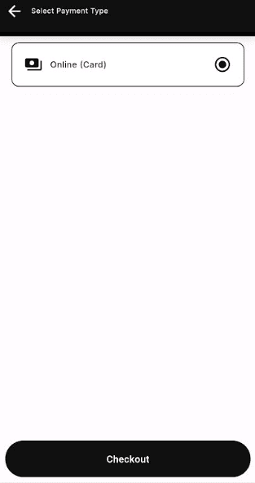

Before the lead expires, the staff will receive a notification in their app within the lead time set by the vendor. After that, the staff can view and read all the details. Before starting the preparation, they need to update the status in the app using the "Change Status" option and mark it as "Preparing."

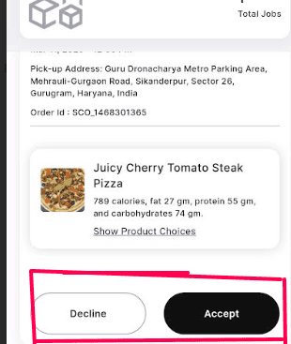

**Before accepting the order, nearby drivers should be ready and stay online.**

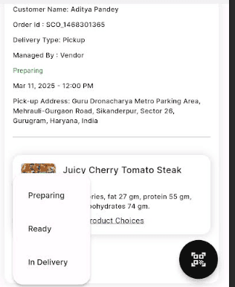

After preparing the order, the staff should update the status in the app and mark it as Ready.

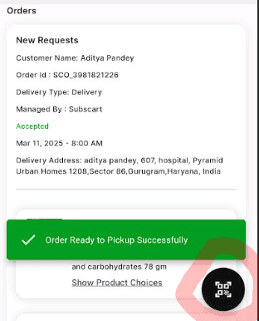

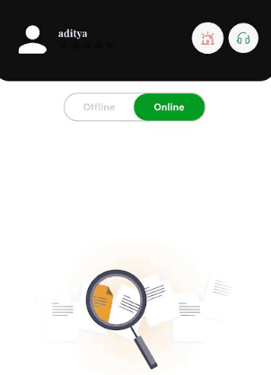

. Once the order is ready, the driver can accept it and proceed with delivery.

After successful delivery, the payment will be credited to the driver's wallet in the driver’s app

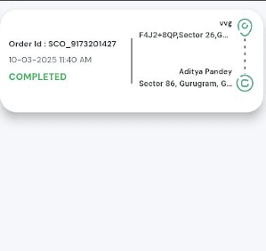

After a successful delivery, the customer can check their order in the app from the bottom navigation tab under the "Orders" section. In the top right corner, under the "Completed" section, they can find their completed order. They can also rate their meal and download a PDF containing all order details.

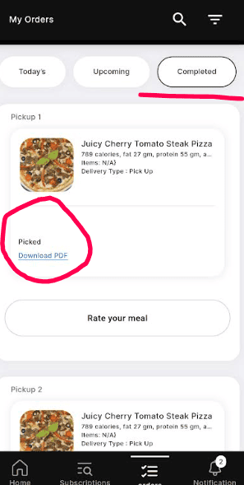

C

**To create a subscription for Subscart Manage Pickup follow these steps:**

1->First after login we will select Subscription from bottom navigation bar

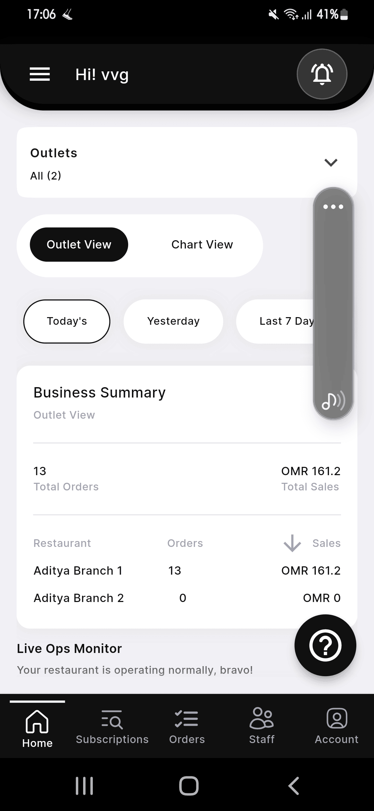

2-> Fill out all the detail here which is given here

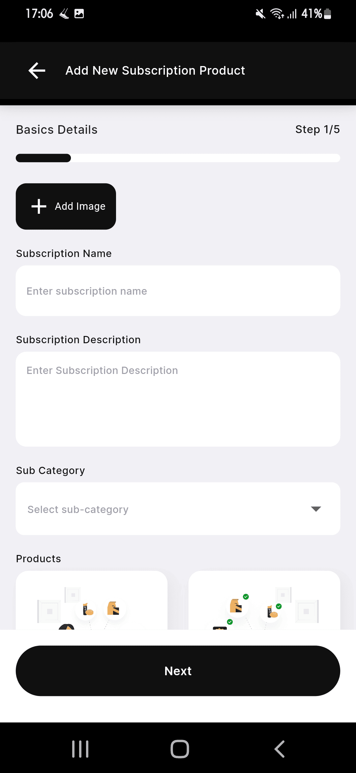

3->After filling out all the details, click on the "Next" button. Here, you will need to enter the complete product details, including name, description, price, and any additional spe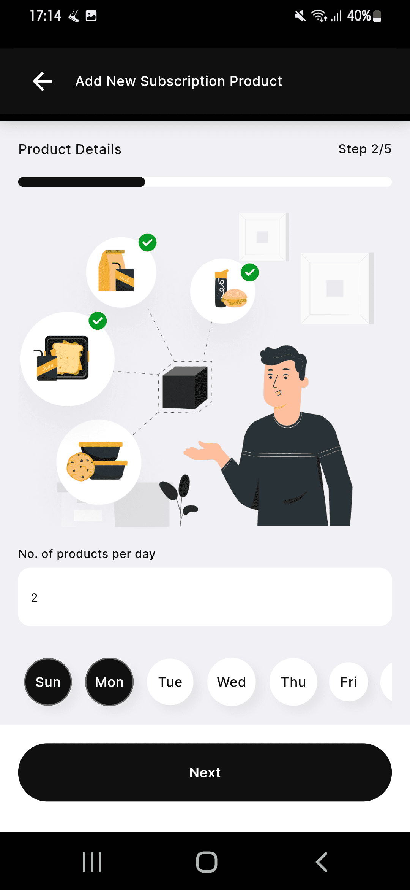

4->The next step is to fill in the details of the products you want to purchase based on the selected days. This includes selecting specific items for each day as per the subscription plan.

4o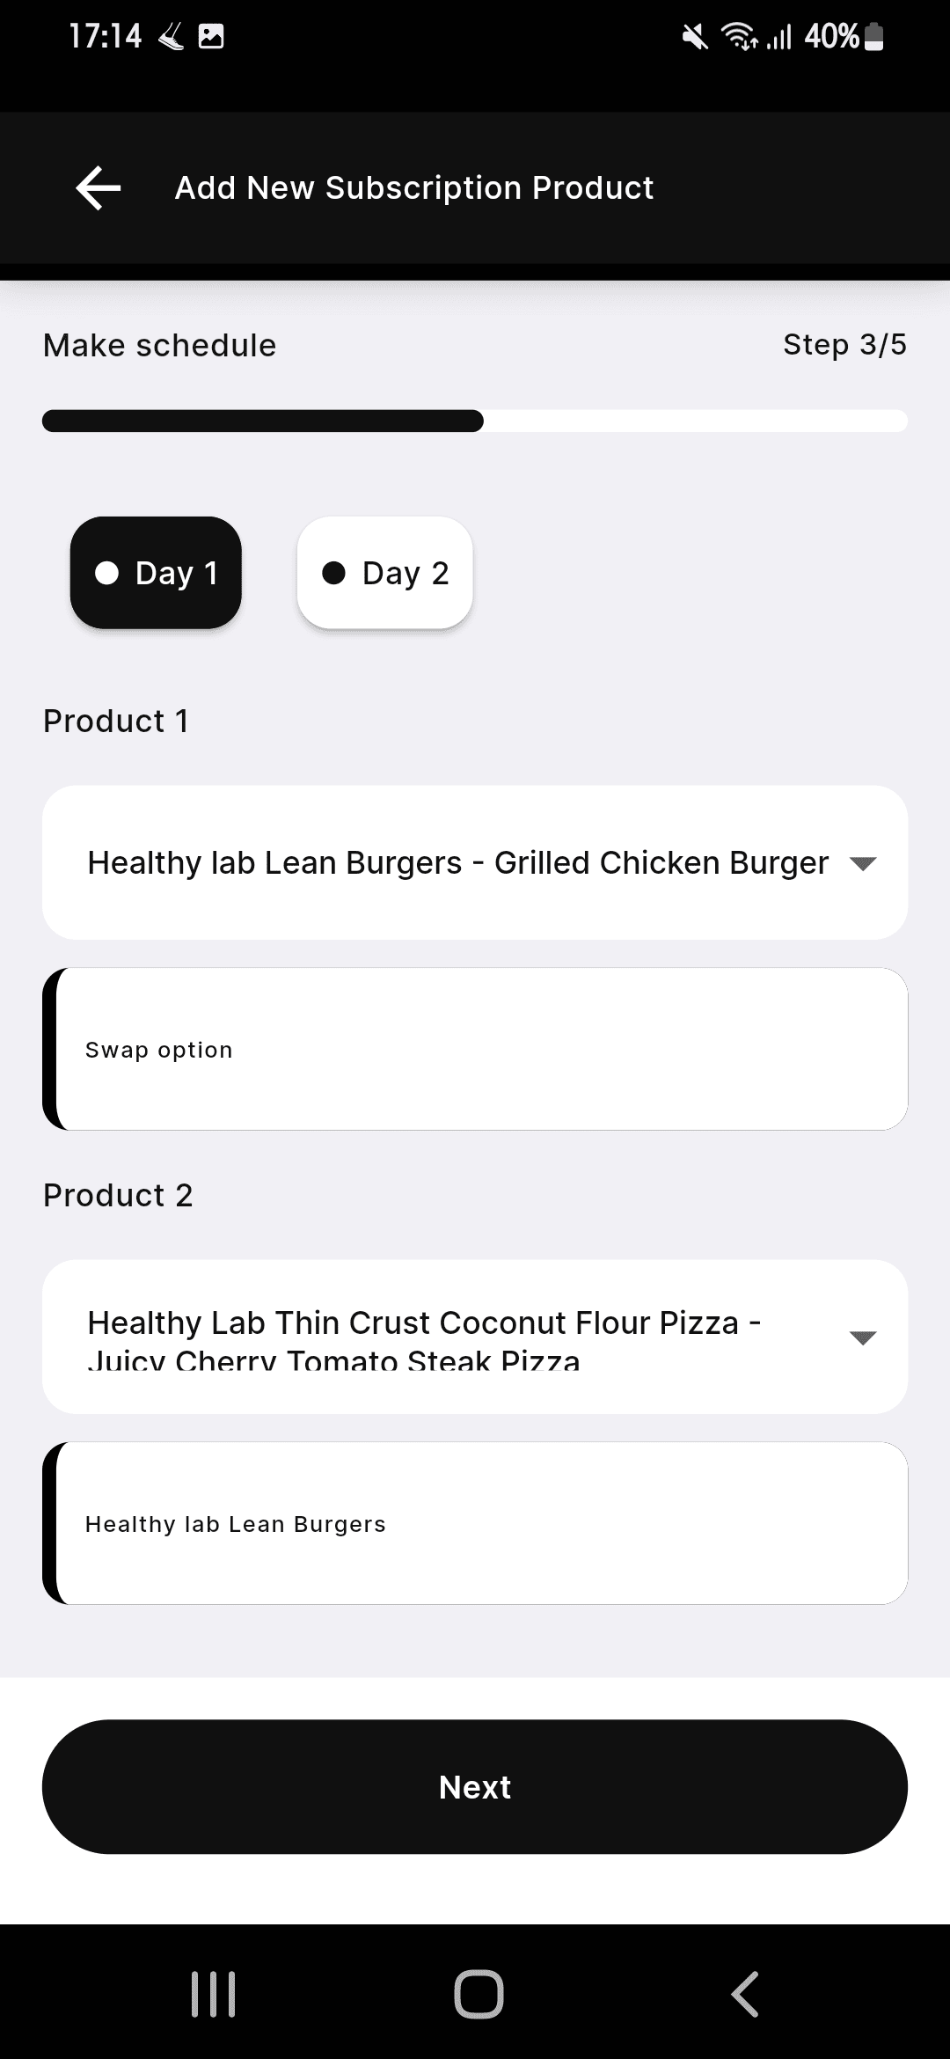

5-> The next step is to fill in the details, where you need to:

1. **Add Variation** – Specify different variations of the food item.
2. **Choice Name** – Define the choice category (e.g., toppings, spice level, etc.).
3. **Minimum & Maximum Choices** – Set the minimum and maximum number of choices a customer can select.
4. **Extra Food Options** – If additional food items are available, include them as optional add-ons.

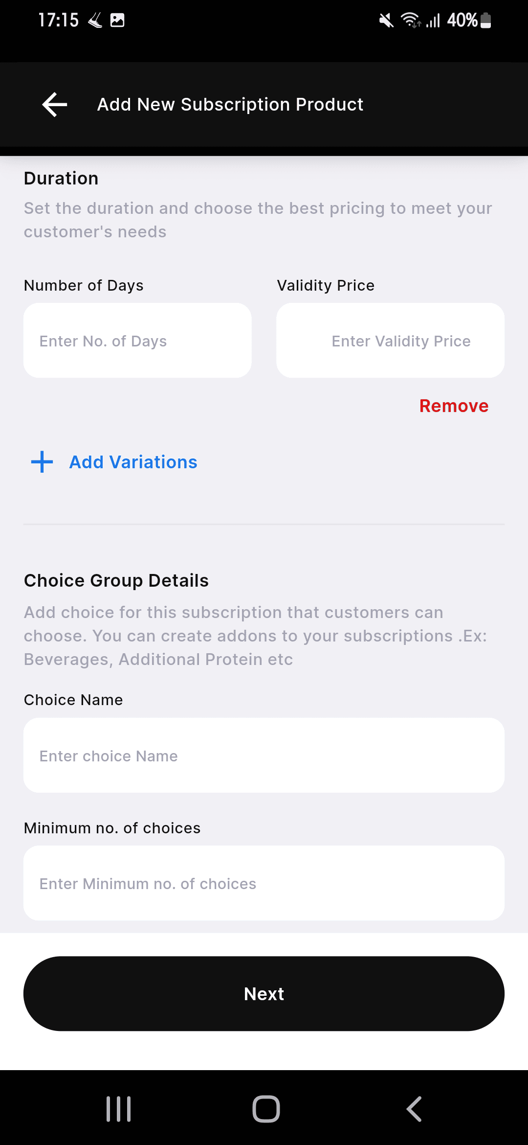

6-> After Selecting this all we have select the the Pickup From here

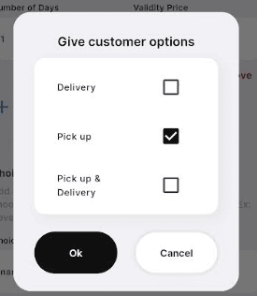

7-> Select Here Yes

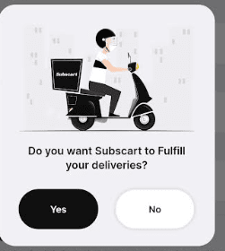

8->After this Select here Lead Time

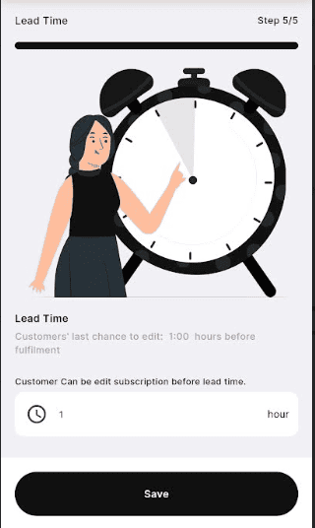

9->After clicking on "Save," click "Yes" if you want to enable the pause option. You can then select the number of days for the pause and choose the respective outlet.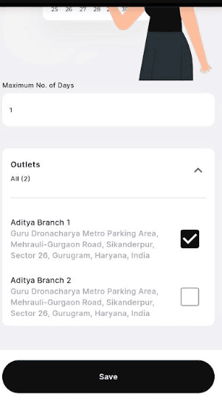

11->After this Clicking on save button Subscription will be created Successfully and Like this Screen will look 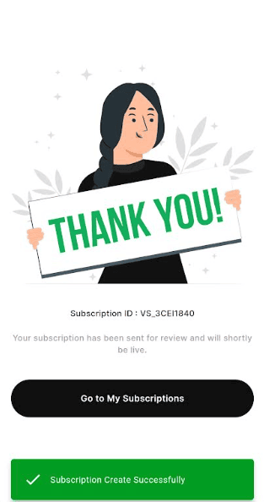

After this We have to give the Approval from the Admin Pannel

After purchasing the order, when the customer open his order they will find a QR code in the top right corner. This QR code must be presented to the staff at the time of order pickup

.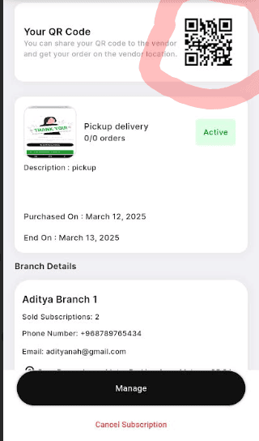

#### Step 2:

Before the **lead time** set by the vendor expires, the staff will receive the **order details** (as shown in the image) and will proceed to **accept the order**.

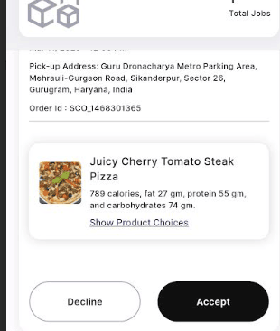

#### Step 3:

After **accepting** the order, the staff will get three status options:

* **Preparing**
* **Ready**
* **In Delivery**

From the **"Change Status"** section, the staff can **mark the order as "Preparing"** when they start preparing it.

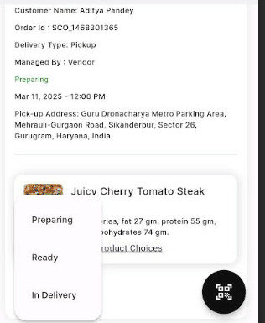

#### Step 4:

Once the order is fully prepared, the staff can **mark it as "Ready"**.

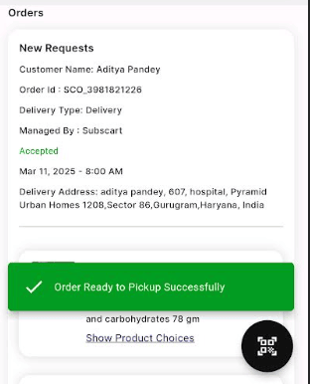

#### Step 5:

The customer can now visit the pickup point with their **QR code**.

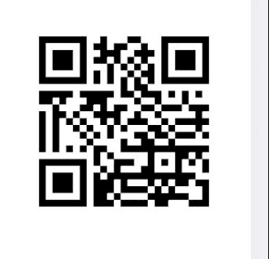

#### Step 6:

Upon arrival, the customer will **show the QR code**, and the staff will **scan it**. from here

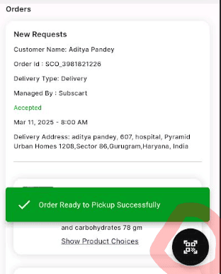

#### Step 7:

After scanning, the staff will receive **order details** along with an option to **"Complete Order"**.

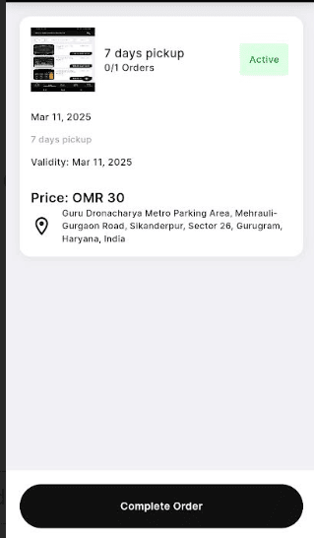

#### Step 8:

Once the staff **completes the order**, they will see a confirmation screen. They will **mark "Okay"** if the order is successfully completed.

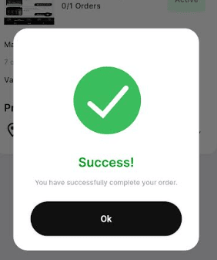

#### Step 9:

* In the **Staff App**, the order will move to the **"Completed Orders"** section.
* In the **Customer App**, the order will appear in the **"Completed Orders"** section under the **Orders Tab** (as shown in the image).

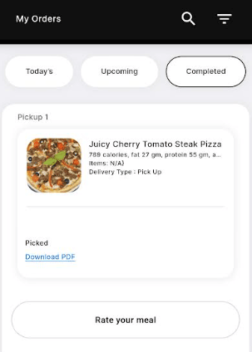

After completing the process, the customer will see a confirmation message like **"1/1 orders"** as shown in the image.

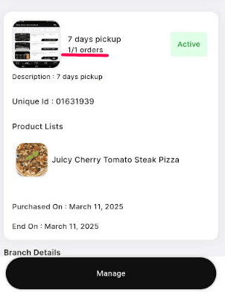

**To create a subscription for Vendors Manage Delivery follow these steps:**

1->First after login we will select Subscription from bottom navigation bar



2-> Fill out all the detail here which is given here



3->After filling out all the details, click on the "Next" button. Here, you will need to enter the complete product details, including name, description, price, and any additional spe

4->The next step is to fill in the details of the products you want to purchase based on the selected days. This includes selecting specific items for each day as per the subscription plan.

4o

5-> The next step is to fill in the details, where you need to:

1. **Add Variation** – Specify different variations of the food item.
2. **Choice Name** – Define the choice category (e.g., toppings, spice level, etc.).
3. **Minimum & Maximum Choices** – Set the minimum and maximum number of choices a customer can select.
4. **Extra Food Options** – If additional food items are available, include them as optional add-ons.



6-> After Selecting this all we have select the the Delivery From here

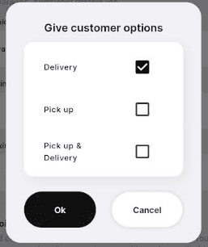

7-> Select Here "No"

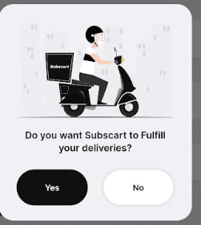

8-> After this I have to select the pause day Details

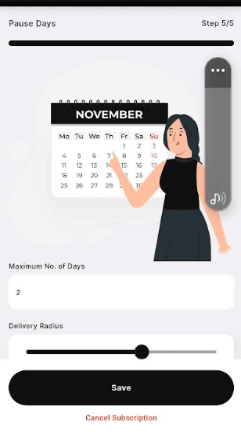

After the vendor saves the subscription, customers will be able to make purchases through the app once approved by the admin. When a customer opens the app, they can select their desired category from the available options.

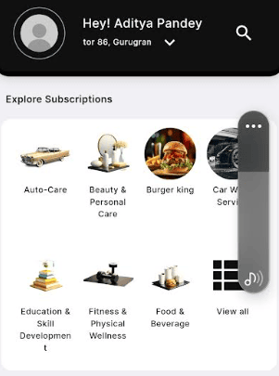

10->After selecting the subscription, the customer can browse and choose whatever they want from the available options.

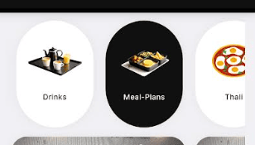

11->After selecting the subscription, the customer can choose their preferred branch, select their meal, and proceed with the purchase.

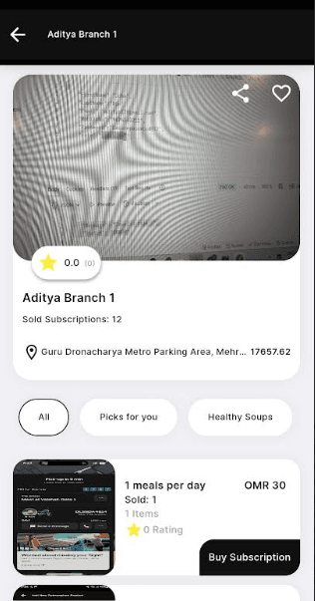

12-> After selecting the meal, the customer can view its details as shown in the image and proceed by clicking on the "Buy Now" button.

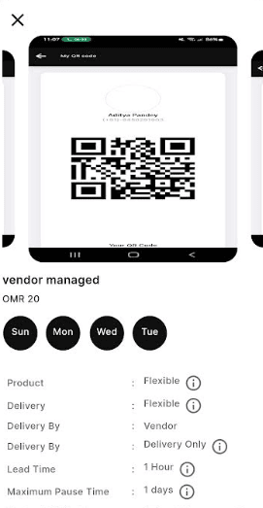

13-> After clicking on "Buy Now," the customer can review the validity duration, check the price, and complete the purchase.

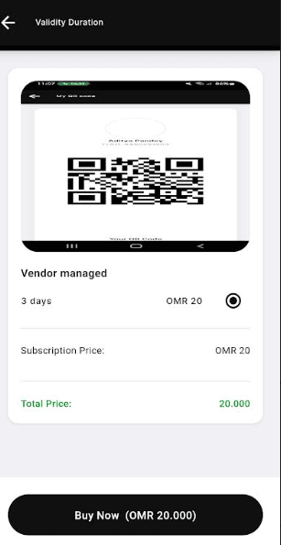

14-> After this, the customer can select the delivery location, as well as add or change the address if needed

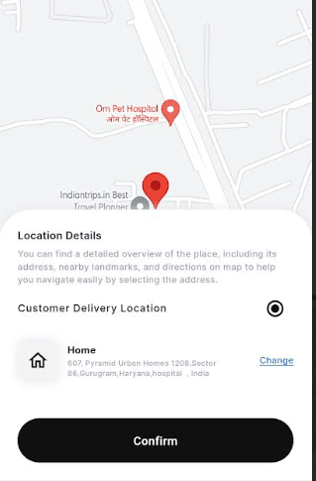

15->Once the payment is completed, the vendor's pre-set lead time will begin. After this time elapses, the



staff can view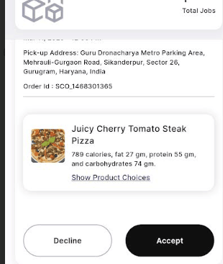

and accept the order,

updating its status to Preparing,"

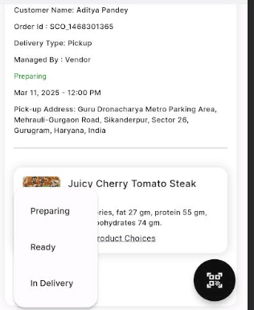

"Ready,"



and "Out for Delivery."

Before the order is ready, the driver should be online

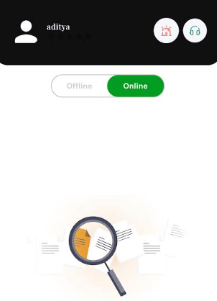

. Once the order is ready, the driver can accept it and proceed with delivery.

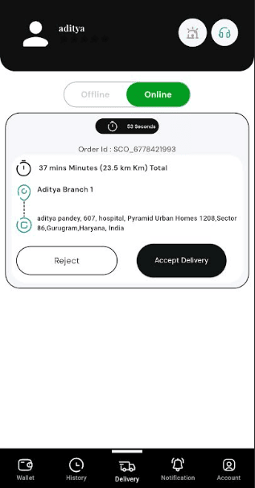

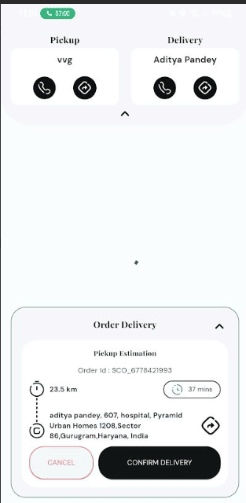

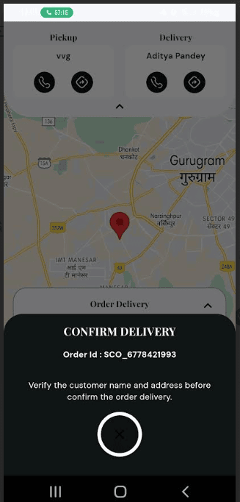

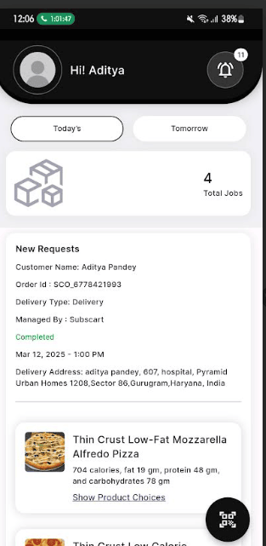

After successful delivery, the payment will be credited to the driver's wallet in the driver’s app

