Air Quality Data Analysis – Tracking Pollution Levels and Their Impact on Health

**A PROJECT REPORT**

Submitted by

**SHREY CHOUDHARY (22BCA10037)**

**in partial fulfilment for the award of the degree of**

**BACHELOR IN COMPUTER APPLICATIONS**



**Chandigarh University**

**Jan- May 2025**

**ABSTRACT**

**Air pollution remains a pressing environmental challenge in modern times. With increasing industrialization, vehicular emissions, and urban expansion, the air quality in many Indian cities has deteriorated significantly. Even Mohali, a planned and green city, has experienced a surge in air pollution levels, particularly with rising concentrations of particulate matter like PM2.5 and PM10. These pollutants penetrate deep into the lungs and bloodstream, causing a range of health issues including asthma, bronchitis, and cardiovascular diseases.**

**This project aims to track and analysis air pollution levels in Mohali during April 2025. The primary objective is to observe variations in PM2.5, PM10, and AQI values and assess their impact on the population’s health. Real-time data was collected and structured into meaningful visual formats using Microsoft Excel, enabling insights and trend identification.**

**Beyond understanding daily pollution patterns, this analysis emphasizes the importance of data-driven environmental monitoring. It highlights the need for immediate action, increased awareness, and stringent policies to control pollution and safeguard public health.**

**INTRODUCTION**

**Air pollution is a pressing environmental concern, particularly in urban areas like Mohali. The city’s high population density, traffic congestion, and industrial activities contribute to deteriorating air quality. Exposure to pollutants like particulate matter (PM2.5 and PM10) can lead to severe health issues, including respiratory diseases, cardiovascular problems, and even reduced life expectancy.**

**This project aims to investigate the fluctuations in air quality in Mohali throughout March 2025. By analyzing the levels of PM2.5, PM10, and the Air Quality Index (AQI), and visualizing the patterns using Excel charts, the project seeks to gain a deeper understanding of pollution trends and their impact on public health.**

DATA OVERVIEW

* **Location: MOHALI**
* **Duration: 1st MARCH to 31th MARCH 2025**
* **Pollutants Monitored: PM2.5 (ug/m3), PM10 (ug/m3), AQI**

Data was collected from reputed online sources like IQAir, OpenAQ, and the Central Pollution Control Board. The raw data was then organized into an Excel sheet with each row representing daily pollutant levels. The pollutants were chosen because they are widely recognized as key indicators of air quality and have a direct impact on human health.

OBJECTIVES

* **To monitor and record the daily AQI, PM2.5, and PM10 levels in MOHALI during MARCH 2025.**
* **To analyze the trends and identify peak pollution days.**
* **To assess the health impacts of air pollution based on the observed**

levels.

* **To visually represent the pollution levels using graphs and charts for**

easy understanding.

**TOOLS USED**

* **Microsoft Excel 365 for data recording, calculation, chart creation, and**

**formatting.**

* **Online Air Quality APIs for gathering daily pollution data.**

**STEPS TO ANALYZE THE DATA**

**1. Data Collection:**

* **Sourced daily values of PM2.5, PM10, and AQI.**

**2. Data Entry in Excel:**

* **Input data in rows with columns: Date, PM2.5, PM10, AQI.**

**3. Calculation of Averages:**

* **Used AVERAGE functions to compute mean values.**

**4. Chart Creation:**

* **Line graphs were used to track AQI, PM2.5, and PM10 trends.**

**5. Conditional Formatting:**

* **Highlighted days with AQI > 120 as red (unhealthy).**

**6. Trend Analysis:**

* **Analyzed spikes, dips, and weekly averages.**

**7.**





**8.**

9. Insights Derived:

* **Identified peak pollution days and compared against safe**

thresholds.

OUTPUT SCREENSHOTS

* **AQI Trend Chart: Daily AQI levels with highlighted peaks.**
* **Pollutant Concentration Chart: Visual comparison of PM2.5 and**

PM10 over 30 days.

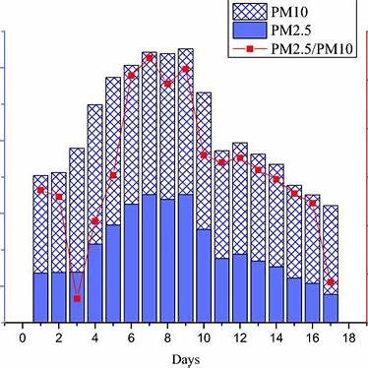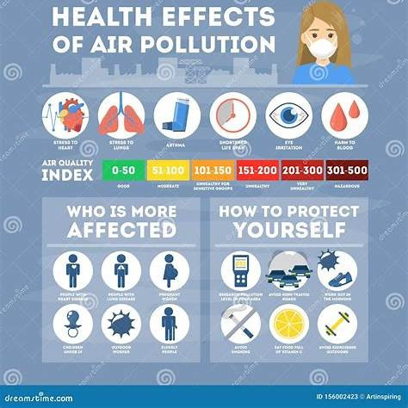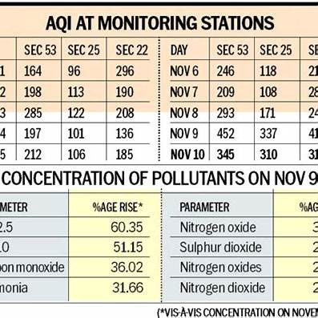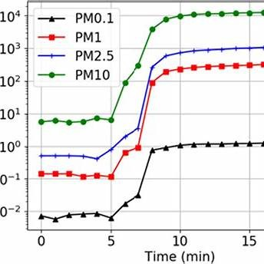

CONCLUSION

This analysis reveals that Mohali experienced moderate to high pollution levels in March2025. The PM2.5 and PM10 levels frequently exceeded the safe threshold, particularly on days with an AQI exceeding 130. These elevated levels pose significant risks to individuals with respiratory conditions, children, and the elderly. Excel proved to be an effective tool for visualizing and interpreting air quality trends. These findings underscore the urgent need for pollution control measures and heightened public health awareness.