A Report on ALM2 Project
A report submitted in partial fulfillment of the requirements for the award of the degree of computer science and information technology
by
Student Name : KP. Shreya ID.NO : 2420090093
Dr. Jagan Mohan Reddy . D

KONERU LAKSHMAIAH EDUCATION FOUNDATION, BOWRAMPET
Hyderabad-500043, Telangana, India
2026

Abstract
Project 1 : CryptoVault is an interactive web application developed to demonstrate the practical implementation of public-key cryptography and digital signature techniques. It allows users to register and log in, generate RSA key pairs, encrypt and decrypt messages, create and verify digital signatures, perform Diffie–Hellman key exchange, and generate SHA-512 message hashes.The application also supports public-key storage and self-signed X.509 certificate generation to demonstrate basic Public Key Infrastructure (PKI).
Project 2 : SecureTunnel is an educational web application designed to visualize and explain how secure communication channels are established using TLS/SSL, SSH, and IPsec concepts. It simulates the TLS handshake between a client and a server, demonstrating cipher-suite negotiation, server certificate verification, key establishment, session-key derivation, and handshake confirmation. It also illustrates the SSH connection process, including protocol negotiation, Diffie–Hellman key exchange, server authentication, and user authentication.

Contents
List of Tables 3
List of Tables 4

List of Tables
Project 1 : Component | Technology / Algorithm
Frontend UI | React
API Communication | Axios
Backend Framework | Python with Flask or FastAPI
Cryptographic Library | Python cryptography
Database | SQLite or PostgreSQL
User Authentication | Registration and login module
RSA Module | RSA algorithm
Key Exchange Module | Diffie–Hellman
Digital Signature Module | ElGamal signature scheme
Hashing Module | SHA-512 using hashlib
Certificate Module | X.509

List of Tables
Project 2 : Component | Technology
Frontend UI | React
API Communication | Axios, if used
Backend Framework | Python with Flask or FastAPI
Cryptographic Library | Python cryptography
TLS Handshake Visualizer | Client–server interface
Certificate Verification Module | X.509 certificates
Key Exchange Module | RSA-based exchange or Diffie–Hellman
Session-Key Module | Key-derivation function
SSH Visualizer | Protocol and authentication steps
IPsec Visualizer | React Flow or Mermaid.js, if used
ESP Module | Encapsulating Security Payload
Handshake State Manager | Backend session/state logic
Step-by-Step Log | React components

Screenshots
Project 1 :

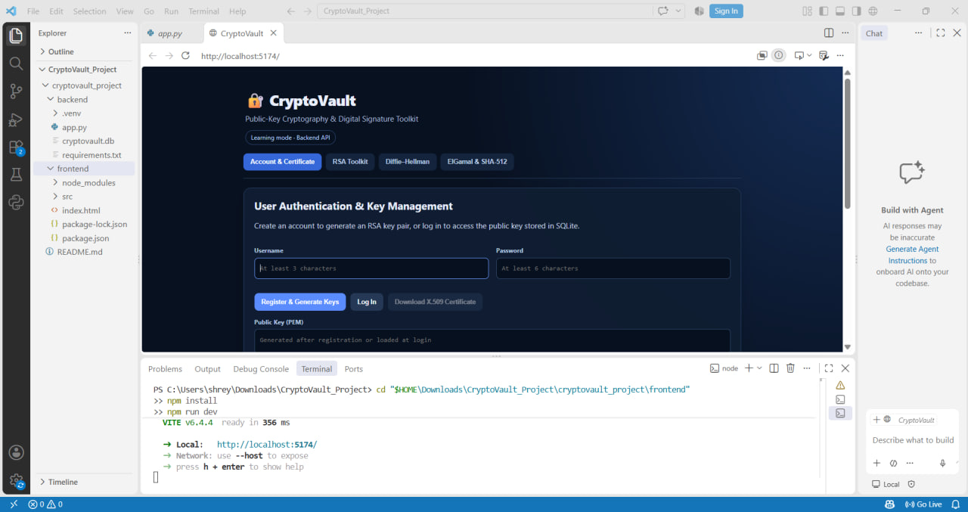
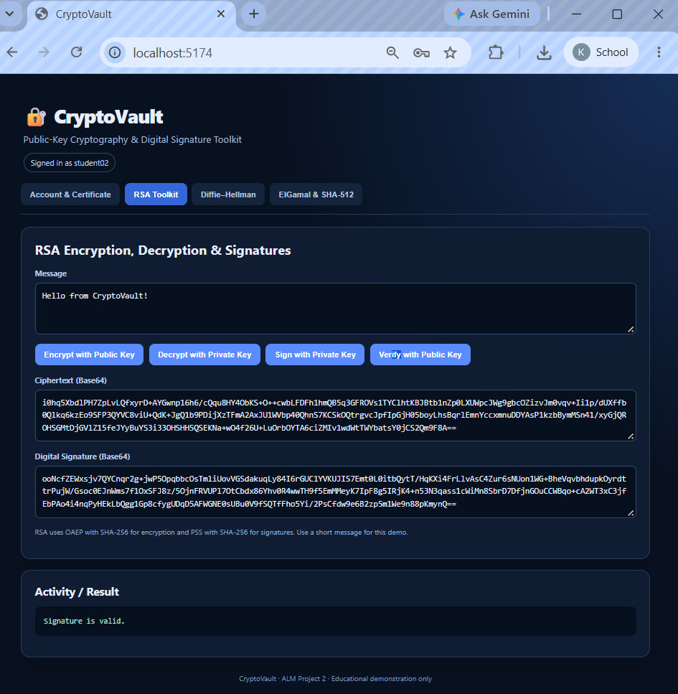

Project 2 :

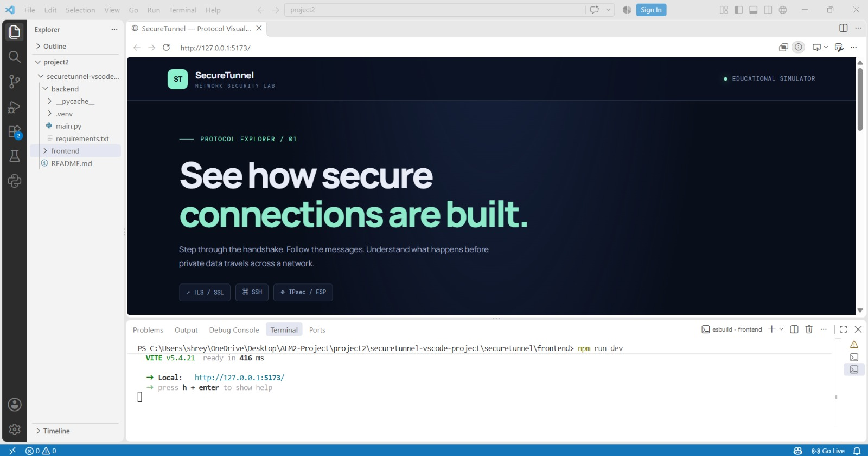
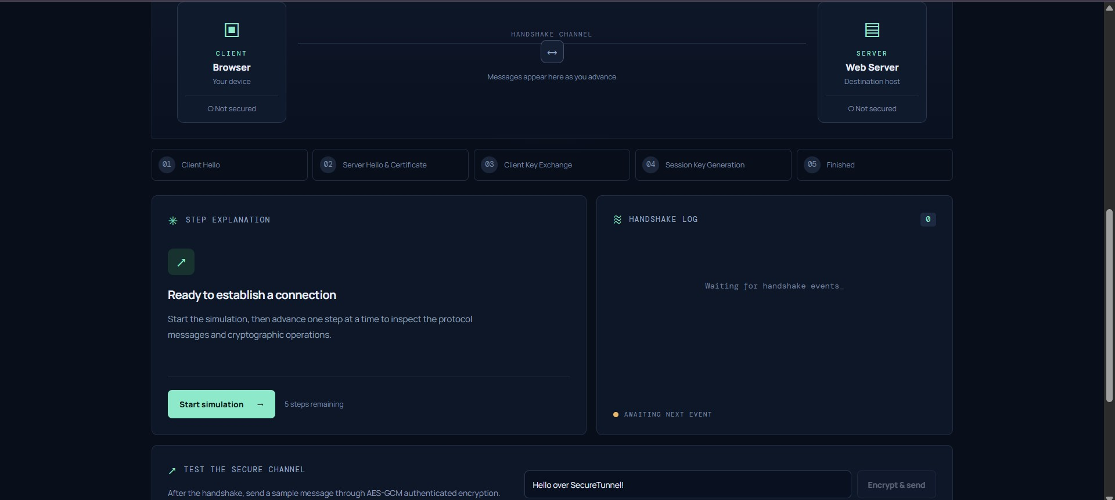

Algortihms
Project 1 : ”CryptoVault” - A Public-Key

Cryptography Digital Signature Toolkit
Algorithm 1: RSA (Rivest–Shamir–Adleman) Purpose: Public-key encryption and digital signatures. 1. Select two large prime numbers, p and q. 2. Calculate n = pq and ϕ(n) = (p− 1)(q− 1). 3. Choose a public exponent e that is relatively prime to ϕ(n). 4. Calculate the private exponent d, satisfying ed≡ 1 (mod ϕ(n)). 5. Encrypt a message representative m using c = m^{e} mod n. 6. Decrypt using m = c^{d} mod n. 7.
For signatures, sign a message digest with the private key and verify it with the public
key.
Algorithm 2: Diffie–Hellman Key Exchange Purpose: Establishes a shared secret over a public communication channel. 1. Agree on public parameters: a large prime p and generator g. 2. Alice selects a private value a and computes A = gª mod p. 3. Bob selects a private value b and computes B = g^{b} mod p. 4. Alice and Bob exchange their public values A and B. 5. Alice computes S = Bª mod p. 6. Bob computes
S = A^{b} mod p. 7. Both obtain the same shared secret, which can be processed through a key-derivation function to produce a symmetric session key.
Algorithm 3: ElGamal Digital Signature Purpose: Provides message authentication and integrity verification. 1. Select a suitable prime p and generator g. 2. Choose a private key x and compute the public key y = g^{x} mod p. 3. Compute the SHA-512 digest of the message. 4. Select a fresh, secret signing value k that is relatively prime to p− 1. 5. Calculate r = g^{k} mod p. 6. Calculate s = k⁻¹(H(m) −xr) mod (p− 1). 7.
Verify the signature using the public key and the message digest.
Project 2: ”SecureTunnel” - A Transport Layer

Security (TLS/SSH) Visualizer
Algorithm 1: TLS Handshake Simulation Purpose: Establishes a secure channel between a client and server. 1. Client Hello: The client sends supported protocol versions, cryptographic capabilities, and other negotiation parameters. 2. Server
Hello: The server selects compatible parameters and provides the information needed for key establishment. 3. Certificate Verification: The client checks the server’s certificate, identity, validity, and trust chain. 4. Key Establishment: The client and server establish shared secret material using the negotiated key-exchange method. 5.
Session-Key Derivation: Both parties derive symmetric traffic keys using a key-derivation function. 6. Finished Messages: Both sides verify handshake integrity and confirm that the negotiated handshake state matches. 7. Secure Communication:
Application data is protected using symmetric authenticated encryption.
Algorithm 2: SSH Connection Establishment Purpose: Creates an authenticated, encrypted connection for remote access and secure data transfer. 1. Protocol Version
Exchange: Client and server identify their SSH protocol versions. 2. Algorithm
Negotiation: Both parties select compatible key-exchange, host-key, encryption, and integrity algorithms. 3. Key Exchange: The parties use a method such as
Diffie–Hellman or elliptic-curve Diffie–Hellman to establish shared secret material. 4.
Server Authentication: The client verifies the server’s host-key signature against a trusted or previously recorded host key. 5. Session-Key Derivation: Both sides derive keys for encrypting and authenticating traffic. 6. User Authentication: The client authenticates using a supported method, such as a password or public key. 7. Secure
Channel Established: The connection can carry protected remote commands, data, or
other supported services.

GitHub Url
https://github.com/shreya-007-ctrl/IAS-ALM2-Project

