Q1 V
Simple Perceptron with margin
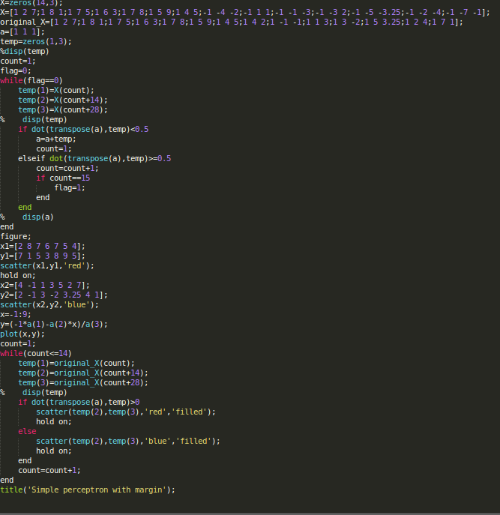
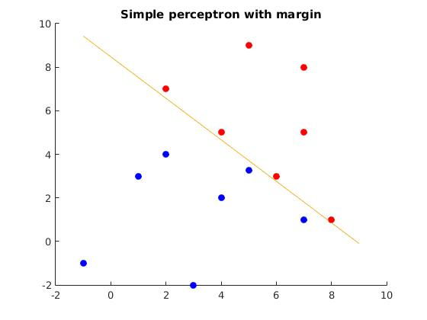

Simple Perceptron with no margin
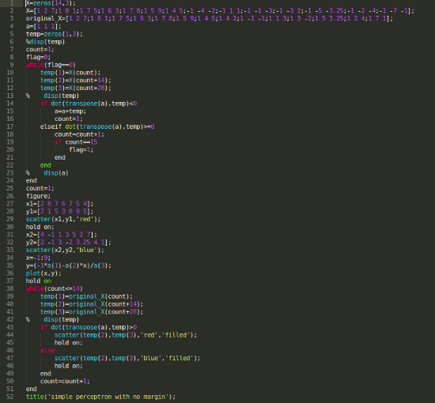

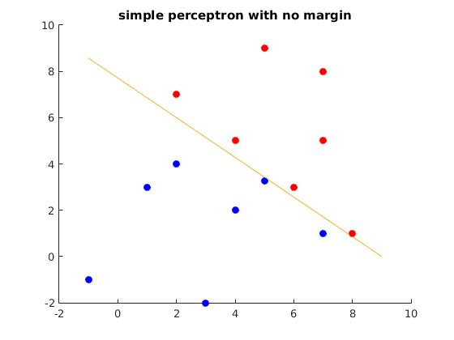
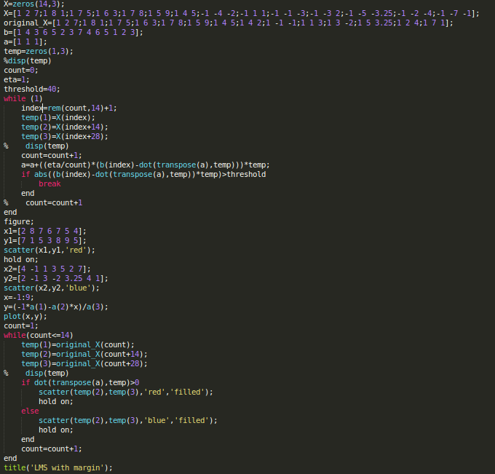
LMS with margin

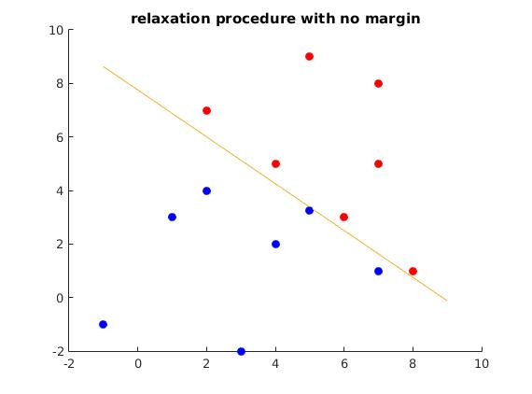

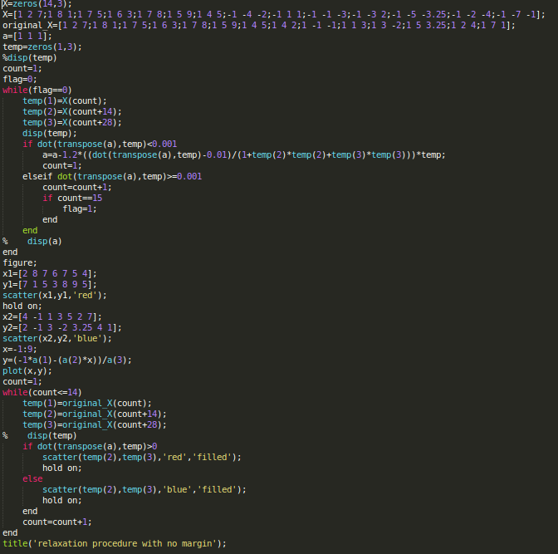

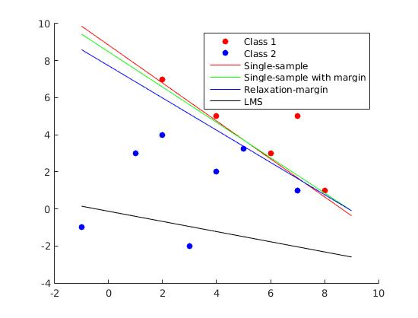
Q1 I

Q1 II
For simple perceptron with no margin
For a=[1 1 1] the time for convergence is 0.604 s
for a=[0 0 0] time required is 0.425 s
for a=[1 0.3 0.7] time required is 0.548 s
for a=[1 20 30] time required=0.568s

For simple perceptron with margin
for a=[1 1 1] time required is 0.474s
for a=[0 0 0] time required is 0.497s
for a=[1 0.3 0.7] time required is 0.493s
for a=[1 20 30] time required is 0.485s

For relaxation procedures with margin
for a=[1 1 1] time required is 3.939s
for a=[0 0 0] time required is 3.884s
for a=random(0,1) required time is 6.630s

For LMS procedure
for a=[1 1 1] time required is 0.230s
for a=[0 0 0] time required is 0.227s
for a=random(0,1) time required is 0.219s

Q1 III
For simple perceptron with margin
b=0.5 then convergence time is 0.474
b=10 time required is 1.696s

For relaxation procedure with margin
b=0.001 time required is 3.939s
b=1 time required is 4.779s

Q1 IV graph is drawn at last

Q2
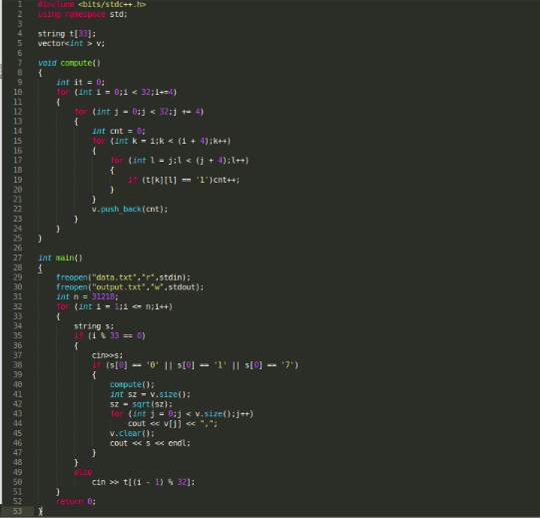

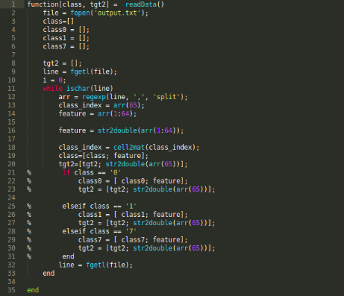

The first code is written in c++ to extract 32*32 matrix of 0,1,7 digits and convert to 8*8 matrix which instead of 2D array is converted to 1D array of 1*64 dimension.
The second code is a function to import the output file of first code to matlab with indexing
of each row matrix mapped to corresponding digit stored in tgt2 array while the row matrices of size 64 are stored in class array.
The bias weight is considered to be 1
Initially weights from input layer to hidden layer is in -1/8 to 1/8 and weights from hidden layer to output layer is -1/sqrt(8) to 1/sqrt(8).
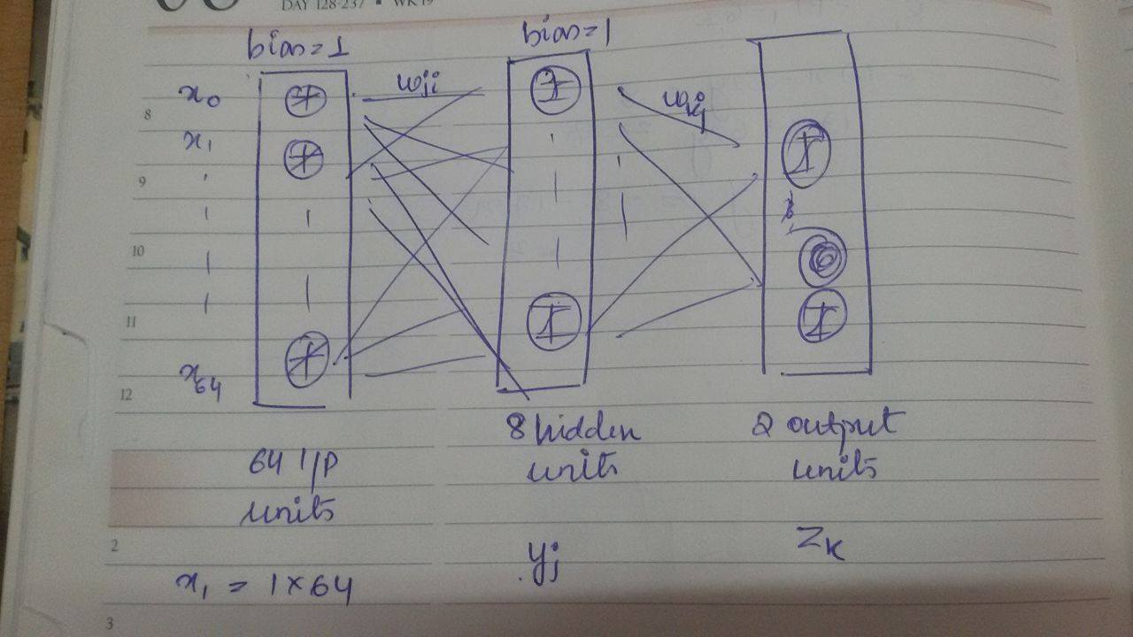
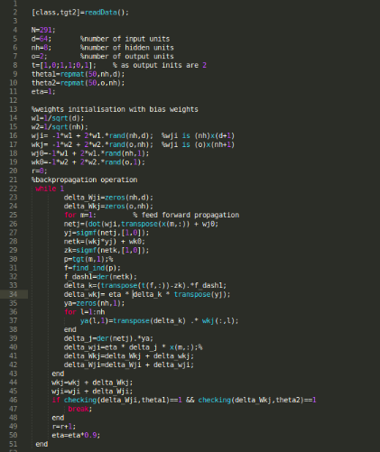

Firstly we are doing feed forward propagation and using the squared error function and trying to minimise it we will get learning rates which will help to find the updated weights. This process is continued till the error is greater than the threshold.

Q2 IV The extra data point 3,4 is classified wrongly
