Curriculum Vitae of  SHREYA DAS  Mailing Address: 24/1 Gopal Saha Lane, Sutrapur, Dhaka.  Post Code: 1100  Contact: +88 01631-224232  Emergency Contact: +88 01716-237673  Email: shreya15-14489@diu.edu.bd  Alternate Email: shreyadas2810@gmail.com | 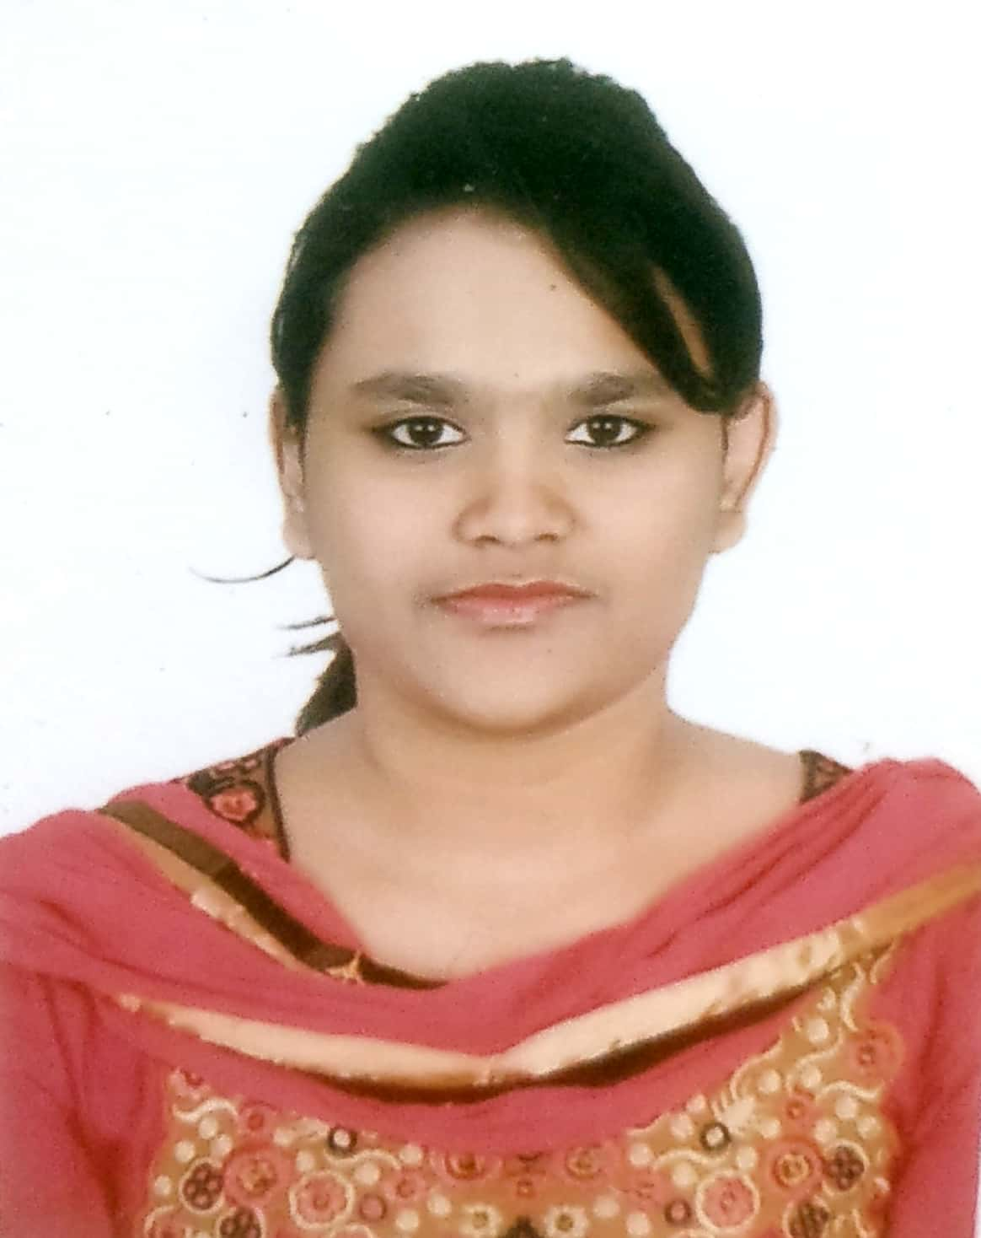

Career Aspiration:

To work in a responsible position where there are opportunities to be able to help in the improvement of IT sector and contribute to the growth of the technological organization as well as can have the motivation for self-development. It would be great opportunity for me if I can get a chance to study and work in a friendly, challenging and dynamic environment where I can build up my career in an honest and descent way.

Educational Background:

Bachelor of Science (BSC) in CSE
Daffodil International University
Course Start Date: 27/July/2020
CGPA Obtained (1st year): 3.67

Higher Secondary Certificate (HSC)
Bir Shreshtha Munshi Abdur Rouf Public College, Dhaka, Bangladesh
GPA Obtained: 3.92
Course Start Date: 10/July/2016
Course End Date: 03/March/2018
Result Publication Date: 19/July/2018

Secondary School Certificate (SSC)
St. Francis Xaviers’s Girls’ High School, Dhaka, Bangladesh
GPA Obtained: 5.00
Course Start Date: 01/January/2014
Course End Date: 05/January/2016
Result Publication Date: 11/May/2016

EXPERIENCE
- Working as a course instructor in Catadu from 01/09/2021 to present.
- Working as a volunteer in Heart to Heart for Humanity Bangladesh from 07/01/2017 to present.
- Working as a Campus-Ambassador Care for Women's from 01/05/2018 to present.
- Worked as an intern in rPETech Industries Ltd. from 01/06/2018 to 31/05/2019.

TRAINING
- I have successfully completed Certificate course on Easy Ways for Effective Content Writing from 06 to 13 December 2021.
- I have successfully completed Certificate course on Preparing to Network in English on September 7, 2021.
- I have successfully completed Certificate course on How to Write an Awesome Term Paper to Get A+ from 05 to 07 June 2021.
- I have successfully completed the certificate course on ICT Skill for University Students from 1st November 2020 to 31st December 2020.
- I have successfully completed Internship in rPETech Industries Ltd. from 01/06/2018 to 31/05/2019.
Responsibilities Handled as Intern
- Assisting the senior data management officer in data management system.
- Diagnosing the problems of the system and resolve it accordingly.
- Observing and analyzing the data collection and processing system.
- Learning the diagnostic methods and equipment.
- Periodically attending meetings with seniors, colleagues & other personnel and observing & analyzing their improvements and making reports.

CONFERENCES/ WORKSHOPS ATTENDED
- Workshop on Self Presentation.
- International Congress on Women’s health, lifestyle and empowerment, 2018.
- Career Symposium and Gala night.

Skills & Expertise:
- Fluent in English with IELTS score of 7.5
- Excellent communication skills.
- Ability to handle different types of critical situations.
- Extremely motivated towards career.
- Polite and soft in nature.
- Quick Learner.
- Punctual and Disciplined.

Computer Skill:

- Microsoft Office 2007, 2010, 2019, 2020, 2021 (Word, PowerPoint, Excel, Access)
- Operating Systems: Linux, Android OS, z/OS
OS- Microsoft Windows XP, Vista, 7, 8, 8.1, 10.
iOS- 8, 9, 10, 11, 12, 13, 14, 15
- Programming Skills: C, C#, C++, Java, JavaScript.
- Expertise in Google doc, Google sheet, Google form, Google slide.
- Fast typing skill and skilled at UI, UX Design.
- Research and making reports, E-mail & Internet Browsing etc.

Others Qualification

- Participated in the 1st inter college science festival 2017- organized by science club of Birshreshtha Munshi Abdur Rouf Public College and secured 1st position in project display.
- Participated in ICPC 2020.
- Culinary Skills.
- Content creating and Writing Skills, Reading.
- Volunteering Activities specially during pandemic situation and charity work.
- Helped to disseminate information during pandemic situation through telemedicine programs.
- Acting as a teacher & educator for deprived primary level students.
- Capable of collecting data, preparing reports and Power Point Presentation.

Capability & Communication skill

- Proficiency in Bengali, English(IELTS 7.5) and Hindi.
- Strong motivation and commitment for study/work, Capable of adopting in any type of environment & ability to cope with people at any level.
- I keep myself updated in social media ie. Facebook, YouTube, Twitter.
- Strong communications, motivation, team building &leadership.
Reference:
Referee 1 | Referee 2
Name: Narayan Das  Position: CEO  Organization: rPETech Industries Ltd.  E-mail: fatcopet@gmail.com  Contact No: +8801711566710 | Name: Dr. Keya Das  Position: Medical Officer  Organization: MOHFW, National Health Call Center Shastho Batayon (16263), Synesis IT.  E-Mail: keyadas001@gmail.com  Contact No: +8801716237673

Declaration:

I declare that the above all information I have given is true and correct according to my best knowledge.

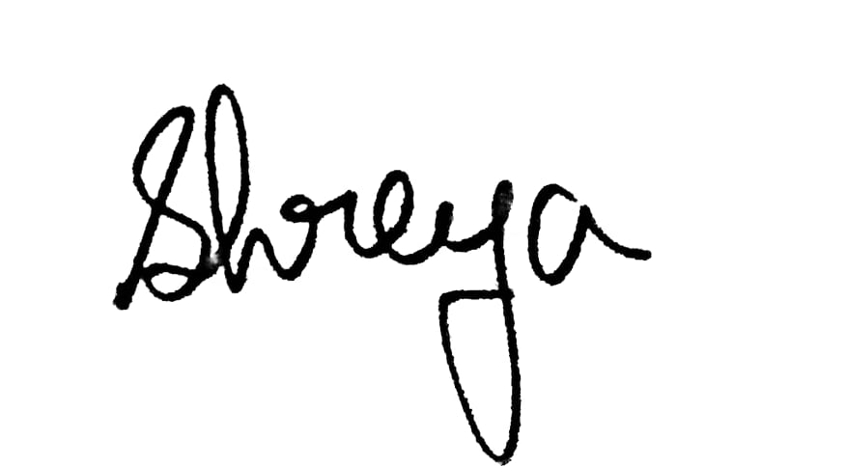

Shreya Das

