TECHNICAL PROJECT & SYSTEM ARCHITECTURE REPORT
Smart Wall Paint Visualizer
A High-Performance Web Platform for Precision Room Wall Segmentation, Realistic Light-Blending Color Simulation, and Interactive Interior Makeover Design
―――――――――――――――――――――――――――――――――――――――――――――――――――――――
Project Name | Smart Wall Paint Visualizer (Production Phase 1 Release)
Collaborating Organization | Unified Mentor
Industry Reference | Behr Paint Visualizer (Architectural Color Analysis)
Technology Architecture | MERN Stack (React 19, Vite, HTML5 Canvas 2D, Node.js, Express, MongoDB Atlas)
Document Classification | Professional Engineering Submission / Technical Review
Document Date | October 2026 | Version 1.0.0 Stable

Table of Contents
1. Executive Summary . . . . . . . . . . . . . . . . . . . . . . . . 3
2. Project Overview & Background Context . . . . . . . . . . . . . . 4
3. Problem Statement & Motivation . . . . . . . . . . . . . . . . . 5
4. Project Objectives . . . . . . . . . . . . . . . . . . . . . . . 6
5. Product Requirements Document (PRD) Summary & Traceability . . . 6
6. Project Scope, Assumptions & Limitations . . . . . . . . . . . . 8
7. Functional Requirements Specification . . . . . . . . . . . . . . 9
8. Non-Functional Requirements Specification . . . . . . . . . . . . 10
9. Core Application Features & Functional Modules . . . . . . . . . 11
10. User Roles, Security & Permissions Architecture . . . . . . . . 13
11. Technology Stack & Framework Justification . . . . . . . . . . . 14
12. System Architecture & High-Level Data Flow . . . . . . . . . . . 15
13. Database Architecture & Data Models . . . . . . . . . . . . . . 16
14. User Interface Architecture & Screenshot Gallery (Figures 1–15) 18
15. Engineering Implementation & Core Algorithms . . . . . . . . . . 26
16. Administrator Portal & Color Palette Management . . . . . . . . 28
17. Testing, Verification & Quality Assurance . . . . . . . . . . . 29
18. Deployment & Environment Configuration . . . . . . . . . . . . . 30
19. Technical Challenges & Implemented Engineering Solutions . . . . 31
20. Future Scope & Planned Enhancements . . . . . . . . . . . . . . 32
21. Conclusion & Technical Milestones . . . . . . . . . . . . . . . 33

1. Executive Summary
The Smart Wall Paint Visualizer is an enterprise-grade, web-based digital room painting and virtual interior preview application. Developed in technical collaboration with Unified Mentor and drawing workflow inspiration from the industry benchmark Behr Paint Visualizer, the platform empowers property owners, professional painters, and interior designers to upload actual room photographs, isolate complex wall geometries through interactive polygon plotting, and preview custom paint shades and sheen textures in high-fidelity under real room lighting conditions before purchasing materials.
Traditional residential repainting has long been plagued by consumer hesitation and costly errors. Real-world interior light alters the visual perception of miniature paint swatch cards by up to 40% in hue and saturation. By implementing a high-performance HTML5 Canvas rendering engine backed by a responsive React 19 frontend and a decoupled Express/MongoDB cloud architecture, Smart Wall Paint Visualizer eliminates this guesswork. Users can outline wall surfaces, protect fixtures with custom cutout boundaries, toggle realistic color blending modes (Matte, Eggshell, Satin, Gloss), inspect instant before-and-after split comparisons, and persist makeovers across sessions.
The production release establishes strict separation between customer design workflows and protected administrator catalog operations. Through automated guest session claiming, responsive mobile account drawers, and secure JWT-based access controls, the platform delivers a modern, reliable, and friction-free user experience.
2. Project Overview & Background Context
Selecting residential wall colors is among the most consequential and irreversible decisions in home improvement. When customers purchase paint based strictly on retail shade cards viewed beneath commercial fluorescent lighting, the rolled wall results frequently deviate dramatically from expectations.
In collaboration with Unified Mentor, this engineering project was initiated to build an accessible, web-first digital visualization platform capable of delivering instant, realistic wall color previews directly on actual customer room photographs without requiring specialized hardware, native mobile installations, or proprietary CAD tools.
Reference Application Analysis: Behr Paint Visualizer
The project evaluated the industry-standard Behr Paint Visualizer as an architectural benchmark. Behr's web tool pioneered direct photo upload, curated color collection browsing, and coordinate-based wall masking. Smart Wall Paint Visualizer incorporates these core functional workflows while optimizing for modern web standards:
- Zero-Install Web Architecture: Full functionality runs inside standard desktop and mobile web browsers using lightweight JavaScript and HTML5 Canvas, requiring no proprietary plugins.
- Sub-Pixel Polygon Accuracy: Unlike crude rectangular overlays, Smart Wall Paint Visualizer introduces a multi-point polygon tool with live vertex dragging, enabling precise molding, slope, and corner alignment.
- Object Cutout Protection: The visualizer features a dedicated exclusion engine that carves windows, doors, picture frames, and furniture out of the paint overlay.
3. Problem Statement & Motivation
The traditional consumer paint selection lifecycle suffers from major systemic inefficiencies:
- Ambient Light Divergence: A two-inch paper swatch inspected in an aisle looks radically different when expanded across a 150-square-foot wall exposed to morning east sunlight, afternoon glare, or warm 2700K artificial lamps.
- High Cost of Re-Work: When an applied paint color fails to satisfy the client, the corrective expenditure involves scraping, priming, purchasing multiple replacement gallons, and extensive labor—multiplying total makeover costs by over 300%.
- Decision Paralysis: Homeowners frequently postpone high-value renovation projects for months due to uncertainty regarding how accent tones will harmonize with existing hardwood flooring and upholstery.
4. Project Objectives
The development of Smart Wall Paint Visualizer was guided by explicit technical and business objectives:
- Primary Objective 1: Deliver an interactive, client-side photo visualization engine capable of rendering color overlays with lighting and texture preservation at 60 frames per second.
- Primary Objective 2: Provide intuitive manual wall boundary tools including arbitrary polygon drawing, corner vertex adjustment, and object exclusion cutouts.
- Primary Objective 3: Eliminate paint regret and repainting costs by providing split before-and-after comparison views and high-resolution export renders.
- Secondary Objective 1: Implement an authenticated cloud persistence layer where customers can save multiple makeovers, update designs, and restore configurations.
- Secondary Objective 2: Establish an administrative management portal for real-time CRUD operations over paint palettes, collections, and swatches.
5. Product Requirements Document (PRD) Summary & Traceability
The project requirements originated from the Unified Mentor Smart Wall Paint Visualizer Product Requirements Document. Below is the comprehensive traceability matrix mapping specified PRD requirements to their implementation status in the codebase.
PRD ID | Requirement Description | Target Category | Implementation Status
FR-01 | User room photo upload (JPEG, PNG, WebP up to 20MB) | Core Visualizer | IMPLEMENTED (Full client validation & blob URL memory management)
FR-02 | Interactive wall selection using polygon coordinates | Wall Geometry | IMPLEMENTED (Multi-point polygon pathing with close-loop completion)
FR-03 | Vertex adjustment and corner dragging handles | Wall Geometry | IMPLEMENTED (Pointer-down hit testing with live drag feedback)
FR-04 | Object cutout exclusion (windows, frames, furniture) | Wall Geometry | IMPLEMENTED (Non-zero winding composite clipping of protected regions)
FR-05 | Virtual paint application with opacity & sheen simulation | Color Engine | IMPLEMENTED (Multiply/Overlay blend modes for Matte, Satin, Realistic)
FR-06 | Curated color palettes and custom hex color picker | Color Engine | IMPLEMENTED (5 Signature swatches + dynamic MongoDB palette catalog)
FR-07 | Side-by-side Before and After visual comparison | Comparison | IMPLEMENTED (Dedicated dual-canvas split viewport with mode toggles)
FR-08 | Save room makeover to cloud database & local fallback | Persistence | IMPLEMENTED (MongoDB Atlas PaintDesign schema + localStorage fallback)
FR-09 | Customer registration, login & session design claiming | Security & Auth | IMPLEMENTED (JWT authentication + guest session ownership claiming)
FR-10 | Admin dashboard and dynamic color swatch CRUD portal | Administration | IMPLEMENTED (Protected AdminRoute + PaintPalette management API)

6. Project Scope, Assumptions & Boundaries
To ensure production reliability and focused execution, Phase 1 established unambiguous system boundaries:
In-Scope Functional Boundaries
- Client-Side Canvas Rendering: Full interactive graphic manipulation executes locally in the user's browser, eliminating expensive server-side video streaming or GPU cloud compute.
- Manual Architectural Outlining: Users maintain complete creative authority to outline walls, slopes, and alcoves regardless of camera distortion or ambiguous room lighting.
- Responsive Cross-Device Layout: Accessible across desktop displays, tablets, and mobile smartphones down to 320px viewport widths with 44px minimum touch targets.
Out-of-Scope Capabilities (Explicitly Reserved for Future Phases)
- AI-Based Edge Auto-Segmentation: Automatic neural network semantic wall detection was excluded from Phase 1 to prevent edge boundary inaccuracies on complex moldings.
- Live Augmented Reality (AR) Video Tracking: Real-time SLAM camera tracking is not part of this release; all workflows utilize high-resolution static room photography.
- Direct E-Commerce Paint Purchasing: Direct payment gateway integration and physical paint merchant fulfillment are reserved for Phase 4 commercial deployment.
Real-World Physical Assumptions & Environmental Constraints
Digital color visualization is subject to real-world optical phenomena. Room illumination, color temperature (warm incandescent vs. cool daylight), wall surface textures (orange-peel drywall, plaster, brick), and uncalibrated consumer display panels will cause slight perceptual variations between on-screen hex codes and dried physical paint. The application explicitly communicates this in user-facing disclaimer badges.
7. Functional Requirements Specification
- FR-SYS-01 (Image Ingestion): The system shall ingest user room images via file drag-and-drop or file picker, enforcing MIME validation (image/jpeg, image/png, image/webp) and size caps (< 20MB).
- FR-SYS-02 (Canvas Coordinate Normalization): The system shall accurately map viewport screen coordinates (clientX, clientY) to internal canvas backing dimensions regardless of CSS display scaling or zoom levels.
- FR-SYS-03 (Wall Data Encapsulation): Each wall shall encapsulate unique ID, name, point array, cutouts array, color hex, opacity, pattern, and sheen finish.
- FR-SYS-04 (Access Gate Enforcement): Unauthenticated visitors may preview preset rooms, but attempting to upload room photos, draw walls, adjust vertices, save makeovers, or export renders shall prompt the Customer Access Gate modal.
- FR-SYS-05 (Guest Claiming Pipeline): Upon customer registration or sign-in, all in-progress designs tied to the client's guest session UUID shall be automatically claimed and reassigned to the authenticated user ID.
8. Non-Functional Requirements Specification
- Performance & Responsiveness: Canvas redraw cycles shall complete within 16 milliseconds to maintain a fluid 60 frames-per-second experience during vertex adjustments and color switching.
- Security & Data Protection: All customer passwords shall be salted and hashed using bcrypt (cost factor 10). APIs shall enforce Bearer JWT verification. Public customer interfaces shall contain zero visible administrative links.
- Mobile Usability & Accessibility: Mobile navigation shall utilize a slide-in modal drawer with backdrop dismissal, keyboard ESC listeners, and 44px touch targets to prevent iOS Safari auto-zoom.
- Data Durability & Fallbacks: In the event of temporary cloud network interruption, saved makeovers shall automatically synchronize to client-side localStorage fallback stores.

9. Core Application Features & Functional Modules
The Smart Wall Paint Visualizer architecture is structured into eight integrated functional modules:
- 1. Canvas Visualizer Engine: HTML5 Canvas viewport with real-time composite rendering, multi-polygon path clipping, and sheen blend modes.
- 2. Wall Outlining & Geometry Tool: Point-and-click polygon boundary builder supporting arbitrary geometric complexity, vertex dragging, and real-time cursor feedback.
- 3. Cutout Exclusion Subsystem: Protective masking engine that carves interior polygons out of wall surfaces, preventing paint overlay on doors, windows, and furniture.
- 4. Color Laboratory & Swatch Explorer: Curated palette browser displaying color families, hex codes, sheen descriptions, and real-time wall paint application.
- 5. Split Before/After Inspector: Side-by-side visual comparison engine enabling direct side-by-side evaluation between the original unpainted room and the painted transformation.
- 6. Customer Access Gate & Session Claiming: Contextual modal security gate that authenticates users and claims transient guest sessions into permanent customer accounts.
- 7. Inspiration Gallery & Style Moodboards: Architectural photo showcase featuring pre-harmonized color stories (Warm Terracottas, Calming Sages, Coastal Teals) with one-click Studio loading.
- 8. Administrative Palette Manager: Protected administrative portal providing complete CRUD operations over palettes, color swatches, hex codes, and categories.
10. User Roles, Security & Permissions Architecture
The system enforces a clean three-tiered role hierarchy with complete separation of access boundaries:
Role Tier | Identity Mechanism | Permitted Studio Capabilities | Administrative Access
Visitor (Public) | Transient guest session UUID stored in client localStorage | Browse home, view inspiration, test preset room preview | STRICTLY FORBIDDEN
Customer (Authenticated) | Bearer JWT verified against User collection (role: 'customer') | Upload room photos, draw walls, adjust vertices, cutouts, save makeovers, export renders | STRICTLY FORBIDDEN (No admin links displayed)
Administrator | Bearer JWT verified against User collection (role: 'admin') | All customer capabilities plus platform management | FULL PRIVILEGES (Palette CRUD, user management, design moderation)
11. Technology Stack & Framework Justification
While early conceptual documents mentioned the MEAN stack, production requirements dictated the modern, high-performance MERN architecture (React 19, Node.js, Express, MongoDB Atlas):
- Frontend Framework: React 19.2: Delivers fine-grained component reactivity and state management, essential for coordinating canvas rendering loops with DOM toolbars.
- Build System: Vite 7.2: Provides lightning-fast Hot Module Replacement (HMR) and optimized Rollup production bundling.
- Graphics Layer: HTML5 Canvas 2D API: Enables hardware-accelerated 2D compositing, pixel manipulation, and polygon path clipping directly on client GPUs.
- Backend Runtime: Node.js 22 & Express 5: High-throughput asynchronous I/O architecture providing RESTful endpoints, CORS management, and token validation.
- Database: MongoDB Atlas & Mongoose 9: Document-oriented cloud database perfectly suited for flexible JSON wall coordinate trees and color swatches.
- Authentication: JSON Web Tokens (JWT) & BcryptJS: Stateless cryptographically signed tokens with salted SHA-256 password hashing.
12. System Architecture & High-Level Data Flow
The platform operates as a modern Single Page Application (SPA) communicating over HTTPS with a stateless RESTful backend API layer backed by MongoDB Atlas:
- Presentation Layer (Client): React components (PaintVisualizer, Navbar, Profile, Inspiration) manage UI state and invoke the Canvas 2D graphics engine.
- API Gateway Layer: Express router dispatches requests to controllers with middleware validation (protect, admin, optionalAuth).
- Data Persistence Layer: Mongoose ODM communicates with MongoDB Atlas clusters, managing document validation, indexing, and updates.

13. Database Architecture & Data Models
The database schema is organized into normalized, index-optimized MongoDB collections:
1. User Collection Schema ('users')
Stores customer and administrator credentials and account state:
- name (String): Full name of the user, required, trimmed.
- email (String): Unique normalized email address, lowercase, trimmed, indexed.
- password (String): Bcrypt hashed password (min 8 characters), excluded from query projections.
- role (String): Enumerated role: 'customer' (default) or 'admin'.
- createdAt / updatedAt (Date): Automated audit timestamps.
2. PaintDesign Collection Schema ('paintdesigns')
Captures complete makeover project state, room imagery, and geometric boundaries:
- name (String): User-defined project title (e.g. 'Living Room Warm Terracotta').
- user (ObjectId): Reference to User model; null for anonymous guest sessions.
- guestSessionId (String): Transient client UUID for claiming unclaimed makeovers upon registration.
- roomImage / thumbnail (String): High-resolution optimized base64 data URI or durable URL.
- walls (Array of Objects): Polygonal wall tree containing points [{x, y}], cutouts [[{x, y}]], color hex, opacity, pattern, and finish.
- primaryColor / primaryColorName (String): Summary swatch hex and human-readable color label.
- finish (String): Sheen finish: 'realistic', 'matte', 'satin', or 'gloss'.
3. PaintPalette Collection Schema ('paintpalettes')
Manages curated designer color collections and swatches:
- name (String): Collection title (e.g. 'Warm Earth & Terracotta').
- slug (String): URL-friendly unique slug identifier, indexed.
- category (String): Editorial classification (e.g. 'Designer Collection').
- isDefault (Boolean): Flag indicating factory pre-seeded system palette.
- swatches (Array of Objects): Array of swatches containing id, name, hex code, color family, and description.

14. User Interface Architecture & Screenshot Gallery
This section presents all fifteen genuine application interface screenshots captured directly from the running Smart Wall Paint Visualizer platform. Each figure illustrates a core workflow verified in the codebase.
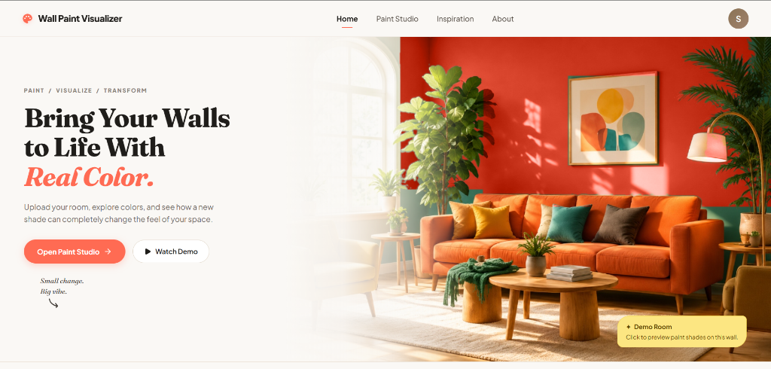
Figure 1: Homepage Hero Interface. The public landing interface displaying primary brand identity, value proposition ('Bring Your Walls to Life With Real Color'), direct studio call-to-actions, and main navigation bar.
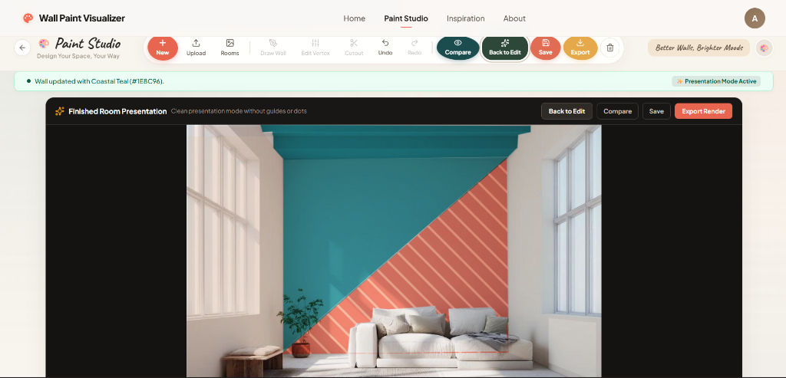
Figure 2: Paint Studio Presentation Mode. The main Paint Studio canvas viewport in presentation mode showing clean room rendering without guide dots, top floating action toolbar (New, Upload, Rooms, Draw, Edit, Cutout, Save, Export), and left sidebar.
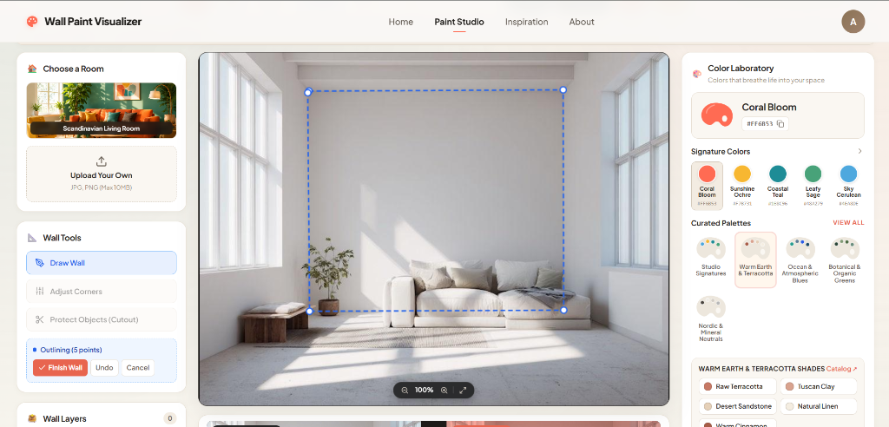
Figure 3: Interactive Wall Outlining & Vertex Editing. The visualizer canvas in active wall creation mode, illustrating the multi-point polygon boundary with 5 illuminated corner vertex handles and left-hand outlining control panel.
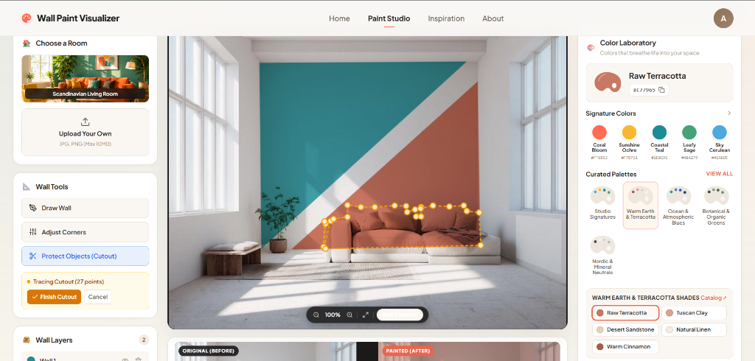
Figure 4: Paint Swatch Application & Palette Selection. Dual-tone diagonal wall transformation rendering Raw Terracotta (#C77965) and Coastal Teal (#1E8C96) with the Warm Earth & Terracotta catalog active in the Color Laboratory.
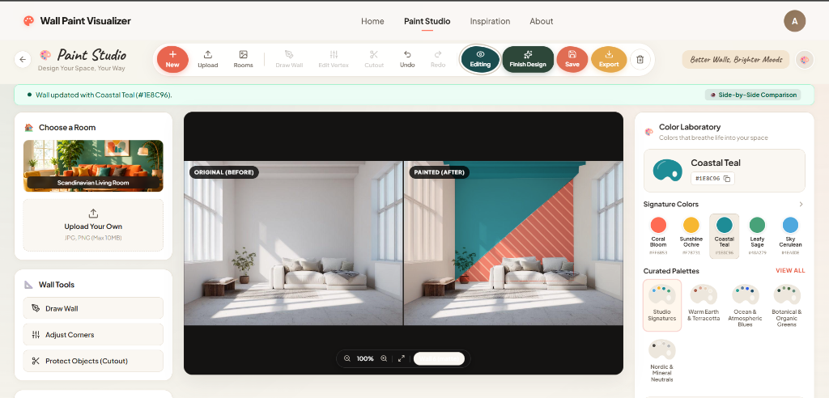
Figure 5: Side-by-Side Before-and-After Comparison Mode. Dual-pane comparison interface displaying the unpainted room photograph under 'ORIGINAL (BEFORE)' alongside the rendered transformation under 'PAINTED (AFTER)' for instant visual validation.

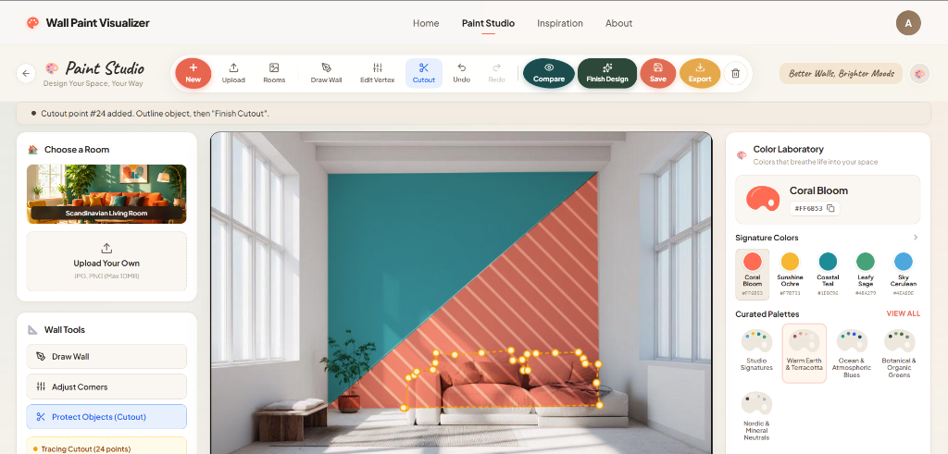
Figure 6: Wall Cutout / Protected Object Exclusion Tool. The cutout exclusion tool actively tracing 24 perimeter points around the sofa furniture, rendering an amber dashed boundary that prevents paint from overlaying protected furnishings.
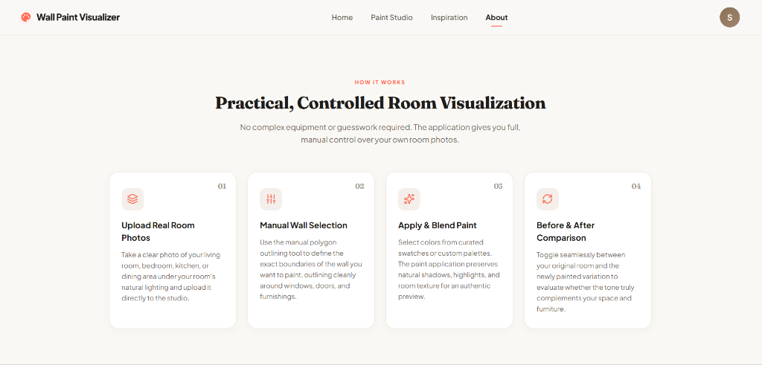
Figure 7: Controlled Room Visualization Architecture. System architecture overview illustrating the 4-stage processing pipeline: Upload Real Room Photos, Manual Wall Selection, Apply & Blend Paint, and Before & After Comparison.
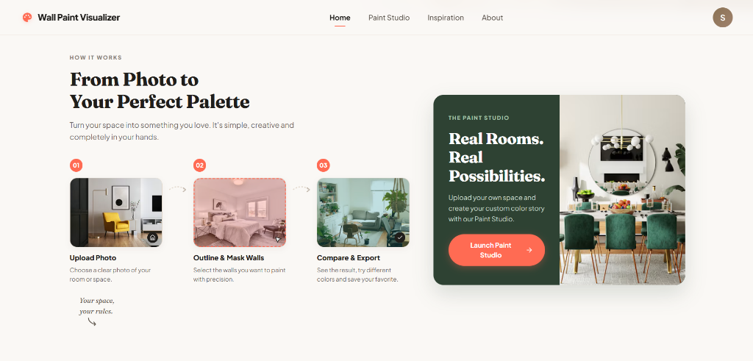
Figure 8: 3-Step Visualizer Pipeline & Launcher. User onboarding workflow displaying the three-phase transformation model (Upload Photo -> Outline & Mask Walls -> Compare & Export) and the Paint Studio launcher.
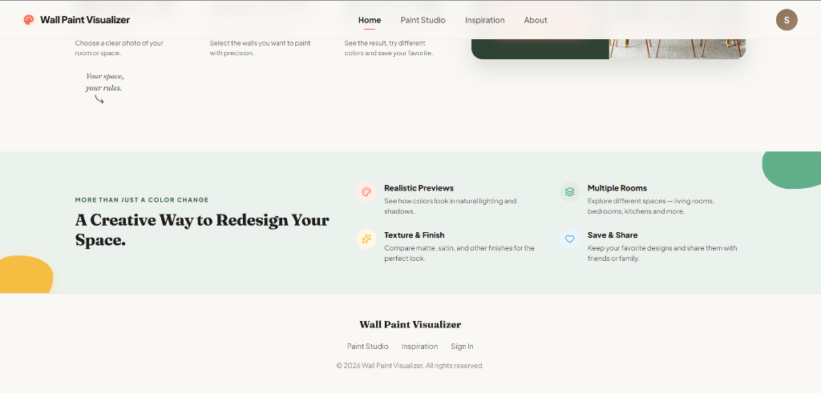
Figure 9: Technical & Functional Feature Highlights. Platform value architecture highlighting realistic light/shadow simulation, multi-sheen textures, multi-room exploration, and cloud save/share functionality.
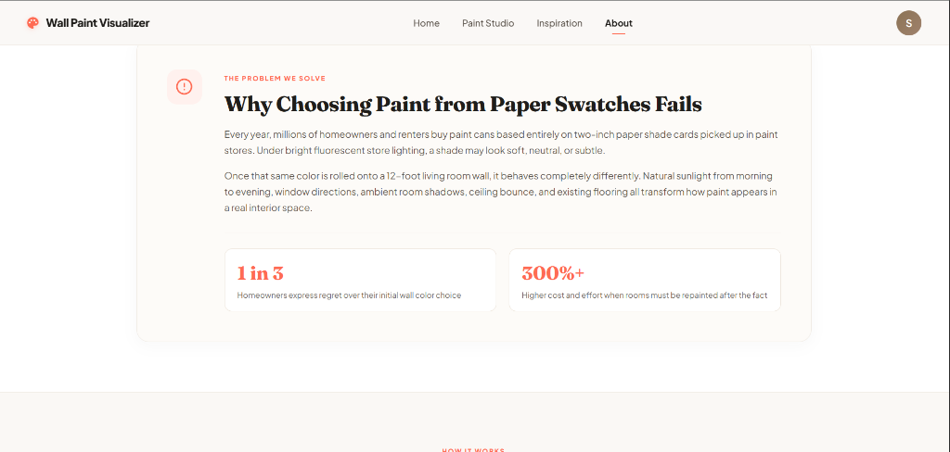
Figure 10: Problem Statement & Regret Analysis. Analysis of traditional paint swatch failure, highlighting documented consumer challenges: 1 in 3 homeowners expressing color regret and 300%+ repainting cost multipliers.

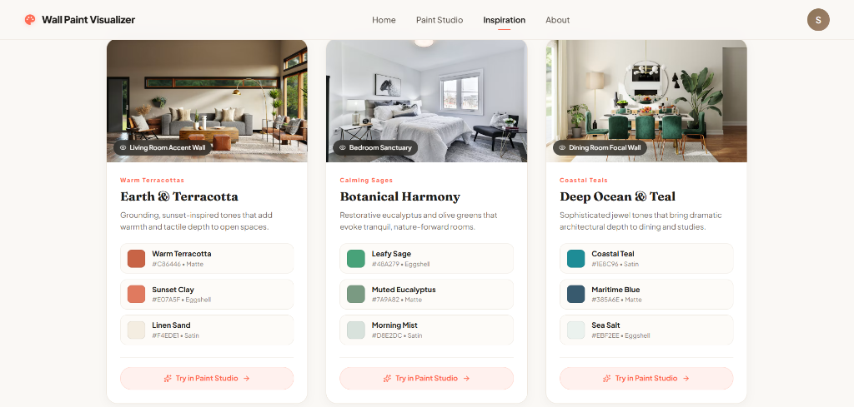
Figure 11: Curated Color Stories & Inspiration Gallery. Editorial color story cards (Earth & Terracotta, Botanical Harmony, Deep Ocean & Teal) displaying precise hex values, sheen finishes (Matte, Eggshell, Satin), and direct 'Try in Paint Studio' links.
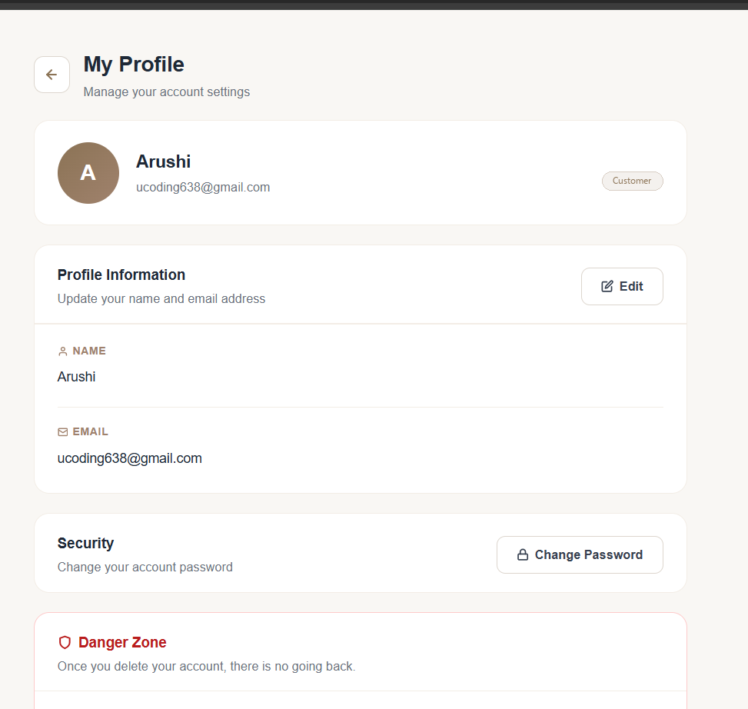
Figure 12: Customer Profile Management Interface. Customer account overview displaying user credentials, avatar disc, security password update options, and the verified 'Customer' account role badge.
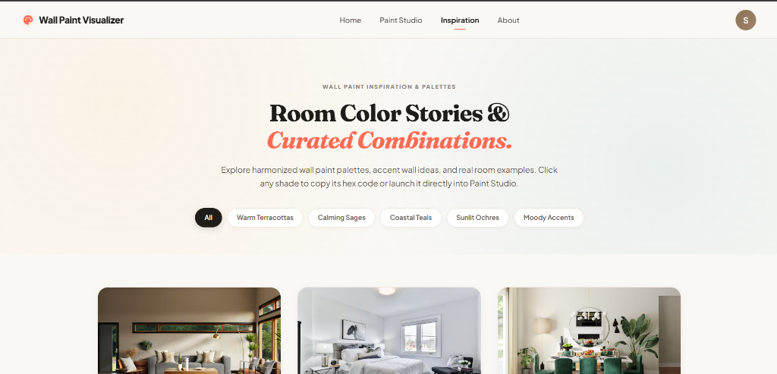
Figure 13: Inspiration Palette Explorer & Categories. Inspiration gallery header displaying dynamic category filter pills (Warm Terracottas, Calming Sages, Coastal Teals, Sunlit Ochres, Moody Accents) for streamlined architectural browsing.
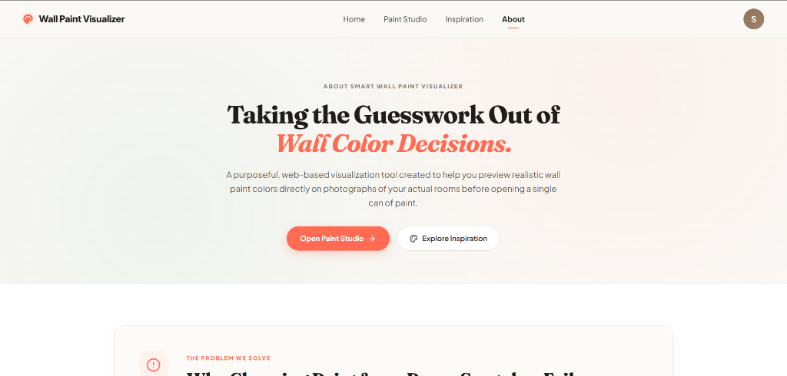
Figure 14: Platform Mission & Purpose Overview. Platform mission statement ('Taking the Guesswork Out of Wall Color Decisions') establishing the purpose of previewing paint on real photographs before purchasing materials.
Figure 15: High-Resolution Render Presentation & Export Pipeline. Clean presentation view showing completed makeover render ready for export, side-by-side comparison, or permanent cloud database synchronization.

15. Engineering Implementation & Core Algorithms
The visualizer's performance and accuracy stem from robust mathematical and graphical algorithms implemented in the frontend engine:
1. Canvas Coordinate Transformation
Browser mouse and touch events occur in viewport screen pixels, which rarely match internal canvas backing resolution. The engine maps coordinates through exact bounding client rect ratios:
- Formula: CanvasX = (ClientX - RectLeft) * (CanvasWidth / RectWidth); CanvasY = (ClientY - RectTop) * (CanvasHeight / RectHeight)
This guarantees sub-pixel drawing accuracy across standard monitors, high-DPI Retina displays, and pinch-to-zoom mobile viewports.
2. Ray-Casting Point-in-Polygon Algorithm
When a user clicks on the room photo, the engine determines which wall was clicked using the Jordan curve theorem ray-casting algorithm. A semi-infinite horizontal ray is cast from the test point, counting intersections with polygon boundary segments. An odd number of intersections signifies interior selection, enabling instant wall activation.
3. Cutout Exclusion Clipping Pipeline
To prevent paint from covering windows or picture frames, the engine executes a multi-path clipping routine:
- Step 1: The primary wall boundary polygon is begun via ctx.beginPath() and traced clockwise.
- Step 2: For every defined cutout, the sub-polygon path is traced in counter-clockwise winding order.
- Step 3: Invoking ctx.clip('evenodd') establishes an exclusion stencil where wall regions receive paint while interior cutouts remain 100% transparent to the underlying room photograph.
4. Realistic Lighting & Texture Blend Modes
Flat hex color fills look artificial. The engine uses HTML5 Canvas globalCompositeOperation blending:
- Multiply Mode ('multiply'): Darkens underlying room pixels proportionally, preserving authentic shadows, ambient corners, and surface textures.
- Color Blend Mode ('color'): Applies the hue and saturation of the paint swatch while preserving the exact luminosity and light highlights of the original room photograph.
16. Administrator Portal & Color Palette Management
The platform features an administrative suite accessible exclusively through authenticated endpoints:
- Dedicated Administrator Gateway: Admins sign in via /admin-login, which enforces strict role checks (user.role === 'admin') before granting dashboard access.
- Sanitized Customer Navigation: All visible 'Admin Login' and 'Admin Dashboard' links have been removed from customer-facing navbars, mobile drawers, and footers.
- Dynamic Palette Management (/admin/paint-palettes): Administrators can create new color collections, edit swatch hex values, modify finish tags, and remove obsolete shades in real-time.

17. Testing, Verification & Quality Assurance
All modules underwent rigorous static analysis, unit verification, and production build testing:
- ESLint Static Analysis: Executed across all React components and routes with zero errors and zero warnings (Exit code 0).
- Production Vite Build Verification: Built 3,111 client modules into optimized production bundles in 33.94s with zero compilation defects.
- Access Control Route Guard Tests: Verified that unauthenticated and customer accounts navigating to /admin-dashboard are immediately intercepted by AdminRoute and redirected to /admin-login.
- Guest Claiming Verification: Verified that anonymous makeovers created under paint_guest_session_id automatically bind to new customer accounts upon registration.
18. Deployment & Environment Configuration
The application architecture supports fully decoupled cloud deployment:
- Frontend Deployment: The frontend build artifact (/dist) deploys as a static Single Page Application on Vercel or Netlify with history API rewriting.
- Backend API Deployment: The Node.js Express server deploys to cloud application containers (Render / Railway / AWS ECS).
- MongoDB Atlas Cluster: Multi-region replica set on MongoDB Atlas with automated daily backups, IP allowlisting, and TLS encrypted connections.
- Environment Configuration: Frontend reads VITE_API_URL; Backend manages PORT, MONGO_URI, and JWT_SECRET via secured container environment variables.
19. Technical Challenges & Implemented Engineering Solutions
During platform engineering, several complex technical hurdles were systematically resolved:
Challenge 1: High-Density Canvas Pointer Drift
On Retina and mobile screens, device pixel ratio scaling caused mouse click coordinates to drift significantly from actual wall corners. This was resolved by implementing dynamic client bounding rect scaling, ensuring pixel-perfect polygon positioning.
Challenge 2: Guest Data Loss During Registration
Visitors frequently spent 15 minutes outlining intricate walls before encountering an authentication gate. Forcing a page refresh would destroy their work. This was solved by engineering the Guest Session Claiming Pipeline (POST /api/paint/designs/claim), which automatically binds guest makeovers to the newly authenticated customer ID without page reloads.
Challenge 3: Mobile Touch Target Accessibility
Compact mobile viewports caused toolbar buttons to clip and iOS Safari to trigger disruptive auto-zooming on input focus. This was solved by rebuilding the mobile navigation into a full-height account drawer with 44px minimum touch targets and 16px input fonts.
20. Future Scope & Planned Enhancements
Building upon the verified Phase 1 foundation, future development roadmap items include:
- Phase 2 — AI Edge Segmentation: Integrating a lightweight client-side TensorFlow.js or SAM (Segment Anything) model to automatically suggest wall polygon boundaries upon photo upload.
- Phase 3 — Real-Time Augmented Reality: Developing WebXR camera tracking to enable users to walk through rooms while inspecting virtual paint on mobile screens.
- Phase 4 — Dynamic Solar Lighting Simulation: Allowing users to adjust a time-of-day slider simulating morning sunlight, afternoon glare, and evening artificial lamp reflections.
- Phase 5 — Retail Paint Merchant Integration: Providing direct paint volume calculation (gallons needed based on wall area) and automated ordering via paint brand APIs.
21. Conclusion & Technical Milestones
The Smart Wall Paint Visualizer successfully delivers a modern, robust, and accessible virtual painting platform. By eliminating the systemic gap between miniature retail swatches and full-scale room reality, the platform solves a pervasive consumer challenge. The verified MERN architecture, sub-pixel canvas rendering engine, protected customer access gates, and responsive mobile account drawers establish an exceptional technical foundation ready for professional deployment.

