**Lesson 2: Java Lab**

**- class header** - consists of the class keyword and the name of the class

**- integrated development environment (IDE)** - a software application for writing, compiling, testing, and debugging program code

○ in our case, that would be Visual Studio Code

**- software** - a collection of instructions that is run by a computer

**- source code** - a collection of programming commands

**- syntax** - the rules for how a programmer must write code for a computer to understand

**- syntax error** - a mistake in the code that does not follow a programming language's syntax

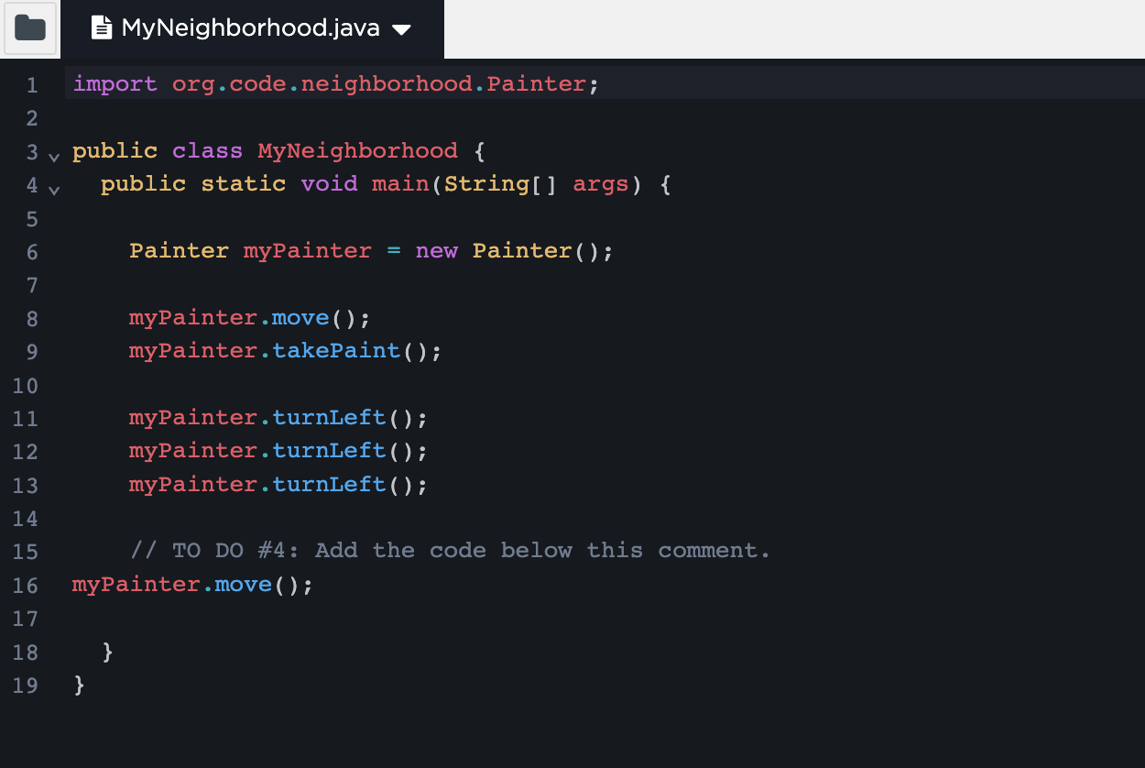

***Key Learnings from Lesson 2***

* made a class and object
* allowed the painter to move and take paint, then turn left
* in other words, learned how to use different methods on the object